**q**

**Western Ohio Junior Footba ll Conferenc**

**M inimum Piny Ruic Verificu t ion Form**

Date:------

Your team:- -

Your opponent: __

The Western Ohio Junior Football Conference requires that each child be afforo7c.l a mi imu of fic plays per each half. This sheet shall be completed by the Head Coach to document compl iance with this requirement.

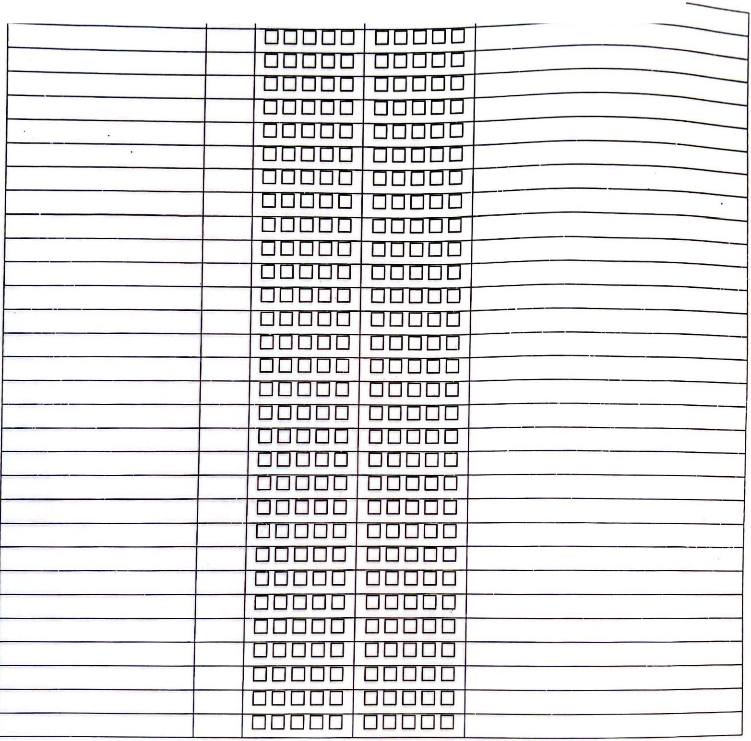

Players Name

No.

**1st half**

**2nd Half**

Com men ts

By signing below, I hereby certify that the above information has been reviewed by me, is complete, truthful, and accurate. I understand that submitting this form with inaccurate or falsified information could result in immediate disciplinary action up to and including my immediate and possibly permanent expulsion from the Western Ohio Junior Football Conference.

HEAD COACH:---------

SIGNATURE:---------DATE: _

(Top sheet (original) - WOJFC copy; Middle sheet -Team copy; Bottom sheet - Opponent's copy) Version 20 Jul 2006

-