Query Generator and Visualizer – A Reverse Query Mapping System

Geoff McGinnis
Computer Science and Engineering
The Ohio State University
mcginnis.1930@osu.edu
Manjari Akella
Computer Science and Engineering
The Ohio State University
akella.4@osu.edu

ABSTRACT
In this paper, we discuss our upcoming plans for the Advanced DBMS class project. Our plan is to create a system which produces the simplest SQL query based on the data selected by the user. This is essentially performing any typical database query in reverse: the uses first selects the data they want from the database, and the system produces a query that will generate that data when executed. This paper discusses our current plan for design as well as a project timeline for the semester.

INTRODUCTION
Query generators and visualizers simplify querying in a database. They allow users to get away with not having an in-depth knowledge of databases to get what they need. The idea is to allow intuitive querying and to have a user select what they want to do using a simplified visual interface. The user picks and selects the tables, columns, predicates etc. The system then converts this input from the user into a standard executable SQL query. The visualizer part of the system shows the relationship between tables and how exactly a query is solved in the form of a pictorial representation. This way the user can easily execute complex and powerful queries without much effort using a simple point and click interface. An example of the output of such a generator is shown in Figure 1 [1]. The aim of our query generator is to simplify things even more. The user can basically know nothing about SQL and still be in a position to generate queries. The idea is to generate the simplest query, given a subset of data we have, as input to the system. Section 2 talks more about the project. Section 3 describes the motivation behind the idea. The proposed design is described in Section 4. Section 5 describes the testing metrics and finally, the tentative timeline is set up in section 6.
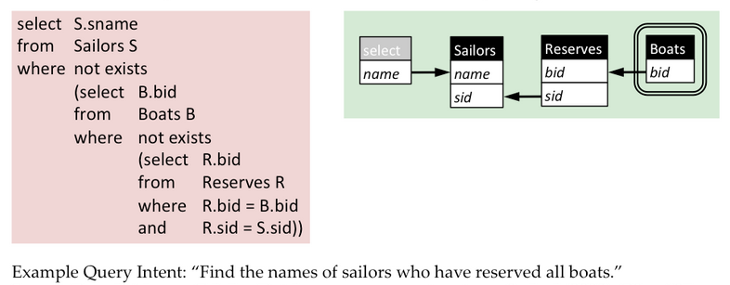
Figure 1

PROJECT DESCRIPTION
The goal of our project is to try and generate the simplest possible query whose result is specified as input by the user. Though there exist many query generators [1][2][3], our search to find an existing system which takes as input a subset of data was futile. The system will take as input a bunch of cells from a table and generate possible and eventually the simplest query which will give the specified result. The most challenging part of the project would be figuring out the relationship between the chosen data. Once these relationships have been established; we can try to represent these in the form of predicates and finally establish the query.

MOTIVATION
The motivation behind creating this system is to educate users on the basics of relational databases and basic SQL queries. We feel that this will be a valuable teaching tool for beginner database developers who are new to RDBMSs. The user begins with the end goal in mind as they select the specific data they want first, and then are able to see how that end goal is reached by learning the exact query that can be used to achieve that result. This system will teach the user about joining tables as they will have to first consider for themselves what tables contain the data they want and how those tables are connected.

PROPOSED DESIGN
The group has not yet finalized the architecture design of the system at this time, though we have some solid ideas on the direction we would like to go. We intend to create a user interface which the user can visually select data contained in the sample database. We are leaning towards doing so in a web-based client, but are also considering a stand-alone client. The back-end of the system will likely be written in a high-level language such as C# or Java, which will allow sufficient support for SQL interactions. We have also considered utilizing Python because of its ease of installation and execution, as well as its many supporting libraries.
Edit:
- We have decided to use a stand-alone client for the time being; though we haven’t completely done away with the idea of making it a web-based design.
- We are using C# as both the frontend to generate user interface and to enable support for SQL interactions.
- We are currently using a small SQLit database, containing two tables for our initial testing and demo purposes.
- We are also utilizing some of the query-building classes from the open-source project found in [4] to organize the building of an individual query.

TESTING METRICS
Our project will be successful if these following metrics are met. These metrics are initial goals and may change as our project’s scope changes. Success can be intuitively defined. If the generated query indeed produces the given input as the result, we can say it is a success. However, to define whether or not it is the simplest is slightly trickier.

TIMELINE
Below is our proposed timeline for this project, and our weekly goals. This schedule is tentative and may be adjusted, but keeping on this track should produce successful project completion.
Week 1 (2/2): Research possible design architectures and platforms to be used. Break down the project into sub-tasks to be completed. Goal: Finalize the design and begin moving forward with implementation.
Week 2 (2/9): Build the relational database to be used in the early stages of development. This will have only 1 table to start, and few columns and rows. Begin implementation of turning user input into the predicates used on the query. Goal: Have a working database and a start on evaluating user input.
Week 3 (2/16): Begin the implementation of query generation. At this point it will not be the simplest query, but will be a correct query. Goal: Successfully convert user input into predicates, and output correct queries for simple inputs. Check for invalid user input.
Week 4 (2/23): Start expanding input complexity and begin searching for simple queries. Create the user interface to allow more freedom of input. Goal: Create correct, more complex queries based on user input. Create a more advanced user interface.
Week 5 (3/2): Begin adding the option of joining multiple tables and selecting more complex combinations of data. Add additional functionality to the user interface. Begin designing the testing method and benchmarking. Goal: Successfully create queries which involve multiple tables. Establish a testing methodology.
Week 6 (3/9): Begin testing the system according to the testing methodology chosen. Increase complexity of the possible selections from the database. Goal: Build the simplest query involving one or more tables, and multiple fields.
Week 7 (3/16): Begin implementation of alternate query statements to allow the user to update the database, not just read from it. Continue testing. Goal: Finalize user interface.
Week 8 (3/23): Begin the final documentation. Continue to implement additional query commands. Continue testing. Goal: Add functionality for other SQL commands besides SELECT (DELETE, INSERT, etc.)
Week 9 (3/30): Continue testing. Finalize implementation. Goal: Resolve most of the outstanding bugs and problems. Optimize the system for performance.
Week 10 (4/6): Finalize documentation and testing. Expand the features of the system if time permits (support for nested queries, for example). Goal: Project completion.

PROGRESS

- At this point of time, we are almost where we expected to be timeline wise.
- We have decided upon architectural and design issues (front –end, back-end, web-based vs stand-alone client etc.)
- We have built and imported 2 relational tables which we will be using in the early stages of our implementation.
- We have a user interface up and running.
- It allows user to select a table and cells of data from the selected table. It generates simple, correct Select queries.
- We are now working towards generating queries from multi-table data (joins).

REFERENCES
[1] http://queryviz.com/index/QueryInterpretation.png
[2] http://www.activequerybuilder.com/
[3] http://www.razorsql.com/docs/query_builder.html
[4]http://www.blackbeltcoder.com/Articles/strings/a-sql-querybuilder-class

