- Create two EC2 Instances in AWS Cloud using,
Additional Information
- Instance Type of both instance is t2.micro
- Operating System for both instances Ubuntu Server 16.04 LTS
- Hostname of Instance 1 : MSR-test-Instance-1
- Hostname of Instance 2 : MSR-test-Instance-2

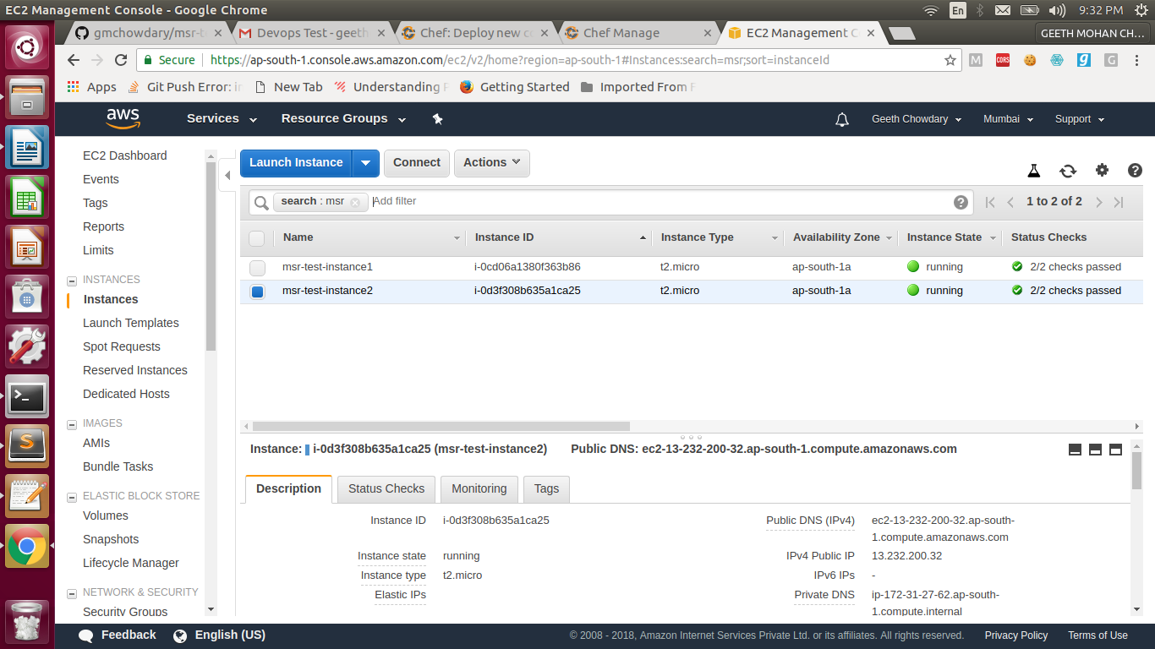

- Once these two servers are provisioned, ensure the below following software packages are installed using configuration management tool in both the provisioned instances.

Additional Information
- NVM – Version 0.33.2
- Node – 8.12.0
- Docker – 18.06 or latest
- Docker Compose – 1.13 or latest
- Openssl – latest version
- Git – latest version
Preferred tools – Chef / Puppet / Salt stack / Ansible.

$chef generate cookbook MSR-Test-Instance

- Create a Docker Container in MSR-test-Instance-1 using Docker Compose file and ensure apache webserver is installed. Try to use configuration management tools to automate the entire installation of apache and deploy a sample html file from a GitHub repository.
Additional Information
- You can create your own GitHub repository with a sample html file.

Preferred tools – Chef / Puppet / Salt stack / Ansible. (Note – Ansible is Preferred)

- Create a Docker Container in MSR-test-Instance-2 using Docker Compose file and ensure CouchDB Database is installed. Try to use any configuration management tool to automate the entire installation processes.
Additional Information
- We should be able to access the Futon – web GUI of CouchDB, from the external system.
Preferred tools – Chef / Puppet / Salt stack / Ansible. (Note – Ansible is Preferred)

- Commit all the code/files to GitHub and write your explanations and documentations into the readme.
- It will be an added advantage if you can draft the step by step procedure in performing the above activities and how to execute the code.

Used chef commands
>$chef generate cookbook MSR-Test-Instance
>$knife cookbook upload MSR-Test-Instance
>$knife bootstrap 13.233.34.247 --sudo -x ubuntu -i /home/geeth/Downloads/devops-demo/geeth-devops-demo.pem -N MSR-Test-Instance-1 -r "role[msr-1]"
>$knife bootstrap 13.232.200.32 --sudo -x ubuntu -i /home/geeth/Downloads/devops-demo/geeth-devops-demo.pem -N MSR-Test-Instance-2 -r "role[msr-2]"

Over all my chef repo structure
├── cookbooks
│ ├── chefignore
│ ├── MSR-Test-Instance
│ │ ├── Berksfile
│ │ ├── chefignore
│ │ ├── LICENSE
│ │ ├── metadata.rb
│ │ ├── README.md
│ │ ├── recipes
│ │ │ ├── apache.rb #seting up MSR1
│ │ │ ├── couchdb.rb #setting up MSR2
│ │ │ └── default.rb #common MSR Instance instalations
│ │ ├── spec
│ │ │ ├── spec_helper.rb
│ │ │ └── unit
│ │ │ └── recipes
│ │ │ └── default_spec.rb
│ │ ├── templates #folder used for storing configuration files
│ │ │ ├── msr-test-instance-1
│ │ │ │ ├── 000-default.conf #apache configuration file
│ │ │ │ ├── docker-compose.yml
│ │ │ │ ├── Dockerfile
│ │ │ │ └── start-msr-1.sh
│ │ │ └── msr-test-instance-2
│ │ │ ├── docker-compose.yml
│ │ │ └── start-msr-2.sh
│ │ └── test
│ │ └── smoke
│ │ └── default
│ │ └── default_test.rb
│ └── starter
│ ├── attributes
│ │ └── default.rb
│ ├── files
│ │ └── default
│ │ └── sample.txt
│ ├── metadata.rb
│ ├── recipes
│ │ └── default.rb
│ └── templates
│ └── default
│ └── sample.erb
├── README.md
└── roles
└── starter.rbCreated CHEF Roles

msr-1(Role)

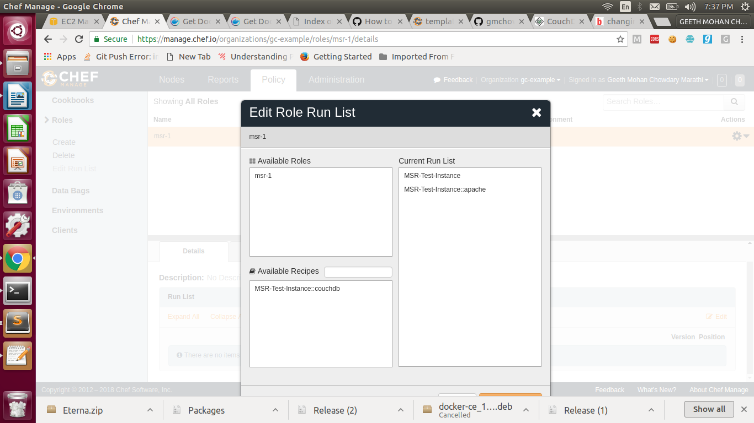

msr-2(Role)
