

Introduction:
Purpose
Use
History and Tool Description
Install Jenkins
Types of release
Latest
Weekly
Steps to Install(Widows)
step1: Install Java 1.7 and above JRE or JDK
step2: Download the jenkins war file
step3: place it in any location in your desktop
step4: cd to location
step5: type $java -war jenkins.war --httpPort=80
step6: for the first time you will get password copy it
step7: goto browser localhost:8080 paste the you git in “step5”
step8: You can choose
Install Suggested Plugins(Try to use it)
Install Selected Plugins(Try when you have good picture on jenkins)
Note: Jenkins have almost 1800 Plugins as of 2018
step9: To see the jenkins installation go to user folder and open .jenkins folder which is a hidden file.
Install or Deploy Jenkins on/using Tomcat
Jenkins can even be run on Tomcat5 and above
Install Java7 and above
Download Tomcat.zip form tomcat website
copy the jenkins.war to extracted tomcat/webapps folder
Note: By default Jenkins runs on Jetty/winstone Servlet container
cd tomcat/bin directory type chmod +x *.sh
and type ./startup.sh
to verify: Goto browser and type localhost:8080
Steps to Install(Ubuntu)
1 ls
2 apt update
3 apt-get install curl vim sudo wget software-properties-common ssh apt-transport-https -y
4 wget -q -O - https://pkg.jenkins.io/debian-stable/jenkins.io.key | sudo apt-key add -
5 ls
6 cd
7 sudo apt-get update
8 wget https://pkg.jenkins.io/debian-stable/binary/jenkins_2.138.1_all.deb
9 deb https://pkg.jenkins.io/debian-stable binary/
10 apt install deb
12 sudo apt install openjdk-8-jre -y
13 dpkg -i jenkins_2.138.1_all.deb
14 apt install daemon psmisc net-tools -y
15 dpkg -i jenkins_2.138.1_all.deb
16 service jenkins start
17 curl localhost:8080
18 cat /var/lib/jenkins/secrets/initialAdminPassword

To change Jenkins Home path
move all the files inside .jenkins to any dir
set JENKINS_HOME=New/Path in ~/.bashrc

jenkins start/stop/restart
Example
on browser= localhost:8080/restart
on cli= service jenkins restart
system properties
systeminfo

Jenkins UI:
Create Projects
FreeStyle
Pipline:
Pipline
Key Management

Configure System
Jenkins CLI:
Jenkins API:

Introduction:
-> CI and CD Tool
-> A Java application
-> To install Jenkins on any Machine Requires
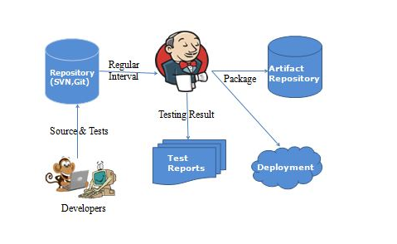

Automate execution of jobs
- Build Job Periodically
- Poll SCM
- Github webhooks
Goto “Manage Jenkins”
Install “Github Plugin”
Goto “Configure System”
Goto (Down the page) “GitHub Servers”
Advanced > Manage Github Actions > convert login password to token > select from login and password

https://www.youtube.com/watch?v=uVXO95syoEg

Go To Setting into the Git Hub Repository

