**TEAM ROSTER**

Team Name: MCHawks

Submission: *Using Every Door Direct Mail Web Push Surveys and Multi-level modelling with Post Stratification to estimate Perceptions of Police at Small Geographies*

The roster is below, and the prizes will be split evenly between the applicants

|  |  |
| --- | --- |
| Name | Percent Prize |
| Giovanni Circo | 50% |
| Andrew Wheeler | 50% |

Signature Andrew Wheeler, Date 7/16/2023

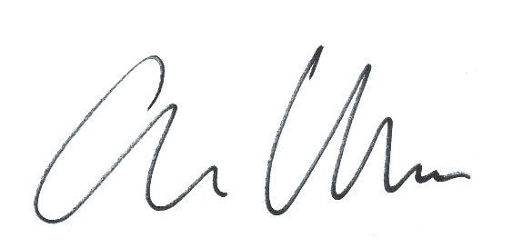

___________________________________________________________________________

Signature Giovanni Circo

___________________________________________________________________________