Getting Started
SeasonStar Database Management (SSDM).
The main UI looks like the below screen snap shot:
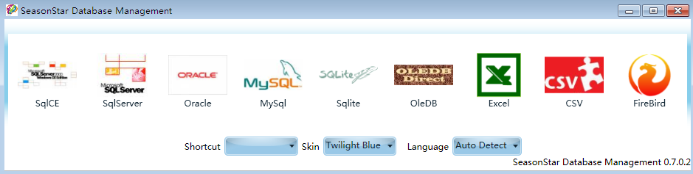

[database type section]
allow user select which type of database he want to manage , just click the icon and it will navigate to the log in page according to the selected database type .
SSDM was originally intended to help end users or developers manage the Microsoft Sql Server Compact Edition 3.5 or up. But later, after made its’ architecture support more widely used database, now it support manage a lot of common used databases. All current supported databases are listed in this section.

*[Skin section] allow user select the skin (theme) which he liked. Currently we list many skins, included system default skins and customized skins.
The system default themes are shown as Text item and the customized themes shown as an icon.

*[Shortcut section]
Shortcut section provides some quick linker to some useful and common functions. Such as “documenting database”, “data transfer”, “connection string help linker”,etc.

Documenting database: help user exporting the schema of database to XML or EXCEL format.
Data transfer: Many end users like this feature. It can transfer the data from Sql Server, Sql CE, MySql, Excel, Sqlite, Firebird/Interbase, Access, and CSV to SqlCE. (And now support to CSV, too).

Example:
Here we navigate to the SqlCE management page.
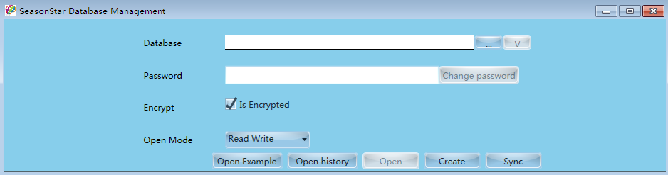
[Open latest file], open the latest opened SqlCE file, if the file and password all ok, it will go to the management page.
[Open history], show a window which list the entire opened SqlCE file; allow you select one to open via double click that item.
[Create], allow you create an empty SqlCE file, make some settings in that SqlCE file. Such as: Password, Encryption Mode, etc.
[Sync], it is Data transfer functionality.
[Change Password], you can input the SqlCE file name in the database textbox, and input the old password (if has), then press this button will allow change your password of that SqlCE file .
[V], detects the current selected SqlCE database file version. It is very useful because SqlCE has some major differences in its’ each version.
[Open Mode], select mode to open selected SqlCE database file, such as read, write, or read-only, etc.

Main Management UI :
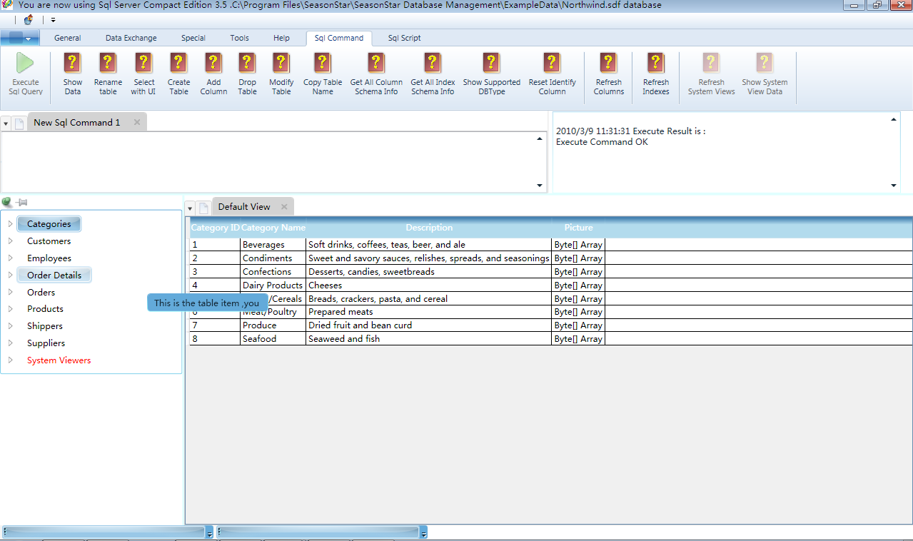
Top is the Ribbon Menu:
It has some basic functions according to the selected database type.
{General Tab}
- Open Script: open a Sql Script file and display it in the Sql editor, you can run the script file.
- Save Script: Save the Sql command in the Sql Editor to a script file.
- Close: Close current management page, and back to the login in page.
- Exit: exit the whole application right now.
- Execute Sql Command: It will execute the Sql command which user input in the Sql Editor.
- Save Sql query result : it will save the data which display in the bottom data grid .(These data are often queried by the Sql command )
- Next Command/Last Command: show the previous or next command text.

{Data Exchange Tab}
1)
Import From Sql server
Import From Access
Import From Excel
Import From CSV
Import From MySql
These functions are similar with Data Transfer .But they has some differences .Data Transfer like an upgrade version of these functions . Because they are based on the different code and architect, so the result data may be different.

2) Generate Linq O/R Map
This function help user generating the Linq to Sql O/R mapping file, because SqlCE Support Linq to Sql. And the target file type can be both c sharp (C#) and visual basic (VB.Net).

3) Generate business entity
This function generates the business entity according to the table schema.
{Tool Tab}
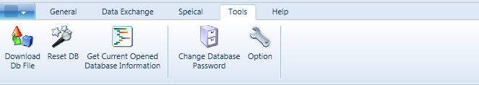
- Download DB File : Support Download a database file or other type file from internet
- Reset DB: Reset (Delete/Clear) all the data of all tables in the database.
- Get Current Opened Database information: Display all the basic information of current opened database.
- Change Database Password: This function is same to the function which placed in the log in page.
- Option: Settings of Main Management UI.

{Special Tab}

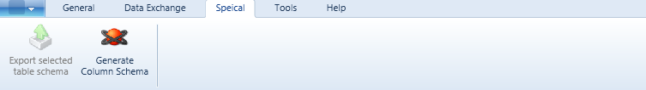
- Export selected table schema: display current table schema information .Display the information in the Sql Editor. User can copy/paste to other tools to do something he wants.
- Generate column schema: generate the column schema information to both Xml and UI. It help user see detail info of selected column.

The following is Management Detail UI:
- Tree List (UI Command Center)
See below .You can right click each item and see some embedded functions (It save your time to input the Sql command directly). Each item will pop up relevant Context Menu when it clicked.
(If you open a SqlCE database file, it will also support a [System View] item allow user see detail information about this database system embedded views. )

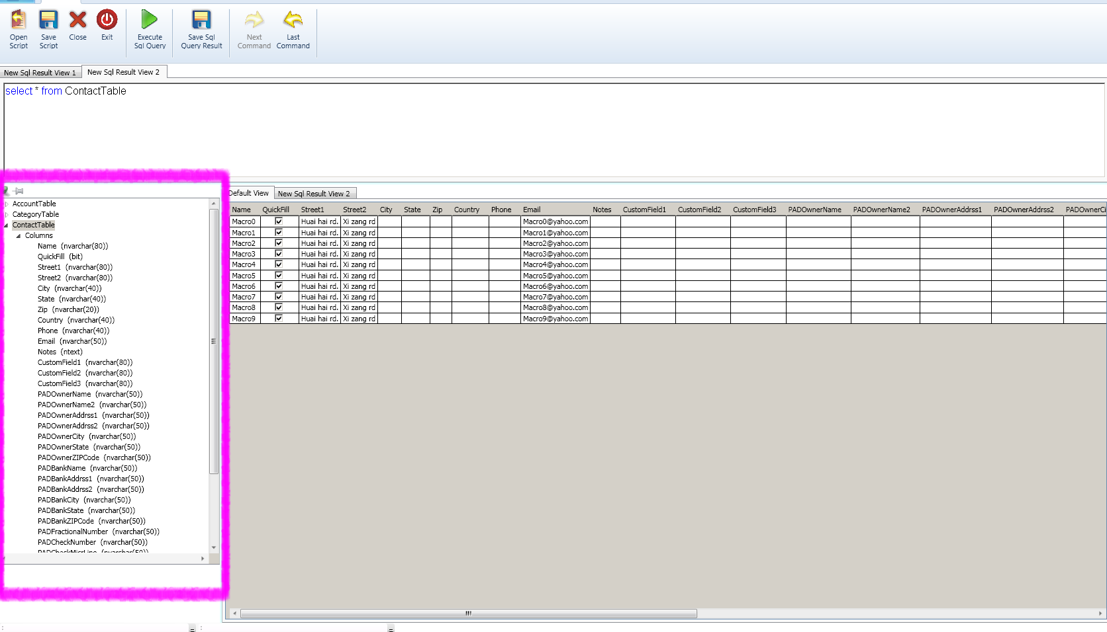
- Sql Command Area
You can input Sql command in each tab of Command Area. Each content is standalone. Here you can input Standard Sql Command ,like “Select “, “Insert”,”Alert”,”Update”,..etc .
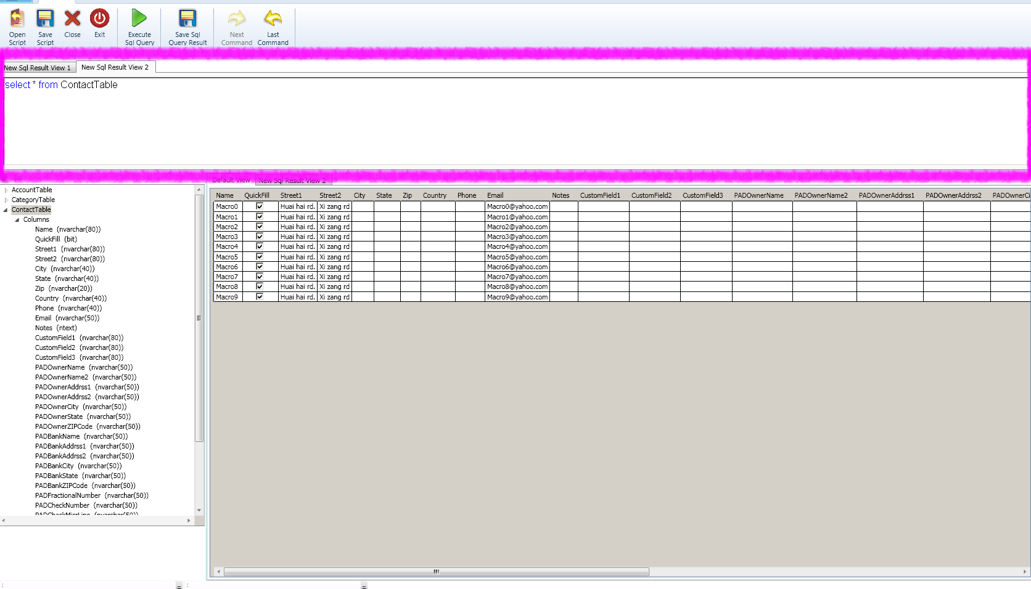
- Sql result section
This section displays the result of your executed Sql command.
You can create a new tab to view many results. (Here we show 2 results in 2 tabs)
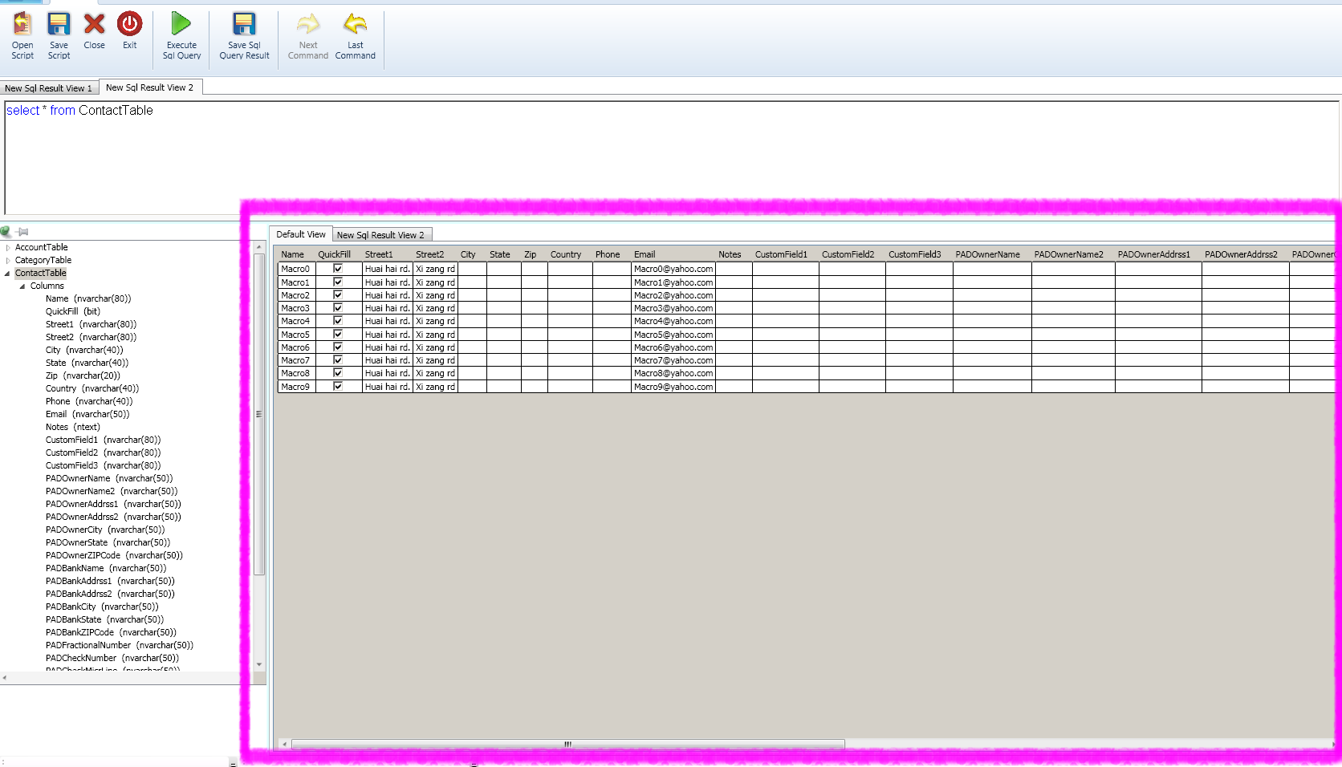

Comments:
The above menus and comments are only used SqlCE 3.5 or up database type.
So if you choose Sql server or other database type, you will see the different Ribbon menu items.

