Hardware Assembly Guide
Bill of Materials and Wiring Diagrams
This guide lists the components needed to physically build one complete Signyales unit (two gloves, one receiver dongle, one Raspberry Pi 5 hub) and shows how each subsystem is wired. Quantities below are per complete unit; multiply accordingly for additional units or spares. A note on cost: component prices, especially for the Raspberry Pi 5, have been volatile through 2026 due to global memory shortages affecting the wider single-board computer market, and prices in local electronics suppliers (e.g., e-Gizmo, Circuit Rocks, or online marketplaces) can differ substantially from official international list prices. Costs are intentionally left for you to fill in from a current local quote rather than quoted here, since a figure given today could be meaningfully wrong by the time this is read.
1. Per-Glove Components (×2 sets — one per hand)
Component | Qty | Notes
ESP32-S3 development board | 2 | One per glove. Any ESP32-S3 DevKit variant with exposed ADC1-capable GPIOs works; confirm pin availability against config.h before ordering a non-standard board.
Flex sensor (2.2″ or 4.5″) | 10 | 5 per glove, one per finger. Longer sensors are easier to mount across the full finger length but need more careful routing near the knuckle.
MPU6050 6-axis IMU breakout | 2 | One per glove. Confirm the breakout exposes AD0 (tie to GND for address 0x68, matching config.h).
10kΩ resistor, 1/4W | 10 | 5 per glove, for the flex sensor voltage dividers. Buy a small assortment (1k–47k) in case the specific flex sensors need a different pulldown value.
3.7V LiPo battery, 500–1000mAh, JST-PH connector | 2 | One per glove. Confirm polarity matches your specific ESP32-S3 board's battery connector before plugging in.
Small protoboard/perfboard | 2 | One per glove, for a compact, semi-permanent version of the voltage divider wiring once the breadboard prototype is validated.
Thin glove (fabric base) | 1 pair | A snug-fitting glove pair (e.g., thin cycling or athletic gloves) that sensors and wiring will be mounted onto.
Hook-and-loop tape / fabric sewing kit | 1 set | For securing the board, IMU, and wiring runs to the glove without restricting finger movement.
Dupont / silicone stranded wire, assorted | 1 set | For flex sensor and IMU connections. Silicone-jacketed wire tolerates the repeated flexing of a wearable much better than solid-core hookup wire.
Heat shrink tubing, assorted sizes | 1 set | For insulating and strain-relieving solder joints at the finger sensor connections, which see the most mechanical stress.
2. Receiver Dongle Components
Component | Qty | Notes
ESP32 development board | 1 | Standard ESP32 DevKit (not S3-specific) is sufficient — the receiver only needs ESP-NOW and two spare UART-capable GPIOs.
USB cable (data-capable, not charge-only) | 1 | For flashing firmware and, optionally, running receiver_link_logger.py during testing.
Small enclosure or protective case | 1 | Optional but recommended once wiring is finalized — the receiver sits exposed near the Pi during normal operation.
Jumper wires (male-male, male-female) | 1 set | For the UART link to the Pi and any breadboard prototyping.
3. Central Processing (Raspberry Pi 5 Hub)
Component | Qty | Notes
Raspberry Pi 5, 4GB | 1 | The target platform this project's software was built and tested against.
microSD card, 32GB+, A2-rated | 1 | A2 rating matters for sustained TensorFlow/inference workloads — a slower card will bottleneck model loading and logging.
Official Raspberry Pi 5 USB-C power supply (27W) | 1 | The Pi 5 draws meaningfully more current than a Pi 4, especially under sustained inference load; an underrated supply causes brownouts, not a clean shutdown.
Active cooling (Pi 5 case with fan, or the official Active Cooler) | 1 | The Pi 5 runs hot enough under sustained CPU load that thermal throttling is a realistic risk during a long demo without one.
USB or 3.5mm speaker | 1 | TTS audio output. A small USB speaker avoids depending on the Pi's onboard audio configuration being correctly set up.
Micro-HDMI to HDMI cable + monitor | 1 | For initial OS setup and debugging. Not needed for normal headless (SSH) operation once configured.
USB keyboard and mouse | 1 set | For initial setup only, unless imaging the SD card and configuring SSH/Wi-Fi headlessly beforehand.
4. Common / Miscellaneous
Component | Qty | Notes
Breadboard(s) | 2–3 | For prototyping the glove and receiver circuits before committing to permanent wiring.
Multimeter | 1 | Essential for verifying each voltage divider's output range (relaxed vs. fully bent) BEFORE connecting it to an ESP32 GPIO — catches wiring mistakes before they can damage a board.
Soldering iron, solder, flux | 1 set | For permanent connections on the glove protoboards, where breadboard connections would work loose with hand movement.
Double-sided tape / cable ties | 1 set | For general mounting and strain relief across all three subsystems.
Glove Wiring
Both gloves use identical wiring — only the IS_LEFT_GLOVE / IS_RIGHT_GLOVE flag in config.h differs between the two firmware builds. Each flex sensor forms a simple voltage divider with a fixed resistor, and the MPU6050 shares the same 3.3V and ground rails.
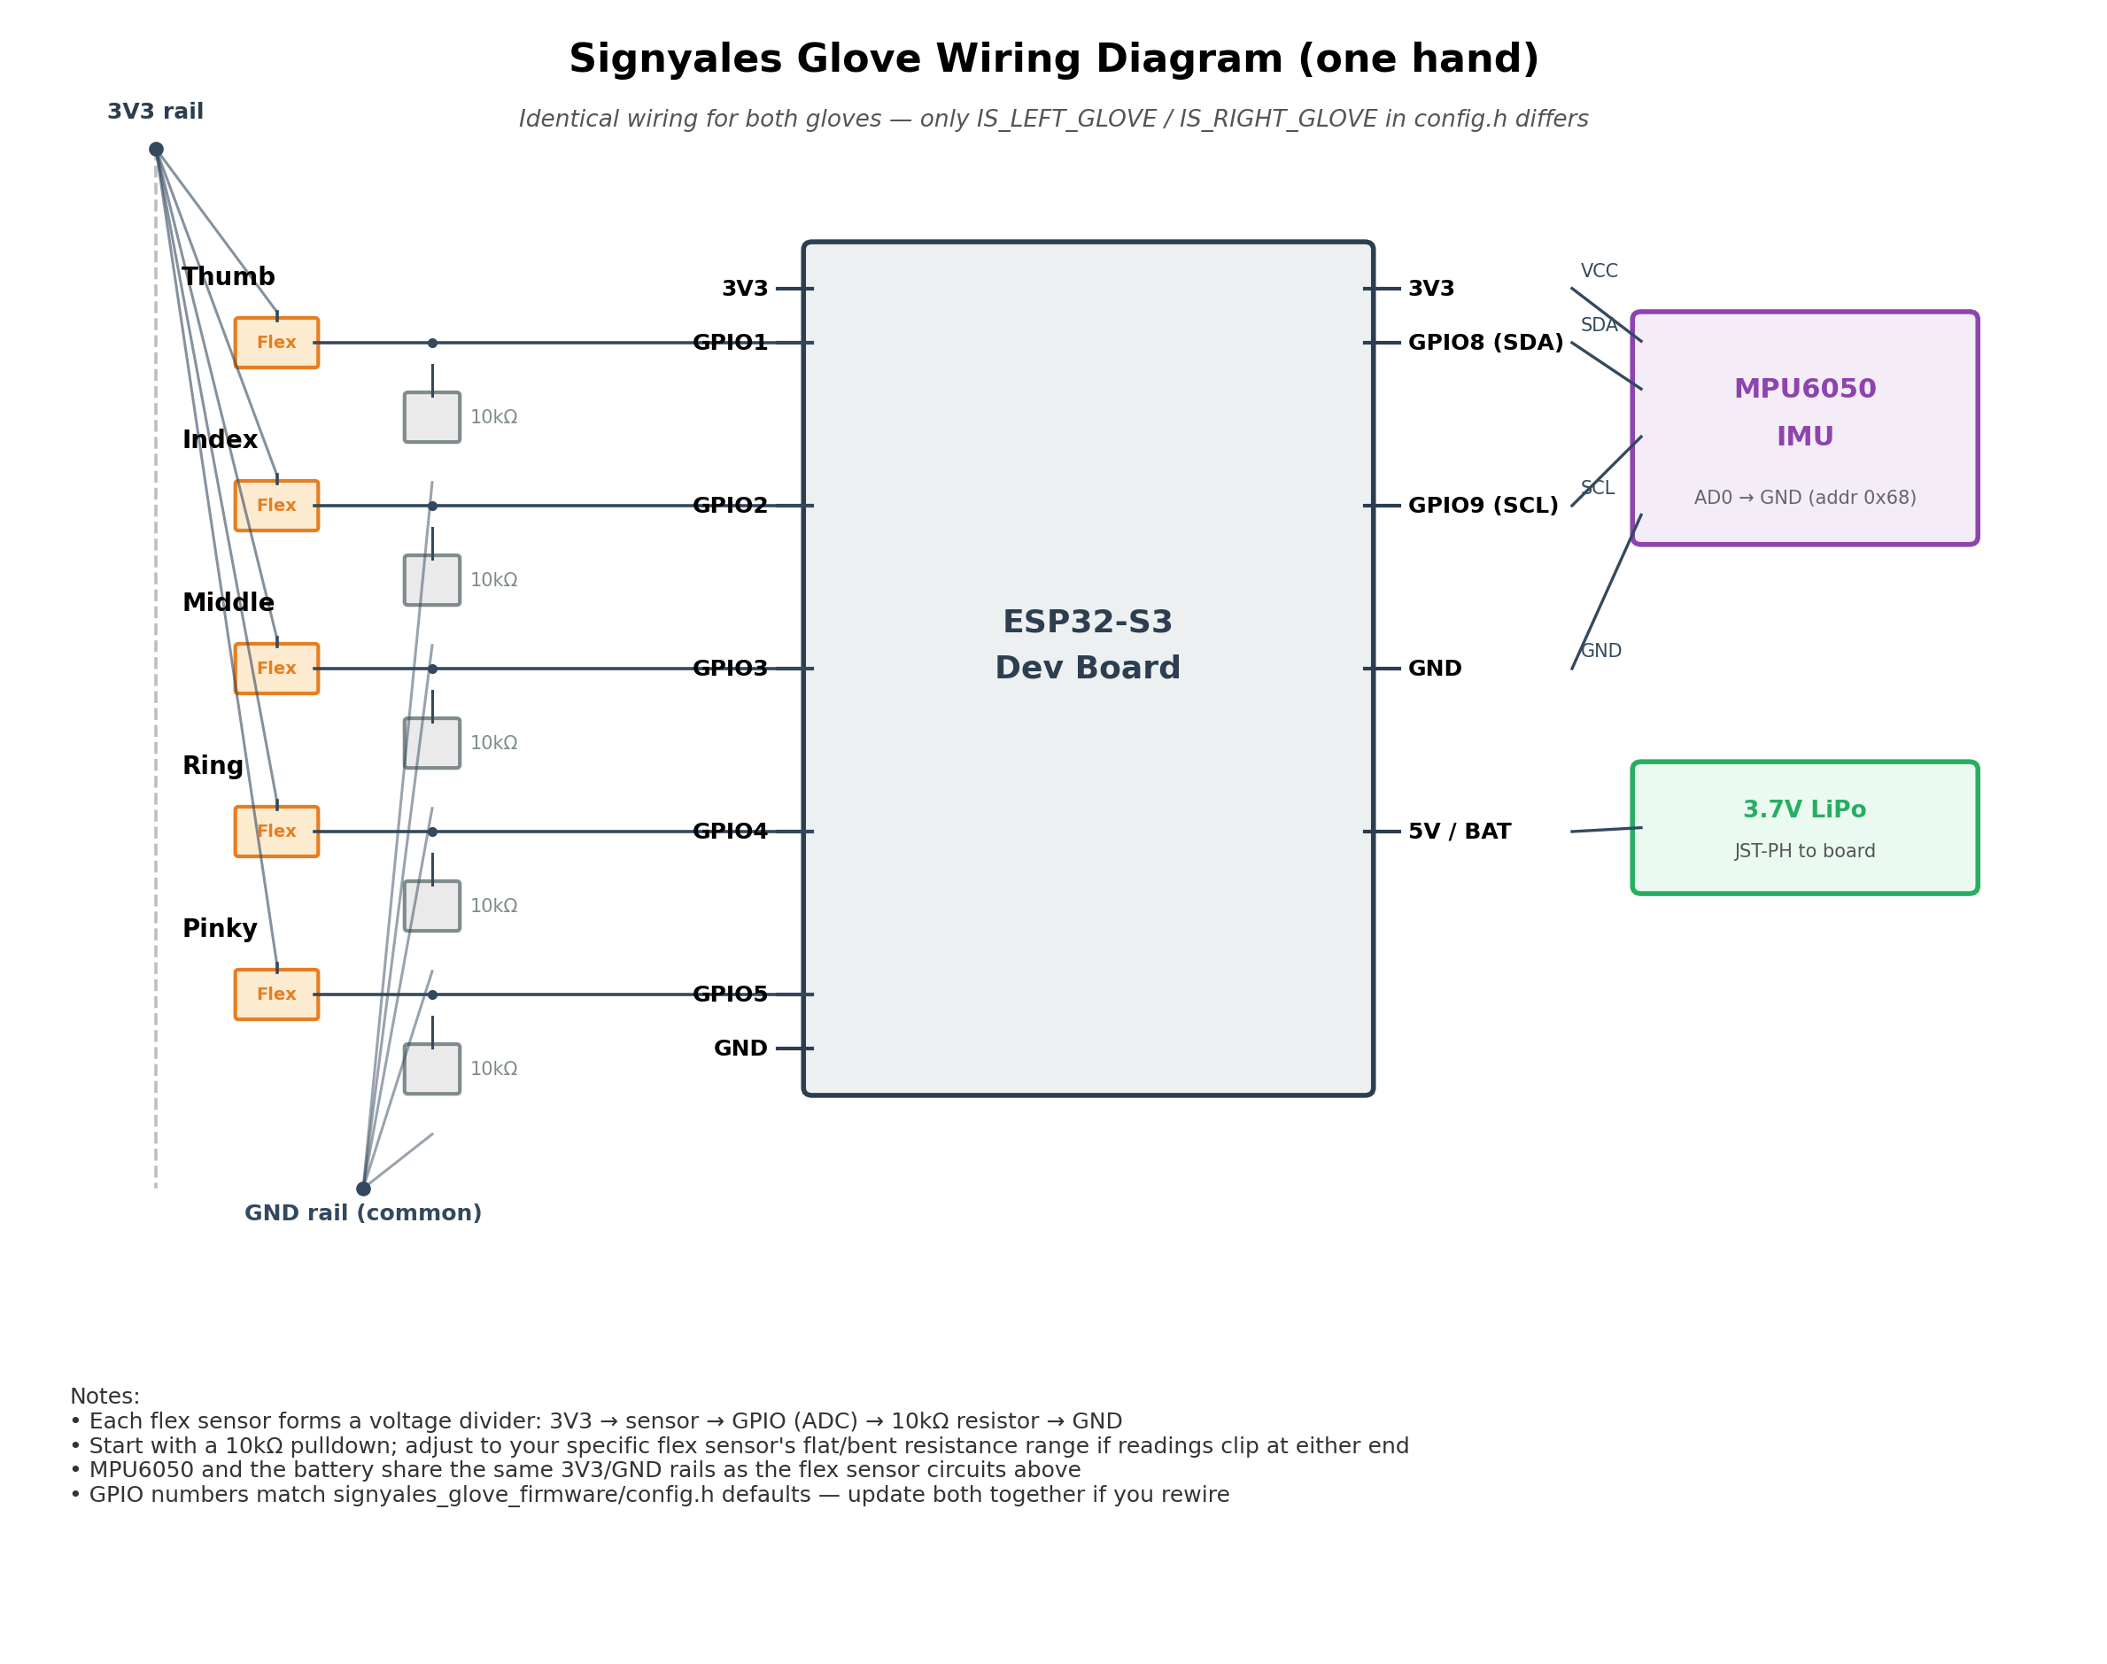
Figure 1. Glove sensor wiring (one hand shown; identical for both).
Receiver ↔ Raspberry Pi Wiring
The receiver dongle connects to the Pi over a dedicated UART link, wired separately from the Pi's USB ports. Getting the crossed TX/RX wiring right, and completing the disable-bt configuration step described in the receiver firmware's README, are the two most common sources of “no data arriving” problems at this stage.
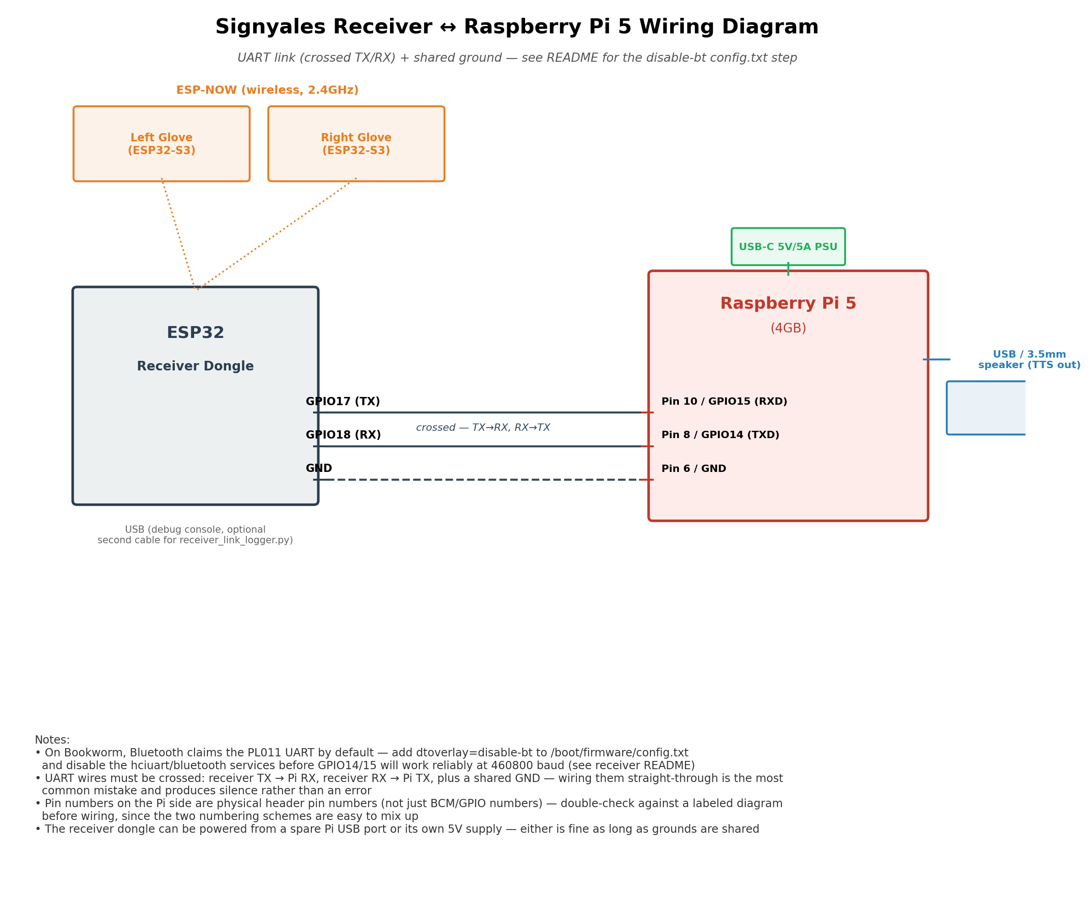
Figure 2. Receiver dongle to Raspberry Pi 5 wiring, including power and audio output.
Suggested Assembly Order
Building and testing each subsystem in isolation before combining them catches wiring mistakes while they're still easy to fix — a mis-wired flex sensor is a five-minute fix on a breadboard and a much bigger one once sewn into a glove.
1. Breadboard one glove's full circuit (all 5 flex sensors + IMU) and flash the glove firmware. Use the Serial calibration routine and confirm all 5 finger readings respond sensibly before moving on.
2. Repeat step 1 for the second glove, with IS_RIGHT_GLOVE set instead.
3. Flash the receiver firmware, note its printed MAC address, and update RECEIVER_MAC in both gloves' config.h.
4. With both gloves powered and the receiver connected only to a laptop's USB port (not yet to the Pi), confirm the receiver's debug console shows both gloves being received with a healthy delivery ratio.
5. Set up the Raspberry Pi 5: flash the OS, complete the disable-bt UART configuration, and verify /dev/serial0 exists before wiring anything to it.
6. Wire the receiver to the Pi's UART pins (crossed, plus shared ground) and confirm the hub application receives frames using `python -m signyales_hub.main -v` with no model yet required.
7. Only after all of the above works on a breadboard should sensors be moved to their permanent glove/enclosure mounting — verify each glove still calibrates correctly after mounting, since mounting can change sensor bend range.
Safety Notes
- LiPo batteries: never leave charging unattended, avoid puncturing or bending the cells when sewing them into a glove, and use a battery with built-in protection circuitry if available.
- Verify voltage divider output with a multimeter before connecting to any ESP32 GPIO — GPIOs are not 5V-tolerant, and a wiring mistake here is a common way to damage a board during early prototyping.
- Double-check polarity on every JST battery connector before plugging in — connector keying is not always consistent across suppliers.

