PEST, PEST++ and DSI: A Short Demonstration

1. The Model

1.1 Brief description
Our model simulates steady state flow of groundwater through a heterogeneous medium. We will calibrate the model using heads measured in 12 observation wells. We will also examine the uncertainty of two predictions. These are the location and timing of particle emergence through the bottom boundary of the system. (The former prediction will receive most of our attention.) This is a fixed head boundary. The situation is illustrated in Figure 1.1.
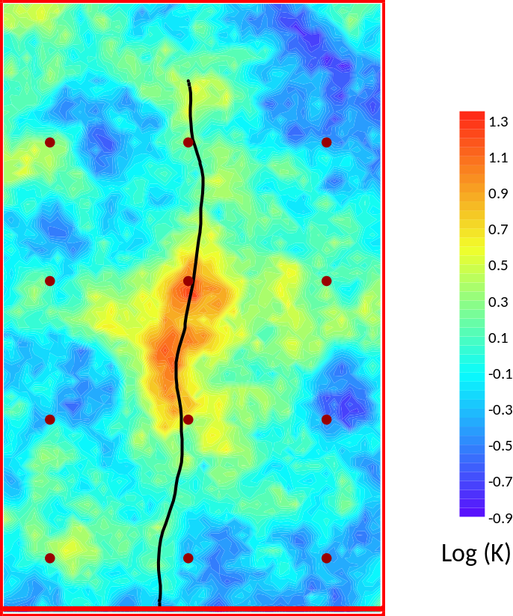
Figure 1.1. Hydraulic conductivity and path of a particle.
The model that PEST runs is encapsulated in a batch file named model.bat. The groundwater model is MODFLOW6. Particle movement is simulated using MODPATH7. The MODFLOW6 grid is structured; all cells are square with sides of 10 m.
Inspect model.bat. This has features in common with most models that PEST must run. The simulator is preceded by a parameter pre-processor (in this case PLPROC), and followed by an observation post-processor (in this case MOD2OBS_DBL). Many PEST-support utility programs were written in order to serve these pre/postprocessing roles. PLPROC is used for pilot points parameterization; pilot points that are used for parameterisation of the present model are shown in Figure 3.1. Meanwhile, MOD2OBS_DBL is used for processing of MODFLOW6-calculated heads arrays. The “DBL” version of MOD2OBS is used instead of the normal version of this program because MODFLOW6 records its system state output files in double precision. MOD2OBS_DBL (and MOD2OBS) read a MODFLOW-generated binary heads file, in this case rect.hds. They undertake temporal and spatial interpolation of MODFLOW-generated heads to the times and locations of field measurements. In the present example, field measurements are recorded in a file named observ.smp. The format used for this file is common to many PEST utilities; it is referred to as a “site sample file”.

1.2 Making Some Pictures
The PEST Groundwater Utility Suite provides many programs that can be used for purposes other than model pre/post-processing. These tasks include the following:
- importing model data into SURFER;
- model data exchange with a GIS;
- production of 3D plots in packages such as PARAVIEW.
These utilities work with structured and unstructured grid models (including MODFLOW-USG and MODFLOW6). Some of these utility programs are demonstrated in other tutorials. In this tutorial we demonstrate how to display some model details in SURFER. The utility programs which we demonstrate below were used to produce Figure 1.1.
First, use GRID2BLN to create a BLN file of the model grid.
> grid2bln

Program GRID2BLN produces a SURFER blanking file of the finite-difference
grid.

Enter name of grid specification file: rect.spc
- grid specifications read from file rect.spc

Enter name of window integer array file: ibound.inf
- integer array read from file ibound.inf

Enter name for SURFER blanking output file: grid.bln

Working.....
- SURFER blanking file ibound.bln written ok.
Now use ZONE2BLN to create a BLN file that shows the boundaries between different zones – that is, between areas that are endowed with different values in a MODFLOW-compatible integer array. (This was used to draw the line which demarcates normal model cells from fixed head cells in Figure 1.1.)
> zone2bln

Program ZONE2BLN produces a SURFER blanking file of the zonation of the
finite-difference grid.

Enter name of grid specification file: rect.spc
- grid specifications read from file rect.spc

Enter name of zoned integer array file: ibound.inf
- integer array read from file ibound.inf

Enter name for SURFER blanking output file: ibound.bln

Working.....
- SURFER blanking file ibound.bln written ok.
The hydraulic conductivity (i.e. K) array that was used to calculate “observed” heads is stored in file reality.ref – a MODFLOW-compatible array of real numbers. We will now re-write the contents of this array as a SURFER grid file after log-transforming K. Program LOGARRAY does the log-transformation, while program REAL2SRF re-writes the transformed array as a SURFER grid file.
> logarray

Program LOGARRAY takes the log (to base 10) of a real array.

Enter name of grid specification file: rect.spc
- grid specifications read from file rect.spc

Enter name of real array file: reality.ref
- real array read from file reality.ref
Enter inactive threshold for array (press <ENTER> if none): <Enter>

Enter name for output real array file: log_reality.ref
- formatted real array written to file log_reality.ref

> real2srf

Program REAL2SRF translates a real array to surfer GRID format.

Enter name of grid specification file: rect.spc
- grid specifications read from file rect.spc

Enter name of real array file: log_reality.ref
- real array read from file log_reality.ref
Enter blanking threshold value for this array: 1e20

Enter name for SURFER grid file: log_reality.grd
- SURFER "grid" file log_reality.grd written ok.
All versions of MODFLOW record calculated system states in binary files. In our case the file is named rect.hds. To list the contents of a MODFLOW6 binary file, use the MF6ARRDET utility. “ARRDET” stands for “ARRay DETails”. Similar utilities are available for standard MODFLOW and MODFLOW-USG. In the present case, the system state file contains just a single array; for multi-layered transient models, a MODFLOW6-produced binary file may contain many arrays. Run MF6ARRDET as follows:
> mf6arrdet

Program MF6ARRDET lists the contents of an unformatted MODFLOW6 output file.

Enter name of binary MODFLOW6-generated file: rect.hds
Is this a dependent variable (eg. head) or cell-by-cell flow file? [d/c]: d
Is the model grid structured (i.e. DIS), DISV or DISU? [s/v/u]: s

Enter name for output file: temp.dat

- 1 datasets read from file rect.hds.
- file temp.dat written ok.
Inspect file temp.dat to see the contents of rect.hds.
Other utilities allow you to extract one or many arrays from these binary files. The simplest of these is MANY2ONE. However MANY2ONE was built for use with older versions of MODFLOW. The binary dependent variable files that are produced by these older versions of MODFLOW record system states using single precision numbers. In contrast, MODFLOW6 records these states in double precision. So before using MANY2ONE we will convert rect.hds to single precision using the DBL2SGL program. Run it as follows to write a new dependent variable file named rect_sgl.hds that looks like it was written by an older version of MODFLOW.
> dbl2sgl

Program DBL2SGL reads a MODFLOW/MT3D-generated, binary,
double-precision, heads/concentration file for a structured grid
model. It re-writes this file in single precision.

Enter name of double precision binary file: rect.hds
Enter name for single precision binary file: rect_sgl.hds

- 1 arrays read from file rect.hds.
- file rect_sgl.hds written ok.
Now run MANY2ONE.
> many2one

Program MANY2ONE allows a user to selectively store individual arrays
contained in a multiple-array MODFLOW or MT3D unformatted output file.

Enter name of MODFLOW/MT3D unformatted output file: rect_sgl.hds
Is this a MODFLOW or MT3D output file? [f/t]: f

MODFLOW head array for layer 1 ----->
Stress period = 1
Time step = 1
Elapsed time since start of stress period = 1.000000
Elapsed time since start of simulation = 1.000000
Store array in separate file? [y/n]: y
Enter name for real array file: heads.ref
- formatted real array written to file heads.ref

No more arrays: 1 arrays read from file heads.dat
If we use REAL2SRF to re-write the heads array as a SURFER grid file, we can superimpose contours of calculated groundwater head on the hydraulic conductivity field of Figure 1.1; see Figure 1.2.
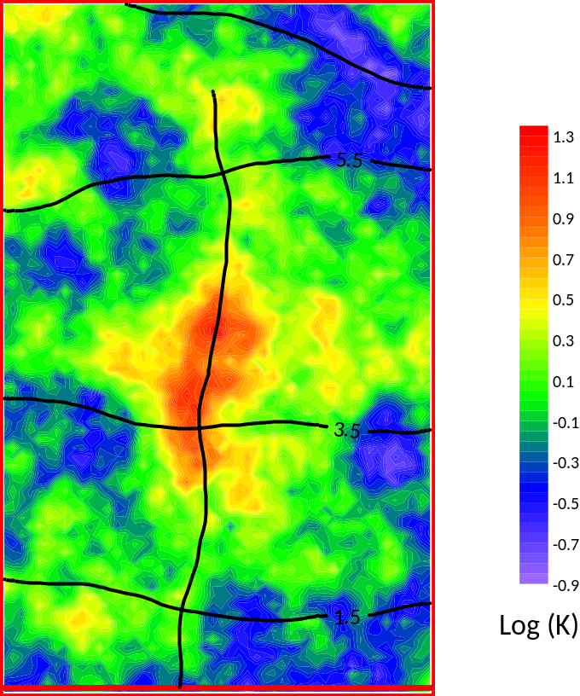
Figure 1.2. Groundwater head contours and particle travel path superimposed on a heterogeneous K field.
We will now describe how to add the particle path to the above picture.
rect.pathline7 is a pathline file written by MODPATH7. Program MP72MIF can be used to record this particle track as a MIF/MID file pair. (“MIF” stands for “MapInfo Interchange Format; this is a text file format that can be read by many contouring and GIS platforms.) Create particle.mif and particle.mid by running MP72MIF in the following way.
> mp72mif

Program MP72MIF writes mif/mid files containing particle tracks read from a
MODPATH 7 particle file.

Enter name of MODPATH 7 pathline file: rect.pathline7
Enter filename base for MIF/MID file pair: particle

Enter minimum particle path length to retain (<Enter> if zero): <Enter>
Enter minimum travel time to retain (<Enter> if zero): <Enter>

- file rect.pathline7 read ok.
- file temp.mif written ok.
- file temp.mid written ok.

2. Adding Regularisation to a PEST Control File
We will start with an already-built PEST control file; see case.pst. There are many ways to build a PEST control file. Its specifications are explained in the PEST manual; so you can build it with a text editor. However it can also be built in other ways. These include:
- a graphical user interface that supports PEST, for example Groundwater Vistas, Visual MODFLOW, GMS, or ModelMUSE;
- PyEMU;
- utilities such as TPL2PST, OLPROC, PESTPREP1 and PESTPREP2 that are supplied with the PEST Groundwater Utility Suite.
Regardless of how it is built, it is good to know your way around a PEST control file so that you can edit parts of it in order to tailor the calibration process to suit your needs.
In its “observation data” section, case.pst contains some observations whose weights are zero. These are in fact “predictions” in the present case.
Note also that singular value decomposition is employed to calibrate the model (see the “singular value decomposition” section of case.pst wherein the EIGTHRESH variable is set to 5×10⁻⁷). In the “control data” section of case.pst, the RLAMFAC variable is set to -3. These are recommended settings for all occasions.
Parameterization is based on pilot points. The pilot points file is hk.pts. The template of this file is hk.tpl.
Regularisation is now added to the PEST control file using the ADDREG1 utility.
> addreg1 case case1
Regularisation of pilot point parameters can be enhanced using a covariance matrix based on a variogram. This can be built using the PPCOV utility from the Groundwater Utility Suite. PPCOV obtains the geostatistical structure which describes this variogram from the “structure file” struct.dat.
> ppcov
Program PP2COV prepares a covariance matrix file for pilot point parameters
based on a geostatistical structure file.

Enter name of pilot points file: hk.pts
- data for 104 pilot points read from pilot points file hk.pts

Enter minimum allowable separation for points in same zone: 0

Enter name of structure file: struct.dat

Enter structure to use for pilot point zone 1: structure2

Enter name for output matrix file: cov.mat
Enter pilot point prefix for parameter name (<Enter> if none): k_

Filling covariance matrix....
- file cov.mat written ok.
The Groundwater Utility Suite includes other utilities which belong to the PPCOV family. These are PPCOV3D, PPCOV_SVA and PPCOV3D_SVA. The last two of these programs can build a covariance matrix based on a spatially varying variogram. This can accommodate the presence of different geological units, or meandering alluvium, within a model domain.
Now do the following:
- Insert the name “cov.mat” in the “observation groups” section of case1.pst opposite the observation group name “regul_k”.
- Set the target measurement objective function (PHIMLIM) to 12 and the value of the variable next to it (PHIMACCEPT) to 12.1. These are in the “regularisation” section of case1.pst.
The “observation groups” section of the PEST control file case1.pst should now look like this.
* observation groups
heads
time
distance
regul_k cov.mat
The “regularisation” section of case1.pst should now look like this.
* regularisation
12.0 12.1 0.1000000
1.0 1.0e-10 1.0e10
1.3 1.0e-2 1
Note that all nonzero weights in the “observation data” section of file case1.pst are set to 10. This is (conveniently) the inverse of the standard deviation of measurement noise.
Check your work with PESTCHEK. Ignore the warning.
> pestchek case1

3. Model Calibration
Run PEST using the command:
> pest case1
The calibrated K field and particle path are shown in Figure 3.1. The calibrated K field allows the model to match head observations very well. However it is considerably less heterogeneous than the real K field.
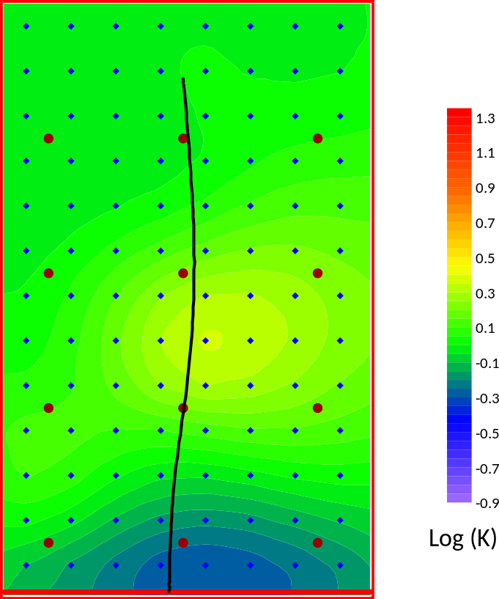
Figure 3.1. Calibrated K field and particle path. Pilot points are shown as diamonds.
In this particular case, the calibrated model also makes a prediction. See the end of file case1.rec, or file case1.res, where model outputs corresponding to elements of the observation dataset (even those with weights of zero) are tabulated. The results are listed in Table 3.1. “True” predictions are also listed in this table. The calibrated model’s prediction of particle travel time is quite wrong. It is important to note, however, that this does make the model “bad”. A model is only bad, when the right prediction does not lie within the uncertainty interval that it calculates.
Prediction | Reality K field | Calibrated K field
Particle emergence easting (m) | 206.8 | 225.9
Particle travel time (days) | 3256.2 | 6840.9
Table 3.1. Predictions made using the reality K field and the calibrated K field.

4. Calibration using SVD-Assist
The “SVD-Assist” methodology saves on the number of model runs required for model calibration by basing the calibration process on so-called “super parameters”. These are defined by undertaking singular value decomposition (SVD) on a full Jacobian matrix. Calculation of the full Jacobian matrix requires one model run for each parameter. Following that, the number of model runs per iteration of the inversion process is equal to the number of super parameters. There should be enough of these to span the calibration solution space.
First, create a JCO file based on initial parameter values.
Copy case1.pst to case2.pst
> copy case1.pst case2.pst
Alter NOPTMAX from 30 to -2 in the “control data” section of case2.pst. NOPTMAX is the first variable for the ninth line of this file. Then run PEST.
> pest case2
We now have a JCO file named case2.jco. This contains the Jacobian matrix. Run SUPCALC to obtain a suggestion on the number of super parameters to use.
> supcalc

SUPCALC Version 17.3. Watermark Numerical Computing.

Enter name of PEST control file: case2.pst
Enter expected value of measurement objective function: 12

To conduct SVD on Q^(1/2)X - enter 1
To conduct SVD on XtQX - enter 2
Enter your choice: 1

Use uncertainty file or bounds to specify parameter variability? [u/b]: b

Enter name for eigenvector gain/loss output file: nul

- reading PEST control file case2.pst....
- file case2.pst read ok.

- reading Jacobian matrix file case2.jco....
- file case2.jco read ok.

- carrying out singular value decomposition of Q^(1/2)X....

- analyzing singular values and writing output file....
- file nul written ok.

Minimum number of super parameters to use = 12
Maximum number of super parameters to use = 12
Now use SVDAPREP to create a PEST control file named case2_svda.pst.
> svdaprep

SVDAPREP Version 17.3. Watermark Numerical Computing.

Enter name of existing PEST control file: case2
Use pre-defined super-parameter file? [y/n] (<Enter> if "no"): <Enter>
For computation of super parameters:-
if SVD on Q^(1/2)X - enter 1
if SVD on XtQX - enter 2
if LSQR without orthogonalisation - enter 3
if LSQR with orthogonalisation - enter 4
Enter your choice (<Enter> if 1): 1
Enter number of super parameters to estimate: 12
Enter name for new super pest control file: case2_svda
Enter offset for super parameters (<Enter> if 10): <Enter>
Enter value for RELPARMAX (<Enter> if 0.1): <Enter>
Write multiple BPA, JCO, REI, none [b/j/r/n] files (<Enter> if "n")?<Enter>
Parameter scale adjustment [SVDA_SCALADJ] setting (<Enter> if 2): <Enter>
Make new model batch file silent or verbose? [s/v] (<Enter> if "s") : <Enter>
Automatic calc. of 1st itn. super param. derivs? [y/n] (<Enter> if "y"): <Enter>
- file picalc.tpl written ok.
- file picalc.ins written ok.
- file case2_svda.pst written ok.
- file svdabatch.bat written ok.
Calibrate the model using SVD-Assist.
> pest case2_svda
Insert the optimized parameters into a new PEST control file named case2_soln.pst. (Optimized parameters are stored in a parameter value file that is named after the base PEST control file, and has an extension of “.bpa”).
> parrep case2.bpa case2.pst case2_soln.pst
Set NOPTMAX to 2 in case2_soln.pst. (It is probably already set to -2 as inherited from case2.pst). Run PEST to verify that the model is indeed calibrated, and to obtain a Jacobian matrix based on optimized parameters. We will need this later for linear analysis.
> pest case2_soln
We can now extend Table 3.1 to include the outcomes of this calibration process. (See file case2_svda.rec or case2_svda.res.)
Prediction | Reality | Calibrated | Calibrated using SVDA
Particle emergence easting (m) | 206.8 | 225.9 | 229.6
Particle travel time (days) | 3256.2 | 6840.9 | 6977.1
Table 4.1. Predictions made using the reality K field and calibrated K fields.
The calibrated parameter field and particle track are shown in Figure 4.1. The parameter field is not quite as smooth as that which was obtained previously. This is the price to be paid for model run reduction.
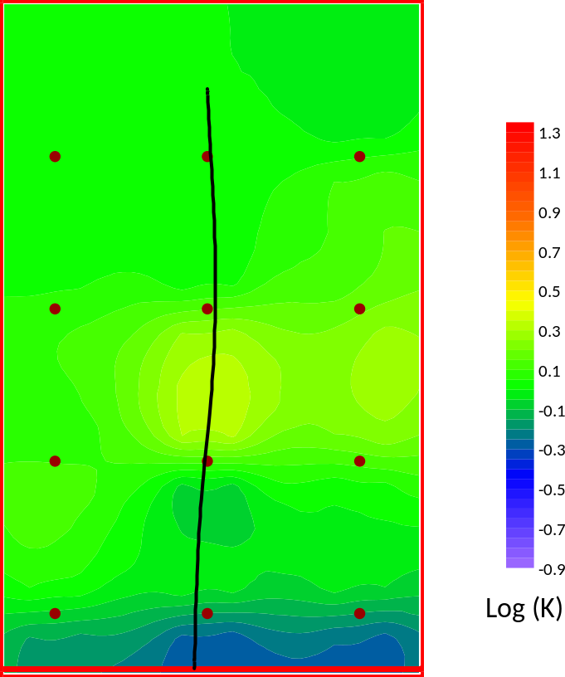
Figure 4.1. Calibrated K field and particle path; calibration achieved using SVD-Assist.

5. Calibration using PESTPP-GLM
Model calibration will now be repeated using PESTPP-GLM from the PEST++ suite. But first we will insert some PEST++ control variables into the PEST control file. Copy case2.pst to case2a.pst. Then open case2a.pst in a text editor.
> copy case2.pst case2a.pst
Insert the following lines at the end of case2a.pst.
++ max_n_super(12)
++ n_iter_super(4)
++ n_iter_base(1)
++ parcov(cov.mat)
++ forecasts(part_east,part_time)
These inform PESTPP_GLM that it must do the following:
- Undertake SVD-assisted inversion with a maximum of 12 super parameters.
- After the first iteration (in which a base Jacobian matrix is calculated), undertake 4 iterations based on super parameters. Then if the inversion process is not complete, repeat this whole cycle.
- When undertaking post-calibration linear analysis, use the covariance matrix in file cov.mat as the prior covariance matrix.
- Compute the uncertainties of predictions part_east and part_time.
Edit case2a.pst some more in order to set the NOPTMAX termination criterion to 5 so that the inversion process ceases after 5 iterations. (NOPTMAX leads the ninth line of the PEST control file.) Also remove the name of the file holding the covariance matrix from the “observation groups” section of the PEST control file. (At the time of writing, PESTPP-GLM does not allow use of a covariance matrix instead of weights.) This section should then appear as follows.
* observation groups
heads
time
distance
regul_k
Now run PESTPP-GLM using the following command.
> pestpp-glm case2a
From its screen output you will notice that PESTPP-GLM undertakes a single iteration of base parameter inversion, and then four iterations of super parameter inversion. It then ceases execution.
Inspect file case2a.rec. Parameter and predictive uncertainties are listed at the end of this file. Note that PESTPP-GLM provides posterior bounds for the logs of parameters rather than for the parameters themselves, as these parameters are declared as log-transformed in the PEST control file. We will conduct uncertainty analysis in greater detail soon.
Now let’s look at the calibrated parameter field. First create a new PEST control file that contains calibrated parameter values as initial parameter values.
parrep case2a.par case2a.pst case2a_soln.pst
Now set NOPTMAX to zero in case2a_soln.pst. Run PEST or PESTPP-GLM to run the model once.
pest case2a_soln
Figure 5.1 shows the calibrated K field and particle path. Heterogeneities that are inferred through the inversion process are more spatially concentrated and “bumpy” than in previous calibration exercises. This is an outcome of failure to use a covariance matrix in the inversion process. Without a covariance matrix, heterogeneity arises on a pilot-point-by-pilot-point basis in positions that are close to observation wells. This is very apparent in Figure 5b.
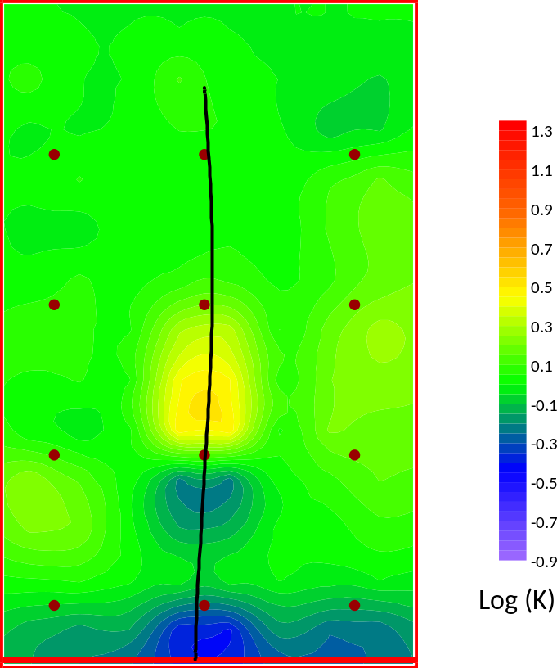
Figure 5.1a. Calibrated K field and particle path; calibration achieved using PESTPP-GLM. Observation wells are also shown.
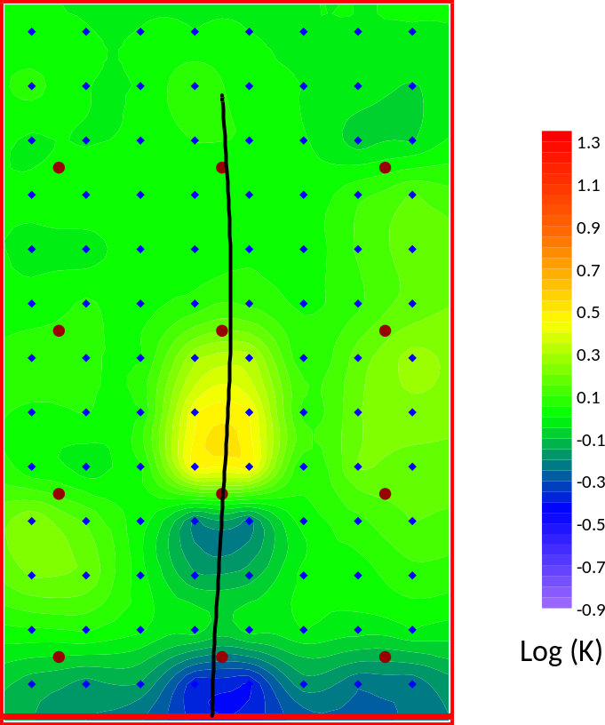
Figure 5.1b. Calibrated K field and particle path; calibration achieved using PESTPP-GLM. Observation wells and pilot points are also shown.
The results table can now be expanded to accommodate the outcomes of the latest model calibration process.
Prediction | Reality | Calibrated | Calibrated using SVDA | Calibrated using PESTPP-GLM
Particle emergence easting (m) | 206.8 | 225.9 | 229.6 | 234.0
Particle travel time (days) | 3256.2 | 6840.9 | 6977.1 | 7024.0
Table 5.1. Predictions made using the reality K field and calibrated K fields.

6. Parallelizing Model Runs
We will now calibrate the model again using both PEST_HP and PESTPP-GLM. In both cases model runs will be parallelized. We will use one manager and three agents (i.e. “workers”). One agent will operate in the same folder as that of the manager. The other two will operate in folders of their own. Create these folders now using the following commands:
> mkdir worker1
> mkdir worker2
Now copy all files to the two worker folders, and then transfer back to the manager folder using the following commands.
> cd worker1
> copy ..\*.*
> cd ..
> cd worker2
> copy ..\*.*
> cd ..
Open three new command line windows. (You can type “start cmd” in your existing command line window to do this.) For one of these windows the working folder should be the same as that which is already open (i.e. the folder in which we have been working up until now). Another one of the other two windows should be open to the worker1 subfolder while the third should be open to the worker2 subfolder.
Next, ascertain the IP (version4) address of your computer, or its hostname. To find out its IP address use the following command.
> ipconfig
Alternatively, to find out its hostname, use this command.
> hostname
Now, in each of the three worker windows open to each of the three worker folders (one of which is also the manager’s folder), type the following command. Substitute the IP (version 4) address or hostname of your own machine for “hostname” in the following command. (You can also use the environment variable %computername%).
> agent_hp case2_svda /h hostname:4004
Then, in the manager’s folder, type the following command. (Note the space between “/h” and “:”.)
> pest_hp case2_svda /h :4004
PEST_HP waits a minute before it commences model runs. This is because its first task is to calculate parameter upgrades using different Marquardt lambdas. It waits to see how many agents that it has at its disposal before allocating upgraded parameter sets to these agents.
Note that BEOPEST is run in a similar fashion to PEST_HP.
Now we will calibrate the model yet again (with model runs undertaken in parallel) using PESTPP-GLM. Recall that, for calibration using PESTPP-GLM, our PEST control file is case2a.pst. The command to start the workers is as follows. (Once again, replace “hostname” with the hostname or IP address of your own machine, or with the string %computername%.)
> pestpp-glm case2a /h hostname:4004
The command to start the manager is:
> pestpp-glm case2a /h :4004
Note that all of the above procedures can be automated if you like. The commands to create new folders, copy files to the new folders and commence execution of the manager and each of the workers can all be placed into a single batch file. Once this has been done, all of the above commands can be replaced by the command to run this batch file. If you are interested, see file run_pest_hp.bat. If you try this and it does not work, replace the “%computername% string in this batch file with the IP address or hostname of your computer.

7. Linear Identifiability and Uncertainty Analysis
Create a new PEST control file featuring optimized parameters, but with no regularisation.
> subreg1 case2_soln case3
Rather than running PEST to obtain a JCO file corresponding to this PST file, use the JCO2JCO utility.
> jco2jco case2_soln case3
If ever you would like to inspect the contents of a Jacobian matrix file, it can be written in text format using a number of programs from the PEST suite. One of these is JACWRIT. It can be run as follows.
> jacwrit case3.jco case3.dat
Before running linear analysis utilities, inspect the parameter uncertainty file param.unc. The contents of this file encapsulate our expert knowledge; prior parameter statistics are specified in this file.
The PEST suite provides many options for undertaking linear parameter and predictive uncertainty/error analysis. An easy way to undertake some simplistic analyses is to use GENLINPRED. GENLINPRED is actually a shell. It runs a suite of PEST linear analysis utilities itself, all based on the contents of a single PEST control file and an accompanying JCO file.
Run GENLINPRED as follows. (Backtrack by pressing “e” followed by <Enter> if you make a mistake.)
> genlinpred

GENLINPRED Version 17.3. Watermark Numerical Computing.

Enter name for response file (<Enter> if none): genlinpred.rsp
Use abbreviated or full input? [a/f] (<Enter> if "f"): f

Enter name of PEST control file: case3.pst

- reading PEST control file case3.pst....
- file case3.pst read ok.

Use bounds or uncert file for param uncertainties [b/u] <Enter> if "b": u
Enter name of parameter uncertainty file: param.unc

Are weights the inverse of measurement uncertainty? [y/n] <Enter> if "y": n
Enter factor for weights to make this so: 1.0

Enter name for output file <Enter> if genlinpred.out: <Enter>

Perform global parameter estimability analysis? [y/n] <Enter> if "n": y
Provide pertinent information:-

Compute parameter identifiabilities? [y/n] <Enter> if "y": y
Compute relative parameter error reduction? [y/n] <Enter> if "n": n
Use SUPCALC to estimate soln space dimensions? [y/n] <Enter> if "y": y
Compute relative parameter uncertainty reduction? [y/n] <Enter> if "n": y

Perform comprehensive analysis of a prediction/param? [y/n] <Enter> if "y": y
Provide pertinent information:-

Enter name of prediction/parameter to analyze: part_east
Enter file to read its sensitivities ["p" if a parameter]: case3.jco

Compute soln/null space contribs to predict error? [y/n] <Enter> if "n": y
Compute predictive uncertainty? [y/n] <Enter> if "y": y

Compute parameter contributions to error? [y/n] <Enter> if "n": n
Compute parameter contributions to uncertainty? [y/n] <Enter> if "y": y
For indiv parameters or for parameter groups? [i/g] <Enter> if "g": i

Compute observation worth wrt error? [y/n] <Enter> if "n": n
Compute observation worth wrt uncertainty? [y/n] <Enter> if "y": y
For indiv observations or for observation groups? [i/g] <Enter> if "g": i

- running SCALEPAR to build scaled PEST input dataset...
- program SCALEPAR run ok.

- running SUPCALC to compute dimensions of solution space...
- program SUPCALC run ok.

SUPCALC has recommended the use of 12 solution space dimensions
for computation of parameter identifiability and relative
error reduction.

Do you wish to over-ride this? [y/n] <Enter> if "n": n

- running IDENTPAR to compute parameter identifiabilities...
- program IDENTPAR run ok.

- running PREDUNC1 to compute rel param uncert variance reductions...
- program PREDUNC1 run ok.

- running program JROW2VEC to extract predictive sensitivities...
- program JROW2VEC run ok.

- running PREDVAR1A to obtain pred. error variance sing. val. dependence...
- program PREDVAR1A run ok.

- running PREDUNC1 to compute predictive uncertainty...
- program PREDUNC1 run ok.

- running PREDUNC4 to compute param contribs to pred uncert variance...
- program PREDUNC4 run ok.

- running PREDUNC5 to compute observ worth through subtraction...
- program PREDUNC5 run ok.

- running PREDUNC5 to compute observ worth through addition...
- program PREDUNC5 run ok.

- see file genlinpred.out for complete GENLINPRED output.
- response file genlinpred.rsp written ok.
Recall two of the above prompts and responses, which are now repeated.
Are weights the inverse of measurement uncertainty? [y/n] <Enter> if "y": n
Enter factor for weights to make this so: 1.0
If we had answered “y” to the first of the above questions, then GENLINPRED would not have asked the second of these questions. Instead, it would have provided a default response of 1.0 to this question. In our case, we could have simply answered “y” to the first of these questions because, for this synthetic case, we know that our weights are correct. In practical cases we often need to back-calculate “measurement noise” from the level of fit attained through the calibration process. A good rule of thumb is that, if weights are “correct”, the measurement objective function should be roughly equal to the number of non-zero-weighted observations comprising a calibration dataset. Using this information, we can calculate the answer to the second of the above GENLINPRED responses as:
$F= \sqrt{\frac{n}{Φ}}$ (1)
where:
F is the factor requested by the above response;
n is the number of non-zero-weighted observations in the calibration dataset; and
Փ is the value of the measurement objective function obtained through the calibration process.
Alternatively, the PWTADJ2 utility can be used to construct a new PEST control file in which weights are correct. PWTADJ2 adjusts observation weights such that equation 1 holds for each observation group featured in a PEST input dataset.
Inspect file genlinpred.out. This informs us that the prior and posterior uncertainty standard deviations of the particle easting emergence location are 97.9 m and 33.2 m respectively.
Some pictures can be plotted based on tables that are recorded in this file.
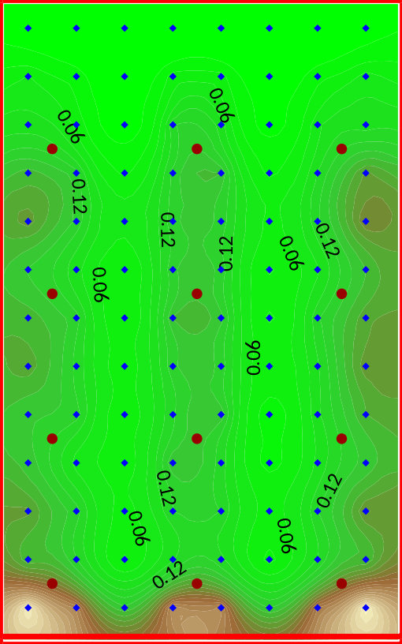
Figure 7.1. Parameter identifiability.

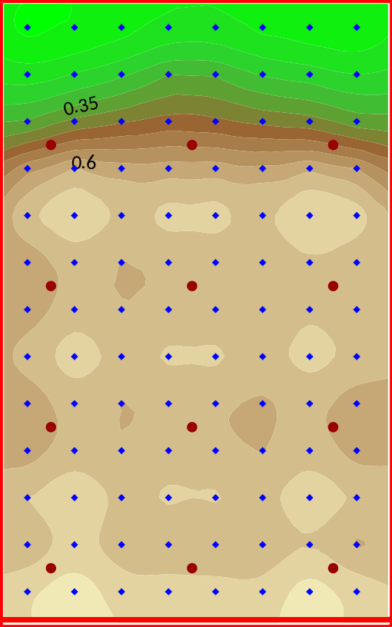
Figure 7.2. Relative parameter uncertainty variance reduction.
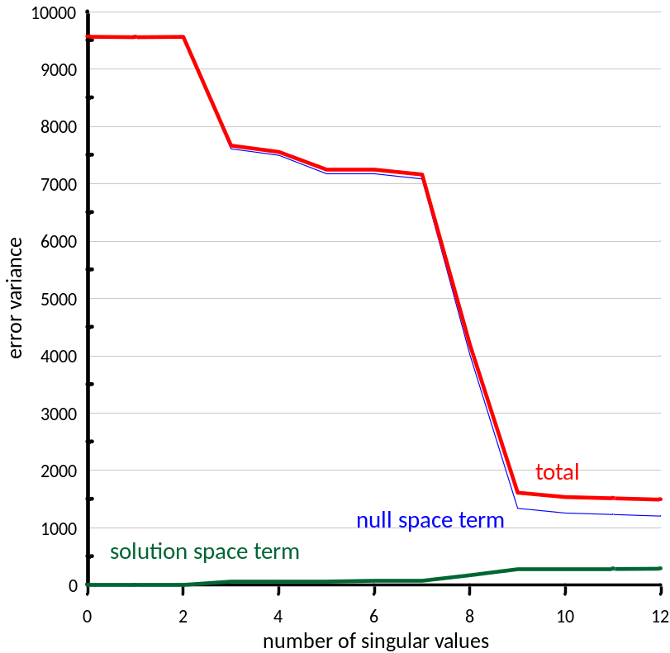
Figure 7.3. Contributions to error variance of particle emergence location.
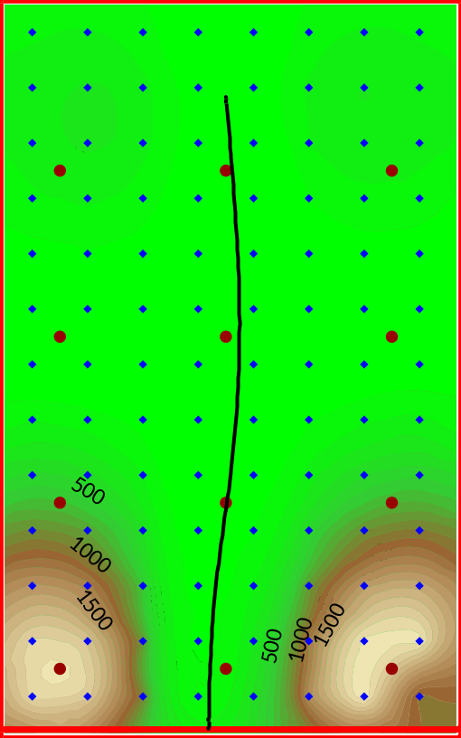
Figure 7.4a. Pre-calibration parameter contributions to uncertainty variance of particle emergence location.
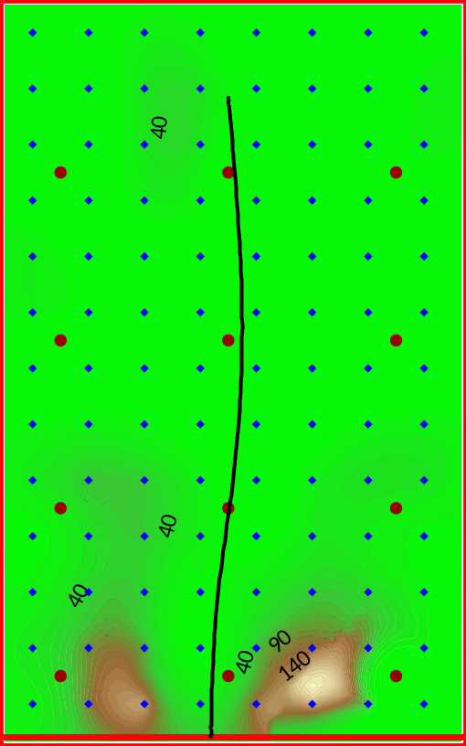
Figure 7.4b. Post-calibration parameter contributions to uncertainty variance of particle emergence location.
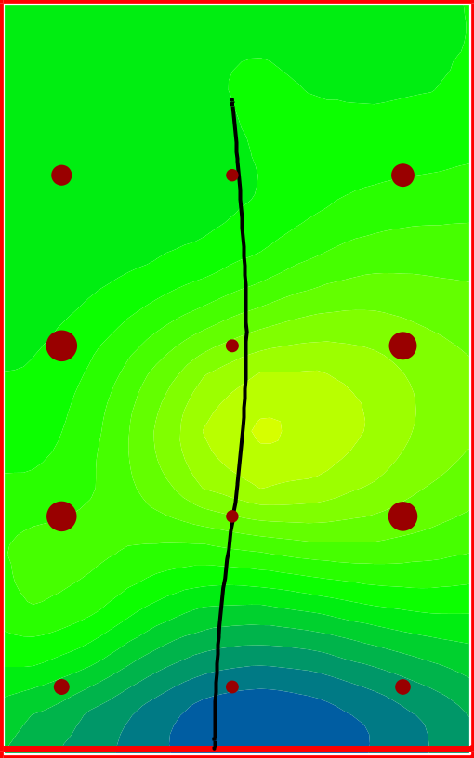
Figure 7.5a. Increase in predictive uncertainty variance incurred through loss of one observation from calibration dataset. Background is calibrated K field.
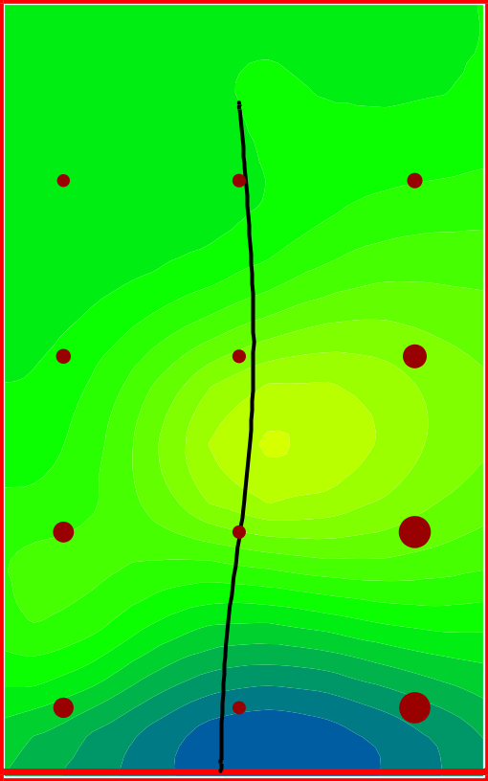
Figure 7.5b. Decrease in prior predictive uncertainty variance if calibration dataset is comprised of only one borehole head. Background is calibrated K field.
A note:
Many of the plots that appear in this section pertain to pilot point parameters. They were created in the following manner.
- Edit file hk.pts; place parameter-pertinent values (for example, identifiability) in the final column.
- Run PLPROC using the command plproc plproc.dat. This produces a MODFLOW-compatible real-array file named hk.ref. Instead of being populated with K values, the real-array is now populated with uncertainty-related values (for example identifiability) that are assigned to pilot point parameters and then interpolated to the model grid.
- Use REAL2SRF to obtain a SURFER grid file; then import this file into SURFER and contour.

8. Sampling the Posterior Parameter Probability Distribution
First, using the PREDUNC7 utility, we will generate a parameter uncertainty file in which posterior (i.e. post-calibration) uncertainties are specified. We will name this file post_param.unc. This is the partner to the prior (i.e. pre-calibration) parameter uncertainty file param.unc which we have already seen.
> predunc7

PREDUNC7 Version 17.3. Watermark Numerical Computing.

Enter name of PEST control file: case3.pst
Enter observation reference variance: 1.0

Enter name of prior parameter uncertainty file: param.unc

Enter name for posterior parameter covariance matrix file: post_cov.mat
Enter name for posterior parameter uncertainty file: post_param.unc

Use which version of linear predictive uncertainty equation:-
if version optimized for small number of parameters - enter 1
if version optimized for small number of observations - enter 2
Enter your choice: 1

- reading PEST control file case3.pst....
- file case3.pst read ok.

- reading Jacobian matrix file case3.jco....
- file case3.jco read ok.

- reading parameter uncertainty file param.unc....
- reading covariance matrix file cov.mat...
- covariance matrix file cov.mat read ok.
- parameter uncertainty file param.unc read ok.
- forming XtC-1(e)X matrix....
- inverting prior C(p) matrix....
- inverting [XtC-1(e)X + C-1(p)] matrix....
- writing file post_cov.mat...
- file post_cov.mat written ok.
- writing file post_param.unc...
- file post_param.unc written ok.
Strictly speaking, the observation reference variance that PREDUNC7 requests is calculated as:
$σ_{r}^{2}= \frac{Φ}{n-m}$ (2)
where:
Փ is the measurement objective function attained through the calibration process;
n is the number of non-zero-weighted observations comprising the calibration dataset; and
m is the dimensionality of the inverse problem solution space.
In practice, m is rarely known. In highly parameterized inverse problems where there are many observations, little error is incurred by setting it to zero. Hence (in accordance with equation 1) the reference variance is 1.0 if weights are “correct” (as they are in the present case).
The diagonal of a covariance matrix provides the variance of each parameter. Variance is the square of standard deviation. We can obtain the diagonal of the matrix contained in file post_cov.mat using the MATDIAG utility. Run MATDIAG as follows.
> matdiag post_cov.mat paramvar.dat
Inspect file paramvar.dat using a text editor. This file is written in PEST matrix file format. The variances pertain to the logs of parameters. Parameter names are recorded in the second part of the file. With a little cutting and pasting (which is made very easy if your text editor is like TEXTPAD or NOTEPAD++ and supports this action for columns), and a little help from Microsoft EXCEL to take square roots, the standard deviations of the logs of model parameters can be readily obtained. See Figure 8.1. Recall that the prior variance of the log of each parameter is 0.2; see files struct.dat and cov.mat. The prior standard deviation of the log of each parameter is therefore 0.4472.
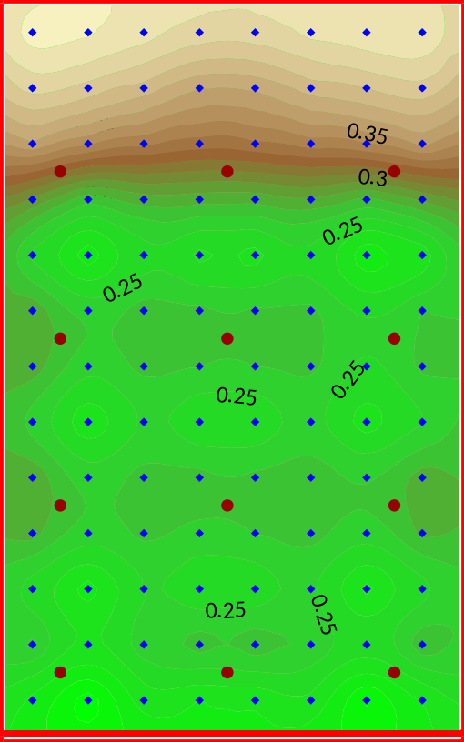
Figure 8.1. Posterior parameter log standard deviations. (The prior log standard deviation of all parameters is 0.4472.)
Sample the prior parameter probability distribution using RANDPAR. Samples will be placed into PEST parameter value files. (Actually, while exhibiting prior parameter variability, these “prior” parameter samples are centred on calibrated parameter values. However these do not differ much from prior parameter mean values. Use of a common parameter mean facilitates comparison with other random parameters sets which we will generate shortly.)
> randpar

RANDPAR Version 17.3. Watermark Numerical Computing.

Enter name of existing PEST control file: case3.pst
- 104 parameters read from file case3.pst.
- 104 of these are adjustable.

Use (log)normal or (log)uniform distrib for param generation? [n/u]: n
Compute means as existing param values or range midpoints? [e/m]: e
Respect parameter ranges? [y/n]: y

Enter name of parameter uncertainty file: param.unc
- reading covariance matrix file cov.mat...
- covariance matrix file cov.mat read ok.
- parameter uncertainty file param.unc read ok.

Enter name of parameter ordering file (<Enter> if none): <Enter>

Enter filename base for parameter value files: random
How many of these files do you wish to generate? 10

Enter integer random number seed (<Enter> if default): <Enter>
- file random1.par written ok.
- file random2.par written ok.
- file random3.par written ok.
- file random4.par written ok.
- file random5.par written ok.
- file random6.par written ok.
- file random7.par written ok.
- file random8.par written ok.
- file random9.par written ok.
- file random10.par written ok.
Now sample the linear approximation to the posterior parameter probability distribution, using RANDPAR again.
> randpar

RANDPAR Version 17.3. Watermark Numerical Computing.

Enter name of existing PEST control file: case3.pst
- 104 parameters read from file case3.pst.
- 104 of these are adjustable.

Use (log)normal or (log)uniform distrib for param generation? [n/u]: n
Compute means as existing param values or range midpoints? [e/m]: e
Respect parameter ranges? [y/n]: y

Enter name of parameter uncertainty file: post_param.unc
- reading covariance matrix file post_cov.mat...
- covariance matrix file post_cov.mat read ok.
- parameter uncertainty file post_param.unc read ok.

Enter name of parameter ordering file (<Enter> if none): <Enter>

Enter filename base for parameter value files: prandom
How many of these files do you wish to generate? 10

Enter integer random number seed (<Enter> if default): <Enter>
- file prandom1.par written ok.
- file prandom2.par written ok.
- file prandom3.par written ok.
- file prandom4.par written ok.
- file prandom5.par written ok.
- file prandom6.par written ok.
- file prandom7.par written ok.
- file prandom8.par written ok.
- file prandom9.par written ok.
- file prandom10.par written ok.
Obtain another set of samples from yet another linear approximation to the posterior parameter probability distribution using the PNULPAR utility. This will operate on samples of the prior parameter distribution. Using subspace principles, PNULPAR removes characteristics from prior random parameter fields that prevent model outputs calculated using these fields from fitting the calibration dataset.
> pnulpar

PNULPAR Version 17.3. Watermark Numerical Computing.

Enter name of PEST control file: case3.pst
Does PEST control file contain calibrated parameter values? [y/n]: y

Enter number of dimensions of calibration solution space: 12
Would you like to store Q(1/2)X matrix in matrix file format? [y/n]: n

Enter filename base of existing parameter value files: random
Enter filename base for new parameter value files: nrandom

- reading PEST control file case3.pst....
- file case3.pst read ok.

- reading Jacobian matrix file case3.jco....
- file case3.jco read ok.

- undertaking SVD of Q(1/2)X...
- SVD completed ok.

- reading parameter value file random1.par...
- projecting parameters onto null space...
- writing new parameter value file nrandom1.par...

- reading parameter value file random2.par...
- projecting parameters onto null space...
- writing new parameter value file nrandom2.par...
etc
We will now run PNULPAR again. This time we will ask it to operate on samples of the posterior parameter probability distribution. This constitutes “double handling” of random parameter fields in order to achieve a good fit with the calibration dataset. However where a model is highly nonlinear, this may yield better-fitting parameter fields than those obtained either by sampling the posterior parameter distribution, or by subjecting samples of the prior parameter distribution to null space projection.
PNULPAR Version 17.3. Watermark Numerical Computing.

Enter name of PEST control file: case3.pst
Does PEST control file contain calibrated parameter values? [y/n]: y

Enter number of dimensions of calibration solution space: 12
Would you like to store Q(1/2)X matrix in matrix file format? [y/n]: n

Enter filename base of existing parameter value files: prandom
Enter filename base for new parameter value files: nprandom

- reading PEST control file case3.pst....
- file case3.pst read ok.

- reading Jacobian matrix file case3.jco....
- file case3.jco read ok.

- undertaking SVD of Q(1/2)X...
- SVD completed ok.

- reading parameter value file prandom1.par...
- projecting parameters onto null space...
- writing new parameter value file nprandom1.par...

- reading parameter value file prandom2.par...
- projecting parameters onto null space...
- writing new parameter value file nprandom2.par...
etc
The following pictures depict the log of K for the first two random fields of each of the above sequences.
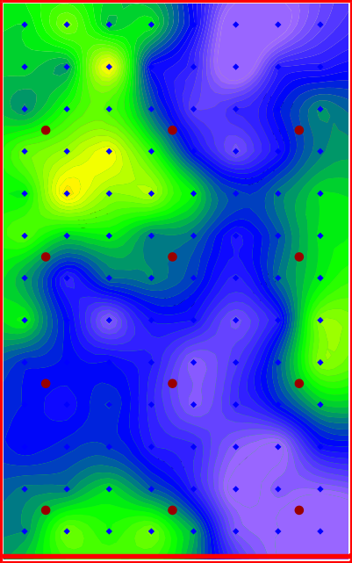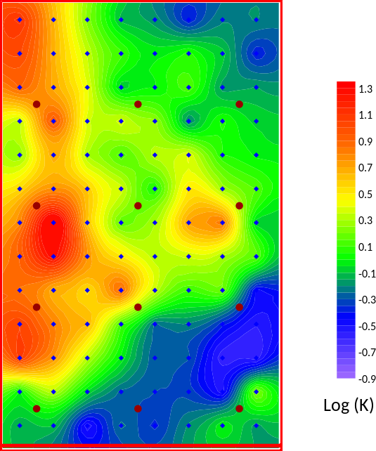
Figure 8.2a. Log of random1.par and random2.par.
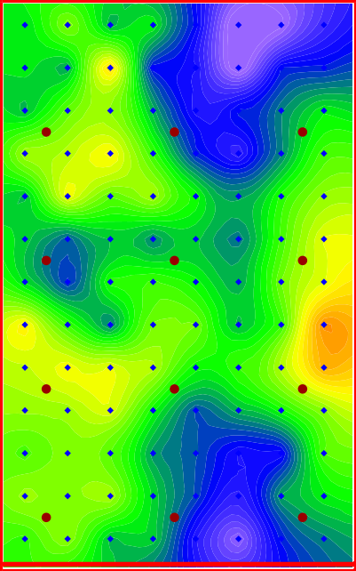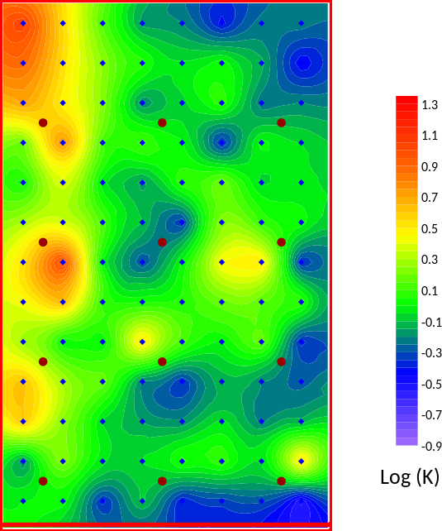
Figure 8.2b. Log of prandom1.par and prandom2.par.
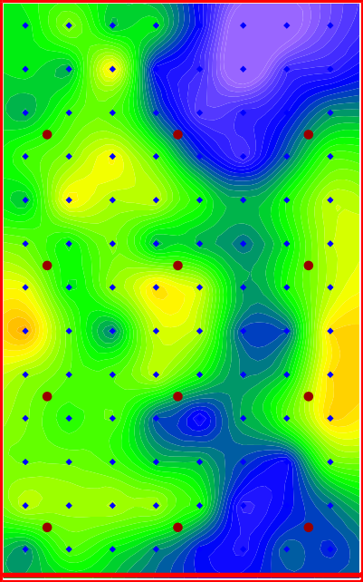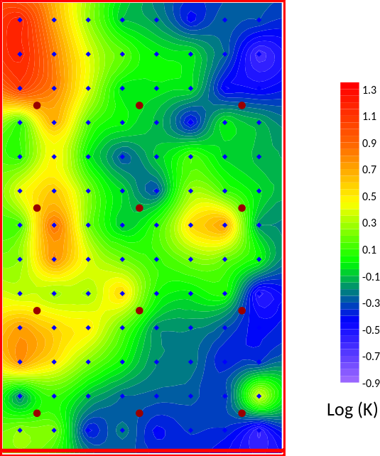
Figure 8.2c. Log of nrandom1.par and nrandom2.par.
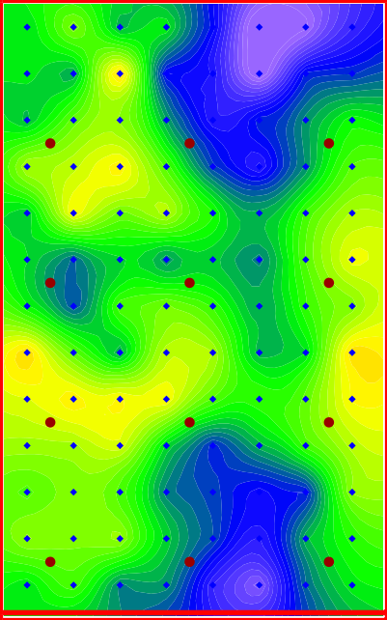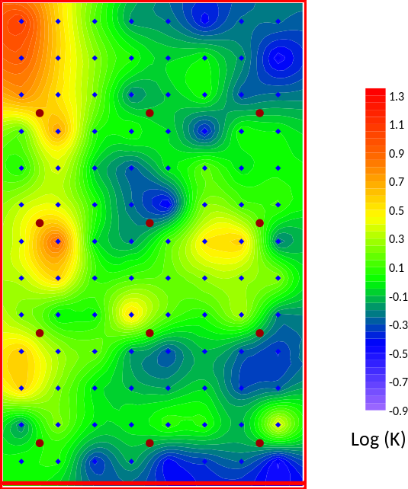
Figure 8.2d. Log of nprandom1.par and nprandom2.par.

9. Testing the Samples
We will now run the model using samples from the prior parameter probability distribution. We will also run the model using members of the three sets of samples that comprise linear approximations to the posterior parameter probability distribution. But first we will create a new PEST control file which will make these tasks easier.
Copy case3.pst to case4.pst.
> copy case3.pst case4.pst
Set NOPTMAX to zero in the “control data” section of file case4.pst. This is the first variable on the nineth line of this file. Other PEST control files which we will generate shortly will inherit this setting. They will therefore run the model once using values recorded in the “parameter data” section of this file, and then cease execution.
Now create a new PEST control file with parameter values contained in file random1.par as the initial parameter values featured in this file.
> parrep random1.par case4.pst case5.pst
Run the model once to see what the objective function is. (Recall that the objective function corresponding to a “calibrated model” should be about 12.0.)
> pest case5
Now repeat for prandom1.par, nrandom1.par and nprandom1.par.
> parrep prandom1.par case4.pst case5.pst
> pest case5

> parrep nrandom1.par case4.pst case5.pst
> pest case5

> parrep nprandom1.par case4.pst case5.pst
> pest case5
The objective functions obtained in the last three cases are much smaller than that obtained in the first case. But these objective functions are not quite low enough to call the model “calibrated”.
Repeat this process for other families of random parameter sets, for example random2.par, prandom2.par, nrandom2.par, nprandom2.par,…,random8.par, prandom8.par, nrandom8.par, nprandom8.par, etc. For the current, relatively simple example, use of a null-space-projected sample from the posterior parameter probability distribution does not result in an objective function that is significantly lower than that achieved by either null-space projection of a sample of the prior parameter probability distribution or direct sampling of the linearized posterior parameter probability distribution on its own. In other cases, however, the outcome of “posterior double handling” can be dramatic. This may be advantageous where model run times are high, for the numerical burden of reducing model-to-measurement misfit below that which is deemed worthy of a “calibrated model” can be considerably reduced.

10. Enforcing Calibration Constraints – The Old Way

10.1 Introduction
We will now use PEST to lower objective functions associated with the prandom*.par, nrandom*.par and nprandom*.par parameter sets to 12.0 or less. (Actually we will call the model “calibrated” if the objective function is 15.0 or less.) Three methodologies for achieving this outcome are demonstrated. It is important to note that all of the methods used for enforcement of calibration constraints that are demonstrated below can be used on any of these sets of random parameter fields. The random parameter fields, and the methods used to adjust them, are interchangeable. It is also important to note that, by placing the sequence of commands that are illustrated below into a batch file, all of these methodologies can be automated with ease.

10.2 Option 1: Using SVD-Assist
First create a JCO file corresponding to case5.pst. We do not need to re-run PEST to do this.
> jco2jco case3 case5
Where parameter numbers are high, SVD-Assist should be used to enforce calibration constraints. Run SVDAPREP based on case5.pst to produce case5_svda.pst.
> svdaprep

SVDAPREP Version 17.3. Watermark Numerical Computing.

Enter name of existing PEST control file: case5
Use pre-defined super-parameter file? [y/n] (<Enter> if "no"): <Enter>
For computation of super parameters:-
if SVD on Q^(1/2)X - enter 1
if SVD on XtQX - enter 2
if LSQR without orthogonalisation - enter 3
if LSQR with orthogonalisation - enter 4
Enter your choice (<Enter> if 1): 1
Enter number of super parameters to estimate: 12
Enter name for new super pest control file: case5_svda
Enter offset for super parameters (<Enter> if 10): <Enter>
Enter value for RELPARMAX (<Enter> if 0.1): <Enter>
Write multiple BPA, JCO, REI, none [b/j/r/n] files (<Enter> if "n")? <Enter>
Parameter scale adjustment [SVDA_SCALADJ] setting (<Enter> if 2): <Enter>
Make new model batch file silent or verbose? [s/v] (<Enter> if "s") : <Enter>
Automatic calc. of 1st itn. super param. derivs? [y/n] (<Enter> if "y") : <Enter>
- file case5_svda.pst written ok.
- file svdabatch.bat written ok.
Edit case5_svda.pst. Set NOPTMAX to 2 in this file. (We will undertake 2 iterations at most – with the first almost for free). Set PSISTOPTHRESH to 15.0. This is added to the end of the second last line in the “control data” section of case5_svda.pst, the line that begins with the NOPTMAX variable; just add the text “15.0” to the end of this line. The “control data” section of the PEST control file should now appear as below.
* control data
restart estimation
12 14 1 0 3
1 2 double point 1 0 0
10.000 -3.0000 0.3 0.03 10
0.100 10.0 0.001
0.1
2 0.005 4 4 0.005 4 15.0
1 1 1 1 nojcosaveitn noreisaveitn
Check your work with PESTCHEK.
> pestchek case5_svda
Now place a null-space projected set of random parameter values into case5.pst. Then run PEST on case5_svda.pst (do NOT run it on case5.pst) to undertake 2 iterations of SVD-assisted inversion.
> parrep nrandom1.par case4.pst case5.pst
> pest case5_svda
Do the same for nrandom2.par, nrandom3.par, etc. Notice that PEST does not have to do any Jacobian runs in the first (and often only) iteration; the same Jacobian matrix is re-used for this iteration on each occasion that PEST is run.
Now do the same for some members of the prandom*.par and nprandom*.par parameter sets. In all cases, parameter adjustment reduces the objective function to a suitably low value in only a few model runs.

10.3 Option 2: Using the /i Switch
Another way to re-use an existing Jacobian matrix is to start PEST with the /i switch. But this time we do not undertake SVD-assisted inversion. Hence if we need to do a second iteration, a full 104 model runs is required.
Set NOPTMAX to 2 and PSISTOPTHRESH to 15.0 in file case4.pst. Then check your work using PESTCHEK. Next create and run case6.pst as follows. When PEST prompts for the name of an existing JCO file, respond with case3.jco.
> parrep prandom1.par case4.pst case6.pst
> pest case6 /i
PEST Version 17.3. Watermark Numerical Computing.
Enter name of JCO file for first iteration sensitivities: case3.jco
etc
Repeat for other members of the prandom*.par family, and for members of the nrandom*.par and nprandom*.par families.

10.4 Option 3: Using the /i Switch and Tikhonov Regularisation
A problem with both of the above methods is that some of the diversity between random parameter fields may be lost as they are adjusted to lower the objective function; the objective function can become too low too quickly. This is especially so in the present case where the “field data” is synthetic, and hence attainment of a very low objective function is possible. This can be prevented through introducing Tikhonov regularisation to the inversion process and setting the target measurement objective function to a level that prevents over-fitting. Meanwhile, Tikhonov constraints ask the inversion process to respect initial parameter values as much as possible.
The steps that must be followed are implemented through the following commands; these are applied to the prandom1.par parameter field. However they could also be applied to any one of the prandom*.par, nrandom*.par or nprandom*.par parameter fields.
> parrep prandom1.par case4.pst case6.pst
> addreg2 case6.pst case6r.pst 10.0
> pest case6r /i
PEST Version 17.3. Watermark Numerical Computing.
Enter name of JCO file for first iteration sensitivities: case3.jco
Etc
The ADDREG2 utility resembles the ADDREG1 utility in that it adds regularisation to a PEST control file. This regularisation is embodied in prior information equations that constrain parameter values to respect their initial values as much as possible. However ADDREG2 also allows a user to provide a target measurement objective function through its command line. In the present case, we provide a value that is slightly less than 12 (the appropriate target if the standard deviation of head measurement noise is 0.1 and head weights are all 10.0) in order to give the constrained inversion process some “room to move”. Note that PSISTOPTHRESH is still set to 15, so that PEST will cease execution if the measurement objective function falls below a value of 15.0.
Repeat the above steps for some other random parameter fields.

11. Enforcing Calibration Constraints – PESTPP-IES

11.1 Introduction
We will now use PESTPP-IES to obtain samples of the posterior parameter probability distribution. Where parameter numbers are high, and where posterior parameter uncertainty is null-space-dominated, this method can be extremely model-run-efficient compared to other methods.

11.2 Running PESTPP-IES
We do not need to calibrate a model prior to using PESTPP-IES, as the processes of model calibration and sampling of the posterior parameter probability distribution are one and the same. (Note, however, that the performance of PESTPP-IES can often be enhanced if it follows model calibration.) So copy the original PEST control file case.pst to a new PEST control file named case7.pst.
> copy case.pst case7.pst
In file case7.pst, set NOPTMAX (first variable on the ninth line of this file) to 7. This instructs PESTPP-IES to stop after 7 iterations. Then add the following lines to the bottom of case7.pst.
++ ies_num_reals(20)
++ parcov(param.unc)
++ ies_subset_size(1)
++ lambda_scale_fac(1.0)
The first of the above lines tells PESTPP-IES that the ensemble size is 20; PESTPP-IES includes a “base realization”, comprised of initial parameter values in this ensemble. The second of the above lines tells PESTPP-IES to obtain its initial parameter ensemble by sampling the prior parameter probability distribution defined by the contents of the param.unc parameter uncertainty file. The last two of the above lines pertain to the way in which the Marquardt lambda is selected during each iteration of the iterative ensemble smoother process. We could have omitted these lines and used PESTPP-IES default settings; however this would have resulted in too many model runs in relation to the number of realizations (which is unusually small for this simple example, but is used to demonstrate how much can be achieved with a comparatively small numerical burden). The third of the above lines instructs PESTPP-IES to experiment with lambda values using only one member of the ensemble. The last line instructs it to restrict its experimentation to a scale factor of 1.0; that is, PESTPP-IES will not calculate parameter upgrades pertaining to fractional lengths along the parameter upgrade vector that is calculated using any lambda.
After you have done this, run PESTPP-IES using the following command.
> pestpp-ies case7
PESTPP-IES carries out 174 model runs. See file case7.phi.actual.csv for a history of objective functions calculated by ensemble members. As is apparent from this file, the average objective function pertaining to all final ensemble members (i.e. all modified parameter realizations) is 29.23; the minimum is 19.64 and the maximum is 43.52. The performance of PESTPP-IES is summarized in the following graph.
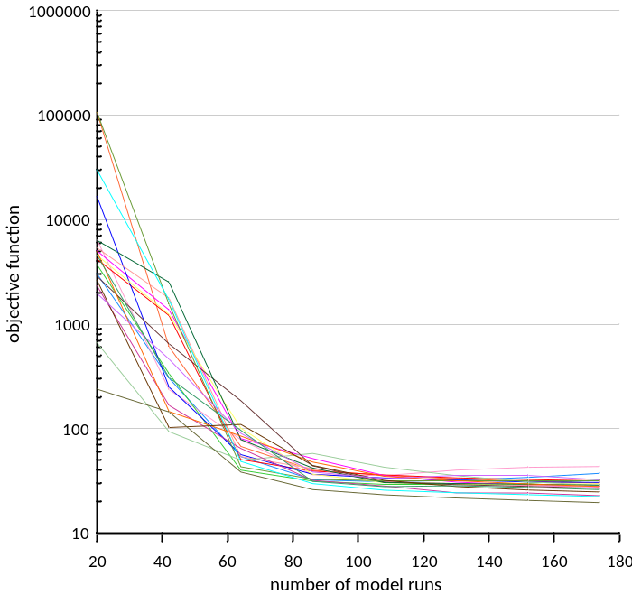
Figure 11.1. Realization objective functions plotted against the number of model runs.
Parameter values pertaining to the final iteration are available in file case7.7.par.csv.
In this brief demonstration of PESTPP-IES, model runs are conducted in serial. In most practical cases model runs would be carried out in parallel. This is achieved by running PESTPP-IES in the same way that PESTPP-GLM was run for parallelization of model runs; see Section 6 of this tutorial.

11.3 Examining Parameter Fields
The PEST suite provides a number of utilities that facilitate setup of PESTPP-IES and post-processing of files produced by PESTPP-IES. We demonstrate just one of them. We will extract two parameter sets from file case7.7.par.csv. Parameter values will be recorded in parameter value files.
Run CSV2PAR twice, responding to its prompts as follows. Parameter set “0” and parameter set “base” are placed into their own parameter value files.
> csv2par

CSV2PAR Version 17.3. Watermark Numerical Computing.

Enter name of CSV file: case7.7.par.csv
Extract param vals from a row or column of this file? [r/c]: r
Enter name of row: 0

Enter name for parameter value file: case7_ies_0.par

- file case7.7.par.csv read ok.
- file case7_ies_0.par written ok.

> csv2par

CSV2PAR Version 17.3. Watermark Numerical Computing.

Enter name of CSV file: case7.7.par.csv
Extract param vals from a row or column of this file? [r/c]: r
Enter name of row: base

Enter name for parameter value file: case7_ies_base.par

- file case7.7.par.csv read ok.
- file case7_ies_base.par written ok.
As has been demonstrated many times during this tutorial, parameter values that are stored within a parameter value file can be inserted into a PEST control file using the PARREP utility. The two parameter sets that were extracted using the above commands are pictured in Figure 11.2.
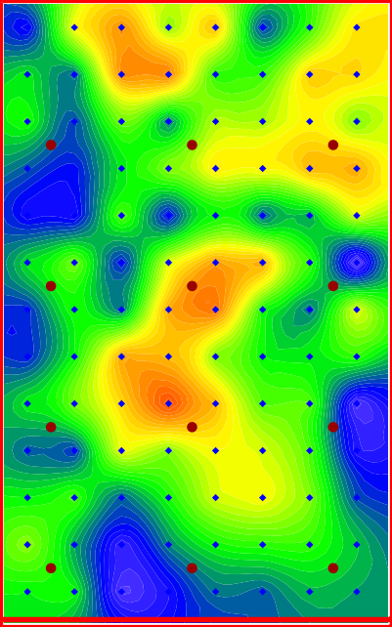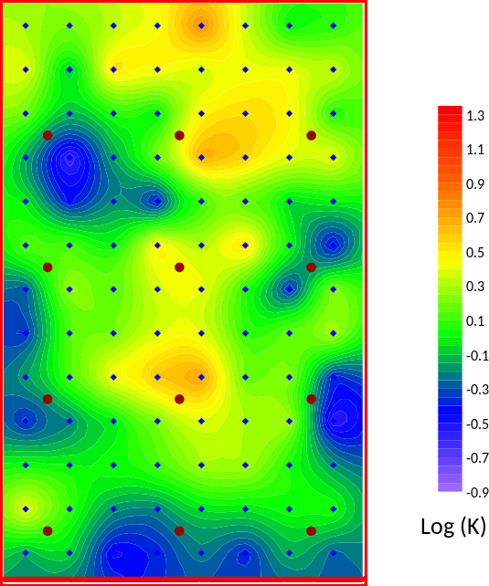
Figure 11.2. Parameter fields contained in files case7_ies_0.par and case7_ies_base.par.
An inspection of file case7.7.obs.csv reveals variability of the part_time and part_east predictions between realisations. Twenty realisations is not nearly enough to calculate reliable statistics. Furthermore, with the use of so few realisations, an ensemble is prone to collapse. Nevertheless we will report them in Table 11.1, along with standard deviations calculated from linear analysis.
Prediction | Mean (IES) | Standard_deviation (IES) | Standard deviation (linear)
Particle emergence easting (m) | 218.5 | 36.2 | 33.2
Particle travel time (days) | 5055.4 | 564.0 | 1661.3
Table 11.1. Posterior statistics of predictions calculated from outcomes of PESTPP-IES run.
The contents of file case7.7.obs.csv can also be used to plot posterior predictive histograms. These can be superimposed on prior histograms obtained from case7.0.obs.csv. We will not do this here as realisations are too small in number. However frequency histograms are shown in the next section when we demonstrate data space inversion.

12. Data Space Inversion

12.1 Introduction
Data space inversion (DSI) allows the posterior distribution of a model prediction to be explored without the need to explore the posterior distribution of model parameters. It does this by building a surrogate model based on principle component analysis (PCA) of the covariance matrix between model outputs that correspond to field measurements on the one hand, and predictions of interest on the other hand. These predictions are then conditioned by real world measurements of system behaviour.
The model that is used in the present workshop runs quickly, so there is little to be gained by using DSI. However if a model is big and cumbersome and runs slowly, DSI can make the difference between being able to undertake predictive uncertainty analysis or not. Furthermore, the big, complex model does not even need to have clearly-defined parameters. It can be populated by random, geostatistically-based hydraulic property fields.

12.2 Building the PCA Model
Our first task is to create a dataset from which statistical relationships between observations and predictions can be constructed. We will do this by running our MODFLOW6/MODPATH7 model 100 times based on 100 samples of the prior parameter probability distribution. This will be done using PESTPP-IES. These are the only MODFLOW6/MODPATH7 model runs that need to be done! All further “model” runs will use a surrogate PCA model which runs very quickly.
To start the process, we will create a new PEST control file named case8.pst that is slightly modified from case7.pst. First make a copy of case7.pst.
> copy case7.pst case8.pst
Now make the following alterations to case8.pst.
- Inform PESTPP-IES to use an ensemble size of 100. That is ++ ies_num_reals(100) instead of ++ ies_num_reals(20).
- Inform PESTPP-IES that it must not add noise to model outputs that correspond to observations. That is ++ ies_no_noise(true)
- Set NOPTMAX (first variable on the ninth line of the PEST control file) to -1; this tells PESTPP-IES that it should not undertake ensemble-based inversion. It should simply commission 100 model runs and then shut down.
Now run PESTPP-IES.
> pestpp-ies case8
Our output file of interest is case8.0.obs.csv. It contains model-generated counterparts to field measurements together with our two predictions, evaluated repeatedly using the 100 random samples of the prior parameter probability distribution.
Now run program DSI2 to build the PCA surrogate model together with other files that will be used to condition model predictions to field measurements.
Initially, construction of posterior predictive probability distributions will be done using PESTPP-IES based on 80 realisations of PCA parameter sets. We could have chosen to use any number of PCA parameter realisations. By choosing 80 in this tutorial we demonstrate that the number of realisations used for predictive uncertainty evaluation does not need to be the same as the number of realisations of complex model parameter fields that are used to build a PCA model. (In most instances, it can actually be more, as PCA model runs are very cheap.)
> dsi2

DSI2 Version 17.4. Watermark Numerical Computing.

Enter name of PEST control file: case8.pst
- 14 observations read from file case8.pst.
- 12 of these have a nonzero weight.

Enter name of observation transformation file (<Enter> if none): <Enter>

Enter name of CSV file containing model-generated observations: case8.0.obs.csv
How many realizations to read from this file? 100
A realisation per row or per column in this file? [r/c]: r
- file case8.0.obs.csv read ok.

Transform to Gaussian space? [y/n]: y

Enter "energy threshold" for SVD truncation.
(Normally between 0.9 and 0.999): 0.999

Enter filename base for output files: case_dsi
How many IES realisations do you wish to employ? 80

- setting up normal score transform space...
- Gaussian transforming observations/predictions...
- computing ZtZ matrix...
- performing singular value decomposition of ZtZ matrix...
- formulation of square root of covariance matrix...

- writing output files...
- file case_dsi.bin written ok.
- file case_dsi.pst written ok.
- file case_dsi.unc written ok.
- file case_dsi.tpl written ok.
- file case_dsi.in written ok.
- file case_dsi.ins written ok.
DSI2 has done everything that needs to be done to support running and history-matching the PCA model.
Inspect file case_dsi.pst that was written by DSI2. PCA parameters are listed in its “parameter data” section. By construction, these are all independently normally distributed with means of zero and standard deviations of 1.0; DSI2 has written a parameter uncertainty file named case_dsi.unc which expresses this. PESTPP-IES will use this file to generate initial realisations of PCA model parameters. It will then alter these realisations so that their joint posterior probabilitydistribution can be sampled.
The model that PESTPP-IES must run is named in the “model command line” section of file case_dsi.pst. This is program DSIMOD. Command-line arguments accompany the command to run this program.

12.3 History-Matching the PCA Model using PESTPP-IES
Set NOPTMAX (first variable on the ninth line of file case_dsi.pst) to 5. To run PESTPP-IES we could type the command “pestpp-ies case_dsi.pst” at the screen prompt. But to hurry things along, we will not do it this way. Instead we will parallelize model runs by using a batch process which first copies files to agent folders and then starts PESTPP-IES agents in each of these folders; another instance of PESTPP-IES is then run as the manager in the main working folder. To run this batch file, type the following command.
> run_pestpp-ies.bat
The model appears to run slowly. This is because PESTPP-IES inserts a small delay between running a model and reading its output files. It does this to ensure that the operating system does not get mixed messages about whether these files are available for reading or not. In fact, the DSIMOD model takes much less than a second to run. In circumstances where it is normally used, this is far smaller than the run time of the real model on which it is based (MODFLOW6 and MODPATH7 in our case).
By the way, when history matching the PCA model, PESTPP-IES adds random realisations of measurement noise to field observations so that the presence of this noise can be taken into account when computing posterior predictive uncertainty.
Have a cup of coffee while PESTPP-IES does its work. It will take 9 to 10 minutes.
Once PESTPP-IES has finished, inspect file case_dsi.phi.actual.csv. This file reveals that PESTPP-IES was able to achieve a mean objective function of 12.17, while the minimum objective function is 0.84 and the maximum objective function is 31.5. These values are within the range of expectations, given measurement noise and weights.
Evaluation of predictive uncertainties requires that we examine the contents of two CSV files. The first is file case8.0.obs.csv. The final two columns of this file contain samples of the prior probability distribution of the part_east and part_time predictions. The second is file case_dsi.5.obs.csv. This file contains samples of the posterior probability distributions of these predictions. The contents of these columns can be used to plot histograms of these distributions. See Figure 12.1.
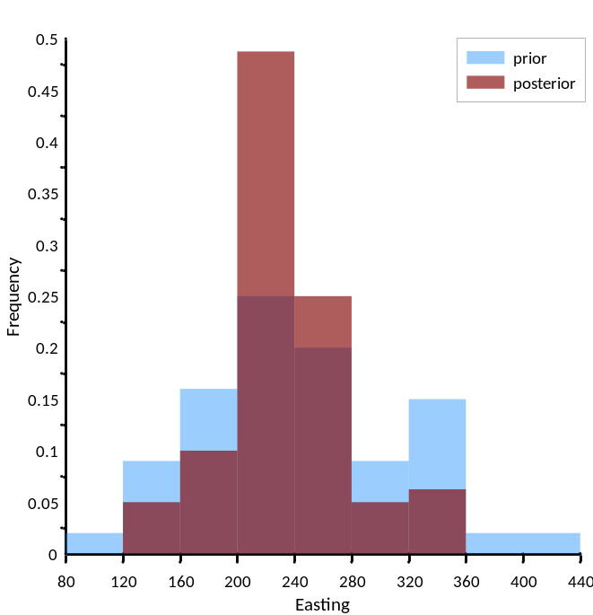
Figure 12.1a. Prior and posterior histograms of the easting of particle emergence.
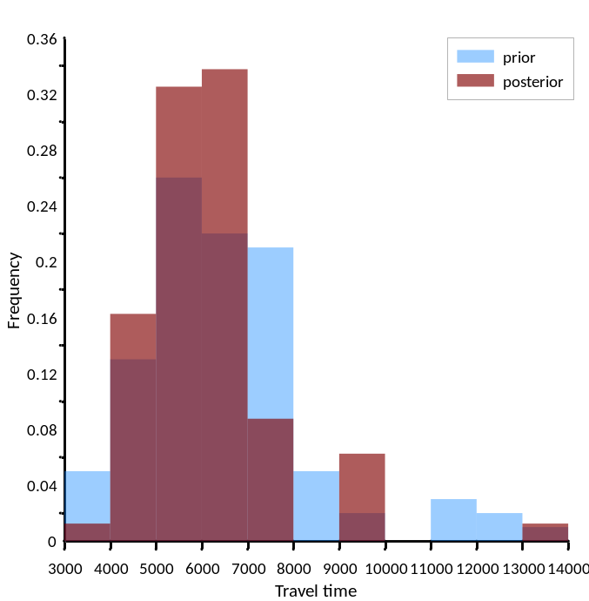
Figure 12.1b. Prior and posterior histograms of particle travel time.
The histograms of the posterior probability distributions of these predictions would be far less “blocky” if we had used more than 80 realisations to explore them. Given the incredibly short run time of the surrogate model, this is easily done.
Table 12.1 contains statistics calculated from the final two columns of files case8.0.obs.csv and case_dsi.5.obs.csv. These agree well with statistics obtained from previous linear and nonlinear analyses.
 | Prior |  | Posterior
Prediction | Mean | Standard deviation | Mean | Standard deviation
Particle emergence easting (m) | 242.4 | 68.4 | 231.1 | 41.9
Particle travel time (days) | 6494.6 | 1869.5 | 6119.2 | 1465.3
Table 12.1. Prior and posterior prediction statistics. Samples of the posterior predictive probability distributions were calculated by PESTPP-IES using the PCA model.

12.4 Calibrating the IES Model using PEST
We will now history-match the PCA model in another way; we will calibrate it using PEST. This will provide us with minimum error variance estimates of the part_east and part_time predictions. (This is roughly the same as their posterior means.) Tikhonov-regularised inversion will be used for this purpose. So add regularisation to the DSI-produced PEST control file case_dsi.pst using the ADDREG2 utility. Inform ADDREG2 that our target measurement objective function is 12.0 through its command line.
> addreg2 case_dsi.pst case_dsir.pst 12.0
Because the PCA model runs so fast, it costs very little to commit some extra model runs to ensuring that the regularisation objective function is as low as it can be. So set the REGCONTINUE variable to “continue” in the “regularisation” section of file case_dsir.pst. The “regularisation” section should then appear as follows.
* regularisation
12.00000 12.24000 5.0000001E-02
1.0 1.0e-10 1.0e10 continue
1.3 1.0e-2 1
As usual, check your work with PESTCHEK. Ignore the warnings.
> pestchek case_dsir
Now run PEST.
> pest case_dsir
An inspection of file case_dsir.rec reveals posterior mean values of 224.8 m and 6022.2 days for the particle emergence easting and the particle travel time predictions respectively. We can now update Table 5.1; see Table 12.2.
Prediction | Reality | Calibrated | Calibrated using SVDA | Calibrated using PESTPP-GLM | Calibrated using PCA model
Particle emergence easting (m) | 206.8 | 225.9 | 229.6 | 234.0 | 224.8
Particle travel time (days) | 3256.2 | 6840.9 | 6977.1 | 7024.0 | 6022.2
Table 12.2. Minimum error variance predictions of particle emergence location and time.
Before undertaking any further analyses, we will create a PEST control file in which initial PCA parameter values are the calibrated PCA parameter values that we have just obtained.
> parrep case_dsir.par case_dsi.pst case_dsi_soln.pst
Note that the new PEST control file case_dsi_soln.pst contains no prior information. Nor does it contain a “regularisation” section. This is because optimised PCA parameter values were substituted into the PEST control file case_dsi.pst which contains neither of these.

12.5 Prediction Maximization/Minimization
Skip this section and go straight to the section on linear analysis if you are running short of time.
We will now use PEST’s predictive analyser to quickly obtain estimates of predictive confidence intervals.
Before doing this, however, we will add regularisation to file case_dsi_soln.pst. Actually, it is not regularisation that we want; what we want are prior information equations These equations will “observe” that, ideally, PCA parameter values are calibrated parameter values. Deviations from this ideal will therefore figure in the objective function. When we minimize and maximize our predictions in search of predictive confidence limits, constraints on these predictions will be imposed by a user-specified objective function limit. This will reflect both model-to-measurement misfit and perturbations of parameters from their ideal values.
> addreg1 case_dsi_soln.pst case_dsip.pst
We must now prepare file case_dsip.pst for predictive analysis. You can either make the following changes yourself, or you can copy file case_dsip.pst.copy (in which the changes have already been made for you) to file case_dsip.pst.
- Alter “regularisation” to “estimation” on the third line of file case_dsip.pst.
- Alter the value of the NOBSGP (number of observation groups) control variable from 4 to 5; this is the last variable on the fourth line of file case_disp.pst.
- Set NOPTMAX (first variable on the nineth line) to 0.
- Eliminate the “singular value decomposition” section.
- Add the group “predict” to the “observation groups” section.
- Alter the group designation of the part_east observation from distance to predict.
- Remove the “regularisation” section and everything below it from file case_dsip.pst.
Now run PEST to see what the objective function is.
> pest case_dsip
The objective function is 11.891.
We will now put the finishing touches on file case_dsip.pst. Suppose that we wish to obtain the 95% confidence limits of our predictions. For a Gaussian distribution these are removed from their posterior means by two standard deviations. It can be shown that the limiting objective function is therefore higher than the calibration objective function by approximately the square of this, that is 4.0. (If we were seeking 99.7% confidence limits we would have added the square of 3.0, which is 9.0, to the calibration objective function.) Note that this rule only applies if observation weights are roughly equal to the inverse standard deviations of measurement noise, so that the measurement objective function is roughly equal to the number of non-zero-weighted observations. It also requires that the weights assigned to prior information equations are correct. Because PCA parameters have standard deviations of 1.0 (by construction), and because weights assigned to prior information equations by ADDREG2 are all equal to 1.0, their weights are indeed “correct”.
Now set NOPTMAX to 50 in case_dsip.pst. Tell PEST to run in “predictive analysis” mode by changing “estimation” to “prediction” on the third line of this file. Then add the following “predictive analysis” section to the bottom of this file.
* predictive analysis
1
15.891 16.5 30.0
0.00 0.005 0.2 1.3 20
0.00 0.05
4 0.0 0.001 4
The number “1” on the first line of the “predictive analysis” section of a PEST control file is the value of variable NPREDMAXMIN. A setting of 1 tells PEST to maximize a prediction, while a setting of -1 tells PEST to minimize a prediction. The first variable on the following line is PD0. This is the limiting objective function. It is set 4.0 above the previously obtained value of 11.891. Other variables are explained in the PEST manual. Check your work with PESTCHEK (ignoring warnings) and then run PEST.
> pest case_dsip
The screen printout at the end of the PEST run informs us that the value of the maximized prediction is 413.4.
Now set NPREDMAXMIN to -1 in the “predictive analysis” section of file case_dsip.pst and re-run PEST. The minimized prediction is 103.1. Thus the posterior 95% confidence interval is:
[103.1 m 413.4 m]
By way of comparison, minimum and maximum predictions in file case_dsi.5.obs.csv (recorded by PESTPP-IES) define the interval:
[139.3 m 335.5 m].
If the part_time prediction is minimized and maximised in the same way, the following confidence interval is obtained:
[2889.0 days 14646.5 days]
Minimum and maximum values for this prediction in file case_dsi.5.obs.csv are:
[3893.1 days 13010.0 days]

12.6 Linear Analysis
Just as for any other model, we can perform linear analysis using a PCA model. However, when working with a PCA model, parameter uncertainty is of less interest to us than predictive uncertainty. Also of interest is exploration of data worth.
In order to undertake linear analysis, we need a PEST control file which:
- contains calibrated parameter values;
- features no regularisation; and
- is associated with a complementary JCO file.
File case_dsi_soln.pst (which was created above) fulfils the first two of these requirements.
Set NOPTMAX to -2 in this file and run PEST to create a Jacobian matrix.
> pest case_dsi_soln
Now run GENLINPRED. (As has already been discussed, this performs basic linear analysis. Other PEST utilities perform more targeted linear analyses. GENLINPRED runs some of these utilities behind the scenes.) If you make a mistake when responding to one of GENLINPRED’s prompts, respond with “e” and then <Enter> to the next prompt in order to backtrack to the previous prompt.
> genlinpred

GENLINPRED Version 17.3. Watermark Numerical Computing.

Enter name for response file (<Enter> if none): <Enter>
Use abbreviated or full input? [a/f] (<Enter> if "f"): f

Enter name of PEST control file: case_dsi_soln.pst

- reading PEST control file case_dsi_soln.pst....
- file case_dsi_soln.pst read ok.

Use bounds or uncert file for param uncertainties [b/u] <Enter> if "b": u
Enter name of parameter uncertainty file: case_dsi.unc

Are weights the inverse of measurement uncertainty? [y/n] <Enter> if "y": y

Enter name for output file <Enter> if genlinpred.out: genlinpred_dsi.out

Perform global parameter estimability analysis? [y/n] <Enter> if "n": n

Perform comprehensive analysis of a prediction/param? [y/n] <Enter> if "y": y
Provide pertinent information:-

Enter name of prediction/parameter to analyze: part_east
Enter file to read its sensitivities ["p" if a parameter]: case_dsi_soln.jco

Compute soln/null space contribs to predict error? [y/n] <Enter> if "n": n
Compute predictive uncertainty? [y/n] <Enter> if "y": y

Compute parameter contributions to error? [y/n] <Enter> if "n": n
Compute parameter contributions to uncertainty? [y/n] <Enter> if "y": n

Compute observation worth wrt error? [y/n] <Enter> if "n": n
Compute observation worth wrt uncertainty? [y/n] <Enter> if "y": y
For indiv observations or for observation groups? [i/g] <Enter> if "g": i

- reading parameter uncertainty file case_dsi.unc...
- parameter uncertainty file case_dsi.unc read ok.
- writing scaled PEST control file...
- file p###.pst written ok.
- reading Jacobian matrix file case_dsi_soln.jco...
- Jacobian matrix file case_dsi_soln.jco read ok.
- writing scaled Jacobian matrix file p###.jco...
- scaled Jacobian matrix file p###.jco written ok.
- writing scaled uncertainty file s###.unc...
- scaled uncertainty file s###.unc written ok.

- running JROW2VEC to extract predictive sensitivities...
- program JROW2VEC run ok.

- running PREDUNC1 to compute predictive uncertainty...
- program PREDUNC1 run ok.

- running PREDUNC5 to compute observ worth through subtraction...
- program PREDUNC5 run ok.

- running PREDUNC5 to compute observ worth through addition...
- program PREDUNC5 run ok.

- see file genlinpred_dsi.out for complete GENLINPRED output.
Table 12.3 compares linear-calculated prior and posterior variances and standard deviations of the part_east and part_time predictions with those calculated using PESTPP-IES (see Table 12.1). (Uncertainties of the part_time prediction can be obtained either by running GENLINPRED again, or by using the PREDUNC1 utility.) Agreement between the two sets of statistics is reasonably good.
 | Prior |  | Posterior
Prediction | Variance | Standard deviation | Variance | Standard deviation
Particle emergence easting (m) | 5965.4 [4678.6] | 77.23 [68.4] | 1755.6 [2469.6] | 49.7 [41.9]
Particle travel time (days) | 2408083.2 [3495030.3] | 1551.8 [1869.5] | 1923769.0 [2147104.1] | 1387.0 [1465.3]
Table 12.3. Prior and posterior prediction statistics calculated using linear analysis. The numbers in brackets were calculated using PESTPP-IES; see Table 12.1. Note that standard deviation is the square root of variance.
File genlinpred_dsi.out finishes with two tables. The first table lists the increase in posterior predictive uncertainty variance that would be incurred if each well in turn is omitted from the part_east conditioning dataset. These are reproduced in Table 12.4, together with corresponding values that were calculated using traditional linear analysis (see file genlinpred.out). While the two sets of numbers are somewhat different, the ordering of observation worth is roughly the same in both of them.
Omitted observation | Variance increase (DSI) | Variance increase (traditional)
well01_1 | 158.54 | 319.572
well02_1 | 4.159 | 1.10E-02
well03_1 | 220.29 | 414.479
well04_1 | 322.686 | 724.836
well05_1 | 34.781 | 21.59
well06_1 | 303.967 | 607.842
well07_1 | 376.066 | 685.385
well08_1 | 30.562 | 0.77
well09_1 | 116.816 | 666.871
well10_1 | 151.119 | 128.635
well11_1 | 30.622 | 16.696
well12_1 | 57.269 | 117.605
Table 12.4. Variance increase of the part_east prediction incurred by omission of each observation well from the calibration dataset.
Reductions of predictive part_east uncertainty variance from its prior value where each well in turn comprises the only member of the calibration dataset are listed in Table 12.5. Numbers from genlinpred_dsi.out and genlinpred.out comprise the second and third columns of this table respectively.
Included observation | Variance decrease (DSI) | Variance decrease (traditional)
well01_1 | 57.167 | 0.426
well02_1 | 47.918 | 0.734
well03_1 | 31.233 | 8.512
well04_1 | 110.454 | 36.24
well05_1 | 33.311 | 1.145
well06_1 | 0.509 | 64.404
well07_1 | 159.55 | 96.919
well08_1 | 9.363 | 0.947
well09_1 | 32.579 | 126.813
well10_1 | 93.643 | 86.21
well11_1 | 6.703 | 1.13
well12_1 | 27.9 | 125.989
Table 12.5. Variance decrease of the part_east prediction accrued from its prior variance if each well is the sole member of the calibration dataset.
At first sight, numbers in the two columns of Table 12.5 are significantly different from each other. However it must be recalled that they are obtained by subtracting one large number from another large number which is very close to it (i.e. the posterior predictive variance from the prior predictive variance), following the addition of one observation to an otherwise empty observation dataset. This does little to reduce the uncertainty of the part_east prediction. As shown in Table 12.3, the prior variance of the part_east prediction is 5965.4. The numbers in Table 12.5 are small in comparison to this.
These results suggest that linear data worth analysis can be usefully conducted using a PCA surrogate model. However predictive variances on which data worth analysis is based are not quite as reliable as those obtained when linear analysis is implemented using a complex model, and sensitivities are calculated by finite-difference variation of individual complex model parameters. Nevertheless, there will be many circumstances where the outcomes of PCA-based data worth analysis are quite useable, particularly when exploring the best way to supplement an existing calibration dataset. Under these circumstances the ordering of data worth evaluations is likely to have integrity. It must also be recalled that PCA-based linear analysis may comprise the only practical option for exploring the relative abilities of different observation and data types to reduce the uncertainties of predictions made by large, complex, slow-running models that are endowed with complicated, geostatistically-based hydraulic property fields.
Sometimes it is easier to work with standard deviations than with variances. Variances are a more “natural” statistical quantity to work with as they are often additive; in contrast, standard deviations are never additive. We finish this tutorial by repeating the second of the above analyses using the PREDUNC5 utility. PREDUNC5 lists standard deviations as well as variances on its output file. In the present case, it becomes immediately clear how small is the reduction in predictive uncertainty accrued by the addition of a single observation to an otherwise empty calibration dataset.
PREDUNC5 reads an “observation type list file” in order to ascertain a user’s wishes pertaining to observations that are added to, or subtracted from, a calibration dataset in exploration of their worth. One has been prepared for you; see file predunc5_add.lst.
Before running PREDUNC5, we must extract sensitivities of the part_east prediction from the case_dsi_soln.jco Jacobian matrix file. This is because PREDUNC5 will ask us for these sensitivities. This is done using program JROW2VEC.
> jrow2vec case_dsi_soln.jco part_east part_east.vec
Now run PREDUNC5, responding to its prompts as follows:
> predunc5

PREDUNC5 Version 17.3. Watermark Numerical Computing.

Enter name of PEST control file: case_dsi_soln.pst
Enter observation reference variance: 1

Enter name of parameter uncertainty file: case_dsi.unc
Enter name of predictive sensitivity matrix file: part_east.vec
Enter name of observation type list file: predunc5_add.lst
Subtract list members or add to base observations [s/a]: a

Enter name for predictive uncertainty output file: part_east_add.dat

Use which version of linear predictive uncertainty equation:-
if version optimized for small number of parameters - enter 1
if version optimized for small number of observations - enter 2
Enter your choice: 1

- reading PEST control file case_dsi_soln.pst....
- file case_dsi_soln.pst read ok.

- reading Jacobian matrix file case_dsi_soln.jco....
- file case_dsi_soln.jco read ok.
etc
The last two columns in the table that is recorded in file part_east_add.dat shows how small are the reductions in the standard deviation of part_east predictive uncertainty from its prior uncertainty when only a single observation comprises the calibration dataset.

