**Visualisation utilities**

**Displaying models in 2D and 3D**

A GMDSI tutorial

by Rui Hugman and John Doherty

# 

Published By

The National Centre for Groundwater Research and Training

C/O Flinders University

GPO Box 2100

Adelaide SA 5001

+61 8 8201 2193

DisclaimeR

The National Centre for Groundwater Research and Training, Flinders University advises that the information in this publication comprises general statements based on scientific research. The reader is advised and needs to be aware that such information may be incomplete or unable to be used in any specific situation. No reliance or actions must therefore be made on that information without seeking prior expert professional, scientific and technical advice.

Preface

The Groundwater Modelling Decision Support Initiative (GMDSI) is an industry-funded and industry-aligned project focused on improving the role that groundwater modelling plays in supporting environmental management and decision-making.

Over the life of the project, GMDSI will produce a suite of tutorials. These are intended to assist modellers in setting up and using model-partner software in ways that support the decision-support imperatives of data assimilation and uncertainty quantification. Not only will they focus on software usage details. They will also suggest ways in which the ideas behind the software which they demonstrate can be put into practice in everyday, real-world modelling contexts.

GMDSI tutorials are designed to be modular and independent of each other. Each tutorial addresses its own specific modelling topic. Hence there is no need to work through them in a pre-ordained sequence. That being said, they also complement each other. Many employ variations of the same synthetic case and are based on the same simulator (MODFLOW 6). Utility software from the PEST suite is used extensively to assist in model parameterization, objective function definition and general PEST/PEST++ setup. Some tutorials focus on the use of PEST and PEST++, while others focus on ancillary issues such as introducing transient recharge to a groundwater model and visualization of a model’s grid, parameterization, and calculated states.

The authors of GMDSI tutorials do not claim that the workflows and methodologies that are described in these tutorials comprise the best approach to decision-support modelling. Their desire is to introduce modellers, and those who are interested in modelling, to concepts and tools that can improve the role that simulation plays in decision-support. Meanwhile, the workflows attempt to demonstrate the innovative and practical use of widely available, public domain and commonly used software in ways that do not require extensive modelling experience nor an extensive modelling skillset. However, users who are adept at programming can readily extend the workflows for more creative deployment in their own modelling contexts.

We thank and acknowledge our collaborators, and GMDSI project funders, for making these tutorials possible.

Rui Hugman

John Doherty

Contents

1. Introduction 5

1.1 The software 5

2. Displaying a model in A GIS 6

2.1 Visualising the grid geometry 6

2.2 Visualising model boundary-conditions 8

2.3 Visualising model properties 10

2.4 Visualising model results 11

3. Displaying a model in three dimensions 14

3.1 Visualising the grid geometry 15

3.2 Visualising model properties 16

3.3 Visualising model boundary-conditions 17

3.4 Visualising model-simulated dependent variables 20

# Introduction

It is often useful to visualize a model setup and/or results. This can sometimes give the modeller unexpected insights, help him/her to identify mistakes and be useful in conveying modelling outcomes. It can also look pretty. Most modelling GUI’s provide visualisation capabilities to various degrees. If a modeller is not using a GUI, other means are necessary. Regardless of the platform in which we build a model, we will want to view model properties and results in platforms such as GIS packages and 3D display packages. This workshop provides some options.

The following chapters demonstrate the use of several utilities available from the PEST software suite for converting model input and result files to formats that can be displayed by common 2D and 3D visualisation software. The example shown below makes use of files from a MODFLOW 6 model; however, with little effort, these workflows can be adapted to other file structures. Variations of the workflows for use with other MODFLOW versions are mentioned but not demonstrated.

## The software

Software demonstrated during this tutorial includes:

* MF62GIS
* Members of the MF62VTK* family
* MF6DEP2CSV

Executable versions for each of these programs are freely available through the PEST [Groundwater Utilities](https://pesthomepage.org/groundwater-utilities) suite. See the “Groundwater Utilities (Part C)” documentation for full descriptions of their use. Before starting the tutorial, make sure that executable versions of these programs are copied to your machine (these are the “*\*.exe*” files)*.* To make completion of this tutorial easy, executables are provided in the tutorial folder. Ideally, however, they should be stored in a folder that is cited in your computer’s PATH environment variable. Alternatively, they can simply be placed in your working folder.

The running of these utilities results in files that can be read by 2D and 3D display packages. MF62GIS generates MIF/MID file pairs and BLN files pertaining to MODFLOW 6 model grids. These grids can then be displayed using packages such as QGIS and SURFER. Utilities of the MF62VTK* family generate so-called “legacy VTK files” that are readable by software such as PARAVIEW (an open source data analysis and visualisation platform).

To make full use of this tutorial the reader should have at least [QGIS](https://qgis.org/en/site/) (or similar GIS software) and [PARAVIEW](https://www.paraview.org/) (or similar 3D visualisation software) installed. Both of these are open source and freely available on the world wide web.

# Displaying a model in A GIS

The following tutorial will demonstrate how to use MF62GIS to convert data pertaining to a MODFLOW 6 model into formats that are readable by common GIS software. Examples are provided for visualising model parameters and boundary-condition data. A workflow to visualise model-simulated system states (i.e. simulated heads or drawdowns) making use of MF6DEP2CSV is also demonstrated.

Files used in this part of the tutorial can be found in the “model2GIS” folder.

MF62GIS reads a binary grid file written by MODFLOW 6. As is discussed in documentation of MODFLOW 6, this file contains complete geometric specifications of the MODFLOW 6 model grid. Currently, MF62GIS only accepts the DIS and DISV grid types.

Though not discussed herein, similar utilities are available for use with MODFLOW-USG. See, in particular, USGNDTF2MIF, USGGRIDLAY, USGPROP2TAB1, USGPROP2TAB2 and others. These are all documented in Part C of the manual for the PEST Groundwater Utilities.

A MODFLOW 6 binary grid file, named *model.disv.grb*, has been provided in the tutorial folder. This grid file pertains to a model that is similar to that used in other GMDSI tutorials. The model has a DISV grid with 3 layers. A stream down the centre of the model domain is represented using the DRN package. The DRN package file for stress period 1 is provided as *model.drn_stress_period_data_1.txt*. This file contains elevations and conductances of the stream bed.

Model hydraulic properties for each layer are recorded in external files; MODFLOW 6 accesses these properties using its OPEN/CLOSE array-reading option. The three files of interest for the present tutorial are named *model.npf_k_layer[1-3].txt*. They each contain a single column of numbers; each number represents Kx in a single model cell.

Several folders are provided. These are tutorial checkpoints. Each of these folders contains the files that should have been produced by the end of each of the following chapters. Should you encounter any problems, these may be useful in troubleshooting. They also allow you to jump into the tutorial at any stage. However, it is recommended that you at least read through those parts of the tutorial that you do not complete.

## Visualising the grid geometry

Let us start off slowly. We start by simply visualising the grid geometry and grid-associated information using MF62GIS.

1. Open the command line in the *tutorial* folder and type “mf62gis”; then press <enter>.
2. You are prompted for the name of a MODFLOW 6 binary grid file. Type in the name of the file that has been provided - *model.disv.grb* - and press <enter>.
3. Next MF62GIS asks you to choose the layer of interest. Let us just focus on the top layer (i.e. layer 1). Type “1” and press <enter>.
4. Now you are prompted for the name of a BLN file which MF62GIS can optionally write. If you have access to SURFER, type *model.bln* and press <enter>. If you are just using QGIS, you can simply press <enter> to skip this step if you prefer.
5. Next, MF62GIS prompts for the base name of MIF/MID files which it will write. As we are reading data for layer 1, let us provide the name *model_layer1*. Type in *model_layer1* and press <enter>. Note that, in this case, we purposely do not provide the file extension. MF62GIS supplies this for us.
6. Lasty, you are prompted for the name of a tabular data file. Let us ignore this step for now. (We will get to it later). Simply press <enter>. You should see the following (with your responses highlighted):

Program MF62GIS writes a BLN file and MIF/MID files for a MODFLOW6 model.

Enter name of MODFLOW6 binary grid file: ***model.disv.grb***

- file model.disv.grb read ok.

Enter layer number of interest: ***1***

Enter name for BLN file (<Enter> if none): ***model.bln***

Enter filename base for MIF/MID files (<Enter> if none): ***model_layer1***

Enter name of tabular data file (<Enter> if none): ***<enter>***

- file model.bln written ok.

- file model_layer1.mif written ok.

- file model_layer1.mid written ok.

1. Check your working folder; you should see several new files. Go ahead and open them in your preferred visualisation software.
2. If you are using SURFER: Open SURFER and load *model.bln* as a base map. That is about as fancy as it gets with a BLN. It is useful as a base map for making figures. For the sake of expediency, from here onwards we will describe steps for a QGIS workflow.
3. If you are using QGIS: Open QGIS and load the MIF file as a vector layer. (When working with a real-world model, inform QGIS of the coordinate reference system. This allows you to download satellite images to form a background for your grid.) You should now see your model grid. If you check the layer attribute properties, you will see that there are two columns of data, namely ICPL and IDOMAIN. These are the layer-based identifier and IDOMAIN value for each cell. They allow you to identify where a given cell is situated, and whether it is active. In this model all cells are active, therefore IDOMAIN is “1” in all cells. (Note that for a DIS grid, cells are identified using ROW and COLUMN numbers rather than ICPL.)
4. Below is an example of the model grid, with each cell labelled with its ICPL value.

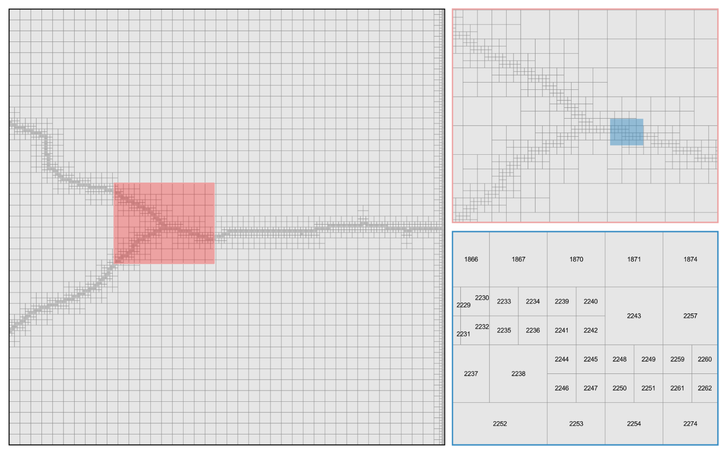

a

b

c

Figure 1 (a) Plan view of the full extent of the model grid; (b) zoomed in view of the grid; and (c) detailed view of the grid with each cell labelled according to the ICPL number. The red and blue rectangles mark the areas displayed in (b) and (c) respectively.

All files generated so far can be found in the folder *t1*.

## Visualising model boundary-conditions

It may be useful to visualize other data associated with model grid cells. For example, you may wish to display the locations (and values) of boundary-conditions and/or hydraulic properties. In order to enable this, MF62GIS allows the user to provide pertinent data in tabular format. In such a tabular data file, values must be separated by whitespace or commas. The first line of the file must contain column headers. Depending on the MODFLOW 6 grid type, the first columns must follow a specific format; see the documentation. As the model which forms the basis for the present tutorial employs a DISV grid, the first column header must be “ICPL”; the column itself must contain the grid ICPL numbers.

Next, we shall construct a tabular data file from the contents of the MODFLOW 6 DRN package input file *model.drn_stress_period_data_1.txt*; this will allow us to display the elevation of the stream bed.

1. Open *model.drn_stress_period_data_1.txt* in a text editor (for example, NOTEPAD or spreadsheet package (e.g. EXCEL). This file contains five columns of data. In case you are not familiar with MODFLOW 6 input files, these columns are (1) layer number, (2) ICPL, (3) drain elevation, (4) drain conductance and (5) a user-supplied boundary label. For our present purposes, we are only concerned with the second and third columns.
2. Open a new empty text file. Copy columns 2 and 3 from *model.drn_stress_period_data_1.txt* and paste them into the new file. (This is easy if you are using a text editor such as TEXTPAD and ULTRAEDIT) which supports column cut-and-paste.)
3. Make sure to add column headers to the first line of this file. Name the new column 1 “ICPL” and the new column 2 “DRN”. Save the file in your working folder. Name this file *layer1_drn.dat*. In practice, you can name it whatever you like, however for consistency with the tutorial we recommend using the file names suggested in this document.
4. Repeat steps 1 to 5.
5. This time, when you are prompted for the name of a tabular data file (step 6), type *layer1_drn.dat* followed by <enter>.
6. If the file has been constructed according to the above instructions, you should be asked if you wish to transfer data in column “DRN” to the MIF/MID files which it is MF62GIS’s task to write. Type “y” and press <enter>.
7. The column contains real data, so type “r” and press <enter>.
8. MF62GIS prompts for a value to represent missing data. Type “-999” and press <enter>.
9. Finally, you are asked if duplicate cells should be replaced or added. In our case we wish to replace them. Type “r” and press <enter>. If all went well, you should see the following (with your responses highlighted):

Program MF62GIS writes a BLN file and MIF/MID files for a MODFLOW6 model.

Enter name of MODFLOW6 binary grid file: ***model.disv.grb***

- file model.disv.grb read ok.

Enter layer number of interest: ***1***

Enter name for BLN file (<Enter> if none): ***model.bln***

Enter filename base for MIF/MID files (<Enter> if none): ***model_layer1***

Enter name of tabular data file (<Enter> if none): ***layer1_drn.dat***

The following columns have been detected in the table file.

Indicate whether you would like pertinent data transferred to MIF/MID file.

Data in column labelled "DRN"? [y/n]: ***y***

Does column contain integer or real data? [i/r]: ***r***

Enter value for missing data: ***-999***

Add or replace values for duplicated cells [a/r]: ***r***

- reading tabular data file...

- 619 lines of data read from file layer1_drn.dat.

- file model.bln written ok.

- file model_layer1.mif written ok.

- file model_layer1.mid written ok.

1. Import the MIF/MID file pair into QGIS again. You should now see an additional column in the layer attributes table. Go ahead and display it. This is the elevation of the stream bed.
2. The figure below is a zoomed-in look at the intersection of the three streams in the model grid. And, oh dear, what is this? Looks like the stream is flowing uphill in some places. Perhaps the modeller needs to re-think how stream elevation is being obtained and assigned to the model. It is a good thing he/she went through the trouble of visualizing the model setup!

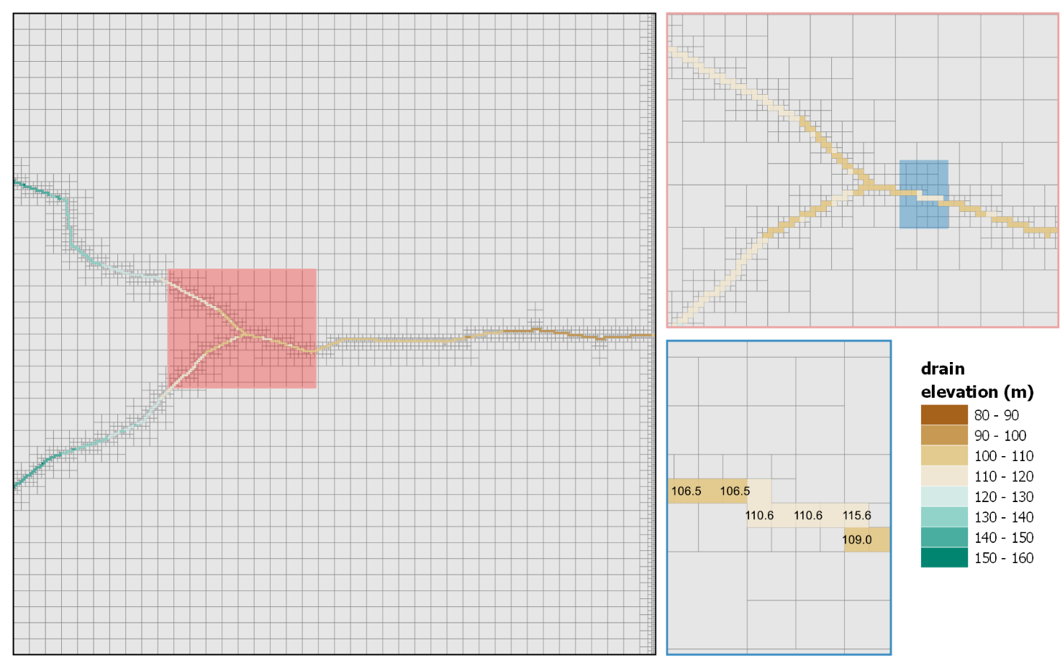

c

b

a

Figure 2 Plan view of the model grid with elevation of DRN cells in Layer 1. (a) Plan view of the full extent of the model grid; (b) zoomed in view of the grid; and (c) detailed view of the grid with each cell labelled according to the DRN elevation number. The red and blue rectangles mark the areas displayed in (b) and (c) respectively.

All files generated during this chapter can be found in the folder “*t2*”.

## Visualising model properties

Similarly to the previous chapter 2.2, it may be useful to visualize the spatial distribution of hydraulic properties used by a model. In the same manner, a tabular data file must be constructed for MF62GIS to read. We shall do so now, using the model hydraulic conductivity (Kx) values provided in *model.npf_k_layer1.txt*.

This file contains a single column of values. These are the values of Kx for each cell in layer 1, ordered in increasing order of cell ICPL values. As you recall, we need to create a tabular data file in which the first column records ICPL while other columns record associated values that we wish to display. Go ahead and create this file now.

1. Open a blank text (or spreadsheet) file. Name it *layer1_Kx.dat*.
2. Provide the header “ICPL” for the first column. Populate this column with sequential values from 1 to 4633 (the number of cells per layer).
3. Copy and paste values from *model.npf_k_layer1.txt* in the second column. Set the second column header to “Kx”. (If in doubt, see file *layer1_Kx.dat* provided in folder *t3*). Save the file.
4. Repeat steps 14 to 19 with *layer1_Kx.dat* as the tabular data file.
5. Now when you import the MIF/MID file into QGIS, you should see a column for Kx values. Go ahead and display these. You should see something like the following:

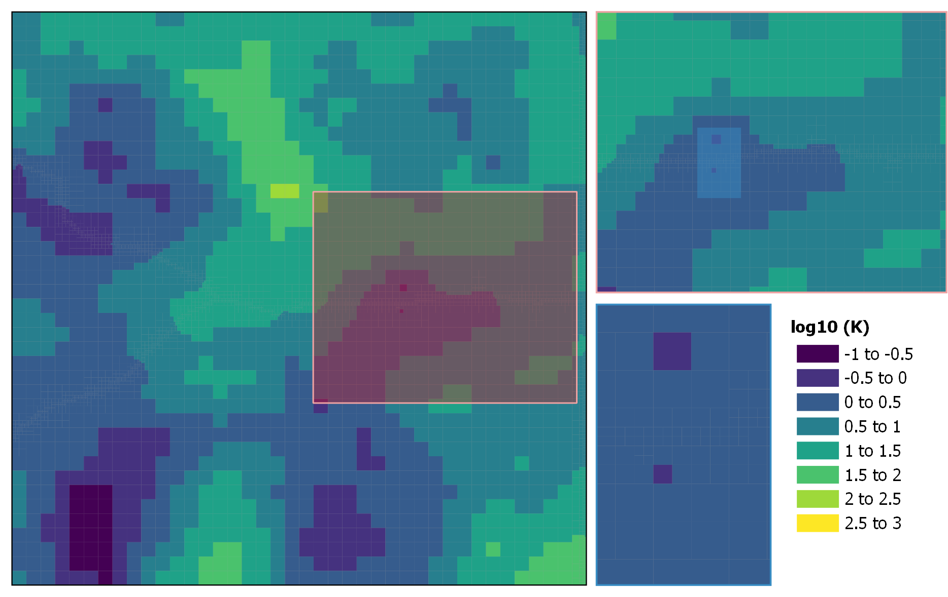

c

b

a

Figure 3 Plan view of the model grid with the spatial distribution of Log10(K) in Layer 1. (a) Plan view of the full extent of the model grid; (b) zoomed in view of the grid; and (c) detailed view of the grid. The red and blue rectangles mark the areas displayed in (b) and (c) respectively.

All files generated using instructions provided in this chapter can be found in the *t3* folder.

## Visualising model results

MF6DEP2CSV reads a MODFLOW 6 dependent variable file. As described in MODFLOW 6 documentation, this is a binary file that contains system states (for example heads, drawdowns, concentrations, etc) that were calculated by MODFLOW 6. Within this file, these states are stored in layer-specific arrays at user-requested simulation times. A binary MODFLOW 6 dependent variable file named *model.hds* has been provided. This file contains hydraulic heads calculated at the end of two stress periods of a model run.

If you ever want to know what data is recorded in a MODFLOW 6 binary dependent variable file, use the MF6ARRDET utility (a member of the PEST Groundwater Utilities) to list its contents. Meanwhile, the present chapter of this tutorial demonstrates how to extract data residing in this file into a text file using MF6DEP2CSV where it can then be re-formatted for display in GIS software.

1. Open a command line window in your working folder, type “MF6DEP2CSV” and press <enter>.
2. Provide the name of the MODFLOW 6 binary grid file *model.disv.grb* and press <enter>.
3. Provide the name of the MODFLOW 6 binary dependent variable file *model.hds* and press <enter>.
4. You will be prompted for the name of the CSV output file which will be written. Type *layer1_heads.csv* and press <enter>.
5. Next, reply “o”, thereby instructing MF6DEP2CSV to read only data pertaining to one model layer. Press <enter>.
6. As you may have guessed, we only want the data for layer 1. Respond to the prompt with “1” and press <enter>.
7. We might as well get the model outputs for all times (there are only two output times anyway). Reply with “a” for all and press <enter>. If all went well, you should see something like this:

Program MF6DEP2CSV records MODFLOW6-calculated system states in CSV format.

Enter name of MODFLOW6 binary grid file: ***model.disv.grb***

- file model.disv.grb read ok.

Enter binary MF6-generated dependent variable file: ***model.hds***

Enter name for CSV output file: ***layer1_heads.csv***

Record "HEAD" data for all model layers or just one? [a/o]: ***o***

Record "HEAD" data for which layer? ***1***

Record "HEAD" data for all model output times or just one? [a/o]: ***a***

- pre-reading file model.hds...

- reading file model.hds...

- file model.hds read ok.

- writing file heads.csv...

- file heads.csv written ok.

1. Check your working folder. You should see the newly written *layer1_heads.csv* file. Open it and take a look. The first four columns of this file provide coordinates and the layer number for all cells in layer 1 of the model domain. The cell identifier (ICPL) is provided in the fifth column. The sixth and seventh columns contain values of hydraulic head calculated for all active model cells for simulation times indicated by respective column headers.
2. As in the previous chapter, we now need to construct a tabular data file for MF62GIS to read. In this case it is quite easy; all we need are columns 5, 6 and 7. Copy these three columns into a new blank file using the column cut and paste functionality of your text editor (or EXCEL). Save this file as *layer1_heads.dat*.
3. As before, repeat steps 14 to 19 but with *layer1_heads.dat* as the tabular data file.
4. Now when loading the MIF/MID file in your GIS software, you should see two new columns with headers corresponding to the two simulation times. This allows you to quickly compare simulated values across different times. If you display heads for time 3652, you should see something like this:

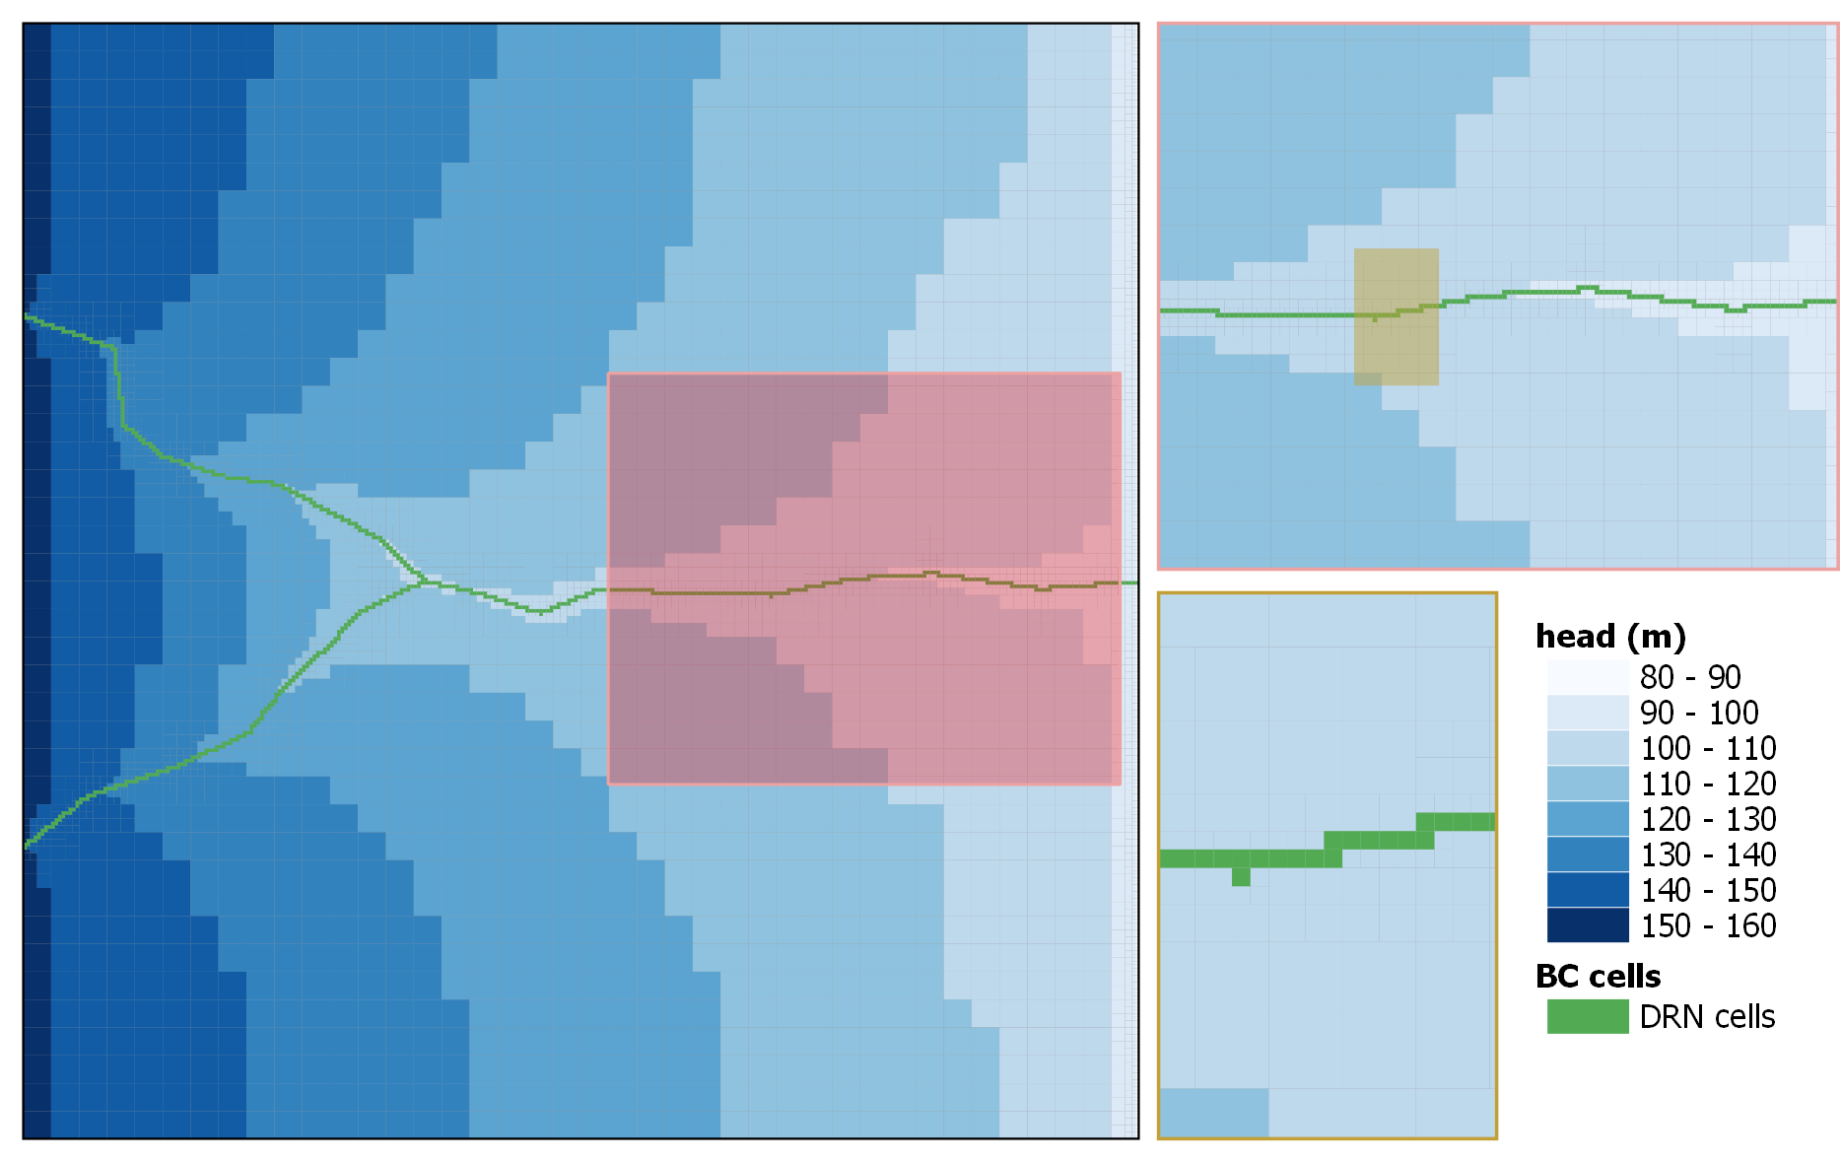

c

b

a

Figure 4 Plan view of the model grid with the spatial distribution of hydraulic head in Layer 1. (a) Plan view of the full extent of the model grid; (b) zoomed in view of the grid; and (c) detailed view of the grid. The red and yellow rectangles mark the areas displayed in (b) and (c) respectively.

# Displaying a model in three dimensions

This chapter demonstrates how to use utilities from the MF62VTK* family to reconfigure data produced by a MODFLOW 6 model so that it is readable by 3D visualization and display software. The following examples allow you to visualise model hydraulic property and boundary-condition data. A workflow to visualise model-simulated system-states (i.e. simulated heads) making use of the MF6DEP2CSV is also demonstrated.

Files used in this part of the tutorial can be found in the *model2VTK* folder.

The various utilities in the MF62VTK* family (part of the PEST Groundwater Utility Suite) read a binary grid file written by MODFLOW 6. As is discussed in documentation of MODFLOW 6, this file contains complete geometric specifications of a MODFLOW 6 model grid. The current versions of MF62VTK* accept only DIS and DISV grid types. Some of these utilities read additional files in order to obtain distributions of hydraulic property values or system states. The following part of this tutorial demonstrates the use of MF62VTK, MF62VTK1A and MF62VTK2. See the Groundwater Data Utilities (Part C) manual for detailed descriptions of these programs.

The PEST Groundwater Utility suite provides utilities which perform similar roles to those discussed herein for MODFLOW-USG models; see the USG2VTK* family of utilities. Meanwhile thePT2VTK Utility enables display of point-associated data, such as the values associated with pilot points. The current tutorial does not cover the use of these utilities. However, the concepts are similar to those that are demonstrated below for MODLOFW 6. The Groundwater Data Utilities (Part C) manual documents all of these utilities and describes how to use them.

A MODFLOW 6 binary grid file, named *model.disv.grb*, has been provided in the tutorial folder. This is the grid file for a variant of the same model that is used in many GMDSI tutorials. The model has a DISV grid with 3 layers. The instructions below demonstrate how to use the MF62VTK* family of utilities to re-format model files so that their contents can be displayed in 3D using the popular PARAVIEW package, or other 3D visualization software.

For the model which is the subject of the present tutorial, hydraulic properties are recorded in external files. Each file pertains to a different model layer. These are accessed by MODFLOW 6 using its OPEN/CLOSE array-reading functionality. The files of interest for the present tutorial are named *npf_k_layer[1-3].ref*. Each of these files contains a single column of values; each value provides Kx for a single model cell in the respective layer. If you completed instructions for use of MF62GIS provided above, these files may look familiar. That is because they are the same. The file names have been altered in accordance with MF62VTK file naming conventions. One last file is provided. This is named *npf_k.dat*. This file contains the same data as the three *npf_k_layer[1-3].ref* but organised into a single column. These will be used to demonstrate two different data-reading options supported by MF62VTK.

As was discussed above, a stream flows down the centre of the model domain; this is represented using the DRN package. GHB boundaries line the western boundary of the model in layer 1 and in layer 3. A CHD boundary runs along the eastern boundary in layer 1, this representing a river. The respective MODFLOW 6 package input files are name *model.drn*, *model.ghb* and *model.chd*; these have been provided. Note that the protocol for these files differs from that employed for the MF62GIS tutorial discussed above, in that package data is not recorded externally. MF62VTK1A is used to read these files in order to display the details of model boundary conditions.

Lastly, a binary file of hydraulic heads calculated by MODFLOW 6 is provided as *model.hds*. This is a binary file which contains model-calculated heads at the end of two stress-periods of the model simulation. Displaying this data is a two-step process. First, MF6DEP2CSV is employed to extract data form the binary file. Then, MF62VTK2 is used to add these values to a VTK file for display in 3D. (Note that the contents of a binary file containing system states calculated by MODFLOW 6 can be listed using the MF6ARRDET utility.)

## Visualising the grid geometry

We shall start off by simply visualizing the model grid and grid properties. This allows us to see the model grid and active domains in 3D. For this we use MF62VTK.

1. Open the command line and type ”mf62vtk”. Press <enter>.
2. MF62VTK prompts for the name of a MODFLOW 6 binary grid file. Type the name of the provided file, *model.disv.grb*, and press <enter>
3. Next, provide the name of the VTK file that you wish to write. Type *model0.vtk* and press <enter>.
4. Reply “n” when asked if you wish to record scalar data. We will get to that later. Press <enter>
5. If all went well, you should receive a message stating the VTK file was written OK as shown below.

Program MF62VTK writes a "legacy" VTK file based on a MODFLOW6 binary grid

output file and, optionally, associated node data.

Enter name of MODFLOW6 binary grid file: ***model.disv.grb***

- file model.disv.grb read ok.

Enter name for VTK output file: ***model0.vtk***

Record scalar data in VTK file? [y/n]: ***n***

- file model0.vtk written ok.

1. Check your working folder. You should see a new VTK file named *model0.vtk*. Open it up in PARAVIEW. You will probably need to adjust the scale to see much (we are using a Z factor of 10). Now you are able to display the various model layers, node numbers, cell types which comprise the active domain. If colouring is according to model layers you should see something like this:

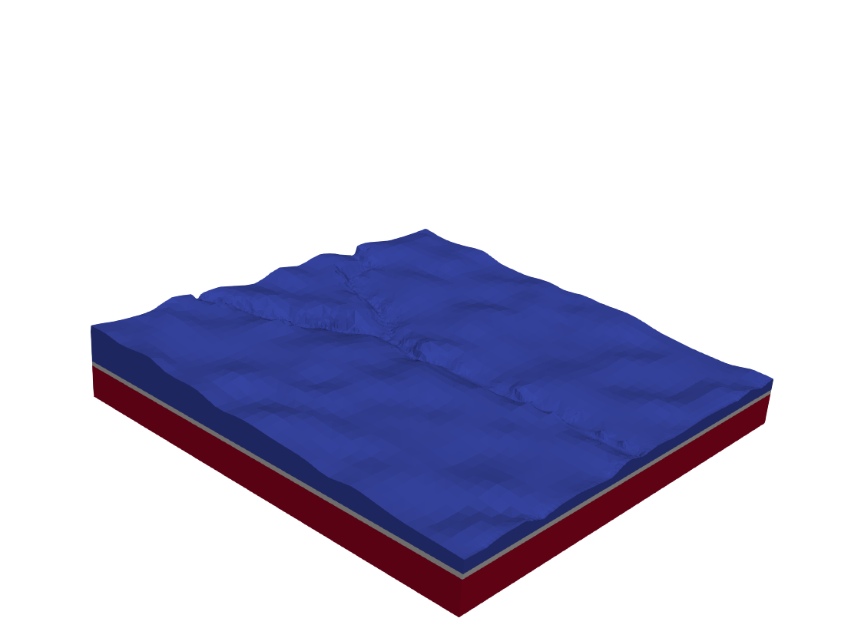

Figure 5 Three-dimensional view of the model grid with cells coloured according to model layer.

## Visualising model properties

We will now include model properties in the display. Two methods are demonstrated, each pertaining to a different type of file.

1. Once again, open a command line window in your working folder, type “mf62vtk” and press <enter>.
2. Provide the binary model grid file name *model.disv.grb* when prompted, and then press <enter>.
3. This time provide *model1.vtk* as the name of the output file, and then press <enter>.
4. This time, we wish to record scalar data in the VTK file, so reply with “y” and press <enter>.
5. We will start by reading layer files (i.e. files which contain hydraulic property data for only a single layer). So, respond to the next prompt with “l” and press <enter>. (That is the lowercase letter “L”, not the uppercase letter “i”.)
6. Now we need to provide the basename for the set of files which MF62VTK will read. MF62VTK will read all files whose names begin with the text that we provide; it will automatically append the layer number, and the extension “.ref” to the basename of these files. So, for example, if we were to reply with *basename*, MF62VTK would search for files which are named *basename1.ref*, *basename2.ref*, and so on. Recall that we have three files with K values; these are named *npf_k_layer1.ref*, *npf_k_layer2.ref* and *npf_k_layer3.ref*. So, our filename base is *npf_k_layer*. Provide this name and press <enter>.
7. The files contain real data. So, respond with “r” to the next prompt and press <enter>.
8. Provide “-999” as the no-data value and press <enter>.
9. Then, provide “k” as the label and press <enter>.
10. Now MF62VTK asks you for a second basename. In principle you can add as many sets of hydraulic properties to the VTK file as you wish. For expediency, we are only going to only use K. So simply press <enter>. If all went well should see the following on your screen (with your responses highlighted):

Program MF62VTK writes a "legacy" VTK file based on a MODFLOW6 binary grid

output file and, optionally, associated node data.

Enter name of MODFLOW6 binary grid file: ***model.disv.grb***

- file model.disv.grb read ok.

Enter name for VTK output file: ***model1.vtk***

Record scalar data in VTK file? [y/n]: ***y***

Obtain scalar data from tabular file or layer files? [t/l]: ***l***

Enter filename base for set 1: (<Enter> if no more): ***npf_k_layer***

Do these files hold integer or real data? [i/r]: ***r***

Enter no-data value if file missing: ***-999***

Enter label for this data type: ***k***

- file npf_k_layer1.ref read ok.

- file npf_k_layer2.ref read ok.

- file npf_k_layer3.ref read ok.

Enter filename base for set 2: (<Enter> if no more): ***<enter>***

- file model1.vtk written ok.

1. Check your working folder. You should see a new VTK file named *model1.vtk*. Open it up in PARAVIEW.
2. You will probably need to adjust the scale to see much (we are using a Z factor of 10). Now you are able to display the K values that the model uses throughout its domain. Here is what they look like:

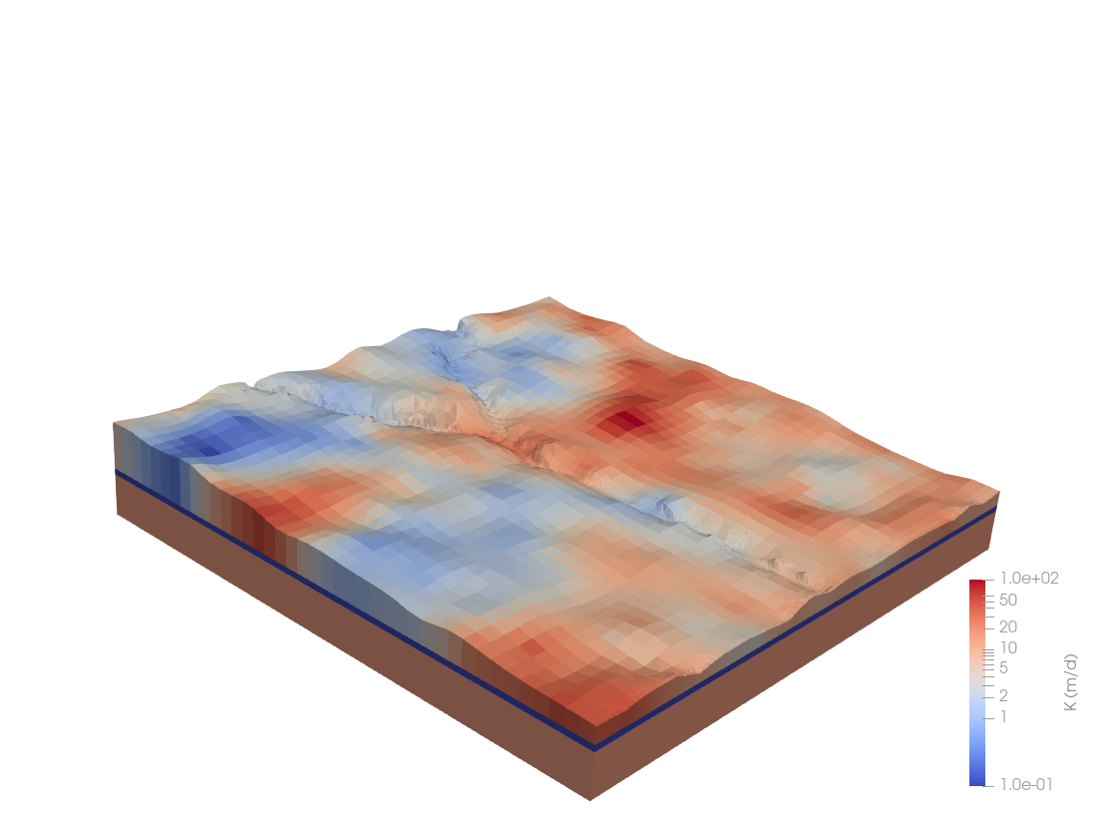

Figure 6 Three-dimensional view of the model grid with cells coloured according to the value of K.

1. Now, let us repeat this process using the tabular data format file with the same values. Type “mf62vtk” at the command prompt again, and repeat steps 44 to 47.
2. This time, when prompted, respond with “t” to read tabular data and then press <enter>.
3. Next, provide the name of the tabular data file *npf_k.dat* and press <enter>.
4. The data we want to read is in the first column, so reply to the prompt with “1” and press <enter>.
5. The data is real, so reply with “r” and press <enter>.
6. Lastly, as the file contains only a single column, simply press <enter> to terminate the process. MF62VTK can actually read a tabular data file with as many columns as you wish to display. You can associate whatever data you like with model cells; however, you must provide a value for every cell.
7. Open the VTK file in PARAVIEW again. It should look exactly the same as before.

## Visualising model boundary-conditions

We will now include model boundary package data in a VTK file using the MF62VTK1A utility. This utility is useful for reading MODFLOW 6 package input files which do not reference data stored in external files. It allows a user to read in as many of these files as he/she wishes; boundary-condition data housed in these files are stored in the VTK file for display. Here, for expediency, we will demonstrate the use of MF62VTK1a using only a single DRN package input file.

1. Type “mf62vtk1a” at the command-line prompt, followed by <enter>.
2. Provide the name of the model grid file *model.disv.grb* and press <enter>.
3. Provide *model2.vtk* as the name of the VTK output file. Press <enter>.
4. Respond with “y” when asked if you want to read scalar data. Press <enter>.
5. This time, MF62VTK1A asks for the name of a MODFLOW 6 input file. Type the name of the DRN package input file *model.drn* followed by <enter>.
6. The next two prompts request that you provide text that identifies the data table from which information is to be transferred to the VTK file. This makes use of the MODLFLOW 6 input file protocol in which data is provided in easily-identified sections and keywords are used to indicate the start and end of these sections. (If you are unfamiliar with MODFLOW 6 file structures, open *model.drn* in a text editor and take a look; you will see a table of data delimited by the words “begin period 1” and “end period 1”). MF62VTK1A asks for these delimiters so that it can find the data which it must read. Type “begin period” and press <enter> for the first prompt; and “end period” and press <enter> for the second prompt. (There are some nuances to choosing what delimiters to use; see documentation of MF62VTK1A for more detail.)
7. Next MF62VTK1A asks how many columns are in the table. Columns that are read from this table cannot contain text; they must contain only real or integer data. If you open *model.drn*, you will see that the 5th column is text. MF62VTK1A must not be asked to read that column. Hence, as far as MF62VTK1A is concerned, the data table must include the first two columns (layer and cell numbers) and however many ensuing data columns that we wish to import. Let us include both drain elevation (column 3) and conductance (column 4). This comes to four columns in total. Type “4” and press <enter>.
8. For DISV grids cells are identified by layer number and ICPL column. As mentioned above, these reside in column 1 and 2 respectively (this will usually be the case for MODFLOW 6 package input files for a DISV-gridded model). Respond to the next prompt with “1” and press <enter>.
9. Next, we must define how MF62VTK1A stores each of these columns. Starting with column 3, you are prompted for a label; this is the name that you will later see in the VTK file which MF62VTK1A writes, and will be associated with pertinent data when the grid is visualized. Type “elevation” and press <enter>.
10. Elevation is real data, so type “r” and press <enter>.
11. Provide “-999” as the no-data value and press <enter>.
12. Lastly, reply with “r” to replace duplicate cells and press <enter>.
13. The same information must now be provided for column 4. Name this column “conductance”. Everything else can be the same.
14. When asked if you wish to include data residing in a second input file in the VTK file which MF62VTK1A writes, simply press <enter>. As previously mentioned, we could include data from multiple input files in the same VTK file. However, for the sake of expediency we shall not do this time. (The process is the same as just described for a single input file). If all went well, your screen should look something like this with your responses highlighted. (Note that if any text supplied in response to a prompt includes a blank, then it should be surrounded by quotes.)

Enter name of MODFLOW6 binary grid file: ***model.disv.grb***

- file model.disv.grb read ok.

Enter name for VTK output file: ***model2.vtk***

Record scalar data in VTK file? [y/n]: ***y***

Enter model input file #1 (<Enter> if no more): ***model.drn***

Enter starting text for data table: “***begin period”***

Enter finishing text for data table: “***end period”***

How many data columns in table? ***4***

In what column do cellid's begin? ***1***

Enter label for data in column #3 (<Enter> if ignore): ***elevation***

Is this integer or real data? [i/r]: ***r***

Enter value for missing cells: ***-999***

Add or replace values for duplicated cells [a/r]: ***r***

Enter label for data in column #4 (<Enter> if ignore): ***conductance***

Is this integer or real data? [i/r]: ***r***

Enter value for missing cells: ***-999***

Add or replace values for duplicated cells [a/r]: ***r***

- 619 lines of data read from file model.drn.

Enter model input file #2 (<Enter> if no more): ***<enter>***

- file model2.vtk written ok.

1. Open file *model2.vtk* in PARAVIEW and take a look. You will probably need to adjust the vertical scale to see much (we are using a Z factor of 10). Now you can colour DRN elevation and conductance values in order to see something like this:

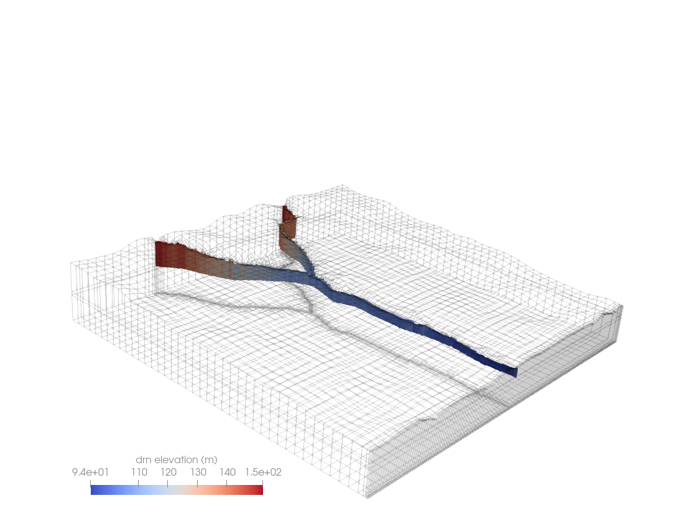

Figure 7 Three-dimensional wireframe view of the model grid. DRN cells are coloured according to the assigned drain elevation.

Other MODFLOW 6 package input files have been included in the tutorial folder (those for the WEL, GHB and CHD packages). To get some more practice, why don’t you experiment by viewing their contents as well?

## Visualising model-simulated dependent variables

The ability to display a models’ outputs is important for verifying coherency of its construction. Visualizing the outcomes of its calculations in two and three dimensions nearly always provides unexpected insights. It is also particularly useful when communicating results to non-expert modelling stakeholders. As well as this, it provides us with a bit of eye-candy as a reward for all of the hard work that we have devoted to the construction or our beautiful groundwater model.

In this section we demonstrate how to use the MF6DEP2CSV utility to extract simulated dependent variables from a binary file generated by MODFLOW 6. This file is named *model.hds*; it is provided in the tutorial folder. We also demonstrate how to use MF62VTK2 to save data contained in this file in a VTK file for display in PARAVIEW.

Let us get started.

1. If you have not already done so, open a command line window in your working folder. Type “mf6dep2csv” at the screen prompt, and then <enter>.
2. Provide the name of the model binary grid file that was written by MODFLOW 6. Its name is *model.disv.grb*. Then press <enter>.
3. MF62VTK2 now prompts for the name of a CSV file o which it will save model outputs. Let us call this file *heads.csv*. Type that in and press <enter>.
4. A three-dimensional display of model-based data requires that these data be provided for all layers. Respond with “a” to the next prompt.
5. Next you are asked if you wish to record model outputs at all times, or at just a single time. Just because we can, let us record data at all times. In a real-world application you may be interested only in outputs pertaining to specific time steps. This reduces the size of the CSV file that we are going to generate despite the fact that the model-generated binary file may record data for many model time steps. In our case, however, this is not a problem, as it is our intention to record all data in the CSV file. So, respond with “a” and press <enter>.
6. If all went well, you should see the following:

Program MF6DEP2CSV records MODFLOW6-calculated system states in CSV format.

Enter name of MODFLOW6 binary grid file: ***model.disv.grb***

- file model.disv.grb read ok.

Enter binary MF6-generated dependent variable file: ***model.hds***

Enter name for CSV output file: ***heads.csv***

Record "HEAD" data for all model layers or just one? [a/o]: ***a***

Record "HEAD" data for all model output times or just one? [a/o]: ***a***

- pre-reading file model.hds...

- reading file model.hds...

- file model.hds read ok.

- writing file heads.csv...

- file heads.csv written ok.

1. Check your working folder. You should see a new *heads.csv* file. If you open this file with EXCEL you should see that the first five columns record cell coordinates, layer numbers, and cell numbers. The remaining columns contain simulated heads for all model cells at each time-step. Column headers are comprised of the time (in days) at which that timestep occurs. You will note that, in this case, heads were recorded at the end simulation day 0 and at the end of simulation day 3652.
2. This file can be quite useful for tasks other than displaying model-generated quantities in two and three dimensions. It is quite simple to calculate drawdown between specific time-steps, or to formulate and display more complex functions of model outputs. However, let us not get distracted by these possibilities, so that we can return to the immediate task of displaying model results in PARAVIEW.
3. We still need to transfer data that is recorded in this CSV file to a VTK file so that it can be imported into a visualization package such as PARAVIEW. Fortunately, this is very easy.
4. Type “mf62vtk2” at a command line prompt, open to your working folder. Then press <enter>.
5. Provide the name of the binary grid file *model.disv.grb* and press <enter>.
6. Provide the name of the CSV file that we have just created (i.e. *heads.csv*) and then press <enter>.
7. And there we have it. All done. You should see something like the following on your screen:

Program MF62VTK2 writes a "legacy" VTK file based on a MODFLOW6 binary grid

output file and an MF6DEP2CSV-written CSV file.

Enter name of MODFLOW6 binary grid file: ***model.disv.grb***

- file model.disv.grb read ok.

Enter name of MF6DEP2CSV-produced CSV file to read: ***heads.csv***

Enter name for VTK output file: ***model3.vtk***

- reading file heads.csv...

- file heads.csv read ok.

- file model3.vtk written ok.

1. Open *model3.vtk* in PARAVIEW. You will probably need to adjust the vertical scale to see much (we are using a Z factor of 10). However, now you can display model calculated heads for all cells at each time step. You should see something like the following.

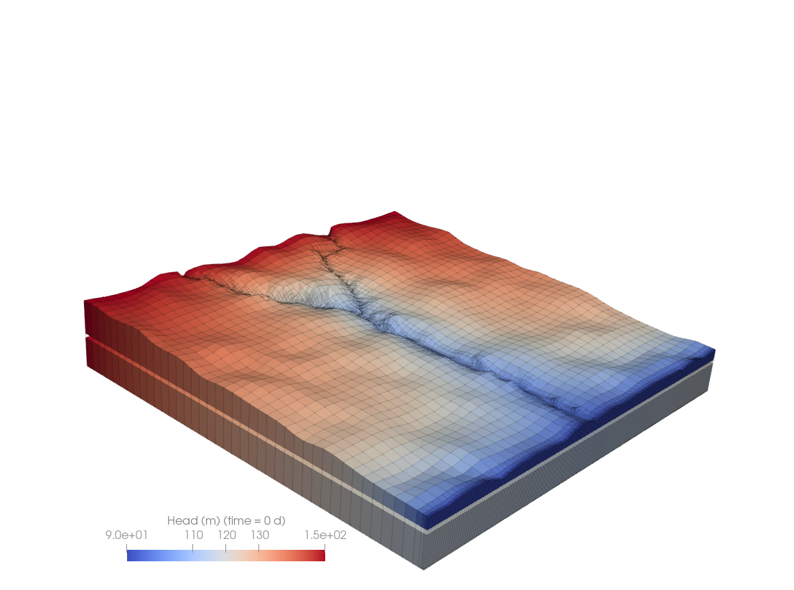

Figure 8 Three-dimensional view of model grid and simulated hydraulic heads at time zero.

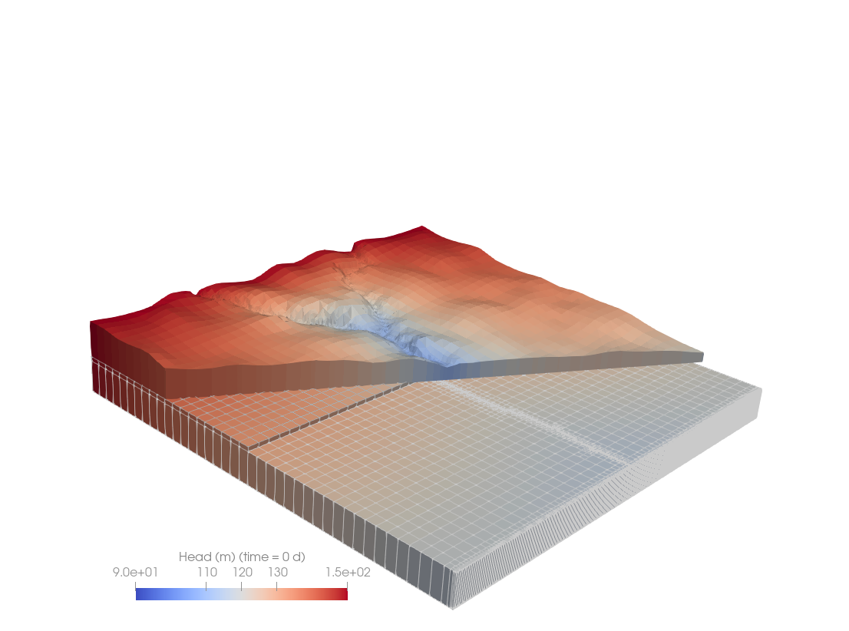

Figure 9 Three-dimensional view of model grid and simulated hydraulic heads at time zero. Layer 1 and layer 2 clipped along distinct planes.

Play around with PARAVIEW. There are many stunning visualisations you can create. See the software documentation and tutorials for inspiration.

All of the files generated during this tutorial are available in the *t1* folder.

gmdsi.org