# Beispielbericht

Owe Jessen

Fri Oct 25 15:07:06 2013

# Inhaltsverzeichnis

* Text
* Tables
* Plots

# Text

## Overview

Lorem ipsum dolor sit amet, consetetur sadipscing elitr, sed diam nonumy eirmod tempor invidunt ut labore et dolore magna aliquyam erat, sed diam voluptua. At vero eos et accusam et justo duo dolores et ea rebum. Stet clita kasd gubergren, no sea takimata sanctus est Lorem ipsum dolor sit amet. Lorem ipsum dolor sit amet, consetetur sadipscing elitr, sed diam nonumy eirmod tempor invidunt ut labore et dolore magna aliquyam erat, sed diam voluptua. At vero eos et accusam et justo duo dolores et ea rebum. Stet clita kasd gubergren, no sea takimata sanctus est Lorem ipsum dolor sit amet.[1]

# Tables

|  |  |  |  |
| --- | --- | --- | --- |
| Sepal.Length | Sepal.Width | Petal.Length | Petal.Width |
| 5.1 | 3.5 | 1.4 | 0.2 |
| 4.9 | 3 | 1.4 | 0.2 |
| 4.7 | 3.2 | 1.3 | 0.2 |
| 4.6 | 3.1 | 1.5 | 0.2 |
| 5 | 3.6 | 1.4 | 0.2 |
| 5.4 | 3.9 | 1.7 | 0.4 |

Table continues below

| Species | |:---------:| | setosa | | setosa | | setosa | | setosa | | setosa | | setosa |

Lorem ipsum dolor sit amet, consetetur sadipscing elitr, sed diam nonumy eirmod tempor invidunt ut labore et dolore magna aliquyam erat, sed diam voluptua. At vero eos et accusam et justo duo dolores et ea rebum. Stet clita kasd gubergren, no sea takimata sanctus est Lorem ipsum dolor sit amet. Lorem ipsum dolor sit amet, consetetur sadipscing elitr, sed diam nonumy eirmod tempor invidunt ut labore et dolore magna aliquyam erat, sed diam voluptua. At vero eos et accusam et justo duo dolores et ea rebum. Stet clita kasd gubergren, no sea takimata sanctus est Lorem ipsum dolor sit amet.[^5] [^5]: Vgl. [Chernobai et. al](http://statistik.econ.kit.edu/download/doc_secure1/tr_composite_goodness_tests.pdf).

# Plots

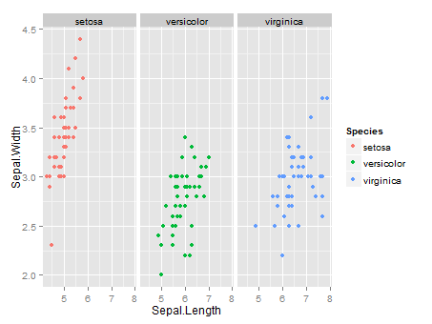

plot of chunk unnamed-chunk-3

# References

* **BCBS 196** *Operational Risk –- Supervisory Guidelines for the Advanced Measurement Approaches*, <http://www.bis.org/publ/bcbs196.pdf>
* **Chernobai et. al.** *Composite Goodness-of-Fit Tests for Left-Truncated Loss Samples* <http://statistik.econ.kit.edu/download/doc_secure1/tr_composite_goodness_tests.pdf>

1. Vgl. [BCBS 196](http://www.bis.org/publ/bcbs196.pdf)