

Holophon

Documentation

6th edition, November 2006 (version 4.0)
Holophon (Holo-Edit & Holo-Spat), spatialisation tools
Copyright (C) 2006 GMEM

This program is free software; you can redistribute it and/or modify
it under the terms of the GNU General Public License as published by
the Free Software Foundation; either version 2 of the License, or
any later version.

This program is distributed in the hope that it will be useful,
but WITHOUT ANY WARRANTY; without even the implied warranty of
MERCHANTABILITY or FITNESS FOR A PARTICULAR PURPOSE. See the
GNU General Public License for more details.

You should have received a copy of the GNU General Public License
along with this program; if not, write to the Free Software
Foundation, Inc., 59 Temple Place, Suite 330, Boston, MA 02111-1307 USA

Apple Macintosh, Mac OS X Tiger & Bonjour are trademarks of Apple Computer, Inc.
ProTools, Sound Designer II are trademarks of Digidesign Inc. All
Max is a trademark of Cycling'74/Ircam, MSP is a trademark of Cycling74
Java is a trademark of Sun Microsystems, Inc.
Microsoft and Windows XP are trademarks of Microsoft Corporation.
JavaOsc is developped by C. Ramakrishnan / Illposed Software (included license).
oscbonjour is developped by Rémy Müller under the terms of the BSD License.
JOGL is developped under the terms of the BSD License.

GMEM

Centre National de Création Musicale
15-17 rue de Cassis
13008 Marseille
Tél. : 04 96 20 60 10
Fax : 04 96 20 60 19

Email : holophon@gmem.org
http://www.gmem.org/

Introduction

Holophon is a set of tools for the programming and real-time manipulation of sound trajectories across different speakers. There are two different software packages:

- Holo-Edit: A graphical and algorithmic editor of sound trajectories. Holo-Edit makes it possible to draw and graphically edit trajectories across a complex sound system. It’s also possible to program those trajectories with different automatic functions.
- Holo-Spat: A group of spatializers working in real-time on Max-MSP, allowing the user to spatialize several sound sources independently over an array of multiple speakers. The control of the source trajectories can be made automatically by either using .holo files (made with Holo-Edit), directly by Holo-Edit using OSC or directly by various means in Max-MSP.

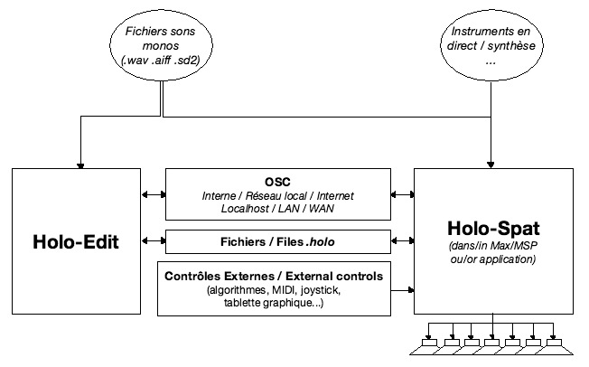

Holophon v4.0 – System Overview

Despite the care taken to design and develop these tools and to write the documentation, some errors could persist. Please share your remarks by writing to the following email address : holophon@gmem.org. If it appears useful to us, we will make the necessary modifications to the software, but this is without any guarantee of time, except in the case of severe problems preventing their use.

Programmers willing to use whole or part of the source code for one of these software packages should not hesitate to contact us at the same address. Given the complexity of the code, we cannot guarantee that one will easily find the section of interest.

Summary
Installation 6
I. Requirements 6
II. Installation 7
A. Apple Mac Os X Tiger 7
B. Microsoft Windows XP 7
C. Firewall configuration 7
D. Max/MSP Configuration 7
Holo-Edit 8
I. Introduction 8
A. Principles 8
B. Definitions 8
II. Editors and their functionalities 9
A. Transport 9
B. Tracks 9
C. Room Editor 10
a. Adding points 10
b. Selecting several points 11
c. Removing points 12
d. Moving points 12
e. Inserting and changing point types 13
f. Point Information 13
g. Handling speakers 13
h. Time scale 13
D. 3D Room 14
E. Score 15
a. Selection 15
b. View and Zoom 16
c. Moving 16
d. Transformations 17
e. Cut/Copy/Paste/Insert/Replace… 19
f. Adding waveforms 19
g. Removing trajectories or waveforms 20
h. Editing Trajectories 20
F. Sound Pool 21
a. Sound file formats 21
b. Import 21
G. Time Editor 22
a. Temporal displacement 23
b. Spatial displacement 24
III. Functions 25
File Input / Output 27
IV. Communication with Holo-Spat & Transport 27
A. Startup 27
B. Configuration 27
C. Track Numbering 28
D. Playing & Recording 28
V. Options & Preferences 28
Holo-Spat 29
I. Introduction 29
II. User interface 29
A. Room 29
B. Mix Window 30
C. Transport 31
D. Options 32
III. Use 32
A. With Holo-Edit 32
B. With .holo file 32
C. Other methods... 33
D. Playing & Recording trajectories 33
E. Choosing the Spatialization Algorithm 33
F. Midi Control 34
G. Input/Output Patches 34
Advanced functions 35
I. Realization of a real time control algorithm 35
II. Obtaining the source code of Holo-Edit 35
III. Development of algorithms for Holo-Edit 36
IV. Development of spatialization algorithms for Holo-Spat 36

Installation

- Requirements

Holo-Edit is based on the Java 1.5 programming language and Jogl. This implies that it will only be able to work under operating systems compatible with java Java 1.5 and Jogl. (Mac Os X Tiger, Windows XP)

Holo-Spat is based on the Max/MSP 4.5 software/programming language. This implies that it will only be able to work under operating systems compatible with Max/MSP 4.5. (Mac Os X et Windows XP).

People wishing to modify Holo-Spat must own a licensed copy of Max/MSP. For the other package, a standard application is available with versions for Apple PowerPC, Apple Universal Binary and Windows XP.

- Installation

- Apple Mac Os X Tiger

Check via software updates that you have the latest java version installed.
Copy Holophon’s folder to the directory of your choice.

- Microsoft Windows XP

Check that you have the latest java version installed at the following address:
http://www.java.com/en/download/installed.jsp
Download the Bonjour installer for Windows at the following address:
http://www.apple.com/macosx/features/bonjour/
Copy Holophon’s folder to the directory of your choice.

- Firewall configuration

For correct communication between Holo-Edit and Holo-Spat, it is necessary to open the following UDP ports on your firewall: 5353 (Bonjour), 13008 (Holo-Edit), 13005 (Holo-Spat).

- Max/MSP Configuration

The following steps are only necessary if you own Max/MSP and wish to modify or use the extended functionality of Holo-Spat.

At the end of the file max.java.config.txt (in Cycling’74/java/), add the following line:

max.java.jvm.version 1.5

Add holoedit.jar (in Holo-Spat/src/To_C74_java_lib) to Cycling’74/java/lib or add the following line to the file max.java.config.txt:

max.dynamic.jar.dir [absolute path to the folder containing holoedit.jar].

Add the To_Max_Folder-XXX to Max’s Files Preferences… or move/copy this folder to the Cycling’74 folder.

Holo-Edit

- Introduction

- Principles

Holo-Edit allows for the precise positioning of multiple sounds in time and space (defined by a set of speakers).

In order to do so, it associates sounds to trajectories (a set of points defined by their position in space (x, y, z) and their date).

The software is a set of graphical editors and algorithmic functions for creating and manipulating sounds in space.

- Definitions

  - Point: a point in space defined by its coordinates (Cartesian x, y, z or polar ray, angle) and its type: editable or non-editable.
  - Trajectory: a set of successively dated points.
  - Waveform: a visualization of a sound in time, (the amplitude curve of this sound.)
  - Track: a set of successive trajectories associated with waveforms.
  - Session: a set of tracks.

- Editors and their functionalities

The following windows share the same set of data, i.e., the same session. Two different sessions cannot be opened at the same time.
Each editor offers a visualization of the set of data from a different point of view.
They all share what is called the time selection, or the portion of the session to visualize. This makes it possible to work only on a given interval of time without viewing the totality of a session.
??But they don’t share object’s selection.

- Transport

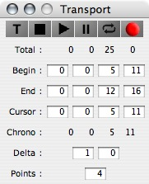
The number boxes in this window allow the precise handling of time in the software.
Total indicates the total duration of the session.
Begin and End respectively indicate the upper and lower limits of the time selection. Cursor indicates the position of the cursor in the Score. Chrono displays the time while playing. Times are expressed in hours / minutes / seconds / 1/100th seconds.
Delta is used to set the time (seconds / 1/100 seconds) between the new point you want to create with the mouse and the last point of the track. Points determines the number of intermediate points which will automatically be created in-between.
There are also traditional transport commands (stop / play / pause / loop / record).

- Tracks

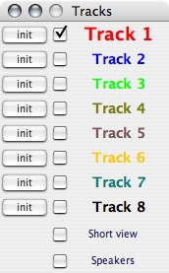
This window allows the management of tracks.

Each track is named and numbered.

The name of a track is for the user’s reference; its number is a unique identifier for the machine or for more complex applications (see V.C. Track Numbering).

The cross below the name indicates whether or not this track is visible. This will affect all editors except the Score.

The active track is written in bold. This is the track that will be modified by the user interface and the menus (copy, paste…).

The Short view mode modifies the time selection so that the editors only display the last point of the active track in the real time selection (+/- delta).

Speakers allows the handling of speakers.
- Room Editor

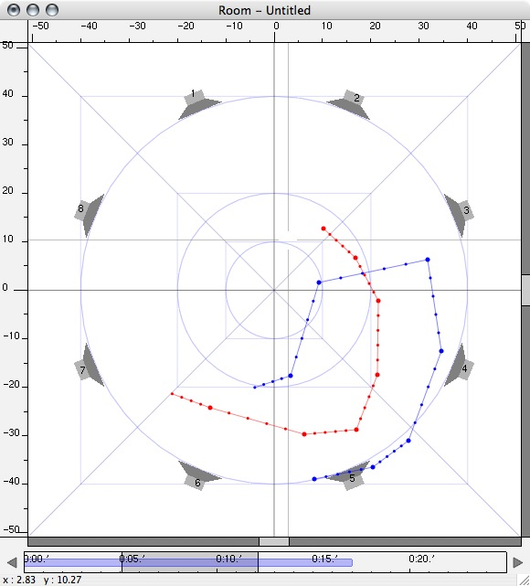
This editor offers a top view of the space and the trajectories contained in the time selection.

Shown here are all the checked tracks in the Tracks window having content in the time selection.
Drawing area

Here we handle trajectories and speakers from a spatial point of view (move, add/remove points…).

Time Scale
Information area

    - Adding points
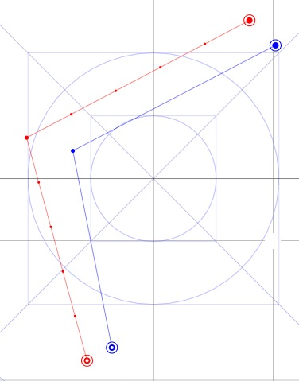
To add points defining trajectories in Holo-Edit, select the track you want to add points to in the Tracks window. It is now visible and active.
Before adding a point, ensure that values for delta and points have been entered in the Transport window.

To add a point, click in the drawing area at the desired position while holding the Command/Ctrl key (Max/Win) down. A new segment appears. If Points = 0, no intermediate points will separate this new point from the previous one, and sound will jump from one position to another, see illustration below.

Intermediate points are referred to as non-editable, as opposed to the larger points on the screen, which are editable.

The first point in a track is represented by a filled circle surrounded by an empty one. The last one is represented by an empty circle surrounded by another. If the last point of a track is not visible, the last drawn point appears empty, helping the user to visualize the direction of the trajectory as in the example below.

If the time selection is empty on the active track when we insert a new point, only one point is created (no intermediate points) at the Begin date. This represents the beginning of a new trajectory.

    - Selecting several points

To select a point and modify it, first make sure that its track is active, or that the option Automatic track selection is activated and then click on that point.
To select several points, there are two possibilities:
  - By default, the selection will include all points between the first (a) and last (b) editable points contained in the selection rectangle (R). The selection in this case is all points on the segment (S).
  - If the Shift key is held down while dragging the selection rectangle, only points in this rectangle (R) will be included in the selection.

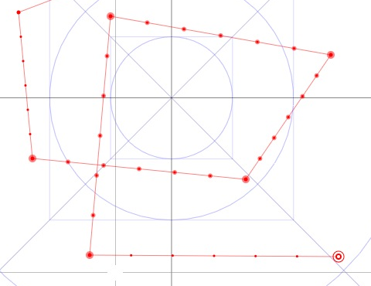
(a)
(b)
(R)
(S)

    - Removing points

To remove a point, click on it while holding the Alt key down. Removing an editable point erases all non-editable points preceding it and shifts the date of all following non-editable points.

    - Moving points

While dragging an editable point with the mouse, its movement distorts the segments surrounding it.

If the Command/Ctrl (Mac/Win) key is held down while moving a point or a selection, the motion will be constrained to the X-axis.

Conversely, if the Shift key is held down while moving a point or a selection, the motion will be constrained to the Y-axis.

To move a point or a selection along the Z-axis, hold Command/Ctrl (Mac/Win) + Shift down while dragging. The new Z value is displayed at the bottom of the window. The same rules apply to this motion as to the motion along the X/Y-axis. Use the Time Editor to visualize it or to modify it more precisely.
    - Inserting and changing point types

While holding down the Command/Ctrl (Mac/Win) key:
  - Clicking on a segment inserts a new point on this segment.
  - Clicking on a point makes it editable if it was not before (and vice-versa).

    - Point Information

The information area below the drawing area quickly gives information on the point under the cursor.
Right-clicking, or clicking while holding the Ctrl key down (Mac) opens a new editor where this point’s position can be numerically modified. These modifications are confirmed by pressing the Enter key.

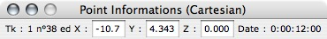

    - Handling speakers

If the Speakers mode is activated in the Tracks window, speakers can be added/removed/moved in similar way (Command/Ctrl + Click to add a speaker, Alt + Click to remove it, and, while moving, Command/Ctrl (Mac/Win) to move it only along the X-axis, Shift to move it only along the Y-axis, Command/Ctrl + Shift move it along the Z-axis).

    - Time scale

(a)
(b)

The time scale below the drawing area displays the temporal information of the active track.
- Total duration of the session.
- Time selection.
- 3D Room

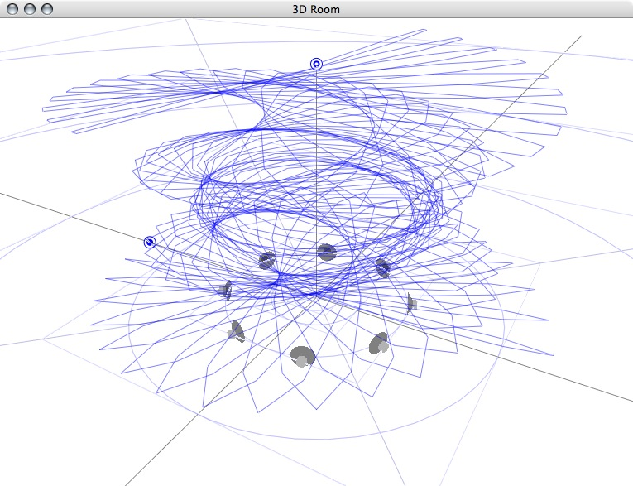

This window offers a three-dimensional view of the tracks. It is useful in visualizing modifications like elevation of the points and speakers. No editing is possible in this window.
- Score

This window represents the score of the session. It displays trajectories as blocks, (condensed views of the x, y and z curves over time) as well as the waveforms of the sound files associated with those trajectories.

The trajectories and waveforms appear here as graphical objects that are easily edited as in traditional audio mixing software: They may be moved, duplicated, stretched/compressed, split…

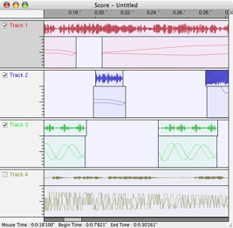

Time scale
Information area

Track
Header

Waveform

Trajectory

Tracks are arranged under a time scale, each of which has a header that shows the status of its activity and visibility.

    - Selection

Dragging in an empty space creates a selection. All trajectories and waveforms contained (at least in part) in the selection’s rectangle are selected. If the Command/Ctrl (Mac/Win) key is held down while dragging, only trajectories are selected. If the Shift key is held down while dragging, only waveforms are selected.
Selected blocks appear darker.
To cancel a selection, click in an empty space.

    - View and Zoom

The View function of the Score menu modifies the time selection, which is displayed in the other editors. The Zoom function modifies the view of this window.

    - Moving

(The following behaviors are valid for selections of one or several waveforms or trajectories)

- Moving objects within tracks: If the Alt key is held down while moving, the object is duplicated. If the Shift key is held down while moving, the motion will be more precise.

- Moving objects between tracks: If the Alt key is held down while moving, the object is duplicated. If the Shift key is held down while moving, the motion will be more precise. If the Ctrl key is held down while moving, the object will move to another track and keep the same time.

- It’s also possible to numerically enter a new start time for the object/selection with the Move function in the Score menu.

    - Transformations

(Valid for selections of one or several waveforms or trajectories)

- Stretching/Compression

If the side of a trajectory is pulled, the trajectory will be stretched or compressed to correspond to the new time. In the following examples, the trajectory is modified by pulling its right side, or end. The left side of the example shows the operation in progress, and the right side it’s result. It is possible to perform the same operations on the start point of the trajectories, as well.

Stretching

Compression

If the Alt key is held down while compressing, then the part marked by a cross will be cut from this trajectory.

Cutting a part

- Division

Clicking on a trajectory while holding the Command/Ctrl (Mac/Win) key down will cut the trajectory in two at the time corresponding to the mouse position.

It is also possible to trim a trajectory to the current time selection with the function Trim from the Score menu.

- Joining

The Join function from the Score menu joins two different trajectories. No points will be added to the trajectory.

    - Cut/Copy/Paste/Insert/Replace…

The functions Cut, Copy, and Replace Paste, Insert and Erase can be found in the Edit menu, the Score menu or from the contextual menu (accessible from a right-click on a trajectory, a waveform, a selection or the background of a track). These different methods offer different possibilities. The default behavior (Edit menu) will act on the content of the active track between Begin and End.
  - Cut erases the content of the active track or the selection between Begin and End and places it in the clipboard.
  - Copy places the content of the active track or the selection between Begin and End in the clipboard.
  - Paste places the content of the clipboard at the end of the active track.
  - Replace places the content of the clipboard at the Begin date of the active track and erases what was previously at this time.
  - Insert inserts the content of the clipboard at the Begin date on the active track and shifts what was previous at this time from the size of the clipboard.
  - Erase erases the content of the active track between Begin and End.

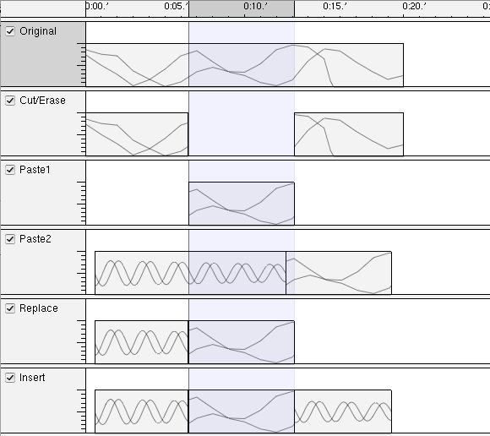

    - Adding waveforms

- Dragging and dropping a sound file on the score will import this sound into the sound library and places it at this point in the score.
- It’s also possible to drop an element from the Sound Pool list and to place this waveform more precisely in the score.
- Another method consists of calling the Import Waveform function from the Score or contextual menus.

    - Removing trajectories or waveforms

Holding the Command/Ctrl (Mac/Win) + Shift key down while clicking on an object or selection deletes it from the session.

    - Editing Trajectories

Double-Clicking on a trajectory opens the Time Editor for this trajectory.

- Sound Pool

This editor lists the different sound files loaded in the session, providing file information and a preview of the waveform for each sound.

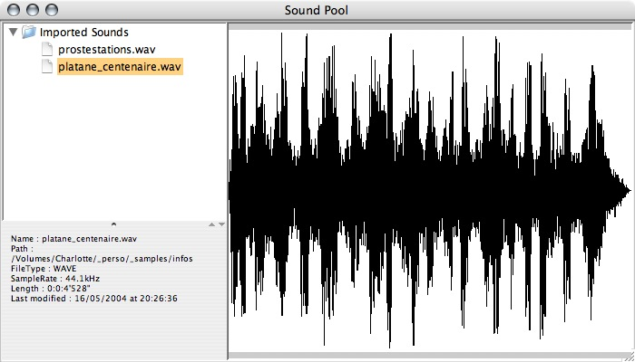

Imported

Sound file’s list

Information’s area

Preview

    - Sound file formats

- For instance, Holo-Edit can only import and handle mono files. However multi-channel sound files will be considered as mono ones (the first channel for multi-channel files, the left channel for stereo ones).
- The sound file formats supported by Holo-Edit are AIFF, WAVE and SD2F (Protools). We do not recommend the use of SD2F formats because they can become unreadable while passing to an external hard drive, or over a network.
- The sound card that will play the sounds in Holo-Spat must support their sampling rate. All sound files used in the session must have the same sampling rate.
- Sound files cannot be modified in Holo-Edit; they can only be placed in time, which implies that they must be clean, well cut and mixed before being imported. They can however be modified after their first import.
- Do not use blank spaces in the filenames, which cannot be longer than 32 characters.

    - Import

- Importing a sound file means extracting the essential data of this file to construct its waveform (amplitude curve).
- This method can take a while, so after an import, this waveform is saved as a file in the cache folder of the software. The next time this session/file is opened/imported, the cache file will be loaded (more quickly) instead of the original file (if a cache file is present either in the cache folder of the application, or in the session’s folder or in the folder containing the sound).
- If the file is modified after its first import, it will be imported again to update its waveform. If it cannot be found when the session is opened, the cache file will be used instead.
- Advice: if you want to work on another computer, take the cache files with the session.
- Time Editor

This last editor permits the precise temporal manipulation of trajectories.

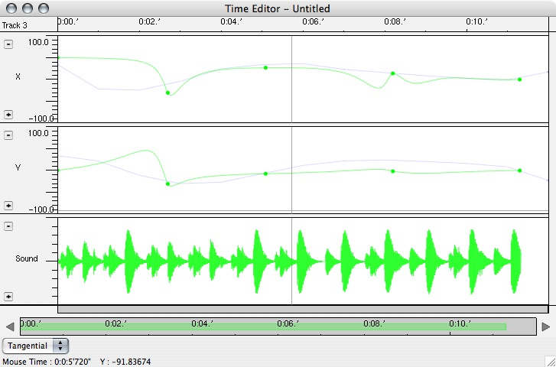

Time scale
Information area

Curve’s header

Secondary time scale
Modification type

Different curves are available (X, Y, Z, Ray, Angle, Sound) according to time. It is possible to add or remove the visualization of a curve and thus concentrate on one or more parameters by clicking on the plus and minus buttons in the headers of the curves.
Clicking on the name of the curve makes a drop-down list appear. Choosing an element in this list modifies the parameters of the curve.

Only the active track can be changed. The other (inactive) tracks are displayed as hatched or shaded.

The following functions apply similarly to any curve, except the sound curve, which cannot be changed.

    - Temporal displacement

According to the value of the modification type (linear, curvilinear, tangential), moving a point or a selection will have different results.

In linear mode, this point will move normally, and the points surrounding it (between the editable points preceding and following this one) will move in time in a linear way.

In curvilinear mode, this point will move normally, and points surrounding it will move so as to create an acceleration or a deceleration on either side.

In tangential mode, this point won’t move, but the points surrounding it will move so as to create an acceleration followed by a deceleration (or the opposite).

    - Spatial displacement

By default, moving a point will only modify its date. If the Shift key is held down while moving a point, the point will also move along the vertical axis.

If the Shift key is held down before moving a point, the point will only move along the vertical axis.

- Functions

All available functions in the Functions menus are algorithms in the form of java files contained in the algo folder in the application folder. Each function saves its own presets in an external file with the same name and having the extension .pst in the same folder.

Generative functions allow the creation of trajectories defined by algorithms. These functions can modify one or more tracks at the same time. Their result can replace the current time selection or can be added at the end of each track.

Transformative functions use the content of the track in the time selection to modify it. They apply from one track A to another track B (A and B can be the same).

All functions are applied between Begin and End.
All generative functions are marked with an asterisk in the list below.

Symmetry
Duplicates the content of the Input track to the Output track after mirroring it about a central point or about the X or Y axes.

Rotation
Duplicates the content of the Input track to the Output track after rotating it about the central point of the graph.

Rotation Progressive
Duplicates the content of the Input track to the Output track after rotating it about the central point of the graph. The value of the angle evolves linearly between two values over the duration of the transformation.

Translation
Duplicates the content of the Input track to the Output track after moving it.

Proportion
Duplicates the content of the Input track to the Output track after reducing or enlarging it.

Proportion Progressive
Duplicates the content of the Input track to the Output track after reducing or enlarging it. The value of this reduction or enlargement evolves linearly between two values over the duration of the transformation.

Interpolation
Makes a dynamic interpolation between the content of two tracks between Begin and End. Interpolation is independent on the X, Y, and Z-axis.

Smooth
Smoothes the input track.

Resample
Modifies the temporal resolution of the starting curve by placing a constant number of one point per unit of time between the editable points.

Time Shift
Shifts in time the portion of the active track starting from Begin.

Time Stretch
Modifies the duration of the content of the active track between Begin and End by multiplying it by a percentage.

Time Reverse
Duplicates the content of the active track between Begin and End and reverse the data.

Acceleration
Modifies the progression in time of the content of the active track between Begin and End (without changing its total duration) so as to create an acceleration/deceleration.

Circle*
Create a circular trajectory (if initial ray = final ray) or in spiral (if not).

Lissajou*
Create a Lissajou figure.

Brownian*
Create a step-by-step random trajectory in a defined area. The length of a step is expressed by the Brownian value: percentage of the defined area to cover between each steps.

Random*
Create a random trajectory in which each point is placed in front of a randomly chosen speaker. The distance to speakers evolves linearly between two values over the duration of the generation.

Other functions place speakers in space. Like the generative algorithms, these functions can replace existing speakers or be added next to them.

Circular Speakers*
Places the speakers in circle around the center of the graph.

Rectangular Speakers*
Places the speakers symmetrically around the vertical axis passing through the center of the figure.

File Input / Output

A session of Holo-Edit is saved in a file with the extension .holo. This file is a XML file easily read by a human being or a computer.
This file is also readable by Holo-Spat: once the composition is finished, it is not necessary to use Holo-Edit to play it, reading the .holo file is enough.

It is also possible to export and import tracks separately (with the extension .tk). This can be done from the Track menu or the contextual menu (accessible by right clicking on the background of a track in the Score window).

Trajectories can also be exported/imported (with the extension .tj). This can be done from the Track menu or the contextual menu (accessible by right clicking on a trajectory in the Score window).

It is also possible to import old versions of Holo-Edit files.

Supported formats for sound files are detailed in part II.F Sound Pool.

- Communication with Holo-Spat & Transport

- Startup

Communication with Holo-Spat is fundamental to listening to your composition as it is written.

Both applications use the OSC network protocol and Bonjour, a network protocol developed by Apple on the zeroconf norm, “a standards-based networking technology that automatically connects electronic devices on a network, allowing them to interoperate seamlessly without any user configuration”.

To enable communication, you must activate the Enable Transport menu from Transport menu.

If several instances of Holo-Spat and Holo-Edit are running simultaneously on the local network, Holo-Edit will provide a list from which you must choose the appropriate one.

In the current and subsequent versions, transport commands from Holo-Edit activate the same commands in Holo-Spat and vice versa.

- Configuration

If the local network is very large and Holophon functions unpredictably on that network, deactivate the Bonjour option to avoid conflicts with other applications once communication has been established between Holo-Edit and Holo-Spat.

If Bonjour is activated, it is possible in Holo-Spat to precisely name the service that Holo-Spat will declare to Bonjour, and thus to Holo-Edit.
If not, it is possible to manually configure the communication between the two applications by entering their IP addresses (or their domain names for WAN applications) and their UDP port numbers in the Preferences… menu, under the OSC tab.

Once you have made modifications, deactivate and reactivate the transport command or restart the application to validate the modifications.

- Track Numbering

The number of a track in Holo-Edit (which can be changed in the Track menu) indicates which track in Holo-Spat will be controlled by Holo-Spat.
One can only have three tracks (numbered 5, 6 and 8) in Holo-Edit respectively controlling the same numbered ones in Holo-Spat. The remaining tracks must be controlled by other means in Holo-Spat.

- Playing & Recording

See Holo-Spat.

- Options & Preferences

Maximum recent files: the maximum number of files to list in the Open recent files menu.

Automatic Track Selection: enables automatic track selection when the mouse passes over a point in the Room Editor or when an object is moved in the Score.

View only editable points: hide/show non-editable points.

View speakers: hide/show speakers.

Load last file on startup: automatically load last file read on startup.

Coordinates: Cartesian or Polar. Changes the type of coordinates in the point or speaker editor.

Draw points number: the number of points to draw while playing. If the computer slows down while playing, you should decrease this number. For a more aesthetic effect, increase it.

Scroll speed: the speed of the zoom when using the mouse wheel. Increase this number if it’s too slow and vice versa.

Holo-Spat
- Introduction

Holo-Spat is an application for the realization of the work done in Holo-Edit. It can also work as a stand-alone application for the real-time spatialization of sounds (voices, instruments, synthesizers…).

Holo-Spat functions as both a multi-channel mixer for an array of loudspeakers and a psycho-acoustic sound processor.

Each track algorithmically places a sound file or an external input in space. By default, this algorithm corresponds to an implementation of John Chowning’s works with eight speakers.

Other algorithms are available (in the algo folder of the application) and allow work with different speaker configurations (4,16,cube…).

To use or create other algorithms, or more complex speaker configurations, please see the Advanced functions section.

- User interface

- Room

This window is at the same time a top view of the speaker configuration and an area for controlling sound positions in real time.
It allows one to visualize the position of each sound played at a given time as well as the speaker’s volume as represented by the peak meters.
The bottom menu of this window gives access to the other windows of Holo-Spat.
The top menu allows one to choose the track controlled by the mouse in the control area.
The button with a speaker is called the DAC, which must be engaged to run sound processing.

- Mix Window

This window displays all tracks available in the form of a mixing desk track. There is also a Master section.

Description of a track:

Track number
Track input menu Sound file / External input
Add a sound to the sound list
List of available sounds
Length of the selected sound
Doppler On/Off
Loop On/Off
Track Reset
Send to a bus
Track activity On/Off
Solo On/Off
Control method of this track by Holo-Edit or .holo files
Enable recording (of trajectory)
Visualization (gain/position controls)
Reverb send gain (dB)
Aux send gain (dB)
Auxiliary post/prefader (default post)
Track gain before spatialization (dB) + peak meter
Distance to center (m)
Position
Angle in degrees
Elevation (0-100)
Algorithm (list of all patches available in the algo folder of the application)
Name

DSP diagram of a track:

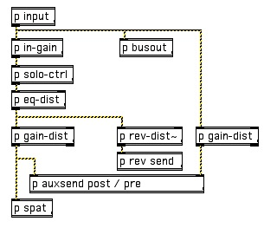

Description of the master Section:
Global initialization
Add a folder to the sound file list
Clear the sound file list
Add a track to the session
Doppler On/Off for all tracks
On/Off for all tracks
Loop On/Off for all tracks
Holo-Edit Control method for all tracks
Enable recording (of trajectories) on all tracks
Track visualization
Reverb Type (default or VST plugin)
Master gain (dB)
Reverb Gain (dB) + peak meter

Aux Gain (dB) + peak meter

- Transport
Transport (rewind, preload, stop, play, pause, loop, record)
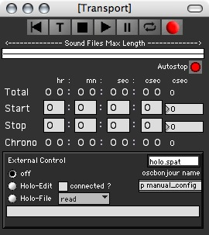
Autostop determines if playing will stop at the end of the time selection.
Total duration of the session
Beginning of the time selection
End of the time selection
Play position
Choice of external control, read/write commands of .holo files
Name of the last read .holo file
Name of the Bonjour service.
Manual configuration of network communications.
Time scale representing the total duration of the session and the time selection’s minimum and maximum limits.

- Options

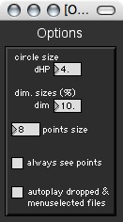
Size of speaker circle : adapt to the natural reverberation of the room
Scaling factor of Holo-Edit trajectories
Size of drawn points
Automatically play a chosen sound file in the sound file list
By default, points are visible only when sound comes out of its track

- Use

Several modes are possible with Holo-Spat.

- With Holo-Edit

Ensure that the External Control portion of the Transport window of Holo-Edit is connected and selected (this should be automatically done when Holo-Edit is launched and its transport command activated).

On each track controlled by Holo-Edit, select a control method:
  - Position: changes the sound file while playing or spatializes an external input (voice, instrument…).
  - Sound: controls the position in real time by another means (algorithm, external controller…).
  - Sound + Position: controls both sound and position parameters of the track.

If the sound part of the track is not controlled by Holo-Edit (method set on position), you must:
  - Either select a sound file (command Open file of the track, or choose a file in the file list, which can be filled with the command Add folder of the Master section),
  - Or select input patch in the input menu and configure the input patch.

- With .holo file

Using a .holo file is similar to using a Holo-Spat file with Holo-Edit. In the External Control portion of the Transport window, check Holo-File, and choose the file to read with the read command.

Then select a control method for each track (see preceding paragraph).

- Other methods...

Select a sound file (command Open file for the track, or choose a file in the file list, populated by the command Add folder under the Master section) or select input patch in the input menu and configure the input patch.

The position of the sound can then be controlled by:
  - The mouse in the main window,
  - An algorithm in real time (see Advanced Functions I),
  - By an external midi controller (see E. Midi Control).

- Playing & Recording trajectories

Transport commands are common to both Holo-Edit and Holo-Spat. Once they are connected, both applications react to the same commands (setting start and stop position, play, stop…).

Don’t forget to start the DAC (the button with a speaker) before playing.

Just as for the reading and recording of trajectories, it is necessary to specify (in Holo-Spat) which track will be recorded the next time the play command is launched.
In the External Control portion of the Transport window, select the record destination (Holo-Edit or Holo-File).
For each track, select a control method (see paragraph A) and check the prepare recording box.
In the transport window, prepare the recording and execute the play command.

In recording mode, each change in the position of a track will be recorded regardless of the method used (user interface, algorithm, external controller…).

Tracks whose record mode is deactivated will be read in the file or in Holo-Edit if they contain information.

If the recording destination is a Holo-File, save your recording with the write command. It is then possible to open and rework this session in Holo-Edit.

- Choosing the Spatialization Algorithm

All patches available in the algo folder of the application are spatialization algorithms. By default, the algorithm p08pan.pat is used.
(See Advanced Functions IV)
- Midi Control

The Midi Control window allows the control of some parameters with the midi protocol (external application, physical controller…).
Several controllers are defined and then assigned to a parameter of a track.

on: activate the controller
lrn: midi learn button to automatically detect the next moved button
name: name
CCch: midi channel
CCnb: number
CCval: last received value
rst: resets the assignment of the controller
tknb: track number to control (0 = Master Section)
param: parameter to control
mapping: mapping type (linear, exponential, inverted, extra (user-defined mapping), boolean (on/off))
outval: effective value sent to the parameter.

Different parameters are available in the param list:
  - on: activate/deactivate the track
  - vol: track gain
  - rev: reverb send gain
  - aux: auxiliary send gain
  - auxpre: auxiliary output pre/post fader
  - doppler: doppler on/off
  - loop: loop on/off
  - d: distance from center
  - t: angle
  - z: elevation
  - p1, p2, p3: additional parameters.

- Input/Output Patches

The input patch is useful when one wishes to spatialize voices or instruments in real-time. It connects the physical inputs of the sound card to Holo-Spat’s tracks.
It is also possible, for example, to connect a Max variable to the input of a track to spatialize a synthesis patch. For that purpose, 8 variables have been provided (1extpatch – 8extpatch). (NB: these variables use traditional send/receive and not send~/receive~).
The output patch connects the virtual speakers and the auxiliary channel to the physical outputs of the sound card.
It is also possible to record in a 8-track sound file the sound result with the Recorder window. It is necessary to connect speakers to the recorder in the output patch to make this possible.
The Output window allows you to visualize the gain of each of the 16 available speakers (by default) in Holo-Spat (only 8 have level meters in the main window). This window also permits the fine adjustment of your speakers (gain, delays…).

Advanced functions

- Realization of a real time control algorithm

For each track, the Max/MSP variables controlling the positions follow (where #1 is the number of the track):

  - #1d: distance from center
  - #1t: angle in degrees
  - #1z: elevation

Example: algorithm for the creation of a spiral with a random elevation.

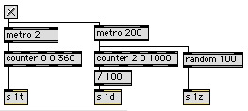

These variables cannot only be used for creating a control algorithm (like the example above), but also for connecting a control interface to a track (graphics tablet, joystick…).

- Obtaining the source code of Holo-Edit

You can obtain the latest version of the source code for Holo-Edit with Subversion. Enter the following command:

svn co svn://gmem.homeip.net

The source code of Holo-Spat is provided in this distribution.

- Development of algorithms for Holo-Edit

(Skills in java needed)

All generative or transformative algorithms in Holo-Edit inherit the holoedit.functions.Algorithm class.
To compile your class, you need the package holoedit.jar in your classpath (in the application bundle (Mac) or in the resource folder (Windows).

Add the compiled .class file in the algo folder of the application and restart Holo-Edit.

All necessary information to develop your own algorithm can be found in the Example.java file in the Documentation folder of the application.

- Development of spatialization algorithms for Holo-Spat

To develop your own spatialization algorithm, you need to create a patch having these five inputs:
  - Input signal
  - Angle in degrees (between 0 and 360)
  - Distance between 0 and 1 (= real distance of the point / dHP)
  - Interpolation time in ms
  - Elevation between 0 and 100

In addition, you can get the number of the track calling your algorithm with the #1 variable.
By default 16 speakers numbered from 1 to 16 are accessible with #1HPin~ (where #1 is the number of the speaker) in Holo-Spat. (NB: these variables use traditional send/receive and not send~/receive~).
Place your patch in the algo folder of the application and restart Holo-Spat.
The example below illustrates the implementation of an algorithm for cubic speaker configuration:

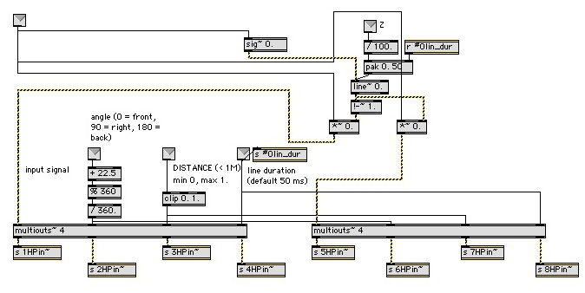

You can also retrieve the position of the speakers in Holo-Edit by sending the command « queryspeakers » to the variable holo.edit. Speakers will be sent to the variable holo.edit.spk one after the other as a list (number, x, y, z) as in the example below.

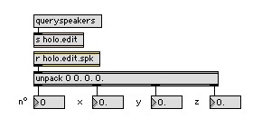

.http://www.cycling74.com/
Open Sound Control http://cnmat.berkeley.edu/OpenSoundControl/
Java bindings for OpenGL https://jogl.dev.java.net/
Open Sound Control http://cnmat.berkeley.edu/OpenSoundControl/
http://www.apple.com/macosx/features/bonjour/
http://www.zeroconf.org/
John Chowning, « The simulation of Moving Sound Sources », in Computer Music Journal, June, 1977, pp. 48-52, reprinted from the Journal of the Audio Engineering Society, 19 :2-6 , 1971
These functions require skills in Java concerning Holo-Edit, and in Max/MSP concerning Holo-Spat.
http://subversion.tigris.org/

