Early Warning Student Success Dashboard: System Architecture Blueprint, Requirements Specification, and Version Control Strategy
Geneva Young
University of the People
MSIT 5910: MSIT Capstone Project
July 8th, 2026
System Requirements Specifications & System Design
The Early Warning Student Success Dashboard (EWSSD) is a web-based application intended to help educators identify students who may be at risk of academic failure by analyzing factors such as attendance, grades, behavioral records, and other academic performance indicators. Instead of requiring teachers and counselors to manually identify patterns across multiple systems, the dashboard consolidates student information into a centralized interface that provides actionable insights and intervention recommendations. This system is intended to support teachers, counselors, and administrators by delivering real-time dashboards, automated alerts, and analytical reports that promote proactive student success initiatives.
A well-designed software architecture provides the foundation for system quality by organizing components into manageable modules that improve maintainability, scalability, and security (Walker, 2022). Similarly, selecting an appropriate software architecture pattern allows developers to isolate system responsibilities while improving reliability and future extensibility (Walker, 2022). To support these goals, the Early Warning Student Success Dashboard follows a layered, modular architecture. This “layered pattern makes it easy to write applications quickly…” (Walker, 2022). The architecture will consist of the presentation layer, authentication services, business logic, analytics engine, and data management into independent components.
System Architecture Blueprint (Figure 1)
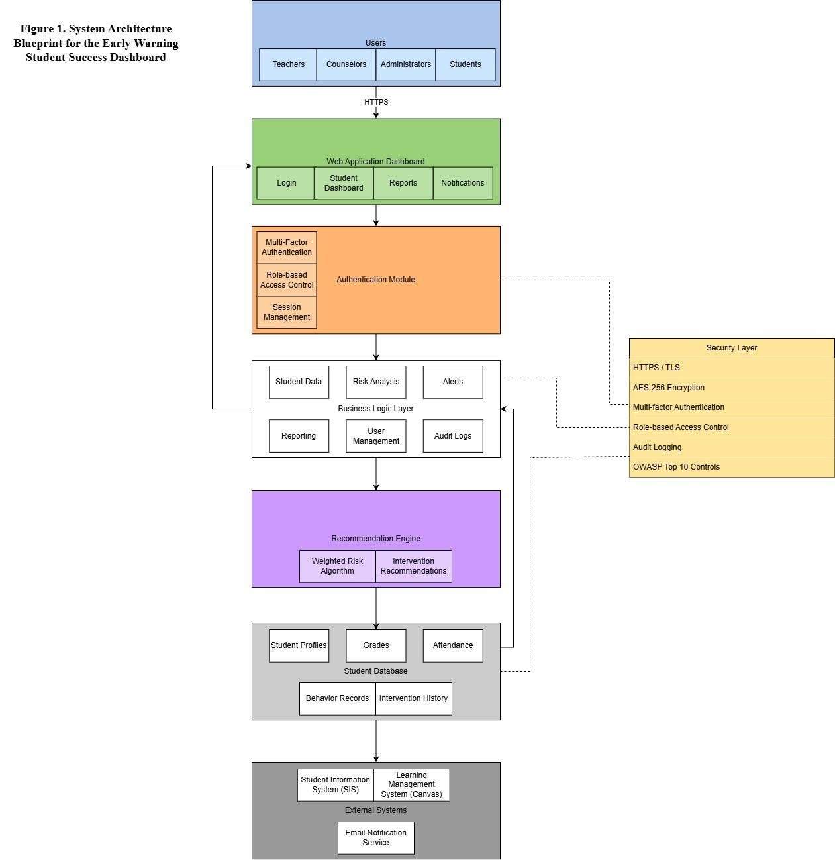

Functional & Nonfunctional Requirements:
The Early Warning Student Success Dashboard has been designed to satisfy both functional and non-functional requirements. According to Letaw (2024), “functional requirements answer the question, “What must the software do?”” (p. 31), while non-functional requirements describe the quality attributes and operational constraints that influence the overall design (Letaw, 2024). Establishing both types of requirements early in the design process ensures the system meets stakeholder expectations while remaining secure, reliable, and scalable throughout its lifecycle.

Functional Requirements Table
FR-1 | The system will authenticate authorized users using secure login credentials.
FR-2 | The system will support MFA for administrators & counselors.
FR-3 | The system will import student attendance, grade, & behavioral data from approved data sources.
FR-4 | The system will calculate student risk scores using predefined academic indicators.
FR-5 | The system will categorize the students into Low, Moderate, and High Risk Categories.
FR-6 | The system will display interactive dashboards tailored to user roles.
FR-7 | The system will download results in two formats: PDF & CSV.
FR-8 | The system will notify educators when students exceed predefined risk thresholds.
FR-9 | The system will maintain audit logs for all user activity.
FR-10 | The system will enforce role-based permissions for all users.

Nonfunctional Requirements Table
Performance | Dashboard pages will load within 3 seconds under normal operating conditions.
Reliability | The system will maintain 99.9% uptime.
Scalability | The architecture will support at least 10,000 student records without performance degradation.
Security | Student data will be encrypted during storage and transmission .
Security | The system will implement role-based access control and multi-factor authentication.
Availability | Daily backups will be performed to protect institutional data.
Maintainability | System components will follow a modular architecture to simplify future enhancements.
Usability | The dashboard will provide an intuitive interface accessible from desktop and mobile devices.

These requirements establish measurable expectations that help guide architectural decisions and provide benchmarks to developers for evaluating system performance throughout the process (Letaw, 2024).

Module Specifications Table
Module | Inputs | Outputs | Methodology
Authentication | Username, Password, MFA | Authenticated Session | JWT + RBAC
Student Data | Grades, Attendance | Student Profile | CRUD Operations
Risk Analysis | Student Metrics | Risk Score | Weighted Scoring Algorithm
Recommendation Engine | Risk Score | Intervention Suggestions | Rule-based Decision Logic
Alerts | High-Risk Students | Email/Dashboard Notifications | Event-Driven Processing
Reporting | Student Data | PDF, CSV, Dashboard Reports | SQL Queries & Analytics
User Management | User Information | Roles & Permissions | RBAC Administration

System Design
Figure 1 illustrates the high-level architecture of the Early Warning Student Success Dashboard. The architecture follows a layered design that separates user interaction, authentication, application processing, analytics, and data storage into distinct components. “Each of these subtasks is represented by a layer in the software—a unit of modules that produces a cohesive set of services—and each layer provides services to the next higher layer in a unidirectional pattern” (Butani, 2020).
The presentation layer consists of a web-based dashboard that serves teachers, counselors, and administrators. Users authenticate through a secure login interface before accessing dashboards, reports, notifications, and intervention recommendations. By separating the presentation layer from the business logic, interface updates can be implemented without affecting the underlying application services.
The authentication module provides secure access through username and password verification, multi-factor authentication, session management, and role-based access control (RBAC). Teachers can only access information for students assigned to their classes, while counselors and administrators receive broader permissions appropriate to their responsibilities. Separating authentication from the application logic follows modular software engineering practices and improves system security by centralizing access management (Davies, 2024).
The business logic layer contains the core application modules responsible for processing student information. The Student Data Module imports and validates attendance, grades, behavioral incidents, and intervention records. The Risk Analysis Module evaluates academic indicators using a weighted scoring algorithm to identify students requiring intervention. Additional modules manage reporting, user administration, alerts, and audit logging. Walker (2022) notes that modular architectures improve maintainability by allowing individual services to evolve independently without disrupting the overall system.
The Recommendation Engine transforms calculated risk scores into actionable recommendations for educators. Rather than replacing professional judgment, the engine supports informed decision-making by suggesting possible interventions based on predefined academic thresholds. This approach encourages educators to use predictive analytics as a decision-support tool while maintaining human oversight throughout the intervention process.
The data layer stores student profiles, attendance records, grades, behavioral information, intervention histories, and system logs within a secure relational database. Data is encrypted both at rest and during transmission to protect sensitive educational records. External systems, including Student Information Systems (SIS), Learning Management Systems (LMS), and email notification services, integrate with the dashboard through secure APIs to ensure timely synchronization of student information.
Security considerations are embedded throughout the architecture rather than treated as standalone features. The system incorporates HTTPS communication, encrypted databases, role-based access control, audit logging, and multi-factor authentication to protect confidential student information. These safeguards align with recommendations from the OWASP Top 10 (2021), which identifies Broken Access Control, Cryptographic Failures, and Identification and Authentication Failures as some of the most significant risks facing modern web applications. “The contributed data (Broken Access Control) indicates that on average, 3.81% of applications tested had one or more Common Weakness Enumerations (CWEs) with more than 318k occurrences of CWEs in this risk category” (OWASP Top 10, 2021). Incorporating these controls during the architectural design phase strengthens both the security and ethical integrity of the system.
Overall, the layered architecture provides a scalable and maintainable foundation for the Early Warning Student Success Dashboard. Systems engineering emphasizes designing interconnected components that satisfy stakeholder requirements while supporting long-term maintainability and adaptability (Summers, 2020). “There should also be a continuous improvement during software engineering design, programming, and development” (Summers, 2020). By separating user interfaces, authentication services, business logic, analytics, and data management into independent modules, the proposed architecture promotes flexibility, improves system reliability, and establishes a secure framework capable of supporting future enhancements as institutional needs evolve.
Version Control & Collaboration Overview
The Early Warning Student Success Dashboard uses GitHub as its version control platform to organize project artifacts and track development progress. The repository is structured into separate folders for documentation, diagrams, source code, and testing resources to maintain consistency throughout the project lifecycle. The main branch serves as the stable production branch, while the development branch is used to integrate new features before they are finalized. Additional feature branches, such as feature-dashboard, allow individual components to be developed independently before being merged through pull requests. Clear and descriptive commit messages document each project milestone, making it easier to review changes, recover previous versions, and collaborate with team members. This branching strategy promotes traceability, reduces the risk of conflicts, and supports a structured software development workflow (Davies, 2024).
References
Butani, A. (2020, December 16). 5 essential patterns of software architecture. Redhat.com. https://www.redhat.com/en/blog/5-essential-patterns-software-architecture#layered
Davies, S. (2024). Blueprints: Creating, describing, and implementing designs for larger-scale software projects (Version 2.5). University of Mary Washington. https://opensource.com/ https://open.umn.edu/opentextbooks/textbooks/blueprints-creating-describing-and-implementing-designs-for-larger-scale-software-projects-davis Licensed under CC BY-SA
Letaw, L. (2024). Handbook of software engineering methods [Open textbook]. Oregon State University. https://open.oregonstate.education/setextbook/ Licensed under CC BY-NC-SA 4.0
OWASP. (2021). OWASP Top 10:2021. Owasp.org. https://owasp.org/Top10/2021/
Summers, B. (2020). Effective methods for software engineering. Auerbach Publishers, Incorporated.
Walker, V. (2022, March 16). 14 software architecture design patterns to know. Red Hat. https://www.redhat.com/en/blog/14-software-architecture-patterns

