Corporate Telecommunication Networks (CN) - Standardization Plan

.

Corporate Telecommunication Networks (CN) - Standardization Plan

.
Brief History

This ECMA Technical Report provides an overview of, and visibility to, the various standardization activities in the area of corporate telecommunication network technology.
The addressees for the information provided herein are within ECMA, in particular among the membership of TC32, but also outside ECMA, e.g. in ETSI and ISO/IEC JTC1. The aim is to facilitate understanding of the area of corporate telecommunication network technology and to allow for synergy when specifying related topics, e.g. in the field of public networks.
A predecessor of this Technical Report has been produced, as an ETSI Guide (EG 201 017), by the former ETSI Standardization Project on Corporate Networks (EP CN). With the closure of EP CN the responsibility for the focus on CN standardization was transferred to (and accepted by) ECMA.
To underline the importance of CN standardization, this document is intended to be published as an ECMA Technical Report and as an ETSI Guide in parallel.
The present version covers the current status of European CN standardization. Due to the dynamic of standardization demands in the CN area, this Technical Report is a living document and will thus be updated regularly.

This Technical Report has been adopted by the ECMA General Assembly of June 2000.
.
Table of contents
1 Scope 1
2 References 1
3 Definitions 1
3.1 Corporate telecommunication Network (CN) 1
3.2 Virtual Private Network (VPN) 1
3.3 Private Integrated Services Network (PISN) 1
3.4 Private Integrated Services Network eXchange (PINX) 2
3.5 CENTREX 2
3.6 Integrated Services Private Branch eXchange (ISPBX) 2
3.7 Integrated Services CenTralized eXchange (ISCTX) 2
3.8 InterConnecting Network (ICN) 2
4 List of acronyms 2
5 Title of the Plan 3
6 Proposer and sponsor 3
7 Area of CN standardization 4
7.1 General 4
7.1.1 The connection-oriented approach (employing PISNs) 4
7.1.2 The connectionless approach (employing internet or intranet technology) 6
7.2 Topics 6
7.2.1 CN Enhanced voice and non-voice services 6
7.2.2 Virtual Private Networks (VPN) 6
7.2.3 CN Mobility 8
7.2.4 CN High-speed/LAN/B-PISN 9
7.2.5 CN Multimedia 9
7.2.6 CN Management 9
7.2.7 CN Scenarios 10
7.2.8 CN Performance 11
7.2.9 Screenphone Terminal Services and Applications 11
7.2.10 Other CN standardization areas of interest 11
7.3 Current Standardization Activities 11
7.3.1 Private Integrated Services Networks (PISNs) 12
7.3.2 Computer Supported Telecommunication Applications (CSTA) 12
7.3.3 Screenphone Terminal Services and Applications 13
7.3.4 IP-based Multimedia Communications in a Business Environment 13
8 Objectives 13
9 Justification 14
10 Global context 14
10.1 ITU-T 14
10.2 ISO/IEC JTC1 14
10.3 Co-operation between ITU-T and JTC1 14
10.4 Global Virtual Network Service (GVNS) Forum 14
10.5 Electronic Industries Association (EIA), USA, in particular the Telecommunication Industries Association (TIA) 14
10.6 Other standardization bodies 14
11 Resource requirements 15
Annex A - CN Taxonomy 17
Annex B - Circular Letter 1053 on private network standardization 21
Annex C - Bon de Commande BC-T-326: Standardization Mandate forwarded to CEN/CENELEC/ETSI in the field of information technology and telecommunications 23
Annex D - Bibliography 25

1 Scope
This Technical Report defines the work areas and contents of the standardization work programme for Corporate telecommunication Networks (CN). The aim is to manage, co-ordinate and give visibility to the standardization process spread over various technical bodies (TBs) in ECMA and ETSI. It can also be used to guide the international standardization process in ISO/IEC JTC1.

2 References
References may be made to:
a) specific versions of publications (identified by date of publication, edition number, version number, etc.), in which case, subsequent revisions to the referenced document do not apply; or
b) all versions up to and including the identified version (identified by "up to and including" before the version identity); or
c) all versions subsequent to and including the identified version (identified by "onwards" following the version identity); or
d) publications without mention of a specific version, in which case the latest version applies.
A non-specific reference to an ETS shall also be taken to refer to later versions published as an EN with the same number.
[1] ECMA Technical Report TR/57: “Private Integrated Services Networks”.
[2] Bons de Commande BC-IT 74 to 77, SOGITS Working Document No. 243.1, Brussels, 2.8.1988.
[3] TCR/TR 034: "VPN Task Group Report".
[4] ETS 300 415: "Business Telecommunication; Terms and Definitions", edition 2.
[5] Bon de Commande BC-T-326, This document is reproduced as annex C.
[6] TCR-TR 033 (1994): Private telecommunication networks (PTN); Integrated scenario.
[7] EG 201 026-1: Corporate telecommunication Networks (CN); Standardization analysis - Part 1: Strategy.
[8] EG 201 026-2: Corporate telecommunication Networks (CN); Standardization analysis - Part 2: Enhanced voice and non-voice services.

3 Definitions
No specific definitions are used within the description of the CN Standardization Plan. The subsequently listed definitions are imported from the sources indicated in [ ] merely for the convenience of the reader:

3.1 Corporate telecommunication Network (CN)
A telecommunication network serving a corporation, i.e. a single organization, an extended enterprise, or an industry application group as defined by the International Chamber of Commerce (ICC) [1]
NOTE
Sets of equipment [Customer Premises Equipment (CPE) and/or Customer Premises Networks (CPN)] are typically located at geographically dispersed locations and are interconnected to provide networking services to a defined group of users.
A CN can employ connection-oriented and connectionless technology.

3.2 Virtual Private Network (VPN)
The capabilities of third-party provided networks (typically using public ISDN infrastructure) to emulate ISCTX and/or ICN functions for a given PISN [1].

3.3 Private Integrated Services Network (PISN)
The connection-oriented part of a CN.

3.4 Private Integrated Services Network eXchange (PINX)
A nodal entity in a PISN that provides automatic switching and call handling functions used for the provision of telecommunication services. The nodal entity can be implemented by one or more pieces of equipment located on the premises of the private network administrator or by functions of a Virtual Private Network [4].

3.5 CENTREX
The service package offered on public networks to emulate PISN capabilities.

3.6 Integrated Services Private Branch eXchange (ISPBX)
The implementation of a PINX offering ISDN-like capabilities, separate from public network equipment.

3.7 Integrated Services CenTralized eXchange (ISCTX)
The switching and ISDN-like service provisioning function offering the CENTREX package of a VPN.

3.8 InterConnecting Network (ICN)
That part of a VPN which provides the functions needed to interconnect PINXs. The functionality of the ICN includes transit-PINX functionality, associated transmission capabilities and may include gateway-PINX functionality.

4 List of acronyms
For the purposes of the present document, the following abbreviations apply:
ATM Asynchronous Transfer Mode
CENTREX CENTRalized corporate telecommunication network EXchange
CN Corporate telecommunication Network
CSTA Computer Supported Telecommunication Applications
CTI Computer-Telecommunications Integration
CTM Cordless Terminal Mobility
EG ETSI Guide
ETS European Telecommunication Standard
ETSI European Telecommunication Standards Institute
ETO European Telecommunication Office
ETR European Telecommunication Technical Report
FR Frame Relay
GVNS Global Virtual Network Service
GW GateWay
ICN InterConnecting Network
IN Intelligent Network
INMS Integrated Network Management System
IP Internet Protocol
ISCTX Integrated Services CenTralized eXchange
ISPBX Integrated Services Private Branch eXchange
ITAEG-T Information Technology Advisory and Experts Group on Telecommunications
IVN Inter-Vening Network
JEEC Joint ECMA/ETSI Committee
LAN Local Area Network
MAN Metropolitan Area Network
MIB Management Information Base
NNI Network-Network Interface
PBX Private Branch eXchange
PDH Plesiochronous Digital Hierarchy
PINX Private Integrated Services Network eXchange
PISN Private Integrated Services Network
PST Project Support Team
PUM Private User Mobility
QoS Quality of Service
QSIG Q Interface Signalling protocol
SAAL Signalling ATM Application Layer
SDH Synchronous Digital Hierarchy
SRC Strategic Review Committee
TMN Telecommunication Management Network
UNI User-Network Interface
UPT Universal Personal Telecommunication
VPN Virtual Private Network
WAN Wide Area Network
WTM Wireless Terminal Mobility

5 Title of the Plan
The plan is titled CORPORATE TELECOMMUNICATION NETWORKS STANDARDIZATION.

6 Proposer and sponsor
In 1992 and 1993 an ETSI Strategic Review Committee on Corporate telecommunication Networks (SRC5) has stated that the ETSI work programme as relevant for this area needs to be harmonized and properly co-ordinated across various experts groups being involved within ETSI and ECMA. Consistently, SRC5 recommended that the ETSI work programme on corporate telecommunication networks be managed as an ETSI Project under the responsibility of TC BTC.
ETSI TA18 has approved this recommendation and assigned the task of managing corporate telecommunication network activities within ETSI to its Technical Committee on Business Telecommunications (TC BTC), and to carry out this as an ETSI Project following the concept of ETSI Project Management.
Within BTC (and later in ETSI Project CN) this task had been carried out by a Project Management consisting of a Project Manager and a Project Support Team (PST).
With the closure of EP CN in 1998 [ETSI Board decision B12(98)02] the responsibility for the focus of CN standardization matters was transferred to, and accepted by, ECMA TC32 [ETSI Board decision B12(98)03]. The functions of the Project Manager and of the PST continue by TC32 officers.
To underline the importance of CN standardization, this document is intended to be published as an ECMA Technical Report and as an ETSI Guide in parallel.

7 Area of CN standardization

7.1 General
The CN standardization area covers the activities related to corporate telecommunication networks, based on both, connection-oriented and connectionless technology.
The connection-oriented part (the Private Integrated Services Network, PISN) of the standardization area has been investigated by an ETSI Strategic Review Committee, SRC5, in the years 1992 and 1993 to help ETSI in building its work programme on CN. In addition, the relevant results of SRC6, further elaborations of user expectations, e.g. on VPN, and of ETSI PT85 (CN future work programme analysis, based on Bon de Commande BC-T-326) are taken into account.
SRC5 identifies six major topics as being of highest current interest to CN users:
- Enhanced voice;
- Virtual private networks;
- CN Mobility;
- High-Speed/LAN, including B-PISN;
- Multi-media;
- CN Management.
Beside these major topics, also inherited work items of ITAEG-T M-IT-05 are considered part of CN Standardization.
CN Standardization covers also:
- CN Scenarios;
- CN Performance;
- Screenphone terminal services and applications;
- IP-based multi-media communication;
- CSTA: the interface between computing and telecommunication entities. This is briefly depicted in figure 1.
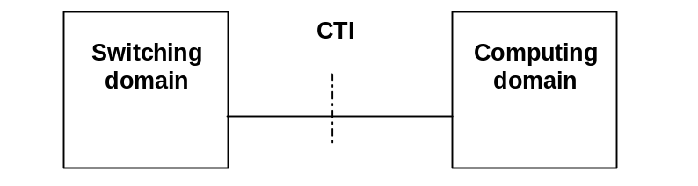
Figure 1 - Interface between Computing and Switching Domains
The interface between computing and telecommunication entities serves the purpose of executing computer supported telecommunication applications (CSTA). This application is likewise applicable to connection-oriented and connectionless parts of a CN, i.e. the switching domain can comprise any combination of PISN and intranet components.
The major topics can be considered sub-areas.
Intra-CN related Mobility work items are seen as part of the CN standardization activities (CN MOBILITY). Interworking related with public networks is a concern of both, the Cordless Terminal Mobility (CTM) Project in ETSI and the CN Mobility standardization activities.

7.1.1 The connection-oriented approach (employing PISNs)
For easier orientation, figure 2 shows an overview of a principal CN employing merely (connection-oriented) PINXs.
The figure represents the simplest form of a typical example, the attachment of a CN to the public ISDN, the use of a public ISDN equipment-based ICN, and an intervening network.
Although other solutions, e.g. an ICN based on dedicated data networks, are not depicted, the same principles apply.
The CN in this example consists of two PINXs. Although in the trivial case a CN need to consist of one PINX only, also more complex configurations can be constructed by applying the same principle in multiple ways.
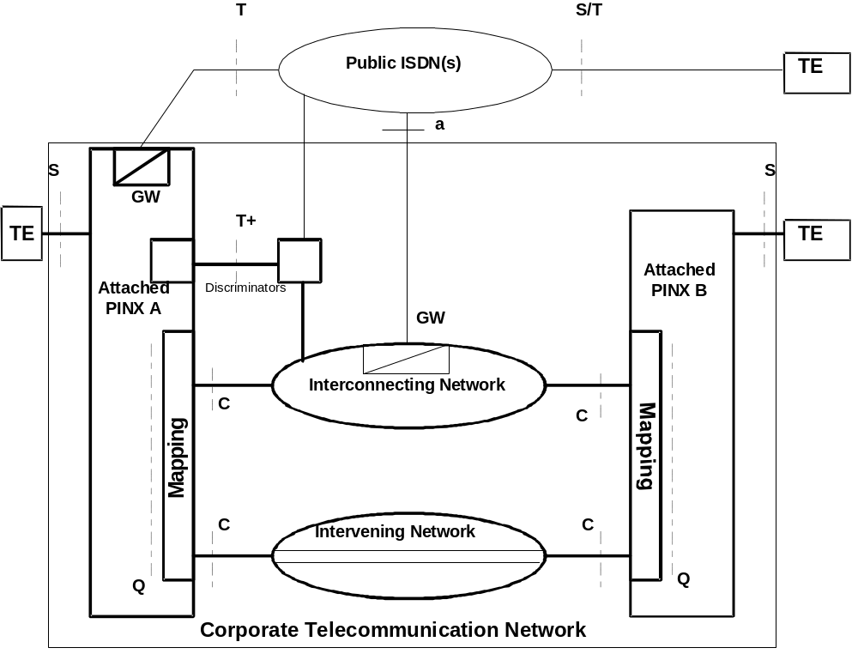
Figure 2 - Overview of a principal CN (simplified example)
The two attached PINXs are inter-connected via four different means:
- the public network (in this example: a public ISDN, via T reference points); this interconnection is external to the CN;
- an interconnecting network via discrimination functions across a T+ reference point;
- an interconnecting network via C reference points;
- an intervening network, via C reference points.
The last three are within the CN, although the switching and/or transmission equipment typically is owned by third parties, e.g. public network operators.
The term (attached) PINX is a generic term covering both, implementations on the customer premises (ISPBX) and in the public network (IS-CENTREX) see ETS 300 415 [4]. In the latter case no physical interfaces will be standardized at the T, T+ and C reference points.
The discriminator functions around the T+ reference point allow to carry attached PINX-to-public ISDN and attached PINX-to-ICN calls on the same interface.
An "attached PINX" can play either role on a specific call: to serve as an end-PINX (i.e. hosting the originating or terminating terminal of that call) or to serve as a transit-PINX, extending the call to/from another PINX that hosts the originating or terminating terminal.
Gateway functionality GW in the ICN is an option allowing for the so called Break-Out and Break-In, i.e. interconnection between the CN and the public ISDN at ICN level across an α reference point.
With the exception of teleservices, the CN standardization activities cover all relevant specifications on the definitions of terminology, architectural aspects, numbering, basic and supplementary services as well as additional network features (descriptions at all three stages, including signalling), performance, etc.
On the basis of a standardization analysis performed by PT85, EG 201 026-1 [7] has been developed and approved which covers the strategy aspects for CN standardization, as requested by Bon de Commande BC-T-326 [5].

7.1.2 The connectionless approach (employing internet or intranet technology)
A Technical Report ploughing through this standardization area is under way. Preliminary results are:
Out of six interconnectivity cases two seem to fall under the scope of the CN standardization, i.e.
- the interconnection of PISN and intranet; and
- the interconnection of PISN and internet.
For these interconnections two scenarios exist:
- interworking; and
- tunnelling.
The interconnection cases are being further studied under various aspects in the context of the scenarios above. Aspects of preliminary studies and possible standardization work include interworking of basic and supplementary services (all three stages of description, including protocols), naming and addressing management, security and CSTA.
Co-operation is needed with various other bodies, predominantly with ETSI Project TIPHON. Internationalization has already agreed with ISO/IEC JTC1.

7.2 Topics

7.2.1 CN Enhanced voice and non-voice services
This sub-area encompasses work on:
- CN basic and supplementary services for the support of voice and non-voice applications;
- interworking of these services with those of the public network;
- interaction of these services with other services of the public and/or private network.
These aspects are to be taken account of in service descriptions, signalling requirements and signalling protocols.
Substructure of the Enhanced Voice Sub-Area
Bon de Commande | Subject | Responsible STC
BC75 B/T-326 | Signalling procedures (basic and suppl. services) at T-RP | SPAN5
BC75 C/T-326 | Signalling procedures (basic and suppl. services) at Q-RP | ECMA TC32-TG14
BC75 D/T-326 | Signalling procedures (basic and suppl. services) at S-RP | ECMA TC32-TG14

The chairman of ECMA TC32 acts as the contact person for BCs 75 C and D/BC-T-326, and the chairman of ETSI/SPS5 acts as the contact person for BC 75 B/BC-T-326.
A common minimum set of services has been defined to offer interoperability across a CN which might be composed of any type of infrastructural elements, including the terminals at either end of a connection. The details can be found in EG 201 026-2 [8].

7.2.2 Virtual Private Networks (VPN)
This subarea covers two main sub-functions: transit functionality as provided by an ICN, and end-PINX functionality as provided by an ISCTX. The architectural approach for accessing the transit functionality (ICN) has higher priority and has been defined in ETS 300 415 [6].
The coverage of the term "VPN" is illustrated in figure 3.
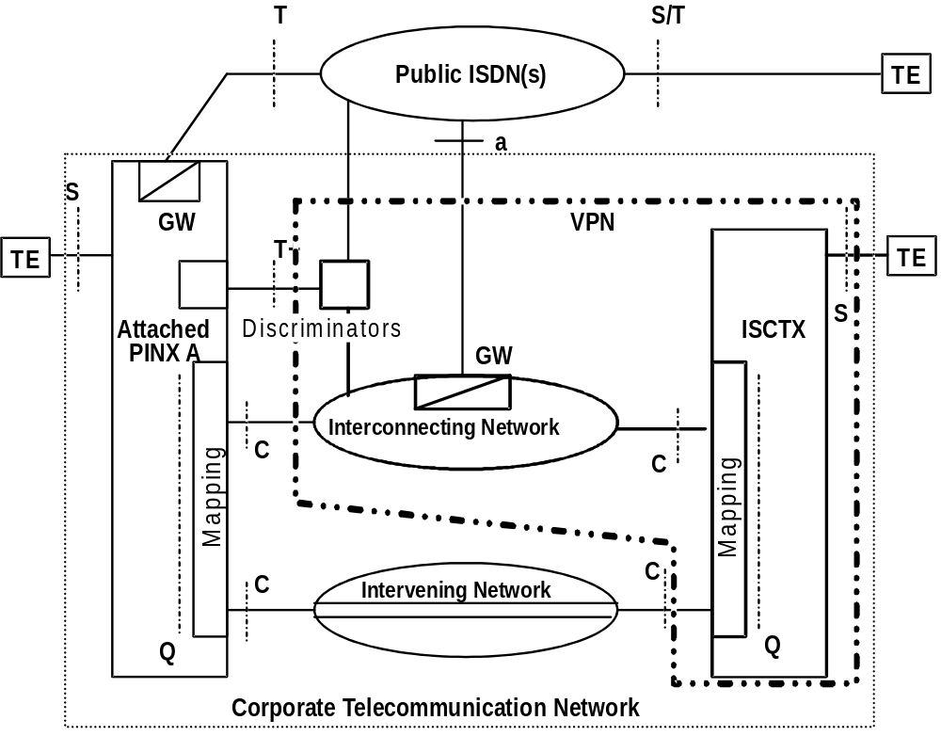
Figure 3 - Coverage of the term "VPN" (example)
The involvement of two or more ICN providers in supporting one VPN requires standardization at their network-to-network boundaries, at the so-called N* reference point, see figure 4.
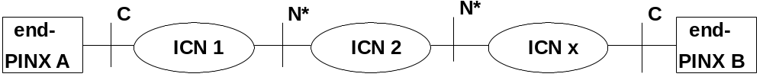
Figure 4 - Multiple ICNs
The base for the VPN sub-project is the report of the VPN Task Group [3], of which the part dealing with services was approved by TA 20 as an ETR.
Standardization activities in this area are carried out in ECMA in collaboration with JTC1/SC6/WG6, and in ETSI/SPAN.

7.2.3 CN Mobility
This subproject is applicable to intra-CN mobility and to mobility interworking with public networks, see figure 5. Related work items were jointly developed by CN WG MOB (stages 1 and 2) and ECMA TC32 (stage 3). They are now fully under the responsibility of ECMA TC32-TG14.
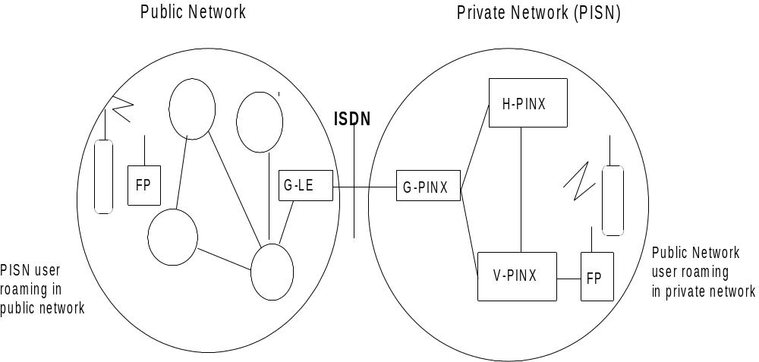
Legend: The model is simplified to show only those entities that are involved in location and call handling. The following entities are used:

FP: Fixed Part (cordless sub-system offering radio access to CTM users)
G-LE: Gateway Local Exchange
G-PINX: Gateway PINX
H-PINX: Home PINX (where the CTM user is registered)
V-PINX: Visitor PINX (where a mobile user has logged on)

Figure 5 - CN Mobility
Figure 5 shows a public and a corporate network with those functions which are relevant to CN mobility. These functions support intra-CN mobility as well as inter-network mobility.
The main working areas are:
- CN Wireless Terminal Mobility (WTM);
- Private User Mobility (PUM);
- support of Universal Personal Telecommunication (UPT) in CN (a public UPT user roaming in a CN).
The major standardization issues are:
 | Standardization issue | Relevant to
a) | location handling | UPT in CN | CN-WTM | PUM
b) | mobile call handling | UPT in CN | CN-WTM | PUM
c) | authentication principles | UPT in CN | CN-WTM | PUM
d) | provision of supplementary services to mobile users | UPT in CN | CN-WTM | PUM
e) | handover |  | CN-WTM | -
f) | expansion of CN-WTM to interwork with WTM provided by other networks to allow multi-network roaming |  | CN-WTM | -

Pre-normative work identifying the general requirements for the respective areas has been finalized. A first set of PUM and CN-WTM standards were completed in November 1995.
Additional work has to be done especially in the fields of CN access signalling (phase 2). A reference configuration for the extension line (P reference point) has been developed in JTC1 and was published at the end of 1999.
The chairman of ECMA TC32-TG14 acts as contact person.

7.2.4 CN High-speed/LAN/B-PISN
This Sub-Area addresses work specific to CN requirements and solutions for the support of High Speed and LAN based services. It covers:
- Integrated Services operating at bearer rates in excess of 64 kbit/s in both, customer premises limited scenarios (LAN) and MAN/WANs.
- Architectural models characterizing the means of providing end-to-end services spanning LAN, intervening WAN and destination LAN segments.
- LAN specific components of the Enhanced Voice and Non-Voice Sub-Area, e.g. LAN bridges and routers, to provide a common signalling and management, peer-to-peer, UNI and NNI for various high speed and multi-media services.
- Realization of these capabilities over current PDH and SDH based leased line bearers, including a migration plan for the use of B-ISDN bearer services as they become available.
- Accommodation of established LAN specific numbering and addressing schemes, within the frame work defined by the CN Scenarios Sub-Project.
- The embedding of ATM technology into broadband CNs providing cell-mode bearer capabilities.
This subarea focuses on the employment of ATM technology in private B-ISDN (B-PISN). A number of standards have been produced in this field, e.g. Generic Functional Procedures (B-QSIG-GF), Separated Bearer Control (B-QSIG-SBC) and B-QSIG basic call/connection control, mostly in close co-operation with SPAN5 which prepares similar standards for application in public networks.
The convenor of ECMA TC32-TG14 acts as contact person.

7.2.5 CN Multimedia
Two sub-areas in this area have been taken up recently:
- a terminal using multi-media communication via circuit-switched and IP networks (Screenphone terminal, see 7.3.3); and
- IP-based multi-media communication in the CN environment, see 7.3.4.

7.2.6 CN Management
This sub-area encompasses work on CN specific requirements and solutions for network management. It covers:
- Integrated Network Management System (INMS) capable of managing the objects obeying to the TMN architecture as well as to the ISO network management architecture as well as to the Internet network management architecture; all three architectural models will exist and need to be catered for in CN related Network Management Standards.
- Multiple types of MIBs need to be employable in parallel ("protocol conversion" and "MIB adapter" are required).
- Management protocols need to be developed on a peer-to-peer based management interworking principle.
- The description of Managed Objects for CN functional components as required for:
- networking in End- and Transit-PINXs, including those of VPNs;
- the management of services in CNs.
This sub-area applies to the Management aspects of the CN which include, inter alia:
- (connection-oriented) PINXs and their on-premises, active and passive line plant;
- (connectionless) intranet components and their on-premises, active and passive line plant;
3) the use of intervening networks employed by that CN;
4) interworking with interconnecting means (e.g. VPN capabilities of public network equipment which is dedicated to that CN).
Some elaboration on the bulleted items above will include:
1) Public ISDN equipment as part of CN in the form of an ISCTX and/or of virtual transit switching equipment:
a) Management of physical equipment.
b) Managing CN services.
c) Conflict of Public & Private management requirements (shared equipment).
f) CNs which encompass multiple Public ISDNs (e.g. international CN).
2) IVN:
a) Balancing CN call management with Public ISDN restrictions;
b) Role of dedicated transmission networks (e.g. SDH).
In this sub-area further study is required.
No specific standardization activities exist in this area at the moment. Thus, a general status report should be made.

7.2.7 CN Scenarios
The connection-oriented part of this Sub-area encompasses work in the course of CEC Bons de Commande BC 74 A, B & C, BC 75 A and BC 76 A. In particular, it covers the following standardization fields:
- Numbering and Addressing.
- Base Definitions (e.g. reference configurations) for the specification of interworking between exchanges of a CN.
- Methodologies for the description of CNs and their services.
- Terminology.
- Approaches for building CNs using public network infrastructure; this includes overlay and integrated scenarios; the latter cover VPN end-PINX functionality (ISCTX) as well as VPN transit functionality (ICN), as covered by BC-T-326, see annex C.
- Signalling protocols for the establishment and maintenance of interworking scenarios.
In addition, the same standardization fields with regard to High Speed / LAN are included in this Sub-Area.
A further standardization subject in the scope of CN Scenarios is the application of CNs for the support of tele-working to cover e.g. remote access to a CN as specified as "a" service entry points in VPN Task Group Report (ETSI TCR/TR 034) [3].
Substructure of the CN Scenario Sub-Area
Bon de  Commande | Subject | Responsible
BC 74 A, B , C | Configurations, Models, Definitions | ECMA TC32-TG13
BC75 A | Signalling procedures and protocols for Networking scenarios | ECMA TC32-TG14
 | Functions required for Networking scenarios | ECMA TC32-TG13
BC 76 A | Numbering, Addressing, Routeing | ECMA TC32-TG13

Also BC-T-326 applies to this subarea.
The chairmen of and ECMA TC32-TG14 act as contact persons for the connection-oriented CN Scenario part.
The development of the ETO report “The Numbering Requirements of Corporate Networks (CNs) and their Impact on Public Network Numbering” is commented, when so applicable.
The connectionless part, and its interworking with the connection-oriented part, of the CN Scenario Sub-area encompasses basically the same standardization fields as the connection-oriented part. However, due to its higher impact in particular on speech transmission, QoS considerations have a higher weight (see 7.2.8).
The convenor of ECMA TC32-TG17 acts as contact person.

7.2.8 CN Performance
This standardization field is to a certain degree covered by "old" work items based on Bons de Commande BC-IT 74 [2].
In particular, values need to be allocated to transmission and grade of service related network parameters in the VPN context, as part of the overall CN budget, see SRC5 Report.
STC BTC2 (CN Performance) prepared an ETR on transmission planning for private networks when connected to public networks. The document takes account of the perspective liberalization of public networks.
As a follow-up activity, the successor organization, ETSI STQ, is now specifying the stage 1 and stage 2 descriptions of an Additional Network Feature “Transfer of Performance Parameters” across any concatenation of private (i.e. corporate) and public networks.
Due to re-organization in ETSI, the responsibilities of sub-project CN Performance have been handed over to the Technical Committee on Speech Transmission Quality (TC STQ).
The chairman of TC STQ, acts as contact person.

Screenphone Terminal Services and Applications
This standardization field defines architectural, services and protocol aspects of screenphone terminals. The aim is to provide telephony services as well as access to internet services and co-ordination between them.
The target is to identify:
- the protocols to be used;
- the parameters to be used in order to configure the applications;
- which security model should be used for access control and security;
- the functional split between the terminal and the network;
- possible constraints in case of multiple users and/or multiple Internet Service Providers (ISP), and/or multiple Telecommunication Service Providers.
The convenor of ECMA TC32-TG16 acts as the contact person.

7.2.10 Other CN standardization areas of interest
- Future work may encompass impact of teleworking on CN.

7.3 Current Standardization Activities
The following activities are currently being undertaken within TC32 and its Task Groups:
- Private Integrated Services Networks (PISNs);
- Computer Supported Telecommunication Applications (CSTA);
- Telephones with integrated Internet access; and
- IP-based multimedia communications in a business environment.
The chairman of ECMA/TC32 acts as contact person.

Private Integrated Services Networks (PISNs)
Work in TC32 has resulted in the publication of ECMA Standards and Technical Reports and ongoing work on the following aspects of PISNs:
- architecture;
- scenarios for the interconnection of PINXs;
- numbering and addressing in PISNs;
- services in PISNs;
- inter-PINX signalling - "QSIG";
- signalling for PISN access - "SSIG".
The first three topics are undertaken in TC32-TG13 and the remaining topics are undertaken in TC32-TG14.
Most of these publications have been contributed to ISO/IEC JTC1 and have resulted in the publication of corresponding fully-aligned International Standards by ISO and IEC, and endorsing ENs or ETSs by ETSI.
In addition, TC32 has addressed Broadband PISNs (B-PISNs) based on Asynchronous Transfer Mode (ATM). ECMA Standards have been published on services in B-PISNs and on inter-PINX signalling - "B-QSIG".
The convenors of ECMA TC32-TG13 and TG14 act as contact persons.

Computer Supported Telecommunication Applications (CSTA)
This standardization field defines methods for the interaction of "computing" and "switching" domains which are to co-operate in the support of telecommunication applications.
Work in this standardization field can be characterized by being "practice-driven", i.e. over the past years there was a continuous feed-back starting from the specification work, via implementations in the field, via gaining operational experience with the customers, and looping back to re-specifications.
Figure 6 shows the functional model achieved today, after several steps of refinement, as the stable platform for CSTA architecture, CSTA services , and underlying CSTA protocols.
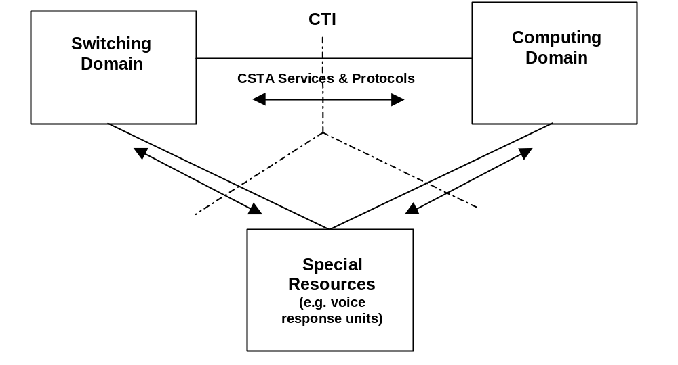
Figure 6 - CSTA Functional Model
In addition to the two base functional groups "switching" and "computing", a third functional group has been introduced called "special resources". These functions can be implemented in the CN or in, or close by, the computing equipment. An example for these functions is a centralized voice response unit guiding a calling user through a menu of decision trees.
CSTA standardization work is now based on a stable road map and has been carried forward to the international standardization process in ISO/IEC JTC1.
The convenor of ECMA TC32-TG11 acts as contact person.

Screenphone Terminal Services and Applications
This activity in TC32-TG16 started in early 1999 and is concerned with the integration of telephony and Internet access in a single device, often known as a "screenphone". Although simple integration of these functions does not depend on standardization, TC32-TG16 is focusing on the management of such devices by a service provider to achieve:
- implementation of low-cost dedicated terminal devices;
- service mobility / user mobility in the sense of VHE (Virtual Home Environment);
- zero maintenance end-user terminals (maintenance by network services, e.g. software updates);
- provision of “click-to-dial” features.
An ECMA Technical Report giving an overview of the subject is in the final stages of preparation and work is beginning on identifying requirements.
The convenor of ECMA TC32-TG16 acts as the contact person.

IP-based Multimedia Communications in a Business Environment
TC32-TG17 was formed in mid-1999 and is focusing initially on the interoperation of PISNs and Internet Protocol (IP) Networks for voice or multi-media communications, with emphasis on the following aspects:
- interworking of PISNs and IP networks via a gateway, primarily between QSIG and H.323 [but other protocols (e.g., SIP) are not precluded];
- connection of PISN components via IP network infrastructures (i.e., QSIG tunnelling);
- interworking H.450.1 and QSIG-GF;
- interworking considerations for Call Diversion;
- interworking considerations for Call Transfer;
A Technical Report analyzing the complex standards situation in this field is under preparation.
The convenor of ECMA TC32-TG17 acts as the contact person.

8 Objectives
The objective of the standardization plan is to get, in the context of corporate telecommunication networks, a complete overview of possible documents (European and international Standards and Technical Reports) covering all aspects of inter-operability between multi-vendor elements such as ISPBXs, computing devices, leased lines, public network capabilities such as VPN (including CENTREX), and interworking with relevant public networks services.
CN standardization planning has been set up at a time when ECMA worked co-operatively with CENELEC, which was based on a precursor plan (i.e. project M-IT-05). Numerous documents under the classical headers "Private Telecommunication Networks (PTN)" and, later during the co-operation with ETSI, under "Business Telecommunications" are already approved.
Since then the planning has been further developed continuously. Precursors of this document had been published as ETSI Technical Reports.

9 Justification
There is a strong market need for meeting requirements of corporations, end-users, CN managers, service providers (typically public network operators) and equipment suppliers, under their individual perspectives, for corporate telecommunication networks. In the modern economy world the globalization of corporative activities becomes more and more important. This is not only restricted to Europe, but is of world-wide significance.
Standardization in the CN field needs to ensure inter-connectivity and inter-operability between all CN elements and externally provided ("out-sourced") services, thereby taking account of international multi-vendorship in an international competitive environment.

10 Global context
Work related to CN standardization is also going on in organizations outside Europe, e.g. in ITU-T and in ISO/IEC JTC1. An overview of the most important subjects will be provided in the course of maintaining the EG. A first overview is given hereafter.

10.1 ITU-T
VPN activities have been taken up in SG11. They are focusing on the signalling aspects linked with the T+ reference point concept, see figure 2. The idea is to design a new protocol (called DSS1+) which is compatible with DSS1 and allows to distinguish between public ISDN and intra-VPN calls. For the latter the integrity of the corporate network signalling ("QSIG") information flows will be preserved.
SG16 has decided to base their Multi-Media specifications on QSIG.

10.2 ISO/IEC JTC1
Within the joint technical committee #1 of ISO and IEC, subcommittee SC6 is engaged in private network/corporate network standardization. A considerable number of European and ECMA standards has been adopted as international standards, in many cases without substantial modifications.

This Technical Report will be made available to ISO/IEC JTC1/SC6.

10.3 Co-operation between ITU-T and JTC1
Co-operation has been established between ITU-T SG 11 and JTC1/SC6 on the specification of VPN.

10.4 Global Virtual Network Service (GVNS) Forum
The GVNS Forum promotes the standard of GVNS, which is a global switched service supported by multiple (public) networks and which is offered to customers over PSTN and/or ISDN. While minimizing the need for dedicated network resources, GVNS provides private network functions to users at geographically dispersed (international) locations, ITU-T Recommendation F.16, ITU-T Recommendation Q 85.5 and ITU-T Recommendation Q 735.6.

10.5 Electronic Industries Association (EIA), USA, in particular the Telecommunication Industries Association (TIA)
Liaison with TIA has originally been established in the area of CN transmission aspects. Work is proceeding to define a common set of definitions and terminology. The work may be extended to cover transmission planning for PBX networks and for trans-Atlantic corporate networks.
Since the inauguration of TG17 closer co-operation in the IP multi-media field has taken place.

10.6 Other standardization bodies
There are numerous national and regional standardization bodies around the world which specify partial aspects of CNs, mainly limited to data transmission. However, interest in voice communication is growing and needs to be carefully monitored.

11 Resource requirements
The following committees are considered to be involved in the European environment (ETSI and ECMA):
ETSI TC/EP & ECMA TC | STC or TG
SPAN | SPAN2, ECTM
SPAN | SPAN1, SPAN3, SPAN5
TM
ECMA TC32 | TG11, TG13, TG14, TG16, TG17
HF | HF1
STQ
TIPHON
UMTS

Annex A

CN Taxonomy

The following tables show excerpts of the full taxonomy which is kept as a stand alone document.
Table A.1 shows a sample of the taxonomy data base.
The twigs of the taxonomy tree are logically structured in an open-ended way, i.e. any twig can be split into as many sub-twigs as necessary should new findings require so.
The Type column indicates whether a twig is actually a branch (Headline of subsequent sub-divisions) or should result in a Report or in a Standard.
The @ in the Committee column indicates either
- that at the respective level of the branch no definite allocation to a committee can be made; or
- that (as in 1.1.3.2) "foreign" standards can be used outside the control of ECMA (in ITU-T in this particular case).
Table A.1 - Sample of the taxonomy data base
Clause_Subject | Committee | PM Remarks | Type | ECMA-WI | ECMA Doc
0 General | TC32 |  | H
0.1 Taxonomy Document on possible CN Standards | TC32 | In Progress | R
1 Connection-oriented portion (PISN) | @ |  | H
1.1 General | @ |  | H
1.1.2 PISN Glossary of Terms | TG13 | Completed | S
1.1.3 Guidelines and Methods | @ |  | H
1.1.3.1 Methods for the Specification of Basic Services and Supplementary Services | TG13 | Completed | S | 32-11 | 134
1.1.3.2 CCITT/ITU-T Recs. and other standards applicable for PISNs | @ | No Stand. req. | S
1.1.3.3 Code of practice for network planning | STQ | Completed | R |  | ?
1.1.3.4 Application of Quality of Standards criteria to CN | TC32 | No Stand. req.
1.1.4 Functional requirements | TG13 |  | H
1.1.4.1 General principles and service aspects | TG13 | Completed | R |  | TR/57
1.2 Services | TG14 |  | H
1.2.1 Stage 1 (Description) | TG14 |  | H
1.2.1.1 Basic Services | TG14 |  | H
1.2.1.1.1 Bearer services | TG14 |  | H
1.2.1.1.1.1 Circuit-mode 64 kbit/s unrestricted | TG14 | Completed | S | 13-01 | 142
1.2.1.1.1.2 Circuit-mode 64 kbit/s unrestricted with tones and announcements (T/A) | TG14 |  |  |  | ?
1.2.1.1.1.3 Circuit-mode 3,1 kHz audio | TG14 | Completed | S | 13-01 | 142
1.2.1.1.1.4 Circuit-mode speech | TG14 | Completed | S | 13-01 | 142
1.2.1.1.1.5 Multi-rate bearer service | TG14 | Completed | S
1.2.1.1.1.6 Packet mode | TG14 | No Market
1.2.1.1.1.7 Frame mode | TG14 | No market
1.2.1.1.1.8 Cell mode (ATM) | TG14 | No Stand. req.
1.2.1.1.1.9 Broadband circuit mode (B-BC-SD) | TG14 | Completed | S |  | 261
1.2.1.1.2 Teleservices | TG14 |  | H
1.2.1.1.2.1 7 kHz telephony | TG14 | No Stand. req.
1.2.1.1.2.2 Videotelephony | TG14 | No Stand. req.
1.2.1.2 Supplementary Services, Overview Document | TG14 | Completed | R | 13-09 | TR/60
1.2.1.2.1 Number Identification services (IS-SD) | TG14 | Completed | S | 13-02 | 148
1.2.1.2.2 Name Identification services (NA-SD) | TG14 | Completed | S | 13-04 | 163
1.2.1.2.3 Call Forwarding (CF-SD) | TG14 | Completed | S | 13-05 | 173
1.2.1.2.4 Call Transfer (CT-SD) | TG14 | Completed | S | 13-07 | 177
1.2.1.2.5 Call Priority Interruption (CPI-SD) | TG14 | Completed | S |  | 263
1.2.1.2.6 Call Completion CCBS/CCNR (CC-SD) | TG14 | Completed | S | 13-11 | 185
1.2.1.2.7 Do Not Disturb (Override)(DND(O)-SD) | TG14 | Completed | S | 13-16 | 193
1.2.1.2.8 Call Offer (CO-SD) | TG14 | Completed | S | 13-14 | 191
1.2.1.2.9 Call Intrusion (CI-SD) | TG14 | Completed | S | 13-15 | 202
1.2.1.2.10 Advice of Charge (AOC-SD) | TG14 | Completed | S | 13-13 | 211
1.2.1.2.11 Conference CONF | TG14 |  | H
1.2.1.2.11.1 Add-ON conference | TG14 | No Stand. req. | S
1.2.1.2.11.2 Meet-Me conference | TG14 | No Stand. req. | S
1.2.1.2.12 In-Call Modification IM (IM-SD) | TG14 | No market | S | 13-23
1.2.1.2.13 User-to-user Signalling (UUS-SD) | TG14 | No market | S | 13-25

Further data fields (not shown in table A.1) relate the taxonomy twigs to the achievements in ETSI and in ISO/IEC JTC1.
Table A.2 shows, in a condensed format, the overview of the CN standardization area. The key for the Committee column is as for table A.1.
Table A.2 - Taxonomy Overview
Clause_Subject | Committee
0 General | TC32
0.1 Taxonomy Document on possible CN Standards | TC32
1 Connection-oriented portion (PISN) | @
1.1 General | @
1.1.2 PISN Glossary of Terms | TG13
1.1.3 Guidelines and Methods | @
1.1.4 Functional requirements | TG13
1.2 Services | TG14
1.2.1 Stage 1 (Description) | TG14
1.2.2 Stage 2 (Functional Model and Information Flows) | TG14
1.3 User-Network Interfaces (S Reference Point, Signalling Issues) | TG14
1.3.1 Layer 1 | TG14
1.3.2 Layer 2 | TG14
1.3.3 Layer 3 | TG14
1.4 Intra-PISN Interfaces (Q Reference Point, Signalling Issues) | TG14
1.4.1 Layer 2 | TG14
1.4.2 Layer 3 protocols | TG14
1.5 Inter-Network Interfaces | @
1.5.1 PISN --- Public ISDN (T Reference Point; Signalling aspects) | @
1.6 End-to-End Protocols | @
1.6.1 Channel aggregation | @
1.7 Network Aspects | @
1.7.1 Architecture | TG13
1.7.2 Network scenarios | TG13
1.7.3 PINX Functions to handle specific Scenarios | TG13
1.7.4 B-PISN Architecture | TG14
1.7.6 Open Network Provisions for PISNs | STQ
1.7.7 Network capabilities | @
1.7.8 Numbering, addressing and routeing | TG13
1.7.9 VPN, 64 kbit/s ISDN-based | TG13
1.8 Mobility architecture | TG14
1.8.1 General Principles | TG14
1.8.2 CN Support of Universal Personal Telecommunications (UPT) | TG14
1.9 Teleworking | @
1.9.1 Principles | @
1.10 High Speed/LAN | TG13
1.10.1 General | TG13
1.11 CN Network Management | @
1.11.1 General | @
1.11.2 Management Services | @
1.11.3 Management Protocols | @
1.11.4 Real Parts | @
1.11.5 Outsourced Parts | @
1.11.6 Security | @
1.12 CN Performance | STQ
1.12.1 General | STQ
1.12.2 Performance of the VPN | STQ
1.12.3 Overall Performance | STQ
1.12.4 Portion boundaries, reference connections and reference events | STQ
1.13 CN Human Factor Aspects (HF) | @
1.13.1 Man Machine Interface (MMI) | @
1.13.2 Audible and Visible Indications | @

1.14 Demonstration of Interoperability (Testing) | @
1.14.1 Formal (conformance) Testing | @
1.14.2 Interoperability Testing (T reference point) | SPAN5
1.15 Method for interworking between computer and switching applications (CSTA) | TG11
1.15.1 General | TG11
1.15.2 Services for CSTA | TG11
1.15.3 Protocols for CSTA | TG11
1.15.4 Application programming interface | TG11
1.15.5 Management | TG11
1.16 PISN IN | @
1.16.1 Architecture | @
1.18 CN Multimedia | TG13
1.18.1 General | TG13
1.19 Screen Phone Terminal Applications | TG16
1.19.1 General | TG16
1.19.2 Architecture | TG16
1.19.3 Protocols | TG16
1.19.4 Security | TG16
1.19.5 Multiple usage aspects | TG16
2 Connectionless portion (IP-networks) | TG17
2.5 Internetwork Interface (PISN---IP-networks) | TG17
2.5.1 Interoperability B-PISN<>IP-networks | TG17
2.7.1 Architecture | TG17
2.7.8 Addressing | TG13
2.15 CSTA call control in IP networks | TG11

Annex B

Circular Letter 1053 on private network standardization

Summary
ETSI has signed contracts with external bodies with regard to its responsibility on private network standardization.
It is necessary that the existence of these contracts and their impact on the daily work in ETSI are made aware to ETSI officials (TC Chairmen, STC Chairmen, etc.) and member delegates, since these contracts bind the whole of ETSI with this regard.
It is also necessary that ETSI officials and member delegates respect these contracts in all their ETSI activities.

B.1 Contracts
These contracts are:
- ETSI committed to accept Bons de Commande IT-74 to IT-77 [2].
- The settlement of the Private Telecommunications Network Field between CENELEC, ETSI and ECMA (16.1.1991).
- The Agreement on Co-operation in the Work Activity for Standardization in the Field of Telecommunications (26.4./2.5.1991), between ETSI and ECMA establishing JEEC, a decisive joint ECMA/ETSI committee.
- The JEEC decisions.
- Liaison with ISO/IEC JTC1.
- Agreement between ETSI and CEN on the conversion of International Standards produced by JTC1/SC6/WG6 into ETSs.

B.1.1 Bons de Commande
The Bons de Commande cover private networks and their components, and define:
- private networks can consist of PABXs and/or private network services offered by the public telecommunication networks;
- this includes subjects like VPN and CENTREX.
The Bons de Commande require the production of standards for:
- private network architecture, numbering, routeing, methodology;
- basic and supplementary private network services, down to protocol level at the terminal interface and at the interface between PINXs;
- interworking of services with those of public networks and vice versa;
- performance within private networks and for overall-connections passing through public and private networks.
ETSI committed on the Bons de Commande at ITSTC.
B.1.2 The settlement of the Private Telecommunications Network field between CENELEC, ETSI and ECMA
This contract endorses the above commitment according to 1.1 binding to ETSI. In particular, it puts an onus on all TCs to take care of interworking with private networks.

B.1.3 The co-operation agreement between ETSI and ECMA
Within the framework of 1.2, ETSI stepped into the co-operation agreement which ECMA had with CENELEC. This required that the allocation of work between ETSI and ECMA be under the control of a common paritary committee. As a consequence the Joint ECMA/ETSI Committee (JEEC) has been founded. JEEC's work includes, but is not limited to, partitioning of standardization work between ECMA and ETSI.

B.1.4 JEEC Decisions
In principle, JEEC decisions are binding for ETSI and ECMA. Exceptionally, there may be the need for ratification by the ETSI TA and by the ECMA GA.

B.1.5 Liaison with JTC1
ETSI has applied for A liaison with JTC1, the main reason being that ETSI can use JTC1's so called fast track procedure to forward ETSs to be endorsed as International Standards. In order to avoid arguments at international level whether Europe would deserve a single vote only rather than multiple national votes, the fast track procedure shall only be used in very exceptional cases. Since ECMA committed to provide its long standing experience on this subject to JEEC, JEEC has decided that any fast track intention be approved by JEEC before it is actually initiated.

B.1.6 Conversion of International Standards produced by JTC1/SC6/WG6 into ETSs or ENs
In Europe the regular mirror body for JTC1/SC6/WG6 is CENELEC. However, aligned with the contract under 1.2 above, CENELEC has delegated this role to ETSI for the SC6/WG6 part of JTC1. ETSI has, in so far, stepped into the CENELEC/JTC1 arrangements. These require that International Standards developed by SC6/WG6 be converted by ETSI into European Standards, i.e. ETSs or ENs.

B.2 CN Standardization situation in ETSI
Based on 5 years experience in the standardization of private networks/corporate networks in ETSI, a number of problems have been encountered. As the objective of The present document is to draw the attention mainly to the contractors part as mentioned in clause 1, not detailed cases are referred to here.

B.3 Measures to be taken
It is proposed that the following measures be taken:
- The present document shall be distributed by the TC Chairmen through the mailing lists of their TCs and STCs, together with the urgent request that the TC and STC members have to respect the ETSI external and internal contracts for all their ETSI related activities.
- Any activities infringing the contracts ETSI has signed are to be abandoned. If members indicate that they cannot adhere to the contracts, the ETSI Officials are obliged to bring the case up to the TCC Chairman.

Annex C

Bon de Commande BC-T-326: Standardization Mandate forwarded to CEN/CENELEC/ETSI in the field of information technology and telecommunications

EUROPEAN COMMISSION

DIRECTORATE-GENERAL III
INDUSTRY
Legislation and standardization and telematic networks
Standardization
Brussels, 8 March 1995
KHL/uk/5320-003
DGIII/B/2

M/92

SOGT 94/65.2

SOGITS N 797.2

BC-T-326

DRAFT STANDARDIZATION MANDATE FORWARDED TO CEN/CENELEC/ETSI IN THE FIELD OF INFORMATION TECHNOLOGY AND TELECOMMUNICATIONS

TITLE

Corporate telecommunication Network standardization
PURPOSE
The purpose of this mandate is the establishment of voluntary European Standards covering the elements involved in Corporate telecommunication Networks. These elements include, inter alia, Telecommunication Terminals, Leased Lines, Public Network Services such as Centrex, Virtual Private Networks and Switched Network Infrastructures. The interoperability between private and public domains for the purpose of Corporate telecommunication Networks should also be covered by the standards and the standards should include specifications as to how interoperability of elements conforming to the above standards can be demonstrated.

JUSTIFICATION
This mandate derives from the need to ensure that standards permit the widest possible range of customer facilities in the construction of Corporate telecommunication Networks. This need is clearly spelt out in the Action Plan contained in "Europe and the global information society. Recommendations to the European Council" (The Bangemann Report) under the subchapter: "Interconnection and Interoperability".
There is a need to develop further standards in this area due to the various interest groups involved:- network operators, terminal equipment manufacturers and end users. It should be noted that standards involved in this area can straddle both Mandatory and Voluntary regimes and Corporate telecommunication Networks are often world-wide.
ETSI has recognized the importance of this area, which is covered by several Standardization Work Areas. To that effect a mandate, BC-T-245, was launched by the commission to support the conformance testing activities in this area. Under mandate BC-IT-74 - 77 some of the standards for interworking between private and public services have been developed (QSIG etc.).
In order to ensure the timely development of standardization a project management approach is applied to Corporate telecommunication Network standardization.

ORDER
This mandate constitutes in two parts to be implemented consecutively. The first part requires the preparation of an ETSI Technical Report (ETR) with a proposal for a work programme in the area of Corporate telecommunication Network standardization. The second part, based on the options and possibilities identified in the ETR shall require the establishment of European Standards covering elements involved in Corporate telecommunication Networks, and the specifications on how interoperability of the elements conforming to the above standards can be demonstrated.

RECOMMENDATIONS
The need for end users, special interest groups such as the IPNS Forum and industry associations like ECMA should be taken into account. Similarly, the experience of test laboratories and Notified Bodies is vital to the specifications on interoperability demonstration.

PROPOSED SCHEDULE
December 1995 | Adoption of ETR
December 1996 | Adoption of ETS(s)

ALIGNMENT WITH OTHER INTERNATIONAL WORK
Proposals for Corporate telecommunication Network standardization shall be based on existing standards. In particular, account shall be taken of relevant work done in ETSI/CEN/CENELEC. As Corporate networking is of interregional interest alignment with equivalent activities in other regions, the ITU and in ISO/IEC should be ensured.

STANDSTILL
For the terms of Article 7 of the Directive 83/189/EEC, the standstill applies for the standards developed under this mandate.

PUBLICATION IN THE OFFICIAL JOURNAL
A title and summary in the 9 languages of the Community is required.

Annex D

Bibliography

This annex lists documents providing background information considered helpful for the understanding of the present document.
- ITAEG-T M-IT-05.
- Settlement of the Private Telecommunication Network Field between CENELEC, ETSI and ECMA (16.1.1991).
- The Agreement on Co-operation in the work activity for standardization in the field of telecommunications (6.10.1995), between ETSI and ECMA, establishing JEEC.
- Agreement between ETSI and CEN on the conversion of International Standards produced by JTC1/SC6/WG6 into ETSs.
- SRC4 Report.
- SRC5 Report.
- SRC6 Report.
- Circular Letter 1053 with attachment "Private Network Standardization". The attachment is reproduced as annex C to this Technical Report.
- ETR 076: The ETSI Standards Guide.
- EG 201 017: "Corporate telecommunication Networks (CN); Project Plan".
- ITU-T Recommendation F.16: "Stage 1 Description for Global Virtual Network Services".
- ITU-T Recommendation Q.85.5: "Stage 2 Description for community of interest supplementary services, Global Virtual Network Services".
- ITU-T Recommendation Q.735.6: "Stage 3 Description for Global Virtual Network Services (GVNS); Supplementary Service using Signalling System No. 7".
- EG 201 050: "Corporate Telecommunication Network (CN); Overall transmission planning for telephony on a corporate network".

.
.

Free printed copies can be ordered from:
ECMA
114 Rue du Rhône
CH-1204 Geneva
Switzerland
Fax: +41 22 849.60.01
Email: documents@ecma.ch
Files of this Technical Report can be freely downloaded from the ECMA web site (www.ecma.ch). This site gives full information on ECMA, ECMA activities, ECMA Standards and Technical Reports.

ECMA
114 Rue du Rhône
CH-1204 Geneva
Switzerland
See inside cover page for obtaining further soft or hard copies.

The term “Wireless Terminal Mobility” (WTM) is replacing the term “Cordless Terminal Mobility” (CTM), due to international agreement at JTC1.

