Creating MovieLib
==============

1. Server
========

$ mkdir movielib
$ cd movielib
$ npm init (start NodeJS project)

> info about app
package name: …
version: ---
test command: jest

$ npm I express --save (“I” here is lowercase) (Add express dependencies)
$ npm I typescript @types/node @types/express --save-dev (Add to dev dependencies)

> info about github
$ npm I (When you work in paralell in a project. Download the repot from Github and then write npm i to download all those dependencies from package.json)

> test API

- create a movie in server/movie.service

let movies: {[key : number] : Movie} = {
35 : {
id: 35,
titel: "Harry Potter- Viselsten",
year: "2005",
description: "Harry som ung",
picture: "hfhfhf",
genre: "Adventure",
favorite: false
}
};

$ npm run dev //start the server
$ curl localhost:8080/movie // you should see the movie info as an object

- create a movie via PUT or POST

$ curl localhost:8080/movie -X PUT -H 'Content-Type:application/json' -d '{"titel":"Superman", "year":"1999", "picture":"link", "description":"Louise & Clark", "genre":"Adventure"}'

- Delete a movie with DELETE
$ curl localhost: -X DELETE localhost:8080/movie/movieId

- Add movie as favorite
$ curl -X PUT localhost:8080/movie/favorite/movieId

- Delete a movie from favorite with DELETE
$ curl localhost: -X DELETE localhost:8080/movie/favorite/movieId

2. Tets server
==========
$ npm install --save-dev jest typescript ts-jest @types/jest

$ npx ts-jest config:init to create the jest.config.js file.
- Change the scripts field in package.json to:
"scripts": {
"dev": "ts-node-dev --respawn --pretty --transpile-only src/index.ts",
"test": "jest"
},

> Write some tests and the run

$ npm test or npx jest

3. Frontend React
=============
$ cd movieLib
$ cd client
$ npx create-react-app . --template typescript

>> If your project is not created with TypeScript enabled, npx may be using a cached version of create-react-app
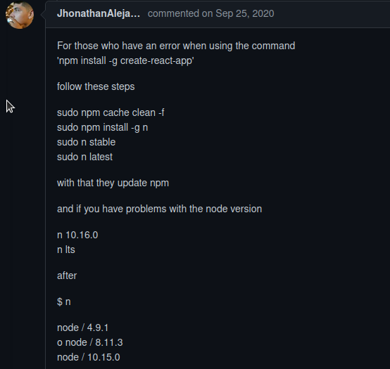
>> Otherwise:

$ npm start //Start the server for the web page

Now when we are two server (one for backend and an other for frontend), Let’s unified it for a simplicity purpose).

$ npm run build

>> make the connection backend and frontend in server/start.ts

$ npm run dev

> http://localhost:8080/

$ npm I axios - -save

4. Design frontend with prime react
============================

$ npm install primereact --save
$ npm install primeicons –save
$ npm install react-transition-group –save
5. Mongo DB
===========

$ npm i mongodb mongoose –save
$ npm i @types/mongodb @types/mongoose –save-dev

> mongodb+srv://gmiak:<password>@movielib.eexy9.mongodb.net/myFirstDatabase?retryWrites=true&w=majority

> MongoDB Compass is a GUI for MongoDb

