Quick Overview:

Open the PolarographicSystemMonitor.m Matlab function, and run it. You will be presented with the following GUI

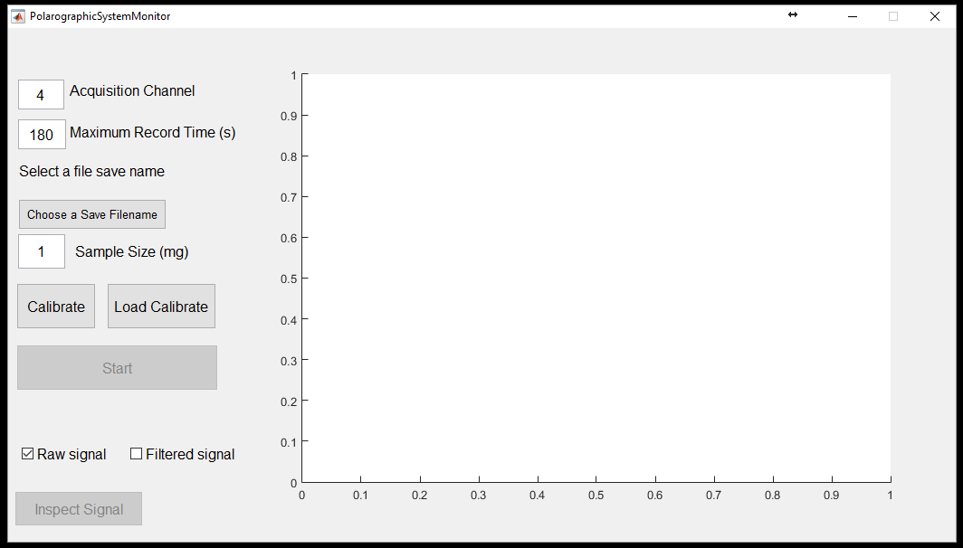

Enter the Acquisition channel from the NI DAQ (Should be between 0 and 7 with the current DAQ, default is 4 because that is how the leads were attached upon arrival).

Enter the Maximum Record Time in seconds. Your experimental data collection will stop after this amount of time. However, you can always stop it early. Maximum time is set to 40 minutes, and the default is set to 3 minutes.

If you don’t have a calibration dataset yet, you must first create one of those. Select the ‘Calibrate’ pushbutton. It will open a new figure:

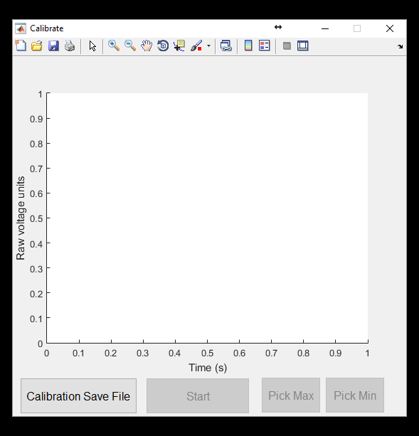

Choose the file you want to save your calibration results to, e.g., Calibration_08072016 in our example. Create the environment of 100% oxygen, and press the ‘Start’ button. After eliminating the oxygen, press the stop button. You might have something that looks as follows:

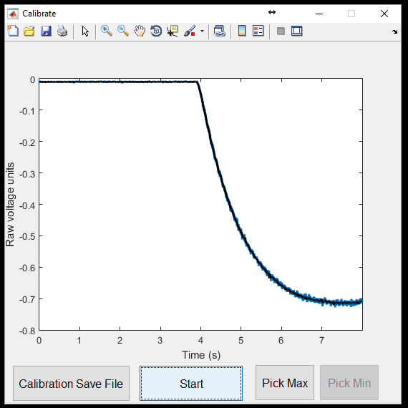

Now you need to get the Maximum and Minimum setpoints, to scale the raw voltage units to the Oxygen percentages (100% and 0%). Press the ‘Pick Max’ button and use the Zoom in button to select the area under which you would like to average to get the ‘Maximum’. Click on figure to set the first point, then shift+click to set the second point. You can drag these points around until you’re satisfied with their placement. Press ‘OK’ on the dialog when you’re satisfied. The average vale will become your maximum setpoint, and appears at the top right of the box

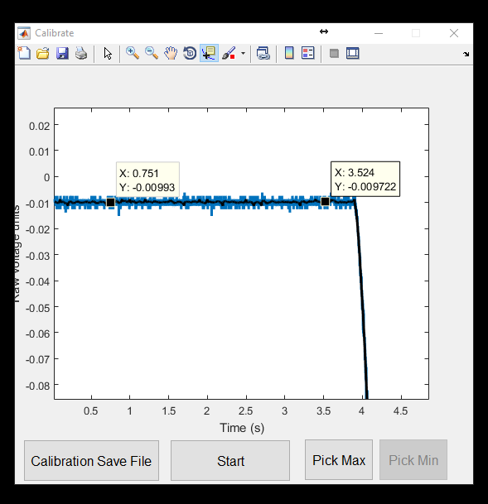

Repeat for selecting points for the minimum:

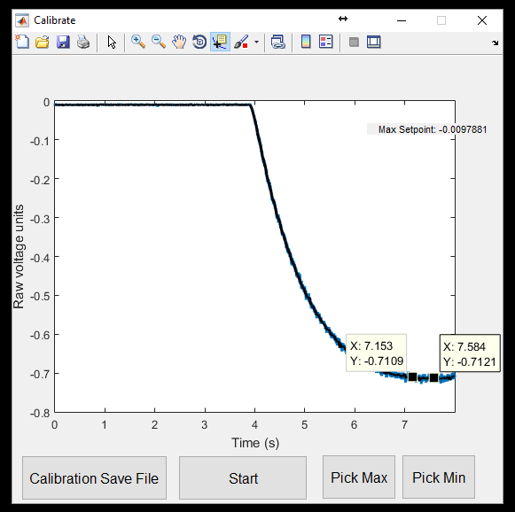

And press the ‘OK’ button when satisfied. When you have both the Max and Min setpoint in the top right of the figure (as below), and are satisfied with those selections you can just close the window. Upon closing the window, the calibration data and setpoints are written to .csv files as you specified.

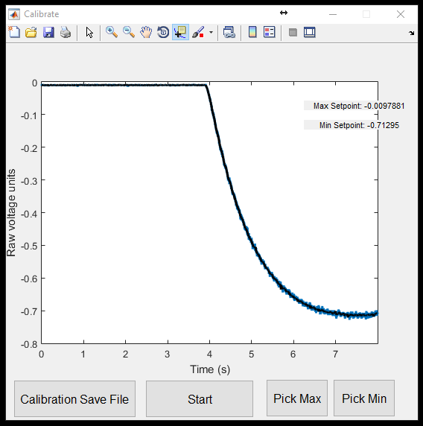

Choose the filename to save your experimental data to by clicking the ‘Choose a Save Filename’ pushbutton.

After creating the calibration file, you can load this in by selecting ‘Load Calibrate’, and then load in the calibration file you just created. The filename you select will be Calibration_08072016.pick.csv. This file just has the maximum and minimum setpoints. If you look inside the file, you’ll see it has something like: 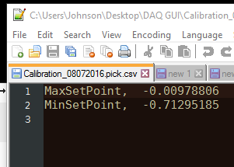

The other file created, Calibration_08072016.data.csv contains the raw data from the experiment. If you import that data somewhere (like Matlab, for instance), the first column is the time stamps, the second contains the raw voltage units measured, and the third column contains a slightly filtered version of the raw units, i.e., the blue and black lines in the previous figure.

After the calibration setpoints are loaded, you need to select a filename to save the data in your experiment to. Do this by pressing the ‘Choose a Save Filename’ button. We will name ours in this example ‘experiment1’:

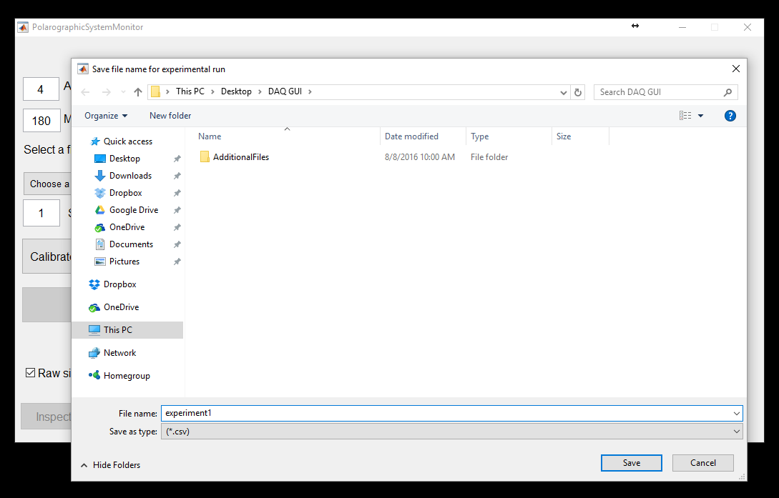

Enter the sample size of your experiment (in milligrams). The derivative will later be scaled by this value.

At this point, you’re ready to start your experiment. Press ‘Start’ to begin recording data. You can select to view the raw data, or lightly smoothed data by checking/unchecking the ‘Raw signal’ and ‘Filtered signal’ boxes. After some time you may have something like this:

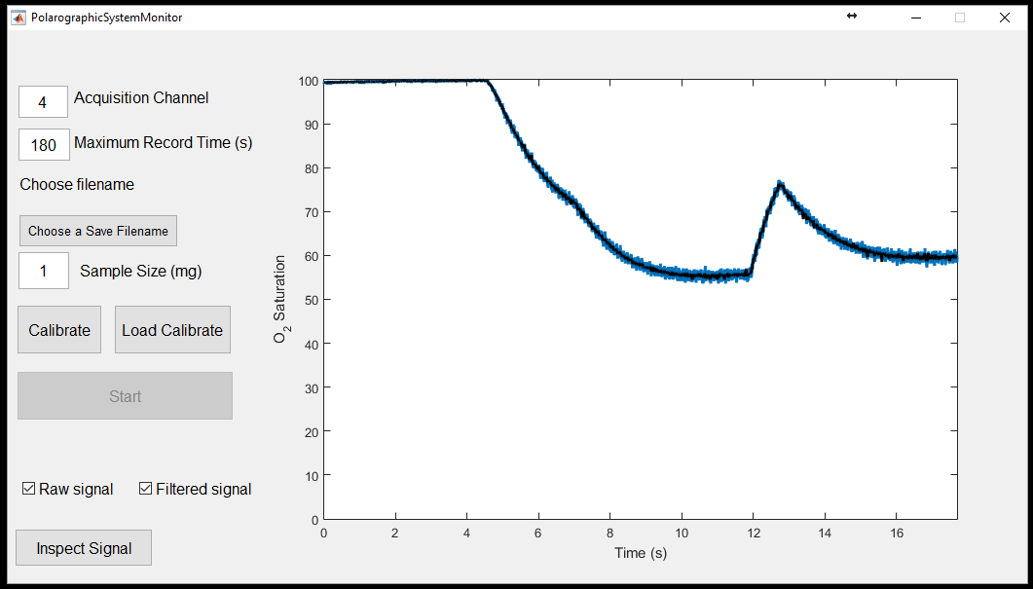

Maybe you’re done after about 18 seconds or so, and hit ‘Stop’ instead of recording all 3 minutes.

Now you have the option to ‘Inspect Signal’ by pushing the associated button.

A new figure opens, displaying the Raw, Filtered, and Scaled derivative of the signal (scaled by dividing by the Sample Size (mg) previously entered). The default filter applied is a zero-phase moving average filter of length 0.1 seconds. You can see there is still a lot of noisy activity:

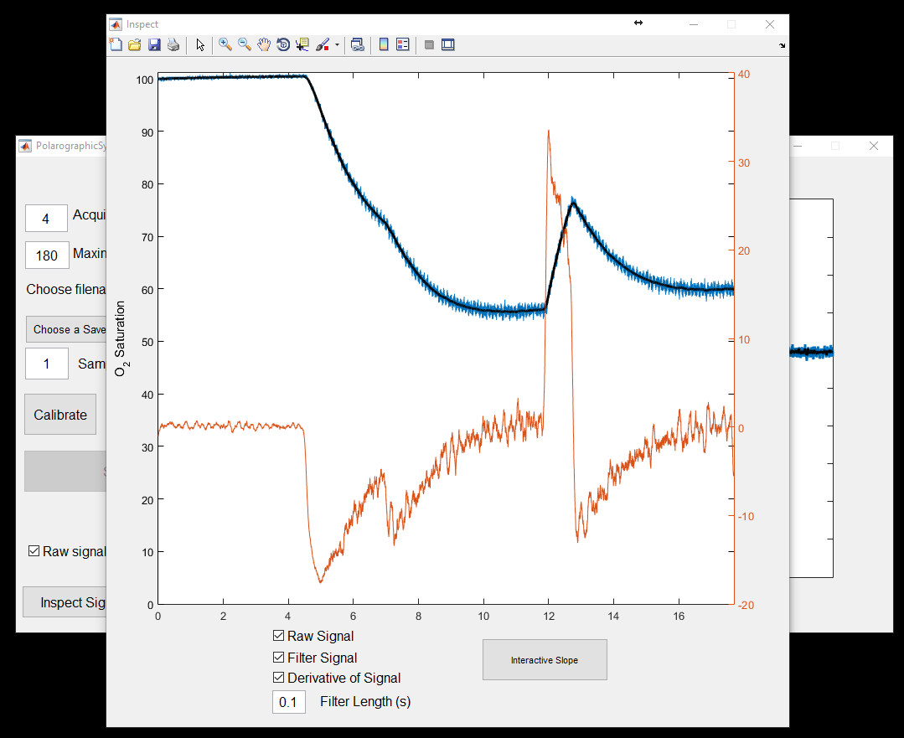

If you increase the filter length, this can smooth the signal out more. For instance, at a filter length of 0.3 seconds we have a much smoother signal:

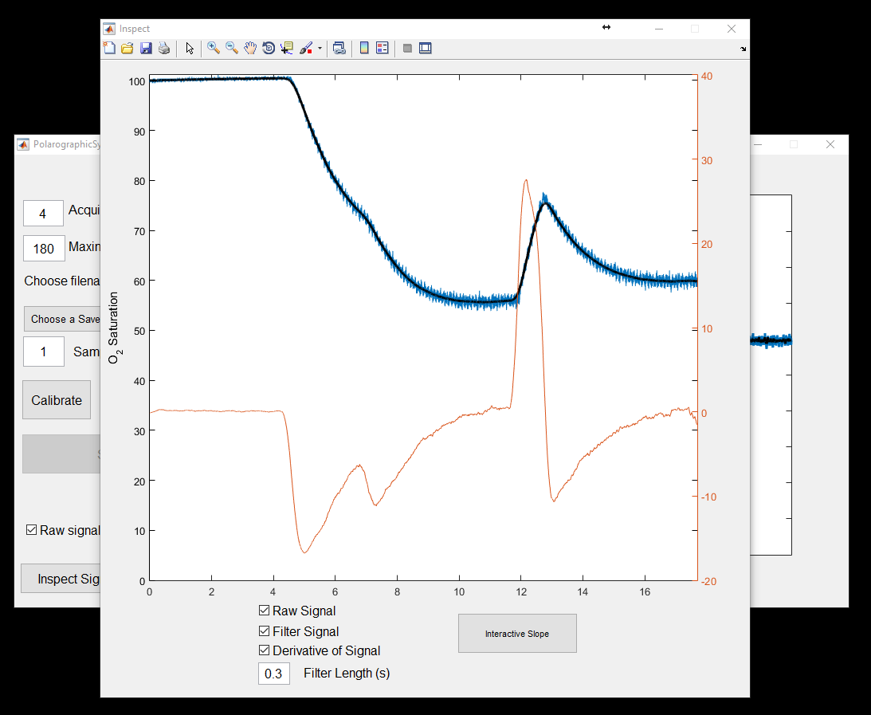

Be wary of over-smoothing, but this filter length should be determined by the dynamics of your system. Once satisfied with the filter length, you can also manually determine slopes over different ranges by pushing the ‘Interactive Slope’ button. This will prompt for a the user to select two points (as before) using the Cursor:

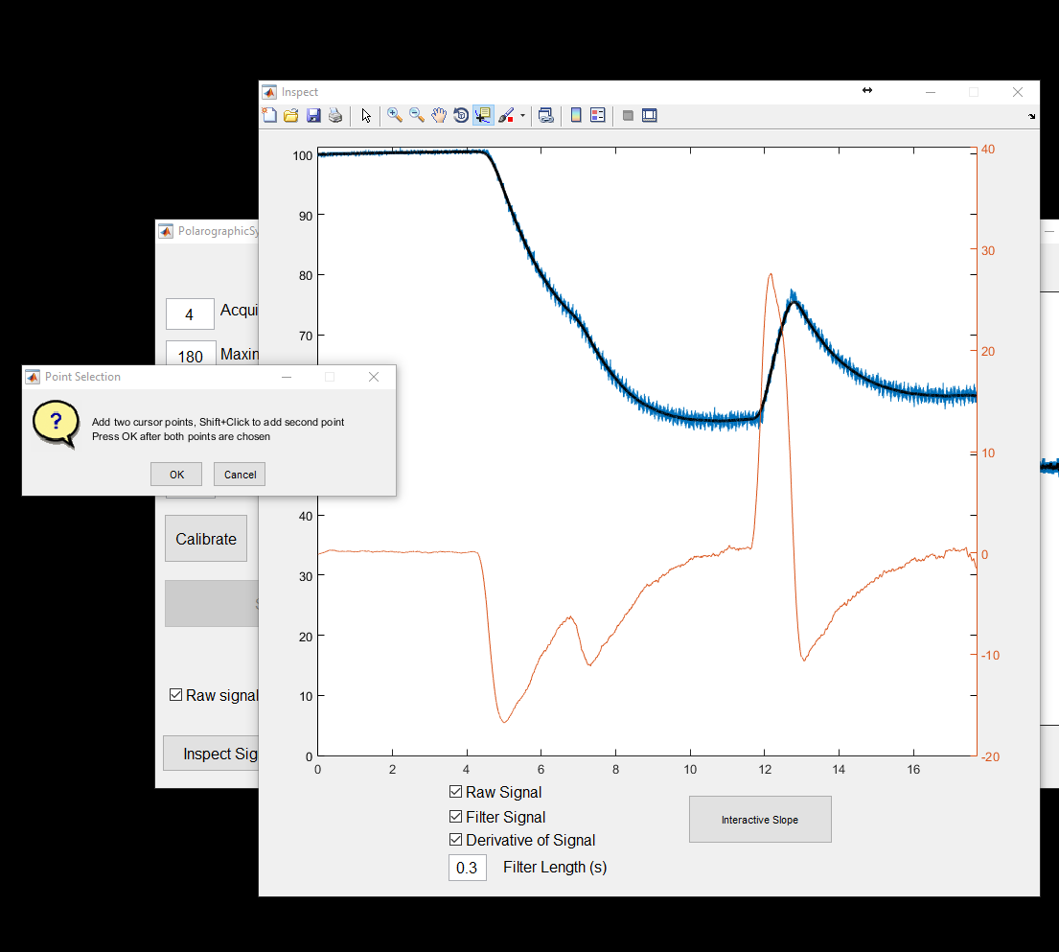

Zoom in and select the points as before:

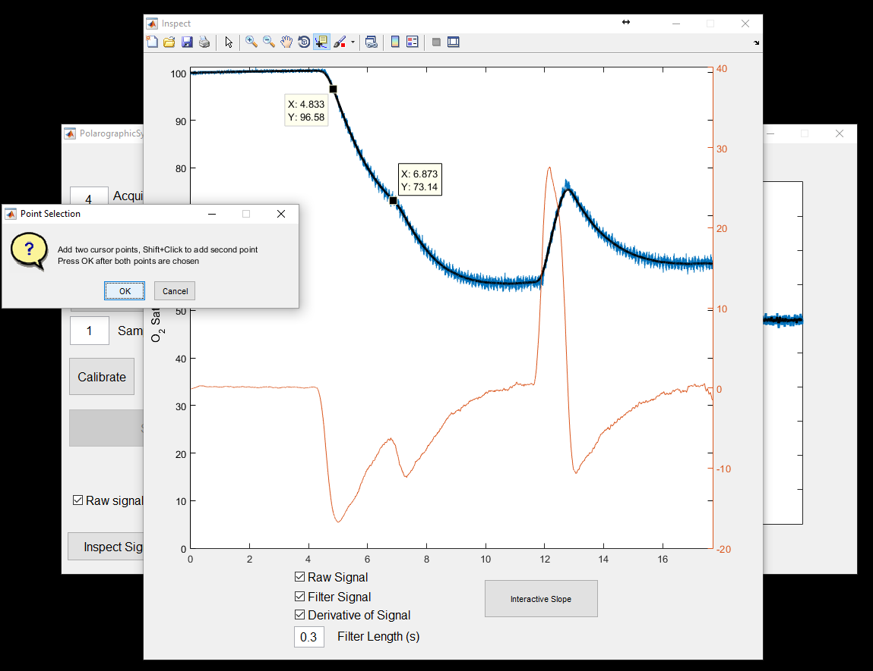

Pressing ‘OK’ will add vertical bars to the graph and give you a scaled calculation of the derivative over that time period (as opposed to the instant derivative calculation of the orange plot):

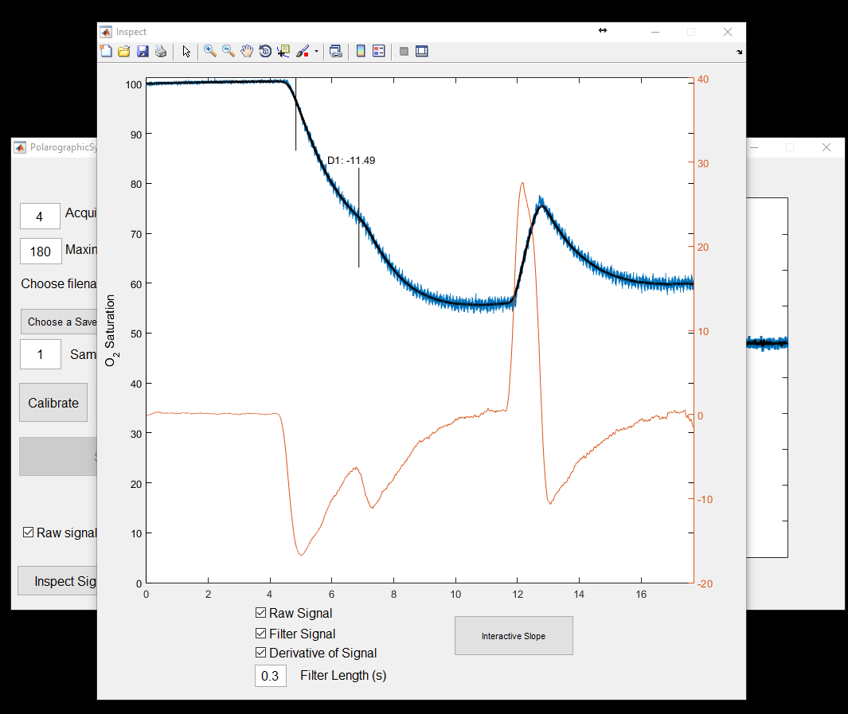

After we repeat this for all the time periods we find, we can just close the figure. This saves the .filtered.csv file, and the .slopePoints.csv file. The .filtered .csv file has 5 columns of data: Timepoints, raw DAQ voltages, DAQ voltages converted to the Oxygen scale, the filtered Oxygen values (based on the last filter length selected), and the instantaneous estimates of the derivatives. The slopePoints.csv file contains the points of interest that we previously selected:

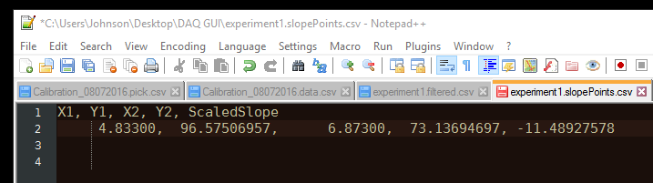

You can now close the GUI, or run a new experiment by selecting a new filename.