How Well Do State-of-the-Art Large Language Models Write Ancient Greek? A Chunk-Level Stylometric Resource and Evaluation
George K. Mikros
[Affiliation — department, institution, city, country to be confirmed]
ORCID: [0000-0000-0000-0000 — to be confirmed]
Corresponding author. E-mail: [email to be confirmed]

Abstract
We release a chunk-level corpus of human Attic-orator prose paired with rewrites produced by two state-of-the-art large language models, GPT-5.5 and Claude 4.8, under two prompting regimes — a close-rewrite (Restricted) regime and a meaning-preserving but flexible (Free) regime — together with an older-generation baseline that supports a longitudinal view. The resource comprises 6,610 chunk-level texts (1,322 human and 5,288 machine) spanning the ten canonical Attic orators, with a datasheet, the generation prompts and the full analysis code. Using it, we evaluate how closely the generated Ancient Greek reproduces human style across 84 stylometric features and two families of neural document embeddings, with linear mixed-effects models that respect the nesting of chunks within documents and authors. Human and machine Ancient Greek differ on a majority of features (36 of 69 estimable features are significant after false-discovery-rate correction), but every effect is small (all Cohen’s d below 0.34): the models write denser, lexically richer and more finely segmented prose, while the orators favour longer, more periphrastic sentences. The pooled contrast conceals a sharp gradient — model choice and especially prompting regime move the texts at least as much as the human/machine distinction — so that the most constrained configuration (Claude 4.8, Restricted) is statistically indistinguishable from genuine Attic oratory under a stylometric classifier, whereas the freest (GPT-5.5, Free) is trivially detectable. State-of-the-art models can therefore write stylometrically human-like Ancient Greek, but only under prompting that constrains length, segmentation and register.
Keywords Ancient Greek · Stylometry · Large language models · Language resources · Machine-generated text detection · Computational philology

1 Introduction
Large language models now produce fluent, controllable prose in dozens of languages, and their few-shot and instruction-following abilities make it possible to elicit text in a target language and register through prompting alone (Brown et al. 2020; Bommasani et al. 2021; Wei et al. 2022). Their competence is, however, distributed very unevenly: performance remains markedly weaker for low-resource languages (Zhu et al. 2024), and the historical languages of the scholarly canon — attested only in a finite, centuries-old corpus and largely absent from everyday web text — are among the most data-scarce of all. Ancient Greek is the paradigm case. It is at once a high-prestige object of study, with a continuous philological tradition and a large readership of students and scholars, and a genuinely low-resource target for natural-language processing. The question this paper addresses is not whether a model can read or translate Ancient Greek, which a growing body of work already examines, but whether it can write it: produce original prose that reproduces the measurable stylistic profile of a specific historical register.
The question matters in three distinct communities. For classical pedagogy and the construction of language resources, models that generate stylistically faithful Greek would offer a new source of graded reading material, exercises and — most consequentially for natural-language processing — synthetic data to augment the small annotated corpora on which Ancient Greek tools are trained (Bamman and Crane 2011; Vatri and McGillivray 2018; Keersmaekers 2021). For stylometry and authorship analysis, the same capability is a challenge rather than an opportunity: if a model can write convincingly in the manner of a fourth-century orator, the provenance of digital text becomes harder to establish, and the detection of machine-generated text — already a fast-moving field for modern English (Crothers et al. 2023; Tang et al. 2024) — must be extended to historical languages and to the forensic questions that classics will increasingly face (Mikros 2025b). And for the study of the models themselves, a historical register with a rich, well-described stylistic signature is an unusually demanding and well-instrumented testbed for controllability: how far, and under what prompting, a general-purpose model can be steered toward a precise stylistic target.
Ancient Greek is also an informative case because it is hard in ways that bear directly on measurement. Its rich fusional morphology and relatively free word order push much of its stylistic signal below the lexical surface — into case and mood distributions, dependency structure and particle usage — where authorship signals are correspondingly harder to recover than in less inflected languages (Juola et al. 2019). Syntactic stylometry over dependency treebanks can nonetheless identify the authors of short Greek texts without recourse to vocabulary (Gorman 2020), which makes morphosyntactic features the natural instrument for a human-versus-machine comparison. The most directly relevant precedent is cautionary: an earlier-generation model’s attempts to imitate individual authors stayed measurably separable from genuine human writing (Mikros 2025a). Whether the latest generation of models closes that gap, and under what prompting, remains an open question.
It is open in part because the evidence needed to answer it does not yet exist. Prior work concentrates on understanding or translating historical text, or on imitating modern authors; no study, to our knowledge, evaluates at corpus scale how closely contemporary large language models reproduce the style of a historical language, using a statistical design that respects the nested structure of the data and accompanied by a released resource that others can reuse. This paper is built to fill that gap.
We assemble and release a chunk-level parallel corpus of human Attic-orator prose and state-of-the-art machine rewrites, and we use it to evaluate stylistic fidelity rigorously. The human side comprises 119 texts from the ten canonical Attic orators, segmented into 1,322 length-controlled chunks. Each chunk is rewritten by two current models, GPT-5.5 and Claude 4.8, under two prompting regimes — a Restricted regime that asks for a close, length- and order-preserving rewrite, and a Free regime that preserves meaning but allows idiomatic licence — yielding a balanced two-by-two design and a corpus of 6,610 chunk-level texts. The resource additionally includes an older-generation baseline (GPT-4o and Claude 3.5) to support future longitudinal study of model progress; because that material is anchored on whole documents rather than re-chunked, it is released with the corpus but is not analysed here. We compare human and machine prose across 84 stylometric and linguistic features and two families of Ancient-Greek neural document embeddings, using linear mixed-effects models with random intercepts for author and document, false-discovery-rate control, bootstrap confidence intervals, and author-grouped classifiers.
Three research questions organise the evaluation. RQ1: how closely does the Ancient Greek produced by state-of-the-art models match the style of the human orators, measured both by interpretable stylometric features and by neural embeddings? RQ2: how is that fidelity modulated by the choice of model and, especially, by the prompting regime? RQ3: which authors and which linguistic features are hardest for the models to reproduce, and what does the residual difference consist of?
In answering them the paper makes four contributions. First, it releases a documented language resource — the parallel human/machine corpus, a datasheet, the generation prompts, and the complete feature-extraction, embedding and analysis pipeline — designed for reuse in stylometry, machine-generated-text detection and historical-language natural-language processing. Second, it introduces a chunk-level methodology that solves the length-reproduction problem of whole-document rewriting and fixes the segmentation granularity through an explicit calibration experiment. Third, it provides a rigorous, reproducible evaluation that respects the nested and heavily imbalanced structure of the oratorical canon through author-level random effects and author-grouped cross-validation. Fourth, it reports a clear empirical result: the difference between human and machine Ancient Greek is pervasive but uniformly small, and it is strongly modulated by prompting, to the point where the most constrained configuration is statistically indistinguishable from genuine Attic oratory while the freest is trivially detectable.
The remainder of the paper is organised as follows. Section 2 reviews the five research strands on which the study builds. Sections 3 to 5 describe the resource — corpus construction, feature extraction and document embeddings, and the evaluation methodology. Section 6 reports the results, and Sections 7 and 8 discuss their implications and conclude.

2 Related Work
This study sits at the convergence of five research strands: computational stylometry and authorship attribution, the computational philology of Ancient Greek, language resources and pretrained models for Ancient Greek, large language models for low-resource and historical languages, and the detection of machine-generated text. We review each in turn, drawing out the methods and findings on which the present resource and evaluation build, and the gap they are designed to fill: a documented, chunk-level corpus that pairs human Attic-orator prose with state-of-the-art large-language-model rewrites, and a statistically rigorous account of how closely, and under what conditions, the machine prose reproduces the style of human Ancient Greek.

2.1 Stylometry and authorship attribution
Stylometry — the quantitative study of linguistic style — has a long pedigree in the digital humanities, from early word-length and function-word studies to modern machine-learning pipelines (Holmes 1998). Its central premise, that authors leave measurable and relatively stable stylistic fingerprints in features largely below conscious control, underpins both authorship attribution and the human-versus-machine comparison pursued here. The most influential distance-based method is Burrows’s (2002) Delta, which ranks candidate authors by the mean absolute difference of standardised high-frequency word frequencies; its geometric and probabilistic foundations were subsequently clarified by Argamon (2008), and the wider family of Delta measures was systematically evaluated by Evert et al. (2017).
Comprehensive surveys (Juola 2006; Koppel et al. 2009; Stamatatos 2009) and comparative evaluations of techniques (Grieve 2007) map the broader feature space — function words, character and word n-grams, part-of-speech and syntactic patterns, and lexical-diversity indices — together with the classifiers built upon it, much of which is now packaged in widely used tools such as the stylo package for R (Eder et al. 2016). The present study inherits this tradition’s feature families and its reliance on standardised effect sizes and distance metrics, but redirects them from their usual target — discriminating among human authors — toward a different contrast, that between human and machine writers of the same language.

2.2 Computational philology and stylometry of Ancient Greek
Quantitative authorship study of Greek is itself decades old: Michaelson and Morton’s (1972) one-word test for Greek writers is an early instance of statistical authorship discrimination on the classical corpus. Modern work has moved from word-frequency methods to syntactic stylometry over dependency treebanks, an approach especially attractive for a heavily inflected, relatively free-word-order language: Gorman and Gorman (2016) use syntactic n-grams to probe text reuse in Greek historiography, and Gorman (2020) shows that author identification of short Greek texts is feasible from dependency-treebank features alone, without recourse to vocabulary.
Stylometric and computational methods have likewise been brought to bear on canonical authorship problems, including the Homeric question (Pavlopoulos and Konstantinidou 2023) and the disputed Aeschylean authorship of Prometheus Bound (Manousakis 2020). The same verification machinery has resolved high-profile cases in the sister classical language, attributing a newly discovered work to a major second-century author (Stover et al. 2016) and authenticating the writings transmitted under Caesar’s name (Kestemont et al. 2016). Closer to the present author’s own work, stylometric attribution has been applied to Modern Greek social-media text (Mikros and Perifanos 2013), and a tightly controlled bilingual study found authorship attribution to be markedly harder in Greek than in English — a gap attributed to Greek’s richer morphology (Juola et al. 2019). This last finding directly motivates two design choices in the present work: the prominence of morphological features (case, mood, tense, and aspect) in our feature set, and the author-level random effects and author-grouped cross-validation used to keep the unevenly represented orators from dominating the estimates.

2.3 Language resources and models for Ancient Greek
The feasibility of a large-scale computational evaluation of Ancient Greek rests on more than a decade of resource building. Syntactically annotated treebanks — the Ancient Greek and Latin Dependency Treebanks (Bamman and Crane 2011), the PROIEL treebank (Haug and Jøhndal 2008), and the Pedalion treebanks (Keersmaekers et al. 2019) — supply the training data for modern parsers, while large lemmatized corpora such as Diorisis (Vatri and McGillivray 2018) and GLAUx (Keersmaekers 2021) support distributional study. These annotations are now exposed through general toolkits, notably Stanza (Qi et al. 2020), whose Ancient Greek models are trained on the PROIEL treebank and provide the morphosyntactic analysis used here, and the Classical Language Toolkit (Johnson et al. 2021).
In parallel, transformer encoders pretrained on classical corpora have become available: Ancient-Greek-BERT (Singh et al. 2021), the GreBERTa and PhilBERTa models (Riemenschneider and Frank 2023a), and, for the sister language, Latin BERT (Bamman and Burns 2020); recent work continues to push morphological tagging and lemmatisation of Greek and Latin with such models (Celano 2024; Keersmaekers and Mercelis 2024). Our evaluation uses this infrastructure directly — Stanza’s PROIEL pipeline for the stylometric features and Ancient-Greek-BERT and GreBERTa for the neural document embeddings — and, as a resource paper for Language Resources and Evaluation, contributes back to the ecosystem a documented parallel corpus of human and machine-generated Attic prose.

2.4 Large language models for low-resource and historical languages
The systems evaluated here are general-purpose large language models whose few-shot and instruction-following abilities (Bommasani et al. 2021; Brown et al. 2020) make it possible to elicit Ancient Greek prose through prompting alone. Because the output is steered entirely by the prompt, the way an instruction is framed materially shapes what is generated (Wei et al. 2022), which motivates our explicit contrast between a Restricted (close-rewrite) and a Free prompting regime.
Although multilingual models still perform unevenly on low-resource languages (Zhu et al. 2024), a growing body of work probes their competence on historical and classical languages specifically: cross-lingual models that link Latin to Ancient Greek (Riemenschneider and Frank 2023b), the use of ChatGPT for endangered and low-resource languages (Hämäläinen 2024), and expert evaluation of large-language-model translations of technical Ancient Greek such as the medical and philosophical prose of Galen (Zainaldin et al. 2026). Most relevant to the question of stylistic fidelity, Mikros (2025a) shows that although GPT-4o can approximate the surface style of individual literary authors, its imitations remain stylometrically separable from genuine human writing. Prior work, however, concentrates on understanding or translating historical text, or on imitating modern authors; the complementary question of how faithfully state-of-the-art models can generate prose in the style of a specific historical register — measured stylometrically and at scale — is largely open, and is the question this resource is built to answer.

2.5 Detecting and distinguishing machine-generated text
Finally, the detectability analyses in this paper connect to the fast-moving literature on distinguishing machine-generated from human text. Early detectors exploited the statistical signature of model sampling, from the GLTR visualisation tool (Gehrmann et al. 2019) and the fine-tuned neural classifiers released with GPT-2 (Solaiman et al. 2019) to the observation that the most fluent generations are paradoxically the hardest for humans — though not always for machines — to flag (Ippolito et al. 2020). The field has since been mapped by several surveys (Crothers et al. 2023; Jawahar et al. 2020; Tang et al. 2024) and advanced by zero-shot, curvature-based methods such as DetectGPT (Mitchell et al. 2023), purpose-built comparison corpora such as HC3 (Guo et al. 2023), small-model detectors (Mireshghallah et al. 2024) and proactive watermarking (Kirchenbauer et al. 2023); at the same time, robustness studies caution that detection can degrade sharply under paraphrase and adversarial pressure (Sadasivan et al. 2023).
Stylometric features remain competitive and complementary in this setting, both as standalone signals and in ensembles with transformer representations (Mikros et al. 2023), with direct implications for forensic linguistics as generative models mature (Mikros 2025b). The overwhelming majority of this work targets modern, high-resource English. The present study repurposes a detectability metric — the cross-validated area under the ROC curve of a human-versus-AI classifier — not as an end in itself but as a graded, interpretable measure of stylistic fidelity for a historical language, and shows that it varies systematically with model and prompting regime, thereby tying the detection question back to the stylometric one.

2.6 Summary
Across these five strands, no prior study, to our knowledge, evaluates how closely contemporary large language models reproduce the style of a historical language at corpus scale, with a nested statistical design that respects the structure of the data and an accompanying released resource. The remainder of the paper addresses this gap: Sections 3 to 5 describe the corpus, the features and the evaluation methodology, and Section 6 reports the results.

3 The Resource: Corpus Construction

3.1 Source corpus
The human side of the corpus consists of 119 source texts drawn from the canonical corpus of the ten Attic orators: Aeschines, Andocides, Antiphon, Demosthenes, Dinarchus, Hyperides, Isaeus, Isocrates, Lycurgus and Lysias. The orators are unevenly represented in the surviving record, and this imbalance propagates into the chunk counts. Demosthenes alone supplies 669 of the 1,322 human chunks (50.6%), followed by Isocrates (279) and Aeschines (109), whereas Lysias contributes only 14 (Table 1). This skew is intrinsic to the transmitted oratorical canon rather than a sampling artifact, and we preserve it so that the resource reflects the genre as it actually survives; the evaluation models below accommodate it through author-level random effects and author-grouped cross-validation.
These texts derive from the Perseus Digital Library (Crane n.d.), specifically its openly released TEI XML corpus PerseusDL/canonical-greekLit, from which we extracted running plain text. Each source document is named by its canonical Thesaurus Linguae Graecae (TLG) author identifier — Aeschines 0026, Andocides 0027, Antiphon 0028, Demosthenes 0014, Dinarchus 0029, Hyperides 0030, Isaeus 0017, Isocrates 0010, Lycurgus 0034 and Lysias 0540 — and the extracted text is full polytonic Greek in the Perseus orthographic convention, which we normalised before feature extraction (Section 3.4). The Perseus Greek texts are distributed under the Creative Commons Attribution-ShareAlike 4.0 International (CC BY-SA 4.0) licence; the released human-derived chunks therefore inherit this share-alike condition, as recorded in the accompanying datasheet.

3.2 Chunking and length calibration
Generating stylistically faithful Ancient Greek requires that a model reproduce not only the meaning of a passage but also its length. Whole documents are too long and too heterogeneous for length-faithful rewriting, so each source text is segmented into units of approximately 400 words with sentence- and word-aligned boundaries, yielding 1,322 human chunks. To choose the chunking granularity we ran a calibration experiment that generated pilot rewrites at several candidate sizes and measured, for each, two complementary quantities: length preservation, operationalised as the median ratio of rewrite length to source length and as the share of rewrites falling within a tolerance band, and content fidelity, operationalised as the token-level Jaccard overlap between rewrite and source (Figure 1).
Length was preserved almost exactly at every size tested (median ratio 1.02 at 150 words and 1.01 at 400 words, with a mean absolute deviation from the target of at most 0.016 and zero length failures at both 150 and 400 words). Content fidelity, however, was highest at the 400-word unit (0.687, against 0.620 at 150 words). We therefore adopted the 400-word unit for the main run, which additionally yields fewer and longer chunks that are efficient to submit through the providers' asynchronous batch interfaces. An automatic minimum-size selector flagged 150 words as the smallest size meeting the tolerance threshold, but the released corpus is built on 400-word chunks; the empirical mean chunk length of the human texts is 399.5 tokens, confirming that the segmentation met its target.
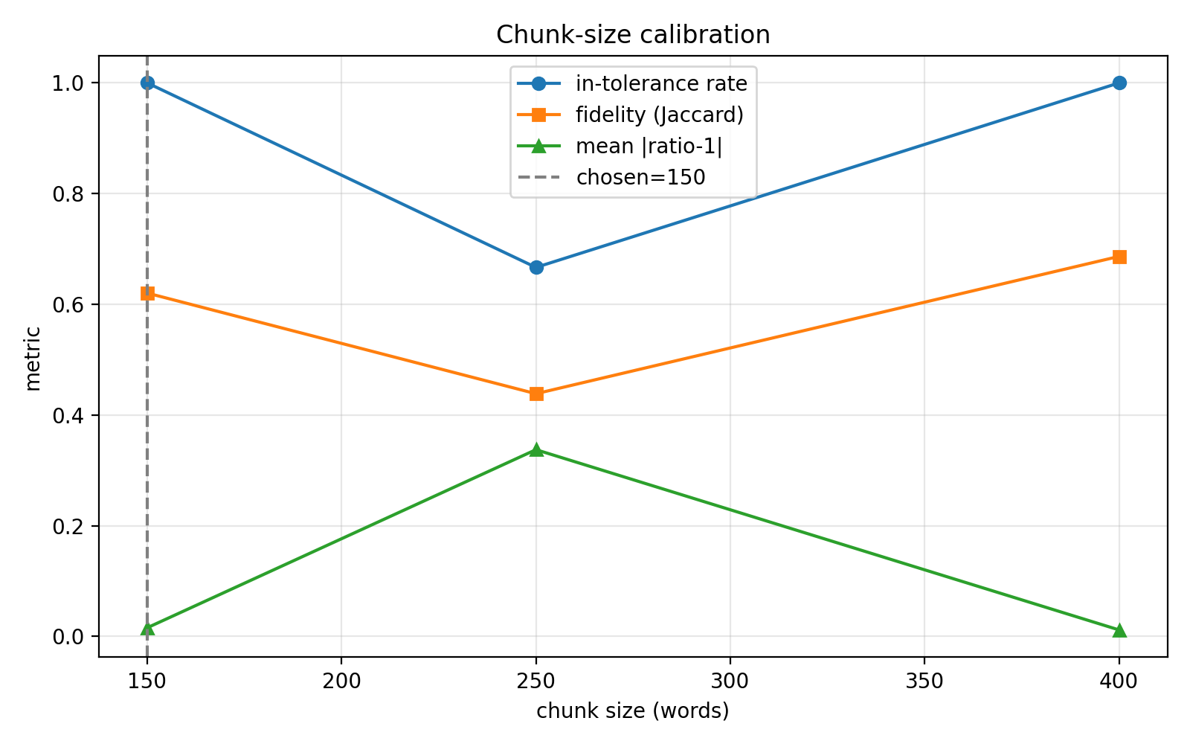
Figure 1. Chunk-size calibration. For each candidate size (150, 250 and 400 words) the figure reports the in-tolerance rate (the share of pilot rewrites whose length falls within the band), content fidelity (token Jaccard overlap with the source), and the mean absolute deviation of the length ratio from one. Length is preserved almost exactly at 150 and 400 words, whereas fidelity peaks at the 400-word unit adopted for the main run.

3.3 Generation design
The generation design is a 2×2 factorial that crosses two systems, GPT-5.5 (gpt-5.5) and Claude 4.8 (claude-opus-4-8), with two prompting regimes. Under the Restricted regime the model is asked to rewrite the passage as closely as possible, preserving meaning and the clause-by-clause order of ideas, the Attic prose register, particle and connective usage, and sentence segmentation. Under the Free regime the model is asked to preserve the essential meaning and argument but to express it freely in idiomatic Classical Attic prose. Both prompts enforce a length band of ±15% of the source chunk and require Greek-only output with no commentary, titles, translation, transliteration or notes.
Each of the four conditions was generated for all 1,322 source chunks through the providers' asynchronous batch interfaces (OpenAI for GPT-5.5, Anthropic for Claude 4.8). A small number of Claude requests (approximately 44, about 1.7% of the 2,644 Claude requests) returned transient errors within the batch and were re-issued synchronously to fill the gaps, so that every condition ends with a complete set of exactly 1,322 rewrites, verified by file count. The corpus is additionally accompanied by an older-generation baseline (GPT-4o and Claude 3.5) that supports a longitudinal comparison; because the legacy material was anchored on whole documents rather than re-chunked, it is reported separately and is not pooled with the chunk-level analysis below.

3.4 Orthographic normalization
All texts, human and machine, were normalised to a single orthographic convention before feature extraction: Unicode NFC composition, polytonic-aware lowercasing, removal of punctuation and elision apostrophes, retention of diacritics, and whitespace collapse. This step ensures that the downstream features reflect stylistic rather than editorial or orthographic differences, so that, for example, an editor's choice of punctuation or capitalisation in a printed edition does not register as a difference between human and generated prose.

3.5 Annotation schema and corpus size
Each text is annotated with a four-level category schema used throughout the analysis: Category1 = system (Human, GPT-5.5 or Claude 4.8); Category2 = author (the ten orators); Category3 = prompt (Human, Restricted or Free); and Category4 = label (Human or AI). The final corpus comprises 1,322 human chunks and 4×1,322 = 5,288 AI rewrites, for a total of 6,610 chunk-level texts (Table 1, Figure 2). By system the corpus splits into 2,644 GPT-5.5, 2,644 Claude 4.8 and 1,322 human texts; by prompt into 2,644 Restricted, 2,644 Free and 1,322 human texts. The four AI conditions are exactly balanced at 1,322 texts each.
Table 1. Corpus composition by orator. Counts are chunk-level. Each human source chunk yields one human text plus four AI rewrites (two systems × two prompting regimes), so the per-orator total is five times the human-chunk count.
Orator (Category2) | Human chunks | All texts (×5)
Demosthenes | 669 | 3,345
Isocrates | 279 | 1,395
Aeschines | 109 | 545
Isaeus | 83 | 415
Antiphon | 49 | 245
Andocides | 40 | 200
Hyperides | 28 | 140
Dinarchus | 26 | 130
Lycurgus | 25 | 125
Lysias | 14 | 70
Total | 1,322 | 6,610
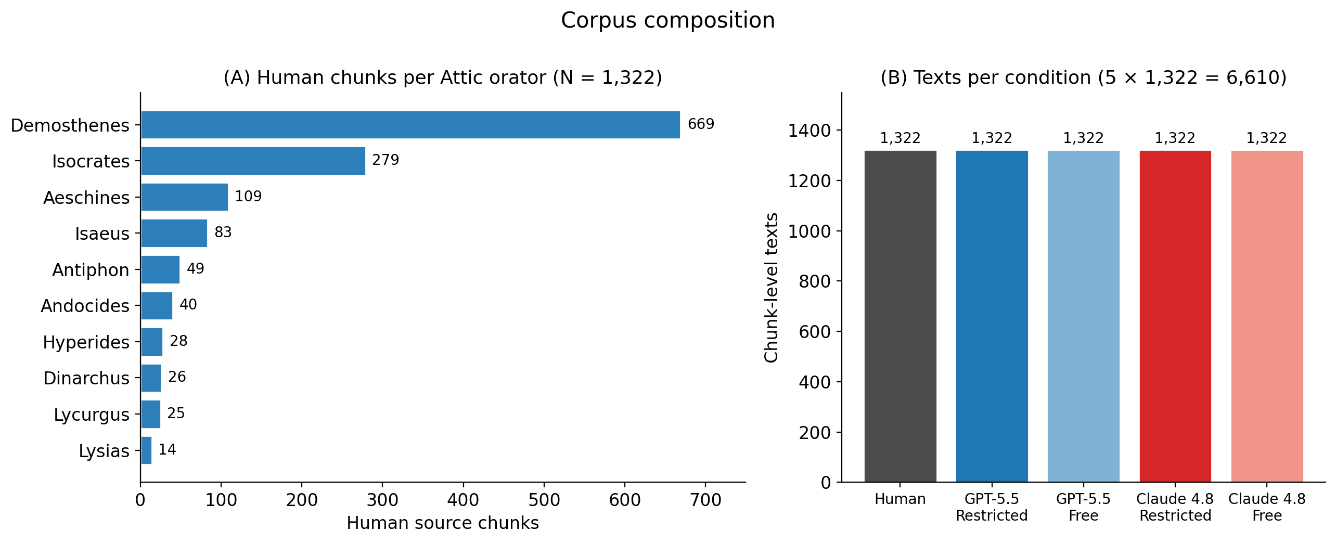
Figure 2. Corpus composition. (A) Human source chunks contributed by each of the ten Attic orators, showing the dominance of Demosthenes (669 of 1,322 chunks) and the long tail down to Lysias (14). (B) The five chunk-level conditions are exactly balanced at 1,322 texts each, for a total of 6,610 texts.

4 Feature Extraction and Document Embeddings

4.1 Stylometric features
Each chunk was represented by an 84-dimensional feature vector (a 6,610 × 84 matrix) whose components are drawn from two complementary sources. The first is the automatic linguistic annotation produced by the Stanza Ancient Greek pipeline, whose tagger and parser are trained on the Ancient Greek PROIEL treebank (grc_proiel). From these annotations we computed part-of-speech proportions over the universal tag set; morphological distributions for case, tense, aspect, mood and gender, together with case and mood entropy; dependency-relation proportions and the mean and standard deviation of dependency distance; sentence count and average sentence length; and two part-of-speech ratios, lexical density and the noun-to-verb ratio. The PROIEL treebank therefore supplies the model used to annotate the texts, not the texts or the features themselves.
The second source is a Greek-aware word tokenizer applied directly to the normalised text, independent of the parser, from which we derived the length and vocabulary features: lexical diversity, captured by the type-token ratio (L_TTR), root type-token ratio (L_Root_TTR), log type-token ratio (L_Log_TTR) and the Measure of Textual Lexical Diversity (L_MTLD); text entropy; token, type and hapax counts; and average word length. Computing the vocabulary features on an independent tokenizer ensures that they do not inherit any error in the automatic morphosyntactic tagging. Because MTLD is largely invariant to text length, it provides a length-robust complement to the raw type-token ratios, which matters given the controlled but not identical chunk lengths.

4.2 Neural document embeddings
In parallel we computed neural document embeddings with two transformer encoders pre-trained for Ancient Greek: pranaydeeps/Ancient-Greek-BERT and the more recent bowphs/GreBerta. Each chunk was embedded by mean-pooling the final hidden state over up to 512 tokens, and the resulting vectors were reduced to 50 principal components (WE1 to WE50) for analysis and classification. The two encoders provide a deliberate contrast: a widely used domain model and a current state-of-the-art model, so that any conclusion about embedding-based detectability can be checked against encoder choice rather than resting on a single representation.

5 Evaluation Methodology
The primary analysis fits, for each stylometric feature, a linear mixed-effects model contrasting Human and AI with random intercepts for author and for source document, so that the nesting of chunks within documents and within authors is respected and the heavy representation of Demosthenes does not dominate the fixed-effect estimate. The p-values are corrected across features with the Benjamini-Hochberg false-discovery-rate procedure, and standardised effect sizes are reported as Cohen's d, signed so that d = (meanHuman − meanAI) / SD, where a positive value indicates a higher mean in the human texts. Confidence intervals (95%) for each effect are obtained from a 5,000-sample bootstrap. The same modelling is applied within the system contrast (Category1) and the prompt contrast (Category3).
Complementing the mixed-effects analysis, an established analysis pipeline produced a suite of twenty-four numbered analyses over the same feature matrix and embeddings: corpus counts and summaries; sentence length; Jensen-Shannon divergence of morphological families by author and by condition; global and stratified effect sizes; principal-component analysis; author-proximity distances under four metrics (Canberra, cosine, Euclidean and Manhattan); Human-versus-AI and by-condition classifiers with grouped cross-validation and ROC analysis; clause complexity and lexical richness; clustering with silhouette scores; and a dedicated embedding analysis. In total the suite emits 91 figures. Every classifier in this study uses logistic regression with five-fold GroupKFold cross-validation grouped by author, so that no author appears in both the training and the test partition of any fold and the reported detectability cannot be inflated by author memorisation.

6 Results

6.1 Corpus statistics and length preservation
The released corpus contains 6,610 chunk-level texts (1,322 human and 5,288 AI), evenly balanced across the four generation conditions at 1,322 texts each. The length-control protocol was effective: the mean chunk length is 399.5 tokens for the human texts and 390.0 for the AI rewrites (Cohen's d = +0.246 for n_tokens), so the AI texts undershoot the source length only slightly and well within the ±15% band. The batch generation was near-complete on the first pass; only about 1.7% of Claude requests required a synchronous retry, and the final per-condition counts are exact.

6.2 Human versus AI stylometric differences
Of the 75 stylometric features carried into the Human-versus-AI mixed-effects models, six were degenerate (zero variance across the corpus) and could not be estimated, leaving 69; of these, 36 are significant after Benjamini-Hochberg correction. The decisive finding is one of magnitude rather than count: every significant effect is small. The largest standardised effect is |d| = 0.332, and no feature reaches even a moderate effect size. Human and machine Ancient Greek are therefore reliably but only subtly different.
Table 2 lists the ten features with the largest |d|, and the picture they paint is internally coherent. The AI rewrites are built from more, shorter sentences: average sentence length is higher in the human texts (21.5 against 19.9 words, d = +0.321), while the AI texts carry more sentences and a higher density of root dependencies per token (d = −0.332). The machine prose shows marginally higher lexical density (d = −0.329) and higher lexical diversity (L_TTR d = −0.292, L_Log_TTR d = −0.269, and L_MTLD likewise higher in AI, 220.7 against 208.5), together with a longer mean dependency distance (d = −0.330) and more adverbs (pos_ADV, d = −0.287). The orators, conversely, make greater use of auxiliary and copular constructions (pos_AUX d = +0.274, dep_rel_cop d = +0.271) and write slightly longer chunks. In short, the models write denser, lexically richer and more finely segmented prose, whereas the orators favour longer sentences with more periphrastic (auxiliary and copular) syntax. The per-feature forest plot (Figure 3) makes the ceiling on these effects visible directly: every confidence interval lies inside the small-effect band, and none approaches a moderate effect.
Table 2. Top ten Human-versus-AI stylometric differences, ranked by |d|. The effect is signed as d = (Human − AI) / SD, so a positive value denotes a higher mean in the human texts. All ten are significant after Benjamini-Hochberg FDR correction. Feature names follow the released feature matrix.
Feature | d | 95% CI | p (FDR) | Mean Human | Mean AI | Higher in
dep_rel_root | -0.332 | [-0.390, -0.273] | 9.1×10⁻³⁵ | 0.0490 | 0.0527 | AI
dep_distance_mean | -0.330 | [-0.387, -0.271] | 5.5×10⁻³⁰ | 2.905 | 2.967 | AI
lexical_density | -0.329 | [-0.387, -0.272] | 2.6×10⁻³⁴ | 0.5662 | 0.5756 | AI
avg_sentence_length | +0.321 | [0.257, 0.383] | 4.3×10⁻³² | 21.49 | 19.94 | Human
L_TTR | -0.292 | [-0.357, -0.230] | 7.0×10⁻²⁹ | 0.6492 | 0.6605 | AI
pos_ADV | -0.287 | [-0.347, -0.226] | 3.1×10⁻²⁹ | 0.1362 | 0.1441 | AI
pos_AUX | +0.274 | [0.213, 0.335] | 2.9×10⁻²⁴ | 0.0193 | 0.0171 | Human
dep_rel_cop | +0.271 | [0.209, 0.333] | 9.3×10⁻²⁴ | 0.0171 | 0.0150 | Human
L_Log_TTR | -0.269 | [-0.336, -0.205] | 1.9×10⁻²⁶ | 0.9275 | 0.9302 | AI
n_tokens | +0.246 | [0.190, 0.305] | 2.5×10⁻¹⁷ | 399.5 | 390.0 | Human
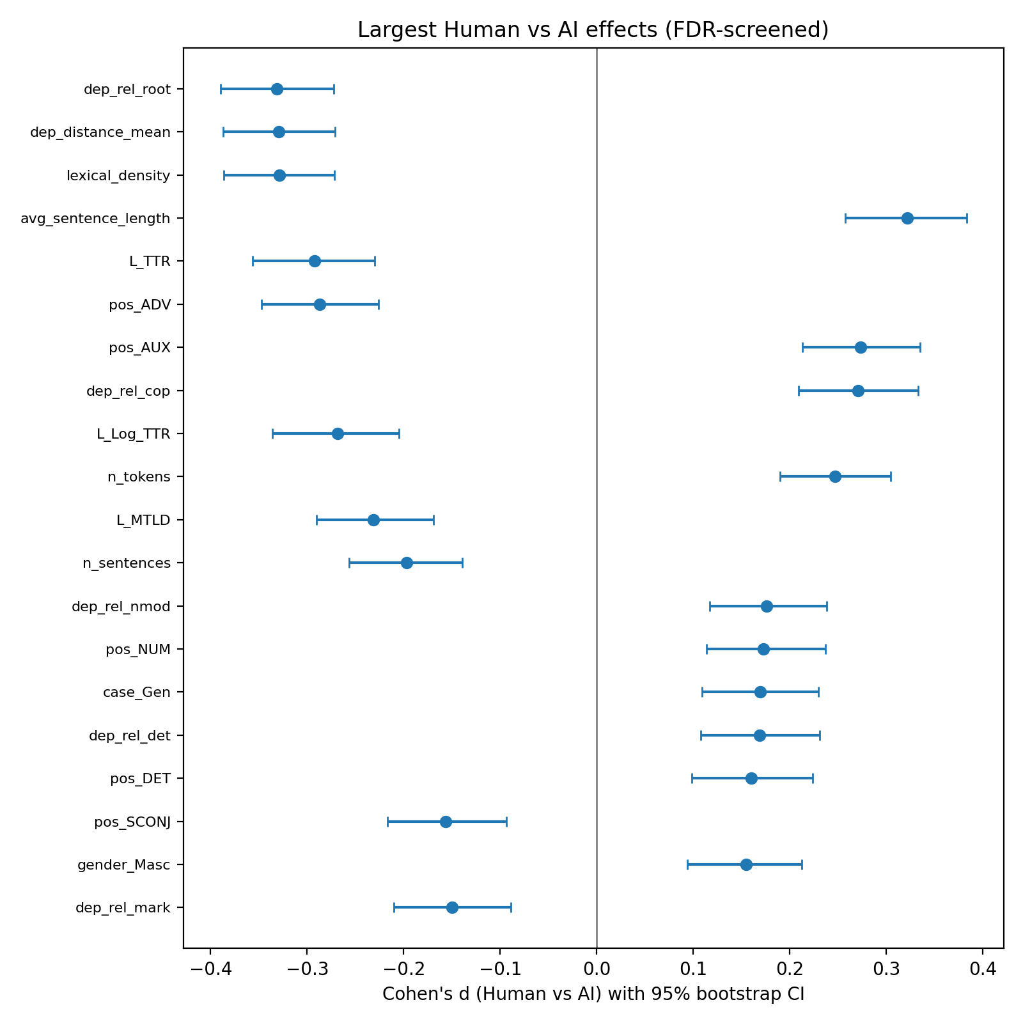
Figure 3. Human-versus-AI stylometric effect sizes. Cohen's d with 95% bootstrap confidence intervals for the most discriminative features; positive d denotes a higher value in human texts. Every interval lies inside the small-effect band (|d| < 0.34), and no feature approaches a moderate effect.

6.2.1 Lexical richness and morphological divergence
The lexical-richness signal is consistent in direction but small in magnitude (Figure 4). On a dedicated comparison of four diversity indices, the AI prose is the more diverse on every measure, yet only two reach a meaningful effect: the type-token ratio (L_TTR d = −0.292; 0.660 in AI against 0.649 in humans) and the log type-token ratio (L_Log_TTR d = −0.269; 0.930 against 0.927). Root type-token ratio is essentially tied (d = −0.069), and the raw count of hapax legomena does not differ at all (d = −0.029; 202.8 against 202.1 words occurring once per chunk). The richer-vocabulary effect is therefore real but confined to the normalised ratios; humans and models deploy almost exactly the same number of once-occurring word forms per chunk.
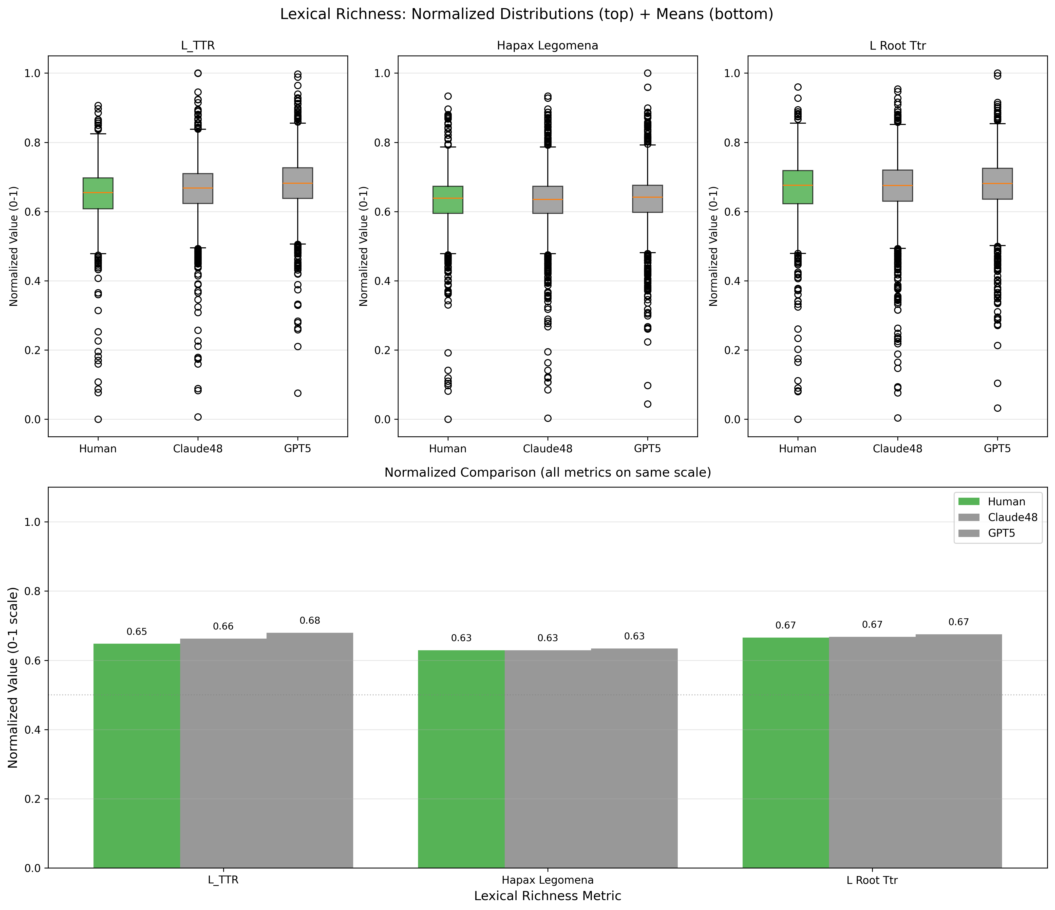
Figure 4. Lexical-richness comparison across the human, Claude 4.8 and GPT-5.5 subcorpora. Box plots (top) and normalised group means (bottom) for the type-token ratio, hapax-legomena count and root type-token ratio. AI prose is marginally more diverse on the type-token ratios, while the raw hapax count is essentially identical to human prose.
Turning from the lexical to the morphological level, the Jensen-Shannon divergence between human and AI distributions shows that the largest deviations are in verbal mood rather than in case. Across authors, mood distributions diverge an order of magnitude more than case distributions, and the two are essentially uncorrelated (Pearson r = −0.03), so they capture distinct facets of the mismatch. The mood divergence is strongly modulated by condition (Figure 5): it is largest under GPT-5.5 Free, peaking at Lysias (JS = 1.06×10⁻³) and Lycurgus (8.97×10⁻⁴), and smallest under Claude 4.8 Restricted, falling to 3.7×10⁻⁶ for Demosthenes, exactly the ordering seen in the detectability results below. Case divergence follows the same pattern at a lower overall level. The orators whose verbal-mood profile is hardest for the models to reproduce are Hyperides (3.8×10⁻⁴) and Lysias (3.5×10⁻⁴), both relatively under-represented authors, which suggests that scarce training signal, rather than any intrinsic property of the style, drives the residual divergence.
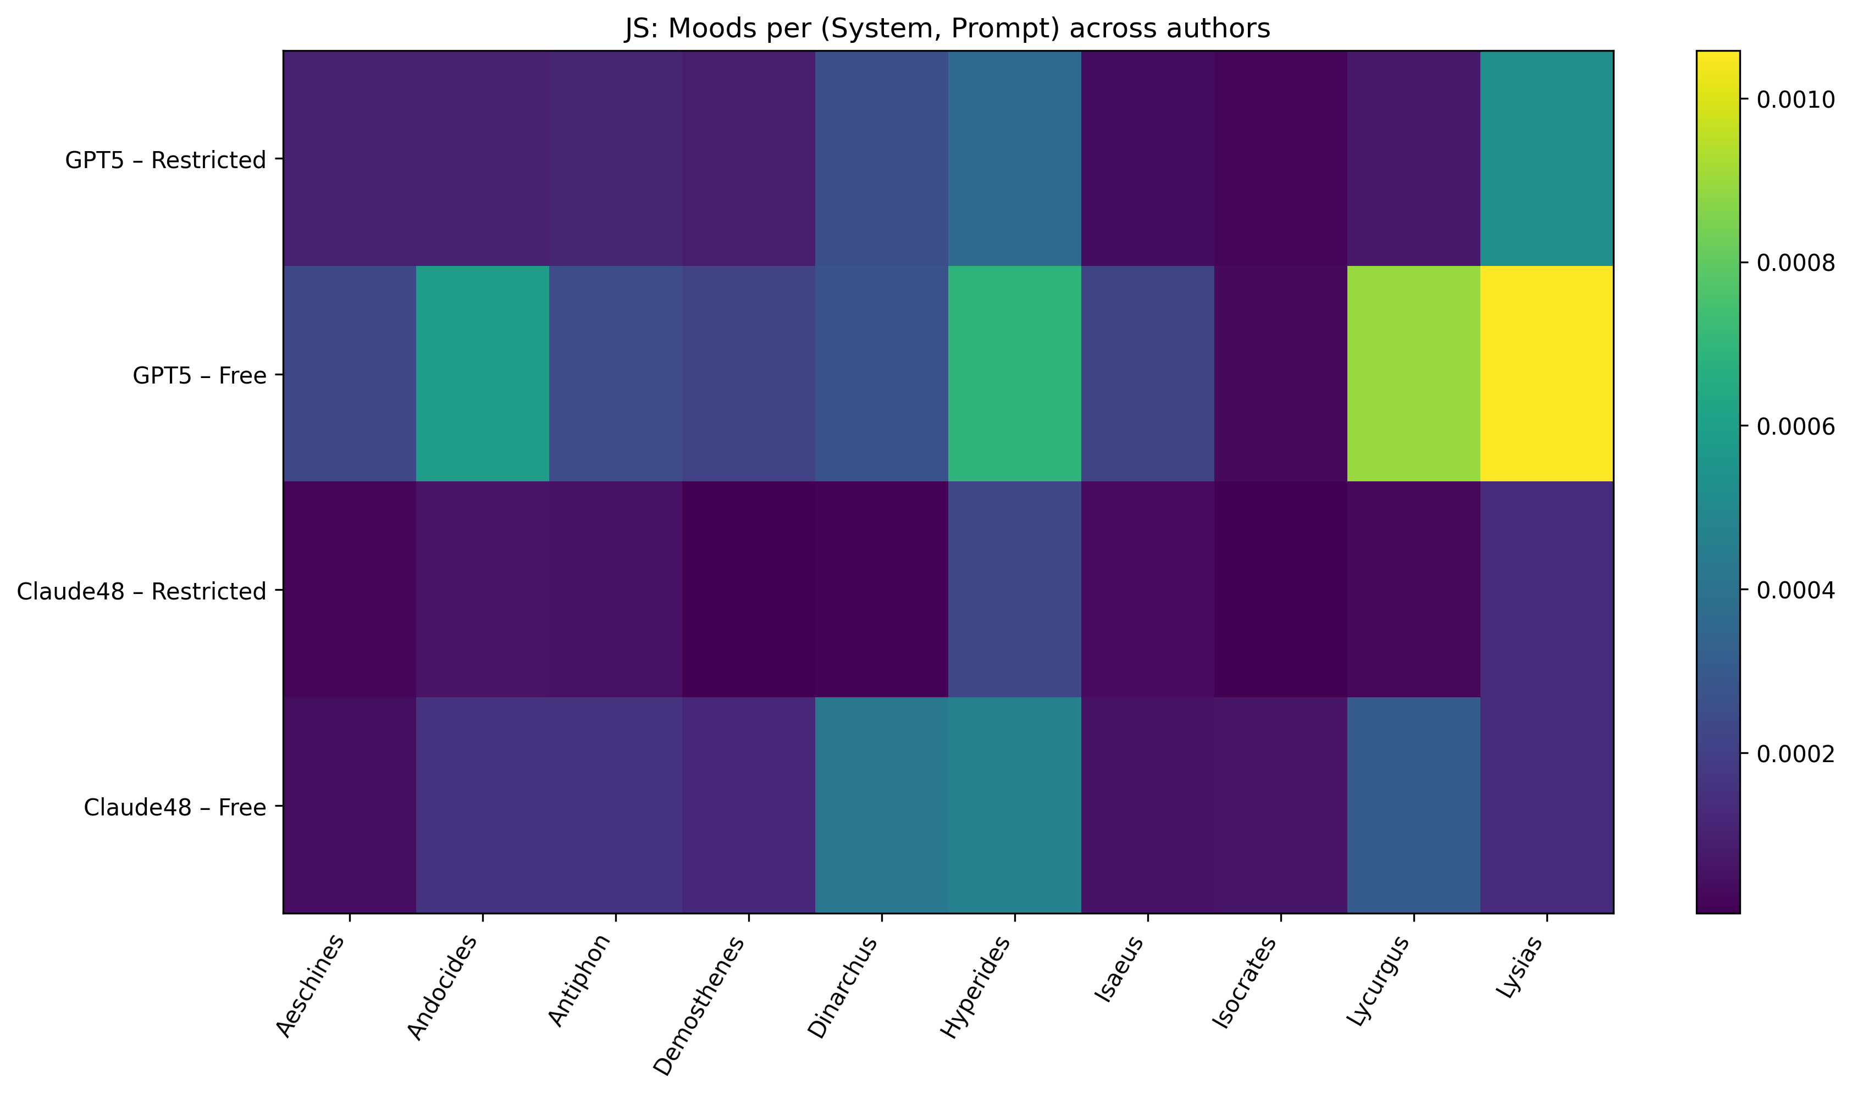
Figure 5. Jensen-Shannon divergence between human and AI verbal-mood distributions, resolved by author (columns) and by system × prompt condition (rows). Divergence is largest for GPT-5.5 under the Free prompt, peaking at Lysias and Lycurgus, and collapses toward zero for Claude 4.8 under the Restricted prompt.

6.3 Effect of system and prompting regime
The contrast sharpens markedly when the AI texts are partitioned by system and by prompt. The system contrast (GPT-5.5 against Claude 4.8) yields 52 FDR-significant features, and the prompt contrast (Restricted against Free) yields 54. Both exceed the 36 features that separate the pooled Human-versus-AI comparison, which means that the choice of model, and especially of prompting regime, moves the texts at least as much as the human/machine distinction itself.
The prompt effect points consistently toward the Restricted regime being the closer to human (Figure 6). Restricted rewrites are longer (400.4 against 379.6 tokens, so the Restricted mean matches the human 399.5 almost exactly), carry longer sentences (20.8 against 19.1 words, against the human 21.5), and show a lexical diversity nearer the human value (L_MTLD 209.2 against 232.1 for Free, with the human value at 208.5). Free rewrites diverge further on all three axes. The author-centroid distances confirm this ordering and add a system effect: the mean Canberra distance from the human authors is lowest for Claude 4.8 (12.83 Free, 12.85 Restricted) and highest for GPT-5.5 Free (13.21), with GPT-5.5 Restricted (12.89) in between. Claude 4.8 is thus closer to human style overall, and Restricted prompting narrows the gap most for GPT-5.5.
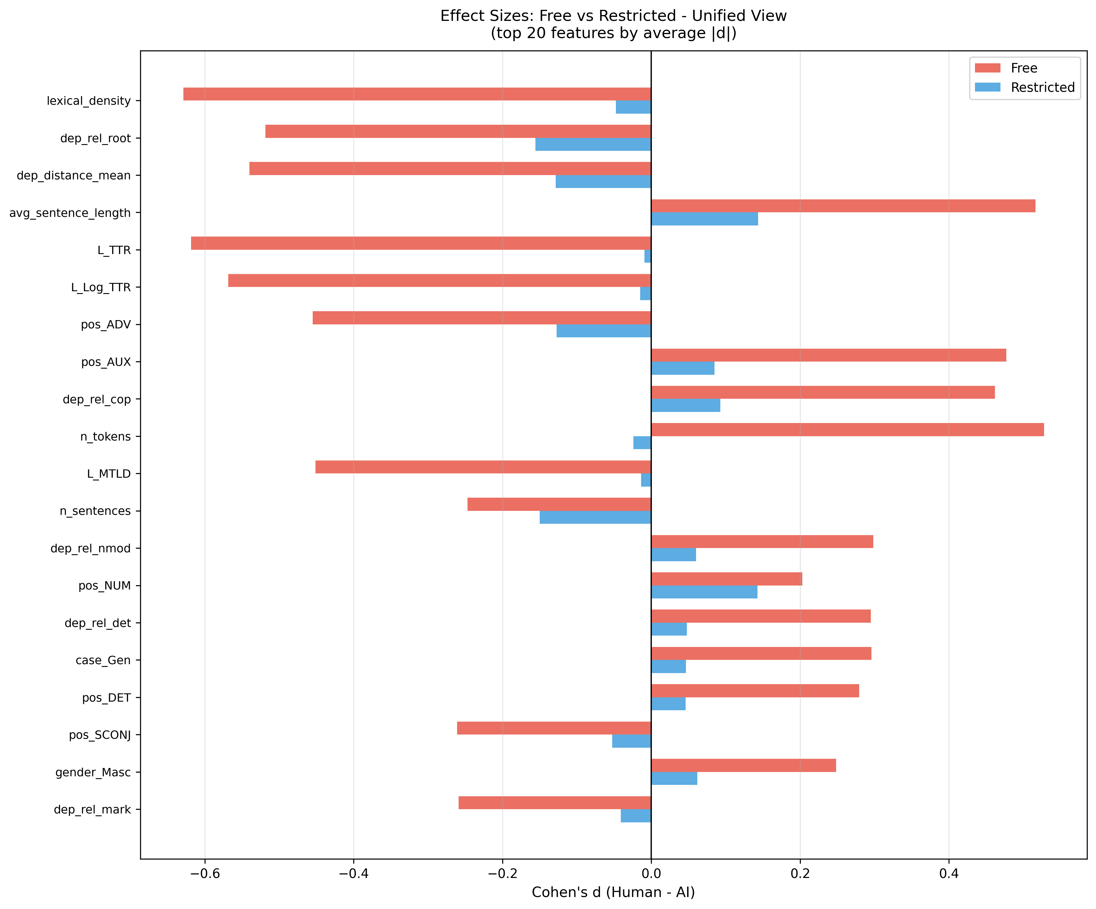
Figure 6. Free-versus-Restricted feature effect sizes (top 20 features by mean |d|). Bars give Cohen's d relative to human prose for each prompting regime. The Restricted regime moves consistently toward human values on length, sentence length, lexical density and lexical diversity, whereas Free rewrites diverge further on the same axes.

6.4 Dimensionality reduction and clustering
Both linear projection and unsupervised clustering confirm a heavy overlap between human and machine texts. In a principal-component analysis of the standardised feature matrix, the Human and AI chunks form a single overlapping cloud rather than distinct clusters (Figure 7). The first two components carry very little of the structure (PC1 explains about 13% and PC2 about 9% of the total variance), so even together they account for under a quarter of the variation, and neither axis separates Human from AI, the two systems, or the two prompts. k-means clustering gives a near-zero silhouette for the Human-versus-AI split (0.009 on stylometric features and 0.013 on embeddings), and the silhouettes by condition are similarly weak (highest for GPT-5.5 Free at 0.025 and negative for Claude 4.8 Restricted at −0.023). The separation is real but faint.
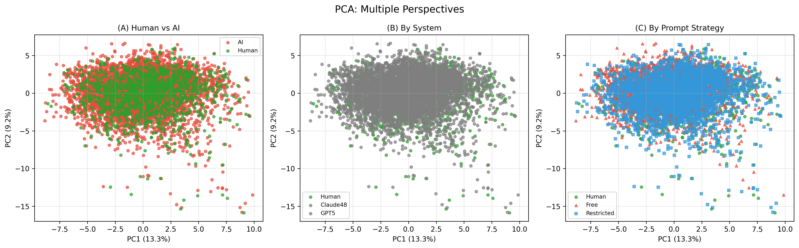
Figure 7. Principal-component projection of the standardised feature matrix, coloured by (A) human versus AI, (B) system and (C) prompting regime. PC1 and PC2 together explain under a quarter of the variance (about 13% and 9%, respectively). Human and AI chunks form one overlapping cloud under every partition, with no axis separating the classes.

6.5 Detectability
A Human-versus-AI classifier trained on the 69 stylometric features (logistic regression, GroupKFold by author) reaches AUROC 0.701 with a Brier score of 0.152 (Figure 8). Document embeddings are somewhat more discriminative: an Ancient-Greek-BERT classifier reaches AUROC 0.745 and the more recent GreBerta encoder 0.710 (Figure 9). Ancient-Greek-BERT also yields a slightly larger mean cosine distance from the human centroid (0.566 against 0.546) and a marginally better silhouette (0.013 against 0.003). The faintness of the gap is visible directly in the embedding space: t-SNE and UMAP projections of the Ancient-Greek-BERT vectors show the human chunks dispersed throughout the AI cloud rather than occupying a separate region (Figure 10). Human and AI Ancient Greek are therefore distinguishable but only modestly, with AUROC in the 0.70 to 0.75 range rather than near the ceiling.
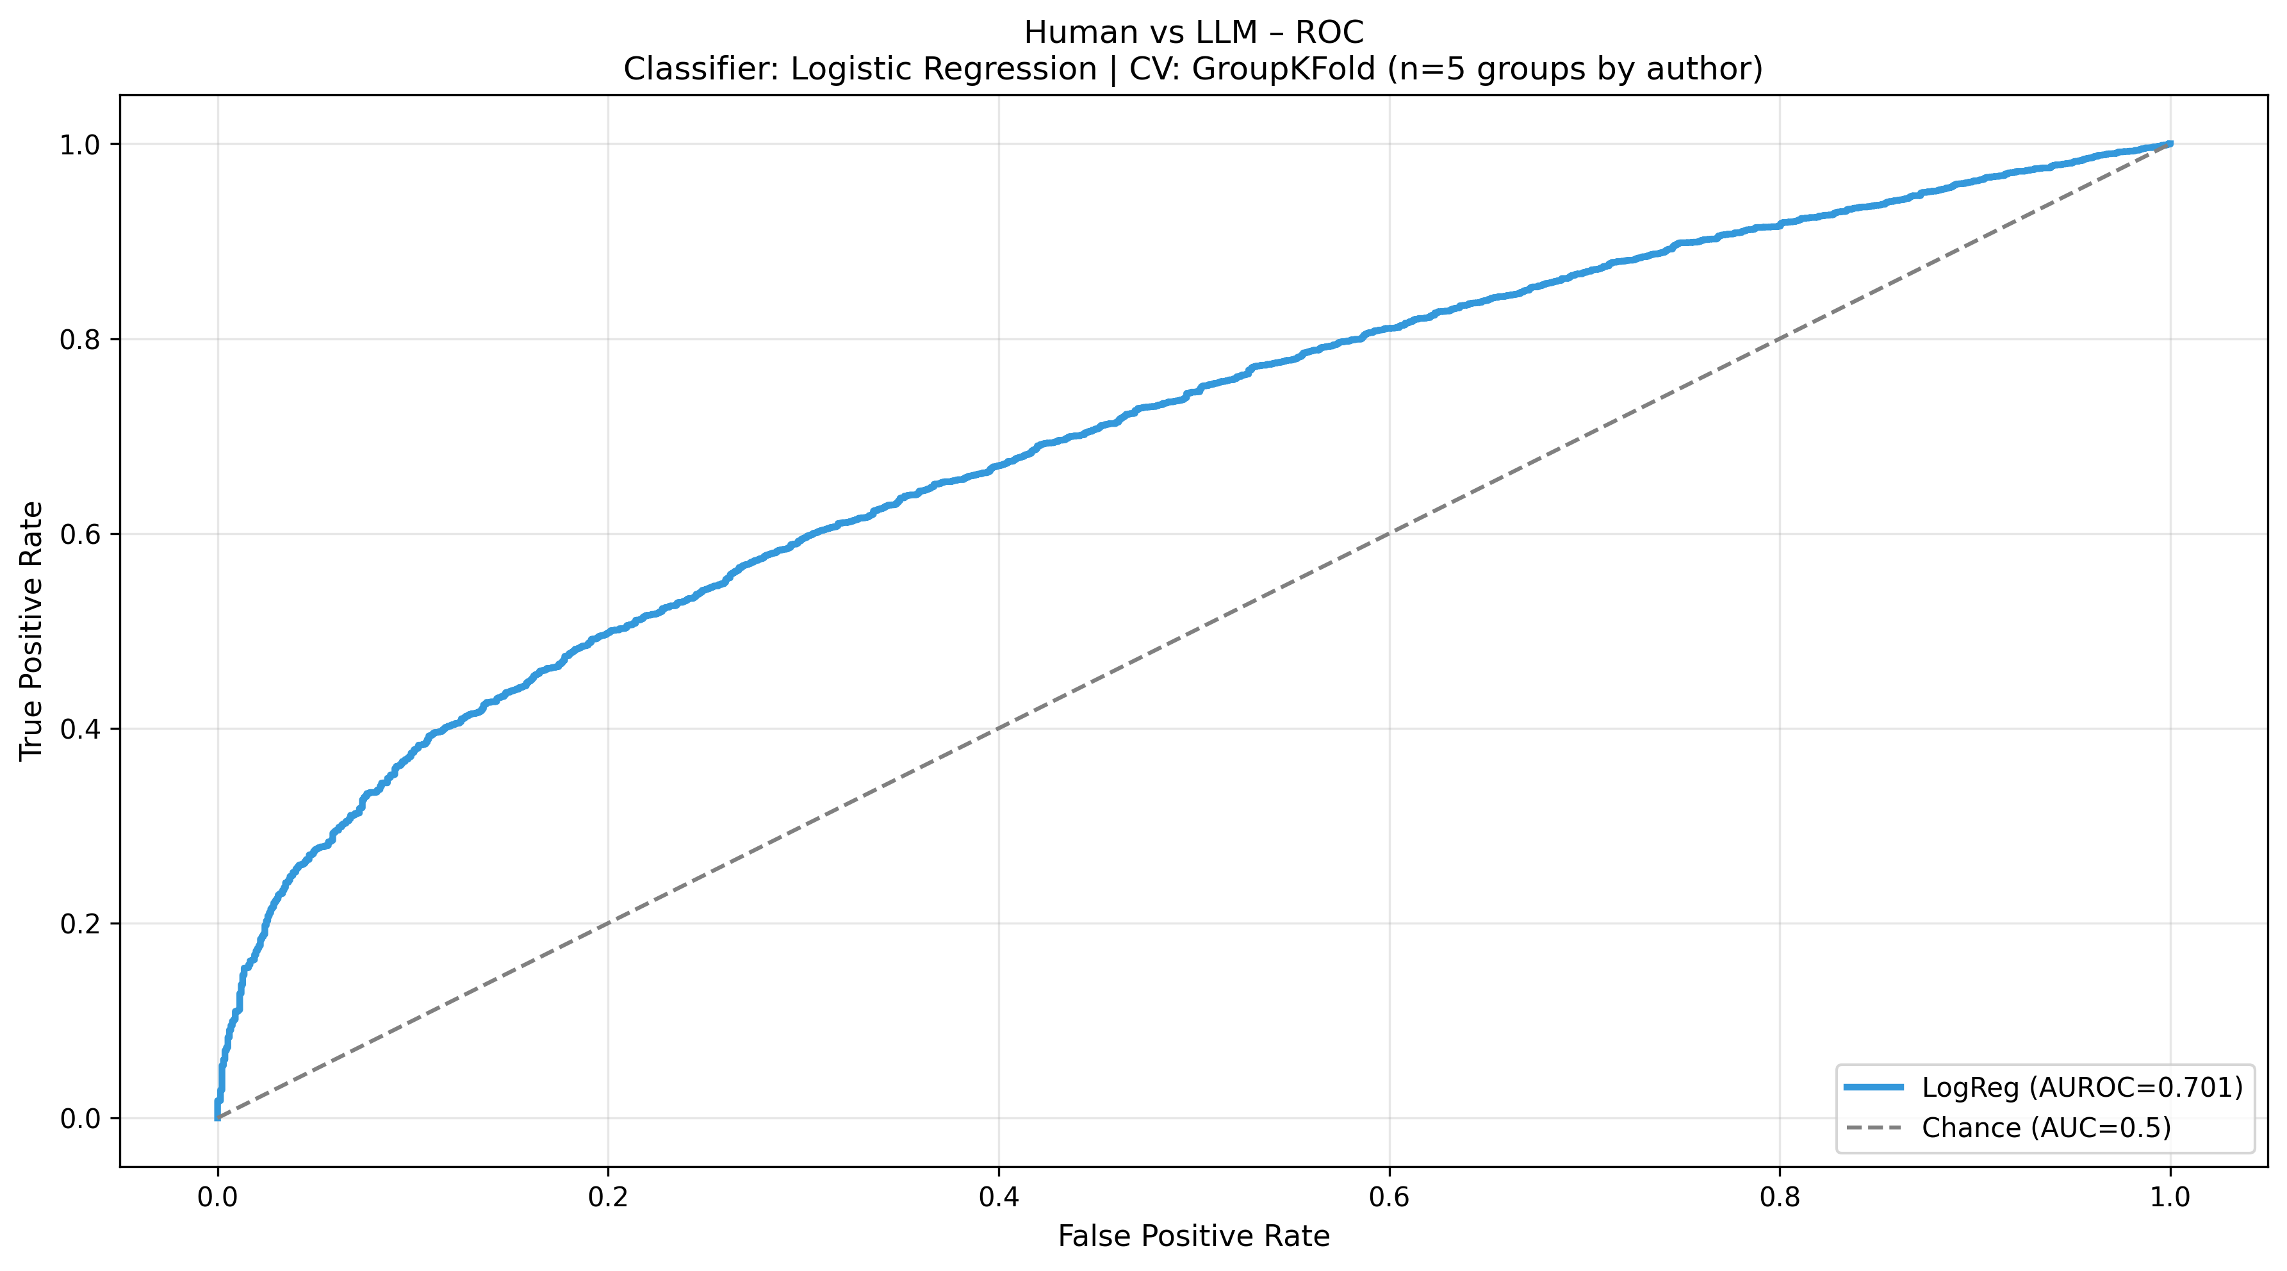
Figure 8. Receiver-operating-characteristic curve of the Human-versus-AI stylometric classifier (logistic regression with author-grouped five-fold cross-validation). The classifier reaches AUROC 0.701, clearly above chance but far from ceiling.
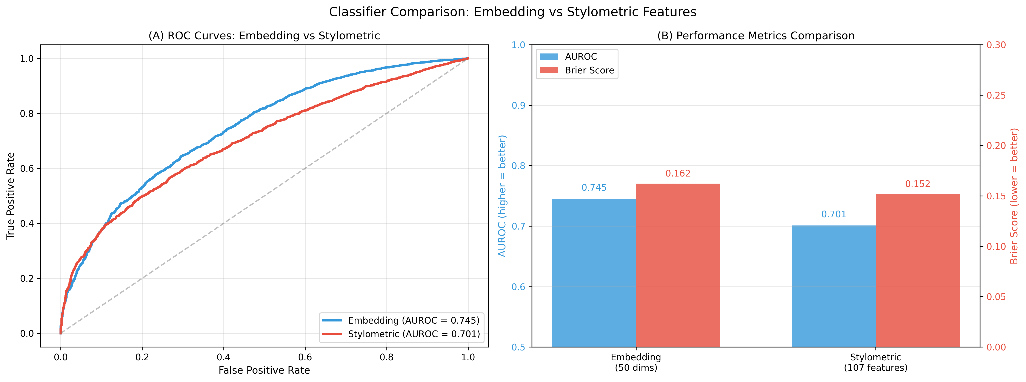
Figure 9. Detectability from document embeddings versus stylometric features. (A) ROC curves and (B) AUROC and Brier scores for a classifier trained on 50-dimensional Ancient-Greek-BERT embeddings (AUROC 0.745) and on the stylometric feature set (AUROC 0.701). Embeddings are slightly more discriminative, but both remain well below ceiling.
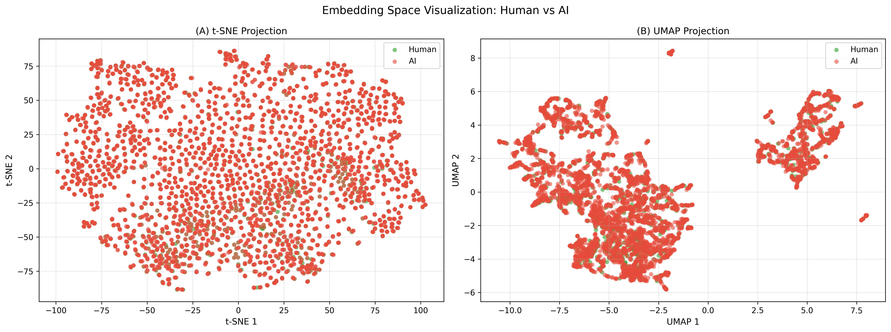
Figure 10. t-SNE (A) and UMAP (B) projections of the Ancient-Greek-BERT document embeddings, coloured by human versus AI. Human chunks are dispersed throughout the AI cloud rather than forming a separate region, mirroring the modest classifier performance.
Detectability is strongly modulated by condition (Figure 11, Table 3). Free rewrites are far easier to flag than Restricted ones, and GPT-5.5 is easier than Claude 4.8: the per-condition AUROC is 0.945 for GPT-5.5 Free, 0.720 for Claude 4.8 Free, 0.681 for GPT-5.5 Restricted, and only 0.516, essentially chance, for Claude 4.8 Restricted. The most human-like configuration, Claude 4.8 under the Restricted prompt, is thus nearly indistinguishable from genuine Attic prose by a stylometric classifier.
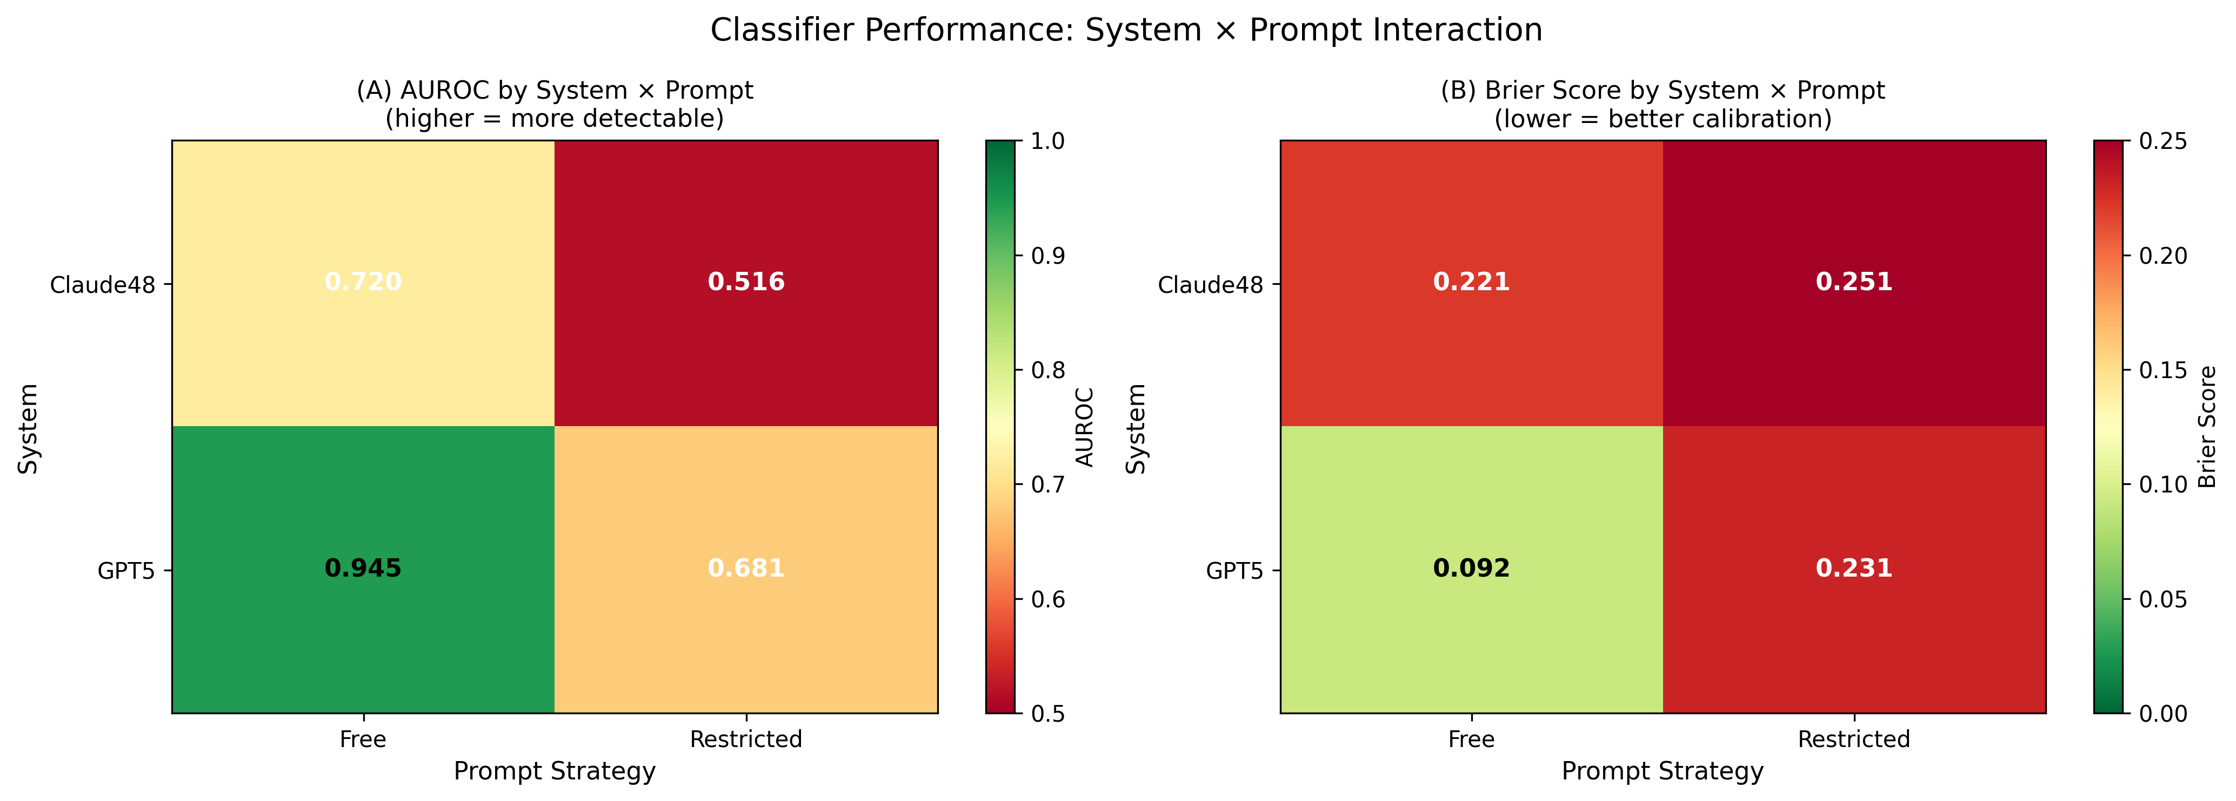
Figure 11. Detectability by system × prompt. (A) Per-condition AUROC and (B) Brier score for the stylometric classifier. Detectability ranges from 0.945 for GPT-5.5 Free down to 0.516, essentially chance, for Claude 4.8 Restricted.
An independent composite separation metric tells the same story. Combining the most discriminative features into a single composite score and measuring the standardised gap between the human and AI predictions per condition, the separation is largest for GPT-5.5 Free (0.673), much smaller for Claude 4.8 Free (0.208) and GPT-5.5 Restricted (0.147), and effectively absent for Claude 4.8 Restricted (0.003). Three independent lenses, a supervised classifier, the morphological Jensen-Shannon divergence, and the composite separation score, thus converge on the same condition ordering (Table 3), which is strong evidence that the effect is a property of the generated texts rather than of any single modelling choice.
Table 3. Convergent evidence on detectability by condition. Four independent measures, the stylometric-classifier AUROC, the verbal-mood Jensen-Shannon divergence, the composite separation score, and the k-means silhouette, agree on the same ordering, from the trivially detectable GPT-5.5 Free to the near-indistinguishable Claude 4.8 Restricted. Starred JSD entries give the per-condition extrema (Lysias for GPT-5.5 Free; Demosthenes for Claude 4.8 Restricted); dashes denote conditions not at an extremum.
Condition | Classifier AUROC | Mood JSD | Composite separation | Silhouette
GPT-5.5, Free | 0.945 | 1.06×10⁻³ * | 0.673 | +0.025
Claude 4.8, Free | 0.720 | – | 0.208 | -0.002
GPT-5.5, Restricted | 0.681 | – | 0.147 | -0.015
Claude 4.8, Restricted | 0.516 | 3.7×10⁻⁶ * | 0.003 | -0.023

6.6 Per-author imitability
Across the AI texts, the orators differ in how closely the models approach their style (Figure 12). By Canberra distance the AI rewrites land closest to Dinarchus (11.86), Lycurgus (12.14) and Lysias (12.20), and farthest from Isocrates (14.50) and Antiphon (14.09); the cosine metric agrees that Antiphon is the hardest author to imitate. The two extremes are instructive. Isocrates, with his famously long, periodic and rhythmically governed sentences, and Antiphon, the earliest and most idiosyncratic of the orators, both sit at the edge of the stylistic space the models can reach, whereas the plainer styles cluster near the centre and are approached most easily.
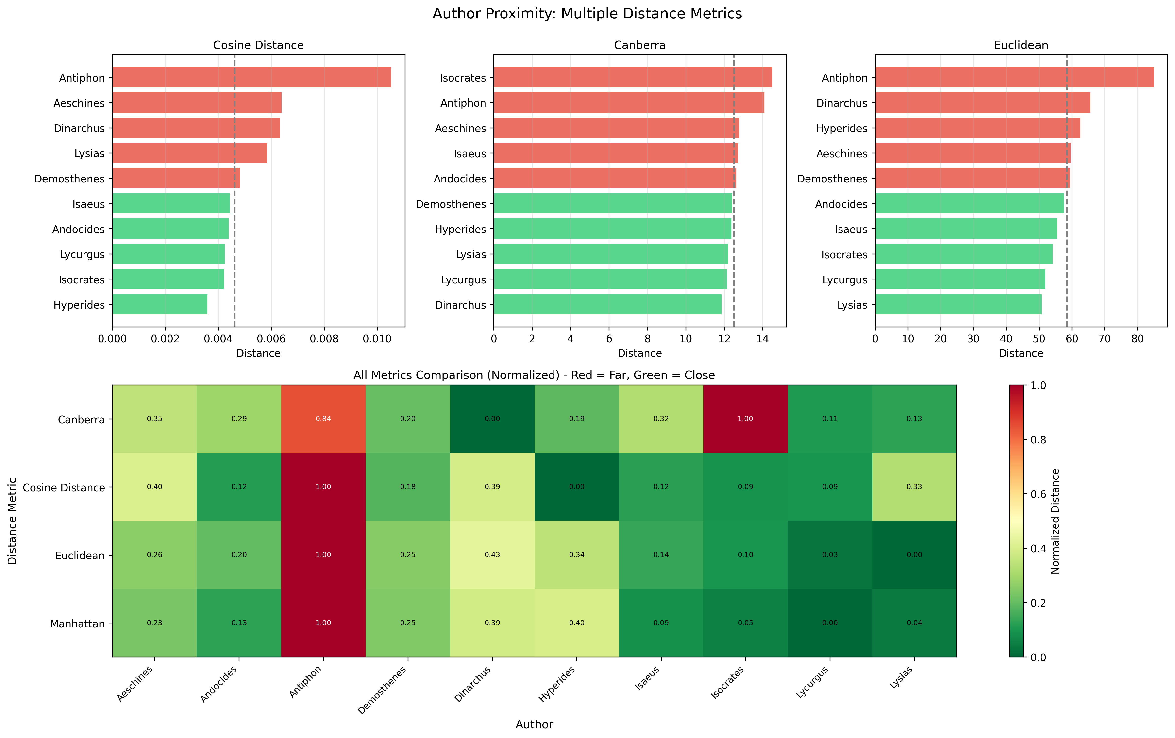
Figure 12. Distance of AI rewrites from each orator's stylometric centroid. The upper panels rank the orators under the cosine, Canberra and Euclidean metrics; the lower heat-map places all four metrics on a common normalised scale. The models approach Dinarchus, Lycurgus and Lysias most closely and Isocrates and Antiphon least.

6.7 Synthesis
Taken together, the results draw a coherent picture. At the level of individual features the human/machine difference is pervasive but uniformly small (36 of 69 estimable features are FDR-significant, all with |d| < 0.34; Figure 3), and it is dominated by a single stylistic axis: the models write denser, more lexically varied and more finely segmented prose, while the orators write longer, more periphrastic sentences. This faint signal is precisely why unsupervised projection and clustering fail to separate the classes (Figure 7) and why both the stylometric and the embedding classifiers plateau in the AUROC 0.70 to 0.75 range. Yet the pooled comparison conceals a sharp internal gradient: model choice and especially prompting regime move the texts at least as much as the human/AI contrast (52 and 54 significant features, respectively), and the same ordering, Restricted closer to human and Claude closer than GPT, recurs across author-centroid distance, mood and case divergence, the composite separation score, and per-condition detectability. The most controlled configuration, Claude 4.8 under the Restricted prompt, is statistically indistinguishable from genuine Attic oratory (AUROC 0.516, separation 0.003), whereas the freest configuration, GPT-5.5 Free, is trivially detectable (AUROC 0.945). State-of-the-art large language models can therefore produce Ancient Greek that is stylometrically very close to the human source, but only when the prompt actively constrains them toward the source's length, segmentation and register.

7 Discussion

7.1 A small but coherent residual difference
The central result is one of magnitude. Across the 69 estimable stylometric features, 36 separate human from machine prose after false-discovery-rate correction, yet no effect exceeds |d| = 0.34 and the great majority are far smaller (Section 6.2). A difference that is statistically pervasive but uniformly small is exactly the signature of two text populations drawn from nearly — but not quite — the same stylistic distribution. The residual is not noise, however: it is a coherent stylistic axis. The models write denser, more lexically varied and more finely segmented prose — shorter sentences, more sentences, higher lexical density and type-token ratios, longer mean dependency distance — while the orators write longer, more periphrastic sentences with greater reliance on auxiliary and copular constructions. Even when dressed in Attic morphology and vocabulary, in other words, machine prose retains a faint trace of a more essayistic packaging of information: it distributes content over more, tighter clausal units than the periodic style of the human orators. This is a subtle but interpretable fingerprint, and it is consistent with what one would expect of models whose default register is shaped by modern expository text.

7.2 Stylistic fidelity is steerable: prompt and model outweigh the human/machine divide
The pooled human-versus-machine contrast conceals a much sharper internal gradient. Partitioning the machine texts by system and by prompt yields more discriminating features (52 and 54, respectively) than the 36 that distinguish human from machine overall: the choice of model, and above all the prompting regime, moves the texts at least as much as the human/machine distinction itself. The direction is consistent across every lens we apply. The Restricted prompt, which constrains length, clause order and segmentation, pulls the machine texts toward human values on exactly the features that carry the residual difference, and Claude 4.8 sits closer to the human authors than GPT-5.5. The convergence is the strongest part of the evidence: a supervised classifier, the morphological Jensen-Shannon divergence, a composite separation score, and an unsupervised silhouette all rank the four conditions identically, from the trivially detectable GPT-5.5 Free (classifier AUROC 0.95) to the near-indistinguishable Claude 4.8 Restricted (AUROC 0.52, that is, chance). Because four methodologically independent measures agree, the gradient is a property of the generated texts and not an artefact of any single modelling choice. The practical implication is considerable: the detectability of machine Ancient Greek is not a fixed capability ceiling but a quantity that can be dialled up or down by the prompt. State-of-the-art models can already produce Attic prose that a stylometric classifier cannot distinguish from the genuine article — but only when the prompt actively constrains them toward the source’s length, segmentation and register; left free, they revert to the denser, more segmented profile that gives them away.

7.3 What the two views capture, and which styles resist imitation
Neural document embeddings are slightly more discriminative than the interpretable stylometric features (AUROC 0.745 for Ancient-Greek-BERT against 0.701 for the feature set), consistent with their capturing distributional lexical and contextual regularities that the hand-designed features do not encode; but both remain far below ceiling, and the two views agree on the overall picture of heavy overlap. The complementarity, rather than the superiority of either, is the methodological lesson, and it echoes the finding that stylometric and transformer representations are most powerful in combination for machine-generated-text detection (Mikros et al. 2023). The residual difference is concentrated, finally, in two places that are mutually illuminating. Morphologically, it lives in verbal mood far more than in case — the two diverge by an order of magnitude and are essentially uncorrelated — so the last thing the models get wrong is the distribution of moods, the most pragmatically and rhetorically loaded part of the Greek verb. By author, the models approach the plainer styles most closely and the most marked styles least: Isocrates, with his long, periodic, rhythmically governed sentences, and Antiphon, the earliest and most idiosyncratic of the orators, sit at the edge of the reachable stylistic space, whereas the plainer orators cluster near its centre. Tellingly, the authors with the largest residual mood divergence — Hyperides and Lysias — are among the most under-represented in the surviving canon, which points to scarcity of training signal, rather than any intrinsic unreachability of the style, as the driver of the residual. This is an encouraging diagnosis: it implies that the gap is a function of data and constraint, not of a hard limit on what the models can imitate.

7.4 Implications
For classical studies and language resources, the result is enabling but qualified. Under close-rewrite prompting, the best current model produces Attic prose whose stylometric profile is, on the measures used here, indistinguishable from human oratory — which makes machine generation a credible source of synthetic data for augmenting the small corpora that Ancient Greek tools depend on, and a plausible aid for producing register-appropriate examples in teaching. The qualification is that fidelity is highest precisely when the model is given a human passage to follow closely; the further the prompt departs from the source, the more the characteristic machine profile re-emerges, and the morphological evidence shows that mood — the rhetorically decisive part of the verb — is the first thing to drift. Generated Greek is therefore not a substitute for the philological record, and should be labelled and handled as the derived, model-conditioned material it is, not as a gold edition.
For machine-generated-text detection and the forensic linguistics of historical languages, the study offers both a method and a warning. The method is to treat the cross-validated detectability of a human-versus-machine classifier not as an end in itself but as a graded, interpretable measure of stylistic distance, and to read it alongside distributional divergences and embedding geometry. The warning is that detectability is controllable and, for the best model under constraint, can be driven to chance: robust detection in this setting cannot rely on a single signal, and is vulnerable — as it is for modern English (Sadasivan et al. 2023) — to the very prompting strategies that improve fidelity. As generative models become part of the classicist’s toolkit, questions of authenticity and provenance that the field has previously confined to antiquity will arise for contemporary digital text as well (Mikros 2025b).
For stylometric methodology, the study is a reminder that the structure of the data must be built into the evaluation. The oratorical canon is dominated by a single author — Demosthenes supplies half of all human chunks — and treating chunks as independent would let that imbalance, and the memorisation of individual authors, inflate any apparent separation. Author-level random effects and author-grouped cross-validation are what keep the detectability estimates honest, and the same precautions will be necessary for any human-versus-machine comparison in a heavily imbalanced, morphologically rich corpus, in Greek or beyond.

7.5 Limitations
Several limitations bound these conclusions. First, the corpus is confined to a single genre and register, Attic prose oratory; we make no claim about verse, dialogue, technical prose, or other dialects and periods, where both the human stylistic targets and the models’ competence may differ. Second, the design measures faithful rewriting rather than free composition: every machine text is conditioned on a specific human source that supplies its content and anchors its length, so the results speak to how closely models can follow a model passage, not to how well they would compose Attic prose unprompted. Third, and relatedly, the orators are canonical and almost certainly present in the models’ pre-training data, so high fidelity may partly reflect recall of memorised material rather than generative competence; the two cannot be fully separated here, and the very strong performance of the constrained configurations should be read with this in mind. Fourth, the morphosyntactic features are produced by an automatic parser trained on human treebank Greek (the Stanza PROIEL model), which may tag machine text with systematic, label-dependent error; we mitigate this by computing the lexical and length features from an independent tokenizer and by reporting only small, false-discovery-rate-controlled effects, but a residue of tagging artefact cannot be excluded. Fifth, our fidelity measures are stylometric and distributional, not judgements of grammaticality, idiom or philological acceptability by expert readers; a human evaluation in the spirit of recent expert assessments of machine-translated technical Greek (Zainaldin et al. 2026) would complement them. Finally, the longitudinal axis is enabled by the released baseline but not analysed here, and the embedding analysis compresses each encoder to fifty principal components; neither choice affects the cross-sectional conclusions but both bound their scope.

7.6 Future work
These limitations map directly onto a programme of future work: extending the resource and the evaluation to other genres, dialects and periods of Greek and to other historical languages; comparing source-anchored rewriting with free, prompt-only composition; commissioning expert philological evaluation of the generated prose alongside the stylometric measures; carrying out the longitudinal model-progress analysis that the released baseline supports; and pursuing a targeted error analysis of verbal mood, the feature on which the residual human/machine difference is most concentrated. The corpus, code and prompts are released to make each of these directly actionable.

8 Conclusion
This paper set out to determine how closely state-of-the-art large language models can write Ancient Greek, and to leave behind the resource needed to keep asking the question. We assembled and released a chunk-level parallel corpus of human Attic-orator prose and machine rewrites — 6,610 texts spanning the ten canonical orators, produced by GPT-5.5 and Claude 4.8 under close-rewrite and free prompting, with an older-generation baseline for longitudinal study — together with a datasheet, the generation prompts, and the full feature-extraction, embedding and analysis pipeline. Using a statistical design that respects the nested, heavily imbalanced structure of the oratorical canon, we evaluated stylistic fidelity across 84 stylometric features and two families of Ancient-Greek document embeddings.
The evaluation yields a clear and coherent answer. Human and machine Ancient Greek differ on a majority of features, but every difference is small: the models write denser, lexically richer and more finely segmented prose, while the orators favour longer, more periphrastic sentences. This faint residual is why dimensionality reduction and clustering fail to separate the two and why both stylometric and embedding classifiers plateau in the 0.70-0.75 range of area under the ROC curve. Yet the pooled comparison conceals a sharp gradient: the choice of model and, above all, of prompting regime moves the texts at least as much as the human/machine distinction itself, and four independent measures agree that fidelity rises from a trivially detectable GPT-5.5 under free prompting to a Claude 4.8 under close-rewrite prompting that a stylometric classifier cannot distinguish from genuine Attic oratory. State-of-the-art models can therefore write stylometrically human-like Ancient Greek — but stylistic fidelity is a steerable quantity, achieved only when the prompt constrains length, segmentation and register, and the residual difference, where it survives, concentrates in verbal mood and in the most marked authorial styles.
Beyond the specific finding, the study offers the wider community a reusable resource and a template for evaluating historical-language generation rigorously: detectability read as graded stylistic distance, triangulated across interpretable features and neural embeddings, under a design that takes the structure of the corpus seriously. We hope the released corpus and pipeline will support the longitudinal, cross-genre and human-evaluation studies that the present cross-sectional results invite, in Greek and in other languages whose style is worth measuring.

Declarations

Funding
[To be confirmed.] The author received no specific grant for this research from any funding agency in the public, commercial or not-for-profit sectors.

Competing interests
The author declares no competing interests.

Ethics approval
Not applicable. The study did not involve human participants, their identifiable data, or animals; the human texts are published works of the classical canon.

Consent to participate and consent for publication
Not applicable.

Data availability
The resource — the human chunks and machine rewrites, the per-chunk feature matrix, the document embeddings and all analysis artefacts — is documented by an accompanying datasheet and will be archived in a public repository with a citable DOI upon acceptance, at which point the repository will be made public. The human source texts derive from the Perseus Digital Library (Crane n.d.) under the Creative Commons Attribution-ShareAlike 4.0 International (CC BY-SA 4.0) licence, and the released human-derived chunks inherit this share-alike condition; the code is released under the MIT licence, and the licensing of every released component is recorded in the accompanying datasheet. The materials are available to the editors and reviewers on request during peer review.

Code availability
The complete pipeline (chunking, generation, orthographic normalization, feature extraction, embeddings and the numbered analyses) is released under the MIT licence in the same repository as the data.

Author contributions
G. K. Mikros is the sole author and conceived the study, built the corpus and software, performed the analyses, and wrote the manuscript.

Use of large language models
Large language models are the object of study in this paper: GPT-5.5 and Claude 4.8, together with the older-generation GPT-4o and Claude 3.5 baseline, were used to generate the machine Ancient Greek texts analysed here, exactly as described in Section 3. [To be confirmed by the author.] Beyond their role as the object of study, generative AI tools were used to assist with language editing and the drafting of portions of the manuscript; the author reviewed and verified all such content and takes full responsibility for it. No AI system is listed as an author, in line with the journal’s authorship policy.

References
Argamon S (2008) Interpreting Burrows’s Delta: geometric and probabilistic foundations. Literary and Linguistic Computing 23(2):131–147. https://doi.org/10.1093/llc/fqn003
Bamman D, Burns PJ (2020) Latin BERT: a contextual language model for classical philology. arXiv:2009.10053
Bamman D, Crane G (2011) The Ancient Greek and Latin dependency treebanks. In: Sporleder C, van den Bosch A, Zervanou K (eds) Language technology for cultural heritage. Springer, Berlin, pp 79–98. https://doi.org/10.1007/978-3-642-20227-8_5
Benjamini Y, Hochberg Y (1995) Controlling the false discovery rate: a practical and powerful approach to multiple testing. Journal of the Royal Statistical Society: Series B 57(1):289–300
Bommasani R et al (2021) On the opportunities and risks of foundation models. arXiv:2108.07258
Brown TB et al (2020) Language models are few-shot learners. In: Advances in neural information processing systems 33. Curran Associates, Red Hook, NY, pp 1877–1901
Burrows J (2002) ‘Delta’: a measure of stylistic difference and a guide to likely authorship. Literary and Linguistic Computing 17(3):267–287. https://doi.org/10.1093/llc/17.3.267
Celano GGA (2024) A state-of-the-art morphosyntactic parser and lemmatizer for Ancient Greek. arXiv:2410.12055
Cohen J (1988) Statistical power analysis for the behavioral sciences, 2nd edn. Lawrence Erlbaum Associates, Hillsdale, NJ
Crane GR (ed) (n.d.) Perseus Digital Library. Tufts University, Medford, MA. Greek texts of the Attic orators from the PerseusDL/canonical-greekLit repository, https://github.com/PerseusDL/canonical-greekLit, licensed under CC BY-SA 4.0
Crothers EN, Japkowicz N, Viktor HL (2023) Machine-generated text: a comprehensive survey of threat models and detection methods. IEEE Access 11:70977–71002. https://doi.org/10.1109/ACCESS.2023.3294090
Eder M, Rybicki J, Kestemont M (2016) Stylometry with R: a package for computational text analysis. The R Journal 8(1):107–121. https://doi.org/10.32614/RJ-2016-007
Evert S, Proisl T, Jannidis F, Reger I, Pielström S, Schöch C, Vitt T (2017) Understanding and explaining Delta measures for authorship attribution. Digital Scholarship in the Humanities 32(Suppl 2):ii4–ii16. https://doi.org/10.1093/llc/fqx023
Gehrmann S, Strobelt H, Rush AM (2019) GLTR: statistical detection and visualization of generated text. In: Proceedings of the 57th annual meeting of the Association for Computational Linguistics: system demonstrations. Association for Computational Linguistics, pp 111–116. https://doi.org/10.18653/v1/P19-3019
Gorman R (2020) Author identification of short texts using dependency treebanks without vocabulary. Digital Scholarship in the Humanities 35(4):812–825. https://doi.org/10.1093/llc/fqz070
Gorman VB, Gorman RJ (2016) Approaching questions of text reuse in Ancient Greek using computational syntactic stylometry. Open Linguistics 2(1):500–510. https://doi.org/10.1515/opli-2016-0026
Grieve J (2007) Quantitative authorship attribution: an evaluation of techniques. Literary and Linguistic Computing 22(3):251–270. https://doi.org/10.1093/llc/fqm020
Guo B et al (2023) How close is ChatGPT to human experts? Comparison corpus, evaluation, and detection. arXiv:2301.07597
Hämäläinen M (2024) DAG: dictionary-augmented generation for disambiguation of sentences in endangered Uralic languages using ChatGPT. In: Proceedings of the 9th international workshop on computational linguistics for Uralic languages. Association for Computational Linguistics, pp 36–40
Haug DTT, Jøhndal ML (2008) Creating a parallel treebank of the old Indo-European Bible translations. In: Proceedings of the second workshop on language technology for cultural heritage data (LaTeCH 2008). European Language Resources Association, pp 27–34
Holmes DI (1998) The evolution of stylometry in humanities scholarship. Literary and Linguistic Computing 13(3):111–117. https://doi.org/10.1093/llc/13.3.111
Ippolito D, Duckworth D, Callison-Burch C, Eck D (2020) Automatic detection of generated text is easiest when humans are fooled. In: Proceedings of the 58th annual meeting of the Association for Computational Linguistics. Association for Computational Linguistics, pp 1808–1822. https://doi.org/10.18653/v1/2020.acl-main.164
Jawahar G, Abdul-Mageed M, Lakshmanan LVS (2020) Automatic detection of machine generated text: a critical survey. In: Proceedings of the 28th international conference on computational linguistics. International Committee on Computational Linguistics, pp 2296–2309. https://doi.org/10.18653/v1/2020.coling-main.208
Johnson KP, Burns PJ, Stewart J, Cook T, Besnier C, Mattingly WJB (2021) The Classical Language Toolkit: an NLP framework for pre-modern languages. In: Proceedings of the 59th annual meeting of the Association for Computational Linguistics and the 11th international joint conference on natural language processing: system demonstrations. Association for Computational Linguistics, pp 20–29. https://doi.org/10.18653/v1/2021.acl-demo.3
Juola P (2006) Authorship attribution. Foundations and Trends in Information Retrieval 1(3):233–334. https://doi.org/10.1561/1500000005
Juola P, Mikros GK, Vinsick S (2019) A comparative assessment of the difficulty of authorship attribution in Greek and in English. Journal of the Association for Information Science and Technology 70(1):61–70. https://doi.org/10.1002/asi.24073
Keersmaekers A (2021) The GLAUx corpus: methodological issues in designing a long-term, diverse, multi-layered corpus of Ancient Greek. In: Proceedings of the 2nd international workshop on computational approaches to historical language change 2021. Association for Computational Linguistics, pp 39–50. https://doi.org/10.18653/v1/2021.lchange-1.6
Keersmaekers A, Mercelis W (2024) Adapting transformer models to morphological tagging of two highly inflectional languages: a case study on Ancient Greek and Latin. In: Proceedings of the 1st workshop on machine learning for ancient languages (ML4AL 2024). Association for Computational Linguistics, pp 165–176. https://doi.org/10.18653/v1/2024.ml4al-1.17
Keersmaekers A, Mercelis W, Swaelens C, Van Hal T (2019) Creating, enriching and valorizing treebanks of Ancient Greek. In: Proceedings of the 18th international workshop on treebanks and linguistic theories (SyntaxFest 2019). Association for Computational Linguistics, pp 109–117. https://doi.org/10.18653/v1/W19-7812
Kestemont M, Stover J, Koppel M, Karsdorp F, Daelemans W (2016) Authenticating the writings of Julius Caesar. Expert Systems with Applications 63:86–96. https://doi.org/10.1016/j.eswa.2016.06.029
Kirchenbauer J, Geiping J, Wen Y, Katz J, Miers I, Goldstein T (2023) A watermark for large language models. In: Proceedings of the 40th international conference on machine learning, PMLR, vol 202, pp 17061–17084
Koppel M, Schler J, Argamon S (2009) Computational methods in authorship attribution. Journal of the American Society for Information Science and Technology 60(1):9–26. https://doi.org/10.1002/asi.20961
Lin J (1991) Divergence measures based on the Shannon entropy. IEEE Transactions on Information Theory 37(1):145–151
Manousakis N (2020) Prometheus Bound: a separate authorial trace in the Aeschylean corpus. Trends in classics – supplementary volumes, vol 98. De Gruyter, Berlin. https://doi.org/10.1515/9783110687675
McCarthy PM, Jarvis S (2010) MTLD, vocd-D, and HD-D: a validation study of sophisticated approaches to lexical diversity assessment. Behavior Research Methods 42(2):381–392
McInnes L, Healy J, Melville J (2018) UMAP: uniform manifold approximation and projection for dimension reduction. arXiv:1802.03426
Michaelson S, Morton AQ (1972) The new stylometry: a one-word test of authorship for Greek writers. The Classical Quarterly 22(1):89–102. https://doi.org/10.1017/S0009838800034054
Mikros GK (2025a) Beyond the surface: stylometric analysis of GPT-4o’s capacity for literary style imitation. Digital Scholarship in the Humanities 40(2):587–600. https://doi.org/10.1093/llc/fqaf035
Mikros GK (2025b) Large language models and forensic linguistics: navigating opportunities and threats in the age of generative AI. arXiv:2512.06922
Mikros GK, Koursaris A, Bilianos D, Markopoulos G (2023) AI-writing detection using an ensemble of transformers and stylometric features. In: Proceedings of the Iberian languages evaluation forum (IberLEF 2023), CEUR workshop proceedings, vol 3496. CEUR-WS. https://ceur-ws.org/Vol-3496/autextification-paper9.pdf
Mikros GK, Perifanos K (2013) Authorship attribution in Greek tweets using author’s multilevel n-gram profiles. In: Analyzing microtext: papers from the 2013 AAAI spring symposium, technical report SS-13-01. AAAI Press, pp 17–23
Mireshghallah N, Mattern J, Gao S, Shokri R, Berg-Kirkpatrick T (2024) Smaller language models are better zero-shot machine-generated text detectors. In: Proceedings of the 18th conference of the European chapter of the Association for Computational Linguistics (volume 2: short papers). Association for Computational Linguistics, pp 278–293. https://doi.org/10.18653/v1/2024.eacl-short.25
Mitchell E, Lee Y, Khazatsky A, Manning CD, Finn C (2023) DetectGPT: zero-shot machine-generated text detection using probability curvature. In: Proceedings of the 40th international conference on machine learning, PMLR, vol 202, pp 24950–24962
Pavlopoulos J, Konstantinidou M (2023) Computational authorship analysis of the Homeric poems. International Journal of Digital Humanities 5(1):45–64. https://doi.org/10.1007/s42803-022-00046-7
Pedregosa F et al (2011) Scikit-learn: machine learning in Python. Journal of Machine Learning Research 12:2825–2830
Qi P, Zhang Y, Zhang Y, Bolton J, Manning CD (2020) Stanza: a Python natural language processing toolkit for many human languages. In: Proceedings of the 58th annual meeting of the Association for Computational Linguistics: system demonstrations. Association for Computational Linguistics, pp 101–108. https://doi.org/10.18653/v1/2020.acl-demos.14
Riemenschneider F, Frank A (2023a) Exploring large language models for classical philology. In: Proceedings of the 61st annual meeting of the Association for Computational Linguistics (volume 1: long papers). Association for Computational Linguistics, pp 15181–15199. https://doi.org/10.18653/v1/2023.acl-long.846
Riemenschneider F, Frank A (2023b) Graecia capta ferum victorem cepit: detecting Latin allusions to Ancient Greek literature. In: Proceedings of the ancient language processing workshop. INCOMA, pp 30–38
Sadasivan VS, Kumar A, Balasubramanian S, Wang W, Feizi S (2023) Can AI-generated text be reliably detected? arXiv:2303.11156
Seabold S, Perktold J (2010) Statsmodels: econometric and statistical modeling with Python. In: Proceedings of the 9th Python in science conference, pp 92–96
Singh P, Rutten G, Lefever E (2021) A pilot study for BERT language modelling and morphological analysis for ancient and medieval Greek. In: Proceedings of the 5th joint SIGHUM workshop on computational linguistics for cultural heritage, social sciences, humanities and literature. Association for Computational Linguistics, pp 128–137. https://doi.org/10.18653/v1/2021.latechclfl-1.15
Solaiman I et al (2019) Release strategies and the social impacts of language models. arXiv:1908.09203
Stamatatos E (2009) A survey of modern authorship attribution methods. Journal of the American Society for Information Science and Technology 60(3):538–556. https://doi.org/10.1002/asi.21001
Stover JA, Winter Y, Koppel M, Kestemont M (2016) Computational authorship verification method attributes a new work to a major 2nd century African author. Journal of the Association for Information Science and Technology 67(1):239–242. https://doi.org/10.1002/asi.23460
Tang R, Chuang YN, Hu X (2024) The science of detecting LLM-generated text. Communications of the ACM 67(4):50–59. https://doi.org/10.1145/3624725
van der Maaten L, Hinton G (2008) Visualizing data using t-SNE. Journal of Machine Learning Research 9:2579–2605
Vatri A, McGillivray B (2018) The Diorisis Ancient Greek corpus. Research Data Journal for the Humanities and Social Sciences 3(1):55–65. https://doi.org/10.1163/24523666-01000013
Wei J et al (2022) Chain-of-thought prompting elicits reasoning in large language models. In: Advances in neural information processing systems 35. Curran Associates, Red Hook, NY, pp 24824–24837
Zainaldin JL, Pattison C, Marai M, Wu J, Schiefsky MJ (2026) Evaluating LLM-based translation of a low-resource technical language: the medical and philosophical Greek of Galen. arXiv:2602.24119
Zhu S et al (2024) Multilingual large language models: a systematic survey. arXiv:2411.11072

Appendix A Generation prompts
Both prompts were issued as a system message followed by a user message. The placeholders in braces (for example, {target_words}, {min_words}, {max_words}, {source_words} and {source_text}) were filled at generation time from each source chunk; the tolerance band was ±15% of the source length. The verbatim prompt texts are reproduced below and are released with the resource.

A.1 Restricted (close-rewrite) prompt
SYSTEM:
You are an expert in Classical (Attic) Ancient Greek prose, especially the
canonical Attic orators (Demosthenes, Isocrates, Lysias, Isaeus, Aeschines,
Antiphon, Andocides, Lycurgus, Dinarchus, Hyperides). You rewrite Ancient Greek
passages faithfully, preserving meaning, rhetorical structure, register, and
length.

USER:
Rewrite the following Ancient Greek passage in Ancient Greek. Stay AS CLOSE AS
POSSIBLE to the original:

- Preserve the meaning and the order of ideas clause by clause.
- Keep the same Attic prose register and rhetorical structure.
- Keep particle usage, connective style, and sentence segmentation similar.
- CRITICAL: keep the LENGTH close to the original. The rewrite must contain
about {target_words} words (acceptable range {min_words}-{max_words} words).
- Do NOT add commentary, titles, translations, transliteration, or notes.
- Output ONLY the rewritten Ancient Greek text, nothing else.

Original passage ({source_words} words):
---
{source_text}
---

A.2 Free prompt
SYSTEM:
You are an expert in Classical (Attic) Ancient Greek prose, especially the
canonical Attic orators. You compose fluent, idiomatic Ancient Greek that
preserves the meaning of a source passage while expressing it freely.

USER:
Rewrite the following Ancient Greek passage in Ancient Greek, preserving its
meaning but expressing it FREELY in your own Attic prose:

- Preserve the essential meaning and argument.
- You may vary vocabulary, syntax, and phrasing as long as it stays idiomatic
Classical Attic prose.
- Keep the LENGTH close to the original: about {target_words} words
(acceptable range {min_words}-{max_words} words).
- Do NOT add commentary, titles, translations, transliteration, or notes.
- Output ONLY the rewritten Ancient Greek text, nothing else.

Original passage ({source_words} words):
---
{source_text}
---

