Methods and Results
Target venue: Journal of Quantitative Linguistics. This section set is written as a manuscript-grade analytical narrative rather than a technical notebook report.

Methods

2.1 Research design and inferential aim
The study examines how semantic similarity modulates the reliability of stylometric attribution based on Delta distances, and whether embedding-based representations provide measurable robustness under increasing semantic overlap. The design is scenario-based and fully controlled: each scenario contains 60 texts distributed across three author labels (A/B/C), thereby fixing class balance and sample size while varying the geometry of semantic and stylistic similarity.
This architecture allows method performance to be interpreted as a function of corpus structure rather than of class imbalance, document-length asymmetry, or parameter idiosyncrasy. It also supports scenario-wise diagnosis of when local nearest-neighbour signals and global cluster geometry align versus when they diverge.

2.2 Scenario construction and corpus logic
Scenario creation followed a progressive overlap strategy. Scenario 1 acts as a high-separation baseline; Scenario 2 introduces moderate semantic convergence; Scenario 3 is the principal distinct-text attribution condition (restored from the former Scenario 3a folder after audit); Scenario 4 is an intentional identical-text control (three unique base texts replicated across labels); and Scenario 5 maximizes semantic/topic overlap to probe failure behaviour under confounding.
The corpus audit confirms this design: Scenario 3 and 5 are both sizeable and lexically rich, but only Scenario 5 collapses attribution, indicating that lexical richness alone does not guarantee author recoverability when topic alignment dominates.
Table 1. Scenario diagnostics and control status.
Scenario | N docs | Unique texts | Total words | Vocab size | Identical control
1 | 60 | 60 | 10504 | 1067 | False
2 | 60 | 60 | 13597 | 2057 | False
3 | 60 | 59 | 15569 | 1553 | False
4 | 60 | 3 | 17520 | 403 | True
5 | 60 | 60 | 18539 | 2655 | False

2.3 Representational spaces
Three representations were compared under a common evaluation framework. (i) Delta: Cosine Delta (wurzburg) from stylo over MFW profiles (500 MFW for Scenarios 1, 2, 3, 5; 393 MFW for Scenario 4; culling = 0). (ii) OpenAI embeddings: text-embedding-3-small (1536 dimensions), aggregated at document level. (iii) spaCy embeddings: en_core_web_lg document vectors (300 dimensions).
For embeddings, pairwise distances were computed with cosine distance. For stylometry, the native Delta distance matrix was used directly. This preserves methodological parity by evaluating each approach in its intrinsic metric space before classification and clustering.

2.4 Evaluation metrics
Attribution was quantified via leave-one-out one-nearest-neighbour accuracy (1NN-LOO), which captures local identity preservation in the distance geometry. Global structural agreement with author labels was measured by Adjusted Rand Index (ARI) from agglomerative clustering (k = 3, average linkage, precomputed distances).

2.5 Statistical inference
Inference emphasizes effect sizes plus exact testing. In Scenario 3, we estimated pairwise accuracy differences (OpenAI-spaCy, OpenAI-Delta, spaCy-Delta), bootstrap 95% confidence intervals, paired randomization p-values, and exact McNemar p-values. In Scenario 5, exact binomial tests evaluated each method against chance (1/3), since observed performance was at floor level.
Table 2. Scenario-wise performance summary (1NN and ARI).
scenario | Delta 1NN | OpenAI 1NN | spaCy 1NN | Delta ARI | OpenAI ARI | spaCy ARI
1.0000 | 1.0000 | 1.0000 | 1.0000 | 1.0000 | 1.0000 | 1.0000
2.0000 | 1.0000 | 1.0000 | 1.0000 | 1.0000 | 1.0000 | 1.0000
3.0000 | 0.8333 | 0.9167 | 0.8667 | 0.5170 | 0.5497 | 0.4051
4.0000 | 1.0000 | 1.0000 | 1.0000 | 1.0000 | 1.0000 | 1.0000
5.0000 | 0.0000 | 0.0000 | 0.0000 | -0.0345 | -0.0271 | -0.0333

Table 3. Inferential statistics for Scenario 3 and Scenario 5 tests.
Scenario | Contrast | Acc diff | CI low | CI high | p (perm) | p (McNemar)
3 | openai - spacy | 0.0500 | -0.0167 | 0.1167 | 0.3778 | 0.3750
3 | openai - delta | 0.0833 | -0.0167 | 0.2000 | 0.2270 | 0.2266
3 | spacy - delta | 0.0333 | -0.0833 | 0.1500 | 0.7915 | 0.7905
5 | openai vs chance(1/3) | -0.3333 | nan | nan | 0.0000 | nan
5 | spacy vs chance(1/3) | -0.3333 | nan | nan | 0.0000 | nan
5 | delta vs chance(1/3) | -0.3333 | nan | nan | 0.0000 | nan

Results

3.1 Macro-pattern across all scenarios
The complete scenario series reveals three regimes. First, ceiling regimes (Scenarios 1, 2, 4) where all methods reach perfect classification and clustering. Second, a discriminative regime (Scenario 3) where methods separate in a stable rank order. Third, a collapse regime (Scenario 5) where all methods fail simultaneously. This regime-based view is analytically more informative than reporting only global averages, because it identifies the corpus conditions under which each representation is informative or fragile.

3.2 Scenario-by-scenario interpretation
Scenario 1 confirms expected separability under low inter-author semantic interference. Scenario 2 preserves perfect recoverability despite increased overlap, indicating that moderate convergence does not automatically erase author signal. Scenario 3 is the key non-trivial case: OpenAI (0.917) > spaCy (0.867) > Delta (0.833) in 1NN-LOO, with the same ordering in ARI (OpenAI strongest, Delta weakest). Scenario 4 is deliberately degenerate and should be interpreted as a control sanity-check, not as evidence of realistic attribution difficulty.
Scenario 5 shows total nearest-neighbour collapse across all methods. Because this failure is convergent across stylometric and embedding spaces, it indicates a data-structure problem (topic-author entanglement) rather than a model-specific defect. In practical terms, when topic proximity dominates, authorial signal is not recoverable by either classical Delta or dense embeddings.
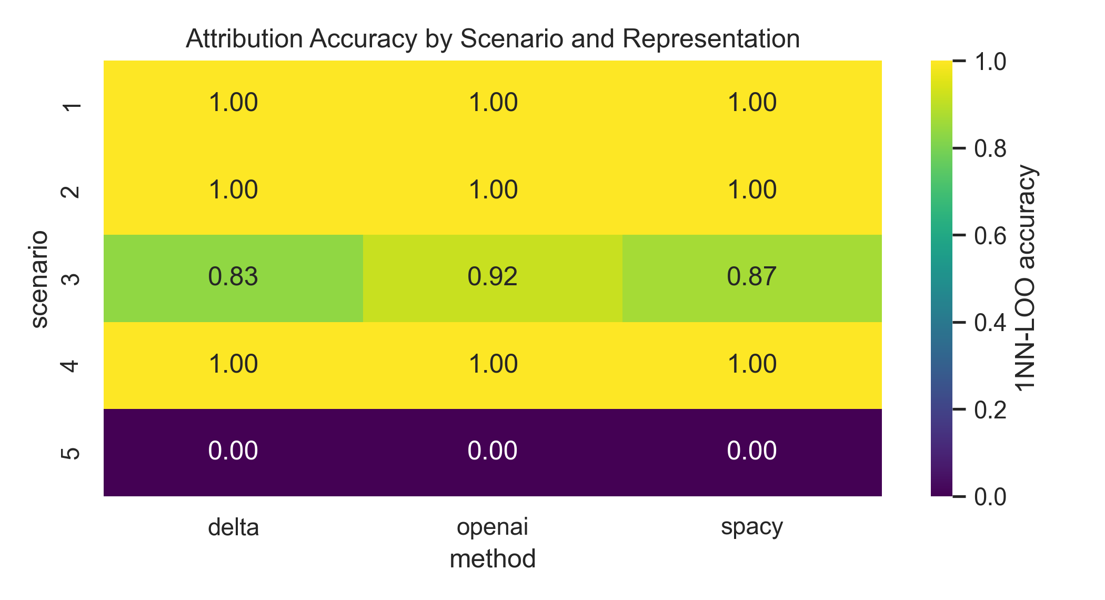
Figure 1. 1NN-LOO accuracy by scenario and representation.

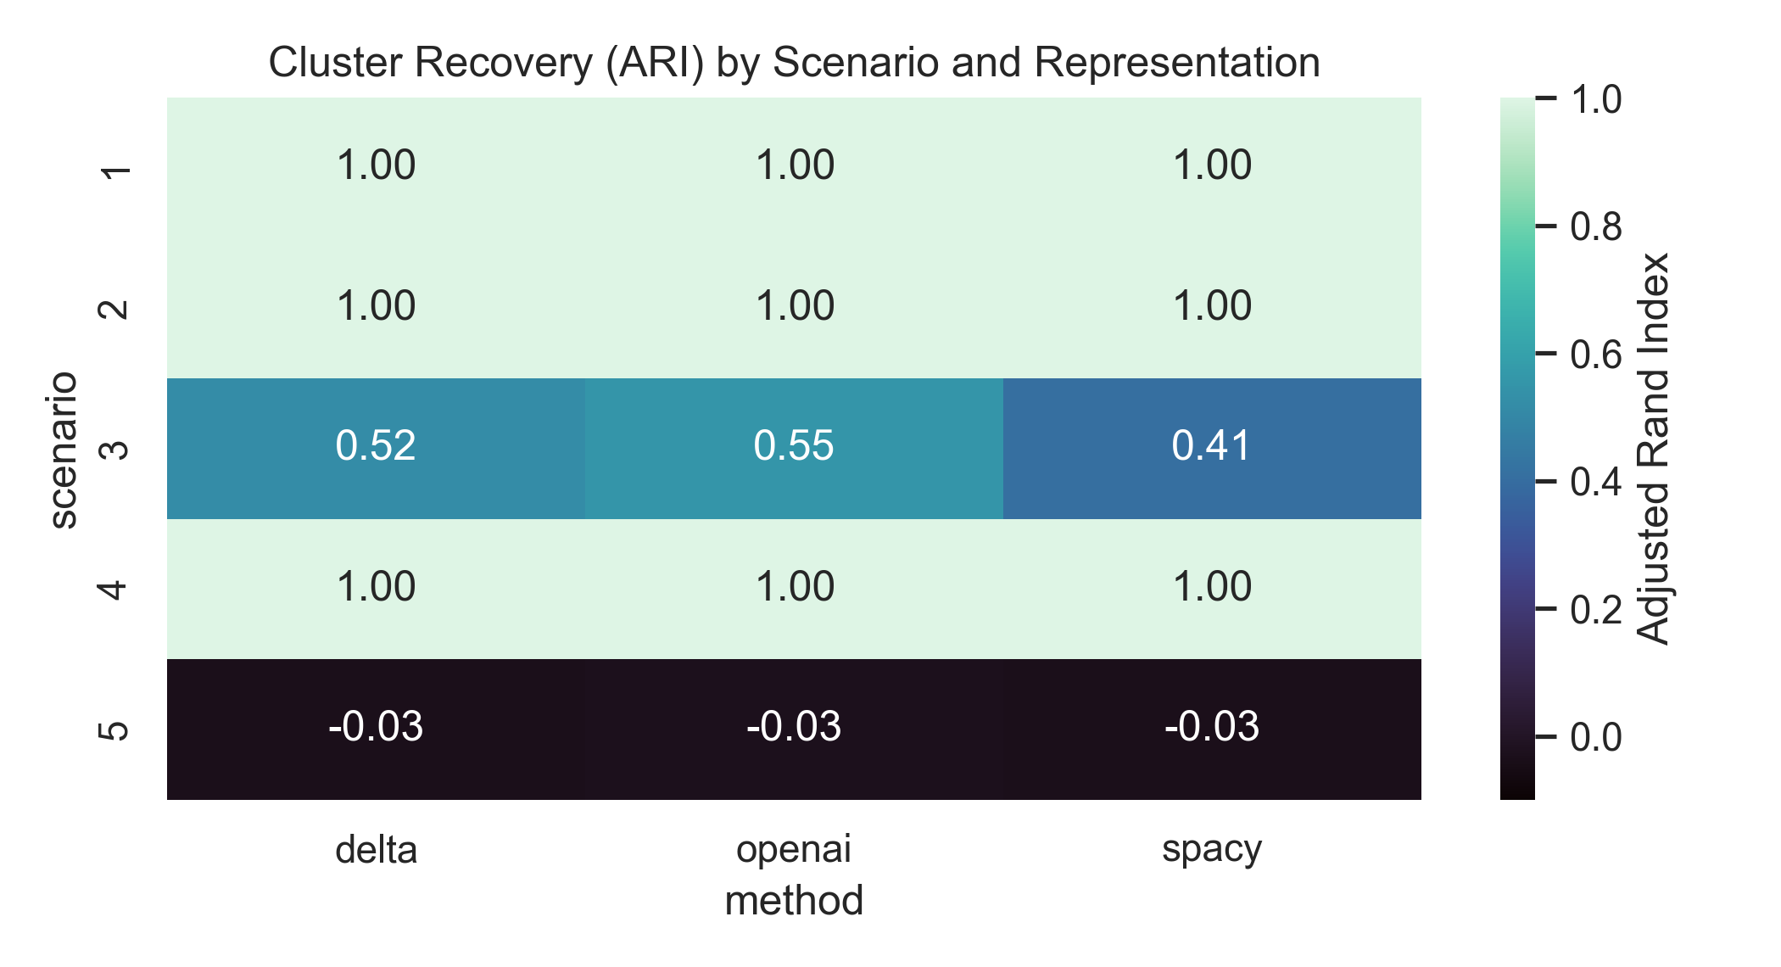
Figure 2. ARI by scenario and representation.

3.3 Scenario 3 inferential profile
Although OpenAI shows the highest point estimates in Scenario 3, inferential tests indicate that superiority should be framed as directional rather than definitive at this sample size. Confidence intervals for pairwise contrasts include zero and exact tests are non-significant at alpha = 0.05. Therefore, the evidence supports a robust descriptive ordering but not a strong null-rejection claim.
- openai - spacy: diff=0.0500, 95% CI [-0.0167, 0.1167], p_perm=0.3778, p_mcnemar=0.3750.
- openai - delta: diff=0.0833, 95% CI [-0.0167, 0.2000], p_perm=0.2270, p_mcnemar=0.2266.
- spacy - delta: diff=0.0333, 95% CI [-0.0833, 0.1500], p_perm=0.7915, p_mcnemar=0.7905.
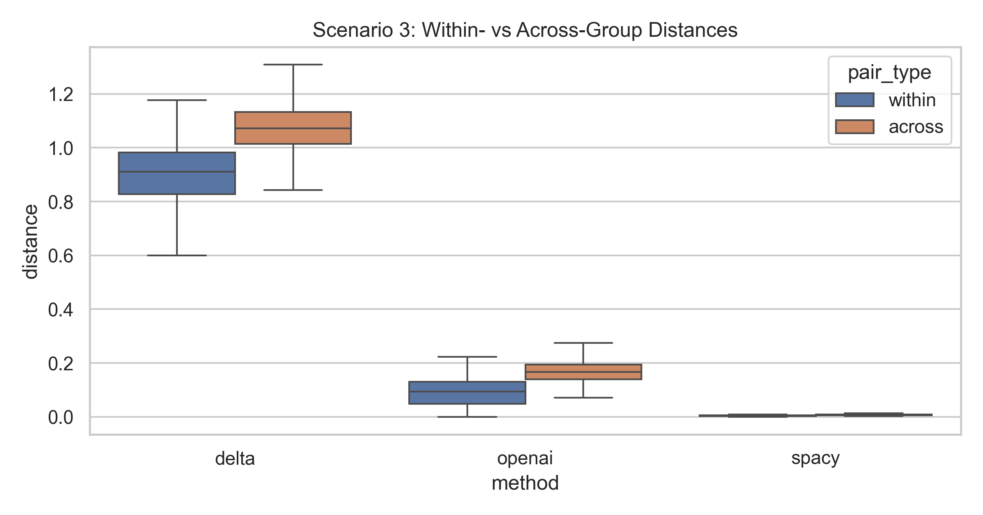
Figure 3. Scenario 3 within-group and across-group distance distributions.

3.4 Scenario 5 collapse and methodological implications
Scenario 5 chance tests are all highly significant in the negative direction (p = 2.72e-11), demonstrating that the 0.00 accuracies are not random fluctuations around chance but systematic misalignment between distance neighbourhoods and author labels. This is a critical substantive finding: under strong semantic confounding, method family becomes secondary to corpus design.
Observed 1NN floor values in Scenario 5: OpenAI=0.000, spaCy=0.000, Delta=0.000.
- openai vs chance(1/3): observed accuracy=0.0000, chance=0.3333, p_exact=2.720e-11.
- spacy vs chance(1/3): observed accuracy=0.0000, chance=0.3333, p_exact=2.720e-11.
- delta vs chance(1/3): observed accuracy=0.0000, chance=0.3333, p_exact=2.720e-11.
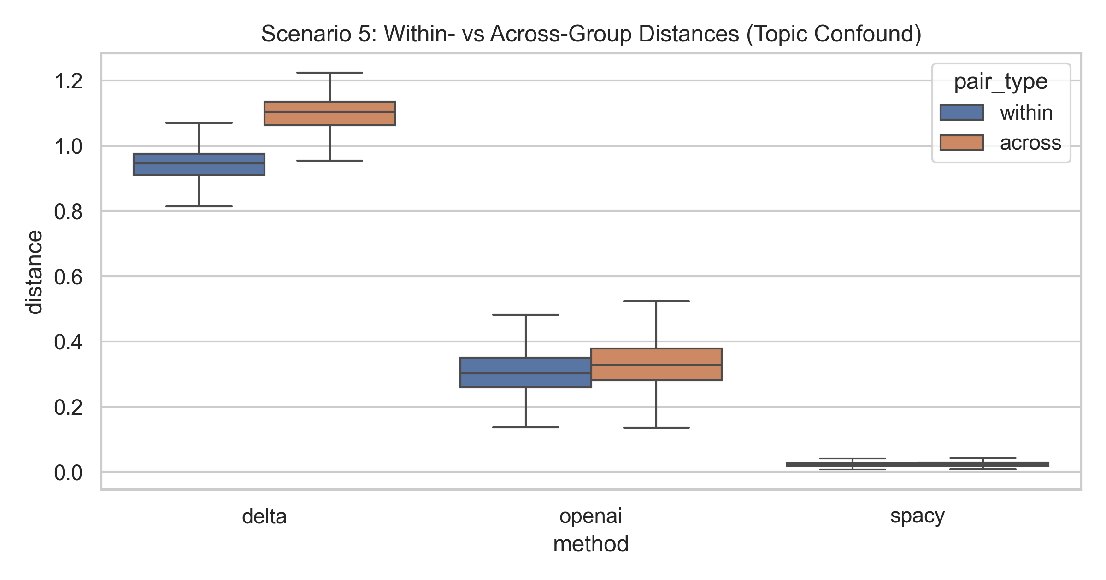
Figure 4. Scenario 5 within-group and across-group distance distributions.

3.5 Synthesis
The scenario sequence supports a bounded but theoretically meaningful conclusion. In the non-trivial distinct-text setting (Scenario 3), embeddings, especially OpenAI, offer measurable gains over Delta. However, this representational advantage disappears under extreme topic confounding (Scenario 5), where all methods fail. For quantitative authorship research, this implies that scenario diagnostics and confound controls should be treated as first-order methodological requirements alongside model selection.

