Investigating the Impact of Semantic Similarity on Stylometric Attribution Using Controlled Artificial Texts and Delta Distances
George Mikros, Radek Čech, Petra Mutlová

Abstract
Stylometric attribution assumes texts carry measurable traces of style, yet its reliability depends on how similar the compared texts are. We ask how textual similarity affects attribution and whether classical distance-based stylometry or dense neural embeddings are more robust as similarity increases. Using a large language model, we generated controlled corpora of 60 texts for 3 authors across five conditions, varying within- and between-author content overlap from 0.9/0.1 to 0.1/0.9. Each corpus was represented with Cosine Delta and two embedding models (OpenAI text-embedding-3-small and spaCy) and evaluated with nearest-neighbor and k-nearest-neighbor accuracy, the Adjusted Rand Index, silhouette width, and matrix correlations. While the authors stay coherent, all representations attribute perfectly. In the balanced condition, embeddings edge out Delta (0.92 and 0.87 versus 0.83, not significant). Under shared-topic similarity, all fail at the nearest neighbor, yet Delta recovers author structure further out (0.95 at k = 5), where embeddings do not. Reliability thus depends on whether the author or the topic dominates corpus geometry, making classical and neural approaches complementary.
Keywords: authorship attribution; stylometry; Cosine Delta; word embeddings; topic confound; cross-topic attribution; controlled artificial corpora; large language models

1. Introduction
Authorship attribution rests on the assumption that texts preserve measurable features of individual linguistic behavior. In stylometric research, these features are typically operationalized through quantitative properties such as the distribution of linguistic units, word or sentence length, and vocabulary richness. However, the extent to which such features are detectable depends on several textual and contextual factors. One such factor, which became central to the present study, is the degree of similarity between the texts being compared.
The motivation for this research emerged from an attempt to apply stylometric methods to a corpus of Latin texts written by authors in medieval Bohemia. In this case, the methods did not bring stable or readily interpretable results. Instead of yielding consistent authorial groupings, they proved highly sensitive to parameter settings. Even minor changes in feature selection or analytical thresholds led to substantially different attribution outcomes. This instability raised a methodological question that extends beyond the particular corpus under investigation: why do methods that are often effective in authorship attribution fail under certain textual conditions? We assume that a crucial factor could lie in the high degree of similarity between the texts under comparison.
This assumption is grounded in the specific nature of medieval Latin textual production and in a historically different understanding of authorship, both of which may reduce the visibility of individual authorial features. Medieval Latin texts were produced and transmitted within a manuscript culture in which authorship did not function as it does in modern literary practice. Texts written in Latin were characterized by frequent anonymity, and medieval authorship was often collective or anonymous. Moreover, medieval textual production was strongly shaped by practices of compilation and textual reuse. Authors commonly incorporated entire passages from other texts, as well as shorter formulations and argumentative patterns, without explicitly marking them as borrowed material. Therefore, medieval texts cannot always be considered products of individual authorship in the modern sense, but rather as dynamic textual formations produced through the selection, rearrangement, and adaptation of existing material. However, in the late Middle Ages (ca 1300–1500), authorial originality came to the foreground, and modern individualized authorship gradually began to emerge. Another factor contributing to textual similarity is the authors' linguistic background. Specifically, Latin was not a native language but a learned language acquired through a shared educational tradition. The teaching was based on similar grammatical manuals and rhetorical models, and it also involved the memorization of large passages from the same texts. This shared educational background may have further contributed to the convergence of linguistic choices and stylistic patterns across authors.
These considerations lead us to the central question of the present study: to what extent can textual similarity itself limit the applicability of stylometric methods? To address this question, we use a controlled experimental design based on artificial text corpora with systematically varied degrees of similarity. Both intra- and inter-author overlap are manipulated to examine how different configurations of textual similarity influence author differentiation. The results show that increasing semantic similarity diminishes the reliability of Delta distances in distinguishing authors.
That headline result needs qualifying, because we did not study Delta distances on their own. The instability that first prompted us came from classical distance-based stylometry, and specifically from the Delta measures introduced by Burrows (2002), which capture authorial style through the relative frequencies of a text's most frequent words, mostly function words such as articles, prepositions, and conjunctions. Much recent work has instead turned to dense distributed representations, such as neural word and document embeddings, which encode a text's semantic content in a high-dimensional vector space. Since the two kinds of representation emphasize different linguistic information, there is no reason to expect them to respond alike as texts grow more similar. If that similarity reflects mainly shared subject matter, embeddings may prove the more vulnerable; if it reflects shared phrasing and function-word usage, classical Delta may be the more fragile. We therefore evaluate, alongside Cosine Delta, two embedding representations, so as to ask not merely whether similarity degrades attribution but which representation degrades, and in what manner.
Within this comparative frame the study pursues four research questions: (i) how does increasing similarity between texts affect the reliability of Delta distances in distinguishing authors; (ii) how do embedding-based representations compare with Delta distances under varying degrees of overlap; (iii) are there systematic relationships between the two families of representation across different similarity configurations; and (iv) what methodological recommendations for stylometric practice follow from the answers. To address them, we apply a single attribution and clustering protocol to a series of controlled corpora, in which the balance between within-author and between-author similarity is varied systematically from one condition to the next.
The answers complicate the idea that more similarity is always harmful. Attribution stays fully reliable while authors are internally coherent and overlap only moderately, and in a balanced condition the embedding representations, especially a modern contextual model, recover authorship somewhat more accurately than Delta. Once shared topic dominates the similarity between authors, though, all three representations fail at the nearest neighbor, even though classical Delta still holds some recoverable author structure a little further out in the distance space. The study thus offers a controlled benchmark that isolates the effect of inter-author similarity on both classical and neural attribution. It also shows where the choice of representation matters: most in the intermediate regime, and least under strong topic confounding, where what decides the outcome is the design of the corpus, not the method.
The paper is organized as follows. Section 2 reviews related work on stylometric authorship attribution, Delta-based distance measures, neural text representations and the influence of topic and content on stylometric analysis. Section 3 describes the construction of the controlled corpora, the three text representations and the evaluation protocol. Section 4 reports the attribution and clustering results across the similarity conditions, together with the supporting statistical analyses. Section 5 discusses the implications of these findings for stylometric practice and for the medieval Latin case that motivated the study, and Section 6 concludes and outlines directions for further research.

2. Literature Review

2.1 Stylometric authorship attribution and distance-based methods
Computational authorship attribution has its origins in the statistical study of disputed texts, the best-known early example being Mosteller and Wallace's (1964) analysis of the Federalist Papers. Modern stylometry rests on the premise that authors leave quantifiable traces in measurable textual properties, and especially in the relative frequencies of the most frequent words, which are predominantly grammatical function words and largely beyond conscious control (Holmes, 1998; Stamatatos, 2009). Among the distance-based methods built on such features, the Delta measure introduced by Burrows (2002) has become a standard reference point: it standardizes the relative frequencies of the most frequent words and compares documents by their aggregated deviations, and later work has clarified why it succeeds and how its variants, including the cosine variant used in the present study, relate to one another (Evert et al., 2017). The wide adoption of Delta owes much to accessible implementations, in particular the stylo package for R (Eder et al., 2016). More recent work continues to refine and benchmark the measure, for example, by reweighting word frequencies with distributional information while retaining a Cosine Delta classifier (Eder, 2022), and broader surveys document the expanding inventory of stylometric features now in use (Lagutina et al., 2019). Within the same tradition, richer document representations have been proposed; Mikros and Perifanos (2013), for instance, introduced Author's Multilevel N-gram Profiles, which combine character and word n-grams of increasing length to capture stylistic regularities at several linguistic levels.

2.2 The influence of topic, genre, and content
A persistent concern in this literature is the extent to which stylometric features are genuinely topic-neutral. The function-word basis of Delta is often justified on the grounds that frequent grammatical words are insensitive to subject matter, yet empirical work has repeatedly qualified this assumption. Mikros and Argiri (2007) built a corpus controlled simultaneously for author and topic and showed that many features commonly treated as purely stylistic, including a number of function words, in fact carry topical information and can separate texts by subject as readily as by author. The robustness of attribution across topics has since been examined systematically: models based on character n-grams degrade under cross-topic and cross-genre conditions while remaining comparatively resilient (Stamatatos, 2013), and explicit strategies for masking or removing topical information have been proposed in order to recover the authorial signal (Stamatatos, 2018). Taken together, these results establish topic as a primary confound for stylometric attribution and directly motivate the controlled manipulation of between-author content overlap that is central to the present study.
More recent work has sharpened this picture in two complementary directions. On the diagnostic side, controlled studies have asked which features actually drive attribution across topics and genres: Sapkota et al. (2015) find that the cross-domain success of character n-grams is concentrated in affix and punctuation n-grams rather than in content-bearing ones, while Sari et al. (2018) show that the usefulness of topic-related and style-related features depends strongly on the dataset, helping when authors write about consistent subjects and hurting when they do not. On the modeling side, cross-domain attribution has increasingly turned to representation learning: Barlas and Stamatatos (2020) report that pre-trained language models such as BERT and ELMo deliver more stable cross-topic and cross-genre attribution than earlier cue-based models, and Wegmann et al. (2022) demonstrate that style representations trained only on the authorship-verification objective tend to absorb topical information, and introduce content-controlled training in order to obtain genuinely content-independent style embeddings. These studies converge on the view that separating authorial style from topical content remains a central and still unresolved problem, which the controlled design adopted here addresses directly by varying between-author content overlap while holding authorship constant.

2.3 Neural and embedding-based text representations
In parallel with the refinement of classical stylometry, authorship research has increasingly adopted distributed and contextual text representations. Static word embeddings represent words as dense vectors learned from co-occurrence statistics (Mikolov et al., 2013), and document-level vectors can be obtained by pooling them, as in the spaCy models used here (Honnibal et al., 2020). Contextual transformer models such as BERT (Devlin et al., 2019) and the large-scale contrastively trained embedding models of the kind we employ (Neelakantan et al., 2022) produce representations that encode substantial semantic content, and such embeddings have been applied to authorship attribution and verification with encouraging results. Their principal strength, a rich encoding of meaning, is at the same time a potential liability for authorship analysis, because meaning is closely bound up with topic. Whether dense semantic embeddings are therefore more or less robust than function-word stylometry as inter-author similarity increases is, to the best of our knowledge, an open question, and it is one of the questions the present study sets out to answer.

2.4 Large language models and controlled artificial corpora
Finally, the study belongs to a growing line of work that uses large language models both as objects and as instruments of stylometric research. As objects of study, language models raise the question of how faithfully they can reproduce an author's style: Mikros (2025), for example, analyzes the capacity of GPT-4o to imitate the stylometric signatures of literary authors and treats the generated subcorpora as artificial authors, finding that surface features are reproduced more readily than deeper stylistic structure. As instruments, the same models make it possible to generate corpora in which textual properties are deliberately controlled, which is difficult to achieve with naturally occurring texts. We exploit this capacity to construct a series of corpora in which the balance between within-author and between-author similarity is varied systematically, so that the effect of similarity on attribution can be isolated while class size, sample size, and document length are held constant. This generative and controlled approach complements the cross-topic evaluations on natural corpora reviewed above and is, we argue, especially well suited to the question of how, and for which representations, similarity degrades authorship attribution.

3. Methods

3.1 Research design and rationale
The aim of this study is to determine how the degree of similarity between texts modulates the reliability of distance-based stylometric attribution, and whether dense neural representations of documents are more or less robust than classical stylometry as that similarity increases. To answer these questions while keeping every other source of variation under experimental control, we adopt a scenario-based design built on artificial corpora. Working with synthetic rather than naturally occurring texts allows us to fix the number of authors, the number of documents per author, and the approximate length of each document, while systematically varying the amount and the structure of the material shared within and between authors. Because class size, sample size, and document length are held constant, differences in attribution behavior across scenarios can be attributed to this controlled similarity structure rather than to class imbalance, unequal document length, or idiosyncratic parameter settings. As detailed in Section 3.2, the scenarios are best understood as five distinct controlled conditions that span a continuum from author-dominated to topic-dominated similarity.

3.2 Corpus construction
Three virtual authors, labeled A, B, and C, were defined as the units of attribution. For each author, we generated 20 short documents of approximately 300 words, giving 60 documents per scenario and a perfectly balanced three-class problem in every condition. Texts were produced with a large language model (OpenAI o1-mini) under fixed prompting templates so that each author retained a recognizable stylistic profile across their 20 samples. Every document was assembled from two complementary blocks: a shared block whose content is common across authors, which controls between-author (inter) overlap, and an author-specific block unique to each author, which controls within-author (intra) coherence. By adjusting the relative weight of these two blocks, we can place a scenario anywhere on a continuum from strongly individuated authors writing about different things to near interchangeable authors writing about the same things.
The five scenarios were specified by two design targets: the share of each text allocated to within-author (intra) content and the share allocated to between-author (inter) content, summarized in Table 1 and Figure 1a. The intended progression moves from Scenario 1, where within-author content dominates (0.90) and authors are clearly individuated, to Scenario 5, where between-author content dominates (0.90) and authors strongly overlap one another, with Scenarios 2 to 4 set at intermediate target levels.
Inspection of the realized texts shows that the shared material is implemented in three structurally different ways across the series, a distinction that is central to interpreting the results. In Scenarios 1 and 2, the shared material is an author block: each author reuses a stable thematic paragraph of roughly 120 to 210 words (technology, environmental policy, and global economics, respectively) across its 20 documents, and the authors differ chiefly in topic, with almost no text shared between authors. In Scenario 3, the shared material is a single global block of about 140 words common to all 60 documents, followed by author-specific content, so that the overlap is constant boilerplate that is neither author nor topic aligned. In Scenario 5, the shared material is a per-topic block of roughly 280 words: the 3 documents carrying the same topic index are near duplicates across authors and are followed only by a short author signature of about 30 words. Scenario 4 forms a fourth case, an identical text control discussed below. Because between-author overlap is realized as topic separation in Scenarios 1 and 2, as common boilerplate in Scenario 3, and as topic-aligned near duplication in Scenario 5, the conditions probe qualitatively different similarity structures rather than different magnitudes of a single quantity. This is a deliberate property of the design: it exposes author-dominated, balanced, and topic-dominated regimes, and, as shown in Section 4.4, it is the topic-aligned organization of the overlap in Scenario 5, not its magnitude alone, that produces the attribution collapse.
Table 1. Design targets and realized corpus diagnostics for the five conditions. Every scenario contains 60 documents (3 authors, 20 documents each). Intra-overlap and inter-overlap are the designed proportions of within-author and between-author shared content. Scenario 4 was implemented as an identical-text control (three unique base texts), as reflected in its small vocabulary. The MFW column is the feature-set size used by the stylometric pipeline; for Scenario 4, it is capped at 393 because the corpus offers no more distinct word types under the stylo tokenization, so the 500-word profile used in the other conditions cannot be formed.
Scenario | Intra-overlap | Inter-overlap | Unique texts | Vocab size | Mean words / doc | MFW used
1 | 0.90 | 0.10 | 60 | 1067 | 175 | 500
2 | 0.70 | 0.30 | 60 | 2057 | 227 | 500
3 | 0.50 | 0.50 | 60 | 1553 | 259 | 500
4 | 0.30 | 0.70 | 3 | 403 | 292 | 393
5 | 0.10 | 0.90 | 60 | 2655 | 309 | 500

3.3 Text representations
We compared three document representations, each evaluated in its own native metric space so that the comparison targets the representation itself rather than any downstream classifier engineering.
Classical stylometry (Cosine Delta). Most frequent word profiles were extracted with the R package stylo (Eder et al., 2016) and compared with Cosine Delta, also known as the Würzburg distance (Burrows, 2002; Evert et al., 2017), which is the cosine distance computed on z-scored relative frequencies of the most frequent words. We used the 500 most frequent words for Scenarios 1, 2, 3, and 5, with no culling, on lowercased word unigrams. In Scenario 4, the profile was necessarily capped at 393 most frequent words. This cap is a property of the corpus rather than a free parameter: because Scenario 4 is an identical text control assembled from only three base texts, it contains on the order of 400 distinct word types in total (393 under the stylo tokenization that defines the Delta feature set), so a 500-word profile cannot be formed and stylo falls back to all available features. The smaller feature space in Scenario 4 is therefore a direct symptom of the degenerate, controlled structure of this condition, not a difference in how the scenarios were analyzed. Cosine Delta is a well-established and widely used authorship measure and serves as the classical baseline here. The Delta distance matrix is used directly because it is already a document-by-document distance matrix.
OpenAI embeddings. Each document was represented by a dense vector from the OpenAI text-embedding-3-small model (1536 dimensions; Neelakantan et al., 2022). Documents were segmented, every segment was embedded, and the segment vectors were averaged into a single document vector, yielding 60 distinct document-level vectors per scenario. Pairwise document distances were then computed as cosine distance (one minus cosine similarity).
spaCy embeddings. As a second, lighter embedding baseline, each document was represented by the en_core_web_lg document vector (300 dimensions) from the spaCy library (Honnibal et al., 2020), obtained by mean pooling the static word vectors (Mikolov et al., 2013) of all tokens, including content words, function words and punctuation. Pairwise distances were again computed as cosine distance. Using two embedding models of very different dimensionality and training regime allows us to separate effects that are specific to a single model from effects that are general to dense semantic representations.

3.4 Evaluation protocol
Local attribution. Primary attribution performance was measured with leave-one-out one-nearest-neighbor accuracy (1NN-LOO): each document is assigned the author label of its single closest neighbor in the distance space, the document itself being excluded, and accuracy is the proportion of documents whose predicted label matches their true author. This criterion is deliberately conservative and probes the most local structure of the distance space. To examine how attribution depends on the size of the neighborhood, we also computed k-nearest-neighbor accuracy for k equal to 1, 3, 5, and 7 using majority voting, which reveals whether the author signal that is absent at the nearest neighbor is recovered slightly further out.
Global structure. To assess whether the global partition of each distance space matches the author labels, we performed agglomerative clustering with three clusters (average linkage on the precomputed distances; scikit-learn, Pedregosa et al., 2011) and scored the result with the Adjusted Rand Index (ARI; Hubert & Arabie, 1985), which is zero for chance level agreement and one for perfect recovery. We complemented ARI with the average silhouette width (Rousseeuw, 1987) computed on the same distance matrix, which summarizes how compact and well separated the author groups are across the whole space rather than only at a small radius.
Corpus geometry diagnostics. For every scenario and representation, we summarized the distance space by the mean within-author distance, the mean between-author distance, and their ratio, which we term the separation ratio (between author divided by within author). A separation ratio well above one indicates that authors occupy distinct regions and attribution should be easy; a ratio near one indicates that within-author and between-author distances are indistinguishable. To expose the mechanism behind any collapse, we further decomposed the between-author distances into pairs that share the same topic index and pairs that carry different topics, and contrasted both with the within-author distances.
Inter-representation agreement. To address whether the stylometric and embedding spaces encode the same or complementary information, we computed matrix correlations between their full pairwise distance matrices. For each scenario and each pair of representations, we report the Pearson correlation over the lower triangle of the two distance matrices, with significance assessed by a Mantel-style permutation test, in which the rows and columns of one matrix are permuted jointly (Mantel, 1967). A high correlation means the two representations rank document relationships similarly; a low correlation means they capture different aspects of textual variation and are therefore complementary.

3.5 Statistical inference
Our inferential strategy emphasizes effect sizes and interval estimates alongside exact hypothesis tests, in line with current reporting standards. For the pivotal balanced scenario (Scenario 3) we examined the three pairwise contrasts between representations (OpenAI versus spaCy, OpenAI versus Delta, spaCy versus Delta). For each contrast, we report the difference in 1NN-LOO accuracy, a bootstrap 95 percent confidence interval for that difference (Efron & Tibshirani, 1993), a paired randomization (permutation) p value, and an exact McNemar p value (McNemar, 1947) computed on the discordant document-level predictions. For the collapse scenario (Scenario 5), where every method scored at the floor, we tested each observed accuracy against the naive chance baseline of one-third using an exact binomial test. All matrix correlations were tested with permutation as described above. Analyses were carried out in Python (scikit-learn, SciPy, NumPy) and the stylometric distances in R (stylo); the full pipeline is scripted and reproducible.

4. Results

4.1 Realized geometry of the five conditions
Before evaluating attribution, we characterized the distance geometry that each condition actually produces. Figure 1 contrasts the design targets (panel a) with the separation actually produced in the Cosine Delta space (panel b). The mean within-author Delta distance rises monotonically from 0.41 in Scenario 1 to 0.94 in Scenario 5, while the mean between-author distance falls from 1.31 to 1.05, so that the separation ratio contracts from 3.22 in Scenario 1 to 1.12 in Scenario 5 (Table 2). Scenario 2 retains a wide separation ratio (3.04), so a moderate reduction of within-author coherence does not yet erode author identity, whereas the balanced Scenario 3 already drops to 1.20. Scenario 4, the identical-text control, has zero within-author distance and therefore an unbounded ratio, so its later perfect scores are a sanity check rather than evidence about realistic attribution. Scenarios 1, 2, 3, and 5 thus span the intended range from strong separation to near collapse and form the backbone of the analysis, while Scenario 4 functions as a control.
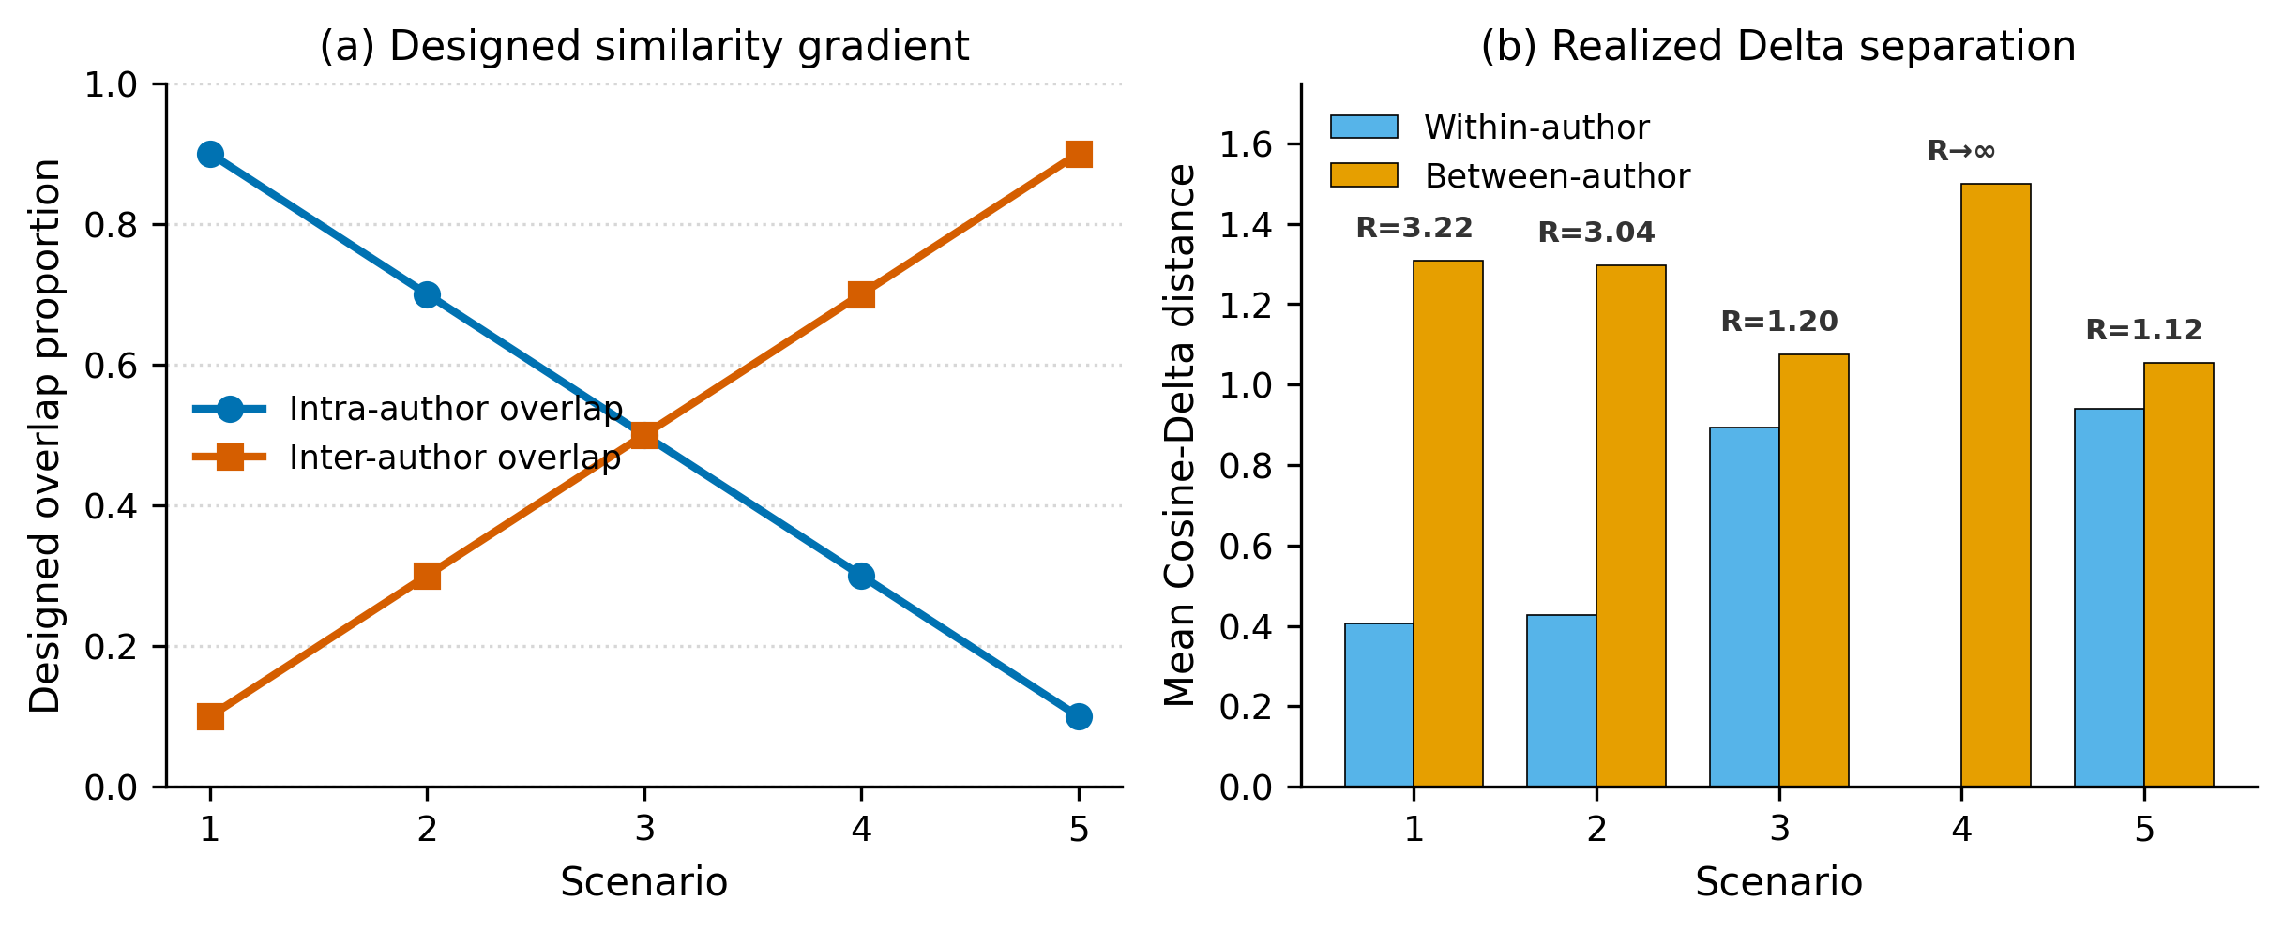
Figure 1. Experimental design and realized corpus geometry. (a) The design targets for within-author (intra) and between-author (inter) overlap across the five conditions. (b) Mean within-author and between-author Cosine-Delta distances per scenario, with the separation ratio R (between/within) annotated above each pair. The separation ratio contracts from 3.22 (Scenario 1) to 1.12 (Scenario 5); Scenario 4 is an identical-text control whose within-author distance is zero (R unbounded).
Table 2. Cosine-Delta separation by scenario: mean within-author and between-author distances, their ratio, and the role of each scenario. The separation ratio falls steadily across the genuine distinct-text scenarios (1, 2, 3, 5); Scenario 4 is the identical-text control.
Scenario | Within-author Δ | Between-author Δ | Separation ratio | Role in the design
1 | 0.405 | 1.307 | 3.22 | High-separation baseline
2 | 0.427 | 1.296 | 3.04 | High separation maintained
3 | 0.893 | 1.076 | 1.20 | Balanced, discriminative condition
4 | 0.000 | 1.500 | ∞ | Identical-text control
5 | 0.940 | 1.053 | 1.12 | Topic confound, attribution collapse

4.2 Three performance regimes across the conditions
Applying the three representations to the five scenarios produces a clear three-regime picture (Figure 2; Table 3). In a ceiling regime comprising Scenarios 1, 2, and 4, all three representations reach perfect 1NN-LOO accuracy (1.00) and perfect cluster recovery (ARI = 1.00). For Scenarios 1 and 2, this reflects genuinely strong author separation; for Scenario 4, it reflects the degenerate identical text structure, in which any nonzero between-author distance trivially dominates a zero within-author distance. In a discriminative regime, represented by the balanced Scenario 3, the methods separate in a stable rank order, with OpenAI embeddings ahead of spaCy embeddings and both ahead of Cosine Delta. In a collapse regime, represented by Scenario 5, every method falls to zero 1NN-LOO accuracy and to an ARI indistinguishable from zero (between -0.035 and -0.027). The regime structure, rather than any single average score, is the central empirical result, because it identifies the corpus conditions under which each representation is informative and the conditions under which all of them fail.
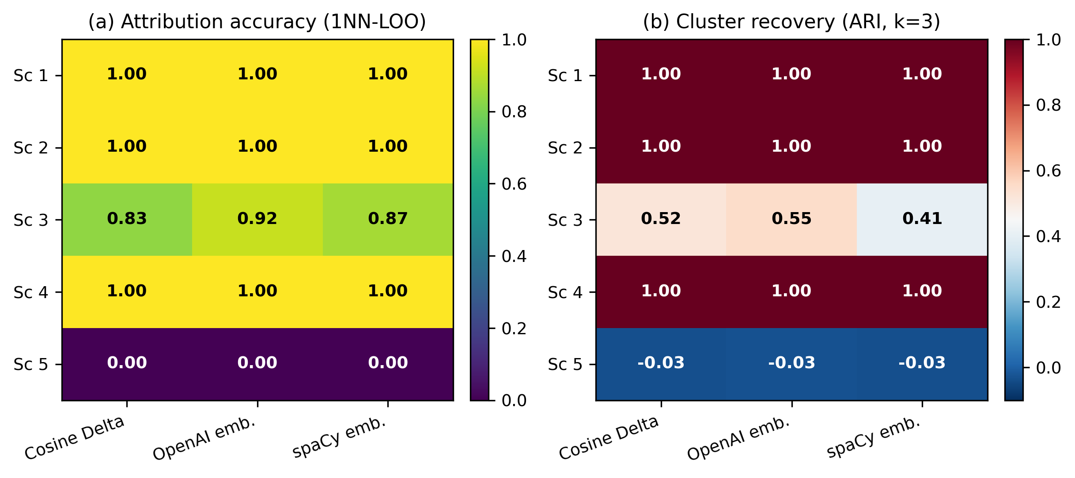
Figure 2. Attribution and clustering performance for each representation across scenarios. (a) Leave-one-out one-nearest-neighbor accuracy (1NN-LOO). (b) Adjusted Rand Index of three-cluster agglomerative clustering. Scenarios 1, 2, and 4 are at ceiling for all methods; Scenario 3 is the only graded distinct-text condition (OpenAI > spaCy > Delta); Scenario 5 collapses to chance for every representation.
Table 3. Per-scenario, per-representation performance: 1NN-LOO attribution accuracy, Adjusted Rand Index of three-cluster agglomerative clustering, and average silhouette width on the distance matrix. Bold patterns of interest are discussed in Sections 4.2 to 4.5.
Scenario | Representation | 1NN-LOO acc. | ARI (k=3) | Silhouette
1 | Cosine Delta | 1.000 | 1.000 | 0.675
1 | OpenAI | 1.000 | 1.000 | 0.918
1 | spaCy | 1.000 | 1.000 | 0.934
2 | Cosine Delta | 1.000 | 1.000 | 0.656
2 | OpenAI | 1.000 | 1.000 | 0.886
2 | spaCy | 1.000 | 1.000 | 0.891
3 | Cosine Delta | 0.833 | 0.517 | 0.127
3 | OpenAI | 0.917 | 0.550 | 0.390
3 | spaCy | 0.867 | 0.405 | 0.308
4 | Cosine Delta | 1.000 | 1.000 | 1.000
4 | OpenAI | 1.000 | 1.000 | 1.000
4 | spaCy | 1.000 | 1.000 | 1.000
5 | Cosine Delta | 0.000 | -0.035 | 0.101
5 | OpenAI | 0.000 | -0.027 | 0.022
5 | spaCy | 0.000 | -0.033 | -0.025

4.3 The discriminative regime: embeddings improve on Delta in the balanced corpus
Scenario 3 is the only condition that is neither trivially separable nor degenerate, and it is therefore the most informative test of whether embeddings improve on Delta as topic overlap varies. Here, the three representations order themselves as OpenAI (1NN-LOO = 0.917) ahead of spaCy (0.867) and ahead of Cosine Delta (0.833), and the same ordering holds for global structure, with OpenAI achieving the highest ARI (0.550) and silhouette (0.390), and Delta the lowest silhouette (0.127). The distance distributions in the top row of Figure 3 show why: for all three representations, the within-author and between-author distributions overlap substantially in Scenario 3, but the overlap is smallest for OpenAI, which preserves the clearest gap between same-author and different-author pairs. Embeddings, and the OpenAI model in particular, thus extract additional discriminative signal when topic overlap is present but does not yet dominate.
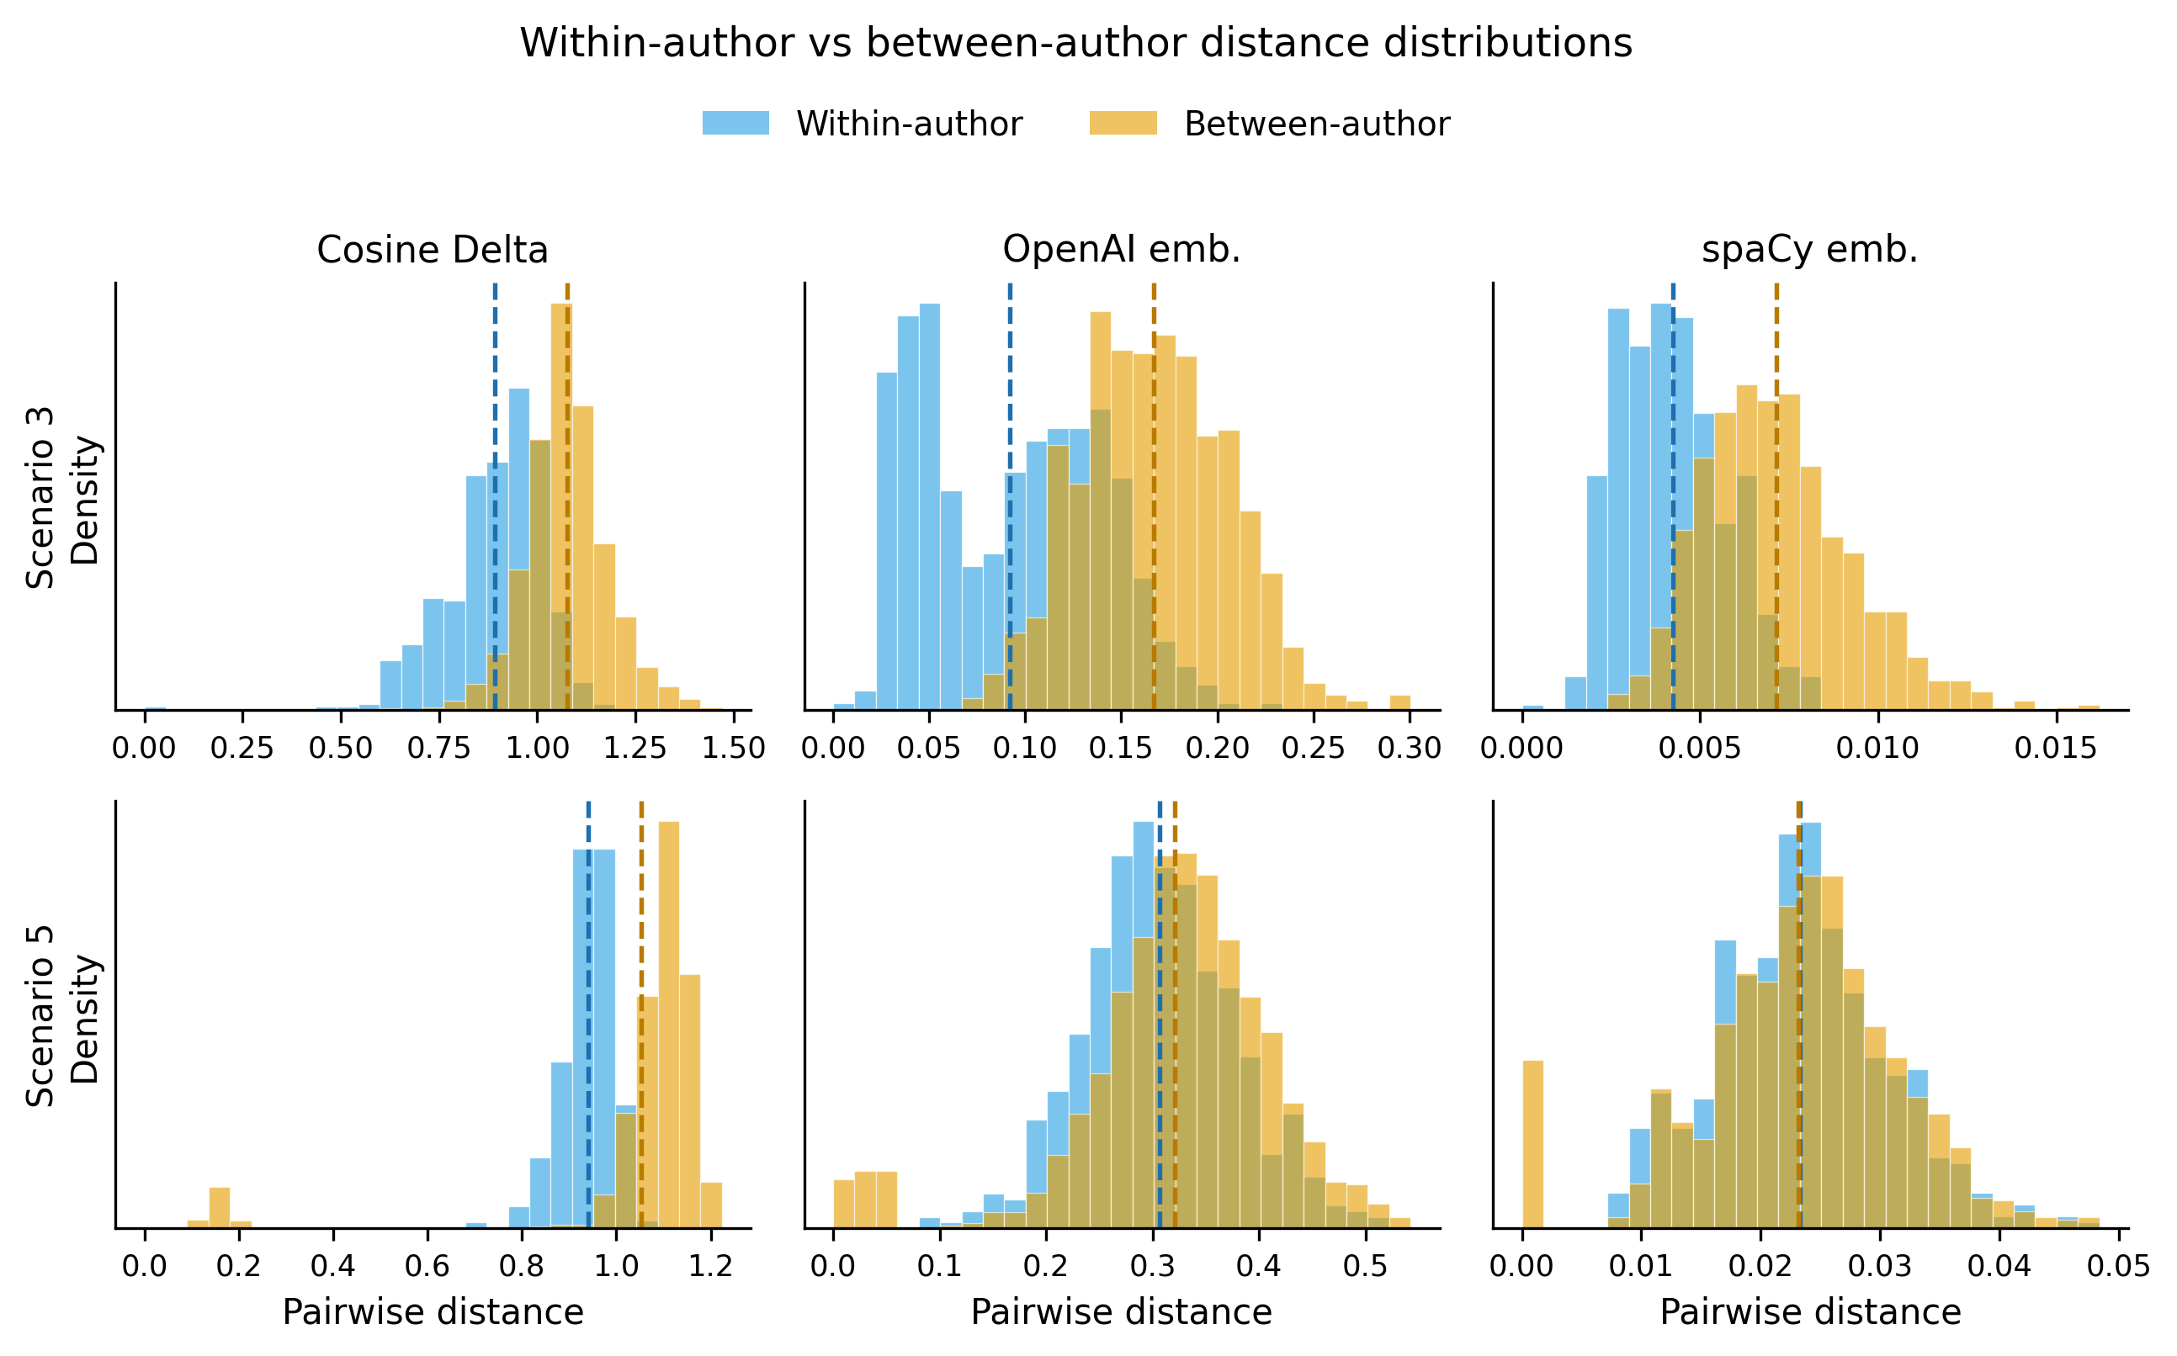
Figure 3. Within-author (blue) versus between-author (orange) pairwise-distance distributions for each representation in the two informative scenarios. Top row: Scenario 3, where the distributions overlap but remain separable, most clearly for OpenAI. Bottom row: Scenario 5, where the within-author distances are systematically larger than a substantial mass of between-author distances, signaling that author identity has been overridden. Dashed lines mark distribution means.
The pairwise contrasts for Scenario 3 are reported in Table 4. The largest effect is the OpenAI advantage over Cosine Delta, an improvement of 0.083 in accuracy (permutation and exact McNemar p = 0.227); OpenAI exceeds spaCy by 0.050 and spaCy exceeds Delta by 0.033. All three confidence intervals include zero, and none of the tests reaches significance at the conventional 0.05 threshold at this sample size, so the ordering OpenAI greater than spaCy greater than Delta is best read as a robust descriptive and directional result rather than as a confirmed inequality. The direction is nonetheless consistent across both the local (1NN) and global (ARI, silhouette) criteria and across the two independent embedding models, which strengthens the qualitative claim that dense semantic representations add value in the balanced regime.
Table 4. Inferential statistics. For Scenario 3, pairwise contrasts between representations with bootstrap 95% confidence intervals, paired randomization p-values, and exact McNemar p-values. For Scenario 5, each representation was tested against the chance baseline (1/3) with an exact binomial test. Scenario 5 exact p-values are 2.72 x 10^-11.
Sc. | Contrast | Acc. A | Acc. B | Δ acc. [95% CI] | p (perm.) | p (exact)
3 | OpenAI vs spaCy | 0.917 | 0.867 | 0.050 [-0.017, 0.117] | 0.378 | 0.375
3 | OpenAI vs Delta | 0.917 | 0.833 | 0.083 [-0.017, 0.200] | 0.227 | 0.227
3 | spaCy vs Delta | 0.867 | 0.833 | 0.033 [-0.083, 0.150] | 0.791 | 0.791
5 | OpenAI vs chance | 0.000 | 0.333 | -0.333 | <0.001 | 2.7e-11
5 | spaCy vs chance | 0.000 | 0.333 | -0.333 | <0.001 | 2.7e-11
5 | Delta vs chance | 0.000 | 0.333 | -0.333 | <0.001 | 2.7e-11

4.4 The collapse regime: topic overrides authorship in Scenario 5
In Scenario 5, every representation attributes zero documents correctly under the nearest neighbor rule, and the three exact binomial tests against chance return p = 2.72 x 10^-11 (Table 4). A zero accuracy that is this far below chance is not a random fluctuation; it signals a systematically wrong neighborhood structure. The mechanism is revealed by decomposing the Delta distances according to pair type (Figure 4). In Scenario 5, the mean distance between documents sharing the same topic index but written by different authors is only 0.16, far smaller than the mean within-author distance of 0.94. That is, a document and its same-topic counterpart in another author group are near-duplicates, while two documents by the same author on different topics sit comparatively far apart. Consequently, the single nearest neighbor of every one of the 60 documents is its cross-author topic twin: the proportion of documents whose nearest neighbor shares their topic index is 1.00 for all three representations, and the proportion whose nearest neighbor shares their author is 0.00. The collapse is therefore a clear topic confound, and because it appears across both the stylometric and the embedding spaces, it is a property of the corpus and not of any single model.
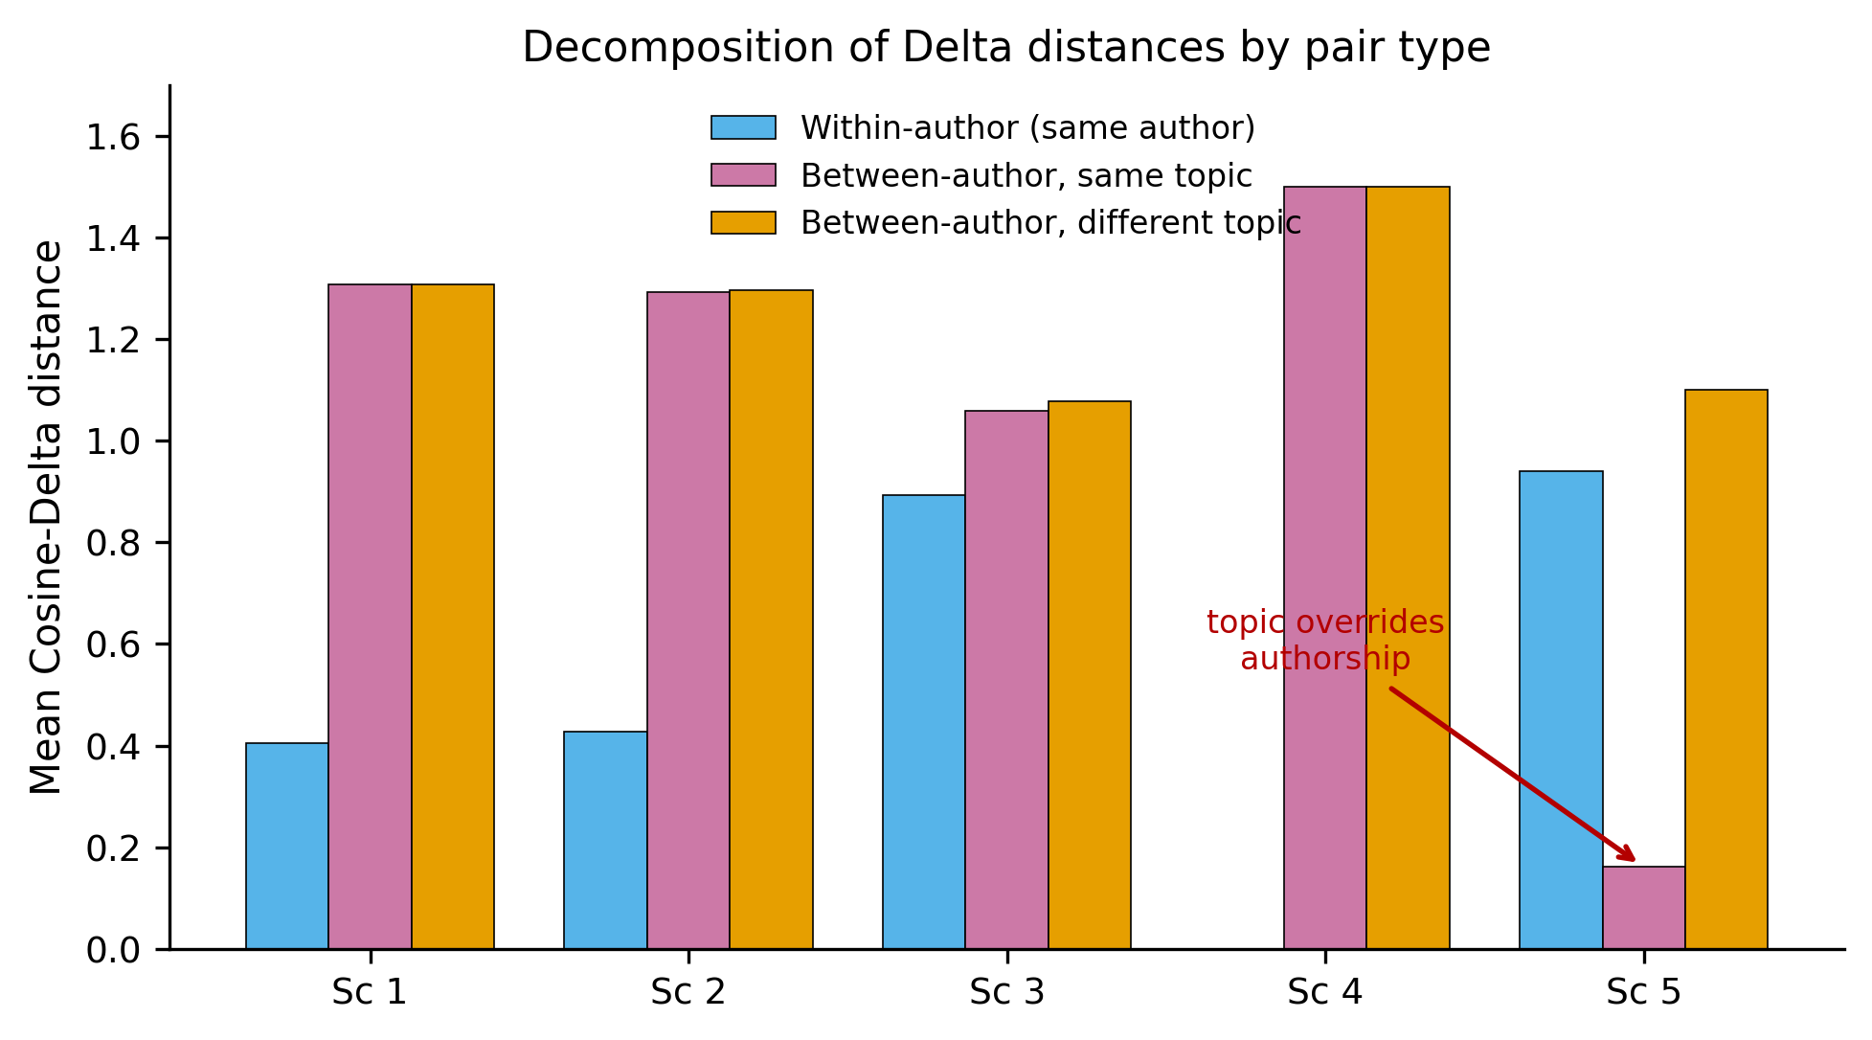
Figure 4. Decomposition of mean Cosine-Delta distances by pair type across scenarios: within-author pairs, between-author pairs sharing the same topic index, and between-author pairs with different topics. From Scenario 1 to Scenario 3, authorship dominates (within-author distances are smallest). In Scenario 5 the ordering inverts: between-author same-topic pairs become the closest of all (0.16), well below within-author pairs (0.94), so topic overrides authorship. Scenario 4 (identical-text control) has zero within-author distance and is omitted from the within-author bar.

4.5 Local versus global structure: Delta is more topic-robust beyond the nearest neighbor
The zero nearest neighbor accuracy in Scenario 5 conceals an important asymmetry between the representations that only becomes visible when the neighborhood is enlarged. Figure 5 plots k nearest neighbor accuracy as a function of k for the two informative scenarios. In Scenario 3, all methods are already near the ceiling at small k and remain stable. In Scenario 5, all methods start at zero for k = 1, because the nearest neighbor is always the cross-author topic twin, but they then diverge sharply. Cosine Delta recovers to 0.95 accuracy at k = 5 and to 1.00 at k = 7, whereas OpenAI rises only to 0.42 at k = 5 and spaCy actually deteriorates to 0.15. The interpretation is that, once the two near-identical topic twins are set aside, the next closest documents in the Delta space are predominantly the same author texts, so a slightly larger vote restores the correct label; in the embedding spaces, by contrast, even the third to fifth neighbors remain topic aligned across authors, so enlarging the vote does not help and can hurt.
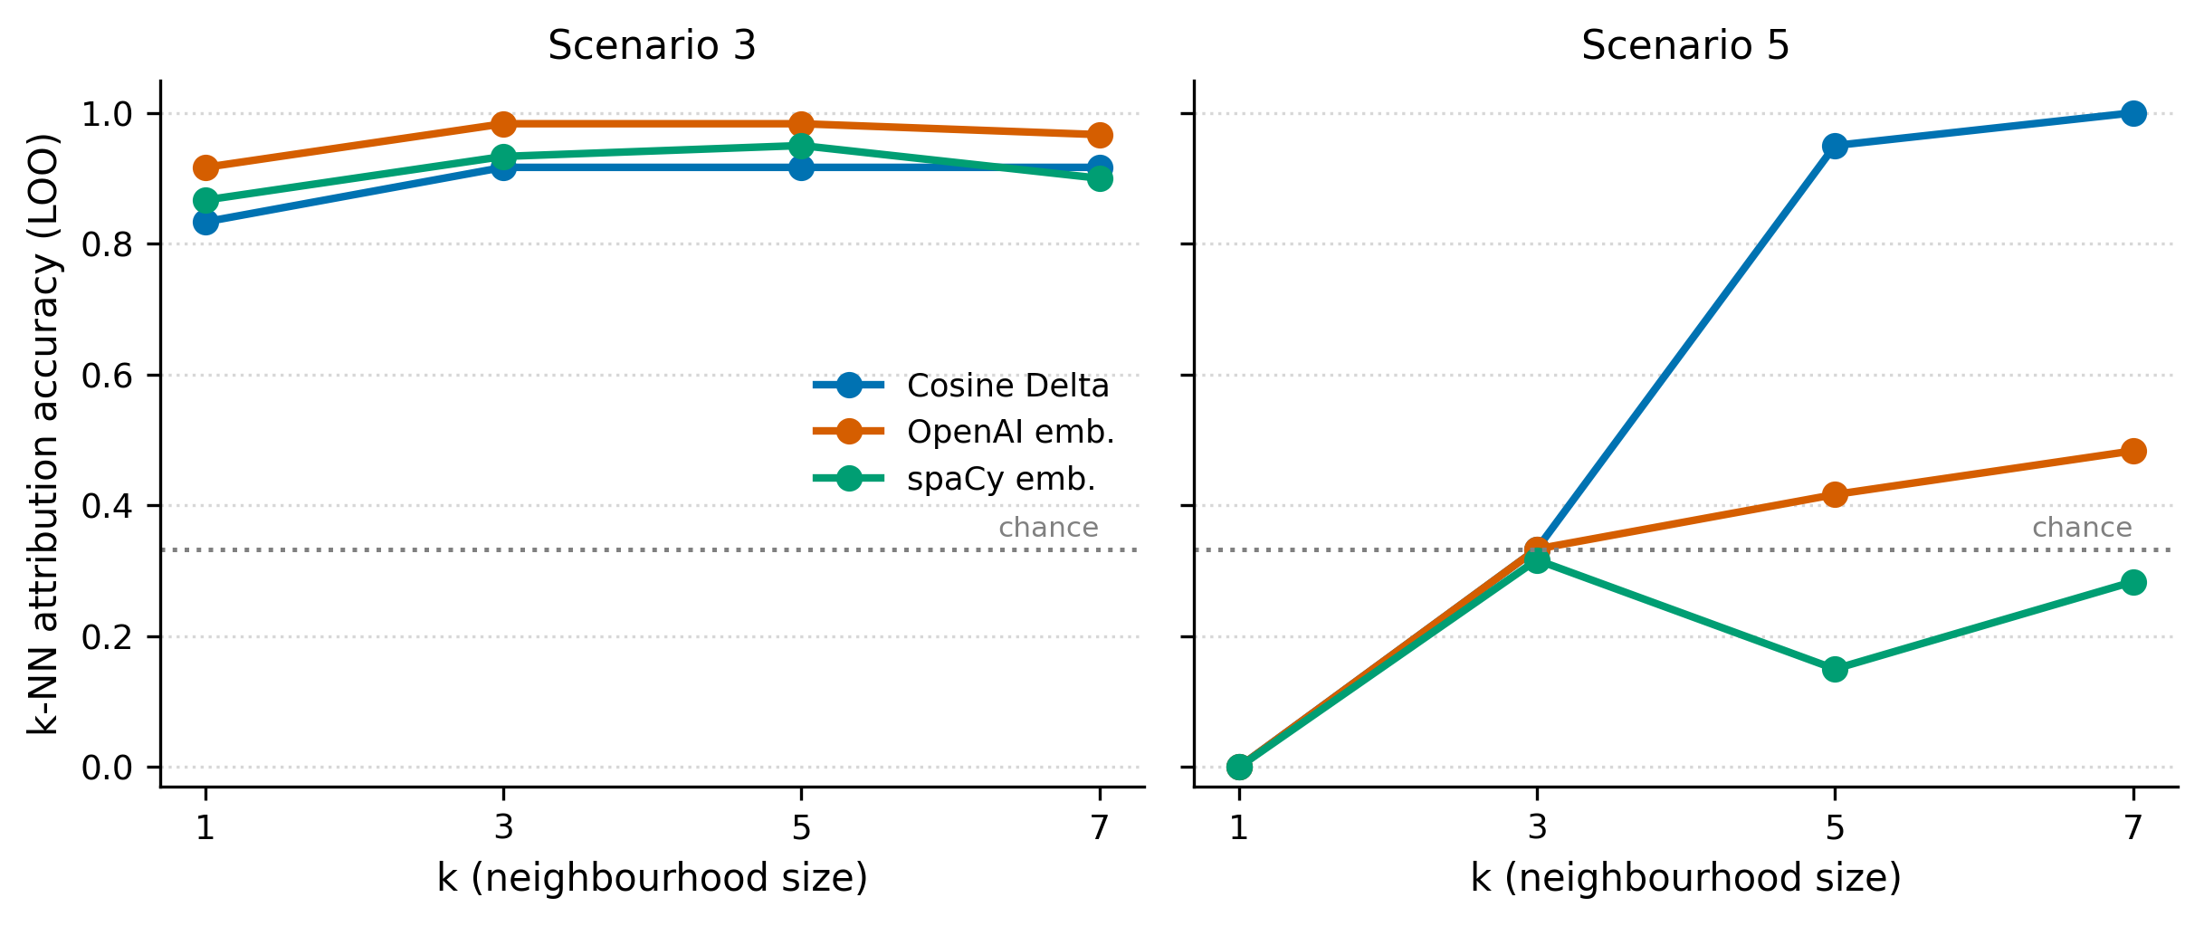
Figure 5. k-nearest-neighbor attribution accuracy (leave-one-out, majority vote) as a function of neighborhood size k. Left: Scenario 3, where all methods are stable near the ceiling. Right: Scenario 5, where every method scores zero at k=1 but Cosine Delta recovers to 0.95 at k=5 and 1.00 at k=7, while OpenAI rises only modestly and spaCy declines. The dotted line marks the chance baseline (1/3).
The same asymmetry appears in the global silhouette widths (Table 3). In Scenario 5, the silhouette of the Delta space remains weakly positive (0.101), whereas OpenAI is essentially zero (0.022) and spaCy is slightly negative (-0.025). The Delta representation, which is built from the relative frequencies of the most frequent (largely functional) words, retains a faint but real author structure beyond the immediate topic twins, while the semantic embeddings, which are optimized to capture meaning, are pulled almost entirely onto the topic axis.

4.6 Agreement between representations across the conditions
Finally, the matrix correlation analysis addresses whether stylometry and embeddings encode complementary information by quantifying how similarly the representations organize the documents (Figure 6; Table 5). In the easy and control scenarios, the three distance spaces agree very strongly: the Delta to OpenAI correlation is 0.94, 0.96, and 0.97 in Scenarios 1, 2, and 4, respectively, and the two embedding spaces agree even more (0.98 to 0.99). Agreement is lowest in the balanced Scenario 3, where the Delta to spaCy correlation falls to 0.50 and the Delta to OpenAI correlation to 0.56. The balanced regime is therefore not only where embeddings outperform Delta, but also where stylometric and embedding spaces are maximally complementary, encoding the most distinct views of the same documents. In the collapse scenario, the correlations recover partially (0.60 to 0.72), because all representations are dominated by the same topic structure and so re-align onto it. All correlations are positive and significant by permutation (p < 0.001 throughout), but their pattern shows that the value added by embeddings is concentrated in exactly the regime where they diverge most from classical Delta.
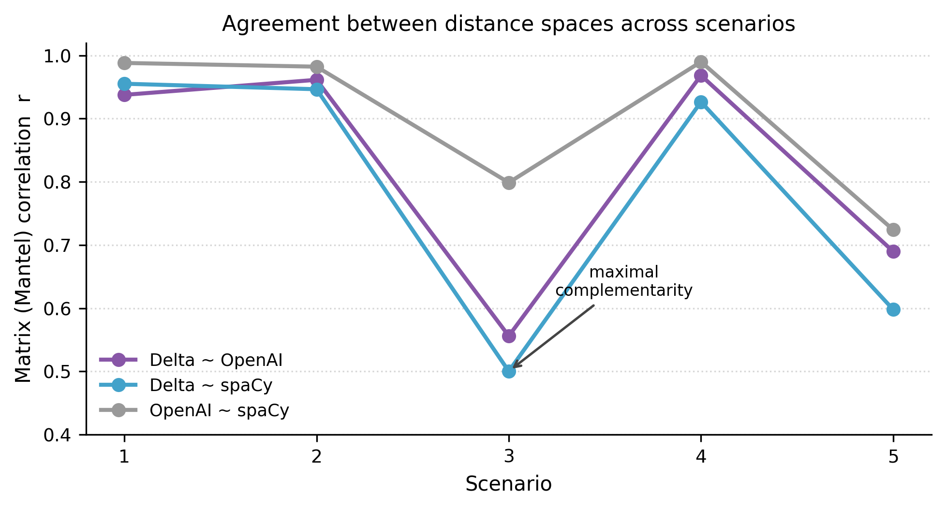
Figure 6. Matrix (Mantel) correlations between the three distance spaces across scenarios. Agreement is very high in the easy and control scenarios (1, 2, 4), drops to its minimum in the balanced Scenario 3 (maximal complementarity between stylometry and embeddings), and recovers partially in the topic-confounded Scenario 5. All correlations are significant at p < 0.001 by permutation.
Table 5. Matrix (Mantel) correlations between the full pairwise-distance matrices of the three representations, per scenario (Pearson correlation over the lower triangle). All values are significant at p < 0.001 by the permutation test. The minimum agreement at Scenario 3 marks the regime of maximal complementarity.
Scenario | Delta ~ OpenAI | Delta ~ spaCy | OpenAI ~ spaCy
1 | 0.938 | 0.955 | 0.988
2 | 0.961 | 0.947 | 0.982
3 | 0.556 | 0.500 | 0.799
4 | 0.968 | 0.927 | 0.990
5 | 0.690 | 0.598 | 0.724

4.7 Summary of findings
Across the five conditions a clear pattern emerges. As between-author similarity rises, attribution stays at ceiling while authors remain internally coherent (Scenarios 1 and 2), turns into a graded problem once within- and between-author similarity are balanced (Scenario 3), and collapses entirely once topic-aligned overlap takes over (Scenario 5); Scenario 4 serves as an identical-text control. In the one genuinely discriminative condition, dense embeddings, and OpenAI text-embedding-3-small in particular, improve on Cosine Delta for both local attribution and global clustering, although the gains are directional rather than significant at the present sample size. Under extreme topic confounding, all representations fail at the nearest neighbor, but they fail differently: classical Delta retains recoverable author structure at slightly larger neighborhoods and a weakly positive global silhouette, whereas the semantic embeddings are drawn almost completely onto the topic axis. The matrix correlation analysis links these observations, showing that stylometry and embeddings are most complementary precisely in the balanced regime where their performance also diverges.

5. Discussion

5.1 Revisiting the medieval Latin corpus
The study was prompted by the unstable behavior of stylometric attribution on a corpus of medieval Latin texts from Bohemia, where small changes in feature selection or culling produced substantially different authorial groupings. The controlled experiments offer a candidate explanation for that instability. Attribution was stable and method-independent only while authors were internally coherent, and between-author overlap was low to moderate (Scenarios 1 and 2). It weakened as soon as within-author and between-author distances converged, and it failed entirely once between-author similarity was organized around shared content (Scenario 5), where every representation assigned each document to an author other than its own. Medieval Latin textual production has exactly the properties that generate this configuration: extensive compilation and textual reuse, formulaic and rhetorical conventions acquired through a shared educational tradition, and a learned rather than native command of the language. Together these reduce the distinctiveness of individual authorial choice and inflate cross-author similarity, much of it tied to shared subject matter and shared sources. On this reading, the parameter sensitivity observed on the Latin corpus is not primarily a defect of Delta but a symptom of a corpus whose geometry sits near or beyond the balance point at which authorial and topical proximity become indistinguishable. The synthetic corpora model this situation rather than reproducing the Latin texts themselves, so the connection is interpretive; it nonetheless yields a testable expectation, namely that the Latin corpus should exhibit a low separation ratio and a high incidence of cross-author, same-topic nearest neighbors.

5.2 Recommendations for stylometric practice
Several practical recommendations follow. First, attribution results should be reported together with a separation diagnostic. The ratio of mean between-author to mean within-author distance summarizes, in a single number, how far a corpus is from the regime in which attribution becomes unreliable, and values approaching unity should be read as a warning that reported attributions may be unstable. Second, analysts should inspect the structure of the distance space rather than a single accuracy figure. The divergence between one-nearest-neighbor accuracy and accuracy at slightly larger neighborhoods in Scenario 5 (Figure 5) shows that local and global structure can tell different stories; reporting accuracy across a small range of neighborhood sizes, or a clustering-quality measure such as the silhouette alongside accuracy, makes this visible. Third, topic confounding should be tested directly. The decisive diagnostic in our data was that documents by different authors on the same topic were closer than documents by the same author on different topics, and computing this same-topic, cross-author proximity is a simple and informative check. Fourth, classical and neural representations work better together than in competition. They agreed least in the one condition where attribution was genuinely hard (Section 4.6), so their disagreement is itself informative: function-word Delta held up better under heavy topic overlap, while embeddings were more accurate when overlap was moderate. That makes them complementary, and it argues for combining or cross-checking the two rather than trusting either on its own.

5.3 Relation to previous work
These findings connect to two long-standing strands of authorship research. The first is the recognition that content, topic, and genre can dominate the authorial signal, which is the original rationale for building Delta on the most frequent, and largely grammatical, words (Burrows, 2002; Evert et al., 2017). Our results both confirm and qualify this rationale: the function-word basis of Cosine Delta did give it a measurable robustness advantage under extreme topic overlap, in that it recovered authorship at slightly larger neighborhoods where the embeddings did not, yet it did not immunize Delta against the confound, since it too failed at the nearest neighbor. The second strand is the growing use of dense and contextual text representations for attribution. We find that such representations can outperform classical Delta when topic overlap is present but not dominant, consistent with their richer encoding of a text, but that the same semantic sensitivity makes them more fragile when the similarity to be overcome is itself topical. The complementary behavior of the two families, together with the observation that their agreement is lowest exactly where the attribution problem is hardest, places the present study within research that treats stylistic and semantic representations as capturing distinct and only partly overlapping axes of textual variation.

5.4 Limitations and directions for future work
Several limitations qualify these conclusions and point to future work. The corpora are synthetic and were produced by a single language model, so they may carry generation artifacts and need not reproduce the variability of natural authorship; the central claims should therefore be retested on natural corpora, including the medieval Latin material that motivated the study. Because one of the two embedding models is produced by the same provider as the generation model, a home-advantage confound cannot be excluded, and future work should include embedding models from independent sources. As disclosed in Section 3.2, the five conditions realize overlap through three different construction mechanisms, and Scenario 4 was instantiated as a degenerate identical-text control rather than as a graded condition; regenerating the series under a single construction, with a genuine intermediate condition in place of the control, would allow the similarity gradient to be treated as a continuous manipulation. The design is also modest in scale, with 60 documents across 3 authors, and the pairwise contrasts in the balanced condition, although consistently ordered, did not reach statistical significance; larger corpora, or several replicate corpora per condition, would yield tighter interval estimates. Finally, topic confounding was inferred from the structure of the distance space rather than measured directly; explicit topic modeling, or attribution after the topical component has been removed, would test the mechanism more directly, as would extending the design to more authors, additional languages, and a wider range of document lengths.

6. Conclusion
This study used controlled artificial corpora to ask how the similarity between texts affects distance-based and embedding-based authorship attribution. Similarity degrades attribution, but neither uniformly nor in the same way for every representation. While authors remain internally coherent, classical Cosine Delta and both embedding spaces recover authorship perfectly; in a balanced condition, neural embeddings, and a modern contextual model in particular, attribute somewhat more accurately than Delta; and once between-author similarity is dominated by shared topic, all three representations fail at the nearest neighbor, although function-word Delta retains recoverable author structure slightly further out in the distance space. Two conclusions follow. Methodologically, the reliability of an attribution depends less on the choice between classical and neural representations than on whether author or topic dominates the geometry of the corpus, so diagnosing separation and topic confounding should precede any attribution claim, and the two families of representation are best treated as complementary. Substantively, the instability that originally motivated the study, a corpus of medieval Latin texts, is consistent with a topic-dominated regime in which authorial and topical proximity can no longer be distinguished. Establishing this directly on natural corpora, with independent representations and an explicit measure of topical overlap, is the principal task for future work.

References
Barlas, G., & Stamatatos, E. (2020). Cross-domain authorship attribution using pre-trained language models. In Artificial intelligence applications and innovations (AIAI 2020), IFIP advances in information and communication technology, vol. 583 (pp. 255–266). Springer. https://doi.org/10.1007/978-3-030-49161-1_22
Burrows, J. (2002). 'Delta': A measure of stylistic difference and a guide to likely authorship. Literary and Linguistic Computing, 17(3), 267–287. https://doi.org/10.1093/llc/17.3.267
Devlin, J., Chang, M.-W., Lee, K., & Toutanova, K. (2019). BERT: Pre-training of deep bidirectional transformers for language understanding. In Proceedings of NAACL-HLT 2019 (pp. 4171–4186). Association for Computational Linguistics. https://doi.org/10.18653/v1/N19-1423
Eder, M. (2022). Boosting word frequencies in authorship attribution. In Proceedings of the Computational Humanities Research Conference (CHR 2022) (CEUR Workshop Proceedings Vol. 3290).
Eder, M., Rybicki, J., & Kestemont, M. (2016). Stylometry with R: A package for computational text analysis. The R Journal, 8(1), 107–121. https://doi.org/10.32614/RJ-2016-007
Efron, B., & Tibshirani, R. J. (1993). An introduction to the bootstrap. Chapman & Hall.
Evert, S., Proisl, T., Jannidis, F., Reger, I., Pielström, S., Schöch, C., & Vitt, T. (2017). Understanding and explaining Delta measures for authorship attribution. Digital Scholarship in the Humanities, 32(Suppl. 2), ii4–ii16. https://doi.org/10.1093/llc/fqx023
Holmes, D. I. (1998). The evolution of stylometry in humanities scholarship. Literary and Linguistic Computing, 13(3), 111–117. https://doi.org/10.1093/llc/13.3.111
Honnibal, M., Montani, I., Van Landeghem, S., & Boyd, A. (2020). spaCy: Industrial-strength natural language processing in Python. Zenodo. https://doi.org/10.5281/zenodo.1212303
Hubert, L., & Arabie, P. (1985). Comparing partitions. Journal of Classification, 2(1), 193–218. https://doi.org/10.1007/BF01908075
Lagutina, K., Lagutina, N., Boychuk, E., Vorontsova, I., Shliakhtina, E., Belov, O., Paramonov, I., & Demidov, P. (2019). A survey on stylometric text features. In Proceedings of the 25th Conference of Open Innovations Association (FRUCT) (pp. 184–195). IEEE. https://doi.org/10.23919/FRUCT48121.2019.8981504
Mantel, N. (1967). The detection of disease clustering and a generalized regression approach. Cancer Research, 27(2), 209–220.
McNemar, Q. (1947). Note on the sampling error of the difference between correlated proportions or percentages. Psychometrika, 12(2), 153–157. https://doi.org/10.1007/BF02295996
Mikolov, T., Chen, K., Corrado, G., & Dean, J. (2013). Efficient estimation of word representations in vector space. arXiv. https://doi.org/10.48550/arXiv.1301.3781
Mikros, G. K. (2025). Beyond the surface: stylometric analysis of GPT-4o's capacity for literary style imitation. Digital Scholarship in the Humanities, 40(2), 587–600. https://doi.org/10.1093/llc/fqaf035
Mikros, G. K., & Argiri, E. K. (2007). Investigating topic influence in authorship attribution. In Proceedings of the SIGIR 2007 workshop on plagiarism analysis, authorship identification, and near-duplicate detection (PAN 2007) (CEUR Workshop Proceedings, vol. 276).
Mikros, G. K., & Perifanos, K. (2013). Authorship attribution in Greek tweets using author's multilevel n-gram profiles. In Analyzing microtext: Papers from the 2013 AAAI Spring Symposium. AAAI Press.
Mosteller, F., & Wallace, D. L. (1964). Inference and disputed authorship: The Federalist. Addison-Wesley.
Neelakantan, A., Xu, T., Puri, R., Radford, A., Han, J. M., Tworek, J., Yuan, Q., Tezak, N., Kim, J. W., Hallacy, C., Heidecke, J., Shyam, P., Power, B., Nekoul, T. E., Sastry, G., Krueger, G., Schnurr, D., Such, F. P., Hsu, K., … Weng, L. (2022). Text and code embeddings by contrastive pre-training. arXiv. https://doi.org/10.48550/arXiv.2201.10005
Pedregosa, F., Varoquaux, G., Gramfort, A., Michel, V., Thirion, B., Grisel, O., Blondel, M., Prettenhofer, P., Weiss, R., Dubourg, V., Vanderplas, J., Passos, A., Cournapeau, D., Brucher, M., Perrot, M., & Duchesnay, E. (2011). Scikit-learn: Machine learning in Python. Journal of Machine Learning Research, 12, 2825–2830.
Rousseeuw, P. J. (1987). Silhouettes: a graphical aid to the interpretation and validation of cluster analysis. Journal of Computational and Applied Mathematics, 20, 53–65. https://doi.org/10.1016/0377-0427(87)90125-7
Sapkota, U., Bethard, S., Montes, M., & Solorio, T. (2015). Not all character n-grams are created equal: A study in authorship attribution. In Proceedings of the 2015 Conference of the North American Chapter of the Association for Computational Linguistics: Human Language Technologies (pp. 93–102). Association for Computational Linguistics. https://doi.org/10.3115/v1/N15-1010
Sari, Y., Stevenson, M., & Vlachos, A. (2018). Topic or style? Exploring the most useful features for authorship attribution. In Proceedings of the 27th International Conference on Computational Linguistics (pp. 343–353). Association for Computational Linguistics.
Stamatatos, E. (2009). A survey of modern authorship attribution methods. Journal of the American Society for Information Science and Technology, 60(3), 538–556. https://doi.org/10.1002/asi.21001
Stamatatos, E. (2013). On the robustness of authorship attribution based on character n-gram features. Journal of Law and Policy, 21(2), 421–439.
Stamatatos, E. (2018). Masking topic-related information to enhance authorship attribution. Journal of the Association for Information Science and Technology, 69(3), 461–473. https://doi.org/10.1002/asi.23968
Wegmann, A., Schraagen, M., & Nguyen, D. (2022). Same author or just same topic? Towards content-independent style representations. In Proceedings of the 7th Workshop on Representation Learning for NLP (RepL4NLP 2022) (pp. 249–268). Association for Computational Linguistics. https://doi.org/10.18653/v1/2022.repl4nlp-1.26

