**HW-2**

**List of Commands**

getwd()

setwd("F:/LUC Study Material/ISSCM 495")

hpind=read.csv("hpi.csv",sep="|")

hpind.boston=hpind[c("YEAR","MA.Boston")]

install.packages("stringr")

library(stringr)

hpind.boston$YEAR=str_replace(str_replace(hpind.boston$YEAR," ",""),"^","01")

hpind.boston$YEAR=as.Date(hpind.boston$YEAR,"%d%B%Y")

plot(hpind.boston,type='l')

DataframeTS = function(x,y) {

styr=as.numeric(format((head(x[1],1)),"%Y"))

stmth=as.numeric(format((head(x[1],1)),"%m"))

endyr=as.numeric(format((tail(x[1],1)),"%Y"))

endmth=as.numeric(format((tail(x[1],1)),"%m"))

return(ts(x[2],start=c(styr,stmth),end=c(endyr,endmth),frequency=y))

}

hpind.ts=DataframeTS(hpind.boston,12)

plot.ts(hpind.ts,type='l')

tsScale=function(x){

fe=x[1]

return((x/fe)*100)

}

hpind.win=window(hpind.ts,start=2008,end=2015)

hpind.win=tsScale(hpind.win)

plot(hpind.win)

hpind.win=window(hpind.ts,start=2012+.25,end=2015)

hpind.win=tsScale(hpind.win)

lag.plot(hpind.win,lag=9,do.lines=FALSE)

install.packages("forecast")

library("forecast")

acf(hpind.win)

seasonplot(hpind.win,year.labels=TRUE, year.labels.left = TRUE,col=1:3)

monthplot(hpind.win)

hpind.test=window(hpind.win,start=2014+.5)

hpind.train=window(hpind.win,end=2014+.45)

hpind.meanf=meanf(hpind.train,h=12)

hpind.meanf

hpind.naive=naive(hpind.train,h=12)

hpind.naive

hpind.snaive=snaive(hpind.train,h=12)

hpind.snaive

hpind.drift=rwf(hpind.train,h=12,drift=TRUE)

hpind.drift

plot(hpind.meanf,plot.conf=FALSE)

plot(hpind.naive,plot.conf=FALSE)

plot(hpind.snaive,plot.conf=FALSE)

plot(hpind.drift,plot.conf=FALSE)

plot(hpind.win,main="House price index projection for next 12 months",ylab="house price index",xlab="years",xlim=c(2012.0,2016.5),ylim=c(100,135))

lines(hpind.meanf$mean,col=2)

lines(hpind.naive$mean,col=3)

lines(hpind.snaive$mean,col=4)

lines(hpind.drift$mean,col=5)

legend("bottomright", lty=1, col=c(2,3,4,5), cex=0.65,

legend=c("Mean method","Naive method","Seasonal naive method","Drift Method"))

res.meanf=residuals(hpind.meanf)

res.snaive=residuals(hpind.snaive)

res.naive=residuals(hpind.naive)

res.drift=residuals(hpind.drift)

acf(na.omit(res.drift))

acf(na.omit(res.snaive))

acf(na.omit(res.naive))

acf(na.omit(res.meanf))

Box.test(na.omit(res.snaive),lag=10,fitdf=0)

Box.test(na.omit(res.snaive),lag=10,fitdf=0,type="L")

Box.test(na.omit(res.naive),lag=10,fitdf=0)

Box.test(na.omit(res.naive),lag=10,fitdf=0,type="L")

Box.test(na.omit(res.meanf),lag=10,fitdf=0)

Box.test(na.omit(res.meanf),lag=10,fitdf=0,type="L")

Box.test(na.omit(res.drift),lag=10,fitdf=0)

Box.test(na.omit(res.drift),lag=10,fitdf=0,type="L")

fit=HoltWinters(hpind.win)

res=residuals(fit)

acf(res)

Box.test(res,lag=10,fitdf=0,type="L")

plot(fit)

**Output**

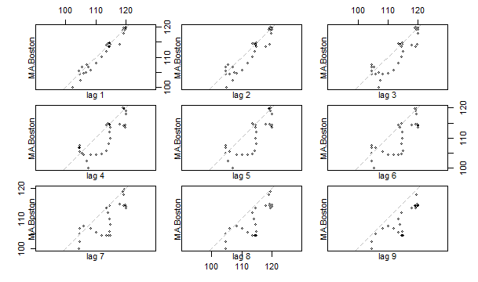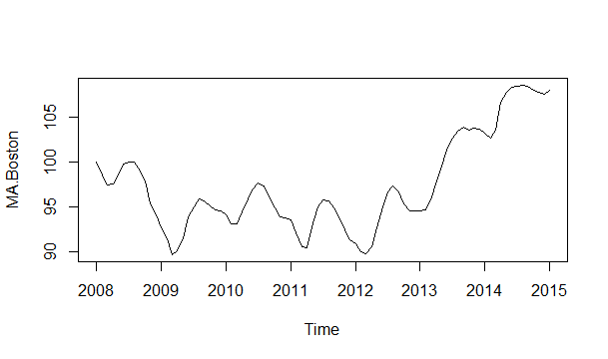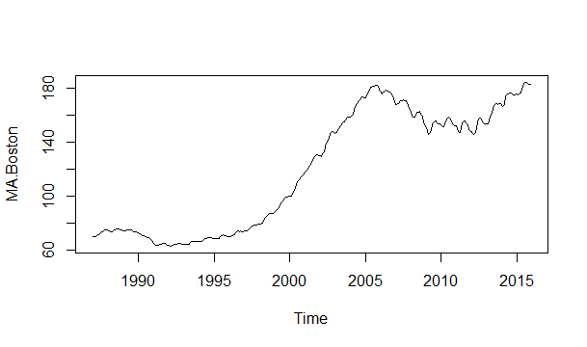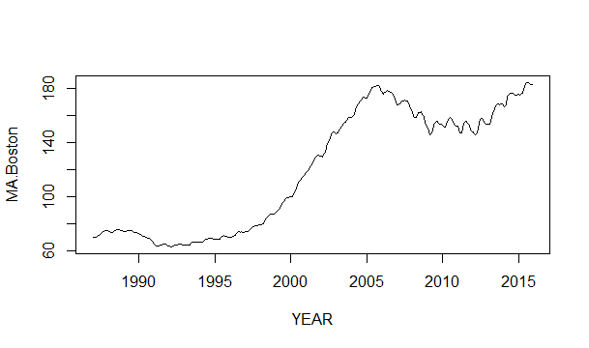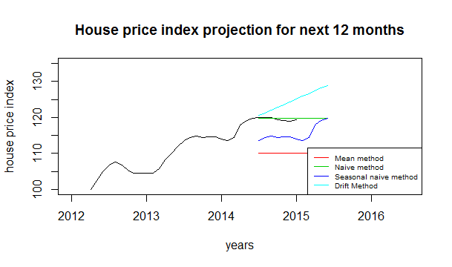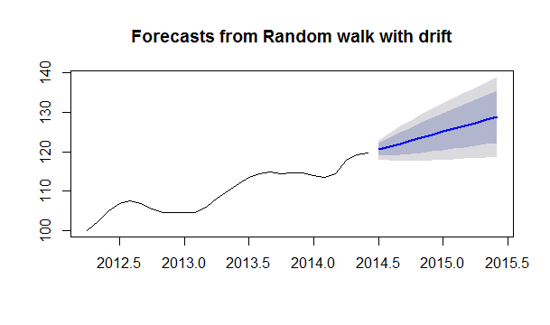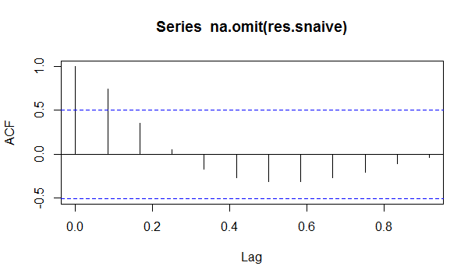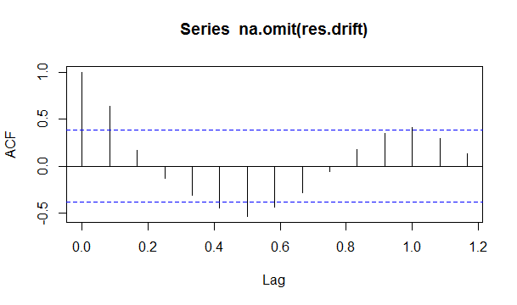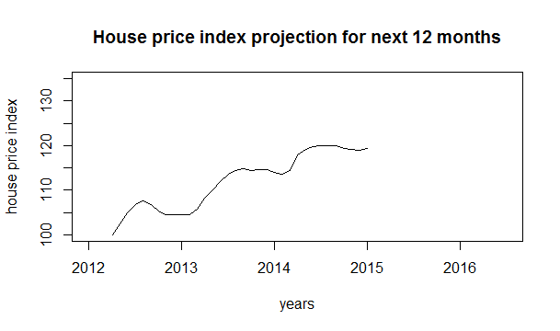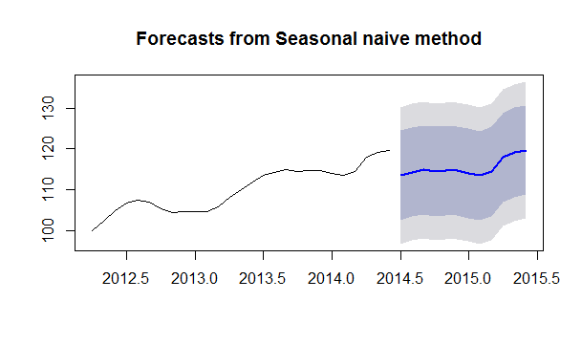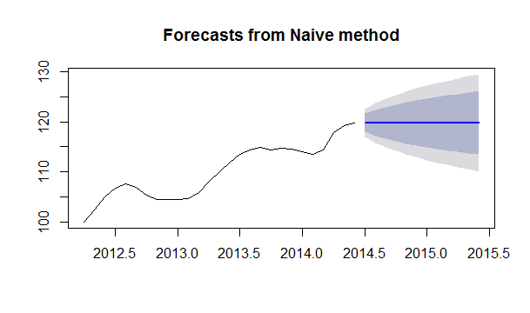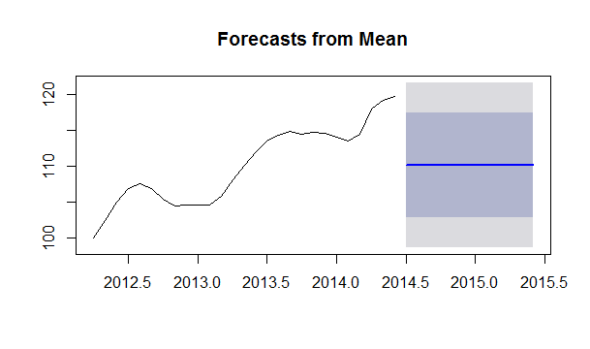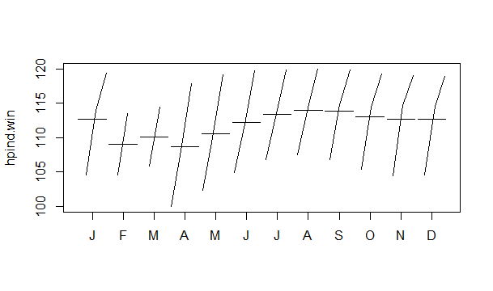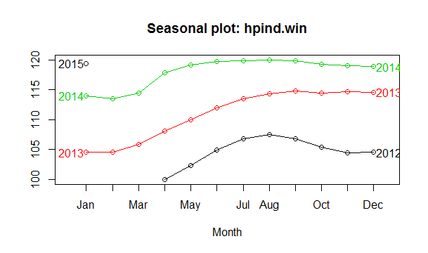 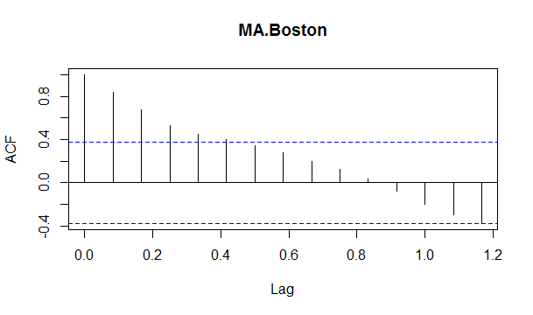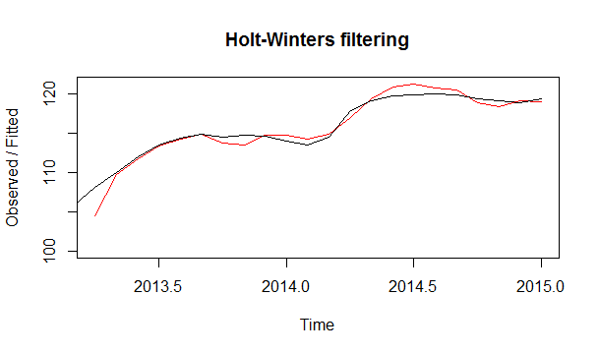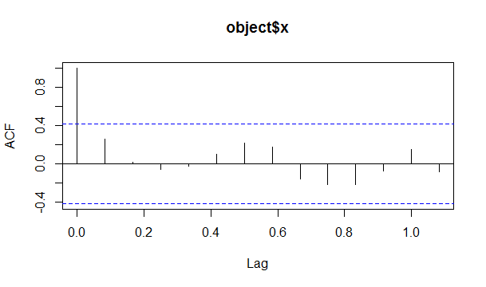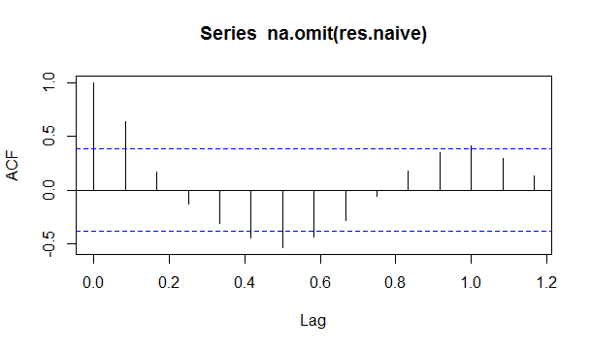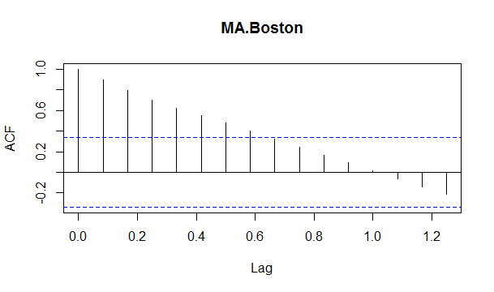

**Command:** **hpind.meanf=meanf(hpind.train,h=12)**

**hpind.meanf**

**Output:**

Point Forecast Lo 80 Hi 80 Lo 95 Hi 95

Jul 2014 110.115 102.7632 117.4667 98.6229 121.607

Aug 2014 110.115 102.7632 117.4667 98.6229 121.607

Sep 2014 110.115 102.7632 117.4667 98.6229 121.607

Oct 2014 110.115 102.7632 117.4667 98.6229 121.607

Nov 2014 110.115 102.7632 117.4667 98.6229 121.607

Dec 2014 110.115 102.7632 117.4667 98.6229 121.607

Jan 2015 110.115 102.7632 117.4667 98.6229 121.607

Feb 2015 110.115 102.7632 117.4667 98.6229 121.607

Mar 2015 110.115 102.7632 117.4667 98.6229 121.607

Apr 2015 110.115 102.7632 117.4667 98.6229 121.607

May 2015 110.115 102.7632 117.4667 98.6229 121.607

Jun 2015 110.115 102.7632 117.4667 98.6229 121.607

**Command: hpind.naive**

**Output:**

Point Forecast Lo 80 Hi 80 Lo 95 Hi 95

Jul 2014 119.754 117.9228 121.5852 116.9535 122.5545

Aug 2014 119.754 117.1644 122.3437 115.7935 123.7145

Sep 2014 119.754 116.5823 122.9257 114.9034 124.6046

Oct 2014 119.754 116.0917 123.4163 114.1530 125.3550

Nov 2014 119.754 115.6594 123.8486 113.4919 126.0162

Dec 2014 119.754 115.2686 124.2394 112.8942 126.6138

Jan 2015 119.754 114.9092 124.5988 112.3445 127.1635

Feb 2015 119.754 114.5747 124.9333 111.8330 127.6751

Mar 2015 119.754 114.2605 125.2475 111.3525 128.1556

Apr 2015 119.754 113.9634 125.5446 110.8980 128.6100

May 2015 119.754 113.6807 125.8273 110.4657 129.0423

Jun 2015 119.754 113.4107 126.0973 110.0527 129.4553

**Command:hpind.snaive**

**Output:**

Point Forecast Lo 80 Hi 80 Lo 95 Hi 95

Jul 2014 113.4955 102.5107 124.4803 96.69571 130.2953

Aug 2014 114.3381 103.3533 125.3229 97.53833 131.1379

Sep 2014 114.8546 103.8698 125.8394 98.05477 131.6544

Oct 2014 114.4469 103.4621 125.4317 97.64705 131.2467

Nov 2014 114.6915 103.7067 125.6763 97.89169 131.4913

Dec 2014 114.6032 103.6183 125.5880 97.80335 131.4030

Jan 2015 114.0391 103.0543 125.0239 97.23933 130.8389

Feb 2015 113.4683 102.4835 124.4531 96.66853 130.2681

Mar 2015 114.4469 103.4621 125.4317 97.64705 131.2467

Apr 2015 117.9193 106.9345 128.9041 101.11946 134.7191

May 2015 119.1560 108.1712 130.1408 102.35621 135.9558

Jun 2015 119.7540 108.7692 130.7388 102.95420 136.5538

**Command**:hpind.drift

**Output:**

Point Forecast Lo 80 Hi 80 Lo 95 Hi 95

Jul 2014 120.5138 118.9033 122.1243 118.0507 122.9768

Aug 2014 121.2735 118.9557 123.5914 117.7287 124.8184

Sep 2014 122.0333 119.1461 124.9206 117.6177 126.4490

Oct 2014 122.7931 119.4042 126.1820 117.6102 127.9760

Nov 2014 123.5529 119.7034 127.4023 117.6656 129.4401

Dec 2014 124.3126 120.0305 128.5948 117.7636 130.8616

Jan 2015 125.0724 120.3777 129.7671 117.8924 132.2524

Feb 2015 125.8322 120.7401 130.9242 118.0446 133.6198

Mar 2015 126.5919 121.1145 132.0694 118.2149 134.9690

Apr 2015 127.3517 121.4984 133.2050 118.3999 136.3035

May 2015 128.1115 121.8902 134.3327 118.5969 137.6261

Jun 2015 128.8712 122.2885 135.4540 118.8038 138.9387

Command: accuracy(hpind.meanf,hpind.test)

Output:

ME RMSE MAE MPE MAPE MASE ACF1

Training set -4.209853e-15 5.387436 4.864576 -0.2399833 4.430252 0.5725136 0.8415791

Test set 9.378879e+00 9.387091 9.378879 7.8478431 7.847843 1.1038034 0.6114099

Theil's U

Training set NA

Test set 27.25708

**Command:** **accuracy(hpind.drift,hpind.test)**

**Output:**

ME RMSE MAE MPE MAPE MASE

Training set -1.852330e-12 1.209963 1.010573 -0.00421814 0.9236792 0.1189347

Test set -3.299242e+00 3.779330 3.299242 -2.76539799 2.7653980 0.3882889

ACF1 Theil's U

Training set 0.6399300 NA

Test set 0.6347554 11.9344

**Command:** accuracy(hpind.snaive,hpind.test):

**Output:**

ME RMSE MAE MPE MAPE MASE ACF1

Training set 8.496874 8.570975 8.496874 7.427459 7.427459 1.0000000 0.7458164

Test set 5.141149 5.184841 5.141149 4.301000 4.301000 0.6050635 0.3851852

Theil's U

Training set NA

Test set 14.50102

**Command:**

|  |
| --- |
| accuracy(hpind.naive,hpind.test)  Output:  ME RMSE MAE MPE MAPE MASE ACF1  Training set 0.7597696 1.428727 1.1235808 0.6847956 1.0209671 0.13223461 0.6399300  Test set -0.2601639 0.470962 0.3921873 -0.2188038 0.3288831 0.04615666 0.6114099  Theil's U  Training set NA  Test set 1.484809 |
|  |
| |  | | --- | | **Command:**  Box.test(na.omit(res.snaive),lag=10,fitdf=0)  Output: Box-Pierce test  data: na.omit(res.snaive)  X-squared = 16.572, df = 10, p-value = 0.0844  **Command:**  Box.test(na.omit(res.snaive),lag=10,fitdf=0,type="L")  Output: Box-Ljung test  data: na.omit(res.snaive)  X-squared = 26.016, df = 10, p-value = 0.003719  **Command:**  Box.test(na.omit(res.naive),lag=10,fitdf=0)  Output:Box-Pierce test  data: na.omit(res.naive)  X-squared = 34.672, df = 10, p-value = 0.000142 | |

**Command:**

Box.test(na.omit(res.naive),lag=10,fitdf=0,type="L")

Output: Box-Ljung test

data: na.omit(res.naive)

X-squared = 45.652, df = 10, p-value = 1.658e-06

**Command:**

**Command:** Box.test(na.omit(res.meanf),lag=10,fitdf=0)

Output: Box-Pierce test

data: na.omit(res.meanf)

X-squared = 55.54, df = 10, p-value = 2.503e-08

**Command:**

Box.test(na.omit(res.meanf),lag=10,fitdf=0,type="L")

Output: Box-Ljung test

data: na.omit(res.meanf)

X-squared = 67.077, df = 10, p-value = 1.621e-10

**Command:**

Box.test(na.omit(res.drift),lag=10,fitdf=0)

Output: Box-Pierce test

data: na.omit(res.drift)

X-squared = 34.672, df = 10, p-value = 0.000142

**Command:**

Box.test(na.omit(res.drift),lag=10,fitdf=0,type="L")

Output: Box-Ljung test

data: na.omit(res.drift)

X-squared = 45.652, df = 10, p-value = 1.658e-06

**Command:**

Box.test(res,lag=10,fitdf=0,type="L")

Output: Box-Ljung test

data: res

X-squared = 9.6962, df = 10, p-value = 0.4675