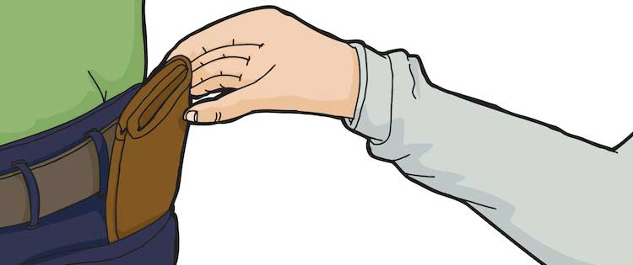

**Fingers**

**By Gary Kagan**

Description: You are part of a family team of pick pockets. Your goal is to loot and sell off everything you steal. Bribe cops to continue looting, talk your family members into not getting too greedy or grab what you need and leave your family to get caught.  Protect your loot from your greedy family members! Will you be the slyest Pick Pocket or end up empty handed?

**Objective:** Score the highest VP before all the pawn shop contracts run out.

**Contents:**

* 5 player aids
* 5 player pawns
* 5 location cards
* 1st pick loot marker
* 10 attack fist tokens
* 10 blackmail tokens
* 26 Cop/Suspicion cards
* 35 Contract cards
* 3 Pawn Boss wants his cut cards
* 68 item cards16 traps
* 40 skill tokens

**Setup:**

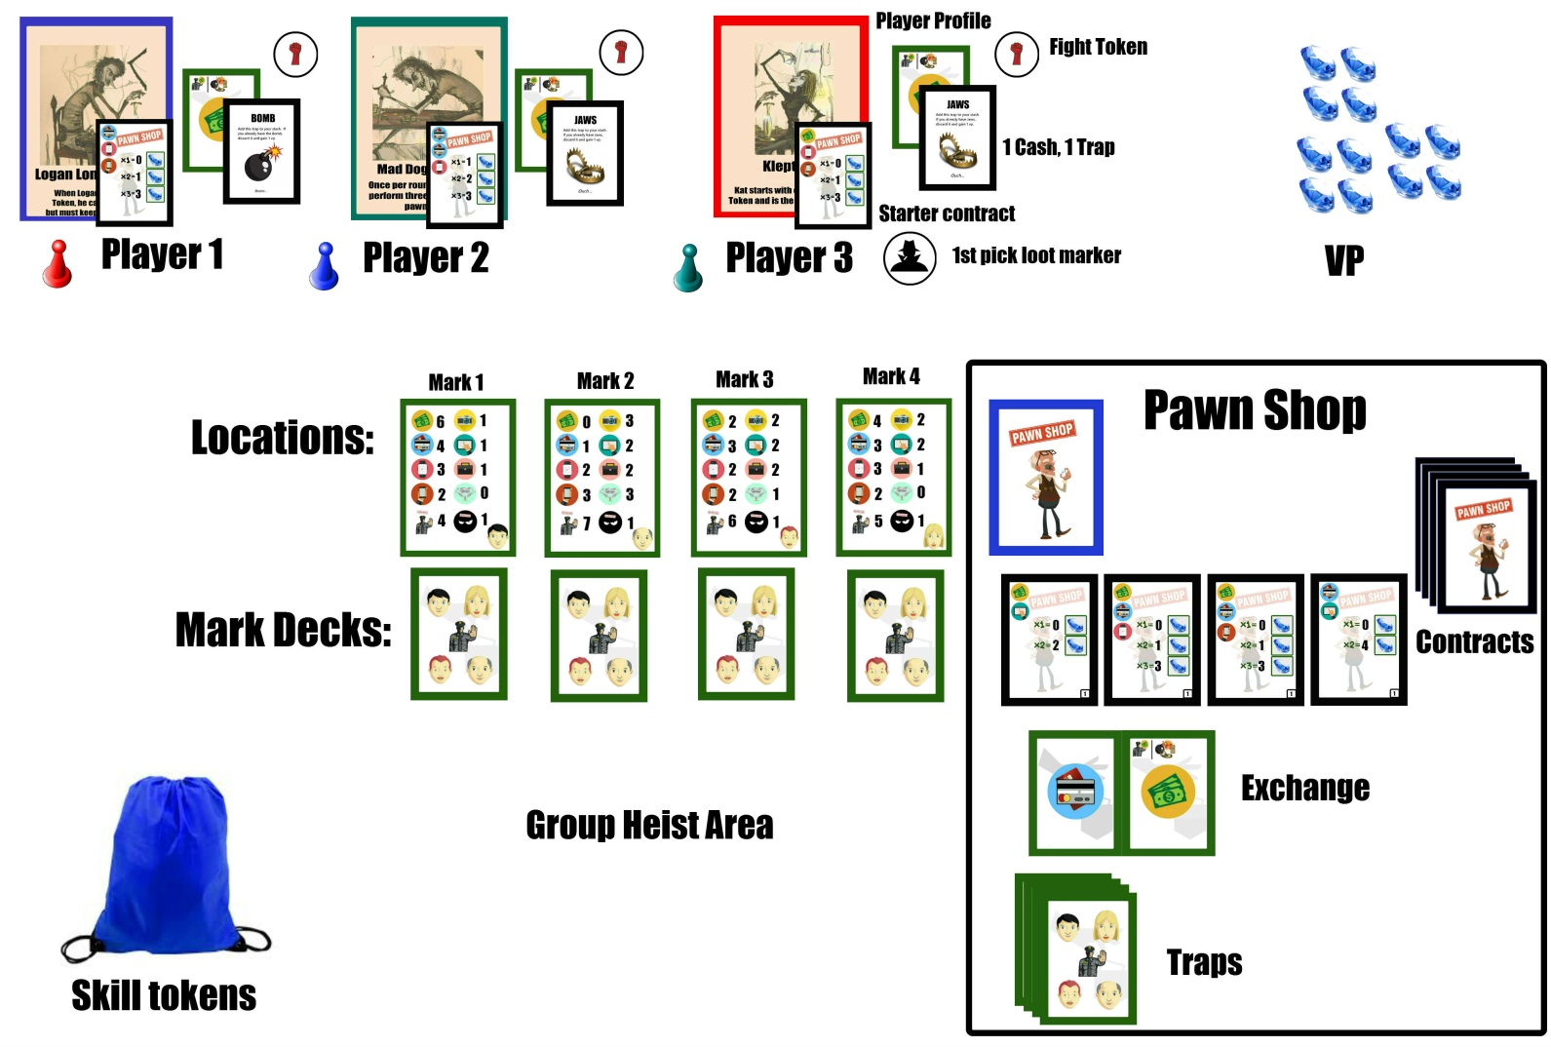

**Marks: Fight Tokens, Blackmail Tokens, Skill Tokens:**

** , 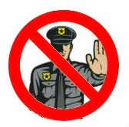 , **

**General / Cop Suspicion: Traps:**

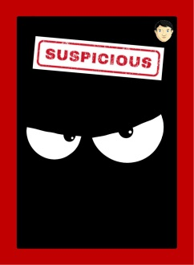 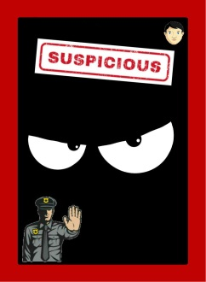 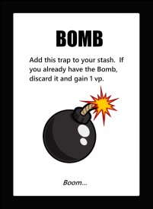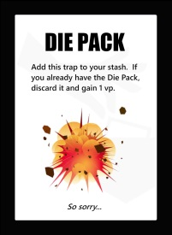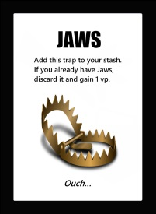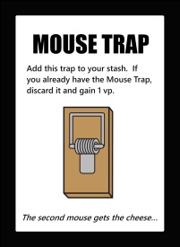

**Items:**

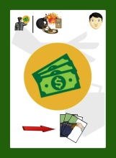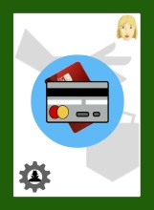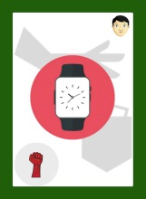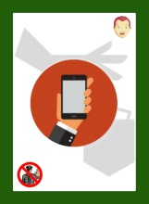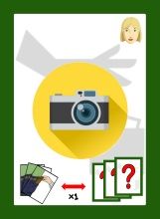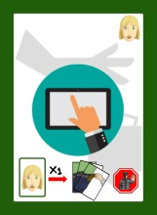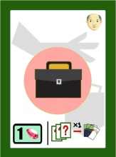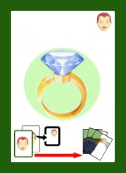

**Locations:**

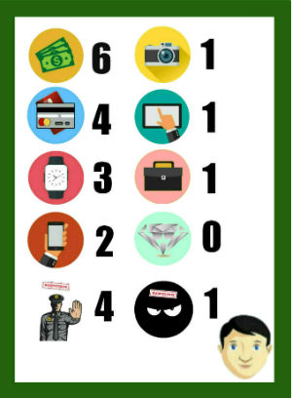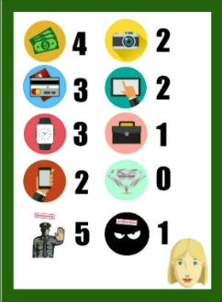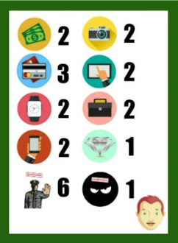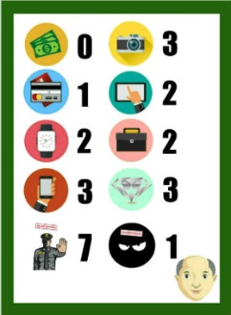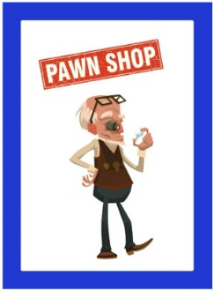

**Contracts / Boss Cut cards:**

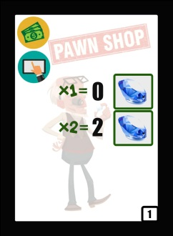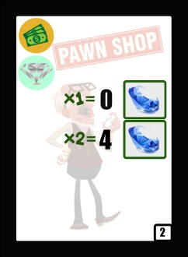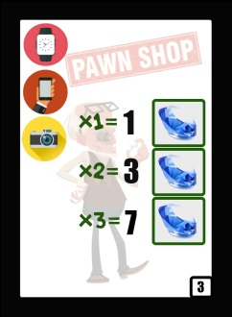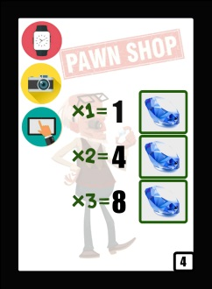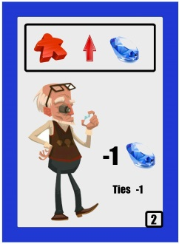

**Game Setup:**

* Shuffle the 68 item cards with the 26 cop/suspicion cards based on the “Mark” image. Create the 4 Mark decks. Place the Mark location card in front of respective Mark deck.
* Shuffle the 16 traps and form a trap pile.
* Place the 40 Skill Tokens into the skill bag.
* Put aside the 5 starter cash items and deal one to each player. The rest are discarded.
* Each player gets 1 random trap and 1 attack fist token.
* Each player gets 1 random starter contract. The starter contracts do not have a number in the bottom right corner.
* 1st loot pick marker goes to Klepto Kat.
* If Kat isn’t playing (or is in jail ☺), youngest player goes first and takes the 1st pick loot marker.
* Pawn Shop Setup:

1. Shuffle together the 4 sets of contract cards to create the contract deck. Level 4 cards make up the bottom of the deck, then level 3, level 2 and finally level 1.
2. Place the Contract Deck by the Pawn Shop location. Flip over 4 level 1 cards.
3. Place 1 cash item & 1 credit item for Exchange (no Mark images on these 2 cards).
4. Place the Deck of traps by the Pawn Shop location.

**Understanding the Contract:**

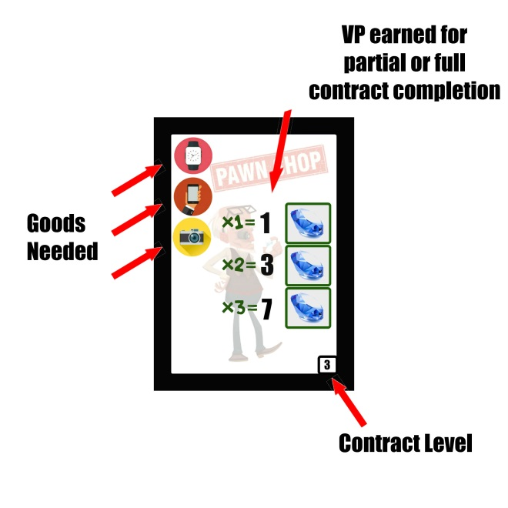

**The goods needed are specific per contract.**

**Example: If you sell 1 watch and 1 camera at the pawn shop, you gain 3 VP. If you sell 1 watch, 1 phone and 1 camera at the pawn shop, you gain 7 vp. You cannot sell 1 watch and 2 phones with this contract.**

**Main Rules:**

1. Move to a new location. Either try to Steal from a Mark, Grab & Go, Split the Loot or Visit the Pawn shop. Moving rules:

|  |  |
| --- | --- |
| **# of Players** | **# of Players at any Location** |
| 2 | 1 |
| 3 | 1 |
| 4 | 2 |
| 5 | 2 |

1. All players continue to Move and play until:
2. One player succeeds in negotiating a split of the goods.
3. The cops catch the players by hitting the suspicion limit.
4. All players have left the round by doing a Grab-n-go.
5. If you do a Grab-n-go (see below) you are out of the round. Once you are out, nobody can steal from you and you cannot play Skill Tokens.
6. Round Ends if too many Suspicions are in play:

|  |  |
| --- | --- |
| **# of Players** | **# of Suspicion** |
| 2 | 3 |
| 3 | 3 |
| 4 | 4 |
| 5 | 4 |

**If the last Suspicion is revealed for the round:**

1. Whoever caused the last Suspicion to end the round must give up something (1 item, trap, token or VP).
2. All central loot is discarded.
3. Remove ½ the cops rounded down from the bust (remove minimum of 1 cop).
4. Add the remaining cops and suspicion cards back into existing marks.
5. Shuffle mark decks.

**Steal from a Mark:**

1. Take a card from one of the marks, perform the action on the card. Then place the card in the center of the heist as part of the group loot.
2. If a cop/suspicion is drawn, you get nothing. Place the card in the center of the heist. Next clockwise player goes.

**Grab-&-Go:**

1. Take one item card from the group heist and put it in your stash.
2. Your turn is done, wait until all players are done with the round. You cannot lose your loot once you are out of the round.

**Split the goods (can only be done if there is at least one item available per player to loot):**

1. Player who initiated the split calls a vote. Initiator breaks all ties.
2. If the vote is to split the goods, the player with the 1st marker token picks first. Then clockwise.
3. If the vote fails, that player must perform the action at their current location (Steal from mark, Grab & Go or Pawn Shop).
4. Any remaining items go to the Pawn Shop Exchange.

**Visit the pawn shop, do any two actions:**

* Buy a Trap (cash).
* Bribe cop (cash).
* Complete Contract.
* Take a new Contract (max 2).
* Exchange any one item with pawn shop (item cards or item tokens).
* Use Action token (Blackmail, Fight, etc) .

If you already have 2 contracts, you can swap out a contract from the Pawn Shop with one of your own. Contracts are only discarded after they are completed, or at the end of any round during Cleanup.

**Playing a Skill Token:**

1. Follow the directions on the Skill Token (see rules for clarity). Unless played out of turn, this counts as one action at the Pawn Shop.
2. Some skill tokens are meant to be played at the end of the round. (Divide & Conquer, Leader)
3. Just Say No skill token can be played at any time to cancel out any player attempting to use a skill token.
4. The Disguise token can be played at any time to take another turn.
5. If you pull a suspicion token, add it into the group heist area for the round.
6. If you steal from another player – discard the fight token and take 1 random card from any player. Discard it if it is a trap. Put it directly into your stash if it is an item.
7. All skill tokens are removed from the game when used.

**Cleanup between rounds:**

* **Remove all face up contracts from the Pawn Shop. Replace with 4 new contracts.**
* **If the big boss at the Pawn Shop wants his cut, player in the lead must pay.** 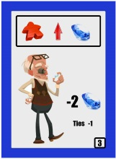

**Notes:**

**If you are the only one left:**

Pawn shop is closed. Either Steal from a Mark or Grab-n-Go.

**Bribing and Blackmailing Cops (Done at the pawn shop)**

* Bribed or Blackmailed cops are gone from the game
* If you do either, gain 1 VP, take 1st pick loot marker

**End of game scoring:**

After the last round when all Pawn Shop contracts are cleaned up, all players may try to complete any remaining contracts they still have. Return UNIQUE traps to the Pawn Shop for 1 VP each. Duplicate traps are discarded. Unused skill tokens have no value. Highest VP total wins! Ties go to the player with any remaining items. Ranking of items for a tie are as follows from low to high: Cash, Credit, Watch, Phone, Camera, Tablet, Briefcase, Ring. Example: A diamond ring beats out Cash for a tie.

**Card Actions:**

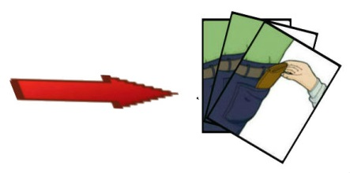

Take directly into hand.



Take one skill token.



Take either a Fight Token or a Skill Token.



Take either a Blackmail Token or a Skill Token.

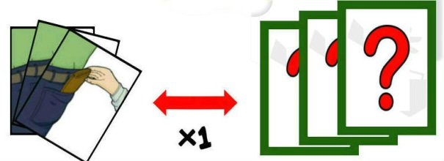

Swap one of your hand item cards for one group heist item in play.

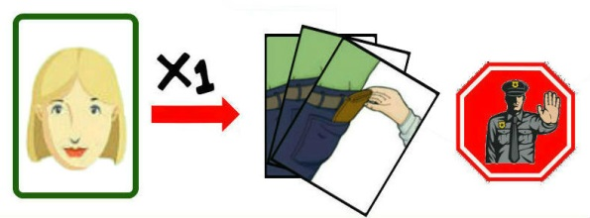

Draw again from the same Mark. If it is an item, place directly into your hand. Ignore the card action. If a suspicion/cop, place in group heist area.

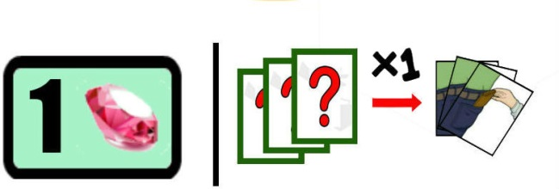

Take either 1 VP or any one item in group heist area directly into your hand.

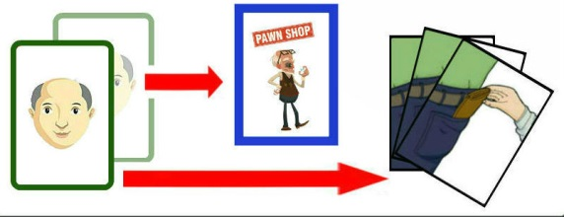

Draw two cards from the same Mark. Choose one and place directly into your hand. Place other into the Pawn Shop Exchange. Ignore the card actions. If suspicion/cops are drawn, place in group heist area.