Gary Kagan’s

Hands Off My Ice Cream

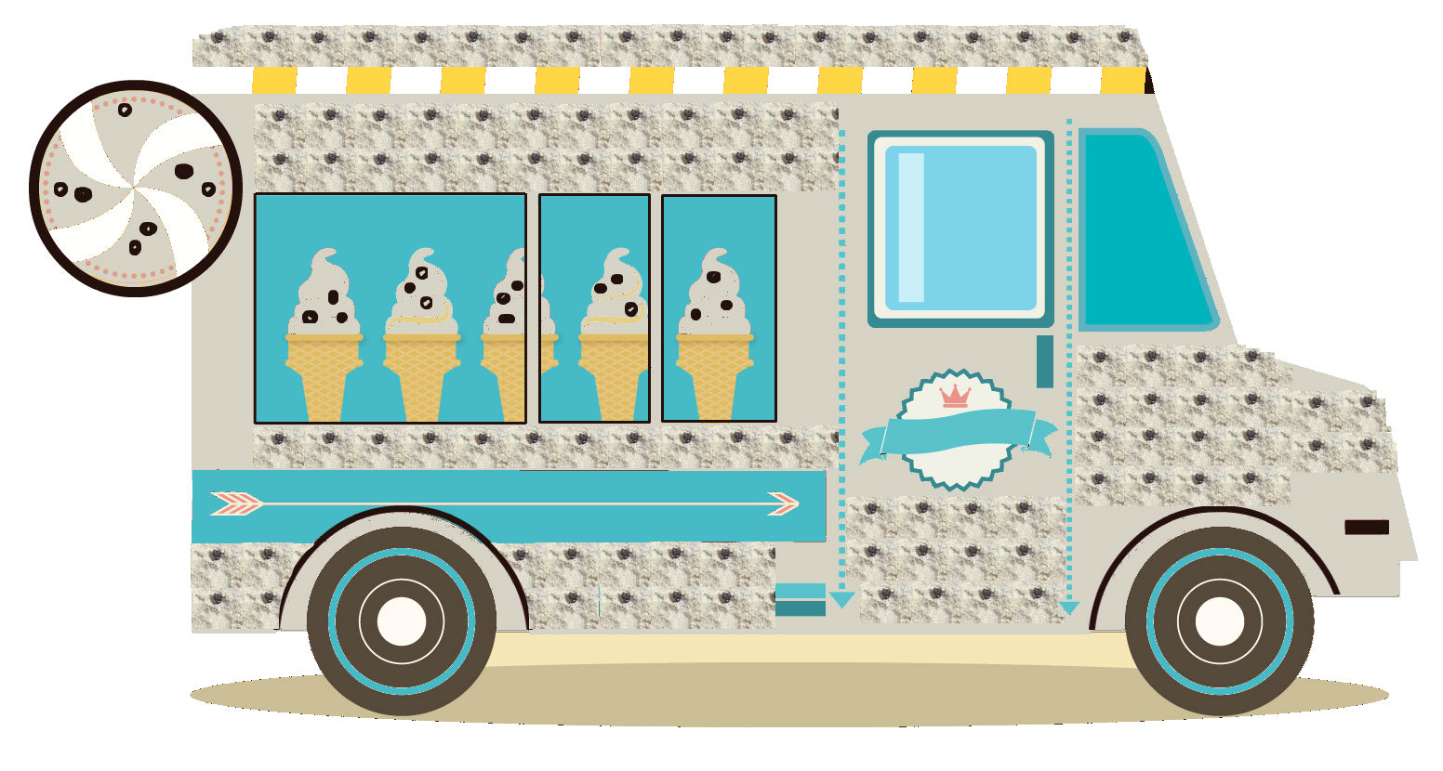

**Players: 2 – 4 Age: 9+ Time: 20 – 30 min**

**Sundae City has one more permit to deliver sweet treats, and it could be you! Prove to them you got what it takes to freeze out the opposition by guessing what the customers want before they buy! Split through the competition and become the King or Queen of the cream!**

**Components:**

1 First Player token 4 Customer Order Challenge Boards

4 Menu Shields 5 Truck Area Mats

16 Topping Tokens 30 Coins (4 nickels, 26 pennies)

42 Customer Order cards (3 of each card)

40 Gumballs (3 green, 3 yellow, 2 blue, 1 orange, 1 cherry - per player)

**Objective:**

At the end of a round, if you have all 4 Customer Order Level challenges correct and you have at least 1 of each of the 4 toppings on your Truck Area Mat (this includes one of your own), you WIN!!!**Setup:**

**Customer Order Challenge Board Truck Area Mat**

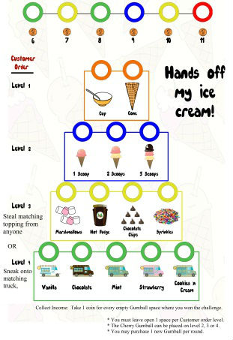 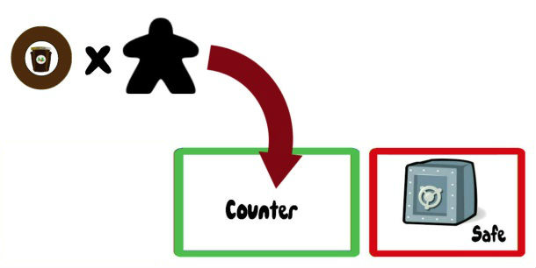

**Menu Shield Toppings**

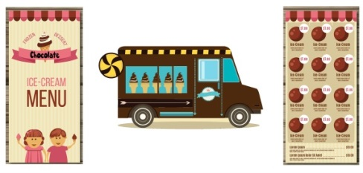 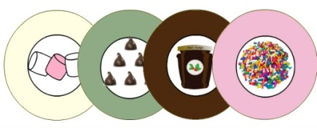

1. Choose a Truck role (**Vanilla, Chocolate, Strawberry or Mint**) and take 1 Custom Menu Shield and 1 Truck Area Mat.
2. Take one Customer Order Challenge Board and place in front of you.
3. Place the Truck Areas Mat in front of the Order Challenge Board.
4. Fold and place the Menu between the Truck Areas Mat and the Order Challenge Board. This shield protects your choices from the sneaky eyes of others.

Take one matching set of toppings per player. The number of toppings should be equal to the number of players. Example: For a three player game, there will be three of each topping in the game.

Vanilla Truck – start with Marshmallows

Chocolate Truck – start with Hot Fudge

Mint Truck – start with Chocolate Chips

Strawberry Truck – start with Sprinkles

Non player Trucks start with topping tokens on their Truck Counter as well.

Place all toppings on the Truck Counters of each Ice Cream Truck owner.

The Cookies ‘n Cream Truck Mat will start with one of every topping. Move one of each topping from each Truck counter to the Cookies ‘n Cream Truck Counter. This truck is the current King of Ice Cream Town.

|  |  |  |
| --- | --- | --- |
| # of Players | Vanilla, Chocolate, Mint, Strawberry Counters | Cookies ‘n Cream Counter starts with |
| 2 | 2 matching toppings | 1 of each topping |
| 3 | 3 matching toppings | 1 of each topping |
| 4 | 3 matching toppings | 1 of each topping |

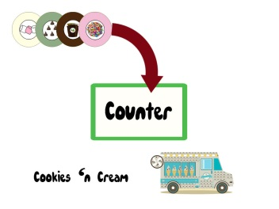

**4 Player Setup:**

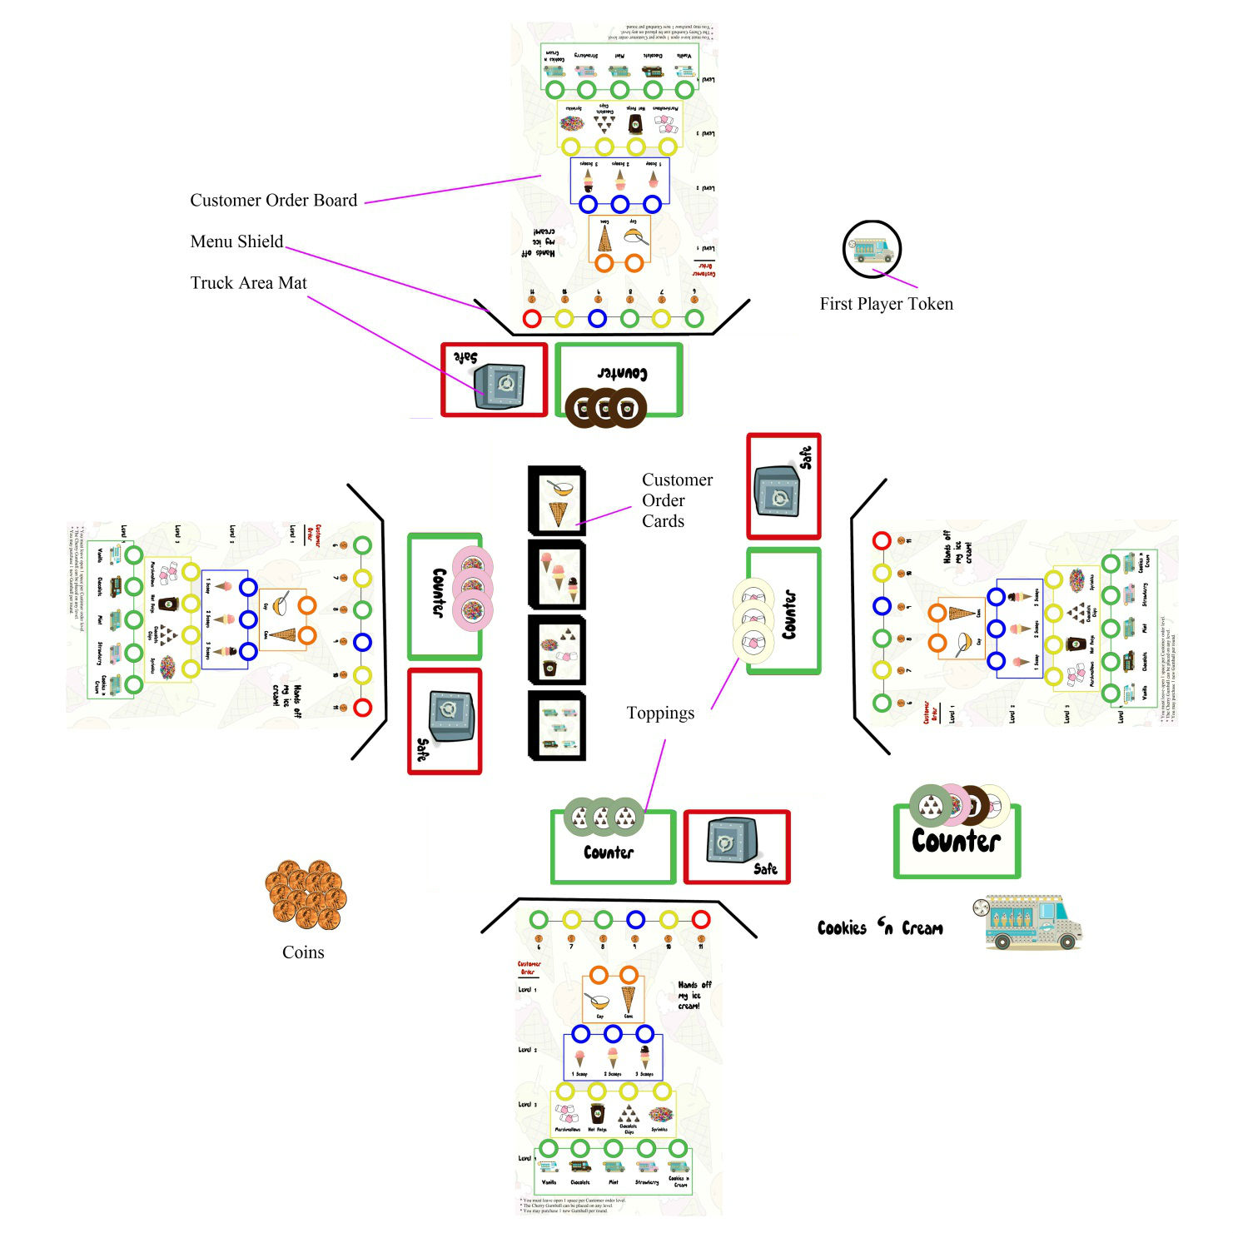

**Prepare for the first round:**

Select any open spot when placing Gumballs.

Place one orange Gumball on the first Order Level (Cup/Cone).

Place one blue Gumball on the second Order Level (1 scoop, 2 scoops and 3 scoops).

Place one yellow Gumball on the third Order Level (Marshmallows, Hot Fudge, Sprinkles and Chocolate Chips).

Place one green Gumball on the fourth Order Level (Ice Cream Trucks – Vanilla, Chocolate, Mint, Strawberry and Cookies ‘n Cream).

Place remaining 6 gumballs on the colored circle spots at the top of the Customer Order Challenge Board. These can be purchased during the game.

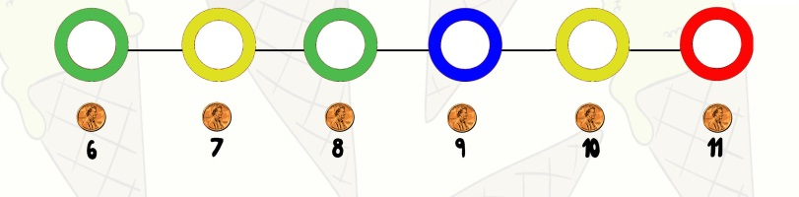

Place the 4 decks in the center of the play area. These represent the Customers and their orders. Shuffle within each Level.

Youngest player goes first, take the 1st player token.

You are now ready to play!

**Understanding the Customer Order Challenge Board and Order Decks:**

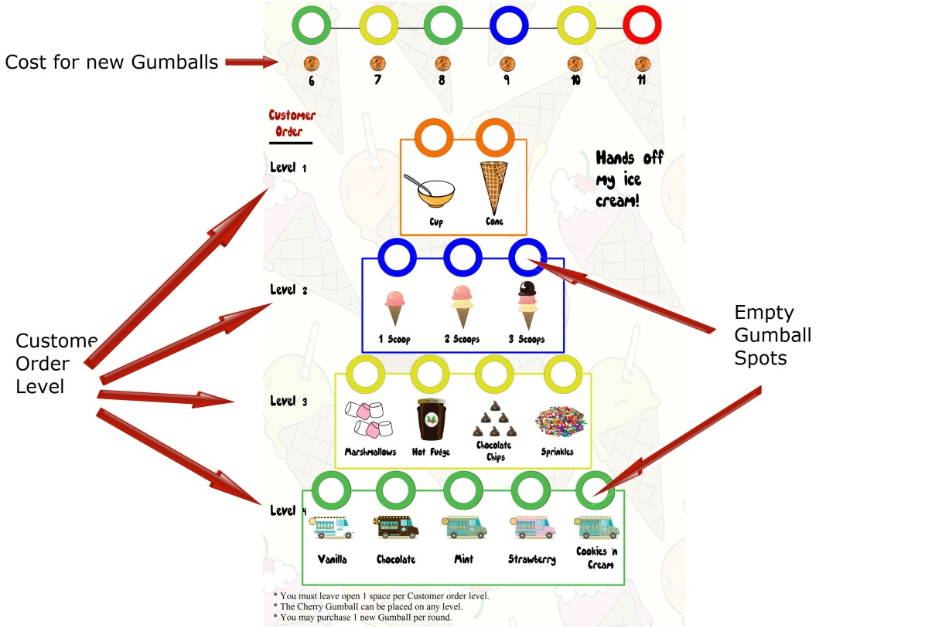 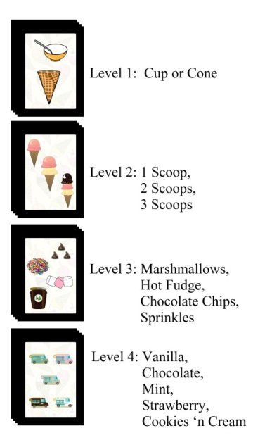

Time to serve the customers!

1st player flips over one card from each Customer Order deck. If you have a Gumball in the correct space that matches the card, you win that Order Challenge Level. **Resolve all 4, THEN** **pass** to the next clockwise player.

Collect Income: Take 1 coin for every empty Gumball space where you won the challenge.

Example: If you correctly completed the 1st and 3rd level challenges and there is one open space on the 1st Level and 3 open spaces on the 3rd Level, you collect 4 coins. If you get all 4 challenges correct, do not take any income. Instead put one unique topping into your Safe, followed by one action below.

|  |  |
| --- | --- |
| **Customer**  **Order**  **Level**  **Challenges** | **Action taken for correct guess per level** |
| Orange | No effect. |
| Blue  (Protect) | No effect. |
| Yellow  (Steal) | STEAL one matching topping from any Truck Counter. Place on your Truck Counter. |
| Green  (Sneak) | TRADE with the Truck you matched, any one topping from your counter with any one topping from their Counter.  No effect if you matched your own Truck. If you have no toppings, no effect. |

You MUST do the Action for the level challenge, if possible. ***You can only steal/trade one topping each turn.*** ***If you could gain more than one, you must choose. (See next page for examples)***

End of round:

If you have all 4 challenges correct:

Check if you have all four toppings on your counter/safe. If you do, you win!

Any player may purchase a new gumball at the end of each round. You can only purchase 1 per round.

When placing the gumball on the Customer Order Board, make sure it goes on the correct level.

Blue/Level 2, Yellow/Level 3, Green/Level 4, Red/Any Level.

Pass the 1st player token to the next clockwise player.

**Notes about Toppings:**

You can only gain one topping each turn. If you could gain more than one, you must choose.

Example: You win the 3rd and 4th challenges. The items matched are the Hot Fudge and the Cookies ‘n Cream. You can EITHER TAKE Hot Fudge from any Counter, or you can TRADE one topping between the Cookies ‘n Cream and your Counter. If possible, YOU MUST DO ONE OR THE OTHER.

**How to Win:**

At the end of the Round:

If you have all 4 Customer Order Level challenges correct and you have at least 1 of each of the 4 toppings on your Truck Area Mat (this includes one of your own).

If there is a tie, continue with the next challenge(s) until one Truck has won more challenges for the round. During the tie rounds, do not collect any coins or toppings.

After 15 Customers have been served, if there is no new King of Ice Cream Town:

Purchase any available gumballs first.

Each Gumball is worth 1, red is worth 2

Each topping in your Safe is worth 2, other toppings are worth 1

Add this to any remaining coins

…and determine the winner! Still a tie? Play again!!

**Understanding Gumballs**

You must leave open 1 spot/space per Customer Order Challenge level.

New Gumballs can be bought ***in any order***. There are six available to buy. Each has an increasing cost. Only one can be bought per round.

If you purchase the cherry, it can be placed on ANY open Gumball space on ANY challenge level. (Just remember to always leave open one space per level!)

**Special Thanks to play testers:**

Katherine Kagan

Logan Kagan

Holly Kagan

Alyson Franek

Lauren Franek

Rachel Franek

Ruth Kagan

Bob Kagan

Mustafa Ozturk

Daniel Wall

Rick Sabella

Peter Harrington

Emily Mccool

Dexcon 19 playtesters

Images Designed by Freepik.com, Pixabay.com, Clipartion.com, eatfunfoods.com

