 Hands Off My Ice Cream 

**2 – 4 Players 20 – 30 min Ages 8+**

**A Family Game**

Welcome to Ice Cream town. One remote neighborhood has been overrun with Ice Cream trucks trying to move in on each other’s territory. Sneak onto the competing ice cream trucks and get all the toppings. Figure out the customers’ order first! Will you be the next King of Ice Cream town?

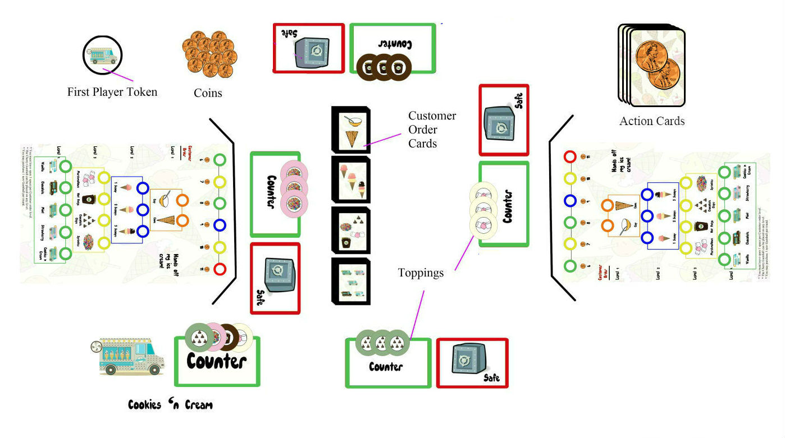

How it works: Players compete to get all four toppings onto their truck counter while also trying to guess the entire customer order for the win. There are three of each type of card (cup/cone, 1/2/3 scoops, 4 toppings, 5 flavors). Players take turns trying to guess the customers’ order. If they are correct, they gain income or can steal/trade for toppings. Players can make their guesses easier by purchasing gumballs which increases the probability of a correct order guess. The more gumballs you buy, the less income you get so you must use simple strategy and your memory to beat out your opponents!

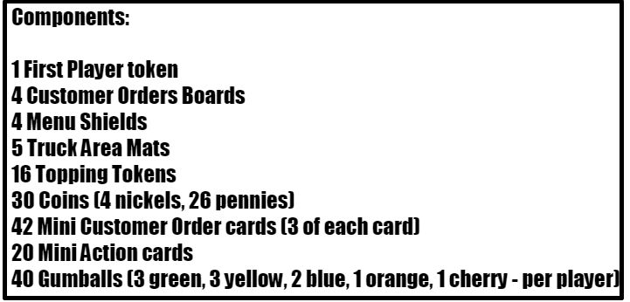 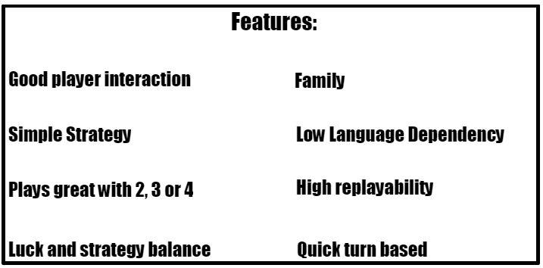

Gary Kagan [garykagan@gmail.com](mailto:garykagan@gmail.com)

## 

## Game Objective: The evil Elf “Rumples” has genetically cloned some of the fairy tale characters and turned them into mutated creatures. We are a group of bounty hunters completing contracts to collect these fairy tale creatures. To gain back the peoples trust, we need to deliver them to one of the five castle arenas for public battle. Be quick to finish the contracts first and watch out for fights among your captured prey!

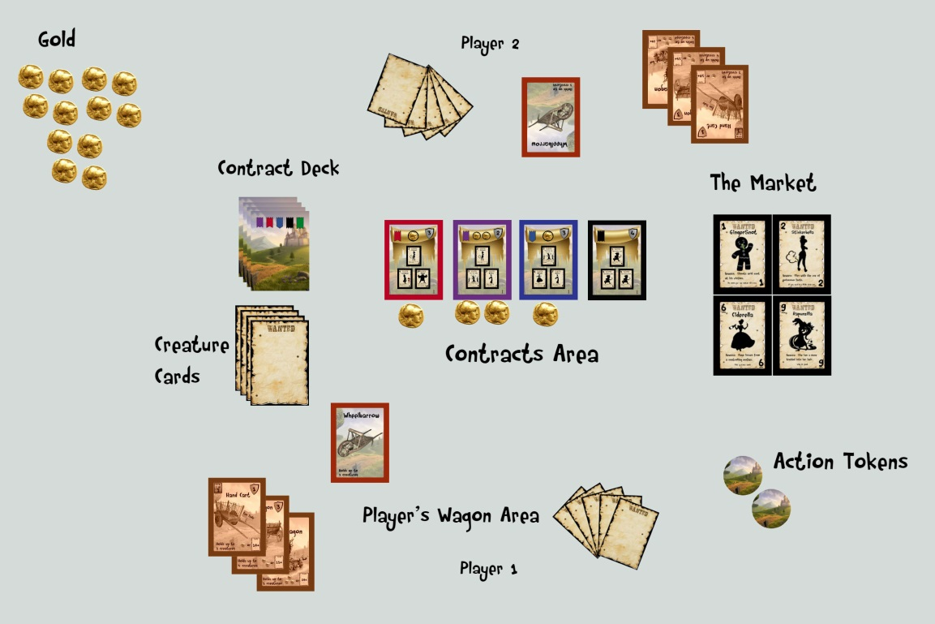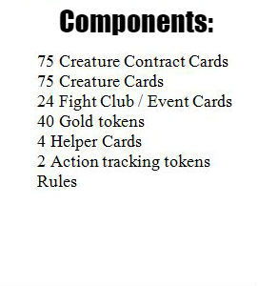

 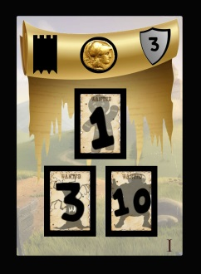 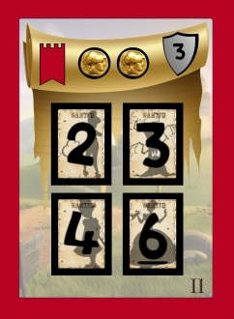 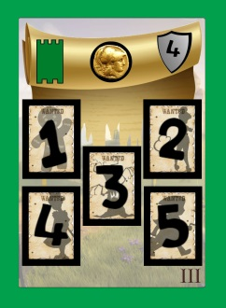 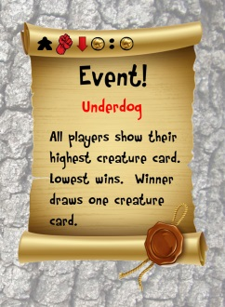

Gary Kagan [garykagan@gmail.com](mailto:garykagan@gmail.com)

 

**The Chemistry Card Game**

**1 – 4 Players 15 mins per player Ages 10+**

**A Light Euro Game**

**Welcome to Elementary, whre players become Scientists as they compete to see who can craft the most potent compounds, while their lab is burning down! Through skillful use of Lab Techniques, Element management and clever time track play, opponents gather the right combination of Elements and Bonds to sore their chemical creation! But beware! Your esteemed colleagues are doing the same! Will they sabotage your best efforts? Or will you both end up in smoke?**

**Game Objective: Complete compounds and collect glassware sets to score the most victory points.**

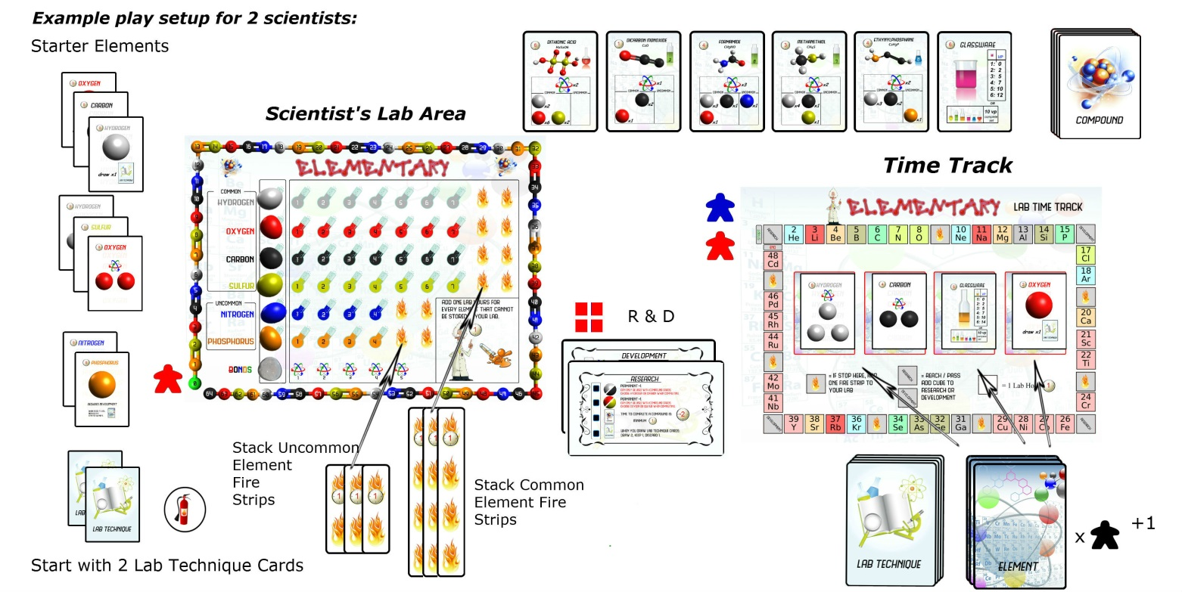

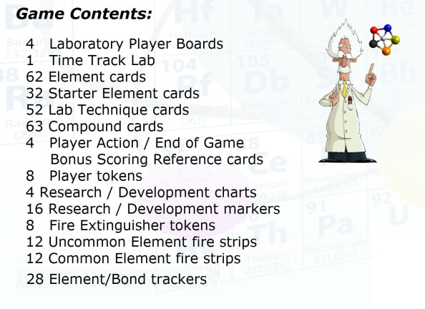 

Gary Kagan [garykagan@gmail.com](mailto:garykagan@gmail.com)

** Fingers **

**By Gary Kagan**

**2 – 5 Players 20 – 60 mins Ages 10+**

**Description**: You are part of a family team of pick pockets. Your goal is to loot and sell off everything you steal. Bribe cops to continue looting, talk your family members into not getting too greedy or grab what you need and leave your family to get caught.  Protect your loot from your greedy family members! Will you be the slyest Pick Pocket or end up empty handed?

**Objective:** Score the highest VP before all the pawn shop contracts run out.

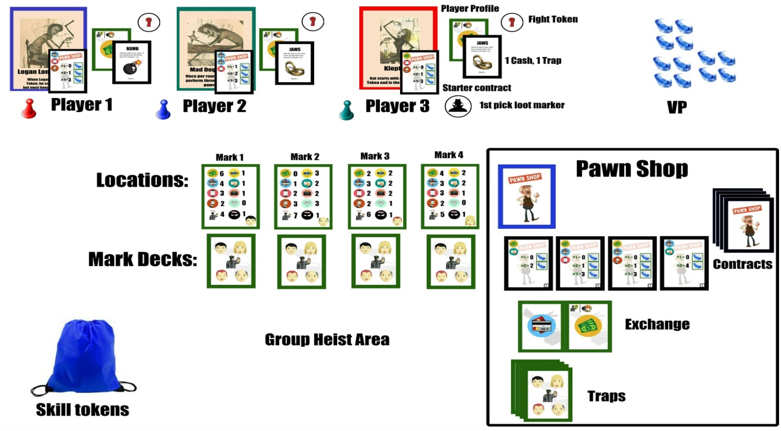

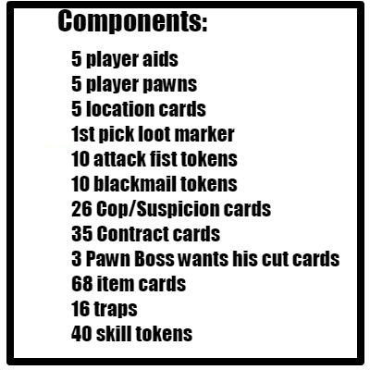  Gary Kagan [garykagan@gmail.com](mailto:garykagan@gmail.com)