Flight MH370 Revisited: Integrated Bayesian Estimation without a Prespecified End-of-Flight Scenario
Large, P. O., Large, J. T., Sarbin, M., ________, ________
[Affiliation(s)]
[Corresponding author email and ORCID]

Abstract
[To be drafted after the integrated-model results are fixed; Journal of Navigation limit approximately 150 words.]

1. INTRODUCTION
Malaysia Airlines Flight MH370, a Boeing 777-200ER registered as 9M-MRO, was lost on 8 March 2014 with 227 passengers and 12 crew on board. More than twelve years later, the main wreckage and flight recorders have not been located. Several items of debris have been confirmed, or assessed as almost certainly, to have originated from the aircraft, but they do not establish the point or manner of impact. The official safety investigation was consequently unable to determine the cause of the disappearance (Malaysian ICAO Annex 13 Safety Investigation Team, 2018). The unresolved location is therefore not only a search problem. It also prevents the physical examination required to test competing explanations of the accident.
The evidential position after the last military-radar contact is unusual. No conventional position reports were received, but the Inmarsat network recorded a small number of signalling exchanges between the aircraft earth station and the Perth ground earth station. The burst timing offset (BTO) constrains the aircraft-to-satellite range, while the burst frequency offset (BFO) contains information about relative velocity after accounting for the satellite motion, the aircraft terminal’s Doppler compensation and frequency biases (Ashton et al., 2015). The received signal level also contains information because the aircraft antenna gain varies with the line-of-sight geometry. None of these is a direct position observation. Each becomes informative only through a physical and statistical model.
Further information accumulated after the flight. Aircraft performance and fuel restrict the trajectories that can join the radar track to the satellite-derived range arcs. Debris arrival locations, buoyancy, windage and ocean circulation provide a likelihood for an earlier impact location. Four Pleiades 1A images acquired on 23 March 2014 contain objects assessed as possibly or probably man-made, although the imagery does not establish that they came from MH370 (Minchin et al., 2017). Finally, the areas searched without locating a debris field supply disconfirming, but not logically absolute, evidence: detection probability is high within well-surveyed areas, not equal to one. These information sources refer to different latent states and times. In particular, the aircraft position at the sixth BTO arc at 00:11 UTC, its state during the partial log-on at 00:19 UTC, and its eventual impact point are not interchangeable.
Early analyses by Inmarsat and the Australian-led flight path reconstruction group established the southern Indian Ocean as the relevant region. Davey et al. (2016) subsequently formulated the problem as a Bayesian particle filter, combining radar, BTO, BFO, aircraft dynamics and an end-of-flight transition model. Their result was appropriately expressed as a probability density function (PDF), rather than as a single track. They also observed that the assumed Mach-number spread and end-of-flight model materially affected the resulting PDF. This matters because the principal underwater search eliminated a large part of the high-probability region produced under those assumptions, yet did not locate the aircraft (Australian Transport Safety Bureau, 2017). Non-detection does not prove that the earlier estimator was wrong, but it is evidence that should be returned to the estimator rather than considered only after a map has been drawn.
The present study therefore treats the problem as one integrated inverse estimate. The baseline inference begins with an uncertain state near the 18:11 UTC radar position and uses BTO, BFO, received power and an aircraft performance/trajectory model through 00:11 UTC. It does not assume that the aircraft was uncontrolled, or that it remained at high altitude, and it does not use the two disputed 00:19 BFO values to determine the sixth-arc airborne state. Alternative controlled and uncontrolled terminal trajectories are then represented by an explicit transition kernel from the airborne state to an impact state. Ocean drift evidence is evaluated at the impact state and marginalised over the unknown terminal trajectory. Search non-detection is likewise introduced as a probabilistic likelihood over the surveyed footprint.
The Pleiades hypothesis is handled separately. There is presently no defensible frequency or base-rate estimate from which to assign a probability that the reported objects were MH370 debris. We therefore report two conditional products: one based on the satellite-communications, received-power, performance, drift and search evidence, and a second conditional on the proposition that the relevant Pleiades objects originated from the aircraft. This avoids hiding an essentially judgemental provenance probability within an otherwise numerical posterior.
Figure 1 summarises the information flow. The distinction between an observation and a scenario is deliberate. BTO, BFO and received power enter as measurement likelihoods. Aircraft control family, terminal descent or glide, Pleiades provenance and detection performance enter as explicit model states or conditions that can be varied. The paper first establishes the scale and origin of disagreement in prior geospatial estimates, then develops and validates the integrated estimator, and finally reports the posterior maps and their sensitivity to the principal unresolved assumptions.
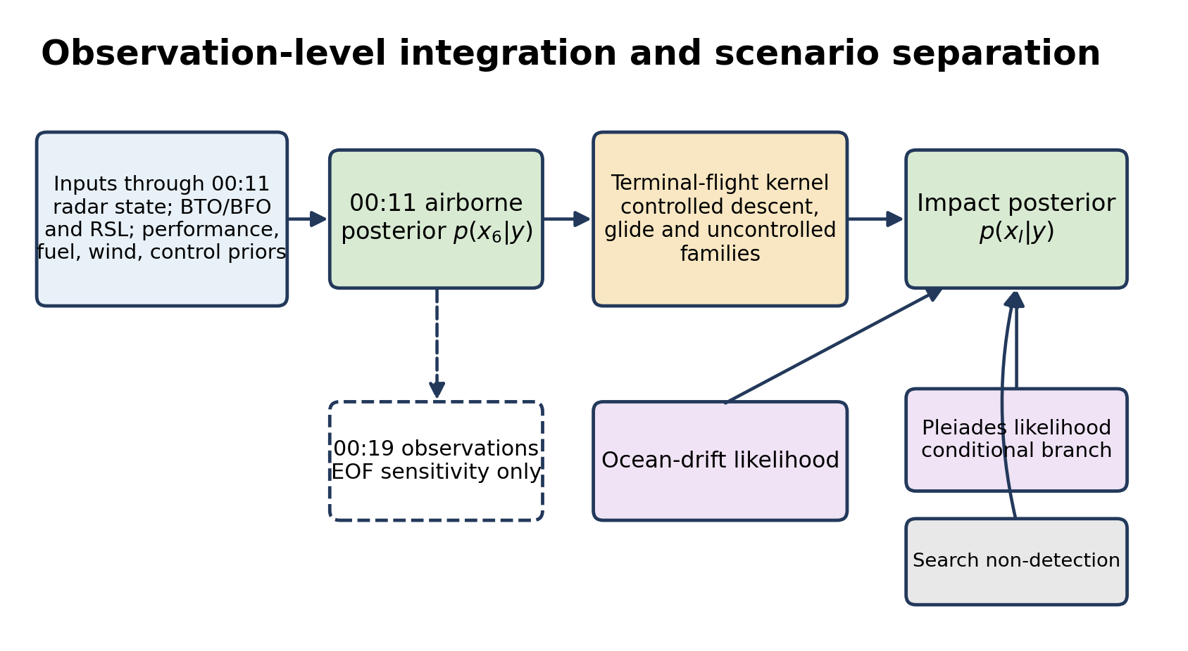
Figure 1. Structure of the integrated estimator. The baseline state estimate ends at the sixth arc at 00:11 UTC. End-of-flight displacement, ocean drift, Pleiades provenance and search non-detection are represented as explicit transition or likelihood terms rather than being imposed on the airborne state.

2. META-ANALYSIS AND REPRODUCTION

2.1. Purpose and scope of the synthesis
Large (2019) conducted a meta-analysis of 38 published geospatial estimates: 26 based principally on satellite communications and 12 based on ocean drift. The synthesis remains useful because it shows the scale of between-study dispersion and identifies assumptions that require explicit treatment. It is not, however, used here as a substitute for the observation-level likelihood. Many studies reuse the same Inmarsat log, radar endpoint, aircraft performance information or debris observations and are therefore statistically dependent. Multiplying their published PDFs would count common evidence more than once; averaging their preferred latitudes would discard the physical meaning of the underlying observations.
The dissertation converted published point estimates and latitude ranges to a common arc-latitude representation. Where a study did not report a mean or uncertainty, these quantities were reconstructed or imputed, including an assumed Gaussian form for some ranges. The resulting intervals are consequently useful descriptions of the literature, but they should not be read as uniformly calibrated confidence intervals. Figure 2 reproduces the forest plots in a compact form and distinguishes the arithmetic centre of the reported study estimates from the model-based pooled value.

2.2. Satellite-communications estimates
The 26 satellite-communications estimates had an arithmetic mean of 32.23°S, a sample standard deviation of 7.38° and a range from 12.00°S to 40.55°S. The unweighted fixed-effect centre was 32.23°S (95% interval 31.56–32.90°S), while the weighted random-effects result was 33.34°S (29.13–37.54°S). The heterogeneity statistic was Q = 6368.5 with 25 degrees of freedom (p < 0.0001). The extreme value of Q is more important than the apparent precision of either pooled centre: the studies do not behave as repeated estimates of one location differing only by sampling noise. Their spread reflects materially different trajectory families, speed and turn assumptions, use of BFO, fuel and wind treatments, and end-of-flight kernels, as well as differences in the stated or imputed uncertainty.
This result also explains why a consensus latitude is not an adequate prior for a new estimator. A pooled centre would mix different physical models and conceal multi-modality. The present work instead returns to the common measurements, introduces uncertain biases as nuisance states, and compares trajectory and control families within one likelihood framework. The published estimates are retained as an external calibration check: a posterior feature is expected to be explainable by identifiable measurements and assumptions, rather than merely by its proximity to an earlier preferred latitude.

2.3. Ocean-drift estimates
The 12 drift-study centres were less dispersed: their arithmetic mean was 28.75°S, their sample standard deviation was 2.97° and their reported centres ranged from 23.50°S to 32.00°S. The dissertation’s inverse-variance descriptive pool was 30.17°S (28.74–31.60°S), with Q = 6.55 on 11 degrees of freedom (p = 0.83). Individual reconstructed intervals were much wider, extending in aggregate from approximately 12°S to 38°S. Thus the study centres were comparatively consistent, but the location information supplied by any one drift model remained broad.
That apparent agreement must also be interpreted cautiously. The drift studies share ocean reanalyses, debris records and assumptions about leeway, windage and object buoyancy; several estimates are not independent, and reverse drift is intrinsically dispersive. In the integrated estimator, drift is therefore applied as a likelihood for the unknown impact point and then marginalised over terminal-flight displacement. It is not applied directly to the aircraft’s 00:11 position. Alternative circulation products and debris classes are retained as model variants so that agreement between drift models is not mistaken for certainty in their common inputs.

2.4. Reproduction strategy
The reproduction proceeds at three levels. First, the published BTO arc geometry, BFO residual behaviour and principal aircraft-performance envelopes are reconstructed from the released source data. Secondly, those components are checked against flights and phases for which the aircraft position is known, including MH371 and the known portion of MH370, so that fast random error can be separated from slower or intermittent bias. Thirdly, the components are assembled in a sequential Monte Carlo estimator through 00:11 UTC and compared with the broad features of the Davey et al. (2016) result. Where a proprietary data product or an unpublished implementation prevents exact replication, the substituted model and its sensitivity range are reported explicitly.
This staged approach also resolves a potential inconsistency in the literature. Davey et al. (2016) treated the BFOs during the 18:25 and 00:19 transient log-ons as unreliable for the flight-path filter, whereas Holland (2018) later used the last two BFOs in a conditional end-of-flight analysis after bounding oscillator warm-up effects. In the present paper these are not competing choices: the 00:19 BFOs are excluded from the baseline sixth-arc estimate and examined separately as end-of-flight evidence. The resulting posterior through 00:11 is therefore not narrowed by assuming the conclusion of a particular terminal-flight model.
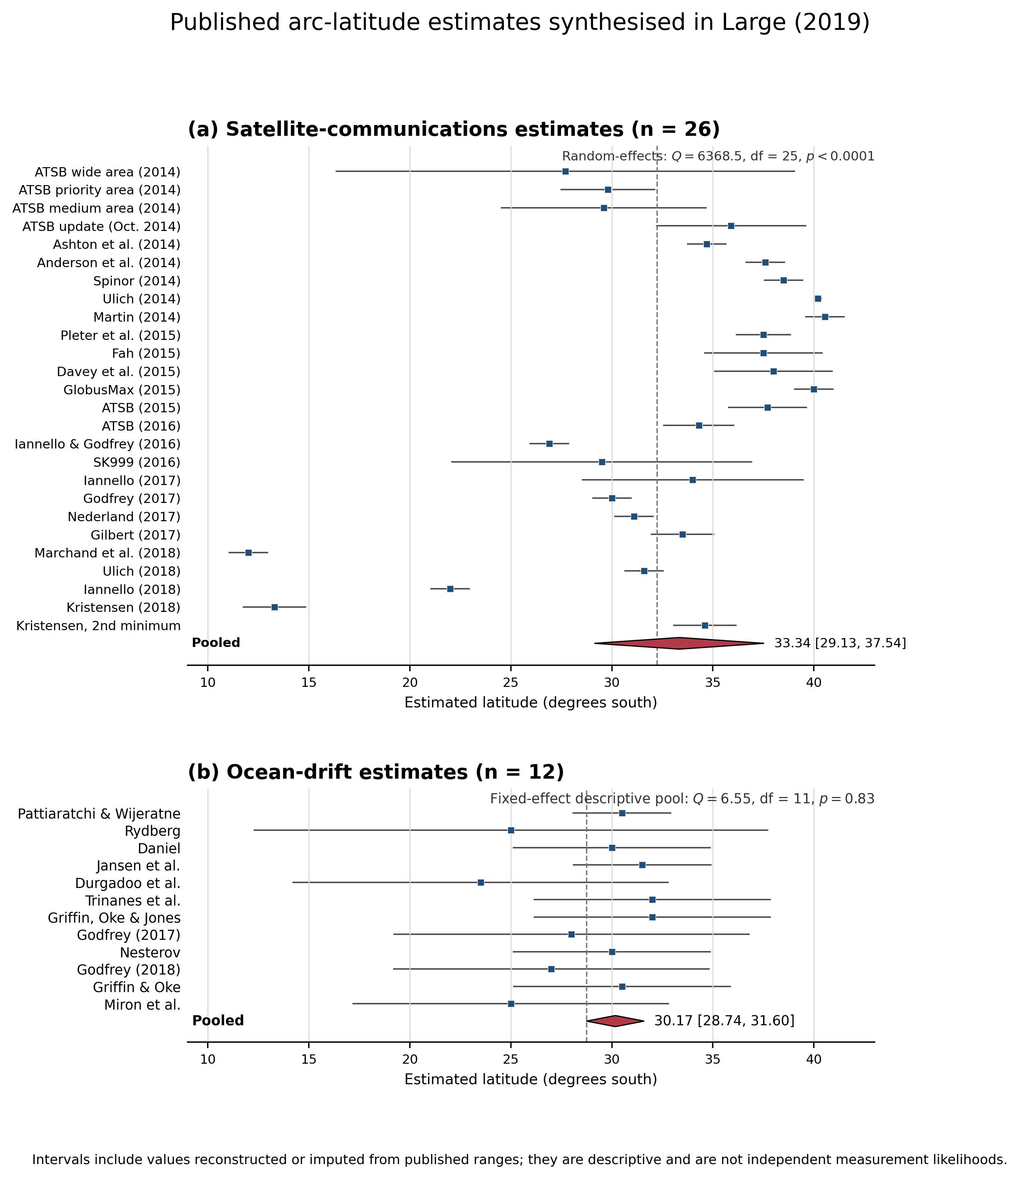
Figure 2. Forest plots of geospatial estimates synthesised in Large (2019): (a) satellite-communications studies and (b) ocean-drift studies. Squares denote study centres and horizontal lines the reported or reconstructed 95% intervals. The diamonds show the dissertation’s random-effects SATCOM result and fixed-effect descriptive drift result. Several intervals were imputed; the estimates share source data and are not independent likelihoods.

3. INTEGRATED OBSERVATION AND TRAJECTORY MODEL
[Next drafting pass: BTO, BFO, received-power/antenna-gain, aircraft performance, control-family priors and sequential Monte Carlo implementation.]

4. CALIBRATION, REPRODUCTION AND VALIDATION
[Next drafting pass: known-position checks, MH371/MH370 gain validation, refined BFO noise model, posterior predictive checks and implementation fidelity.]

5. RESULTS AND SENSITIVITY
[Next drafting pass: 00:11 airborne posterior; drift-marginalised impact posterior; searched-area non-detection; no-power-precompensation sensitivity.]

6. END-OF-FLIGHT AND CONDITIONAL PLEIADES SCENARIOS
[Next drafting pass: 00:19 evidence, controlled/uncontrolled terminal kernels and a separate posterior conditional on Pleiades provenance.]

7. CONCLUSIONS AND RECOMMENDATIONS
[To be drafted after the integrated-model and sensitivity results are fixed.]

REFERENCES
Ashton, C., Shuster Bruce, A., Colledge, G. and Dickinson, M. (2015). The Search for MH370. The Journal of Navigation, 68, 1–22. https://doi.org/10.1017/S037346331400068X.
Australian Transport Safety Bureau. (2017). The Operational Search for MH370. External Aviation Investigation AE-2014-054. Canberra: ATSB.
Davey, S., Gordon, N., Holland, I., Rutten, M. and Williams, J. (2016). Bayesian Methods in the Search for MH370. Singapore: SpringerOpen.
Holland, I. D. (2018). MH370 Burst Frequency Offset Analysis and Implications on Descent Rate at End-of-Flight. IEEE Aerospace and Electronic Systems Magazine, 33(2), 24–33. https://doi.org/10.1109/MAES.2018.170048.
Large, P. O. (2019). A Meta-Analysis of Geospatial Estimates in the Case of Malaysian Airlines Flight MH370. Doctoral dissertation, Oklahoma State University.
Malaysian ICAO Annex 13 Safety Investigation Team for MH370. (2018). Safety Investigation Report MH370/01/2018. Putrajaya: Ministry of Transport Malaysia.
Minchin, S., Mueller, N., Lewis, A., Byrne, G. and Tran, M. (2017). Summary of Imagery Analyses for Non-Natural Objects in Support of the Search for Flight MH370. Geoscience Australia Record 2017/13. https://doi.org/10.11636/Record.2017.013.

