MH370 PAPER DEVELOPMENT NOTE
Sections 1–2 budget, end-of-flight evidence, Penang/Pulau Perak altitude sensitivity, and Pleiades image feasibility

1. EXECUTIVE FINDINGS
1. The Journal of Navigation currently describes research papers as averaging 6,000–8,000 words and up to 20 submission pages including figures and tables. A practical target for this paper is 7,200–7,600 words and 18–20 pages. The first-pass Introduction is 789 words and Section 2 is 825 words (1614 combined), leaving most of the budget for the integrated model, calibration, results and sensitivity analysis.
2. Holland’s calculation is strong evidence for rapid descent at the two 00:19 transmission instants if the recorded BFOs are treated as motion-bearing observations after the stated transient and bias corrections. It does not, by itself, identify whether the aircraft was uncontrolled, how long the descent continued, or how far the impact lay from the seventh arc.
3. The military-radar height read-outs around Penang and Pulau Perak are not reliable measured altitudes. The Malaysian safety report says their variations exceeded aircraft capability and that only latitude and longitude were reasonably reliable. The reported loss of the blip at 18:03:09 and reacquisition at 18:15:25 are nevertheless separate facts about the detection record and should not be discarded with the height labels. The Lido Hotel display was shown in Beijing, not Kuala Lumpur, and its precise provenance and processing remain unpublished.
4. A Pulau Perak ‘eyewitness’ label can be found in discussion of a leaked police-report appendix, but I have not located the authenticated statement behind it. Later reports confirm that Malaysian Army personnel have been deployed on Pulau Perak, making an observer on military watch plausible. They do not establish staffing on 8 March 2014 or the content and timing of the alleged observation. The combination of gap, reacquisition and witness report merits a joint low-altitude sensitivity analysis, but not yet a fixed low-altitude datum.
5. All 70 object close-ups and object tables in the Geoscience Australia Pleiades report can be extracted and inspected. Nine of the twelve ‘probably man-made’ objects lie in the north-east PHR_4 scene. The 0.5-m sampling and the report thumbnails are insufficient for a forensic flaperon identification; a probabilistic size/shape/radiance comparison is possible if the original calibrated imagery and appropriate negative controls can be obtained.

2. JOURNAL LENGTH AND SECTION BUDGET
The current Cambridge University Press instructions give an average length of 6,000–8,000 words, a submission length of up to 20 pages including figures and tables, 12-point Times New Roman, single column and 2.54-cm margins. The abstract should be a single paragraph of approximately 150 words and the submission system permits no more than four keywords. The following budget keeps the paper within that envelope while protecting space for the new integrated estimator.
Component | Target words | Purpose / page pressure
Abstract | 150 | Finalise after results
1. Introduction | 800–950 | Problem, contribution and evidence architecture
2. Meta-analysis and reproduction | 750–900 | Descriptive synthesis and reproduction logic
3. Integrated model | 2,000–2,200 | Largest methodological section
4. Calibration and validation | 850–1,000 | Known-position and predictive checks
5. Results and sensitivity | 1,350–1,550 | Maps, searched-area update and key variants
6. EOF/Pleiades scenarios | 750–900 | Conditional analyses; no provenance probability
7. Conclusions | 400–500 | Claims, limitations and search implications
Total | about 7,250–7,550 | Aim for 7–9 figures/tables and 18–20 pages
The two forest plots are scientifically useful but visually expensive. The compact combined figure in the manuscript is suitable for a first submission; if the final paper reaches the page limit, move the individual study rows to supplementary material and retain only pooled centres, ranges and the heterogeneity statistics in the main text.

3. END-OF-FLIGHT DEEP DIVE: HOLLAND (2017 PREPRINT; 2018 PUBLICATION)

3.1. What was calculated
Holland analysed the BFOs of 182 Hz and −2 Hz recorded eight seconds apart during the 00:19 partial log-on. For level flight near the relevant part of the seventh arc, the expected BFO was approximately 260–280 Hz. The satellite data unit does not compensate for vertical aircraft velocity, giving an approximate sensitivity of 1.7 Hz per 100 ft min−1 of descent. The calculation bounded track, speed, historical BFO error and oven-controlled crystal oscillator (OCXO) warm-up drift under two hypotheses: a fuel-related power interruption followed by auxiliary-power-unit restart, and a short interruption with negligible warm-up drift.
Holland case | 00:19:29 descent | 00:19:37 descent | Interpretive status
Fuel/power interruption with bounded warm-up | 3,900–14,800 ft min−1 | 14,800–25,300 ft min−1 | Conditional on extrapolated OCXO correction
Other/short interruption; no material warm-up | 2,900–6,800 ft min−1 | 13,800–17,600 ft min−1 | Conditional on treating recorded BFO normally
Combined outer bounds | 2,900–14,800 ft min−1 | 13,800–25,300 ft min−1 | Not a joint trajectory posterior
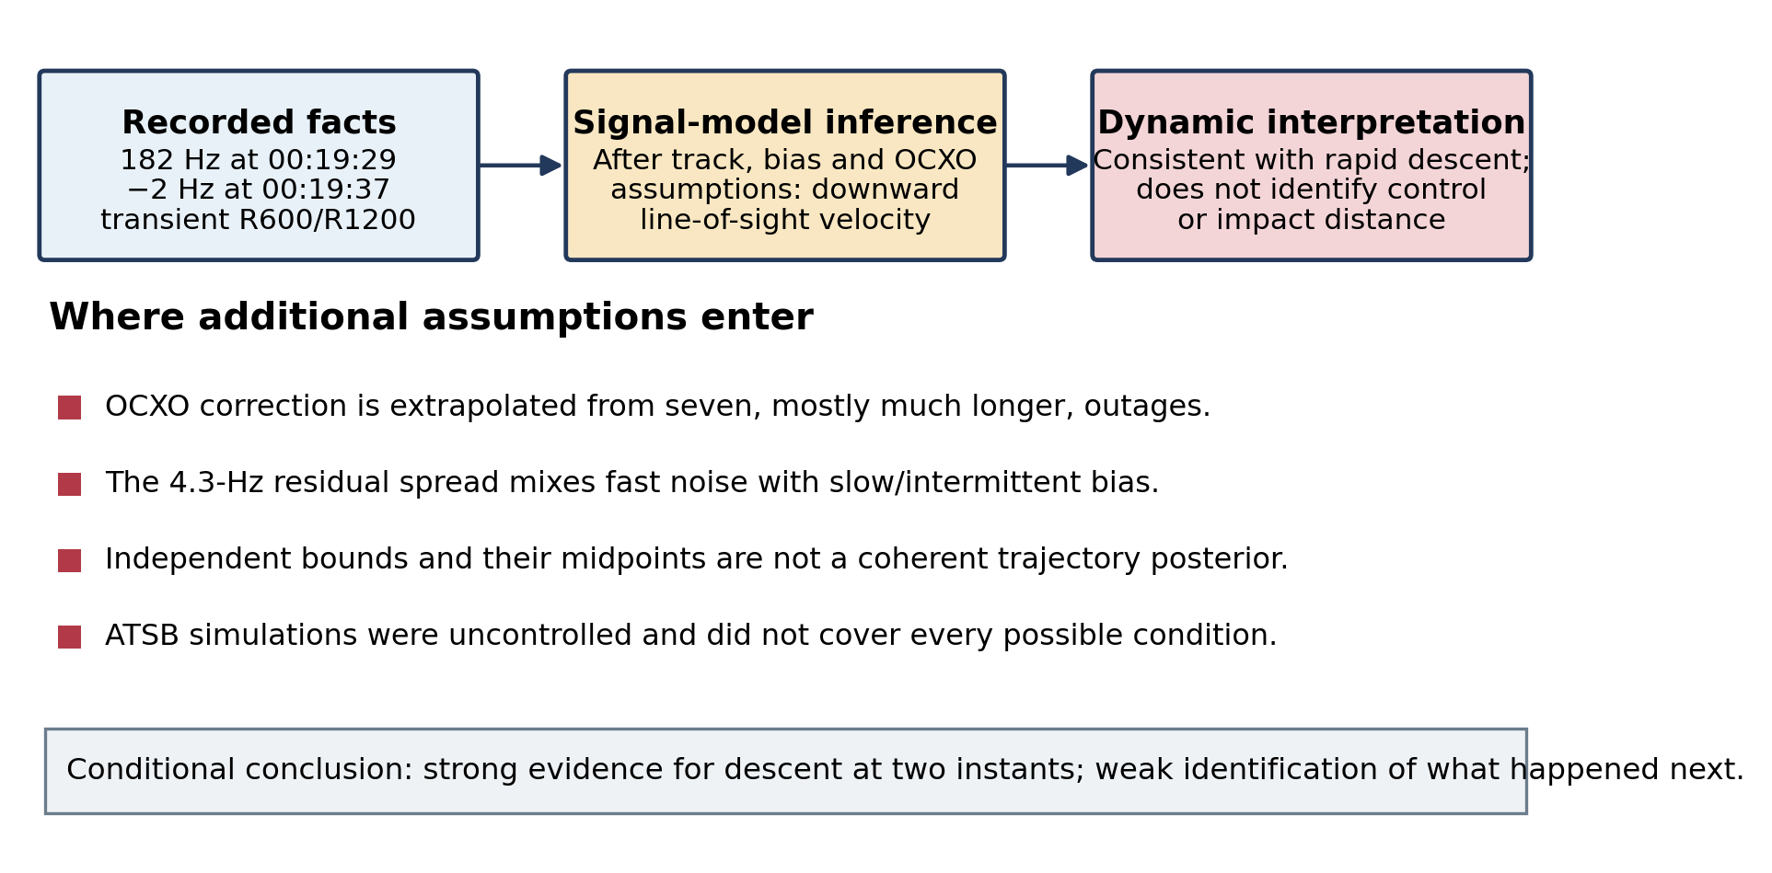
Figure A. Evidential layers in the interpretation of the final two BFOs. The measurement-to-descent calculation and the descent-to-impact scenario should be tested separately.

3.2. Evidence supporting Holland’s narrow conclusion
• The two recorded values are far below the approximately 260-Hz continuation of the preceding BFO trend. Track changes and ordinary fast random error are much too small, by themselves, to explain the second value.
• The vertical-velocity contribution follows from the line-of-sight Doppler geometry and the terminal’s compensation logic; its sign and approximate scale are not controversial.
• Earlier 9M-MRO log-ons show a decaying OCXO transient of the sign required to raise the recorded BFO above its steady-state equivalent. Accounting for that effect generally increases, rather than removes, the descent inferred from the recorded values.
• Boeing engineering simulations produced uncontrolled cases with descent rates and increases over eight seconds of comparable magnitude, showing that the inferred rates are dynamically possible in at least part of that scenario family.

3.3. Reasons not to promote the result to a unique end-of-flight model
• Transient-message status. Davey et al. discarded the 18:25 and 00:19 BFOs from the flight-path filter because the equipment was not in steady state. The last two messages are also of different channel types (R600 and anomalous R1200). Holland’s later treatment is a conditional salvage of those values, not a reversal of their transient character.
• Warm-up extrapolation. The seven comparison log-ons followed outages of approximately 20 minutes to more than seven hours; the hypothesised 00:19 outage was approximately one minute. Holland expressly notes that a short outage may produce less drift. The wide correction bounds are sensible for bounding, but not a calibrated transient distribution for a posterior.
• Error decomposition. Holland used the historical 4.3-Hz BFO residual standard deviation and outer observed residual bounds. Our short-interval estimate gives about 1.0 Hz for the fast random component once local mean changes are removed. The remaining slow/intermittent bias and start-up transient should be represented as separate latent processes, not folded into one Gaussian error.
• Acceleration statistic. The reported approximately 0.68g uses midpoints of two separately bounded intervals. The low bound at the first time and high bound at the second can depend on different track and transient assumptions; the midpoint difference is illustrative, not a posterior estimate of one aircraft trajectory.
• Control and continuation. Two line-of-sight velocity observations do not identify attitude, control inputs, altitude, a later recovery, or a glide. Boeing’s close-to-arc result was generated from specified uncontrolled cases, and the ATSB states that the scenarios did not represent every possible condition. Its ±40-NM width was explicitly an envelope for the uncontrolled simulations.
• Debris configuration. Damage alignment between the recovered flaperon and outboard flap reduced the likelihood that the main flaps were extended at separation. This weighs against a conventional landing configuration, but it is not a direct observation that nobody was controlling the aircraft.
A 2024 Journal of Navigation paper by Lyne proposes a controlled eastward descent and directly challenges Holland. It is relevant as a competing published argument, but its stronger claims rely on assumed tracks, a proposed ‘Penang longitude’ destination, pilot-simulator ‘riddles’, JORN avoidance and contested debris interpretation. Its horizontal-speed objection also assumes a particular path between arcs and does not establish that fuel exhaustion before 00:19 is physically impossible. The appropriate response is therefore not to substitute Lyne’s scenario for Holland’s, but to evaluate the final two transmissions under a vector Doppler model while marginalising over track, transient, control and continuation states.

4. PENANG, THE LIDO DISPLAY AND A LOW-ALTITUDE PULAU PERAK STRESS TEST

4.1. Source assessment
The widely circulated ‘Lido Hotel’ image was photographed during a next-of-kin briefing at the Lido Hotel in Beijing. It was not a Kuala Lumpur display. It resembles a processed or replayed radar presentation, and the raw military returns and processing chain have not been released. The official chronology nevertheless reports that the blip disappeared at 18:03:09, reappeared at 18:15:25 and was then observed until 18:22:12. This interruption is evidence about detection history even though the display is not a calibrated sensor product.
The 2018 Malaysian safety report is decisive on a narrower point: its height values cannot be read as an altitude profile. It lists blip-to-blip values ranging from approximately 24,450 to 47,500 ft before Penang, approximately 44,700 ft near Penang, 4,800 ft at Pulau Perak, and 29,500 ft after the later reappearance. It also states that the implied altitude and speed changes were beyond aircraft capability, that the extracted values were subject to inherent error, and that only latitude and longitude were reasonably reliable. Figure B therefore separates two propositions that are easily conflated: the height labels are quantitatively unusable, while the reported gap and reacquisition remain observations requiring an explanation.
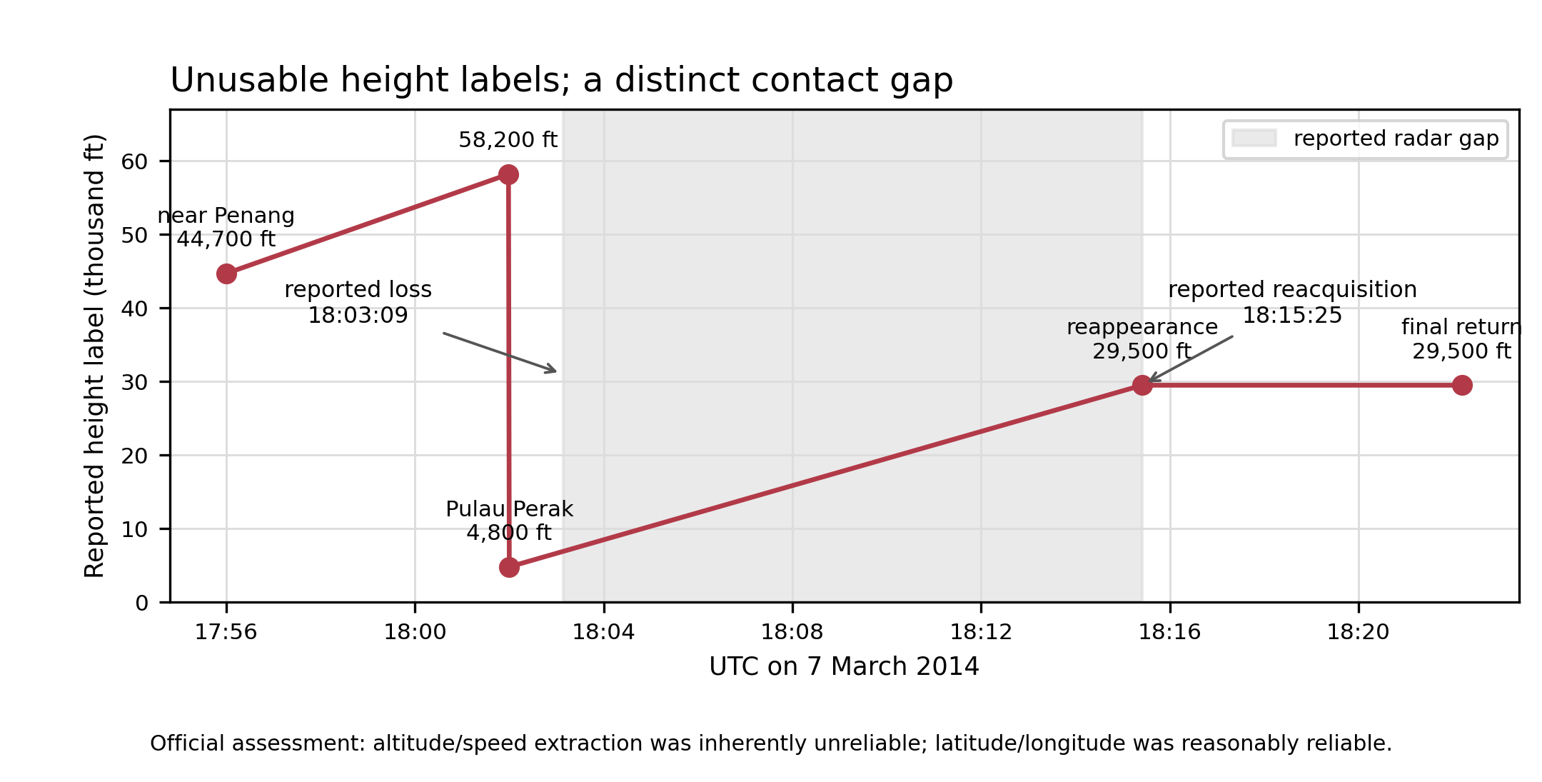
Figure B. Published military-radar height read-outs and the reported contact interruption. Connecting the height values does not create a valid altitude profile, but rejecting those values does not remove the distinct evidence that the blip was lost and later reacquired.
The phrase ‘Pulau Perak – Eyewitness’ appears on a map discussed as page 149 of leaked Police Report Appendix K-2. I have not found a public, authenticated witness statement behind the label. The island is a small, steep and remote rock. Reporting from 2016 and 2019 confirms deployments there by the Malaysian Army’s Fourth Battalion, Royal Ranger Regiment, including duty under Op Pejarak. That makes a military observer, possibly subject to watch routines, a credible class of witness; it does not by itself prove that the post was staffed on the relevant night or establish what any observer saw or heard.
If the statement can be authenticated as an observation from the island, the evidential combination is more informative than the 4,800-ft label alone. At cruise altitude an airliner’s lights—and, with delay, its sound—can still be detected in clear conditions, so a sighting is not impossible. However, a routine aircraft on a well-used airway would have small apparent size and limited salience to a habituated observer. A substantially lower pass would generally increase angular size, sound level and the probability that the event was noticed and later described as unusual. The size of that likelihood ratio depends on the statement’s actual words, slant range, cloud, moon and background light, aircraft lighting, observer location and duty, and the delay and selection process by which the report entered the police material.
A simple scale calculation illustrates the contrast without pretending to estimate a witness likelihood. The Boeing 777-200ER span is 60.9 m. For a directly overhead pass it would subtend about 0.33° at 35,000 ft, 0.57° at 20,000 ft, 1.15° at 10,000 ft and 2.29° at 5,000 ft. The corresponding sound-arrival delays are approximately 31, 18, 9 and 4 s. Geometric spreading alone would make an otherwise comparable sound about 11 dB stronger at 10,000 ft and 17 dB stronger at 5,000 ft than at 35,000 ft. These figures do not account for lateral offset, engine thrust, atmospheric absorption, cloud, aircraft lighting, sea and background noise, or observer attention. They do quantify why a low pass would be much more salient to a watchstander while leaving a cruise-altitude observation physically possible.

4.2. How to test the descent–reclimb hypothesis
The integrated estimator should add an early-altitude scenario variable rather than force the 4,800-ft read-out. A useful family would sample a minimum altitude between 5,000 and 20,000 ft, a low-level duration between zero and ten minutes, and a climb ending between 18:15 and 18:25 at 28,000–35,000 ft. It should be conditioned on the reliable radar latitude/longitude track and on Boeing 777 climb-rate, calibrated-airspeed, cabin-pressurisation and fuel-flow constraints. If the aircraft was still climbing at the 18:25 log-on, the vertical BFO term and antenna geometry must also enter directly.
The radar and witness terms should then be evaluated jointly, not counted as independent votes. Let G denote the reported gap/reacquisition and W the authenticated contents of the witness account. For each sampled trajectory T, the calculation should marginalise P(G | T, radar site, beam and processing parameters) and P(W | T, visibility, acoustics, observer and reporting parameters). A low trajectory can increase both probabilities, creating dependence through altitude. Competing families should include (i) cruise altitude with a coverage, propagation or processing gap; (ii) descent below effective coverage followed by reacquisition during a climb; and (iii) an incorrect track or witness association. Until raw radar data and the statement are obtained, the result should be reported across explicit likelihood-ratio ranges rather than as a single Bayes factor.
A first energy/fuel bracket indicates the scale, not a final estimator result. Re-climbing by 25,000–30,000 ft at a mass near 210 tonnes requires approximately 15–19 GJ of additional potential energy. Across a broad 25–40% effective conversion from fuel energy to aircraft potential energy, that corresponds to approximately 0.9–1.8 tonnes of fuel before crediting the lower thrust used during descent. Descent fuel saving and the duration of low-level flight make a net penalty of roughly 0.3–1.3 tonnes a defensible stress range. At a later two-engine cruise flow of about 5.5–7.0 tonnes per hour, this is equivalent to approximately 3–14 minutes of endurance, or roughly 20–110 NM at 430–480 kt.
The sixth-arc BTO geometry would move only a few nautical miles for the lower altitude itself. The larger effect is reweighting: a fuel penalty removes trajectories with little remaining endurance and tends to favour shorter-range solutions, while a climb still in progress at 18:25 also changes the BFO likelihood. The direction and magnitude of any shift in the two-dimensional PDF cannot be stated from the energy bracket alone. It requires a particle-level rerun with fuel mass carried as a state. The existing working estimator uses a broad endurance/performance envelope, so quoting a precise latitude shift at this stage would be false precision.

5. PLEIADES IMAGE AND DEBRIS-COMPONENT FEASIBILITY
Geoscience Australia examined four Pleiades 1A scenes acquired on 23 March 2014 at 0.5-m pan-sharpened resolution. Seventy objects were catalogued: 12 assessed as ‘probably man-made’ and 28 as ‘possibly man-made’. The north-east PHR_4 scene contains 36 catalogued objects and nine of the twelve highest-rated candidates. Their reported bright-object footprints range from 23 to 70 m². The automated spectral classifications were not reliable because glint and shaded glint resembled the candidate objects; the final ratings relied substantially on manual inspection and principal-components displays.
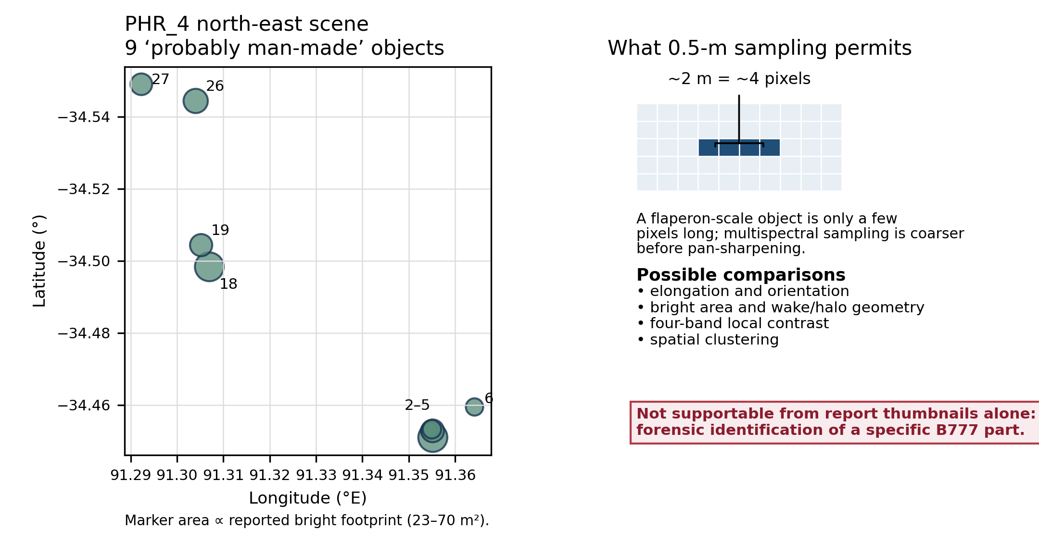
Figure C. Left: positions and reported bright-footprint areas of the nine PHR_4 objects rated ‘probably man-made’. Right: a sampling-scale illustration showing why component identification is under-resolved. This is a new data-derived schematic; it does not reproduce the CNES image pixels.
Scene / object | Latitude | Longitude | Reported area
PHR_4 / 2 | -34.45100° | 91.355206° | 70 m²
PHR_4 / 3 | -34.45289° | 91.354443° | 23 m²
PHR_4 / 4 | -34.45283° | 91.355169° | 43 m²
PHR_4 / 5 | -34.45326° | 91.355020° | 28 m²
PHR_4 / 6 | -34.45946° | 91.364210° | 25 m²
PHR_4 / 18 | -34.49835° | 91.306980° | 69 m²
PHR_4 / 19 | -34.50437° | 91.305206° | 41 m²
PHR_4 / 26 | -34.54438° | 91.304036° | 49 m²
PHR_4 / 27 | -34.54901° | 91.292308° | 39 m²
I can extract and catalogue every true-colour and principal-components close-up in the report, register the reported coordinates and metrics, and compare candidate morphology against dimensions of the flaperon, outboard-flap sections, fairings, aileron and other confirmed or highly likely debris. The report imagery alone supports only a low-dimensional probabilistic comparison: bounding-box length/width where recoverable, elongation, orientation, bright area, wake or halo geometry, four-band contrast relative to local sea surface, and clustering. A recovered flaperon roughly two metres long would span only about four pixels at 0.5-m ground sampling; radiometric mixing, the sensor point-spread function, pan-sharpening and sea-surface motion prevent a reliable visual identification.
A stronger analysis would require the original radiometrically calibrated Pleiades products (not screenshots), acquisition metadata and point-spread information; a set of negative-control scenes with comparable sea state; exact component dimensions and flotation attitudes; and a pre-registered scoring rule tested without knowledge of the candidate labels. The report itself notes the absence of comparable negative-control images. Spectral comparison should be described as four-band radiance/contrast analysis, not material spectroscopy: an object only a few pixels across cannot yield a clean material spectrum from these data.
There is also a rights issue. The Geoscience Australia text is generally CC BY 4.0, but the embedded imagery is marked French Military Intelligence Service © CNES and is expressly excepted from that licence. I can use the close-ups for internal scientific inspection; reproduction in a journal article would require a permission or licensing check. Newly drawn coordinate maps and data tables, such as Figure C, avoid that problem.

6. RECOMMENDED NEXT TESTS
1. Implement the early descent–reclimb family as a latent initial-condition/fuel-penalty model and rerun the estimator through 00:11, reporting the Bayes factor or posterior mass relative to the level-flight family and the change in the two-dimensional sixth-arc PDF.
2. Build a dedicated 00:19 likelihood with separate fast BFO noise, slow/intermittent bias, channel offset and OCXO-transient states; compare controlled continuation, recovery/glide and uncontrolled simulation families without making any one of them the baseline.
3. Acquire or request the underlying Pulau Perak witness statement and 8 March 2014 post roster/watch information before assigning it a likelihood. Until then, retain the gap-plus-witness combination as a labelled joint stress condition with broad radar-detection and human-observation models.
4. Extract the 70 Pleiades object records into a reproducible catalogue, acquire original imagery if possible, and construct negative-control object detections before attempting any flaperon or debris-class score.
5. Keep the Pleiades output conditional: publish one integrated PDF without that hypothesis and one conditional on it, without inventing a prior probability that the objects came from MH370.

PRIMARY SOURCES CONSULTED
Journal of Navigation author instructions
Holland preprint and publication record
ATSB MH370 investigation and end-of-flight material
Malaysian Ministry of Transport MH370 archive
Later reporting confirming Malaysian Army deployments on Pulau Perak
Boeing 777-200ER dimensions
ATSB / Geoscience Australia Pleiades report page
Lyne (2024), Journal of Navigation

