**Final project:**

1. Chooses the project from TCS-India group called the github_sample .

2. Created a file and committed locally

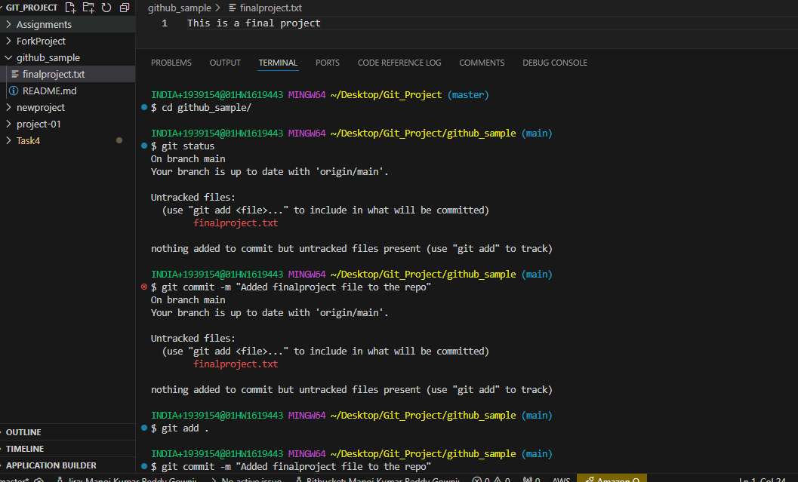

3. Pushed the code to owner's remote repository

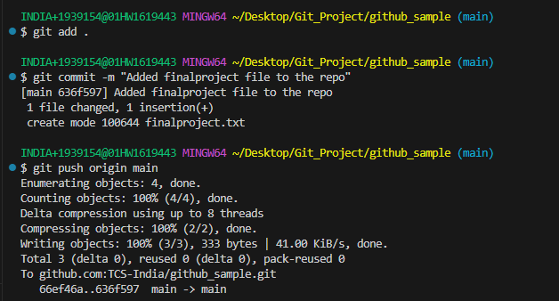

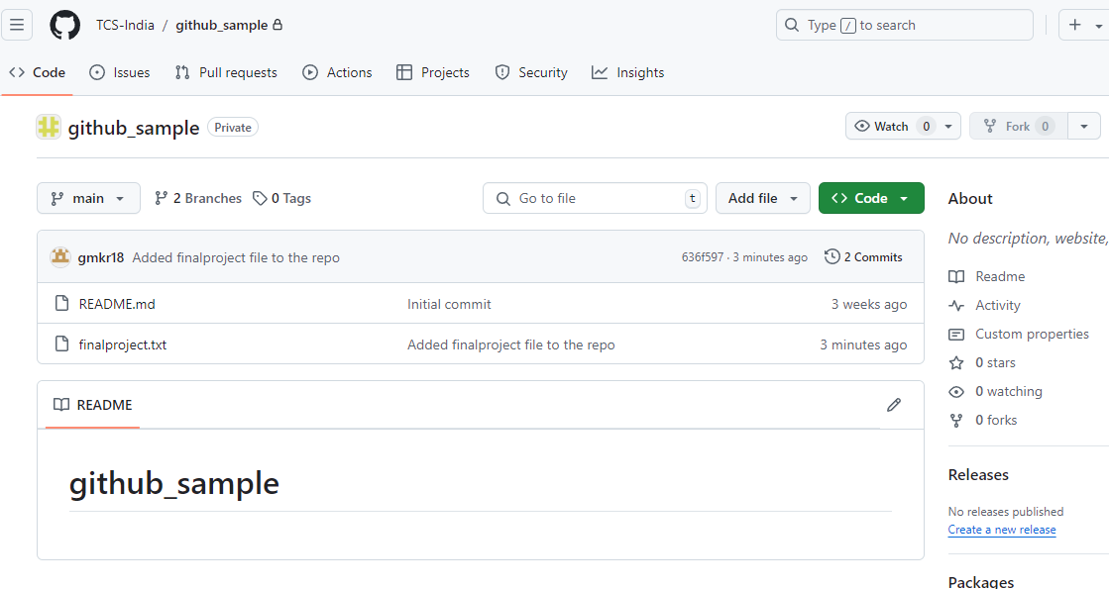

4. Cloned the other project

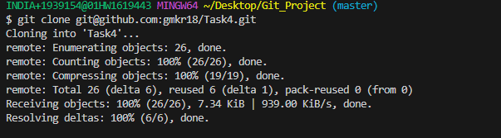

Modified and pushed it to master

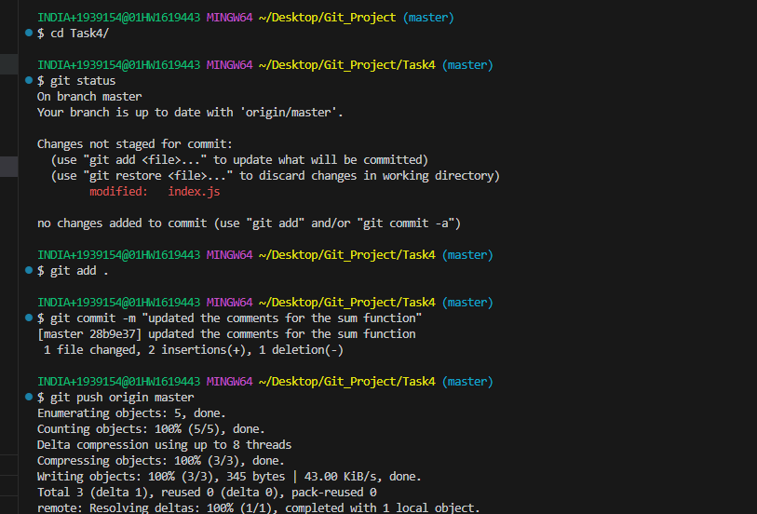

5. Adding the collaborators in the GitHub for the repository

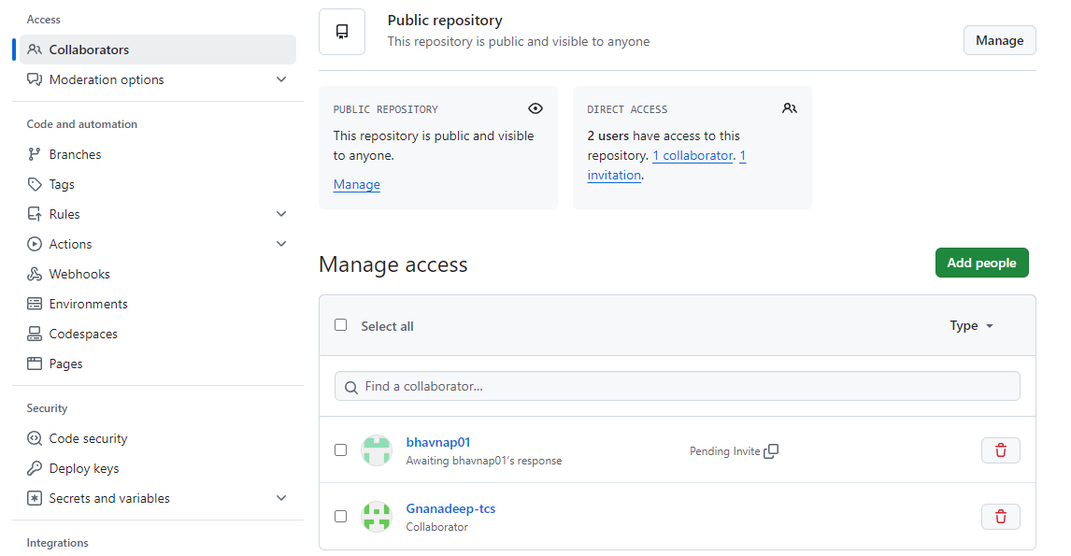

6. Merging the changes with owner branch

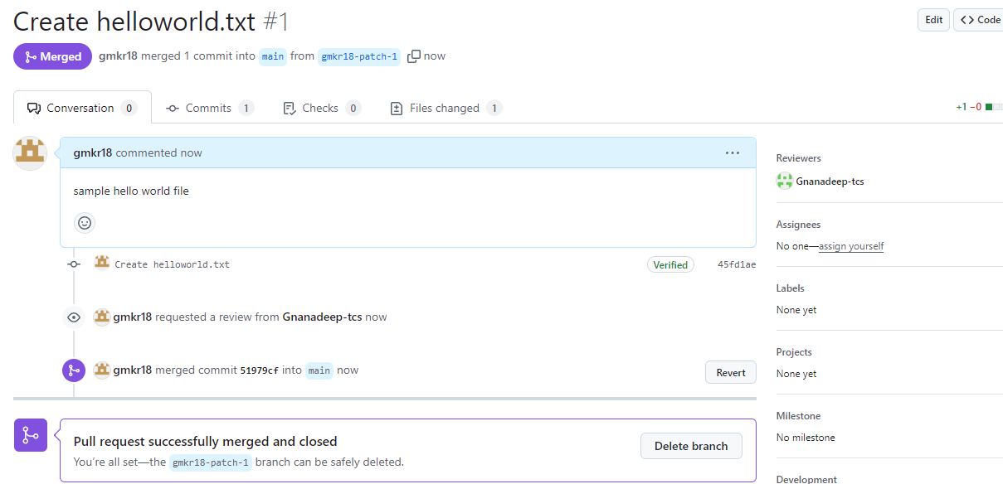

7. Fixing merge conflicts

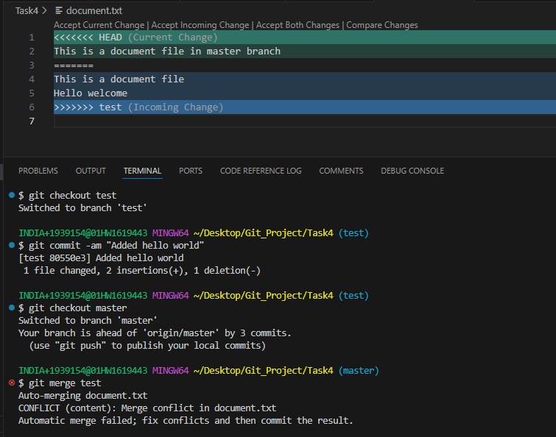

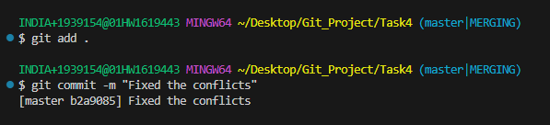

8. Issue tracking by implementing the new features

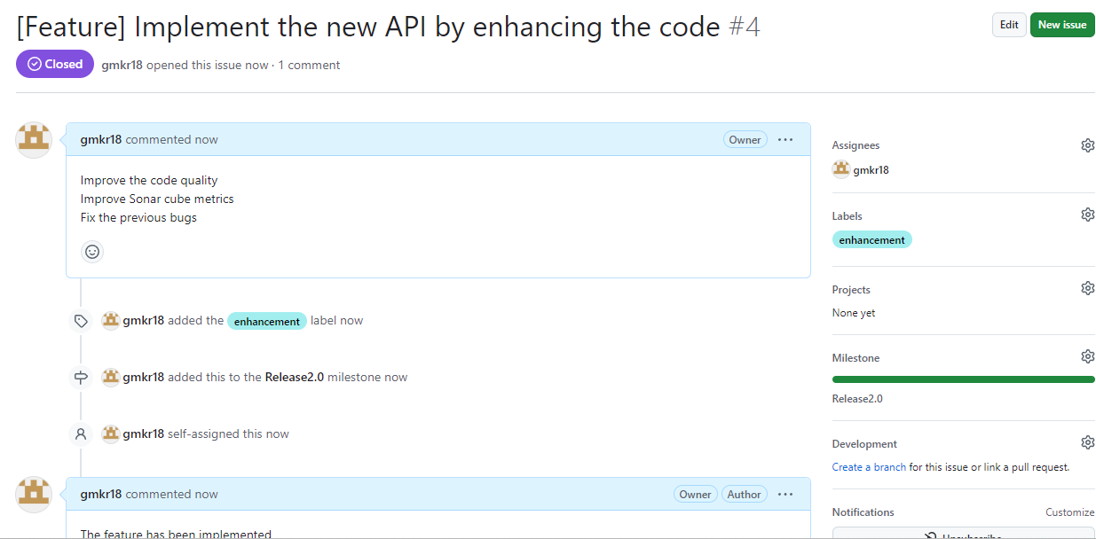

9. Creating and accepting pull request

