Learn reversing list in between and also understand the recursion of reverse function.
https://leetcode.com/problems/linked-list-random-node/

Basic maths:
Extraction of digits:
7789 9,8,7,7
7789%10 9
7789/10 778
Number of divisors:
36 1,2,3,4,6,9,12,18, 36
If we loop from 1 to 36 the TC will be O(N)
NOTE:
1 36
2 18
3 12
4 9
6 6
6 = square root (36), even If we loop till the square root of N we can get all the divisors.
Loop : i*i <= N
If(N%1 == 0){
List.add(1);
List.add(N/1);
}
Prime number : 1 and itself are the only divisors.
23 : is this a prime?
Loop till the square root of 23.
Greatest Common Divider | Highest Common Factor.
N1 = 9
Factors : 1,3,9
N2 = 12
Factors : 1,2,3,4,6,12
Common factors/dividers 1,3
HCF/GCD = 3

GCD (20,40) 20
For given number, one of them can also be a GCD.
Start the loop from 20(lowest number in the given numbers) till 1
Divide all the numbers by 20 to 1 when ever a number divides all the numbers perfectly that is the GCD and break out from loop.
In this case the Worst case scenario would be O(N1 or N2).
So use Equilateral Algorithm:
GCD(N1,N2) == GCD(N1-N2,N2) if N1 > N2
GCD(20,15) Math.max(20,15)
GCD(20-15,15) GCD(5,15) Mah.max(5,15)
GCD(15-5,5) GCD(10,5) Math.max(10,5)
GCD(10-5,5) GCD(5,5) Math.max(5,5)
GCD(5-5,5) GCD(0,5) The moment any one number becomes
Even better solution
GCD(N1,N2) == GCD(N1%N2,N2) where N1 > N2
GCD(20,15) (20%15,15) (5,15) (15%5,5) (0,5) GCD = 5
GCD(27,13) (27%13,13) (1,13) (13%1,1) (0,1) GCD = 1
Power exponentiation:
2 ^5 = 2*2*2*2*2
x =2
n =5
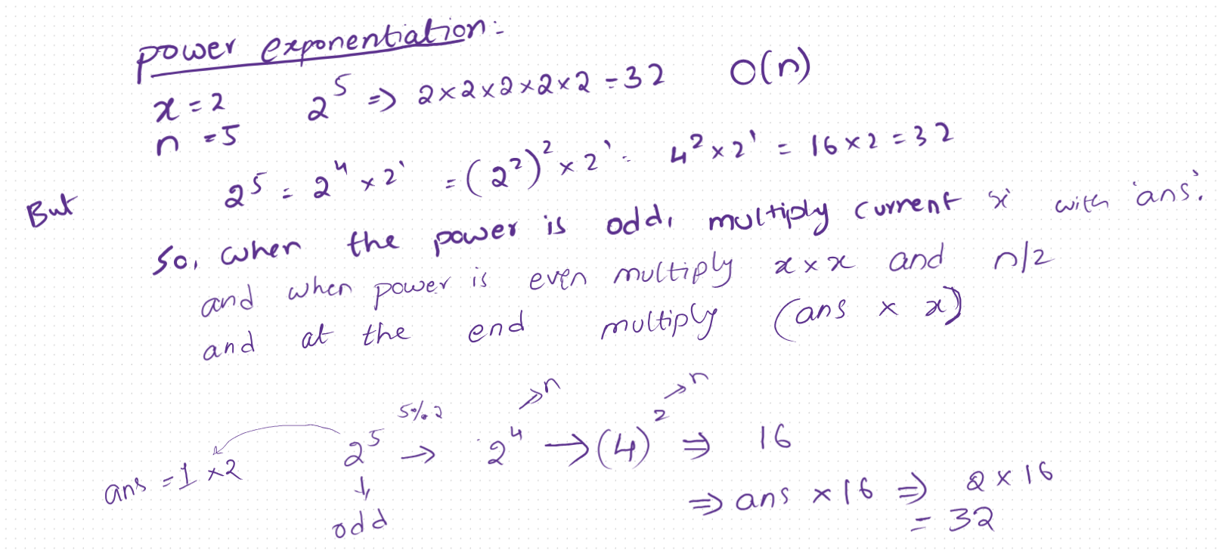

Stack :
LIFO : Last in first out
Push(x) : insert into stack
Pop() : pop the last inserted element
Top() : shows the first element
Size() : gets the size();
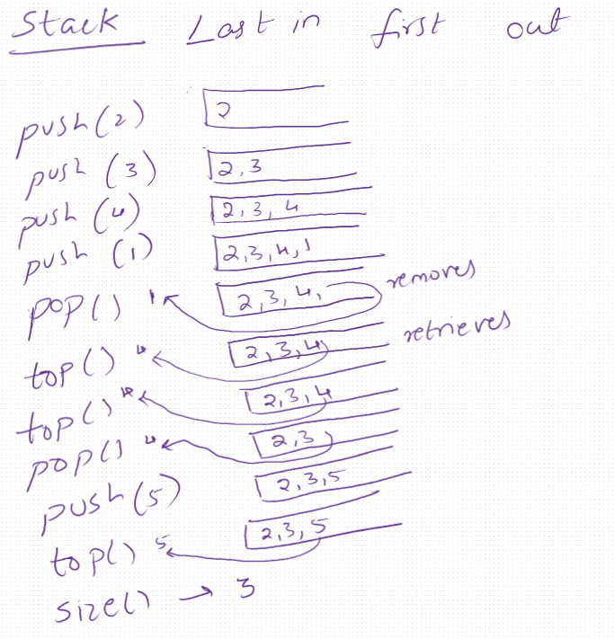
***Important : may ask in interview:
Implementation a stack using array.

Queue:
FIFO : First in first out
Push(x) - inserts
Top() – retrieves firstly added element.
Pop() – removes firstly added element
Size()
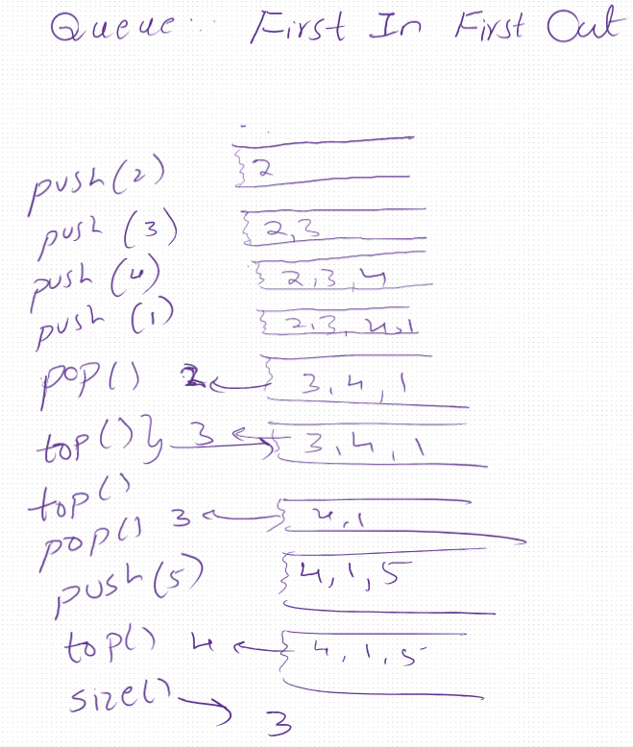

Sliding window and two pointers:
NOTE : Remember, when we are not sure about how to move ‘l’ or ‘r’ in a problem statement to find out the number of subarrays with some condition like K == in this case we can simply find the sub arrays which are <=k and <=k-1 and subtract (<=k) – (<=k-1) to get the ==k sub arrays.
Remember to have a condition if( k < 0) return 0;

Max consicutives of 0ne’s
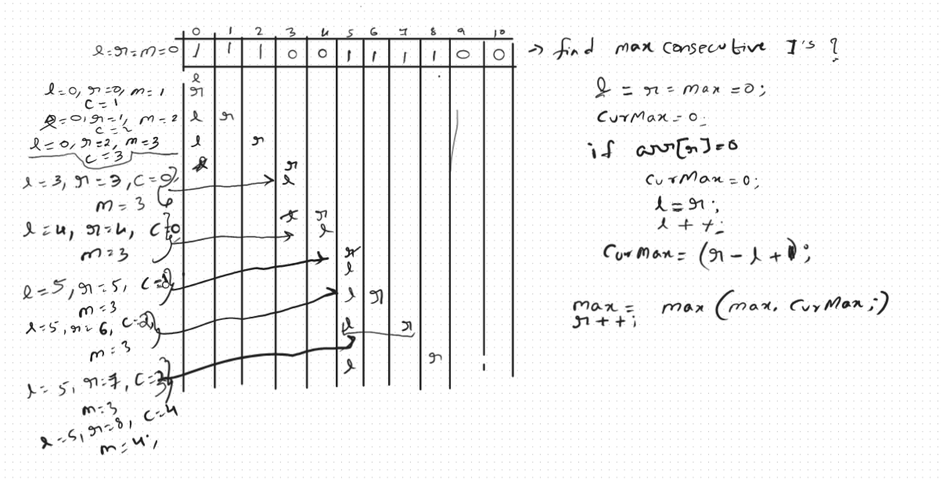
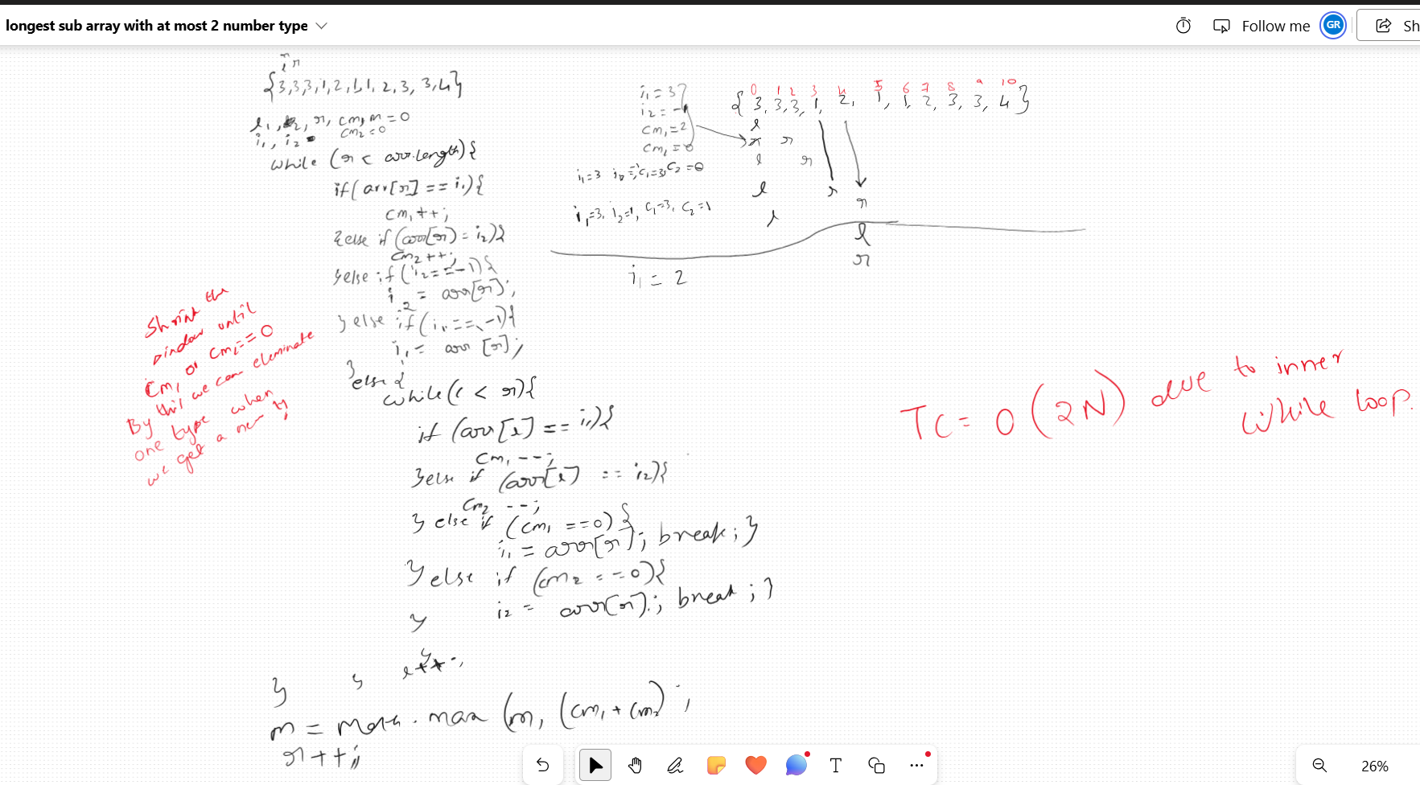

Prefix sum : to find out number of sub arrays with sum k:
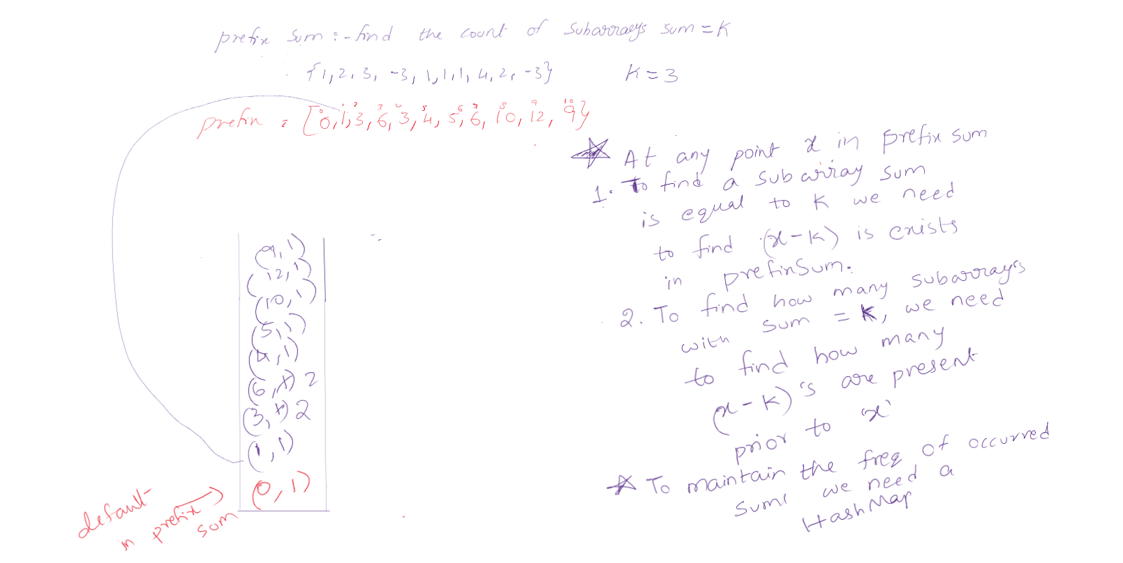

Reverse a linked list
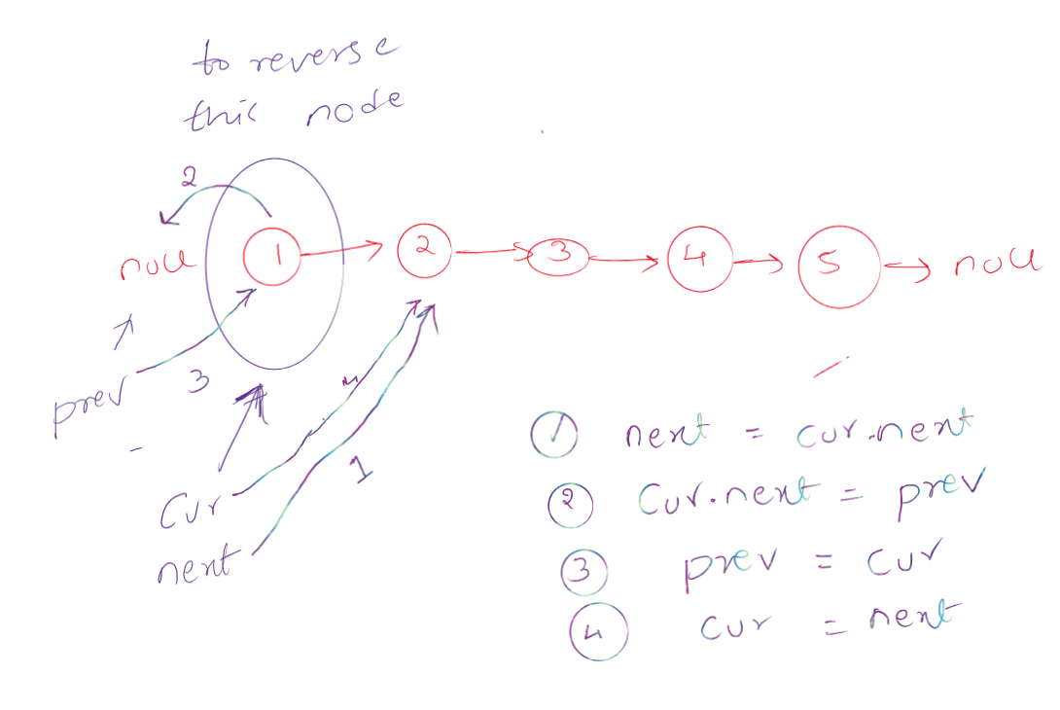

Middle of the list
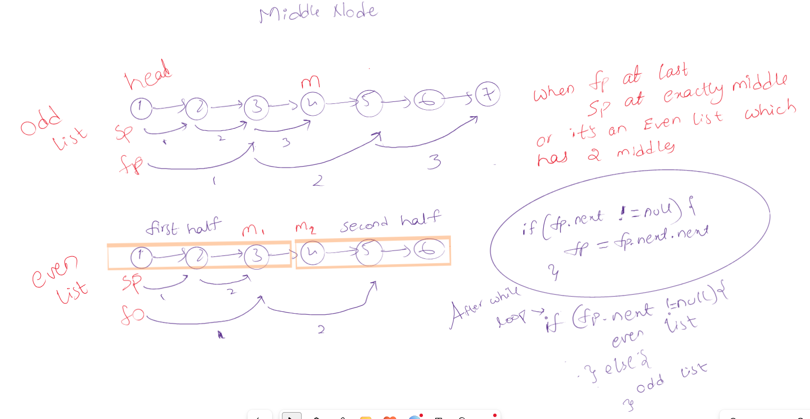

Y intersection between 2 linked lists
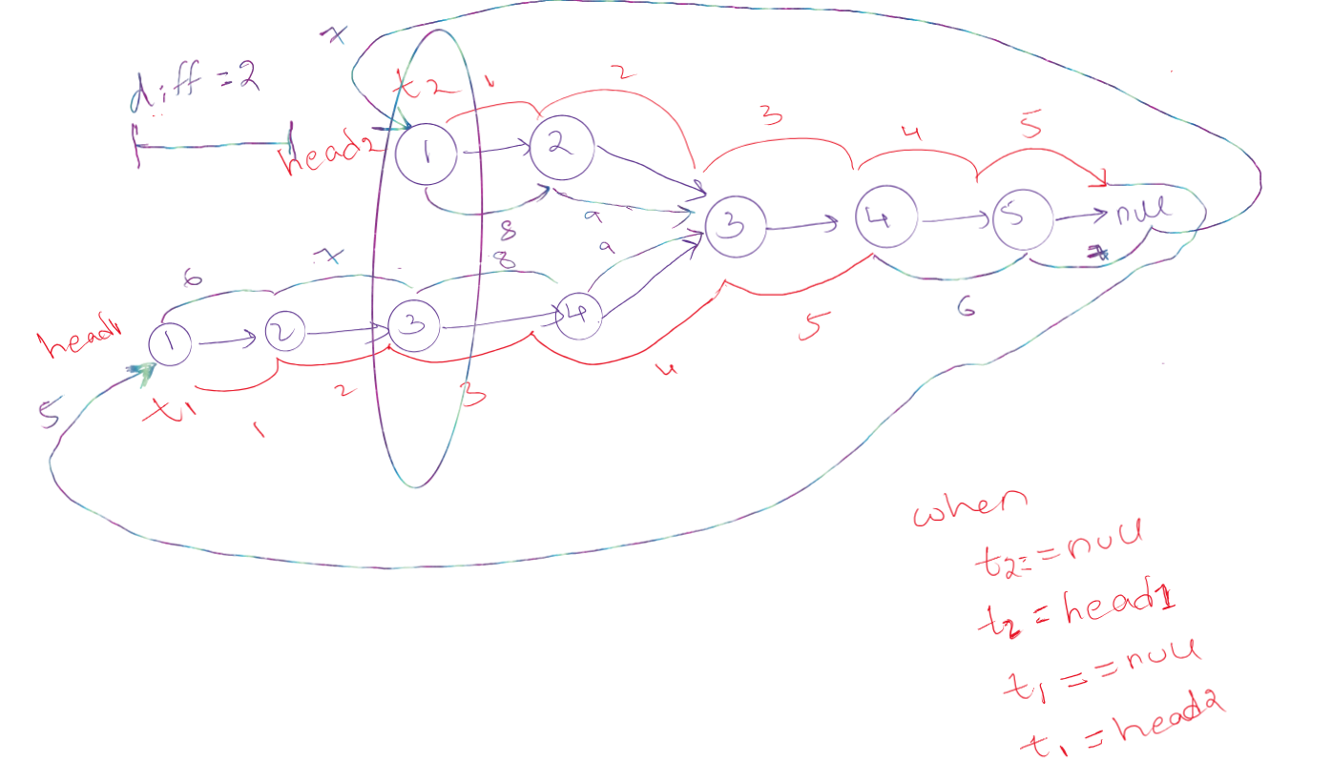
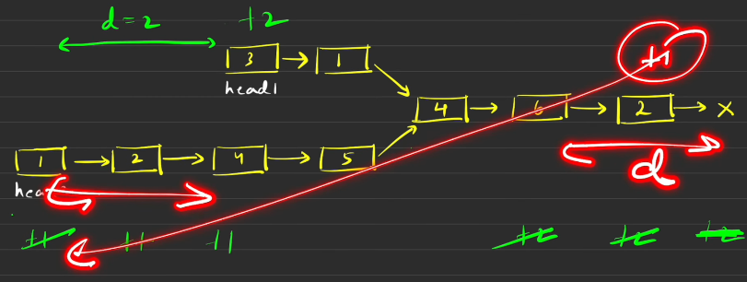

Find the starting of cycle list
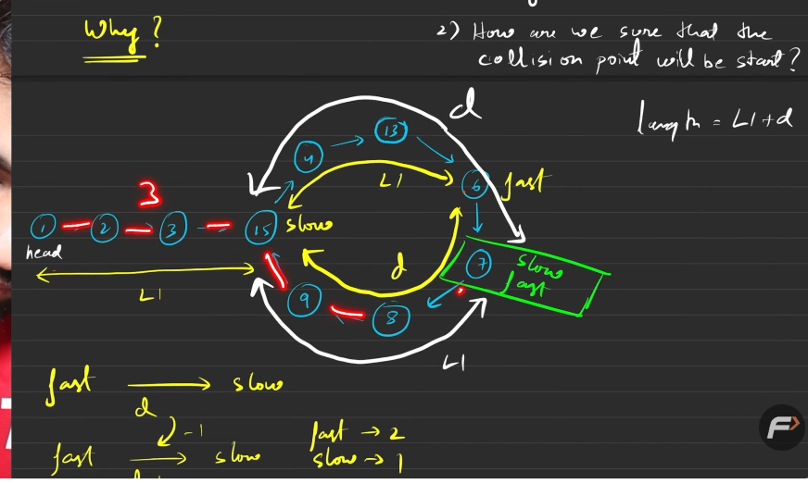
Assume that sp moved 3 steps (points to the beginning of the loop, just assume)
Then fp will move sp*2 steps => 3*2 =>6
Think that sp distance from head is L1
Then fp will be 2 * L1. But from the loop it will be L1
Once sp enters the loop:
The distance between fp sp is D
And every loop fp is nearing to sp by 2 steps, and sp is running away by 1 step.
So the distance reduced between them is
(D – 2 +1) i.e fp is trying to reach sp by 2 so reducing the distance by 2 and sp is running away by 1 so +1 (D-1)
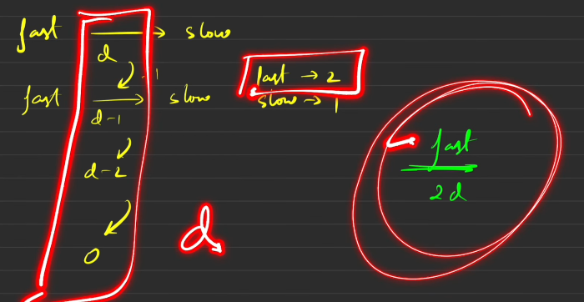
The net distance covered by fp is D ,D-1, D-2,D-3 ….0 so D
And each tiem 2 steps so D*2 2D steps
Sp would have taken D steps
After sp enters the loop it has covered D steps and fp covered 2D steps.
The length of the loop is L1 + D
Now, The distance between starting of the loop to Collison point is D.
So from Collison point to starting point of the loop is L1
So to find exact cycle starting point
Start sp from head again
Fp from there itsel but only one step move.
When they meet at one point that will be the start of the cycle

Flattening a multilevel double linked list
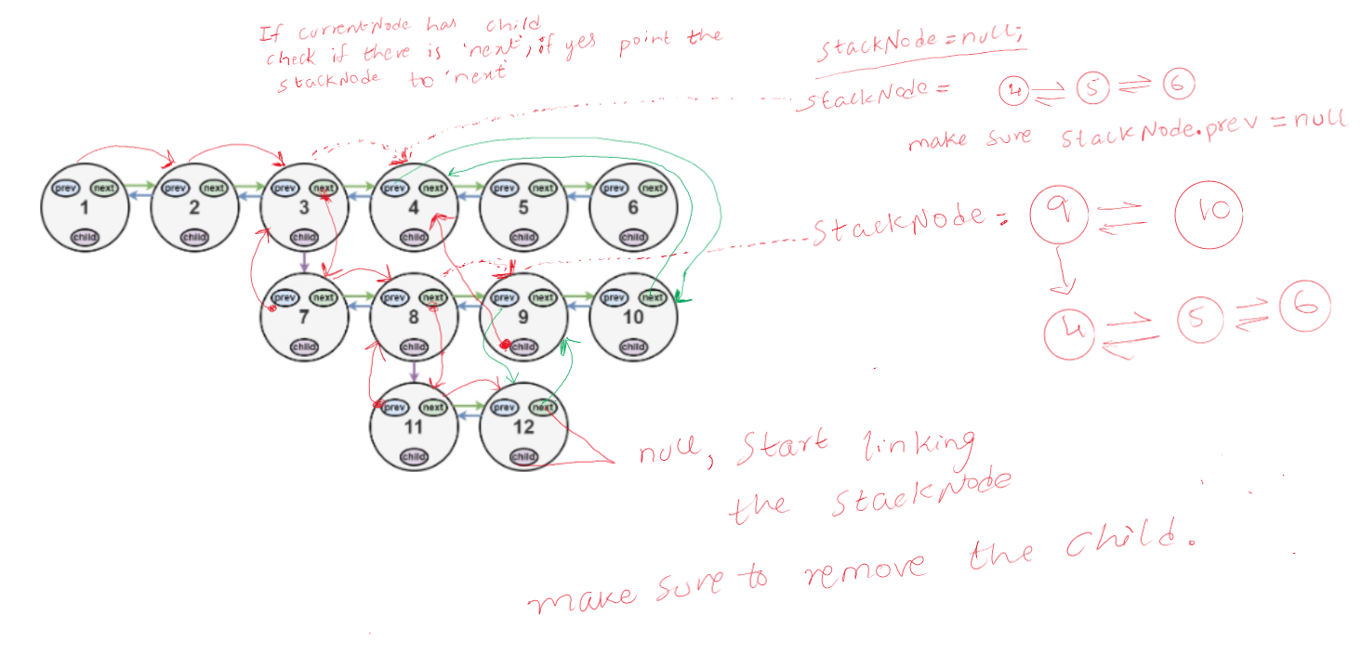
Copy list with random pointers
