System design:
Design patterns:
3 types.
- Creational design patterns:
  - How will the object be created.
  - How many objects to be created.
    - Singleton
    - Builder
    - Factory
      - Simple factory
      - Abstract factory
      - Practical factory
    - Prototype and registry.
- Structural design pattern:
  - How will a class be structured.
  - what attributes will be present in the class.
  - How will classes interact with each other.
    - Adaptor
    - Façade
    - Decorator
    - Flyweight
- Behavioural design patter:
  - How your code will perform actions.
    - Strategy
    - Observer.
Study steps of each DP:
- Definition
- Problem statement
- How to solve
- Pros and cons
Singleton Design patter:
Def : allow a class to create only one object.
Why do we want?
- Take DB connection class as example, one db connection object can have 10 connections which is what db can process at same time, but if we create multiple db connection objects, however the db still allows only 10 connections at a time so other connections will be waiting for db connections. In this scenario we are wasting the resources.
Solution this his problem :
- Make the db connection class have only one object.
- Singleton for logger, because we store in one file, creating multiple logger objects is waste of resources.
- In any cases where shared resources are used, we use singleton.
***obj creation is expensive performance and memory
Implementation :
- Restrict access to constructor.
  - Private constructor.
- Create a public method to access the constructor.
- Since we don’t have an obj, make a static method that return the singleton obj.
- Check if obj is created.
  - Private attribute.
Class Sinlgeton{
Private static Singleton obj;
Private Singleton(){
}
Public static getSingleton(){
If(obj == null){
Obj = new Singleton();
}
Return obj;
}
}

Singleton for concurrent:
- If we are suing singleton in multithread application, there is a chance of creating multiple objects by multiple threads.
Sol 1: eager loading:
- Create a singleton object as soon as the class is loaded.
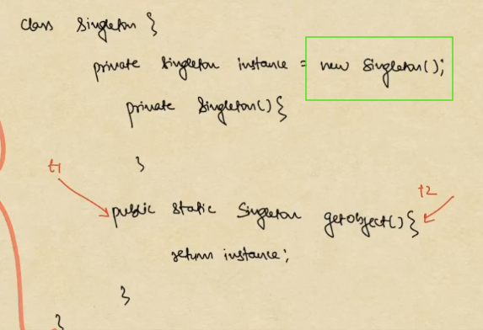
Cons of sol1:
- If we have many such classes, our application start time will increase.
- Obj remain even if we don’t use it ever.
Slo2 : synchronized:
- Make getSingleton() method synchronize.
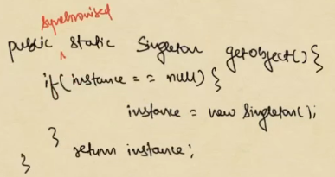
Problem with synchronize:
- Synchronize decreases performance.
- ***Synchronization is not required once the object is created. So we have to ally synchronization only when the object is not created.
Actual solution: Double Check Locking:
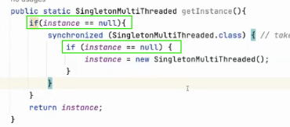
- We have to use synchronized block to create first object and double check if the instance is created inside the synchronized block because, if 2 threads enters into if block in the very first time, even though only one thread acquires lock at a time and create singleton instance, the second thread is waiting to acquire the lock and it will also create another instance which is wrong in singleton design pattern. So an extra null check is required.
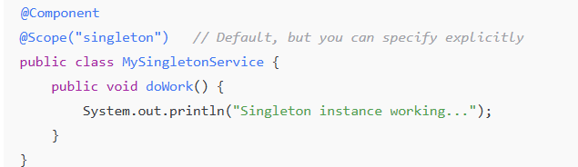

Builder design pattern: creational pattern.
Def: a design pattern helps us to validate data using a Helper or Builder class before creating actual object.
- Builder helps to create objects for a class.
Let’s assume that we have a class with a lot of attributes maybe 20 attributes.
- We can initialize them using constructor
- We can initialize them using setter methods.
Let’s assume we are polling data from database or UI and some data is invalid.
- Fetch form DB/ data from UI.
- Create an object.
- Validate the object. // if object is invalid, then the first 2 steps are invalid and object creation is expensive.
- Decide to use/send or not.
What if we validate the data before object is created?
- This is what builder design pattern.
** validate all attributes of the object before creating the object.
Validate for student:
- Grade year > 2022
- Ph.no must be valid.
- Age >22
- And more validation.
**No student obj should be created until all the validations become true.
Problem statements:
- If we have a lot of attributes, we end up creating a long constructor and it will be difficult to remember the order when creating an object.
- If some attributes can be nullable, then we might end up with a lot of constructors leading to less maintainable / readable code.


Solution1:
- Constructor that accepts a Map<String,Object> and validate all attributes in the constructor and assign to obj attributes.
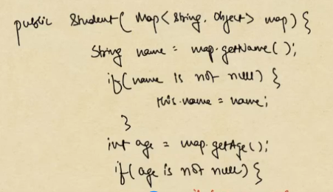

- Map can solve writing multiple constructors and values can be null.
- We can use attributes names as key to fetch the values from map.
- We can validate the data before creating the object.
But there are 2 problems using Map:
- Upcasting loss
  - We are using Object as value type in Map which is an upcasting loss.
- Object inside constructor.
  - Down casting is an extra work for the system.
  - And important thing is that the object will be created as soon as the process enters the constructor and deletes if any exception occurs. We don’t want object before validation.
What we need?
- We need something like a map that can hold the data before we create the actual object.
- It should have properties:
  - Values may or may not be null.
  - Values can be identified by attribute names.
  - Should not use upcasting/down casting.
  - Should not call construction of main class before validation.
In builder pattern we create another class that is called as Helper class.
Class Builder{
Name
Age
Email
phNo
}
With this we can do all the validations before creating an actual object.
- Here the setter method returns Builder instead of void
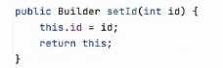
- Create a void validate() method to validate all attributes. Throw exception if invalid.
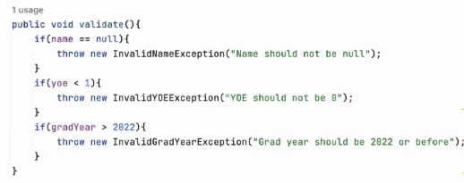
- Create a method called Student build(). which validates and creates Student object.
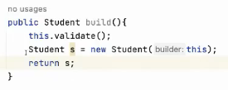
- In Student class create a constructor with Builder as argument.
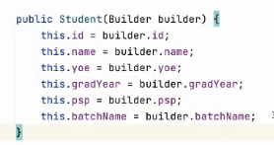
NOTE :Add Builder class as a nested static class inside the Student class. This way we are not writing new class outside Student class.
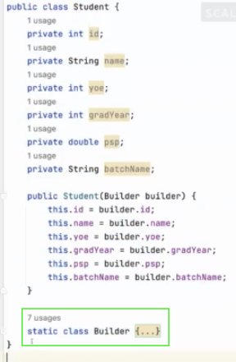
- We create a static Builder builder() method to return Builder object. Its static because we want to create it before creating Student object.
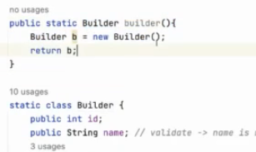
- Now, create the Student object using builder object.
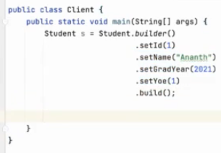
Advantage:
- Much readable code.
- Builder can validate before creating Student object.
- We can make Student constructor private so only through Builder we can create object only after validation is true.
Annotation based
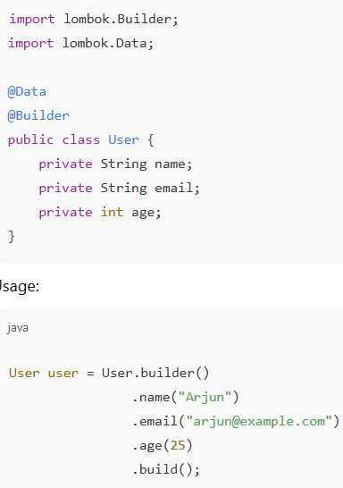
Prototype design pattern:
Def: often times there are scenarios where we don’t want to create object from scratch, rather we prefer creating a copy from the template and changing the values from that.
Problem statement :
- Given an object of a class and we need to create multiple deep copies(creating new objects with attribute values) of it.
Approach 1:
- Copy each attribute from existing object and put in new project.
- Cons:
  - Client needs know all the attributes.
  - Student might have some private attributes which are inaccessible to client.
  - Very lengthy code.
Copy constructor:
Class Student{
Name
Age
Public Student(Student st){
This.name=st.name;
This.age=st.age;
}
}
Main(){
Student st = new Student(“name”,10);
Student stCopy = new Student(st);
}
Cons:
- If we assign IntelligentStudent object to Student reference.
Main(){
Student st = new IntelligentStudent(“name”,10);
Student stCopy = new Student(st);
}
- Here, we tried to copy IntelligentStudent object using Student constructor, since IntelligentStudent has extra attributes than Student, those data will be lost.
- So, use instanceof to find the object type and use appropriate constructors.

Main(){
Student st = new IntelligentStudent(“name”,10);
If(st instanceof Student){
Student stCopy = new Student(st);
}else{
Student stCopy = new IntelligentStudent(st);
}
}

- But the above approach is a violation of 2 principle of SOLID.
  - Open and close principle : in future if we add AverageStudent class then we must add extra condition for AverageStudent.
  - Single responsibility principle : all checks are present in client.
Note:
- If a client wants to create a copy of an object, the logic should not be present in client.
- Ideal solution can be that the copying logic should be outsourced to the object itself.
Student st = new Student();
Student stCopy = st.copy()
  - Benefits :
    - No tight coupling between the Client and Object class.
    - No violation of any SOLID principles.
Class Student{
Name
Age
Copy(){
Student st = new Student();
St.name=this.name;
St.age=this.age;
Return st;
}
}
- Class IntelligentStudent extends Student{
Iq
Copy(){
IntelligentStudent st = new IntelligentStudent();
St.name=this.name;
St.age=this.age;
St.iq=this.iq;
Return st;
}
}
** make sure that all child objects of student should override the copy method.
Again, prototype explanation:
**Often there are scenarios where we create one object and keep copying it and with minimal updates use the copied values.
Example :
- We send a request to google.
  - SearchAPICall object
    - url
    - location
    - device
    - authTokem
    - searchQuery
Way 1:
- Every time we make a Search request, we create SearchAPICall object and fill all the details.
Majority of the times url, location, device and authtoken will be same. Searchquery will be changing.
Way 2:
- Get the copy of the SearchAPICall object and change the searchQuery of that copy object.
Main(){
SearchAPICall searchAPICallProTy = getSearchCallPrototype();
searchAPICall = searchAPICallProty.copy();
searchAPICall.searchQuery = “”;
}
Way2 is much better than way1
Note: we can use Cloneable and clone() to create copies of an object.
Spring boot:
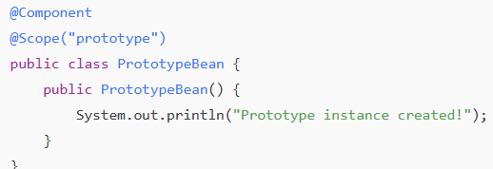

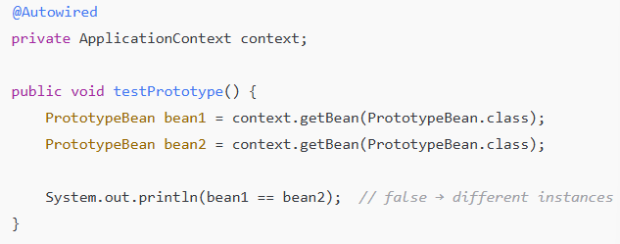
Registry design pattern:
Def: A collection of prototypes in a Map is called Registry.
It is a hash map where we maintain different types of prototypes.
- We cannot create a prototype for all students of an institute.
- Can we create multiple prototypes. A prototype for each batch.
- Let’s assume that we have 50 prototypes.
  - Maintaining so many prototypes would become a big problem.
  - To maintain our prototypes, we use Registry.
Class StudentRegistry{
Map<String, Student> map;
Register(String key, Student student){}
Get(String key){}
}
Create Registry:
- Identify the class for which we want prototypes.
- Create a copy() method in that class.
- Create a class called ________Registry.class having a Map<String, ClassName>
- It should have 2 methods get() and register()
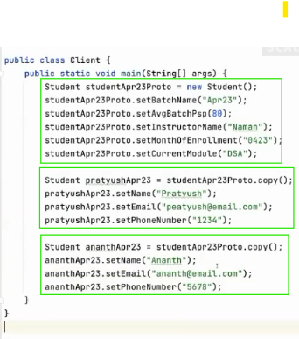
- We have studentApr23Proto prototype;
- Using this prototype copy we have created 2 more object, pratyushApr23 and ananthApr23 but the common fields are already present because we have copied the prototype.
Now, if we want to create multiple such prototypes like studentApr23Proto, studentMay23Proto, studnetJune23Proto etc. we need to create StudentRegistry class.
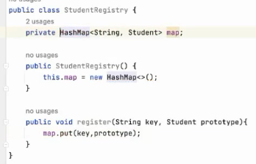
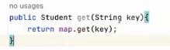

Now we can start registering prototypes in registry.
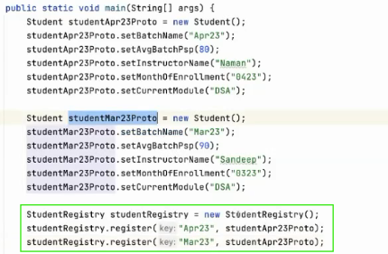
Now we can get specific prototype from the registry and call the copy method to get copy of that prototype and use it.
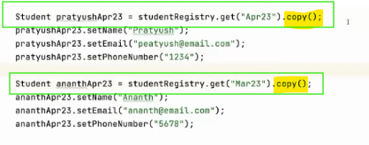
Factory design patterns:
Def:
- Factory method
- Abstract factory
- Practical factory -> not present in Gang of four or anywhere. But this like actual implementation of factory pattern, production level implementation.
Factory method:
- Methods whose only task is to create an object are called Factory methods.
- Let’s say we have UserService.
  - If Database was a class, dependency inversion principle(two classes should be dependent on each other directly) would get violated.
  - We would want database to be an interface/abstract class so that in future if we want to change DB we can change easily.
- <<Database>> interface
  - createQuery():Query
  - connect(): Boolean
  - setPoolsize(): void
- Database have multiple implementations:
  - MySql, Postgres, MongoDB, MsSql.
- <<Query>> interface : Query is not same for all implementations because we have SQL and NoSQL.
- The implementations maybe different, but for the end user, it should look same for all types of DB.
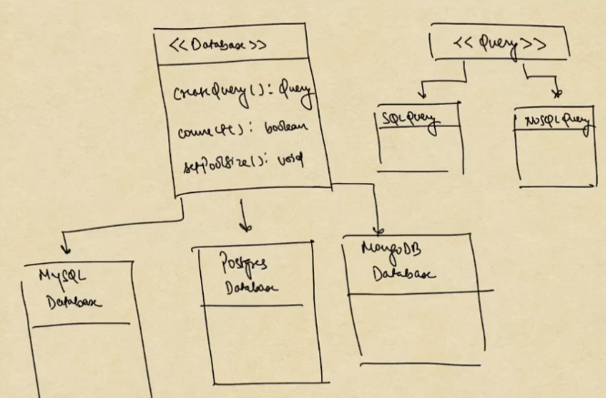
If we have interface, method names and return types are already defined, the implementation classes must implement accordingly.
Take Database.createQuery():Query
- The purpose of createQuery method is to return a Query object corresponding to the query we provide.
- It does not have other responsibilities than creating query.
Example:
OrderService{
Order placeOrder(){
checkinventory();
checkpaymentstatus();
checkpincode()
return createOrder();//inside placeOrder method we have multiple method calls and at last we have createOrder method call.
}
}
createOrder() is the factory method, because its only responsibility is to create Order objects.
<<Order>> interface
- PriorityOrder
- NormalOrder
Let’s see <<Database>>
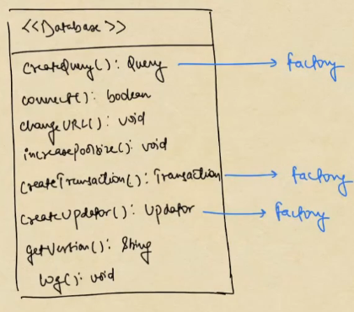
Database responsibilities:
- Holds all methods required for DB connect, updating config and logging.
- Also holds all the factory methods for creating objects.
Database is violating the Singel Responsibility Principle. If it is named as Database, it should only do database operations like connect to db, execute queries, set connection pools but it also does object creations like createQuery{}, createTransaction(), createUpdato() which violates the SRP. So, it should not be creating multiple objects.
In this case we can create Abstract Factory
- To fix the Database SRP violation issue, we will divide it into 2 classes.
  - To have attributes
  - To have all the factory methods.

<<Database>> and <<DatabaseFactory>>
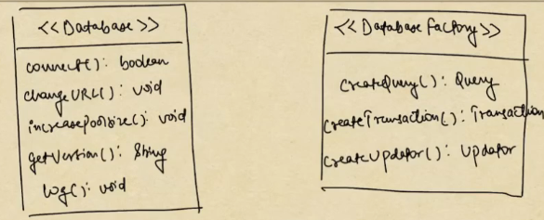
- Database interface has methods specific for DB
Abstract Factory: collection of abstract factory methods .
- DatabaseFactory has abstract factory methods, so this is an Abstract Factory of Database.
Factory methods: the methods that are implemented in classes are Factory methods.
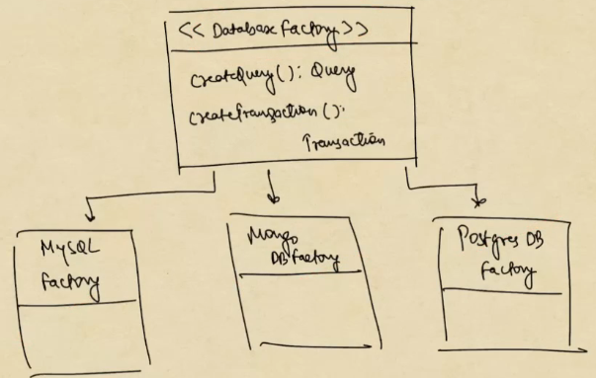
- We applied Interface Segregation Principle.
Practical factory:
- Basically, there are 2 developments
  - Cross platform app development
  - Hybrid development.
- Mobile apps :
  - Native:
    - Android
    - IOS
  - Hybrid/cross platform: develop in one format and deploy on Android and IOS.
    - Flutter
    - Reat native
Assume that we have created a cross platform app that has button functionality.
- At the build time based on what we are building i.e., Android build or IOS build we should create the button.
- It may look like this
Class Flutter{
createButton{
if(platform== android){
createAndroidButton();
}else{
createIOSButton();
}
}
}
- This violates OCP because in future if we want to support for Windows we need to add extra condition.
<<UIFactory>>
createButton();
createMenu();
createDropdown();
- AndroidUIFactory
- IOSUIFactory
In future if we want to implement the code for Windows
- WindowsUIFactory.
Now Flutter class holds config related things, all creation methods are in UIFactory interface.
Now user has to remember all the classes like the Factory interface where we get all the creation methods and Flutter class where we get config properties.
NOTE : User should not remember multiple classes.
- User should only know Flutter, not UIFactory and any other interfaces.
- So, we add createUIFactory() method to Flutter, when user calls this method they get either of the AndroidUIFactory or IOSFactory object.
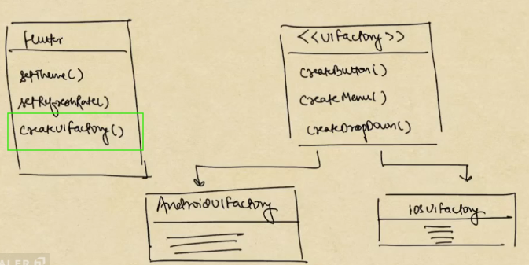
Code example:
Abstract Factory methods:
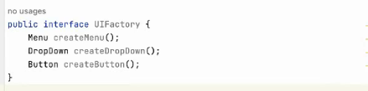
Factory Methods
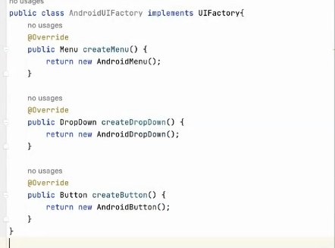
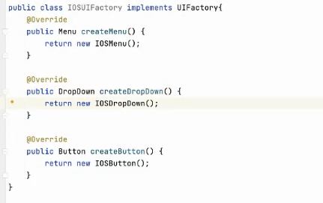
Practical Factory: create an object of Factory.
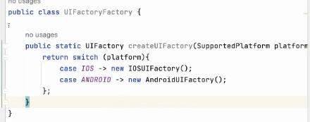
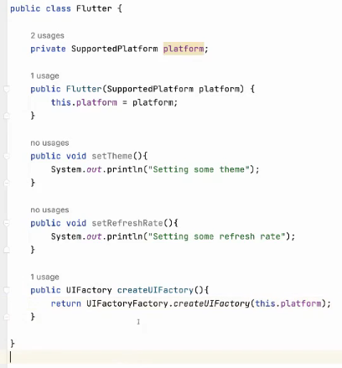
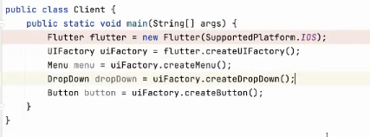
Structural Design pattern: talks about structure of the code
Adaptor Design pattern:
Def: intermediary layer that transforms one form to another.
- Adapter design pattern ensures bifurcation between our codebase and 3rd party components and keeps the coupling loose, so that our codebase remains easily maintainable.
Assume apple wants to support all types of ports:
  - HDMI
  - USB A
  - Ethernet
- They would be required to write supporting code for each port in their platform.
- System becomes bulky / too much maintenance / expensive.
So Apple comes with only Type-C port, apple developers only need to talk to one type of port and the entire work done by other types of ports can be done by Type-C.

Software example:
- I am writing a software system and directly integrating with AWS SNS, suddenly Google is giving 50% discount since we have tightly coupled our system to AWS it will be a lot of work.
- If we maintain some sort of Adapter layer to integrate with any type of Cloud, it will be like our system talks to adapter and adapter talks to the Cloud. If we want to change the Cloud provider, we just change the adapter without touching our software system.
Problem statement:
- There should not be any tight coupling between our software system and any 3rd party library/system frameworks.
Steps:
- Our codebase should never talk to 3rd party components directly.
- When ever we are connecting to a 3rd party component, always use an interface.

Steps for using Adapter Design pattern:
- Don’t involve 3rd party component directly in our code where we have business logic.
- Whatever task we want to do with 3rd party component, create interface/methods for those actions.
- Create implementations of that interface respective to each 3rd component.
Let’s see Phonepe without Adapter:
- Using YesBankAPI directly in Phonepe service.
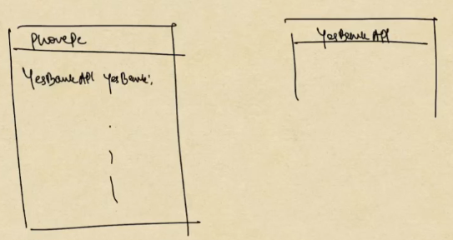
Phonepe with Adapter:
Create <<BankAPIAdapter>> and implement with YesBankAPI
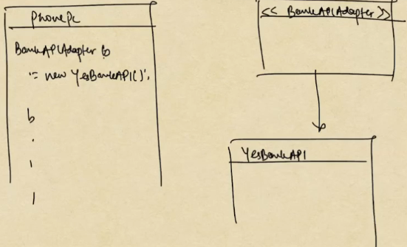

YesBankAPI
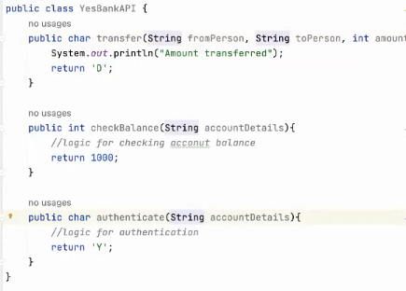
PhonePe : tight coupling YesBankAPI with PhonePe
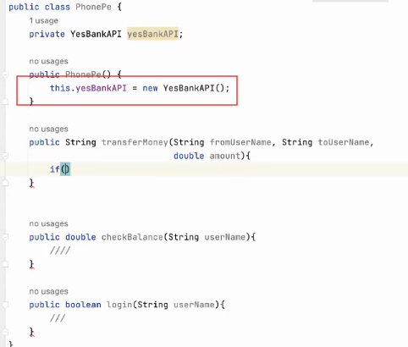
Probleme that may occur here is, suddenly YesBank can go down.
Let’s create ICICIBankAPI
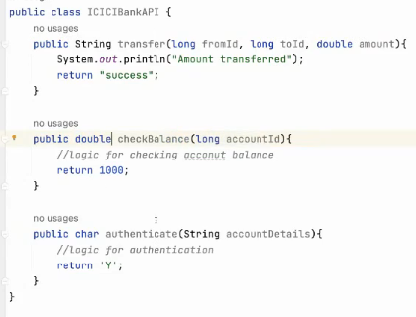
NOTE: If we observe some of the parameters datatypes are changed, so changing the YesBankAPI object wont be enough, argument types should also be changed. Which requires retesting the code.
Now create BankAPIAdapter interface.
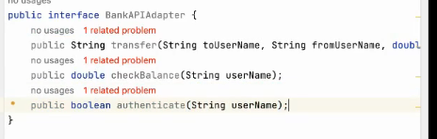
Now in PhonePe, instead of relying on YesBankAPI, we rely on BankAPIAdapter.
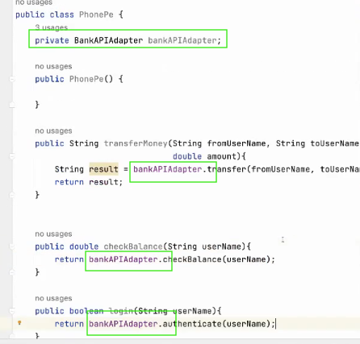
Create YesBankAdapter , this adapter acts as a bridge between YesBankAPI and PhonePe, which will not compromise YesBankAPI implementation, instead it just converts the implementation such that PhonePe can talk to YesBankAPI or any other abnks API in loosely coupled way.
The logic of conversion takes place in the implementation methos of BankAPIAdapter methods in the implementation class.
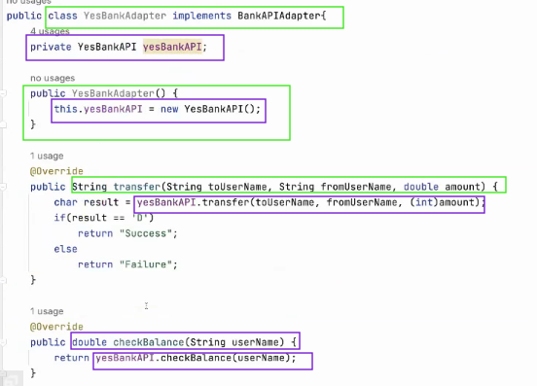
ICICIBankAdapter
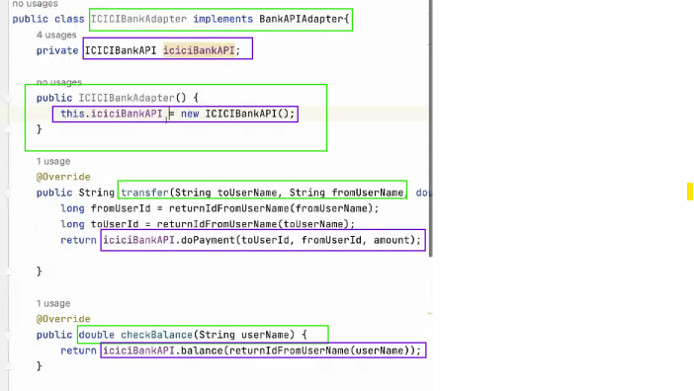
In PhonePe class, we can change the object and do not worry about any code change.

