Angular
- A component-based framework for building scalable web applications.
- including routing, forms management, client-server communication.
- A suite of developer tools to help you develop, build, test, and update your code.
Module in angular
In Angular, a module is a mechanism to organize and structure an Angular application.
consolidates components, services, directives, pipes, and other building blocks of an application.
Modules help in managing the complexity of large-scale applications by providing a way to organize and separate concerns.
NgModule :-
The @NgModule decorator is used to define and configure Angular modules. It takes a metadata object that specifies various details about the module, such as its components, services, directives, and more.
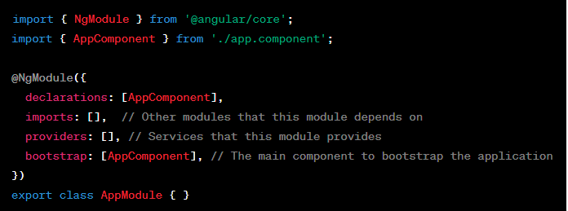
Declarations: The declarations array in the @NgModule decorator lists the components, directives, and pipes that belong to the module. These are the building blocks that the module encapsulates.
Imports: The imports array in the @NgModule decorator lists other modules that are imported by the current module.
Providers: The providers array in the @NgModule decorator lists the services that the module makes available for dependency injection. These services can be injected into components, directives, or other services within the module.
Bootstrap: The bootstrap property in the @NgModule decorator specifies the main component that should be bootstrapped when the application starts. This is typically the root component of the application.
Feature Modules: Angular applications can be organized into feature modules, which are modules that encapsulate functionality related to a specific feature or domain of the application. Feature modules can be imported into the main application module.
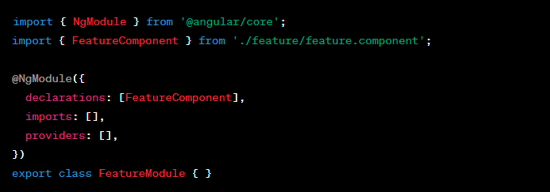
Shared Modules: Shared modules can be created to encapsulate and share common components, directives, and services across different parts of an application.
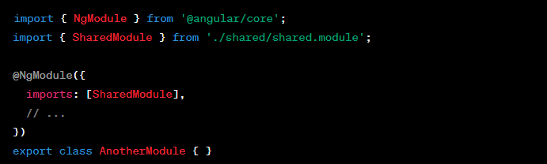
Components
Components are the fundamental building block for creating applications in Angular.
Angular aims to provide structure for organizing your project into manageable, well-organized parts with clear responsibilities so that your code is maintainable and scalable.
- An HTML template that declares what renders on the page
- A TypeScript class that defines behaviour
- A CSS selector that defines how the component is used in a template
- Optionally, CSS styles applied to the template
@Component - decorator is used to define a angular component.
Component encapsulate the logic and view of a specific part of the user interface.
import { Component } from '@angular/core';
@Component({
selector: 'app-example', // The component's selector (used in HTML)
templateUrl: './example.component.html', // The template file for the component's view
styleUrls: ['./example.component.css'] // The style files for the component's view
})
export class ExampleComponent {
// Component logic and properties go here
}
selector:
The selector property defines the HTML element tag that represents the component in the template. For example, if the selector is 'app-example', you can use <app-example></app-example> in your HTML to include this component.
templateUrl:
The templateUrl property specifies the external HTML file that defines the component's view. This is where you write the HTML structure for the component.
styleUrls:
The styleUrls property is an array of external style files (CSS, SCSS, etc.) that are applied to the component's view.
Component Lifecycle
- ngOnChanges: -
The ngOnChanges lifecycle hook in Angular is used when a data-bound property of a directive changes.
It is called whenever an input binding value changes. This hook receives a SimpleChanges object that contains information about the changed properties.
Called before ngOnInit() (if the component has bound inputs) and whenever one or more data-bound input properties change.
Purpose: Called when an input property of the component changes.
Use Case: Respond to changes in input properties.
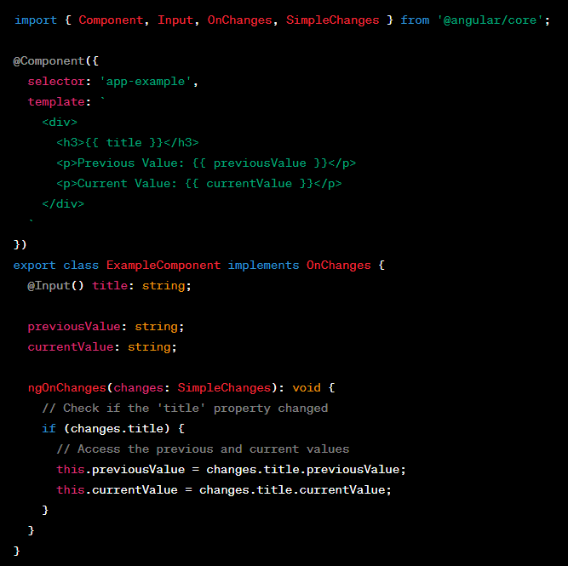
- ngOnInit
Purpose: Called once, after the component is initialized.
Use Case: Initialize data, make API calls, etc.
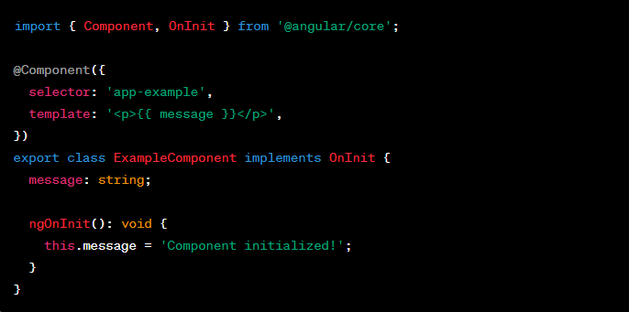
- ngDoCheck
Purpose: Called during every change detection run.
Use Case: Implement custom change detection logic.
Input Changes, Model Changes, Observable Changes, User Interaction, Asynchronous Operations
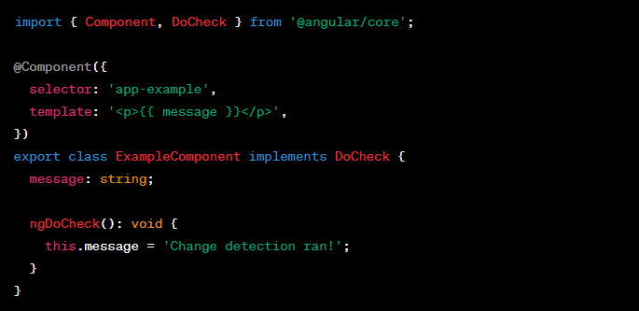
- ngAfterContentInit
Purpose: Called once after the component's content is initialized.
Use Case: Perform actions after content projection.
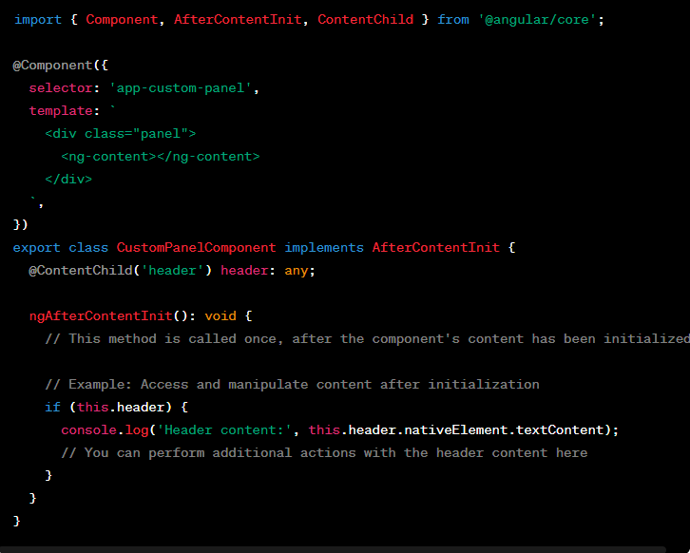
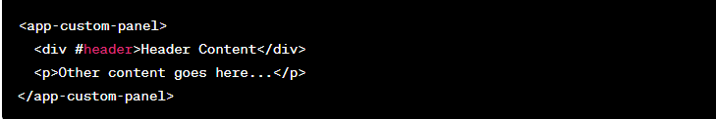
The CustomPanelComponent component has a <ng-content></ng-content> element in its template, allowing it to project content from its parent component.
The ngAfterContentInit lifecycle hook is implemented to perform actions after the content has been initialized.
Inside the ngAfterContentInit method, you can access and manipulate the projected content. In this case, it logs the text content of the header if it exists.
- ngAfterContentChecked
Purpose: Called after every check of the component's content.
Use Case: Perform actions after content projection changes.
This hook is useful when you want to perform actions or checks related to the content projected into the component using <ng-content>.
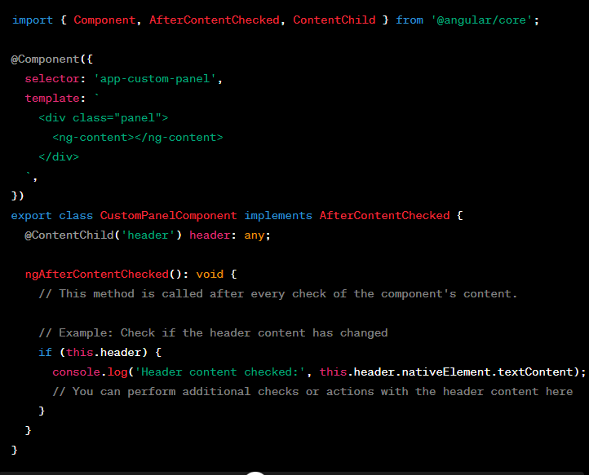
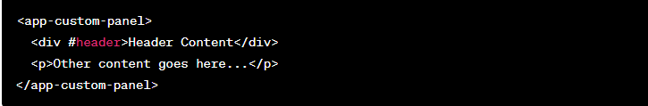
- The CustomPanelComponent component has a <ng-content></ng-content> element in its template, allowing it to project content from its parent component.
- The @ContentChild('header') decorator is used to query the projected content with a template reference variable named 'header'.
- The ngAfterContentChecked lifecycle hook is implemented to perform actions after every check of the component's content.
- Inside the ngAfterContentChecked method, you can check or perform actions related to the projected content. In this case, it logs the text content of the header if it exists.

- ngAfterViewInit
Purpose: Called once after the component's view is initialized.
Use Case: Perform actions after the view is rendered.
This hook is useful when you want to perform actions or operations that involve the component's view, such as accessing and manipulating the DOM elements.
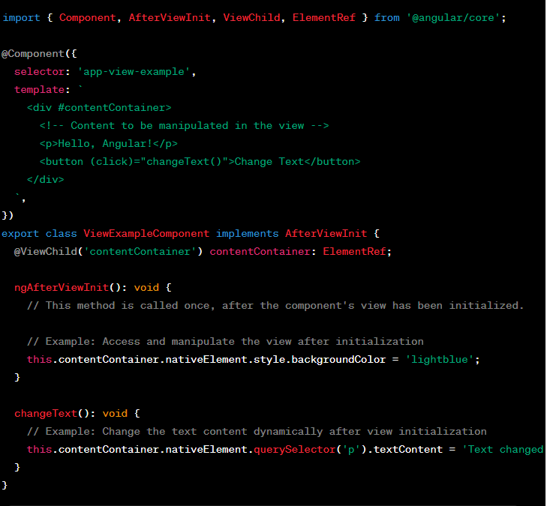
- The ViewExampleComponent component has a <div> with a template reference variable #contentContainer. The component uses @ViewChild('contentContainer') to query and get a reference to this div element.
- The component's template contains a paragraph (<p>) and a button. The button triggers the changeText() method when clicked.
- The ngAfterViewInit lifecycle hook is implemented to perform actions after the component's view has been initialized. In this case, it sets the background color of the contentContainer div to 'lightblue'.
- The changeText() method demonstrates how to dynamically change the text content of the paragraph after the view has been initialized.

- ngAfterViewChecked
Purpose: Called after every check of the component's view.
Use Case: Perform actions after the view is checked.
. This hook is useful when you want to perform actions or checks related to the component's view after each change detection cycle.
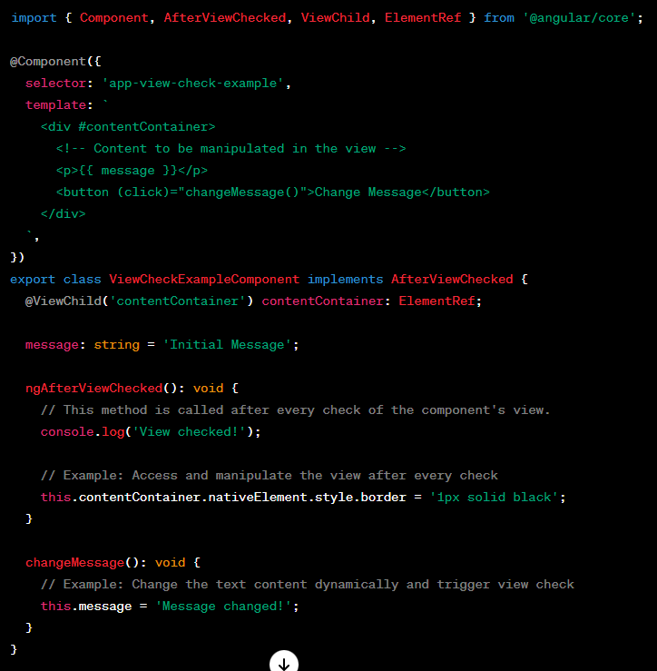
- The ViewCheckExampleComponent component has a <div> with a template reference variable #contentContainer. The component uses @ViewChild('contentContainer') to query and get a reference to this div element.
- The component's template contains a paragraph (<p>), a button, and a property message.
- The ngAfterViewChecked lifecycle hook is implemented to perform actions after every check of the component's view. In this case, it sets a black border around the contentContainer div after each view check.
- The changeMessage() method demonstrates how to dynamically change the text content of the paragraph and trigger a view check.

- ngOnDestroy
Purpose: Called just before the component is destroyed.
Use Case: Cleanup tasks, unsubscribe from observables, etc.
lifecycle hook in Angular is called just before a component is destroyed or removed from the DOM. This hook is commonly used to perform cleanup tasks, such as unsubscribing from observables, cancelling timers, or releasing resources.
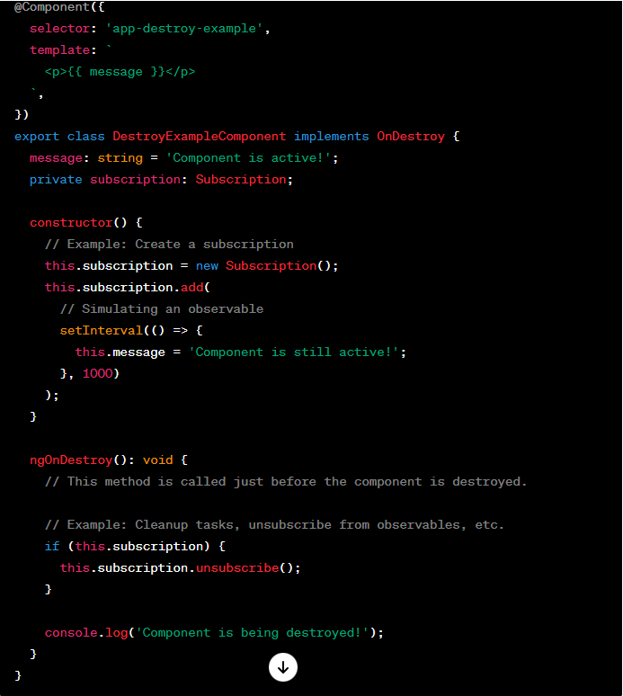
- The DestroyExampleComponent component has a property message that is initially set to 'Component is active!'.
- In the component's constructor, a subscription is created to a simulated observable using setInterval to update the message property every second.
- The ngOnDestroy lifecycle hook is implemented to perform cleanup tasks. In this case, it unsubscribes from the subscription to avoid memory leaks and logs a message to the console.

Directive
- Component Directive:-
Components are a type of directive with templates. They have their own view, encapsulate behaviour, and can be reused throughout the application.
- Attribute Directives:-
Attribute directives modify the appearance or behaviour of an element. They are applied to elements as attributes and typically manipulate the DOM or modify the behavior of components.
  - [ngStyle] The ngStyle directive is used for dynamically applying inline styles to HTML elements based on conditions or expressions.
ngStyle directive dynamically applies styles to the <div> element based on the values of textColor and fontSize. The styles will be updated whenever these values change.
  - [ngClass] The ngClass directive is used for dynamically applying CSS classes to HTML elements based on conditions or expressions.
ngClass directive applies the CSS classes 'active' and 'disabled' to the <div> element based on the values of isActive and isDisabled. Multiple classes can be applied based on different conditions.
  - [ ( ngModel ) ] - FormsModule The ngModel directive is used for two-way data binding. It binds an input, textarea, or select element to a property on the component, allowing changes in the view to update the model and vice versa.
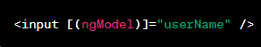
In this example, the value of the input field is bound to the userName property in the component. Any changes to the input field are reflected in the userName property, and vice versa.

- Structural Directives: -
Structural directives modify the structure of the DOM by adding, removing, or manipulating elements. They are responsible for managing the rendering of elements based on conditions.
  - *ngIf: - The ngIf directive is used for conditionally rendering or removing elements from the DOM based on the truthiness of an expression.
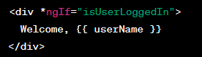
The <div> element is rendered only if isUserLoggedIn is true. If false, the element is removed from the DOM.
  - *ngFor: - The ngFor directive is used for iterating over a collection and rendering a template for each item.
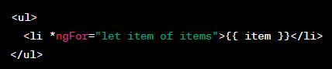
The <li> element is repeated for each item in the items array, rendering a list of items.
  - [ ngSwitch ] : -The ngSwitch directive is used for conditionally rendering content based on the value of an expression.
*ngSwitchCase and *ngSwitchDefault
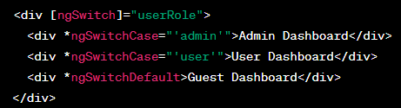
Content within the ngSwitch block is rendered based on the value of userRole. Different blocks are defined for different values.
Custom Directives:-
Example 1:
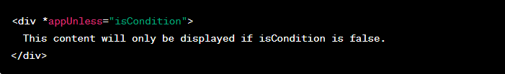
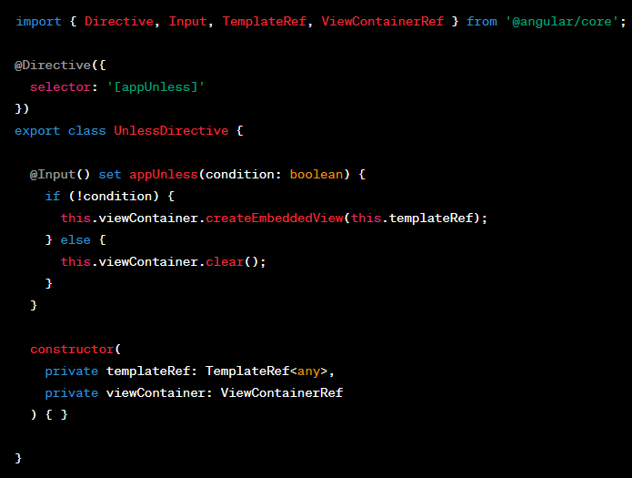

Example 2:
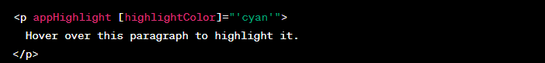
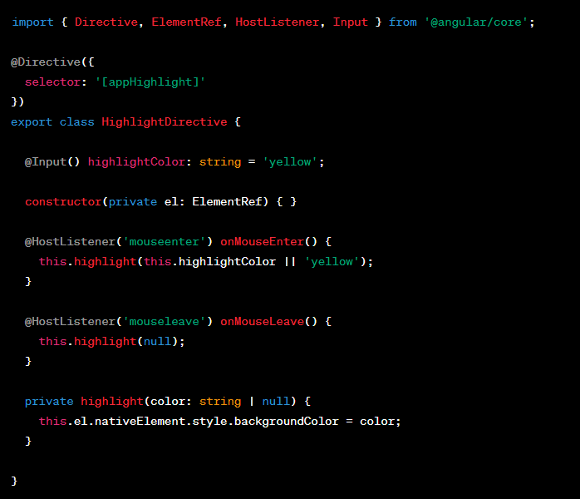
In this example, appHighlight is a custom attribute directive that changes the background color of the element on mouseenter and resets it on mouseleave. The highlightColor input allows customizing the highlight color.
Decorators used inside the Class:-
1. @Input:
Purpose: Marks a class property as an input property, allowing it to receive values from a parent component.
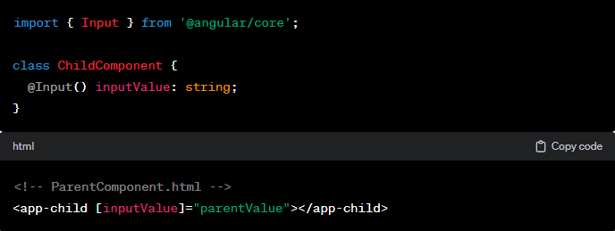
2. @Output:
Purpose: Marks a class property as an output property, allowing the class to emit events that a parent component can listen to.
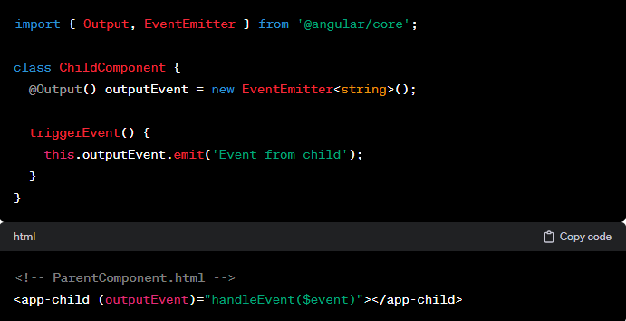
3. @ViewChild:
Purpose: Provides a reference to a child component or element within the class.
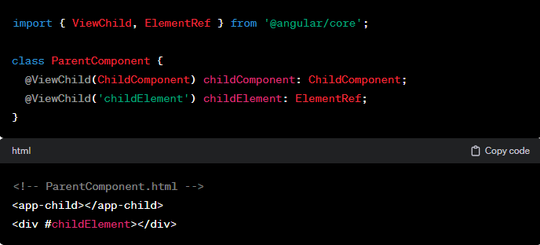

Child component:
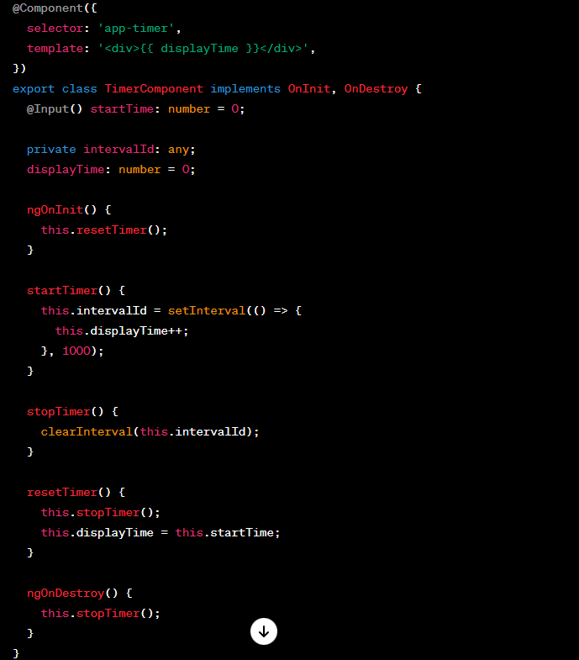

Parent Component:
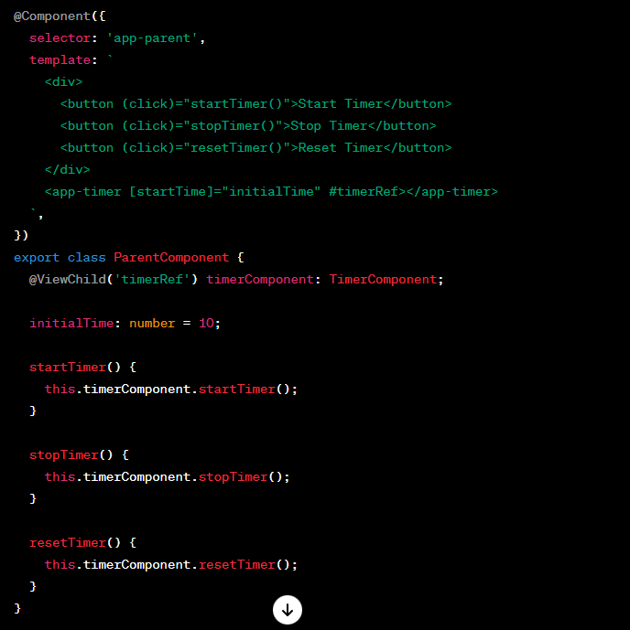
Explanation:
- ParentComponent contains a button panel to control the timer (start, stop, reset) and includes the TimerComponent as a child.
- The @ViewChild('timerRef') decorator queries the TimerComponent using the template reference variable #timerRef and assigns it to the timerComponent property.
- The parent component can then call methods on the child component (e.g., startTimer(), stopTimer(), resetTimer()), allowing communication between the parent and child.

4. @ContentChild:
Purpose: Provides a reference to a projected content child component or element within the class.
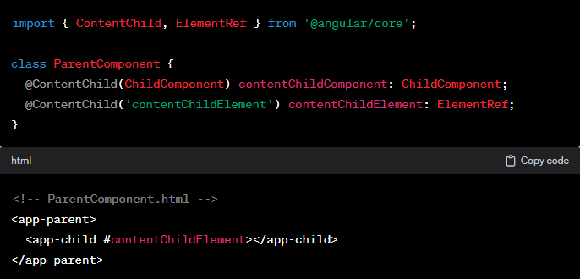
Child Component:
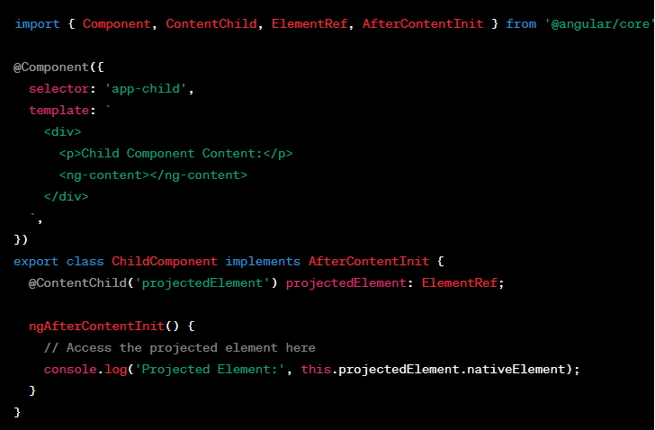

Parent component:
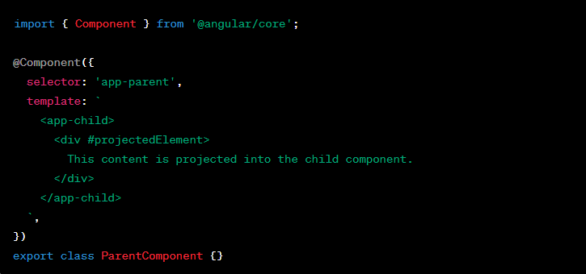
- Content is directly projected into parent template and it can be accessed by child component using @ContentChild decorator.

5. @HostListener:
Purpose: Listens for events on the host element and performs an action.
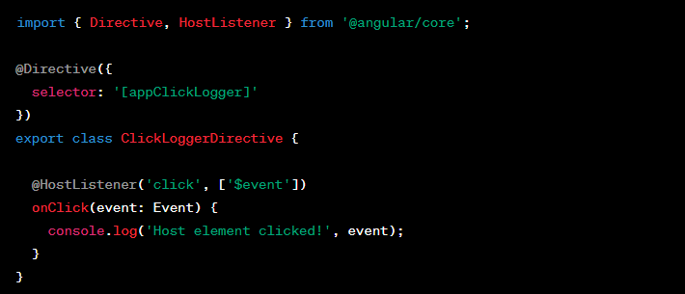
6. @HostBinding:
Purpose: Binds a property of the host element.
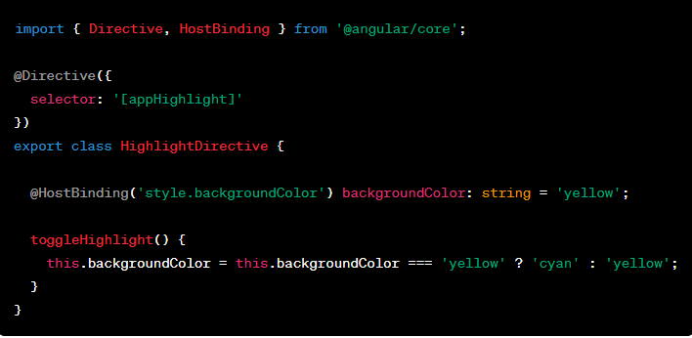
Data Binding
String Interpolation ({{ expression }}):
Usage: {{ expression }}
Description: String interpolation allows you to embed expressions into HTML templates. The expression is evaluated, and the result is converted to a string and inserted into the template.
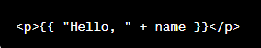
Property Binding ([property]="expression"):
Usage: [property]="expression"
Description: Property binding allows you to bind a component property to an HTML element property. The property is updated whenever the expression changes.
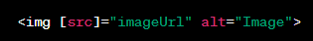
Event Binding ((event)="handler()"):
Usage: (event)="handler()"
Description: Event binding allows you to listen for DOM events (e.g., clicks, keypresses) and execute a method in response to the event.
Two-Way Binding ([(ngModel)]="property"):
Usage: [(ngModel)]="property"
Description: Two-way binding combines property binding and event binding to create a two-way communication link between a property and a form control.
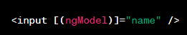
Attribute Binding ([attr.attributeName]="expression"):
Usage: [attr.attributeName]="expression"
Description: Attribute binding allows you to set an attribute of an HTML element based on an expression in the component.
Class Binding ([class.className]="expression"):
Usage: [class.className]="expression"
Description: Class binding allows you to conditionally apply a CSS class to an element based on the value of an expression.
Style Binding ([style.property]="expression"):
Usage: [style.property]="expression"
Description: Style binding allows you to conditionally apply inline styles to an element based on the value of an expression.
Interpolation with Ternary Operator ({{ expression ? trueValue : falseValue }}):
Usage: {{ expression ? trueValue : falseValue }}
Description: You can use the ternary operator within string interpolation to conditionally display values.
Pipe ({{ data | pipeName:param1:param2 }}):
Usage: {{ data | pipeName:param1:param2 }}
Description: Pipes allow you to transform and format data before displaying it in the template.
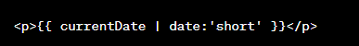

Services and dependency injection
In Angular, services and dependency injection play a crucial role in organizing and sharing code across different parts of an application.
Services are typically used to encapsulate functionality, provide data or business logic, and enable communication between components.
Dependency injection (DI) is the mechanism Angular uses to inject dependencies (such as services) into components, directives, and other services.
Service definition
Service class is marked with @Injectable to indicate that it can be injected into other components or services.
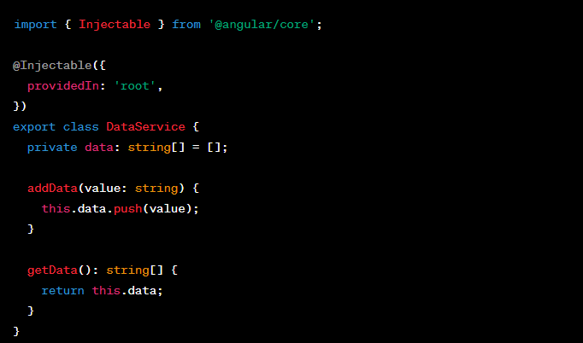
Component using service:
- The AppComponent uses the DataService by injecting it through the constructor.
- It has a method addData to add new data using the service.
- The template binds to the newData property and displays the list of data using the getData method.

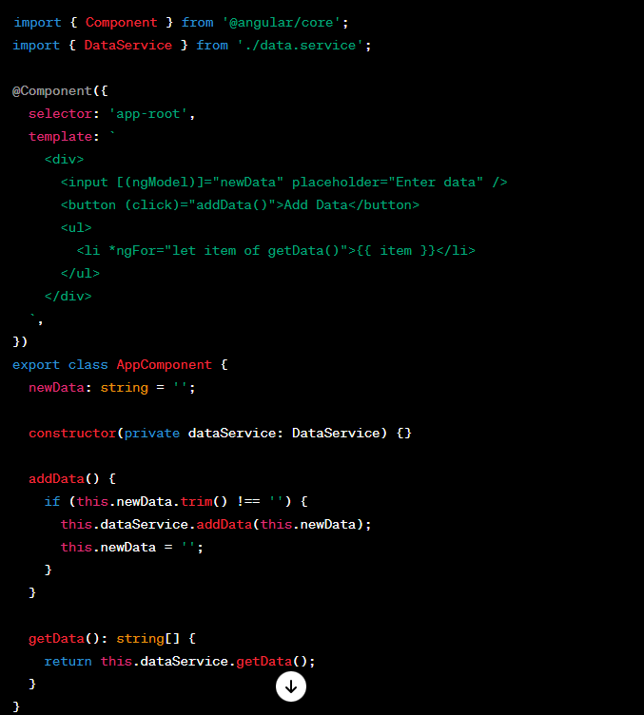
Module configuration:

How Dependency Injection Works:
- The AppComponent constructor requests an instance of DataService.
- Angular's dependency injection system provides an instance of DataService to the constructor.
- The service is marked with providedIn: 'root', making it a singleton service.
- There is a single instance of the service throughout the application.
- The service is marked with providedIn: 'root', making it a singleton service.
- There is a single instance of the service throughout the application.
- The service is marked with providedIn: 'root', making it a singleton service.
- There is a single instance of the service throughout the application.

Routing
Angular routing is a powerful feature that allows you to build single-page applications (SPAs).
different views or components of your application are dynamically loaded without a full page reload.
1. Setting Up Routes:
In your Angular application, routes are defined in the app-routing.module.ts file.
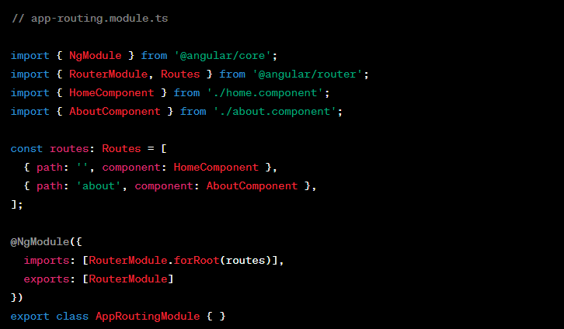
2. Router Outlet – Directive - RouterModule:
Acts as a placeholder that Angular dynamically fills based on the current router state.
In your main app component template (app.component.html), use the <router-outlet> tag to specify where the routed component should be displayed:
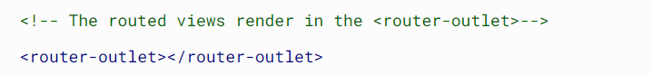
3. Navigation:
Use the routerLink directive to navigate between routes.

RouterLink – Directive - RouterModule
makes that element a link that initiates navigation to a route. Navigation opens one or more routed components in one or more <router-outlet> locations on the page.

RouterLinkActive – Directive - RouterModule
Tracks whether the linked route of an element is currently active, and allows you to specify one or more CSS classes to add to the element when the linked route is active.

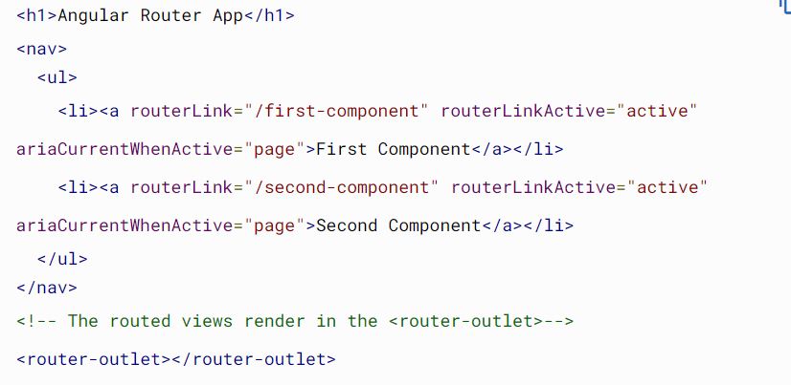

Route order
Router uses a first-match wins strategy when matching routes
List routes with a static path first, followed by an empty path route, which matches the default route. The wildcard route comes last because it matches every URL and the Router selects it only if no other routes match first.
Wildcard routes: -
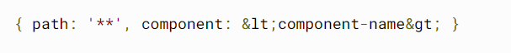
Use to display 404 page.
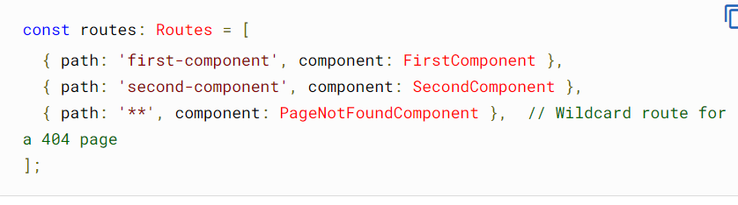
Setting up redirects:-
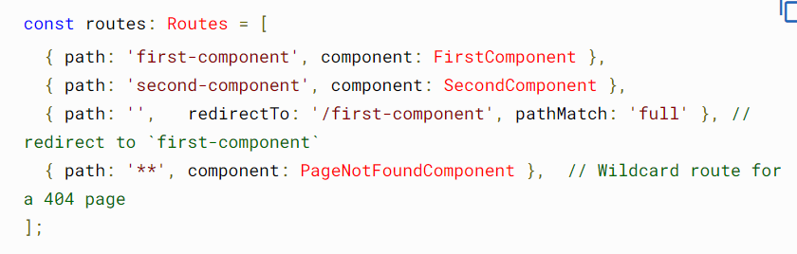

Nesting routes
As your application grows more complex, you might want to create routes that are relative to a component other than your root component.
adding a second <router-outlet> to your app, because it is in addition to the <router-outlet> in AppComponent.
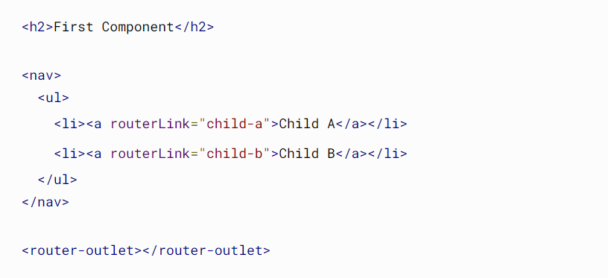
A child route is like any other route, in that it needs both a path and a component. The one difference is that you place child routes in a children array within the parent route.

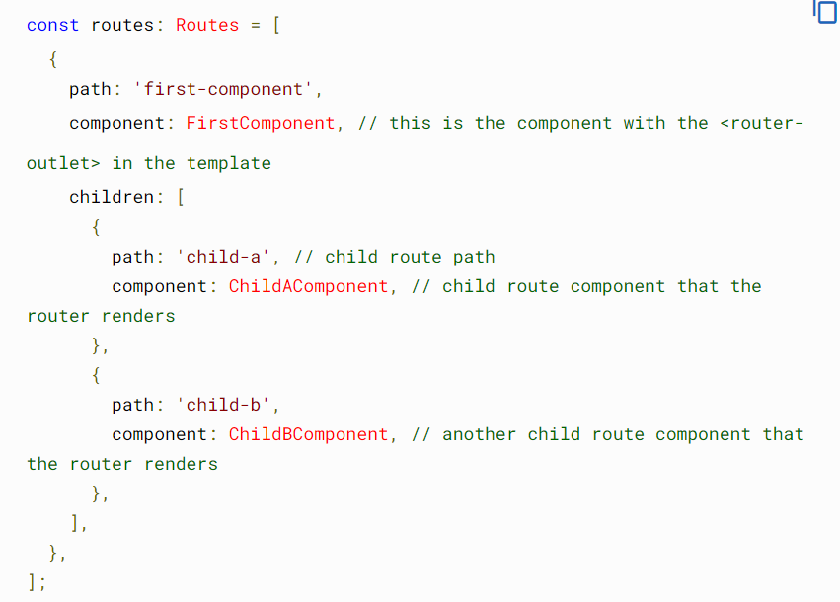
Setting up page title:
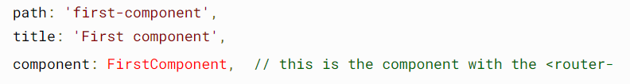

Using relative paths
Relative paths let you define paths that are relative to the current URL segment.
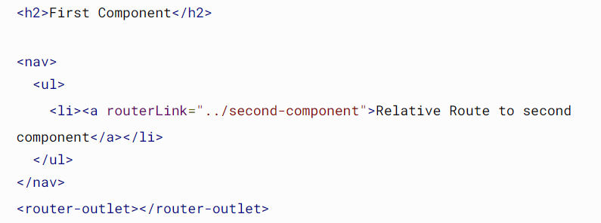
../ means to go up a level and from there navigate to ‘second-component’

Specifying a relative route
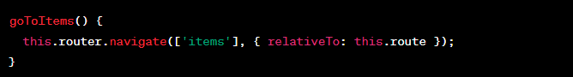
Suppose this.route is /dashboard so the navigating url would be /dashboard/items
the relativeTo option in the navigate method allows for flexible and dynamic navigation by indicating that the specified route should be considered relative to the current activated route.

Accessing query parameters and fragments
you can access query parameters and fragments (also known as hash fragments) from the current route using the ActivatedRoute service. The ActivatedRoute service provides information about the route associated with a component loaded in an outlet.
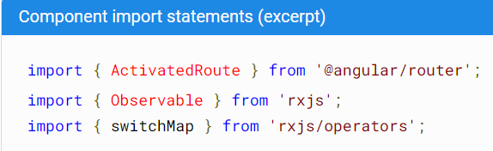
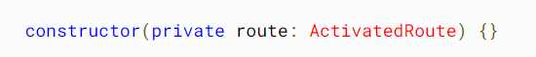
1. Accessing Query Parameters:
Assume you have a URL like: /items?category=electronics&page=1
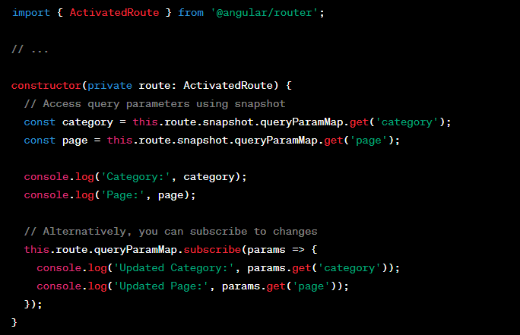
2. Accessing Fragments:
Assume you have a URL like: /dashboard#overview
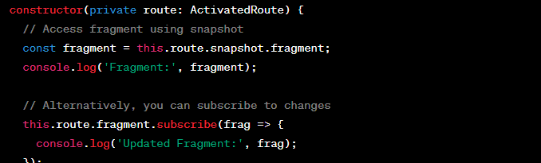
Rsjs operators
Assume you have a URL like: /items?category=electronics&page=1#details
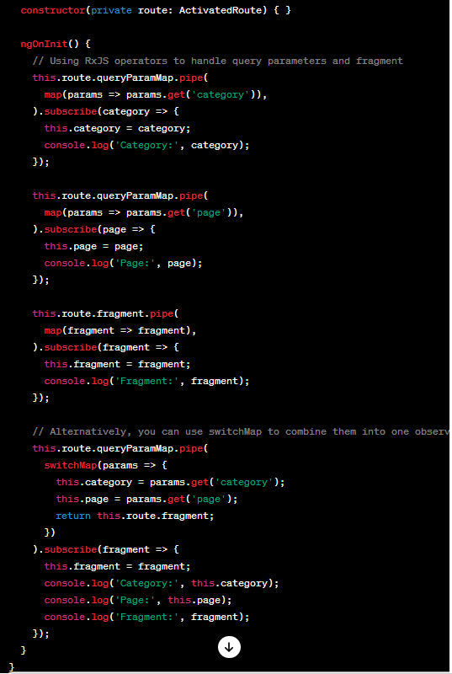
- The map operator is used to extract the values of query parameters and fragments from the route.
- The switchMap operator is used to combine the query parameters into one observable, making the code more concise.
- The subscription block then updates the component's properties (category, page, fragment) with the latest values.
Lazy-loading feature modules
By default, NgModules are eagerly loaded. For large applications with lots of routes, consider lazy loading —a design pattern that loads NgModules as needed.
To lazy load Angular modules, use loadChildren (instead of component) in your AppRoutingModule routes
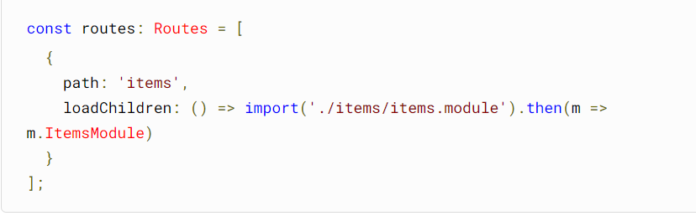
For Feature modules
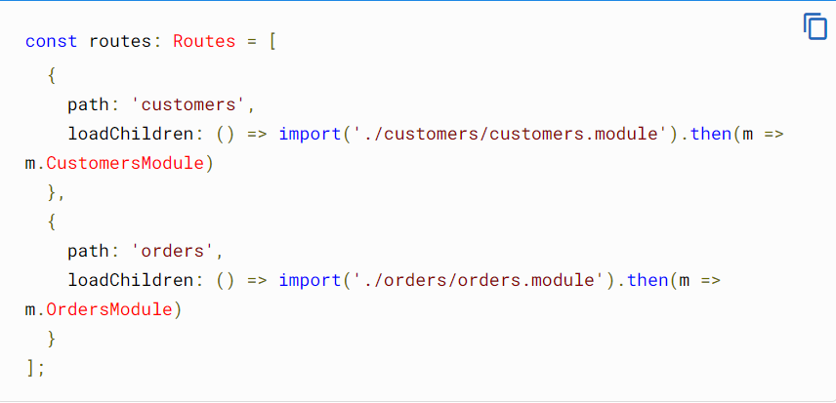

Set up the UI
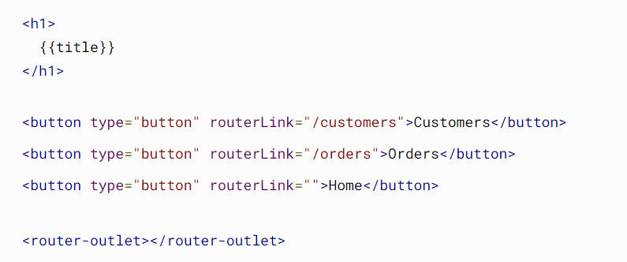

forRoot() and forChild()
Notice that the Angular CLI adds RouterModule.forRoot(routes) to the AppRoutingModule imports array. This lets Angular know that the AppRoutingModule is a routing module and forRoot() specifies that this is the root routing module.
Template Driven Form – FormsModule import
1. NgForm Directive:
- Purpose: The ngForm directive is used to create a form and track its state.
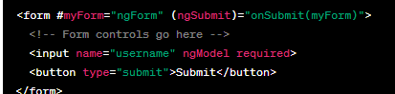
2. NgModel Directive:
- Purpose: The ngModel directive is used to create a two-way data binding for form controls.
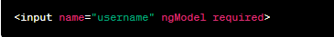
3. Form Validation:
- Purpose: Template-driven forms support built-in and custom validation.
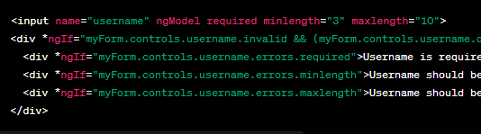
5. Form Submission:
- Purpose: Handle form submission using the (ngSubmit) event.
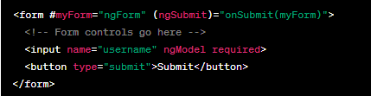

6. NgModelGroup Directive (Form Groups):
- Purpose: The ngModelGroup directive is used to group form controls together.
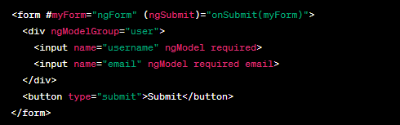
7. ngModelChange:
- Purpose: The ngModelChange event allows you to listen to changes in the ngModel value.
<input name="username" [ngModel]="username" (ngModelChange)="onUsernameChange($event)">
8. Disabling the Submit Button:
- Purpose: Disable the submit button until the form is valid.
9. Resetting the Form:
- Purpose: Reset the form to its initial state.
10. Form Status:
- Purpose: Track form status (pristine, dirty, valid, invalid, touched, untouched).
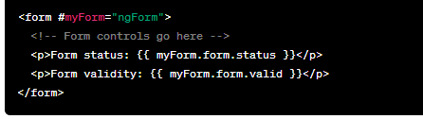

Reactive Form - ReactiveFormsModule
1. Reactive Form in TypeScript File (app.component.ts):
import { Component, OnInit } from '@angular/core';
import { FormBuilder, FormGroup, Validators } from '@angular/forms';

@Component({
selector: 'app-root',
templateUrl: './app.component.html',
styleUrls: ['./app.component.css']
})
export class AppComponent implements OnInit {

// Reactive Form Group
myForm: FormGroup;

// Form initialization in the constructor
constructor(private formBuilder: FormBuilder) { }

ngOnInit() {
// Building the form with formBuilder
this.myForm = this.formBuilder.group({
username: ['', [Validators.required, Validators.minLength(3), Validators.maxLength(10)]],
email: ['', [Validators.required, Validators.email]]
});
}

// Handling form submission
onSubmit() {
if (this.myForm.valid) {
console.log('Form submitted:', this.myForm.value);
}
}

// Resetting the form
resetForm() {
this.myForm.reset();
}
}

2. Reactive Form in Template File (app.component.html):
<!-- app.component.html -->

<div class="container">
<h2>Reactive Form</h2>

<form [formGroup]="myForm" (ngSubmit)="onSubmit()">
<div>
<label for="username">Username:</label>
<input type="text" id="username" formControlName="username">
<div *ngIf="myForm.controls.username.invalid && (myForm.controls.username.dirty || myForm.controls.username.touched)">
<div *ngIf="myForm.controls.username.errors.required">Username is required.</div>
<div *ngIf="myForm.controls.username.errors.minlength">Username should be at least 3 characters.</div>
<div *ngIf="myForm.controls.username.errors.maxlength">Username should be at most 10 characters.</div>
</div>
</div>

<div>
<label for="email">Email:</label>
<input type="email" id="email" formControlName="email">
<div *ngIf="myForm.controls.email.invalid && (myForm.controls.email.dirty || myForm.controls.email.touched)">
<div *ngIf="myForm.controls.email.errors.required">Email is required.</div>
<div *ngIf="myForm.controls.email.errors.email">Invalid email format.</div>
</div>
</div>

<div>
<button type="submit" [disabled]="myForm.invalid">Submit</button>
<button type="button" (click)="resetForm()">Reset Form</button>
</div>
</form>
</div>

- Import Statements in TypeScript File:
  - FormBuilder is used to create an instance of FormGroup.
  - FormGroup is used to represent a form and its controls.
- FormGroup Initialization in ngOnInit:
  - The FormGroup is initialized with controls (username and email) using the formBuilder.group method.
  - Validators are applied to each control.
- Handling Form Submission (onSubmit method):
  - The onSubmit method is called when the form is submitted.
  - If the form is valid, the form values are logged.
- Resetting the Form (resetForm method):
  - The resetForm method is used to reset the form to its initial state.
- Template:
  - The template binds to the form using [formGroup]="myForm".
  - Form controls are bound to input fields using formControlName.
  - Validation messages are displayed conditionally based on the control state.
FormArray:
// app.component.ts

import { Component, OnInit } from '@angular/core';
import { FormBuilder, FormGroup, FormArray, Validators } from '@angular/forms';

@Component({
selector: 'app-root',
templateUrl: './app.component.html',
styleUrls: ['./app.component.css']
})
export class AppComponent implements OnInit {

cityForm: FormGroup;

cities = ['New York', 'London', 'Paris', 'Tokyo', 'Sydney'];

constructor(private formBuilder: FormBuilder) { }

ngOnInit() {
this.initForm();
}

initForm() {
this.cityForm = this.formBuilder.group({
selectedCities: this.formBuilder.array([])
});

// Add a default city selection (optional)
this.addCity();
}

get selectedCities() {
return (this.cityForm.get('selectedCities') as FormArray).controls;
}

addCity() {
const control = this.formBuilder.control('', Validators.required);
(this.cityForm.get('selectedCities') as FormArray).push(control);
}

removeCity(index: number) {
(this.cityForm.get('selectedCities') as FormArray).removeAt(index);
}

onSubmit() {
if (this.cityForm.valid) {
const selectedCities = this.cityForm.value.selectedCities;
console.log('Selected Cities:', selectedCities);
}
}
}

<!-- app.component.html -->

<div class="container">
<h2>City Selection Form</h2>

<form [formGroup]="cityForm" (ngSubmit)="onSubmit()">
<div formArrayName="selectedCities">
<div *ngFor="let city of selectedCities; let i = index" class="city-item">
<label for="city{{i}}">City {{i + 1}}:</label>
<select id="city{{i}}" [formControl]="city" required>
<option value="" disabled>Select a city</option>
<option *ngFor="let cityName of cities" [value]="cityName">{{ cityName }}</option>
</select>
<button type="button" (click)="removeCity(i)" *ngIf="selectedCities.length > 1">Remove</button>
</div>
</div>

<button type="button" (click)="addCity()">Add City</button>

<div>
<button type="submit" [disabled]="cityForm.invalid">Submit</button>
<button type="button" (click)="cityForm.reset()">Reset Form</button>
</div>
</form>
</div>

Reactive form validators:
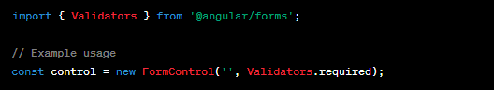
Custom validators:
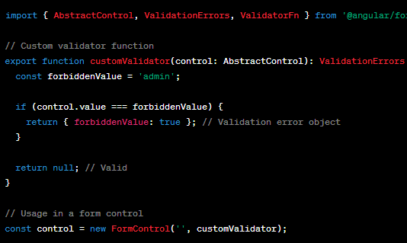

Pipe - Directive
a way to transform the format of output data for display
Pipes are defined using the pipe “|” symbol.
We can apply two formats to single data by chaining pipes. A chained pipe is when the output of the first pipe is input to the next pipe.
Pipes can have optional parameters using the colon(:) symbol to fine-tune the output.
UpperCasePipe and LowerCasePipe:
- Used for converting text to uppercase or lowercase.
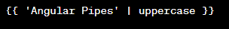
CurrencyPipe:
- Used for formatting currency values.
DecimalPipe:
- Used for formatting decimal numbers.
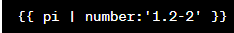
AsyncPipe:
- Used for unwrapping values from Observables.
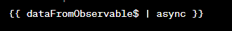
JsonPipe:
- Used for transforming data into JSON format.
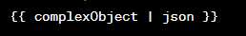

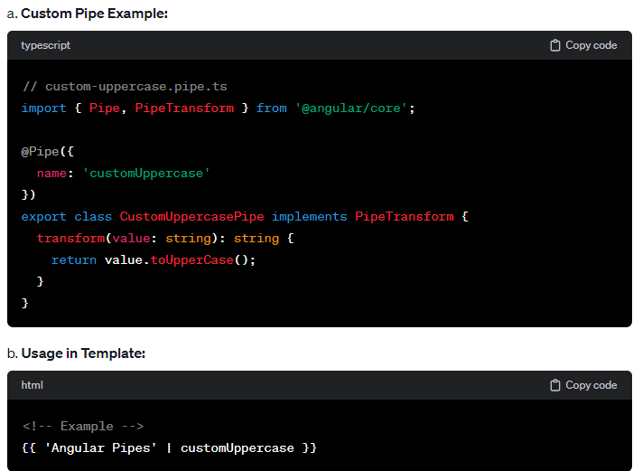

Code decode:
App.module.ts (ngmodule) defines the root module, tells angular how to assemble applications together as a bundle.
Main.ts : bootstrapping the app module. Bootstrapping(creating an instance of app) is where the app is loaded and comes to live.

Index.html -> main.ts -> app.module -> app.component

App.component.ts : defines logic of the app roots component. The view associated with the this becomes the root view in hierarchy as we add services and components to App.

NgModule : ng modules classes are typescript classes which are decorated @NgModule. Part of angular code library. The purpose of it is to declare each thing in angular and group them together like java packages. These helps devs to organize their code and they are helpful when app grows with more components. Application should have atleat one module as app.module
@NgModule : function takes a single json object, this json contains properties, the most imp prop is “declaration” :[AppComponent]. Declaration declares views to make them privately available in a module. Components wont be available to other modules.
“exports”:[] : to export components to other modules that require any component.
“import”:[] to import other modules
“providers”:[] arrays of services that we inject into modules. All services are public and accessible to other views.
“bootstrap”:[] it compiles and creates the actual instance of the app. We provide appcomponent as root component which is an entry point to the logic or the part of the screen.

Services and Dependency injection:
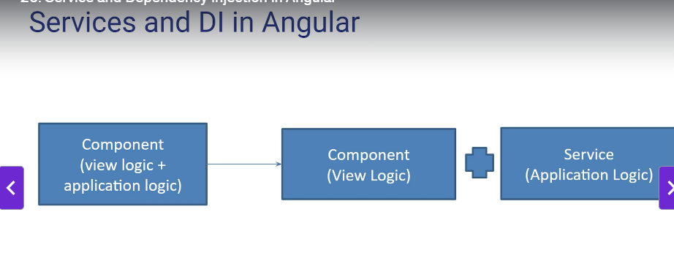
recommendation : get the data and have the application login in the services and view logic in the component.
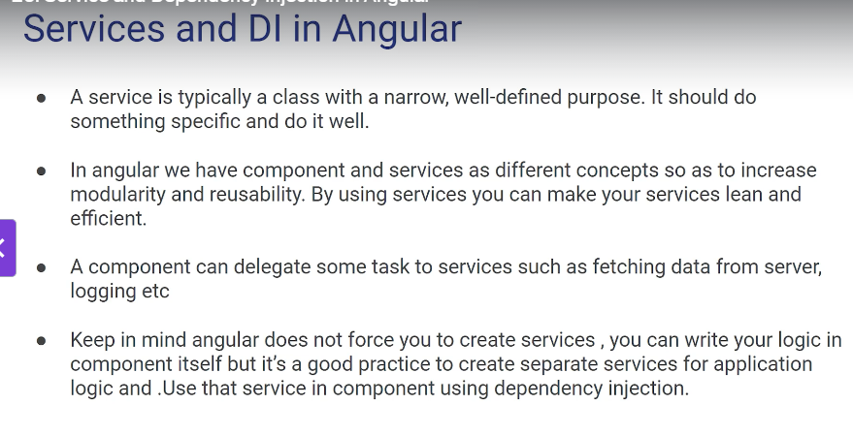
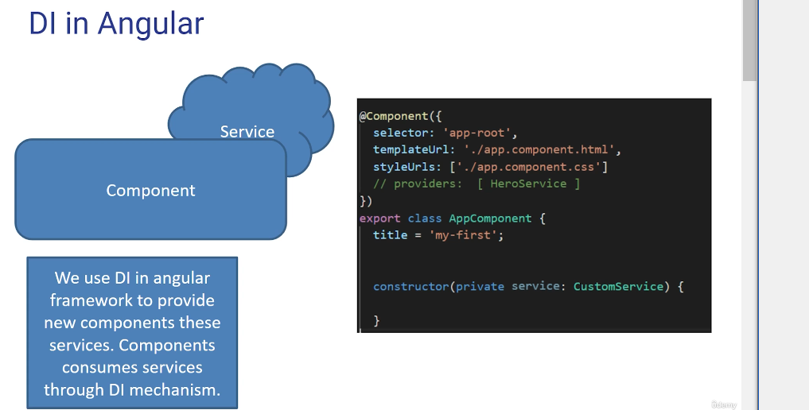

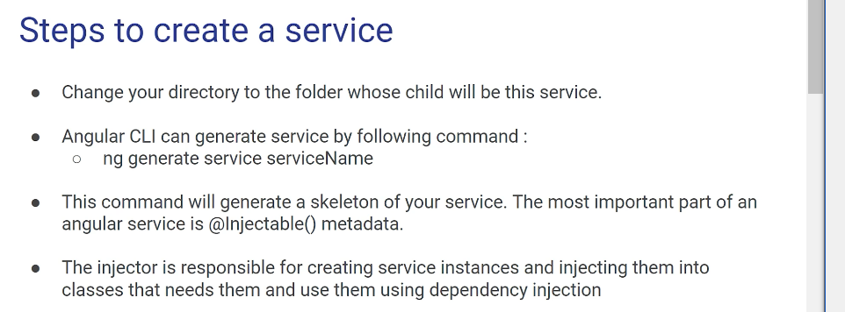
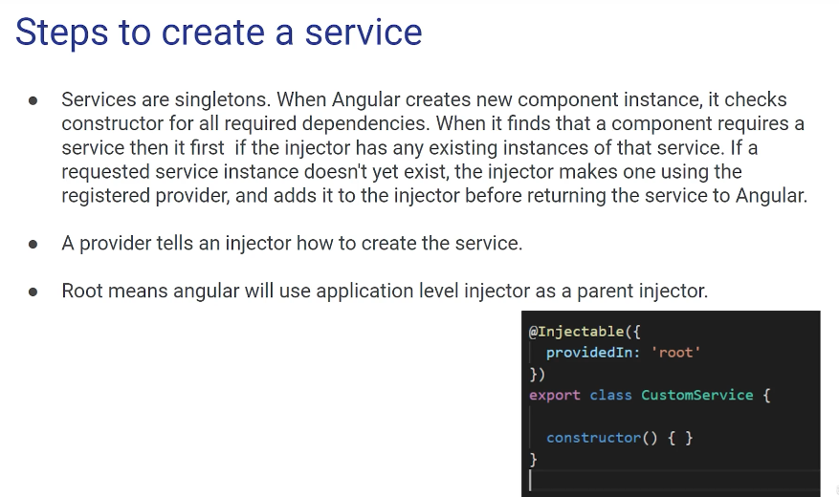
providedIn : “root” or module level injector.
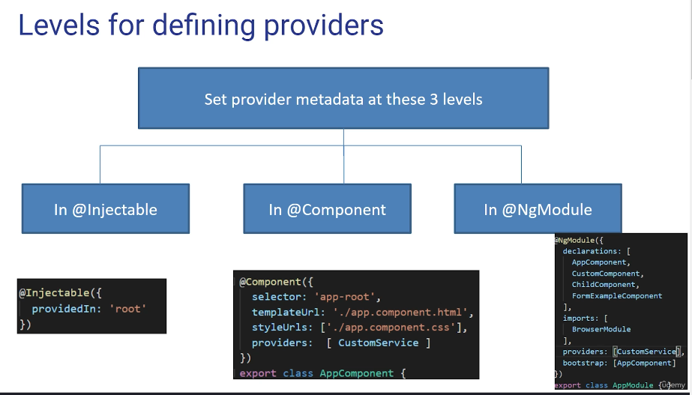
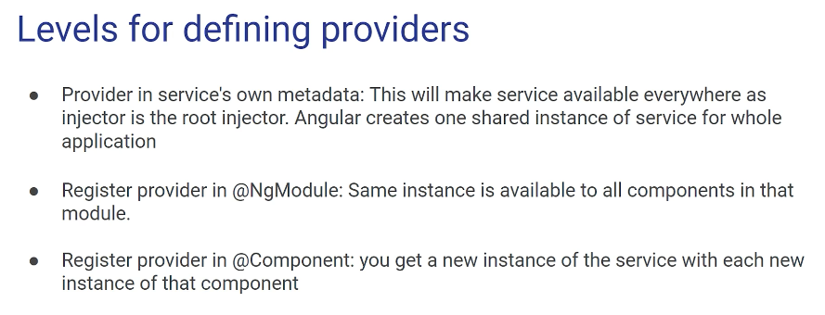
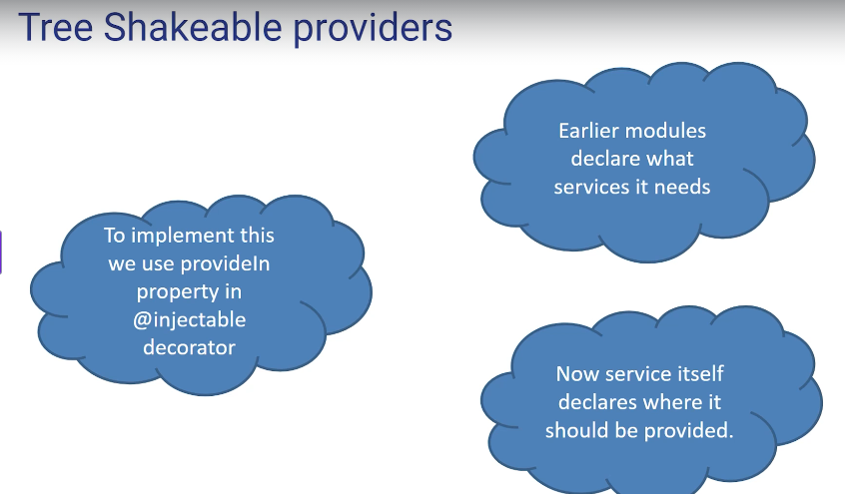
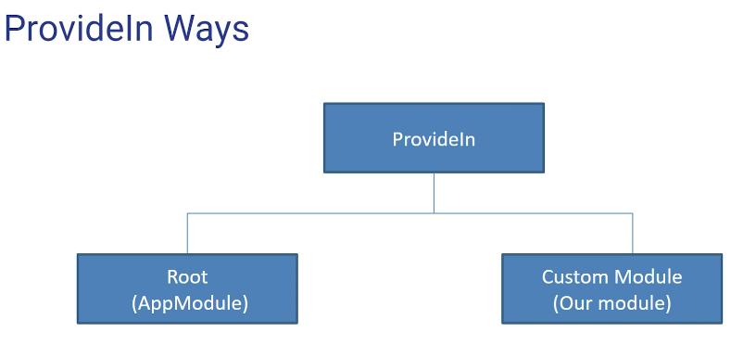

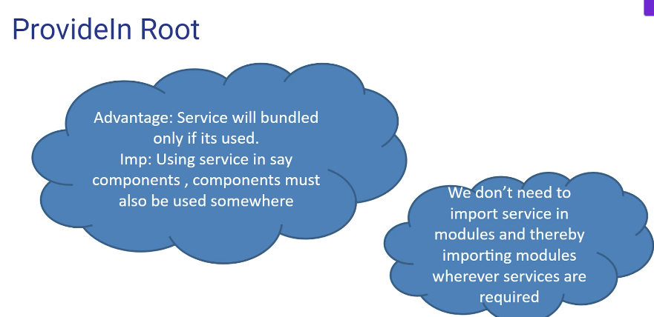

Why Angular: google frameworks. Dynamic, scalable and single page app loads all necessary resources on initial page. It updates the page instead of refreshing.
Component based arch: app is divided into components which are reusable.

