Hibernate Framework
simplifies the development of Java application to interact with the database. It is an open source, lightweight, ORM (Object Relational Mapping) tool. Hibernate implements the specifications of JPA (Java Persistence API) for data persistence.

ORM Tool
An ORM tool simplifies the data creation, data manipulation and data access. It is a programming technique that maps the object to the data stored in the database.
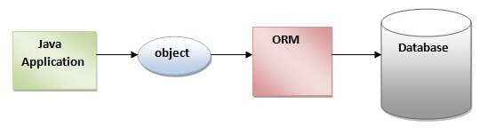
The ORM tool internally uses the JDBC API to interact with the database.
JPA VS Hibernate:
JPA is specification but hibernate is implementation or provider of JPA.
JPA doesn’t have inbuild cache mechanism but hibernate has first level (persistent context) and second level cache.
JPA does not create data base tables based on @Entity configuration but Hibernate does.
Hibernate provides better lazy loading performance than JPA.
Hibernate provides advanced features like Native SQL. Batch processing and Criteria API.

What is JPA?
Java Persistence API (JPA) is a Java specification that provides certain functionality and standard to ORM tools. The jakartax.persistence package contains the JPA classes and interfaces.

Advantages

- Open source
- Fast performance – cache internally – first level enabled by default and second level
- Database independent - HQL is OO version of SQL. generates the database independent queries.
- Automatic table creation
- Simplifies complex join.

Architecture
The Hibernate architecture includes many objects such as persistent object, session factory, transaction factory, connection factory, session, transaction etc.
- Java app layer
- Hibernate framework layer
- Backend Api layer
- Database layer
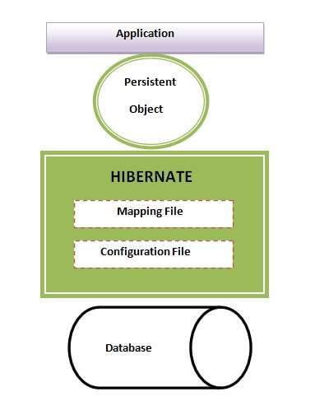
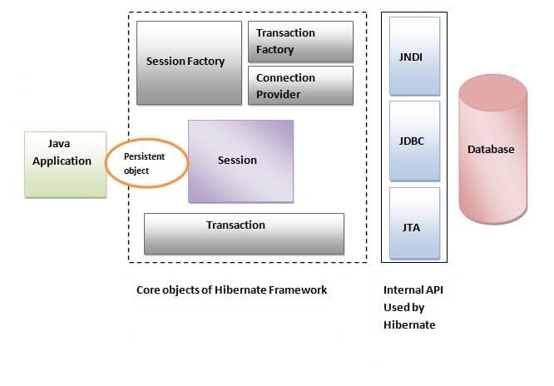

Elements of Hibernate Architecture

SessionFactory – org.hibernate-thread safe
Represents a single data source.
Factory of Session and client of ConnectionProvider. Holds second level cache – optional.
Second – level cache is shared with all instance of session objects.
Provides object of Session.

Session – org.hibernate – not thread safe
- provides an interface between the application and data stored in the database
- short-lived object and wraps the JDBC connection.
- It holds a first-level cache(persistence context) (mandatory) of data.
- provides methods to insert, update and delete the object.
- provides factory methods for Transaction, Query and Criteria.
**** committing transaction does not close session. We can still begin new transaction with same session object.
SESSION METHODS:
- save(entity) – inserts and return primary key value
- Persist(entity) - inserts but no return value
- Update(entity) – updates if present or error if not.
- Merge(entity) – detached entity to persistent context.
- Delete(entity) - Deletes from DB.
- get(Class<T> entityType, Serializable id): used to retrieve specified entity based on the entity id. it first checks first level cache, if entity not found then queries database. And it returns null if entity not found in database.
- void org.hibernate.Session.saveOrUpdate(Object object): either save a new entity or update existing entity.
Transient Entity : if entity is not associated with database, then it uses an INSERT query.
Persistent Entity : If entity exists in database, then it uses UPDATE query.
Detached Entity : when we try to reattach the detached entity in new session, then it performs an UPDATE operation to synchronize the changes to detached entity.
Fetch operations :
- Get(entity, id) – quick load and null if no record found.
- Load(entity,id) – loads lazily, return a proxy first. But throws an exception if no record found.
- createQuery, createSqlQuery -> creates query for fetching records.
- createCritaria – creates a criteria query for dynami filtering.
Trasaction management :
- beginTransaction ()
- getTransaction() – gets current transaction
- flush() – flushes current state of transaction to the database.
  - Id does not commit the changes yet.
  - Reduces memory usage.
  - Get generated values early.
  - Early constrain cheking.
- Clear() – clears the persistent context.
- Evict(entity) – removes from persistent context.
Session connection management ;
- Close() – closes session.
- isOpen() – is connection still open.
- isConnected() -> checks if sssion still connects to db.
- Disconnect() – detaches the session from db temp.
- Reconnect(connection)->reconnects the session to db.
Query execution :
- createdQuery(string hql)->creates HQL query.
- createNamedQuery(name) – predefined in entity class.
- setMaxreslts(limit);
- uniqueResult() – single unique result or null
- list() – execute and return a list of result.
Contains(entity)- checks if present in persistent context.

***If Sessionpool is maintained the closed session goies back to the sessionpool as the db connection would not be lost by closing the session.
***HikariCP connection pool
@Transactional:
Propagation Type Behavior
REQUIRED (default) Joins an existing transaction or creates a new one if none exists.
REQUIRES_NEW Suspends any existing transaction and starts a new one.
SUPPORTS Runs within a transaction if one exists; otherwise, runs non-transactionally.
NOT_SUPPORTED Suspends any existing transaction and runs without a transaction.
MANDATORY Requires an existing transaction; throws an exception if none exists.
NEVER Must not run within a transaction; throws an exception if called within one.
NESTED Runs within a nested transaction if an existing transaction exists; otherwise, behaves like REQUIRED.
Spring framework hibernate5 : HibernateTransactionManager which takes care of beginning, committing and rollbacks of transactions. And Hibernate session manually closed one the method ends.
Life cycle of Session with @Transactional
Method starts : new transaction begins.
Operation execute : hibernate session interacts with DB.
Method end : commits transaction, or rolls back. Close the hibernate connection (returns the connection back to pool).
We provide localsessionfactorybean to hibernatetransactionmanager so it get the current session from the factory and use to complete the transaction and close it automatically.

Useful properties
spring.jpa.hibernate.ddl-auto=none,update,create,create-drop
show_sql to print queries
format_sql for better readablity
hbm2ddl.auto equivalent to ddl_auto

connection pool :
spring.datasource.hikari.maximum-pool-size=20
spring.datasource.hikari.minimum-idle=5
spring.datasource.hikari.connection-timeout=30000
spring.datasource.hikari.idle-timeout=600000
spring.datasource.hikari.max-lifetime=1800000

spring.jpa.properties.hibernate.dialect=org.hibernate.dialect.MySQL5Dialect
spring.jpa.properties.hibernate.jdbc.batch_size=30

why connection pool:
creating a session is a time consuming operation. Opening a TCP connection to the DB server, authentication takes some time.
At restricting to have set of connection make sure the DB is accessed by max with the limited connections so no db crashes or timeouts.

What happens if second level cache is enabled?
Eliminate DB access costs for frequently accessed data.
- If an instance is already present in first level cache, its is returned.
- If an instance is not present in first level cache and corresponding instance state is cached in second level cache, then data is fetched from there and an instance is assembled and returned.
- Otherwise, data is loaded from database and an instance is assembled and returned.

Transaction
- interface provides methods for transaction management.
- object specifies the atomic unit of work.
- Atomicity – all operations within transaction are executed successfully or none of them are. If any part fails whole transaction is rolled back. Database remains unchanged.
- Consistency – it brings from one consistent DB to another DB.
- Isolation – not visible to another transaction. No interference btw concurrent transactions
- Durability – once committed – changes are permanent and stored in non – volatile memory.

ConnectionProvider
A factory of JDBC connections. It abstracts the application from DriverManager or DataSource. It is optional

TransactionFactory
It is a factory of Transaction. It is optional.

Hibernate Example using XML in Eclipse

Create the Persistent class
Employee pojo class

mapping file for Persistent class

employee.hbm.xml
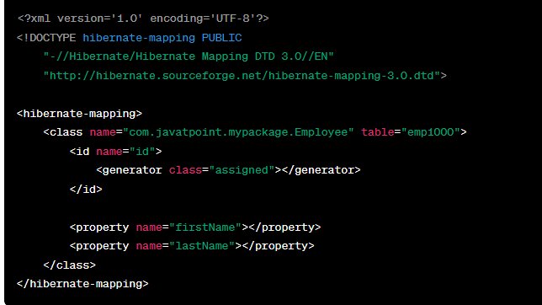

Configuration file
- Connection url
- Driver class
- Username and password
- Hbm2ddl.auto
- Dialect class

hibernate.cfg.xml

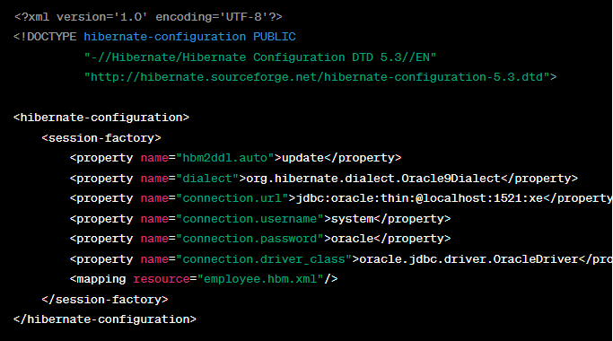

class that retrieves or stores the persistent object
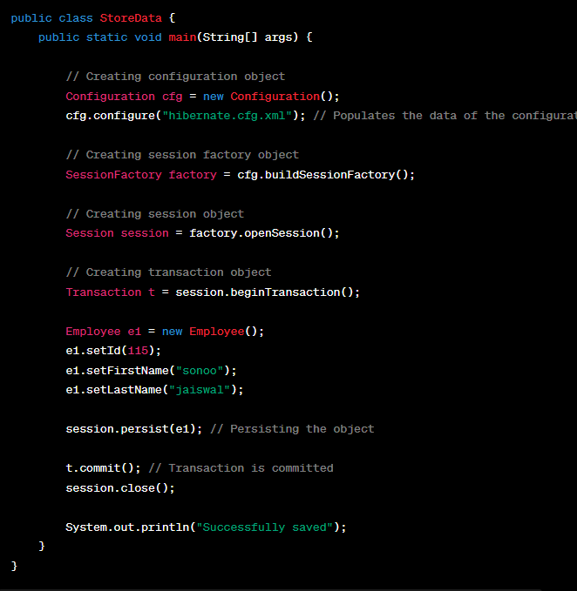

using Annotation
@Entity, @Id, @Table
JPA annotations are defined in the javax.persistence package
Hibernate EntityManager implements the interfaces and life cycle defined by the JPA specification.
Advantage:
- No hbm file to provide metadata, annotations provide metadata.

Persistence class.
@Entity annotation marks this class as an entity
@Table
@Id
@Column

Generator
used to generate the unique identifier for the objects of persistent class
strategies:
assigned – default strategy
increment - generates the unique id only if no other process is inserting data into this table. If a table contains an identifier then the application considers its maximum value else the application consider that the first generated identifier is 1. For each attribute value, the hibernate increment the identifier by 1.
Sequence: - It uses the sequence of the database. if there is no sequence defined, it creates a sequence automatically. it creates a sequence named HIBERNATE_SEQUENCE
Hilo - uses high and low algorithm to generate the id
Native - uses identity, sequence or hilo depending on the database vendor
Identity - It is responsibility of database to generate unique identifier.
seqHilo - uses high and low algorithm on the specified sequence name.
uuid - UUID algorithm to generate the id.
foreign - uses the id of another associated object, mostly used with <one-to-one> association.

Dialects in Hibernate
The dialect specifies the type of database used in hibernate so that hibernate generate appropriate type of SQL statements. For connecting any hibernate application with the database, it is required to provide the configuration of SQL dialect.
MSSQL | org.hibernate.dialect.SQLServer2012Dialect
MySQL | org.hibernate.dialect.MySQLDialect

One to Many
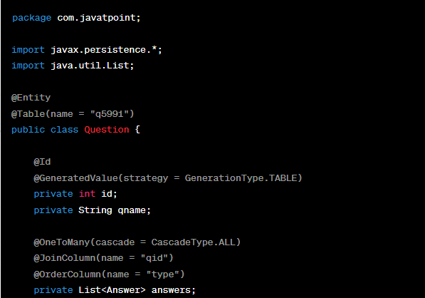
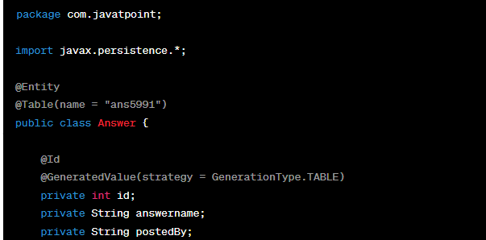
@OneToMany(cascade = CascadeType.ALL): Defines a one-to-many relationship with the Answer entity. It indicates that each Question can have multiple Answer entities associated with it.
@JoinColumn(name = "qid"): Specifies the foreign key column in the Answer table that is used to join with the primary key column of the Question table.
@OrderColumn(name = "type"): Indicates the name of the column that maintains the order of the elements in the collection. It's used to preserve the order of the answers.
CascadeType
PERSIST (CascadeType.PERSIST): EntityManager.persist()
This means that if you persist an entity, and that entity has a relationship with another entity, the associated entity will also be persisted.
MERGE (CascadeType.MERGE): EntityManager.merge()
Merging involves copying the state of the detached entity into the managed entity. If the entity has associations and CascadeType.MERGE is specified, the associated entities will also be merged.
REMOVE (CascadeType.REMOVE): EntityManager.remove()
This means that if you delete an entity, and that entity has a relationship with another entity, the associated entity will also be removed.
REFRESH (CascadeType.REFRESH): EntityManager.refresh()
Refreshing an entity means reloading its state from the database. If there are associations with CascadeType.REFRESH, the associated entities will also be refreshed.
DETACH (CascadeType.DETACH): EntityManager.detach()
Detaching an entity means removing it from the persistence context. If there are associations with CascadeType.DETACH, the associated entities will also be detached.
ALL (CascadeType.ALL):
- Represents all cascade operations: PERSIST, MERGE, REMOVE, REFRESH, and DETACH.
- Applying any operation to the owning entity will cascade to all associated entities.
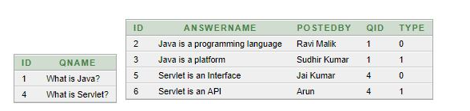
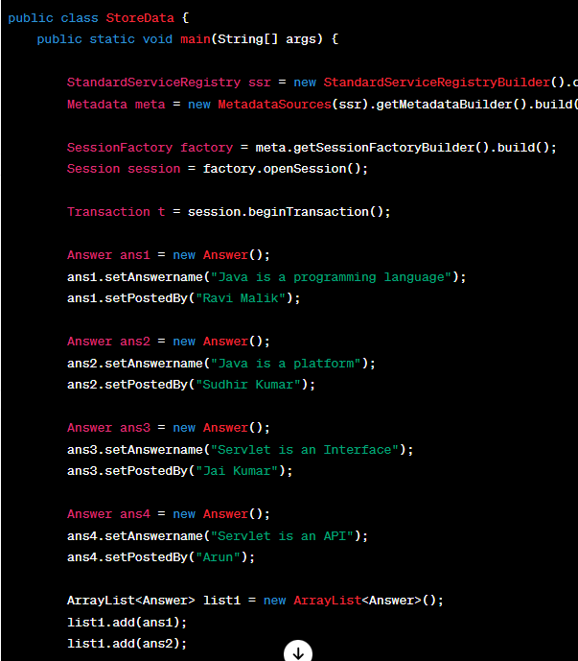
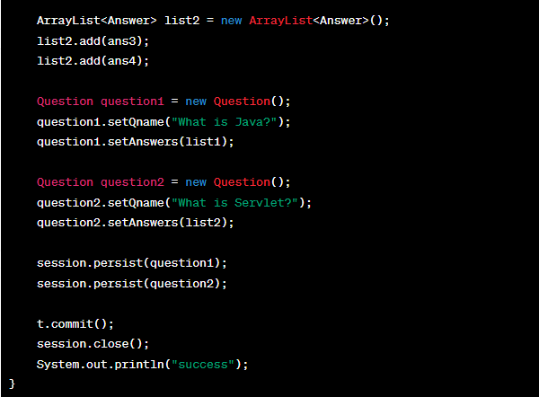

Many to Many
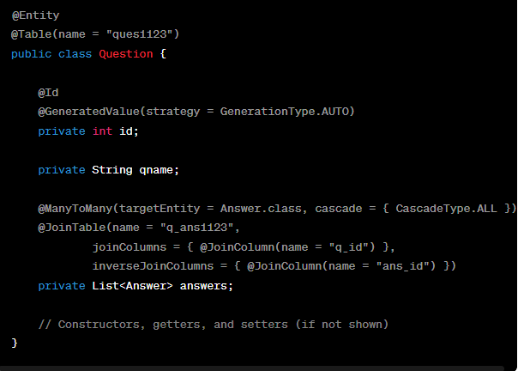
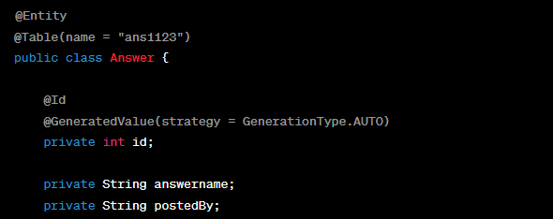
@ManyToMany: Indicates a many-to-many relationship between Question and Answer.
@JoinTable: Specifies the mapping of the join table that is used to store the many-to-many relationship.
joinColumns: Specifies the foreign key column in the join table that refers to the primary key of the owning entity (Question).
inverseJoinColumns: Specifies the foreign key column in the join table that refers to the primary key of the inverse entity (Answer).
The join table q_ans1123 is used to represent this relationship

One to One
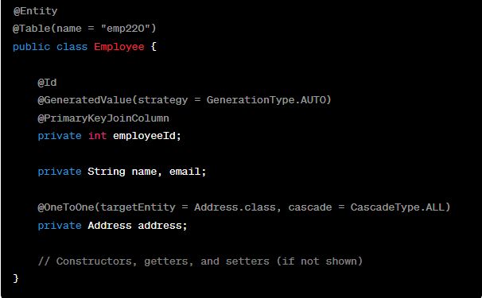
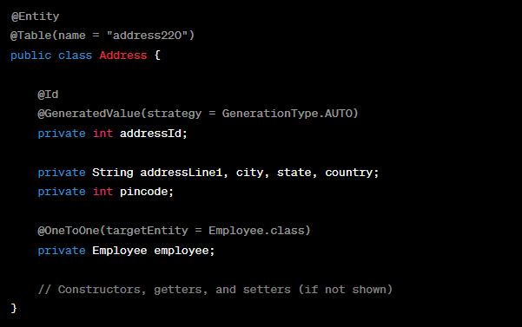
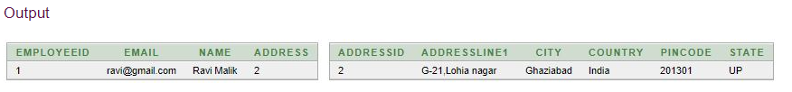

Many to One
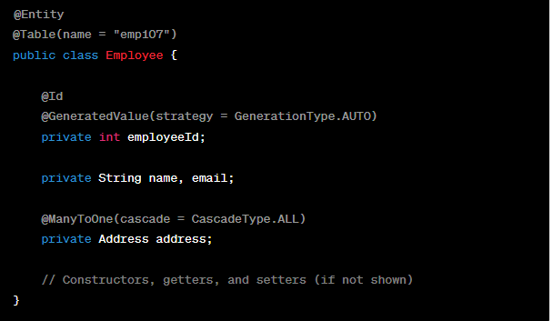
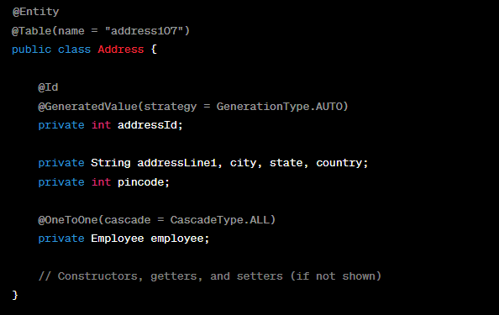
cascade = CascadeType.ALL: Specifies that all operations (persist, merge, remove, refresh) should be cascaded to the associated Employee entity.
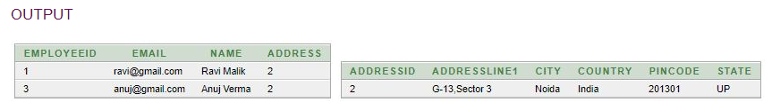

Bidirectional Association
Bidirectional association allows us to fetch details of dependent object from both side.
having the reference of two classes in each other.
example of Employee and Address, if Employee class has-a reference of Address and Address has a reference of Employee. Additionally, you have applied one-to-one or one-to-many relationship for the classes in mapping file as well, it is known as bidirectional association.
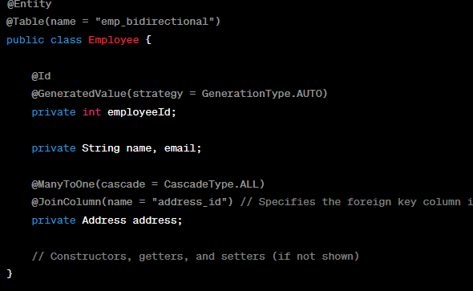
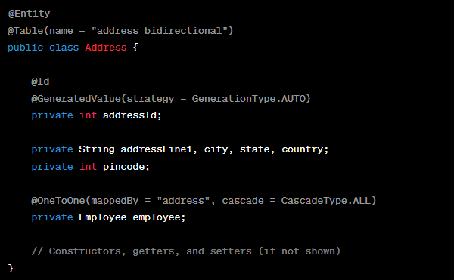
- Employee class:
  - @ManyToOne: Indicates a many-to-one relationship from Employee to Address.
  - @JoinColumn(name = "address_id"): Specifies the foreign key column in the Employee table that links to the primary key column of the Address table.
  - CascadeType.ALL: Specifies that all operations (persist, merge, remove, refresh) should be cascaded to the associated Address entity.
- Address class:
  - @OneToOne(mappedBy = "address", cascade = CascadeType.ALL): Indicates a one-to-one relationship from Address to Employee. The mappedBy attribute specifies the inverse side of the relationship, and it refers to the address field in the Employee class.
  - CascadeType.ALL: Specifies that all operations (persist, merge, remove, refresh) should be cascaded to the associated Employee entity.

Hibernate Lazy Collection
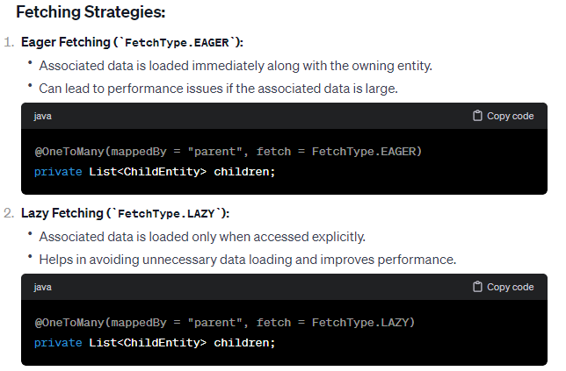

HCQL (Hibernate Criteria Query Language)
used to fetch the records based on the specific criteria.
interface provides many methods to specify criteria.
- public Criteria add(Criterion c) is used to add restrictions.
- public Criteria addOrder(Order o) specifies ordering.
- public Criteria setFirstResult(int firstResult) specifies the first number of record to be retreived.
- public Criteria setMaxResult(int totalResult) specifies the total number of records to be retreived.
- public List list() returns list containing object.
- public Criteria setProjection(Projection projection) specifies the projection.

Restrictions class
Provides methods that can be criterion.
All are static SimpleExpression type
Lt(property,value) – less than
Le(property,value) – less than or equal
gt(property,value)
ge(property,value)
ne(property,value) – not equal
eq(property,value)- equal
Criterion between(property,low,high)
Like(property,value)

Order class
Satic Order asc(propertyName)
Static Order desc(propertyName)
We can get criteria object from session
Criteria c = session.criteria(Employee.class)
c.list()
c.setFirstResult(10)
c.setMaxResult(20)
c.add(Restrictions.gt(“salary”,100000))
c.addOrder(Order.asc(“salary”))

HCQL with Projection
Fetch data of a particular column by projection such as name.
c.setProjection(Projections.property(“name”))
c.list()

Transaction Management
A transaction simply represents a unit of work. In such case, if one step fails, the whole transaction fails (which is termed as atomicity). A transaction can be described by ACID properties (Atomicity, Consistency, Isolation and Durability).
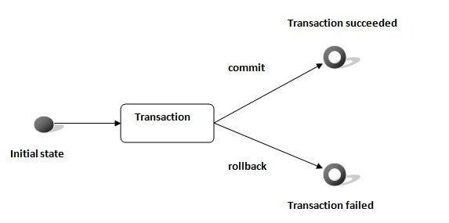

Transaction Interface
Transaction interface that defines the unit of work. It maintains abstraction from the transaction implementation (JTA,JDBC).
A transaction is associated with Session and instantiated by calling session.beginTransaction().
- void begin() starts a new transaction.
- void commit() ends the unit of work unless we are in FlushMode.NEVER.
- void rollback() forces this transaction to rollback.
- void setTimeout(int seconds) it sets a transaction timeout for any transaction started by a subsequent call to begin on this instance.
- boolean isAlive() checks if the transaction is still alive.
- void registerSynchronization(Synchronization s) registers a user synchronization callback for this transaction.
- boolean wasCommited() checks if the transaction is commited successfully.
- boolean wasRolledBack() checks if the transaction is rolledback successfully.

HQL
Hibernate Query Language (HQL) is same as SQL (Structured Query Language) but it doesn't depends on the table of the database. Instead of table name, we use class name in HQL. So it is database independent query language.

Advantage
- database independent
- supports polymorphic queries.
- easy to learn for Java Programmer

Query Interface
- public int executeUpdate() is used to execute the update or delete query.
- public List list() returns the result of the relation as a list.
- public Query setFirstResult(int rowno) specifies the row number from where record will be retrieved.
- public Query setMaxResult(int rowno) specifies the no. of records to be retrieved from the relation (table).
- public Query setParameter(int position, Object value) it sets the value to the JDBC style query parameter.
- public Query setParameter(String name, Object value) it sets the value to a named query parameter.
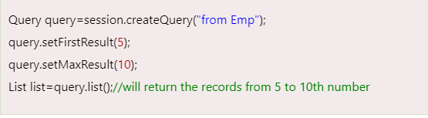
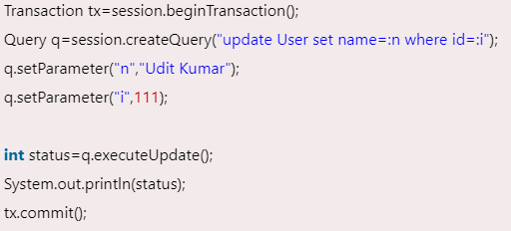
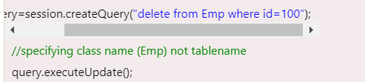

Hibernate Named Query
named query is way to use any query by some meaningful name.
@NameQuery annotation is used to define the single named query.
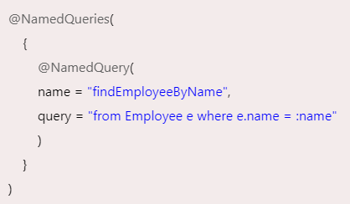
Name – method name

Caching in Hibernate

First Level Cache
Session object holds the first level cache data. It is enabled by default. The first level cache data will not be available to entire application. An application can use many sessions object.

Second Level Cache
SessionFactory object holds the second level cache data. The data stored in the second level cache will be available to entire application. But we need to enable it explicitely.
Sessionfactory
Vendors
- EH Cache
- OS Cache
- Swarm Cache
- JBoss Cache

four ways to use second level cache.
- read-only: caching will work for read only operation.
- nonstrict-read-write: caching will work for read and write but one at a time.
- read-write: caching will work for read and write, can be used simultaneously.
- transactional: caching will work for transaction.

Hibernate Lifecycle
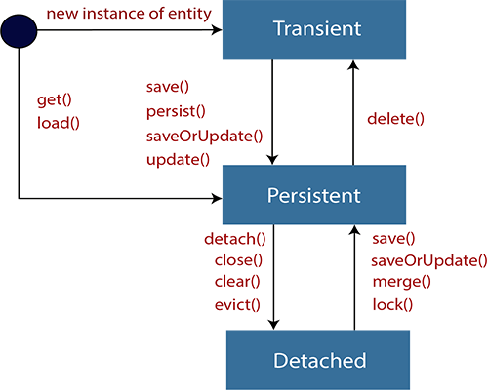

Transient state
- The transient state is the initial state of an object.
- Once we create an instance of POJO class, then the object entered in the transient state.
- Here, an object is not associated with the Session. So, the transient state is not related to any database.
- Hence, modifications in the data don't affect any changes in the database.
- The transient objects exist in the heap memory. They are independent of Hibernate.
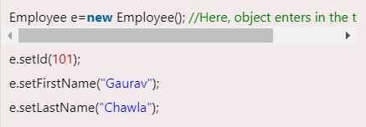

Persistent state
- As soon as the object associated with the Session, it entered in the persistent state.
- Hence, we can say that an object is in the persistence state when we save or persist it.
- Here, each object represents the row of the database table.
- So, modifications in the data make changes in the database.
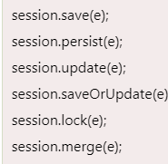

Detached State
- Not in sync with session.
- Once we either close the session or clear its cache, then the object entered into the detached state.
- As an object is no more associated with the Session, modifications in the data don't affect any changes in the database.
- However, the detached object still has a representation in the database.
- If we want to persist the changes made to a detached object, it is required to reattach the application to a valid Hibernate session.
- To associate the detached object with the new hibernate session, use any of these methods - load(), merge(), refresh(), update() or save() on a new session with the reference of the detached object.
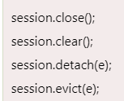
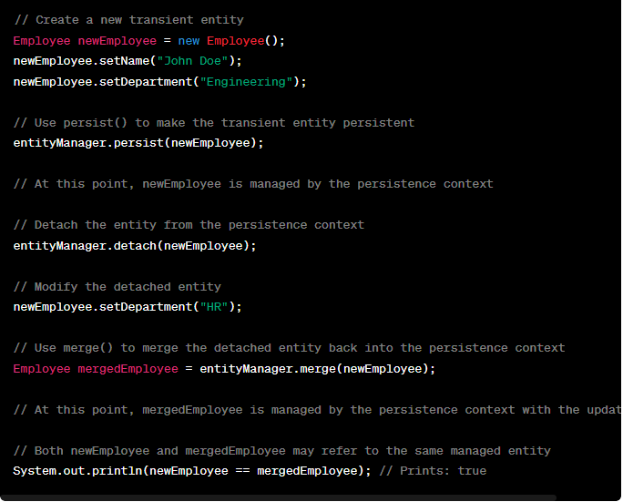
Database connections
Hibernate connects to the database by leveraging JDBC for low-level database connectivity and providing a high-level abstraction through the SessionFactory and Session interfaces.
Datasource config
import javax.sql.DataSource as @Bean
or hibernate.cfg.xml <hibernate-configuration><session-factory>

Persistence Context?
persistence context is a fundamental concept that represents the cache of managed entity instances associated with the current Hibernate Session
It acts as a first-level cache for entities loaded from the database during a particular session.
  - When you load or save entities using a Session, Hibernate tracks these entities within the persistence context.
Managed Entities:
  - Entities associated with current persistence.
  - have been loaded from the database or persisted using the current session.
  - Changes made to managed entities are automatically synchronized with the database during the session's transaction commit.
2 update ops – 2 diff tables

Entity Lifecycle States:
  - Entities within the persistence context go through different lifecycle states, including transient, persistent, detached, and removed.
  - When an entity is loaded or saved using a session, it transitions to the persistent state and becomes managed by the persistence context.
  - If an entity is removed from the session or the session is closed, the entity becomes detached from the persistence context.
- Persistence Context:
  - The persistence context is a short-lived cache maintained by Hibernate within a session. It keeps track of all the entities (objects representing rows in the database) that have been read from or written to the database within the current session.
  - The persistence context is associated with a Hibernate Session, and it manages the lifecycle of entities and tracks any changes made to their state.
- Tracking Changes:
  - Whenever you load an entity from the database or save/update/delete an entity within a transaction, Hibernate keeps track of these changes in the persistence context.
  - Any modifications made to managed entities (entities within the persistence context) are automatically detected and recorded by Hibernate.
- Transaction Commit:
  - When you call tx.commit() to commit the transaction, Hibernate flushes (synchronizes) the changes recorded in the persistence context to the database.
  - This means that any INSERT, UPDATE, or DELETE statements necessary to synchronize the changes with the database are executed during the transaction commit.
- Automatic Dirty Checking:
  - Hibernate performs automatic dirty checking, which means it compares the current state of managed entities with their original state (state when they were loaded from the database) to determine what changes need to be synchronized with the database.
  - Only the changes made to managed entities are flushed to the database during transaction commit. Unmodified entities are not flushed, which helps improve performance.
- Transactional Scope:
  - The persistence context typically exists within the scope of a transaction. Entities are managed and tracked by the persistence context for the duration of the transaction.
  - Once the transaction is committed or rolled back, the persistence context is cleared, and managed entities become detached.
• Session Scope: The persistence context is scoped to the lifecycle of the session. Each session has its own persistence context, and entities are cached within this context for the duration of the session.
• Identity Scope: Within the persistence context, each entity is uniquely identified by its primary key. This ensures that there is only one instance of any entity with a specific identifier within the session.
• Automatic Management: Hibernate automatically manages the persistence context. When you perform operations such as loading, saving, or updating an entity, Hibernate ensures that the entity is properly managed within the context.
• Consistency: The persistence context helps maintain consistency within a session. Since entities are cached, changes made to an entity are immediately visible within the session, avoiding discrepancies between different parts of the application accessing the same entity.
• Session Methods: Operations like session.get(), session.load(), session.save(), and session.update() interact with the persistence context to manage entity instances.

Methods executes on Entity instance
save(): saves entity to database and return identifier
persist(): makes entity persistent, managed by PC
update(): pdates the state of entity in database.
Merge(): merges the state of a detached entity into persistence context.
Get()/load(): retrieves an entity by its identifier
Delete(): deletes the entity from database
Query createQuery(String queryString): creates query for executing against database.
Flush(): forces any pending changes to written to database.
Detach(): as evict() in hibernate, to detach an entity from persistence context.

Interview Questions – code decode

What is Hibernate:
ORM tool to map java objects and database tables
How does mapping is done
2 methods JPA annotations and xml configuration
How come JPA annotations
Hibernate is an impl of JPA specification
Why not JDBC
  - Hibernate Eliminates boilerplate code like database connection.
  - HQL – more Object oriented
  - Provides transaction management implicitly, but in JDBC manually.
  - JDBCException or HibernateException which or unchecked, no try catch
  - Caching for better performance.
Interfaces in Hibernate
SessionFactory – retrieve the Session objects for DB operations. Init once and can cache it to reuse it again. Note: it is per database. connection
Session: its factory for transaction, it is used for connecting applications with persistent store like hibernate framework/DB. Physical connection with database. Also provides CRUD methods
Transaction – specifies single/atomic units of work. Like create and update can be in one transaction and rolled back if any issue occur.
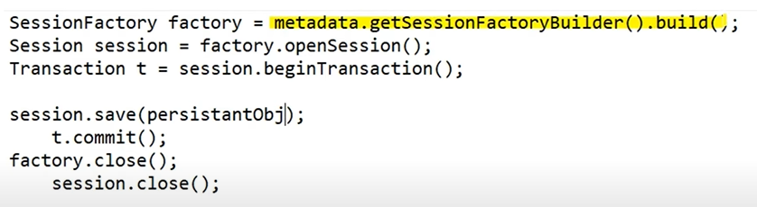
Annotations
Javax.persistence @Entity – specify entity beans that stored in DB
@Table – define table name
@Access – getters or setters used
@Id – primary key
@EmbeddedId – composite primary key (2 or more)
@Column – column name
@GeneratedValue(GenerationType.IDENTITY)
@OneToOne
Org.hibernate.annotations @Cascade – cascading btw to entities
@PrimaryKeyJoinColumn – property for foreign key
Mappings
One-to-one – student – emailid
Many-to-one – students – address
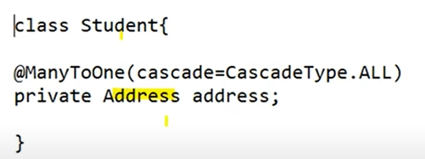
Many-to-many – student – degrees
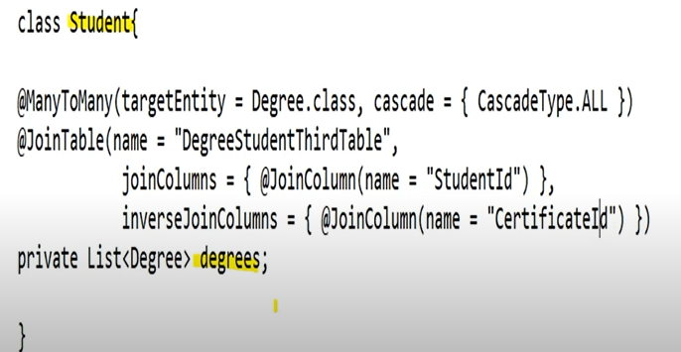

hibernate.cfg.xml file
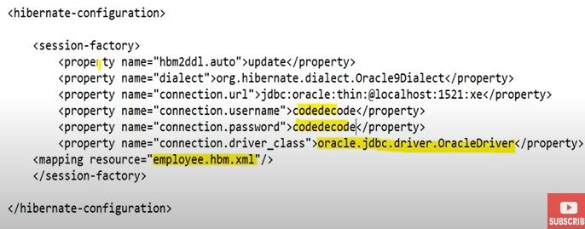
Contains database specific configs and used to initialize SessionFactory
Another session factory for another different database.
Student.hbm.xml
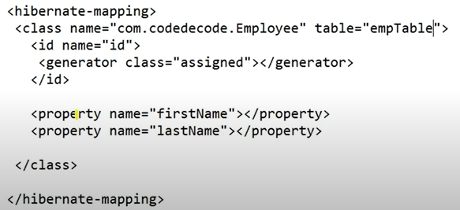
Specifies the persistent class for persistence purpose.

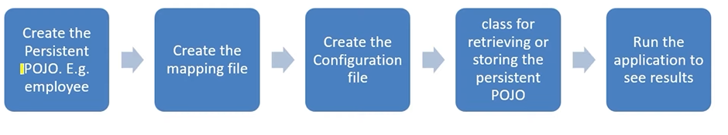

Diff openSession and getCurrentSession
getCurrentSession : session bound to the context, which is context of hibernate.
openSession – new session. Close it. In multi-threade environment for every thread new session.
Diff get and load
Get() – load the data as soon as it is called
Load() – return proxy object and loads dat only when it is actually required. Supports lazy loading.
NOTE: load() throws an exception when no data is found so if u r not sure then use get()

Caching
Improves performance by reducing interaction with DB
  - First level:
Associated with Session object, by default enabled, no disabling.
We can clear cache completely
Any object cached in a session will not be visible to another session.
Cache is lost when session Is closed.
  - Second Level:
By default is disabled
EHCache and InfineSpan
Add hibernate- ehcache dependency
Add properties in hibernate.cfg.xml file
Query level cache 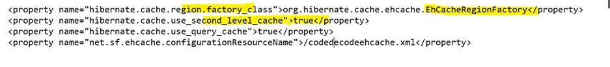
Query level cache will only work with second level cache
Cache.xml - 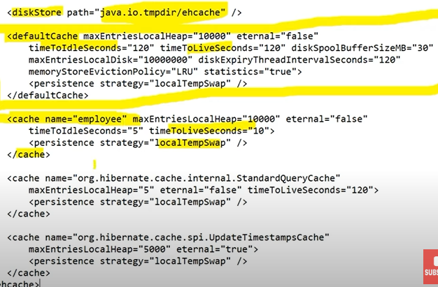
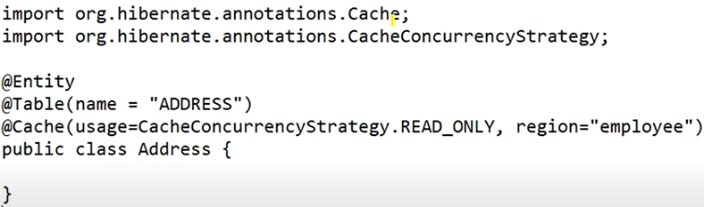
  - Query level:

