I am Mallikarjuna,
I live in Nandyal, Andhra Pradesh.
I have joined DXC in 2021 AUG as a fresher.
I worked in App Remediation project for London’s Markets Xchanging application.
Migrating from java 6 to 8 and from JAX-RS-WS specification to Spring boot rest API’s.

My primary skills are Core java, spring boot, Maven.
And secondary skills are Angular, SQL.

My roles and responsibilities are:
Understanding the

Lloyds of London.
is an insurance and reinsurance market.
insurance means protection from financial losses and Reinsurance is insurance that an insurance company purchases from another insurance company to insulate itself (at least in part) from the risk of a major claims event.
It is a unique place where people and companies come together to share and manage risks. It's not an insurance company itself, but more like a marketplace where these groups, called syndicates(group of people with same interests), work together. These syndicates are made up of individuals and businesses who pool their money to cover insurance risks.
Marine insurance covers the physical loss or damage of ships, cargo,
Lloyds market processing is handled by two companies,
XIS – xchanging ins-sure service: responsible for managing and processing of policies within Lloyds market. Like policy issuance, premium collection, and policy documentation.
XCS – Xchanging claims services – responsible for managing the processing of claims within the Lloyds market. Like claims validations, settlement, and documentation.

Policy – contract btw insurer and insured that outlines the terms and conditions of insurance coverage.
Premium- the amount of money paid by insured to the insurer in exchange for insurance coverage.
Claim- request made by insured to the insurer for payment of a loss covered by the insurance policy.
Underwriting-process of evaluating and assessing the risk of insuring a particular individual or entity.
Ex: Imagine you're buying car insurance. The underwriter will consider things like your driving record, the type of car you drive, and where you live. If you're seen as a higher risk (for example, if you've had multiple accidents), the underwriter may offer you insurance at a higher premium to offset that risk. If you're considered a lower risk (perhaps you have a clean driving record), you might get a lower premium.
Coverage- the specific risks or events that are protected by an insurance policy.
Deductible- amount of money that the insured must pay out of pocket before the insurance company will pay a claim.
Beneficiary: person or entity designated to receive the benefits of an insurance policy in the event or claim
Policyholder: person or entity that owns an insurance policy.
Rider: an additional provision added to an insurance policy that modifies the coverage or terms of the policy.
Exclusion: A provision in an insurance policy that specifies what is not covered by the policy.
Adjuster: a person employed by an insurance company to investigate and settle claims.
Loss: money that an insurer pays out as a result of a claim

claims
UCR Unique Claim Refrence - created by the broker
UMR Unique Market Reference – created by the broker
CLASS Claims Loss Advice and Settlement System
Third Party Administrators- TPA
MA – managing agent(
They are responsible for assessing risks, setting premiums, issuing policies, and ensuring that claims are processed efficiently and fairly
Managing agents act as the representatives of insurers and are tasked with maximizing the profitability and performance of the insurance portfolios they manage.)
Collate - to collect, compare carefully in order to verify, and often to integrate or arrange in order
- Block Claims: These are claims that are part of a block of business. A block of business typically refers to a group of similar insurance policies or contracts that are managed together, often because they share similar characteristics or are underwritten by the same insurer or syndicate. Block claims are those claims that belong to this group of policies.
- Blocked Claims: These are claims that have been flagged or identified as being part of a block of business. The term "blocked" here doesn't mean the claims are prevented from processing; instead, it signifies that these claims are recognized as being part of a block of business and may require special handling or consideration.

Workflow of web services
Step A:
1. submitClaim()– UMR, Risk code, claim report file name, original currency, policy id
- Broker submit the claim on behalf of the insured with UMR, RISK code (provides a common basis for the classification/description of risks )Valid Lloyd’s risk code. Available as a drop down box in the template on UI. Original currency ("original currency" refers to the currency in which a financial amount is denominated at its source). This data should be submitted to the database system. And an email is sent to Managing Agent after a claim is added.
claim status – open, closed.
2. getClaimsDataForSyndicatesValidation () - syndicate can view and validate the data provided by the xchanging with the data it has.
3. forManagingAgent()- MA can see relevant UMRs to be analysed on a look through basis then risk and claims data should be completed to include all data available to MA from TPAs.
4. Resubmission of a claim will be required if the provided claim information, resubmission time is for 2 days from the time it is rejected.
Key fields for risk/premium are: UMR, Risk Code, Original Currency and Risk/Certificate Reference Key fields for claims are: UMR, Risk Code, Original Currency and Claim Reference
Data confirmation
Lloyd’s will require an email from each managing agent, briefly outlining the work that has been done to collate the data, and an appropriate proportion of the each syndicate’s data that the managing agent has been able to include.
Outstanding Claims Amount as at the beginning of the period refers to the total amount of claims that were pending or unpaid at the start of a given period, such as a month, quarter, or year.
Outstanding Claims Amount as at the end of the period refers to the total amount of claims that are pending or unpaid at the end of the same period, after considering all claims incurred during the period and any claims that may have been settled or paid out.
Paid to date amount – till present date
Paid to year amount – within year

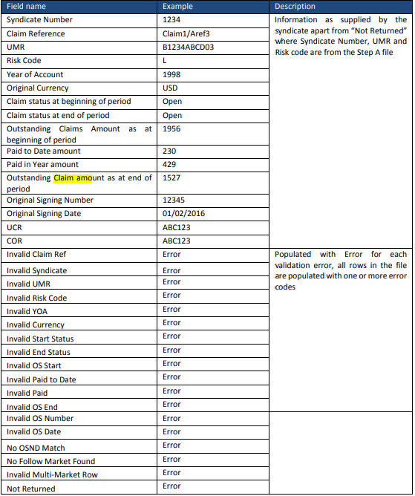

Vehicle insurance application
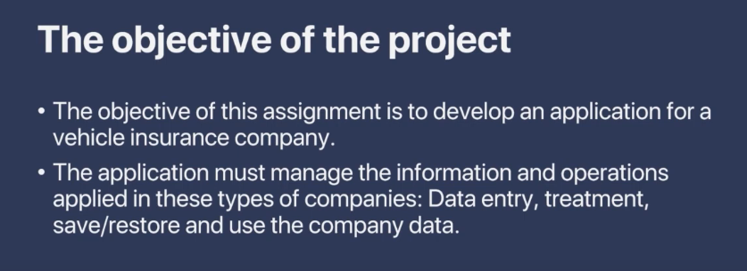
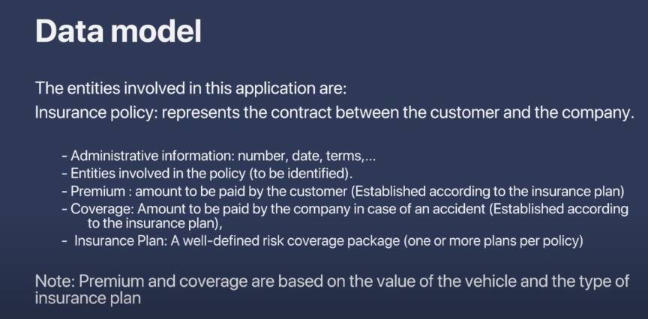
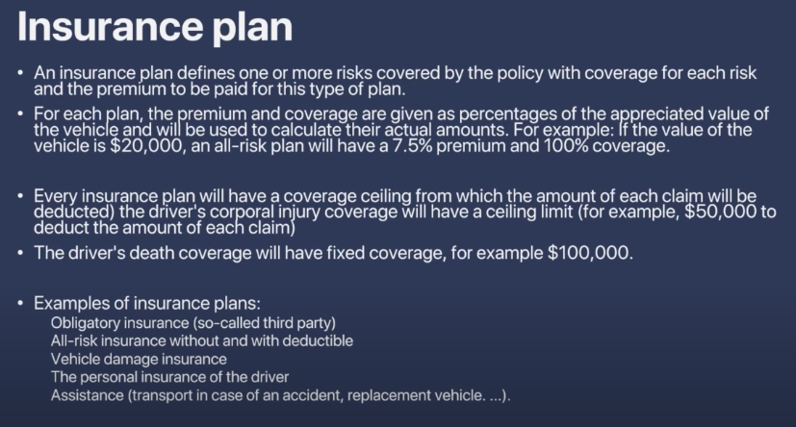
Appreciated value : typically refers to increase in the value of insured item or policy over time.
Typically, vehicles depreciate in value over time rather than appreciate. However, certain aspects of vehicle insurance and unique cases might touch on the idea of appreciation indirectly.
Key Points about Vehicle Insurance and Value:
- Depreciation: Vehicles generally lose value over time due to wear and tear, usage, and aging. Standard vehicle insurance policies account for this depreciation when calculating the payout for claims.
- Agreed Value Policies: Some insurance policies offer agreed value coverage where the insurer and the policyholder agree on the vehicle's value at the time of policy issuance. This agreed value can be used for the payout in the event of a total loss, regardless of depreciation.
- Classic and Collector Cars: For classic, vintage, or collector cars, which can appreciate in value, specialized insurance policies are available. These policies typically involve regular appraisals to adjust the insured value based on the current market value of the vehicle.
Real-Time Example: Depreciation vs. Agreed Value Policy
Scenario 1: Standard Insurance Policy with Depreciation
Vehicle: 2018 Toyota Camry
- Initial Purchase: $30,000 (in 2018)
- Depreciation Rate: Approximately 15% per year
- Current Year: 2023
- Current Market Value:
  - 2019: $30,000 - 15% = $25,500
  - 2020: $25,500 - 15% = $21,675
  - 2021: $21,675 - 15% = $18,423.75
  - 2022: $18,423.75 - 15% = $15,660.19
  - 2023: $15,660.19 - 15% = $13,311.16
Accident Occurs in 2023:
- Total Loss: Vehicle is totalled in an accident.
- Insurance Payout: Based on the depreciated value, the payout would be around $13,311.16.

Scenario 2: Agreed Value Policy
Vehicle: 2018 Toyota Camry
- Initial Purchase: $30,000 (in 2018)
- Agreed Value Policy: Policy taken in 2018 with an agreed value of $30,000, periodically updated.
- Current Year: 2023
- Updated Agreed Value (in 2023): After regular appraisals, the agreed value is adjusted to reflect a well-maintained car with additional features, currently set at $25,000.
Accident Occurs in 2023:
- Total Loss: Vehicle is totaled in an accident.
- Insurance Payout: Based on the agreed value, the payout would be $25,000, regardless of the current market depreciation.
Practical Steps to Implement Agreed Value Policy
- Choose a Policy: Opt for an insurance policy that offers agreed value coverage.
- Initial Appraisal: Get the vehicle appraised to determine its initial agreed value.
- Regular Appraisals: Schedule periodic appraisals (annually or bi-annually) to update the agreed value, especially if the vehicle is well-maintained or upgraded.
- Documentation: Maintain records of all appraisals, maintenance, and upgrades to support the agreed value.
- Communicate with Insurer: Regularly update your insurer with the new appraised value to adjust the policy accordingly.
Insurance companies determine the depreciation of a vehicle using various factors and data sources. Here’s a detailed look at how they assess vehicle depreciation:
1. Age of the Vehicle
- Depreciation Curve: Vehicles lose value quickly in the first few years and then more slowly. This curve is well-documented and used by insurers.
- Standard Rates: Insurers have standard depreciation rates based on the vehicle's age, often around 15-25% per year initially.
2. Vehicle Make and Model
- Resale Value Trends: Some brands and models hold their value better than others. Insurance companies use historical data to predict future values.
- Market Analysis: They analyze the market trends for specific makes and models.
3. Mileage
- Usage Impact: Higher mileage typically means greater wear and tear, leading to faster depreciation.
- Mileage Bands: Insurers often use mileage bands to adjust depreciation rates.
4. Condition of the Vehicle
- Maintenance Records: Regular maintenance and good condition can slow depreciation.
- Wear and Tear: Visible wear and tear, damage, and lack of maintenance accelerate depreciation.
5. Accident History
- Previous Claims: Vehicles with a history of accidents or claims depreciate faster.
- Repair Quality: High-quality repairs may mitigate depreciation to some extent.
6. Market Demand
- Supply and Demand: High demand and low supply for a particular vehicle can slow depreciation.
- Economic Factors: Economic conditions affecting used car markets are considered.
7. Depreciation Calculators and Guides
- Industry Guides: Insurers use guides like Kelley Blue Book (KBB), Edmunds, and the National Automobile Dealers Association (NADA) for current market values.
- Online Tools: They use proprietary algorithms and tools to calculate depreciation.
All-risk insurance without and with deductible:
- All-Risk Insurance Without Deductible: Provides full coverage with no out-of-pocket costs for claims but comes with higher premiums.
- All-Risk Insurance with Deductible: Requires the policyholder to pay a portion of each claim, resulting in lower premiums but higher out-of-pocket costs when a claim is made.
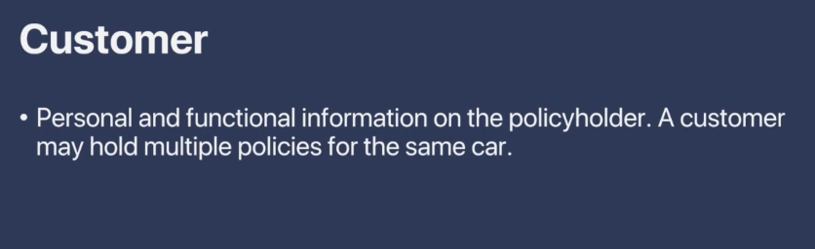
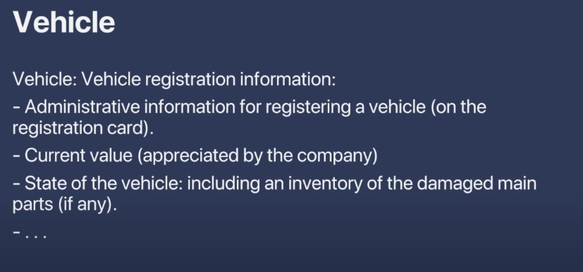
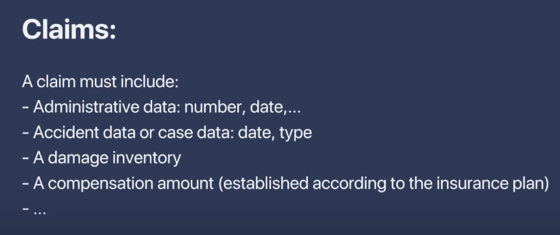
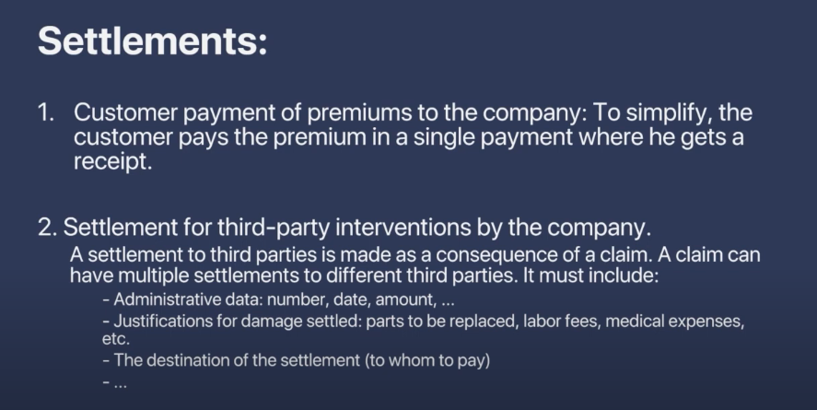
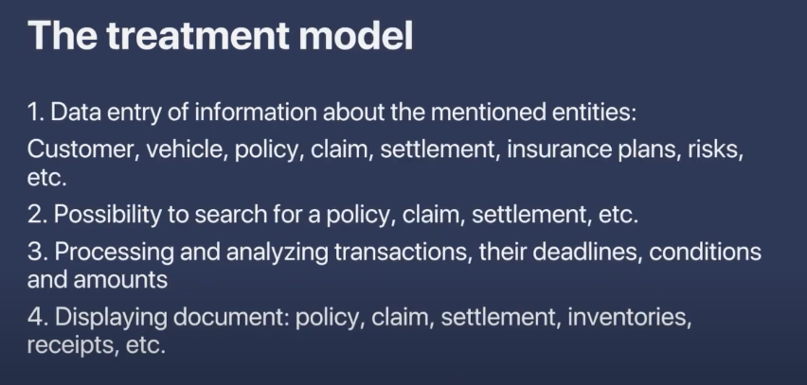

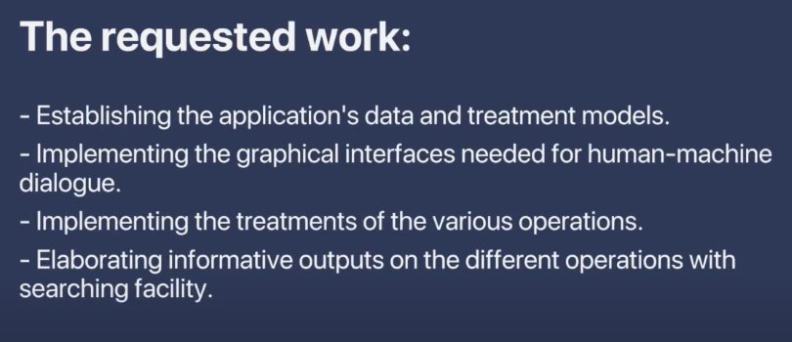
Abstract Risk Class:
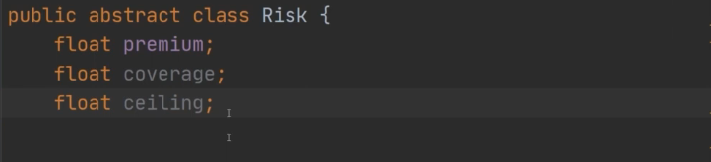
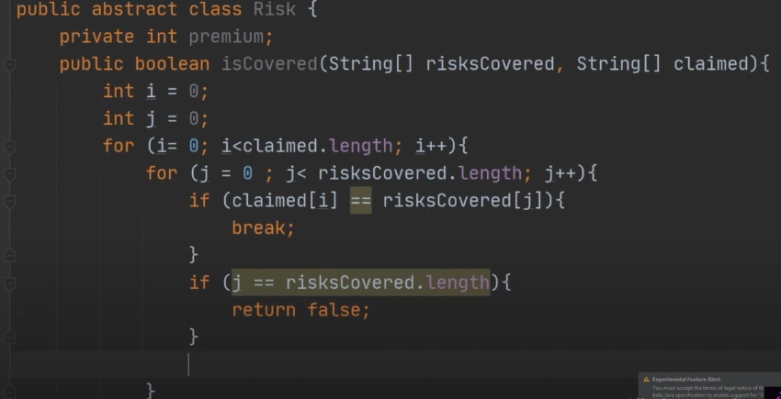
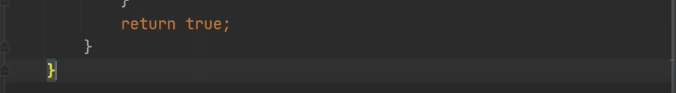

VehicleRisk class extends Risk:
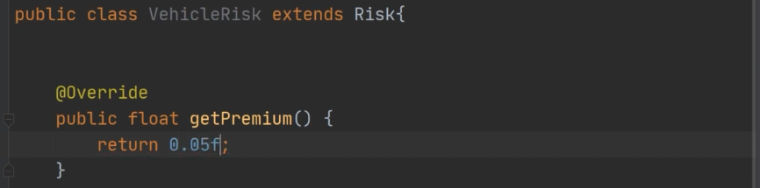
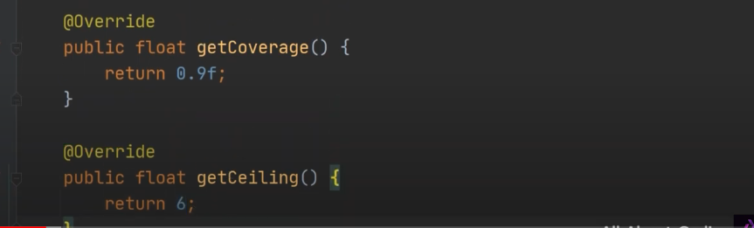
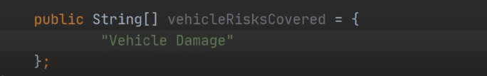
- Premium: The cost of the insurance policy, influenced by risk factors, coverage amount, and deductible choices.
- Coverage: The extent of protection provided by the policy, specifying what is covered and under what circumstances.
- Ceiling: The maximum payout from the insurance company for a covered loss, either per claim or over the policy period.
Obligatory Risk class extends Risk:
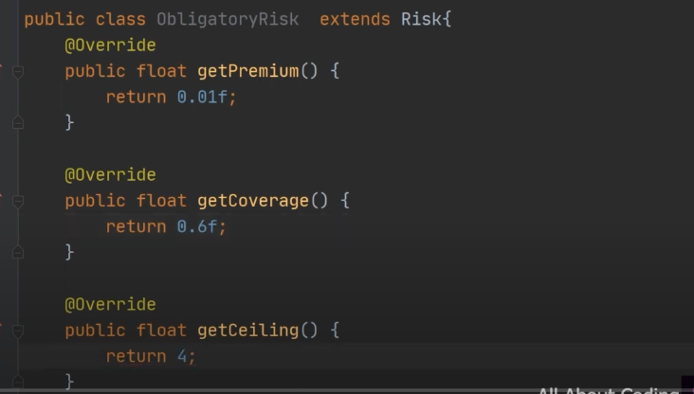
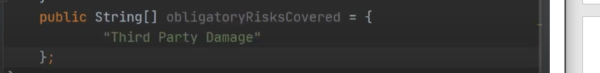
DriverRisk class extends Risk:
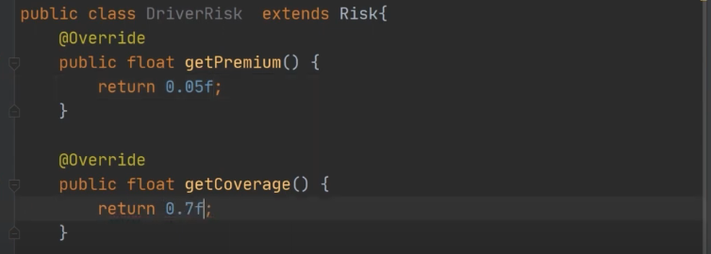
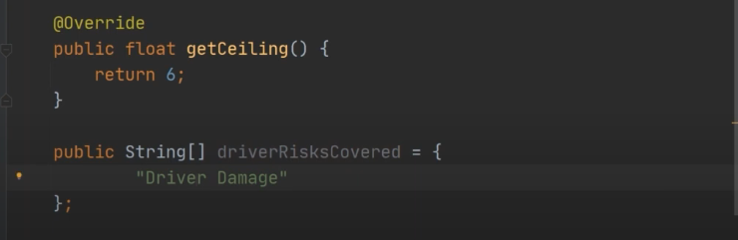
AssistanceRisk class Extends Risk
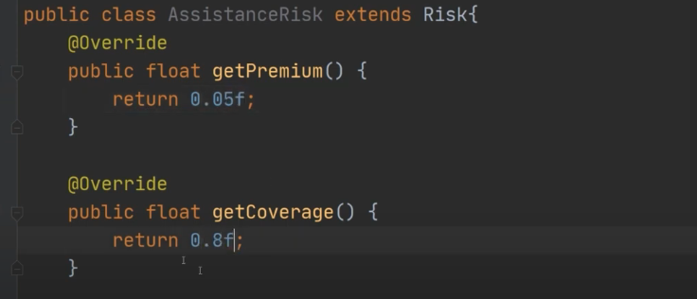
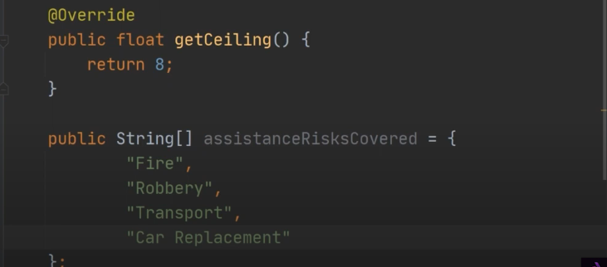
AllRisk class extends Risk:
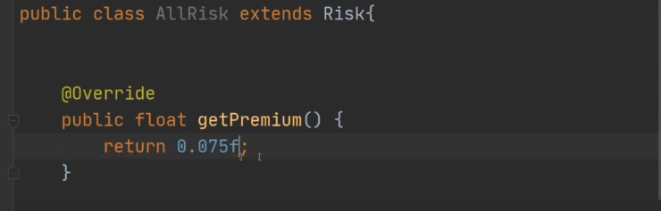
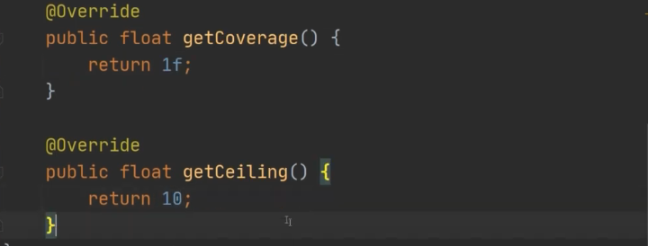
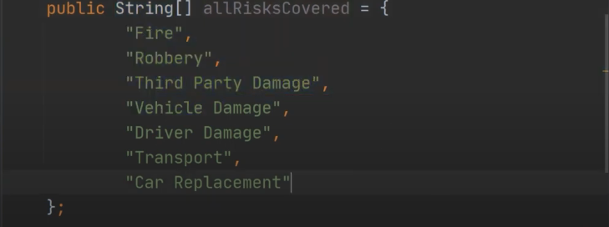
Third party damage : refers loss cause to someone who is not directly involved in a contract or transaction but is affected by the actions of the parties involved.
First party : policyholder.
Second Party : insurance company.

Policy package :
Vehicle class:
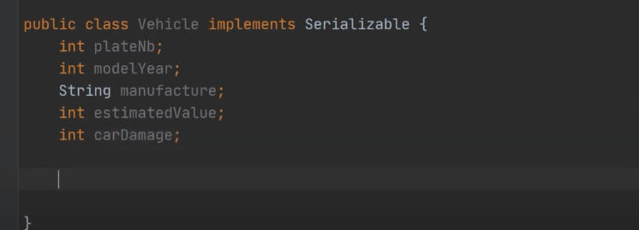
Policy class
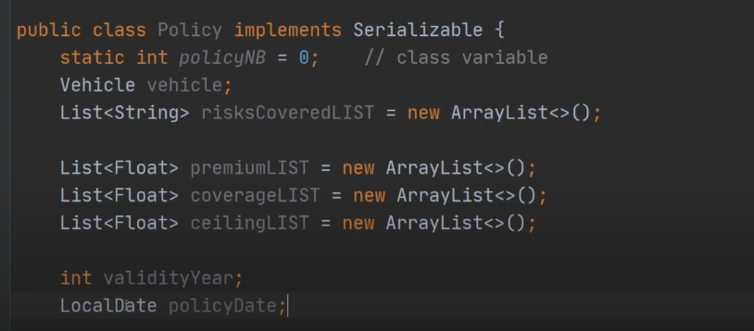
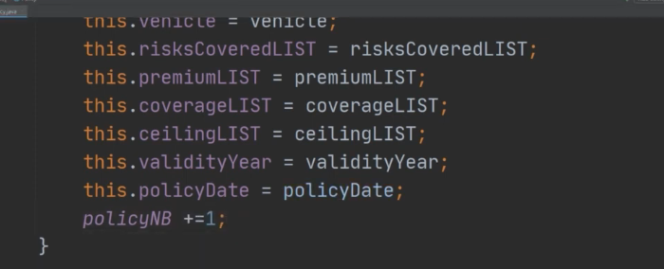
Customer Class:
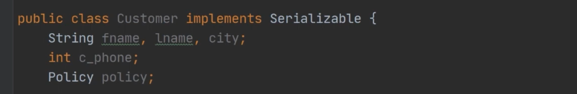

MainScreen class extends JFrame:
