Joined DXC in 2021 Aug. My recent project is PACE.
It is an HPE tool to calculate rebates for HPE partners based on their sales. Sales data is received from upstream system warehouse or inventory once the products are sold. It is done by creating quarterly schemes for the partners by providing the rebate percentage and target which is optional. PACE recalculates the rebates on daily basis using schedulers as partner does

PACE:
Partner compensation calculation engine to calculate rebates/bonus for the HPE partners on quarterly based.
Scheme life cycle management, formula building, pay file generation.

CSV UPLOAD:
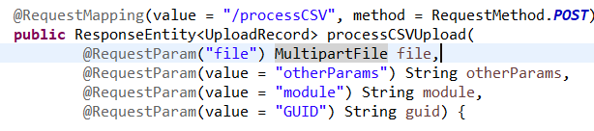
MultipartFile : stores file contents in memory or temporarily on disk and data should be processed or save to persistent store before the storage is cleared at the end of request processing.
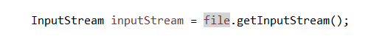
Call getInputStream() to get an InputStreamObject. This gives stream of bytes.
InputStreamReader converts bytes to characters using specified encoding.
BufferedReader improves efficiency by reading data in chunks (buffers) rather than char by char reducing the number of I/O operations.
Buffer Mechanism in BufferedReader
- Instead of reading one character at a time, BufferedReader reads chunks of data into a buffer.
- Default buffer size: 8192 characters (8 KB).
- When the buffer is empty, it refills by reading from InputStreamReader.
- Methods like readLine() fetch data from the buffer instead of direct I/O calls, making it efficient.
Apache commons CSVParser :
CSVParser : parse CSV file according to specified format.
CSVRecord : each row of the parsed CSV file with comma separated values.

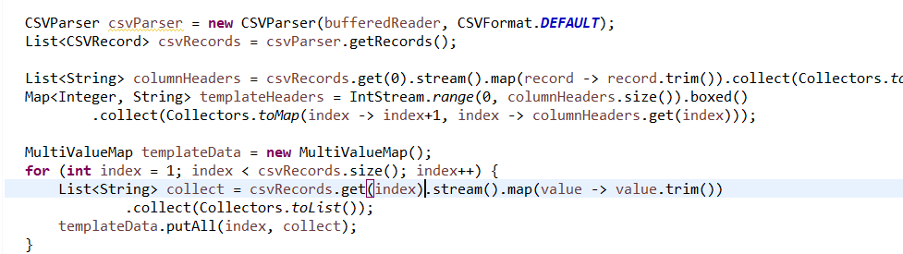

SFTP connection:
Used JCraft library to connect to Secure File Transfer Protocol.
Use private key to authenticate with host.
