Heart Disease Risk Predictor
An End-to-End MLOps Pipeline

Assignment 01
Production-Grade ML Lifecycle
AIMLCZG523 — MLOps
BITS Pilani (WILP)
Author: Mohanraj G
BIT ID: 2024AC05048
Date: 10 July 2026
Repository: https://github.com/gmraj2005/bits_sem3_mlops_001

1. Project Overview

Cardiovascular disease is the leading cause of death worldwide, and early risk stratification materially improves clinical outcomes. This project builds a supervised machine-learning classifier that predicts whether a patient is likely to have heart disease from 13 routinely-collected clinical measurements (age, resting blood pressure, cholesterol, chest-pain type, maximum heart rate, and others), and — critically — wraps that model in a complete, reproducible MLOps lifecycle rather than leaving it as a notebook.
The problem is framed as binary classification: the original UCI severity grade (0–4) is collapsed to 0 = no disease and 1 = disease present. The deliverable is not merely an accurate model but a cloud-ready, monitored, continuously-tested prediction service. The pipeline spans data acquisition and cleaning, exploratory analysis, model development with hyperparameter tuning, experiment tracking and a model registry (MLflow), automated testing and CI/CD (GitHub Actions), containerisation (Docker), orchestration (Kubernetes / Minikube), and observability (Prometheus + Grafana).
A central design decision is that the winning model is persisted as a single self-contained scikit-learn Pipeline that embeds the fitted preprocessor together with the estimator. Inference therefore requires no external feature-engineering code, eliminating training/serving skew — the most common source of silent production failures in ML systems.

High-Level Architecture

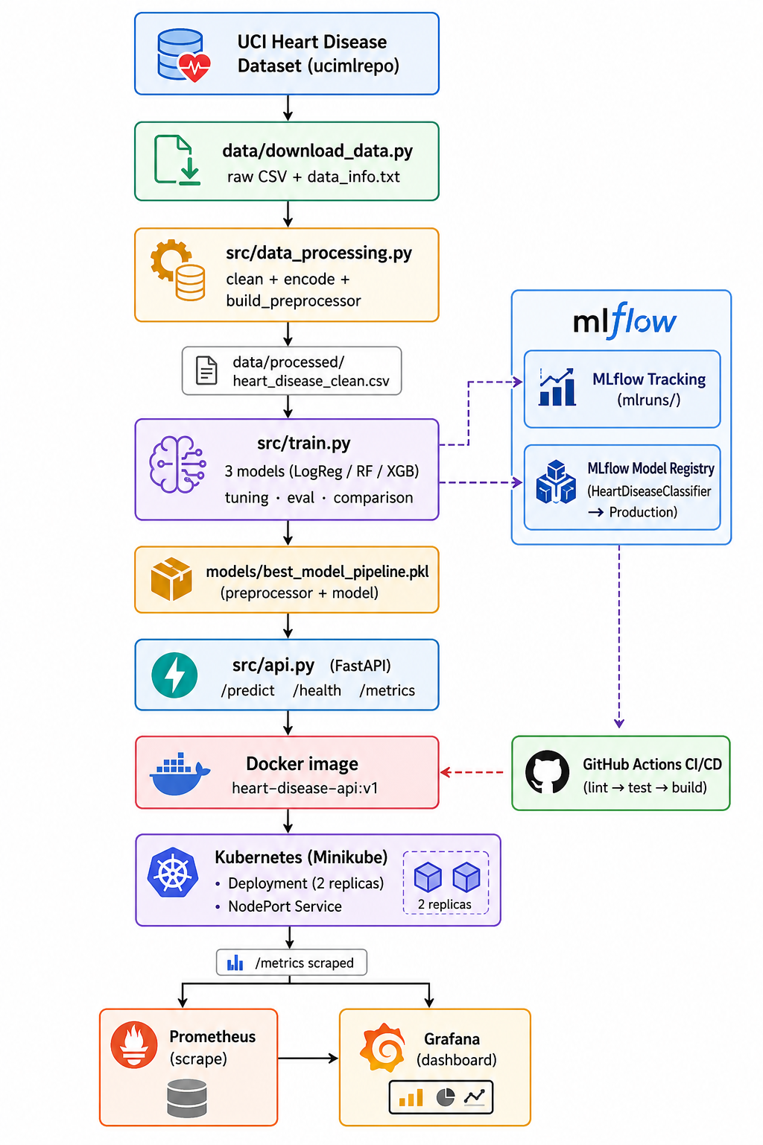

2. Setup & Installation

The project runs from a clean environment using pinned dependencies. Two install paths are provided so the pipeline is reproducible on any machine.

Prerequisites
- Python 3.10 and Git — required for the core pipeline.
- Docker Desktop — required for containerisation and the monitoring stack.
- Minikube + kubectl — required for the Kubernetes deployment phase.

Option A — pip + venv
python -m venv venv
venv\Scripts\activate # Windows
pip install -r requirements.txt -r requirements-dev.txt

Option B — conda
conda env create -f environment.yml
conda activate mlops-heart-disease

Reproducing the model (one command chain)
python data/download_data.py # -> data/raw/heart_disease_raw.csv
python src/data_processing.py # -> data/processed/heart_disease_clean.csv
python -m src.train # -> models/best_model_pipeline.pkl + mlruns/
All randomness is seeded (random_state = 42) across the train/test split, cross-validation folds, and every estimator, so results are deterministic and reproducible run-to-run.

Repository Structure
heart-disease-mlops/
├── data/ raw + processed datasets, download_data.py
├── notebooks/ 01_eda.ipynb, 02_training.ipynb
├── src/ data_processing.py, train.py, predict.py, api.py
├── tests/ test_data.py, test_model.py, test_api.py
├── models/ best_model_pipeline.pkl, model_info.json
├── mlruns/ MLflow tracking store + registry
├── scripts/ test_inference.py, load_test.py
├── docker/ docker-compose.monitoring.yml, prometheus.yml
├── k8s/ deployment.yaml, service.yaml
├── screenshots/ eda / mlflow / cicd / docker / k8s / monitoring
├── .github/workflows/ ci.yml
├── Dockerfile
└── requirements.txt / requirements-dev.txt / environment.yml

Technology Stack
Layer | Tools
Language | Python 3.10
Data / ML | pandas, numpy, scikit-learn, XGBoost
Experiment tracking | MLflow (tracking + model registry)
API | FastAPI, Uvicorn, Pydantic
Testing / lint | pytest, pytest-cov, flake8, ruff, black
CI/CD | GitHub Actions
Container / Orchestration | Docker, Kubernetes (Minikube)
Monitoring | Prometheus, Grafana, prometheus-fastapi-instrumentator

3. Exploratory Data Analysis

The dataset is the UCI Heart Disease (Cleveland) collection, fetched programmatically via the ucimlrepo package (id = 45). It contains 303 patient records with 13 clinical features and one target column (num).
Property | Value
Rows × columns | 303 × 14 (13 features + target)
Numeric features | age, trestbps, chol, thalach, oldpeak
Categorical features | sex, cp, fbs, restecg, exang, slope, ca, thal
Missing values | ca: 4, thal: 2 (imputed)
Target (binarised) | 164 no-disease / 139 disease

Data Quality & Missing Values
The raw feed is clean of the '?' sentinel that plagues some Cleveland variants; only two columns carry genuine NaNs — ca (4 missing) and thal (2 missing). These are imputed with the column median (numeric) or mode (categorical) inside DataProcessor.handle_missing, so no rows are discarded and the full 303 records are retained for modelling.
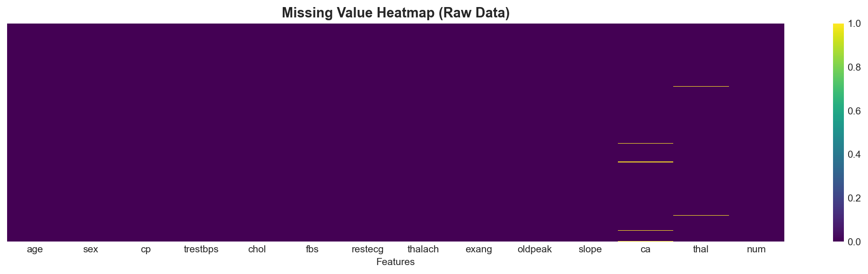
Figure 2. Missing-value heatmap — sparse missingness confined to ca and thal.

Class Balance
After binarising the severity grade, the classes are 164 no-disease (54%) versus 139 disease (46%). This is a mild imbalance well within the tolerance of the chosen algorithms, so no resampling (SMOTE / class weighting) was applied; a stratified split preserves the ratio in both train and test folds.
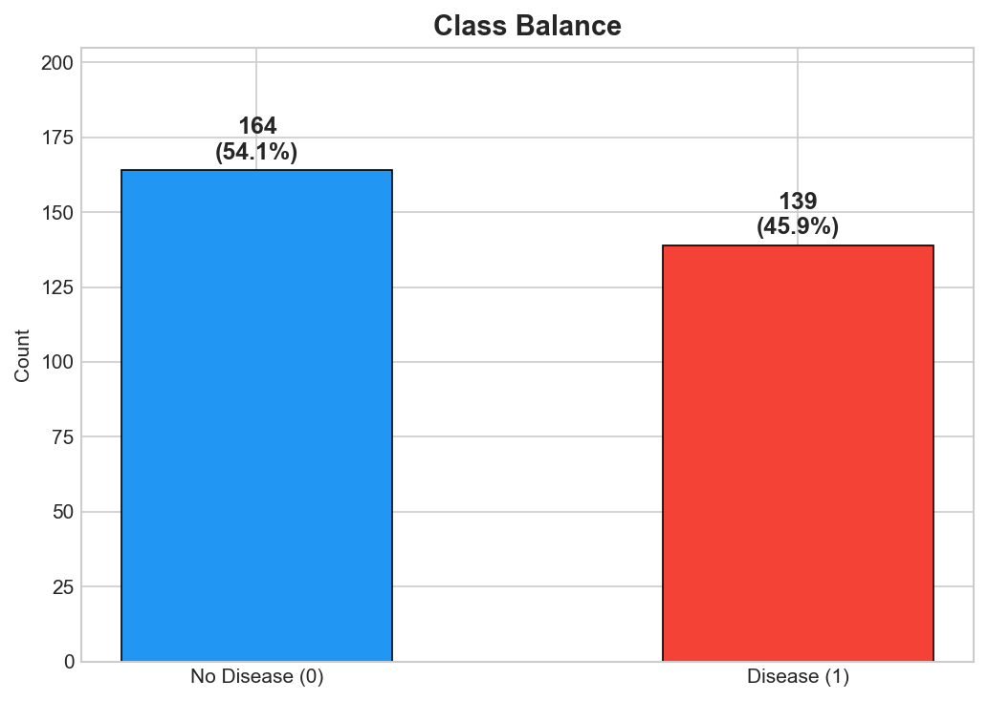
Figure 3. Target class distribution (0 = no disease, 1 = disease).

Feature Distributions & Correlation
Distributions of the five numeric features, split by target class, show clear separation for thalach (maximum heart rate — lower in diseased patients) and oldpeak (ST depression — higher in diseased patients). The correlation analysis confirms this: the features most associated with the target are chest-pain type (cp), thalassemia (thal), number of major vessels (ca), exercise-induced angina (exang), and oldpeak.
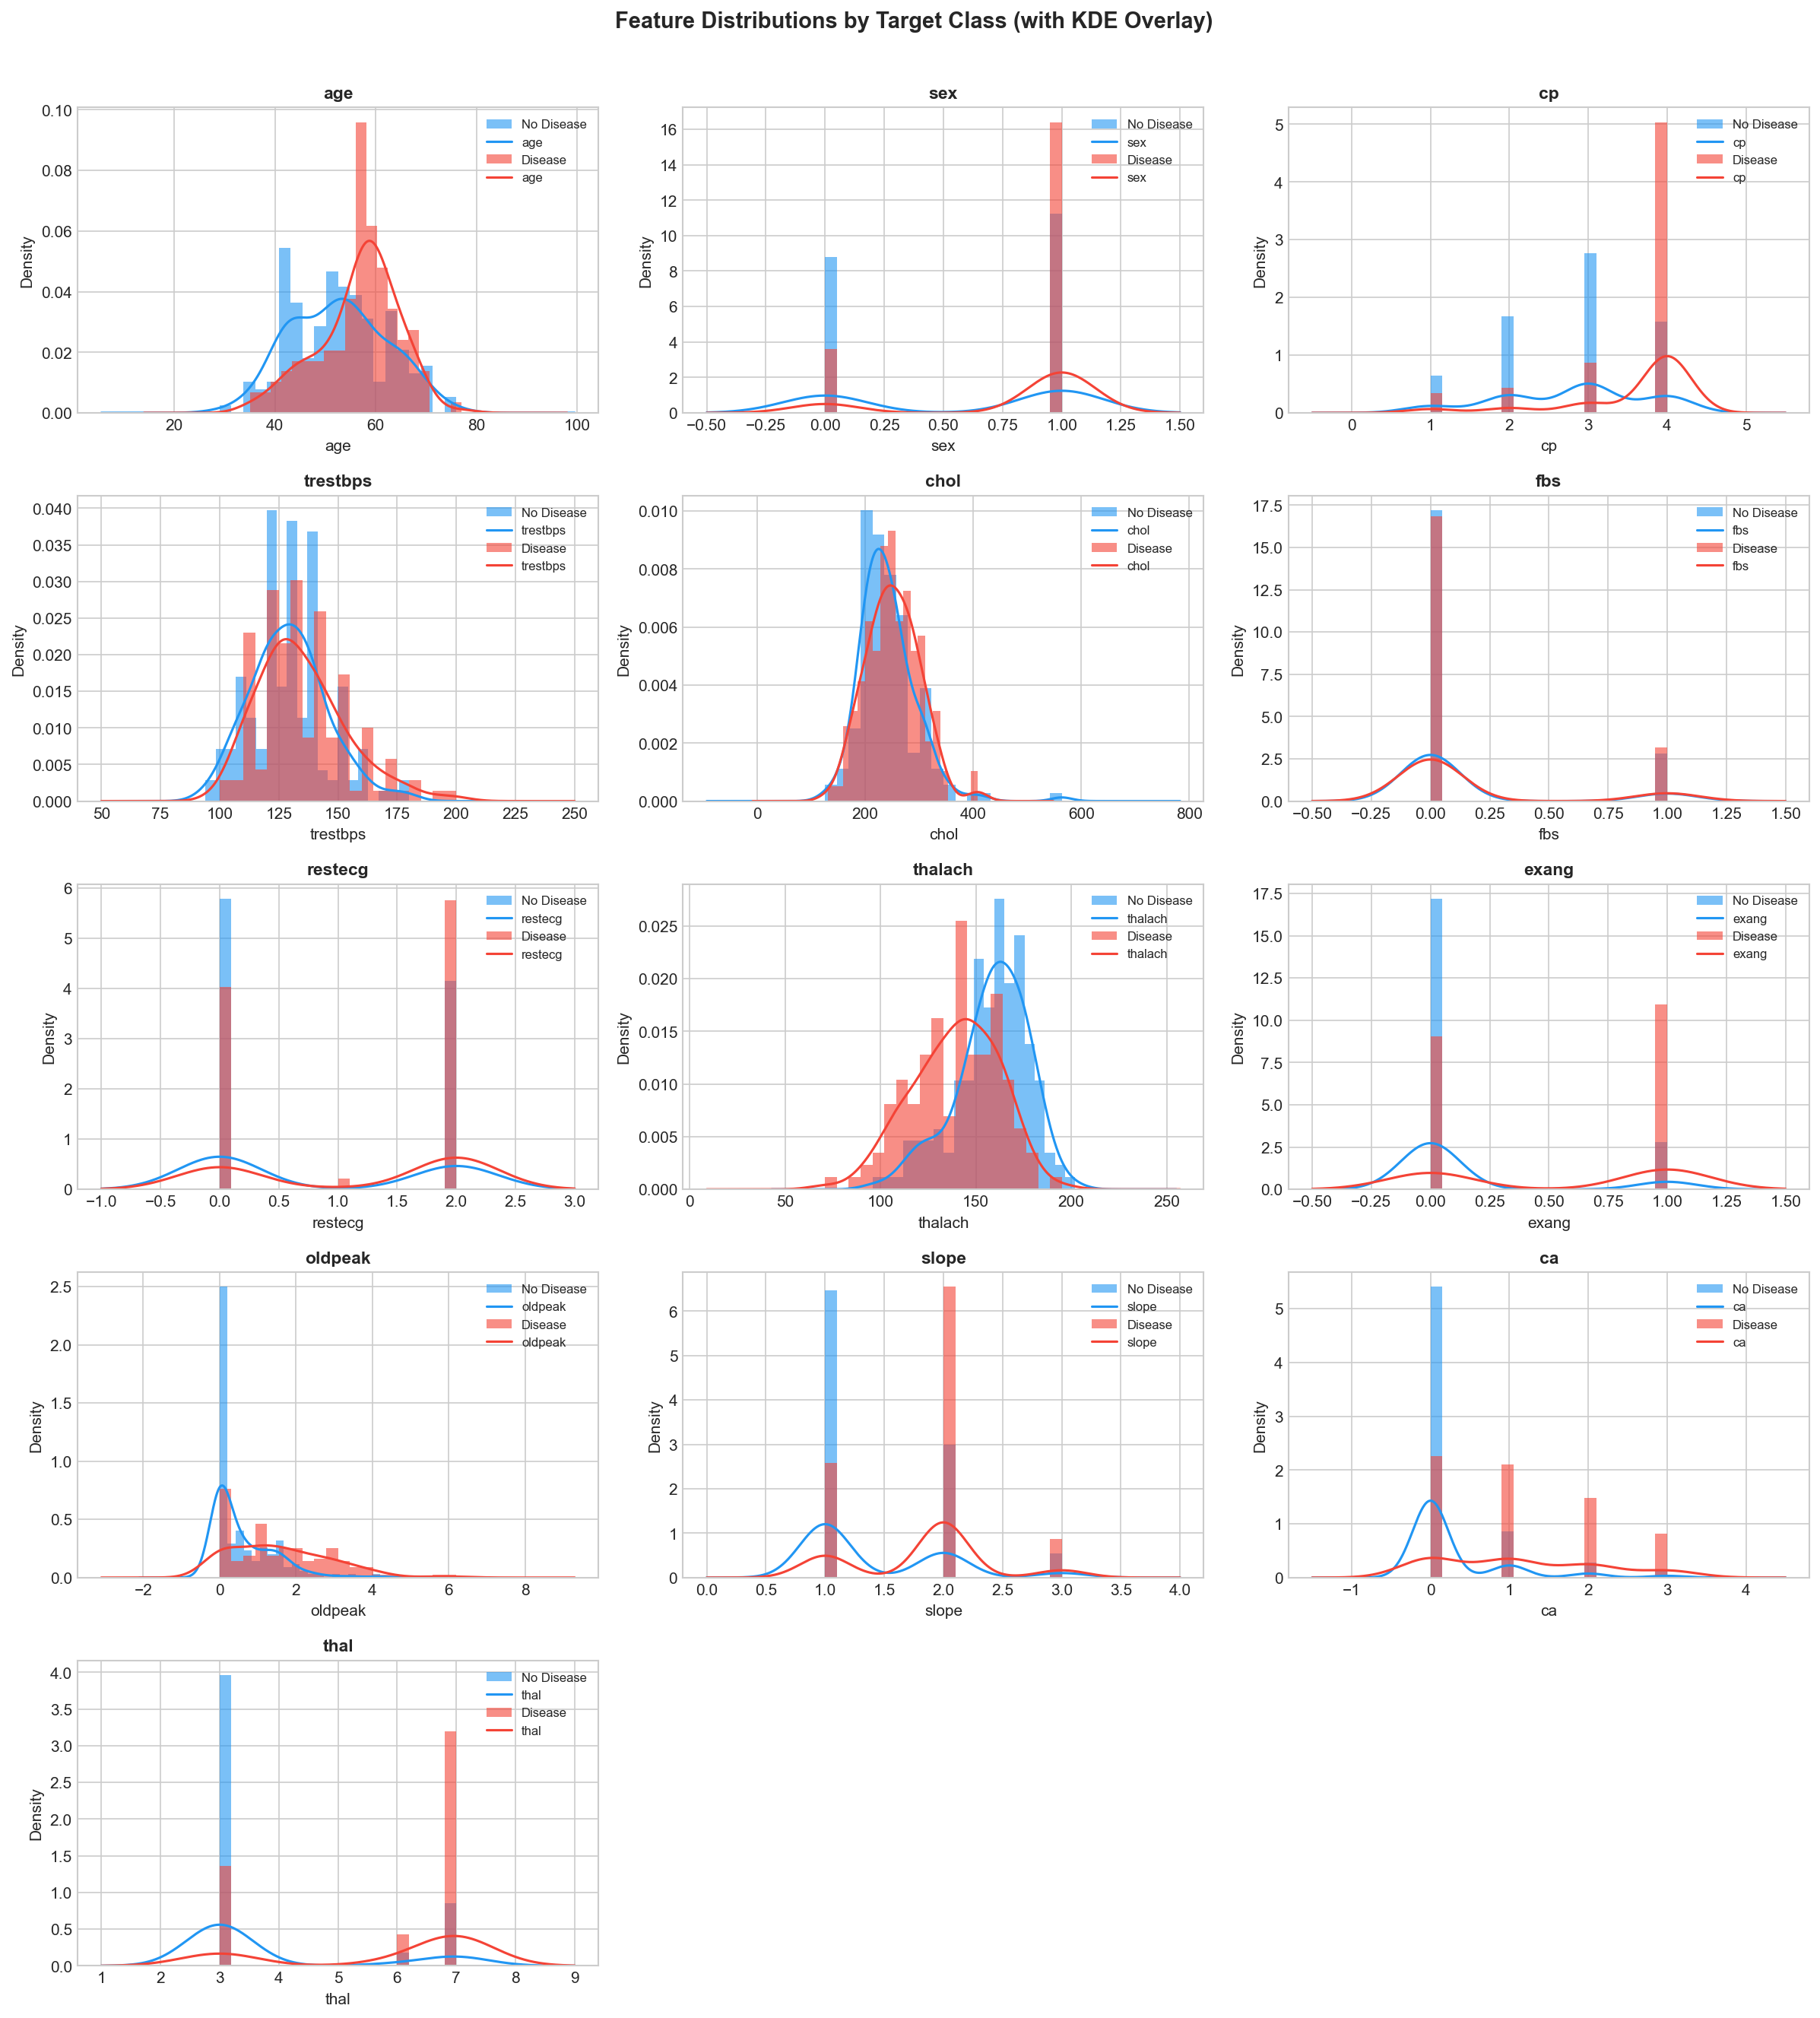
Figure 4. Numeric feature distributions coloured by target class.
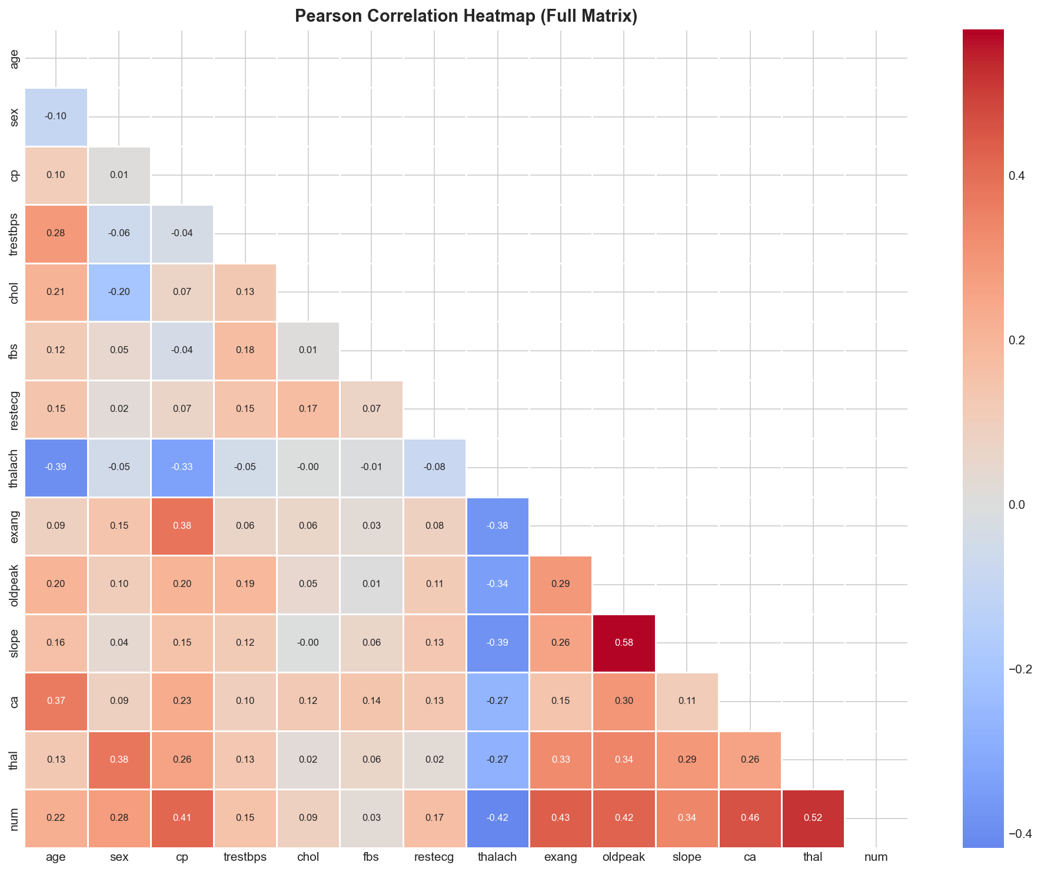
Figure 5. Pearson correlation heatmap across all features and the target.

4. Model Development

Feature Engineering & Preprocessing
Preprocessing is implemented as a scikit-learn ColumnTransformer so it is fitted only on training data and travels with the model:
- Numeric columns (age, trestbps, chol, thalach, oldpeak) are standardised with StandardScaler to zero mean and unit variance.
- Categorical columns (sex, cp, fbs, restecg, exang, slope, ca, thal) are one-hot encoded with handle_unknown='ignore', so unseen categories at inference degrade gracefully instead of crashing.
The transformer is composed with each estimator inside a single Pipeline object: Pipeline([('preprocessor', ...), ('model', ...)]). This is the crux of the packaging strategy — the persisted artifact contains both the fitted scaler/encoder and the trained estimator, so raw patient dictionaries can be scored directly with no separate preprocessing step.

Training Protocol
- Split — stratified 80/20 train/test (242 train, 61 test rows), random_state=42.
- Cross-validation — 5-fold StratifiedKFold, scored on ROC-AUC.
- Selection metric — ROC-AUC on the held-out test set, chosen because it is threshold-independent and robust to the mild class imbalance.

Candidate Models & Hyperparameter Search
Three complementary algorithms were tuned — a linear baseline, a bagging ensemble, and a boosting ensemble:
Model | Tuner | Search space
Logistic Regression | GridSearchCV (exhaustive) | C ∈ {0.01, 0.1, 1, 10}; penalty ∈ {l1, l2}; solver ∈ {liblinear, lbfgs}
Random Forest | RandomizedSearchCV (15 iters) | n_estimators ∈ {100…500}; max_depth ∈ {None,4,6,8,12}; min_samples_split ∈ {2,5,10}
XGBoost | RandomizedSearchCV (15 iters) | n_estimators ∈ {100…500}; max_depth ∈ {3,4,6,8}; learning_rate ∈ {0.01…0.2}; subsample ∈ {0.6,0.8,1.0}
Every search operates over the full Pipeline (hyperparameters prefixed with model__), guaranteeing that preprocessing is re-fitted inside each CV fold and no information leaks from validation folds into training.
5. Model Comparison & Winner Selection

All three tuned pipelines were evaluated on the identical 61-row test set. Results below are from the reproducible training run (seed 42):
Model | Accuracy | Precision | Recall | F1 | ROC-AUC | CV Mean
Logistic Regression ★ | 0.8689 | 0.8333 | 0.8929 | 0.8621 | 0.9589 | 0.9070
Random Forest | 0.8689 | 0.8333 | 0.8929 | 0.8621 | 0.9481 | 0.9017
XGBoost | 0.8852 | 0.8621 | 0.8929 | 0.8772 | 0.9437 | 0.8846

ROC Curves & Confusion Matrices
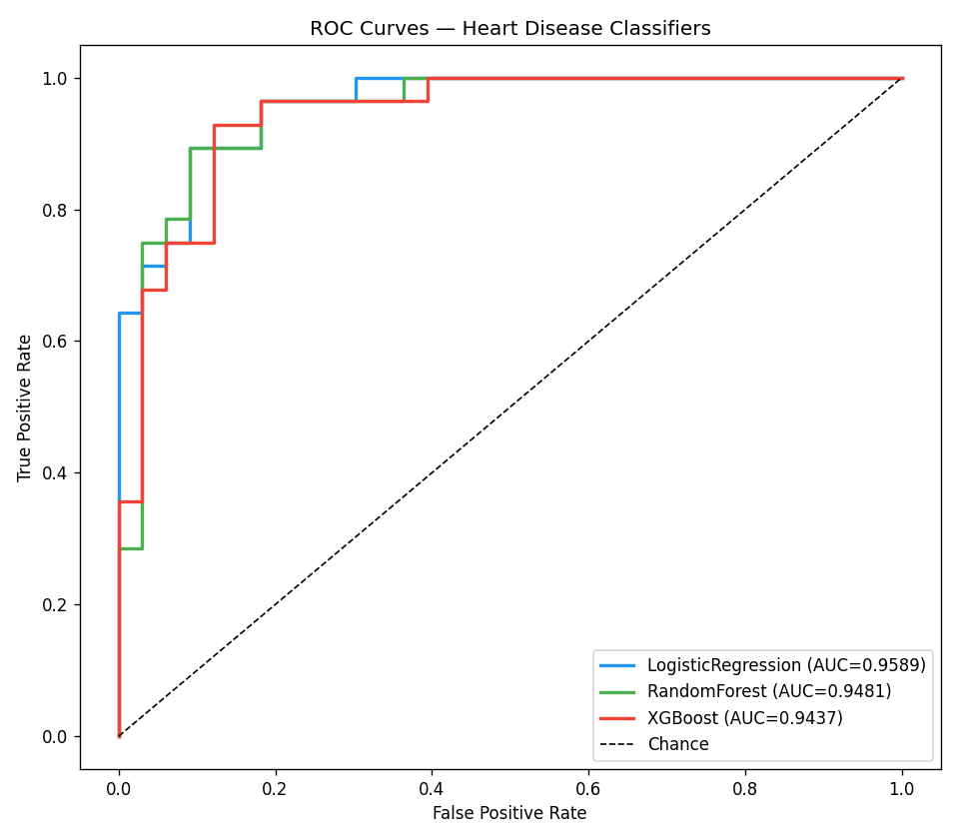
Figure 6. ROC curves — Logistic Regression achieves the highest AUC (0.9589).
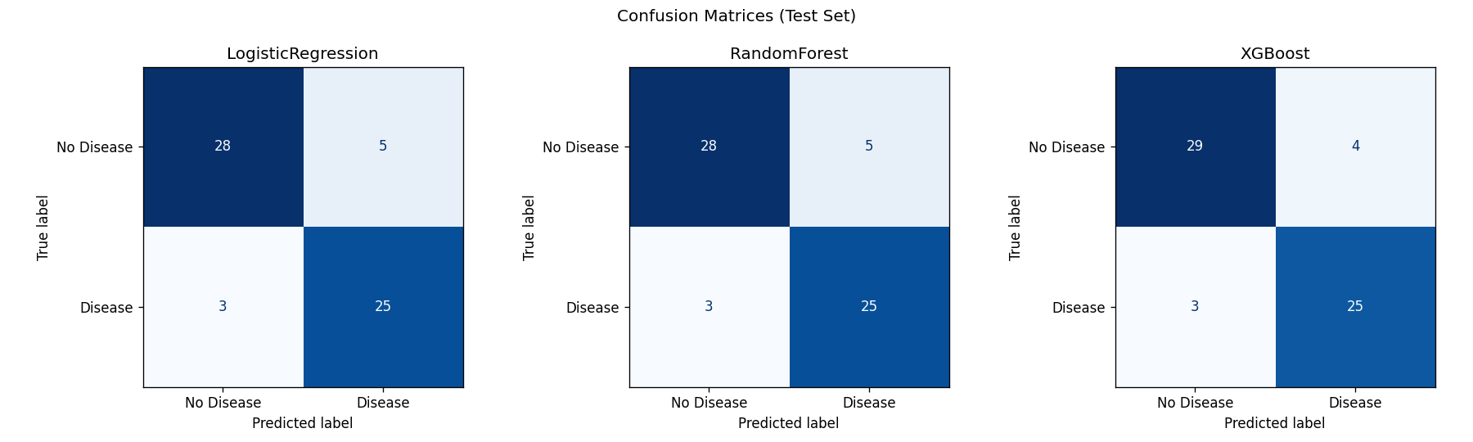
Figure 7. Confusion matrices on the test set for all three candidates.

Winner: Logistic Regression
Logistic Regression (C=1.0, penalty=l1, solver=liblinear) is selected as the production model. Although XGBoost edges ahead on raw accuracy (0.8852), Logistic Regression wins on the primary selection metric, ROC-AUC (0.9589 vs 0.9437), and also posts the best cross-validation mean (0.9070), indicating the strongest and most stable ranking ability across thresholds.
Beyond the numbers, the choice is well-justified for a clinical decision-support setting: the dataset is small (303 rows), where a regularised linear model generalises better and is far less prone to overfitting than deep tree ensembles; the L1 penalty adds implicit feature selection; and coefficient-based models are interpretable, which matters for medical trust and auditability. It is also the lightest artifact (≈4.5 KB) and lowest-latency option to serve.

Feature Importance
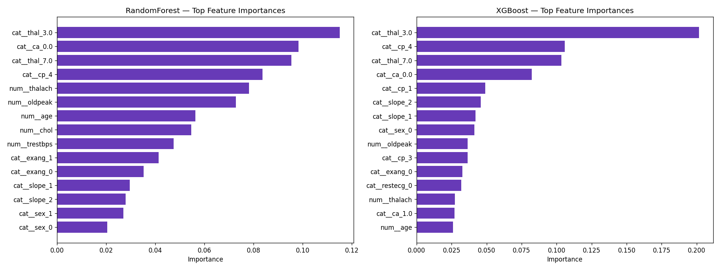
Figure 8. Top feature importances from the tree ensembles, corroborating the EDA: cp, thal, ca, oldpeak, and thalach dominate.

6. Experiment Tracking with MLflow

Every training run is tracked with MLflow using a local file store (file:./mlruns) under a single experiment, heart-disease-classifier. Each of the three models is logged as its own run capturing:
- Parameters — the full set of tuned hyperparameters for the winning configuration.
- Metrics — accuracy, precision, recall, F1, ROC-AUC, and CV mean/std.
- Artifacts — the ROC-curve, confusion-matrix, and feature-importance plots.
- Model — the complete fitted Pipeline via mlflow.sklearn.log_model.
The best run is additionally tagged (status = production-candidate, dataset = heart-disease-uci, author = Mohanraj G). The winning model is then registered in the MLflow Model Registry as HeartDiseaseClassifier and promoted to the Production stage, giving a clean separation between experimentation and the blessed serving artifact.

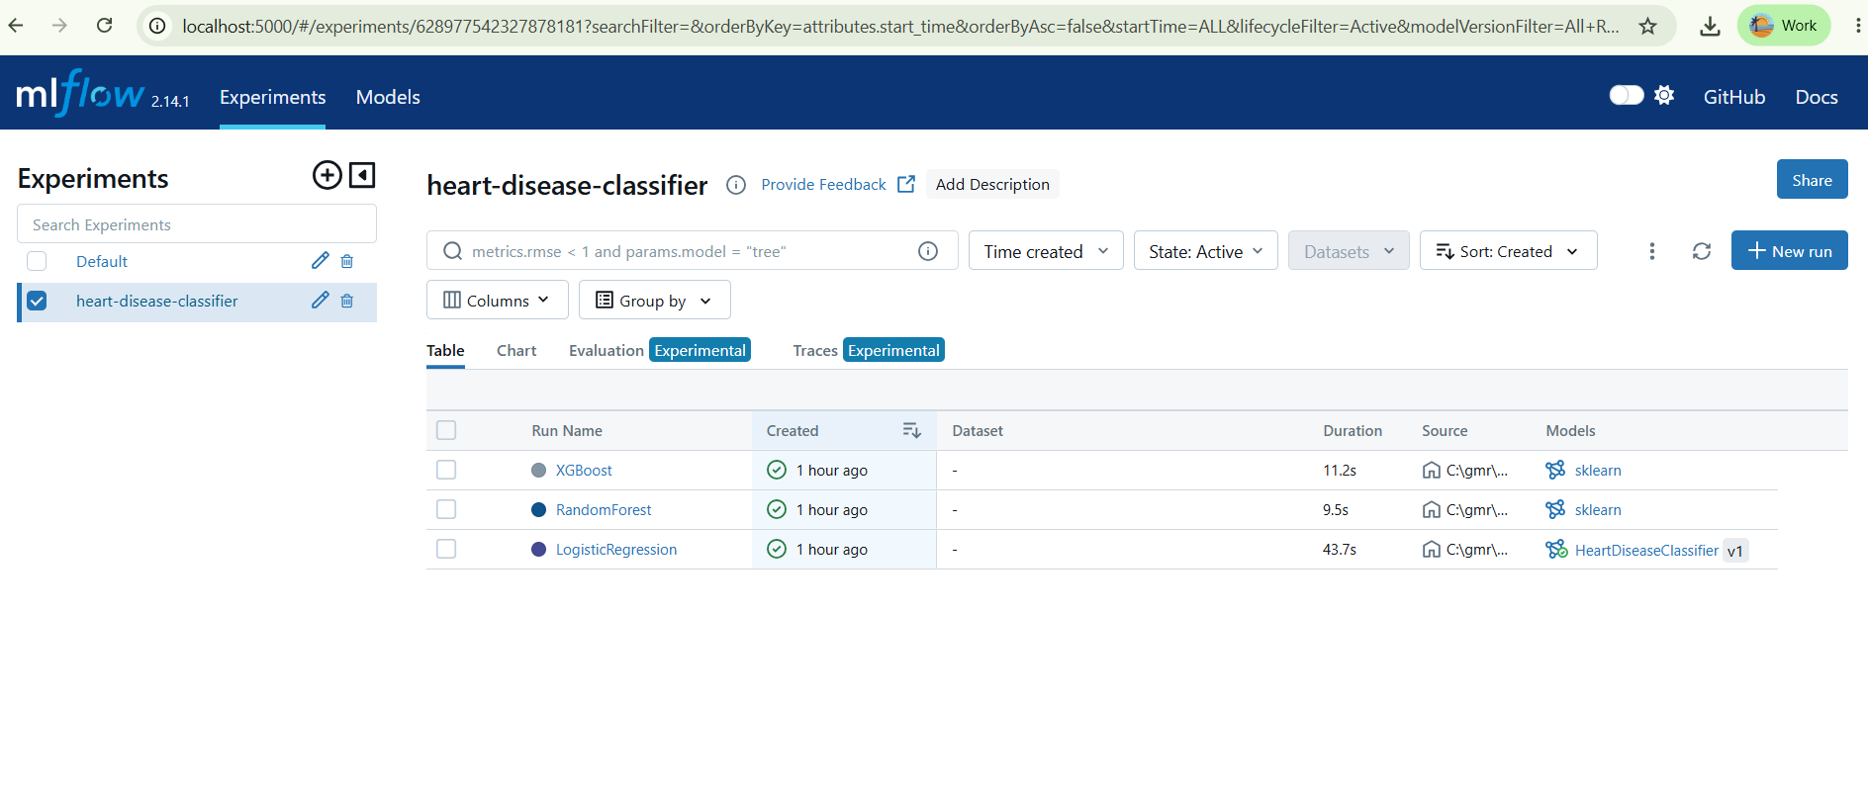
Experiments List

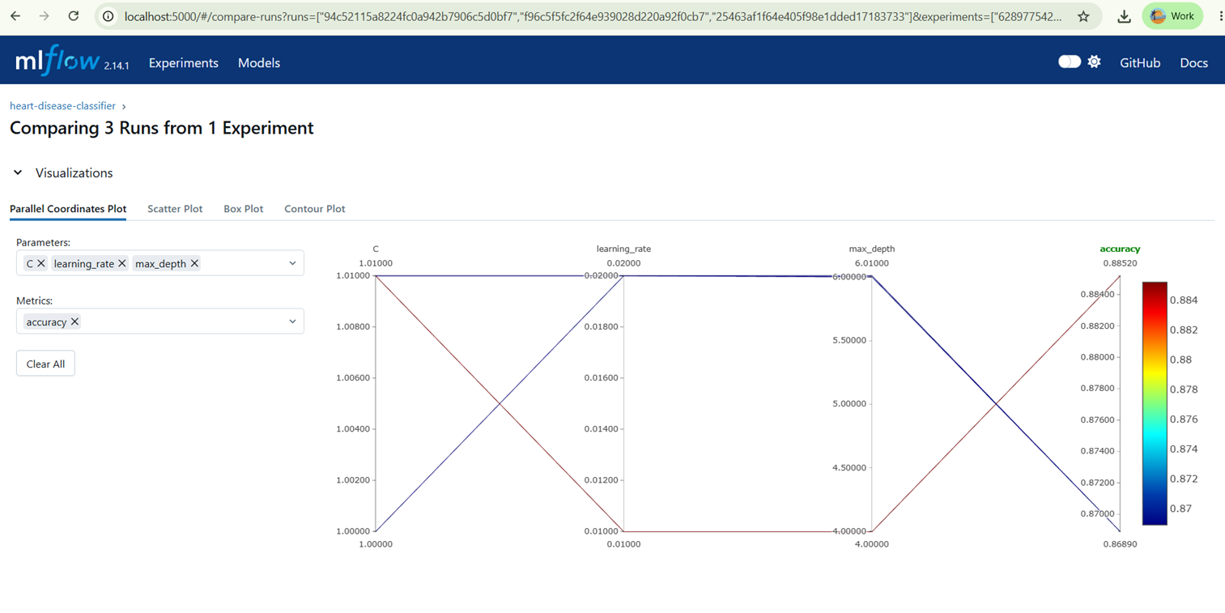

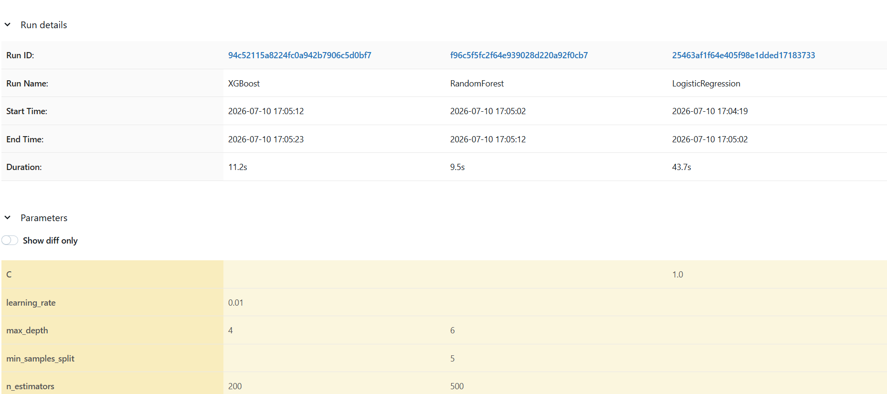
Comparison

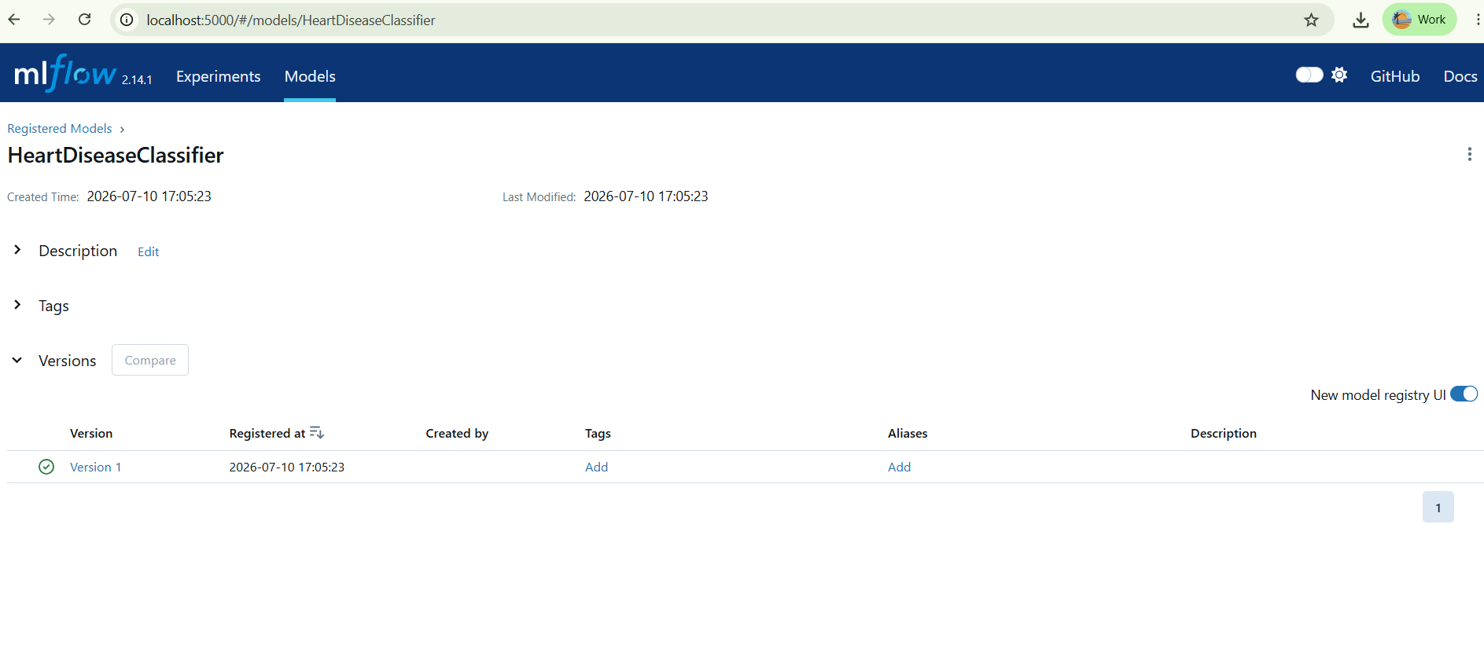
Model Registry

Launch the UI to reproduce these views:
mlflow ui --backend-store-uri ./mlruns --port 5000 # http://localhost:5000

7. CI/CD Pipeline

Continuous integration is implemented with GitHub Actions (.github/workflows/ci.yml) and triggers on every push and pull request to the main and dev branches. The workflow is composed of three sequential, gated jobs — each depends on the previous succeeding, so a failure short-circuits the pipeline and blocks the merge.
Job | What it does | Fails loudly when…
lint | Runs flake8 and ruff over src/ and tests/ | any style or lint violation is found
test | Installs deps, downloads data, trains the model, runs pytest with coverage | any of the 21 unit tests fails
build-docker | Builds the Docker image and smoke-tests /health in a running container | the image fails to build or the container is unhealthy
This ordering enforces a fast-feedback contract: cheap static checks run first, then correctness tests, then the expensive container build — so obvious mistakes are caught in seconds rather than minutes. The 'fail loudly' requirement is satisfied because each tool returns a non-zero exit code on violation, which GitHub Actions surfaces as a red, merge-blocking check.
[ SCREENSHOT PLACEHOLDER ]
GitHub → Actions tab → latest run with all 3 jobs green
→ capture and save to screenshots\cicd/actions_passing.png

Figure 12. A green GitHub Actions run — lint → test → build-docker all passing.

8. Containerisation & API Design

FastAPI Service
The model is served by a FastAPI application (src/api.py) exposing four endpoints:
Endpoint | Purpose
GET / | Service metadata and a pointer to the docs.
GET /health | Liveness/readiness probe: {status, model_loaded}.
POST /predict | Scores one patient; returns prediction, probability, risk_level.
GET /metrics | Prometheus-format metrics (auto-instrumented).
Requests are validated by a Pydantic model (PatientFeatures) whose field bounds follow the original UCI encoding the model was trained on (cp 1–4, restecg 0–2, slope 1–3, ca 0–3, thal ∈ {3,6,7}); malformed or out-of-range input is rejected automatically with HTTP 422. The predictor is loaded once as a process-wide singleton at startup, so the first real request is not penalised by model-load latency.
Example request and response:
POST /predict
{"age":67,"sex":1,"cp":4,"trestbps":120,"chol":229,"fbs":0,"restecg":2,
"thalach":129,"exang":1,"oldpeak":2.6,"slope":2,"ca":2,"thal":7}
→ {"prediction":1,"probability":0.9865,"risk_level":"High",
"model_version":"1.0.0","latency_ms":31.07}

Dockerfile Highlights
- Slim base — python:3.10-slim keeps the image small.
- Layer caching — requirements are copied and installed before application code, so dependency layers are re-used across code changes.
- Security — runs as a non-root appuser.
- Self-healing — a container HEALTHCHECK curls /health every 30s so the orchestrator can detect and restart unhealthy replicas.

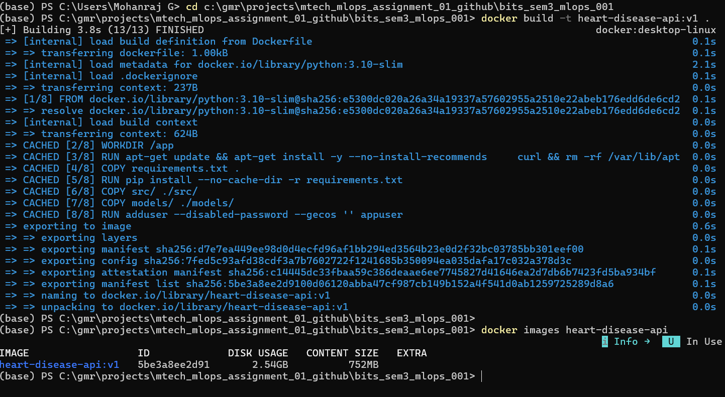
Successful docker build of heart-disease-api:v1.
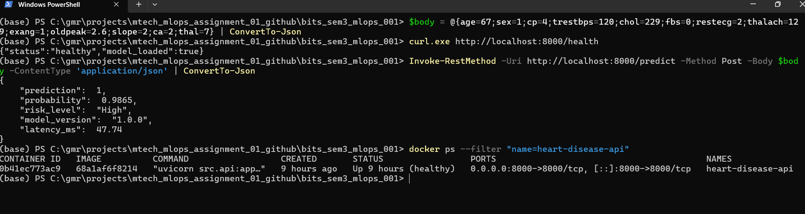
Live /predict response from the running container.

9. Kubernetes Deployment

The containerised API is deployed to a local Kubernetes cluster (Minikube) using two manifests under k8s/.

Deployment
- 2 replicas — for availability and basic load distribution.
- Resource governance — requests 256Mi/250m, limits 512Mi/500m per pod.
- Liveness probe — GET /health every 30s restarts a hung pod.
- Readiness probe — GET /health every 10s gates traffic until the model is loaded.

Service
A NodePort Service (heart-disease-api-service) maps cluster port 80 to the container's port 8000 and load-balances across the two pods. The externally reachable URL is obtained with minikube service heart-disease-api-service --url.
minikube start --driver=docker --memory=4096 --cpus=2
minikube image load heart-disease-api:v1
kubectl apply -f k8s/deployment.yaml
kubectl apply -f k8s/service.yaml
kubectl get pods -w

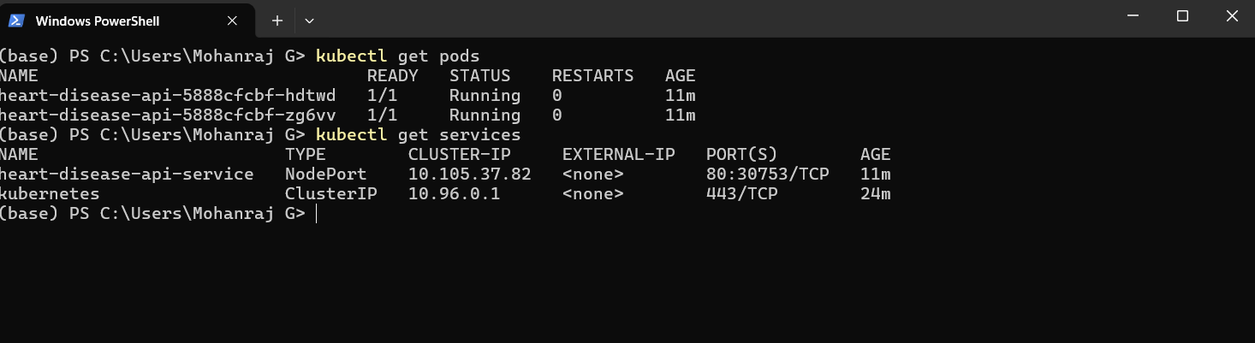 kubectl get pods — two replicas Running.

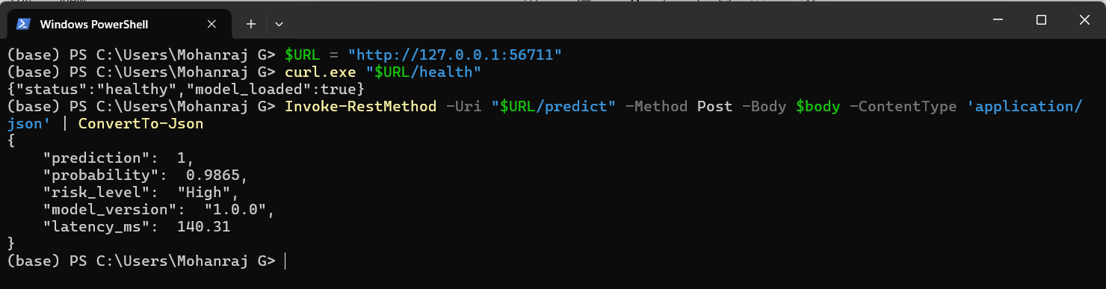 Figure: /predict served through the Minikube NodePort URL.

10. Monitoring & Conclusion

Observability Stack
The API auto-exposes Prometheus metrics at /metrics via prometheus-fastapi-instrumentator. The docker-compose.monitoring.yml stack brings up the API alongside Prometheus (which scrapes api:8000 every 15s) and Grafana. A Grafana dashboard visualises the golden signals: request rate, error rate, P95 latency, and in-progress requests. A load-test script (scripts/load_test.py) generates traffic so the dashboards populate.

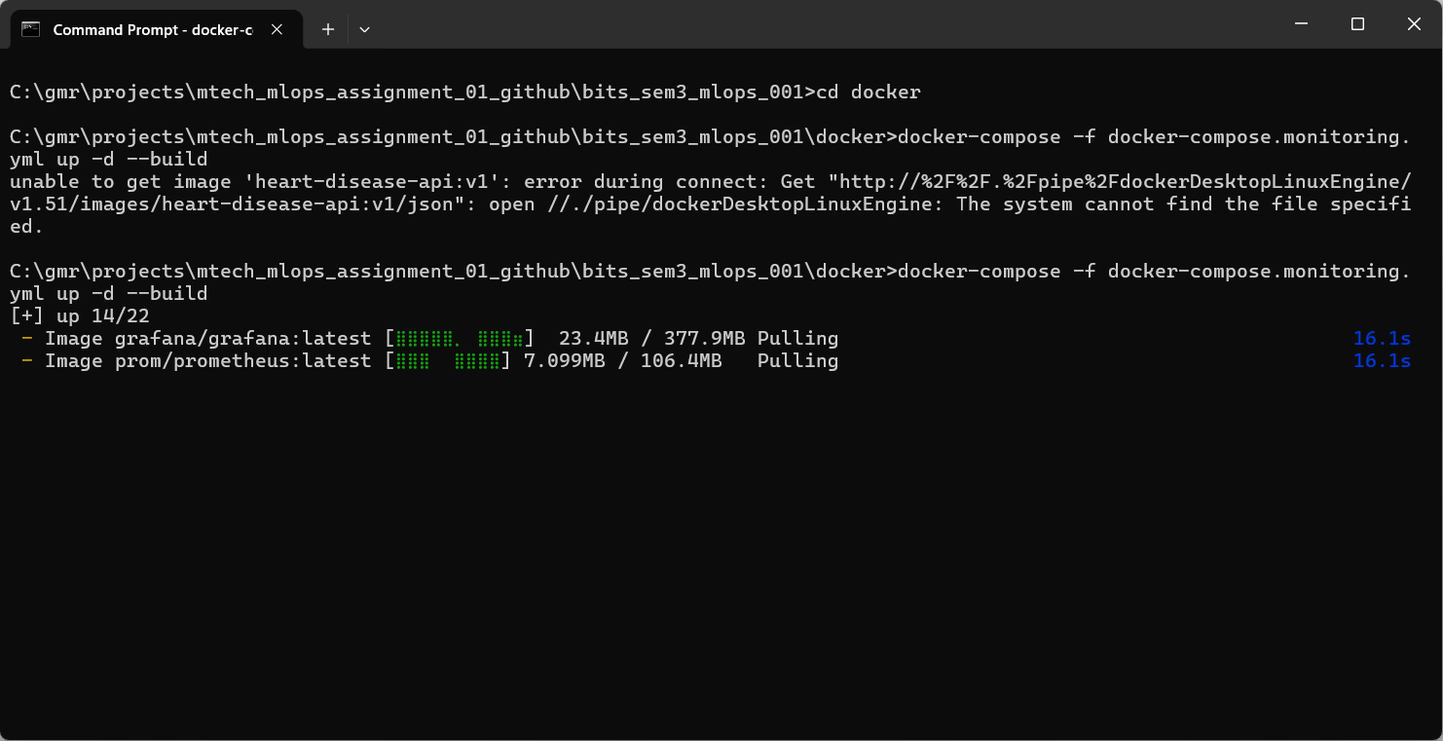
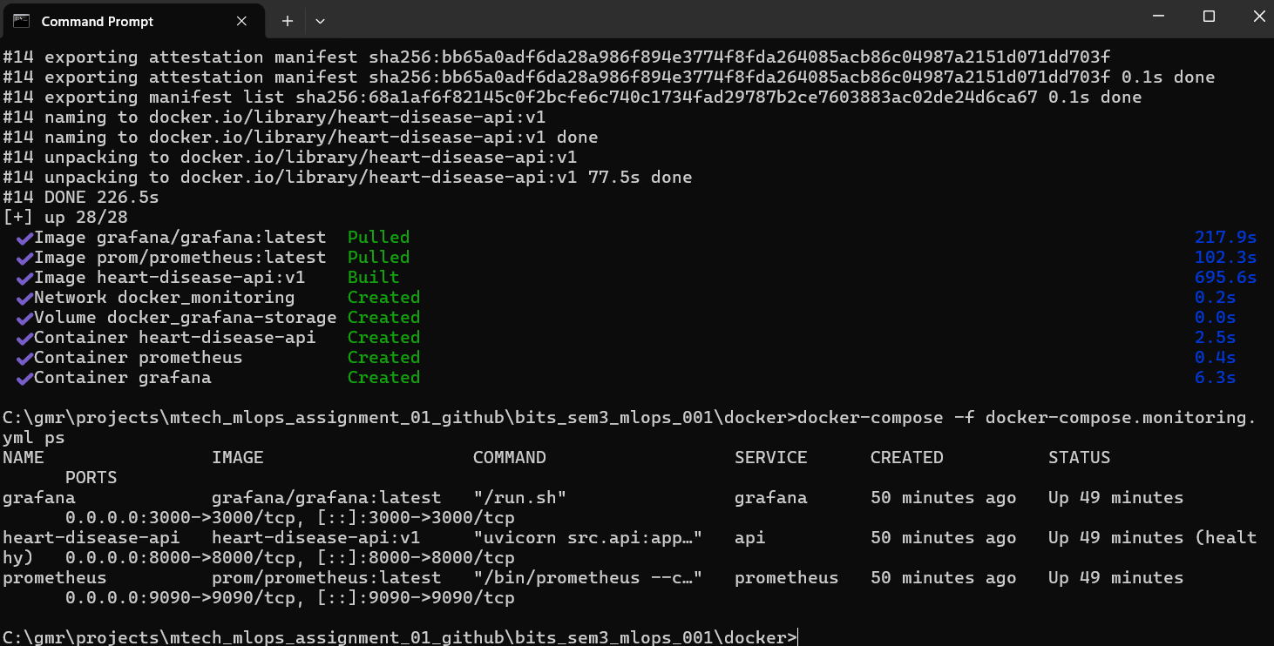
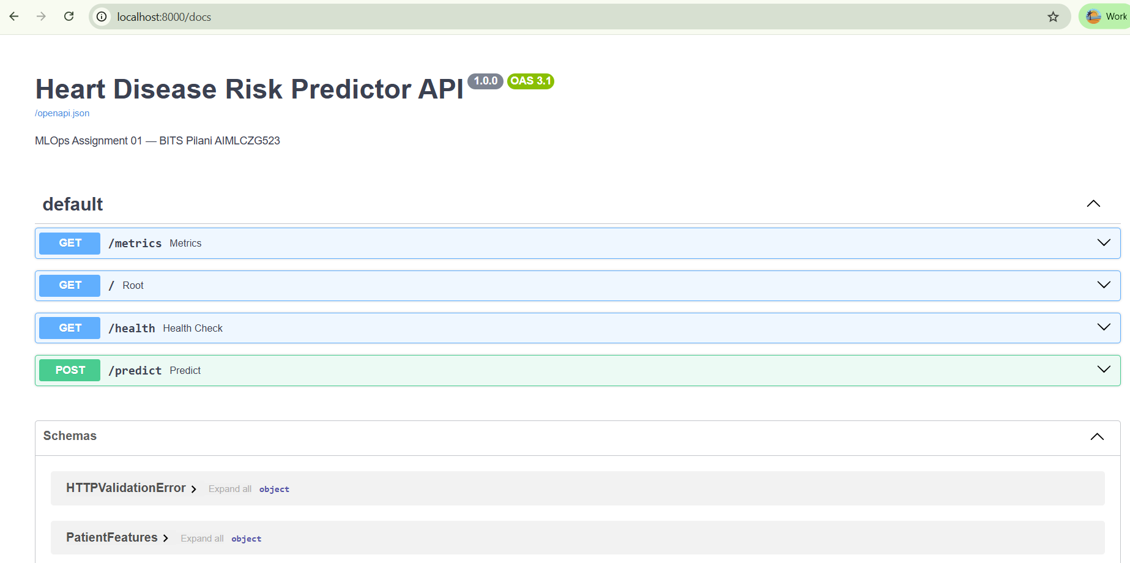

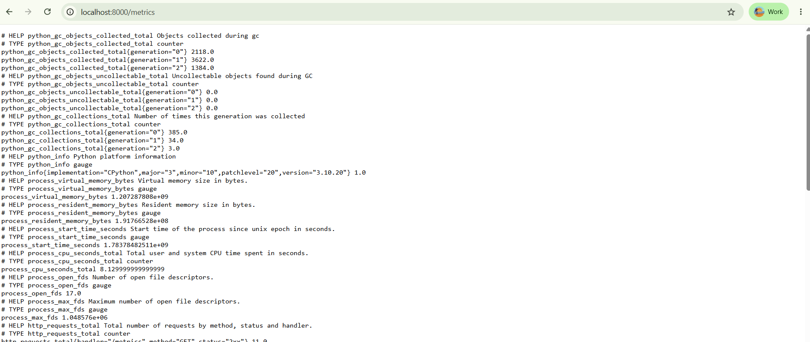

Lessons Learned
- Package preprocessing with the model — bundling the ColumnTransformer inside the Pipeline eliminated training/serving skew and made the API trivial.
- Simplicity wins on small data — a regularised linear model beat two ensembles on ROC-AUC and is cheaper to serve and easier to explain.
- Reproducibility is a feature — seeding everything and pinning dependencies meant the CI-trained model matched the local one exactly.
- Gate early, gate loudly — ordering CI as lint → test → build gives the fastest possible feedback on the cheapest failures.

Future Work
- Add data/model drift detection (e.g. Evidently) and automated retraining triggers.
- Introduce DVC for dataset and artifact versioning.
- Add a Helm chart and horizontal pod autoscaling for production-grade scaling.
- Push the image to a registry and deploy to a managed cluster (EKS/GKE/AKS).

Conclusion
This project delivers a complete, production-grade MLOps pipeline for heart-disease risk prediction: from a cleaned, well-understood dataset through a carefully-selected and tracked model, to a tested, containerised, orchestrated, and monitored service — all reproducible from a single command chain and continuously validated by CI/CD. The winning Logistic Regression model achieves a strong 0.9589 test ROC-AUC while remaining lightweight and interpretable, and the surrounding infrastructure demonstrates every stage of the modern ML lifecycle.
Repository: https://github.com/gmraj2005/bits_sem3_mlops_001

