USER INTERFACE DESIGN

23CSE113
SUBMITTED BY
NAME | GOWRNENI.MOKSHAGNASAI
ROLL NO | AV.SC.U4CSE25111
YEAR/SEM/SECTION | 1ST YEAR/ SEM-2/CSE-B
SUBMITTED TO
NAME | DR. RAJ KUMAR BATCHU
DESIGNATION | ASST.PROFFESSOR (Sl. Grade)
DEPARTMENT | SCHOOL OF COMPUTING

UID PROJECT
AIM:
The aim of this project is to develop an Amazon frontend clone using HTML, CSS and JavaScript. The project is designed to demonstrate frontend web development concepts such as responsive design, search functionality, product display, category filtering, popup system and cart management.
REFERENCE OUTPUT LINK:
https://www.amazon.in
REFERENCE OUTPUT IMAGE:
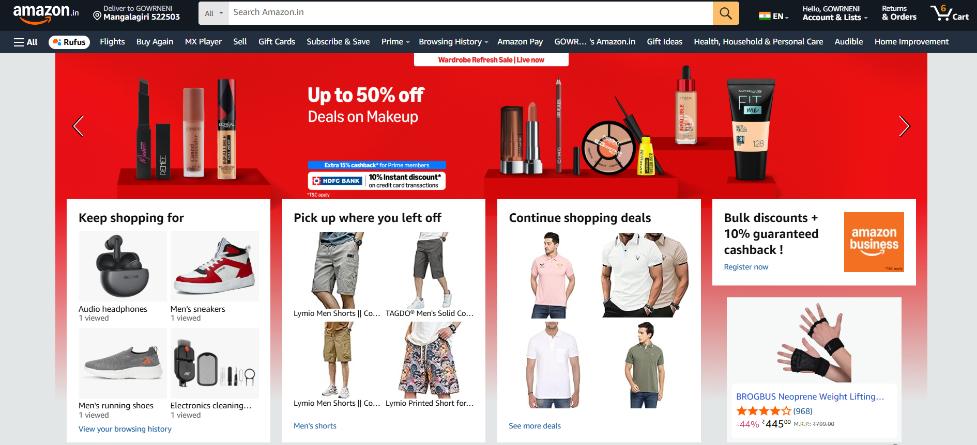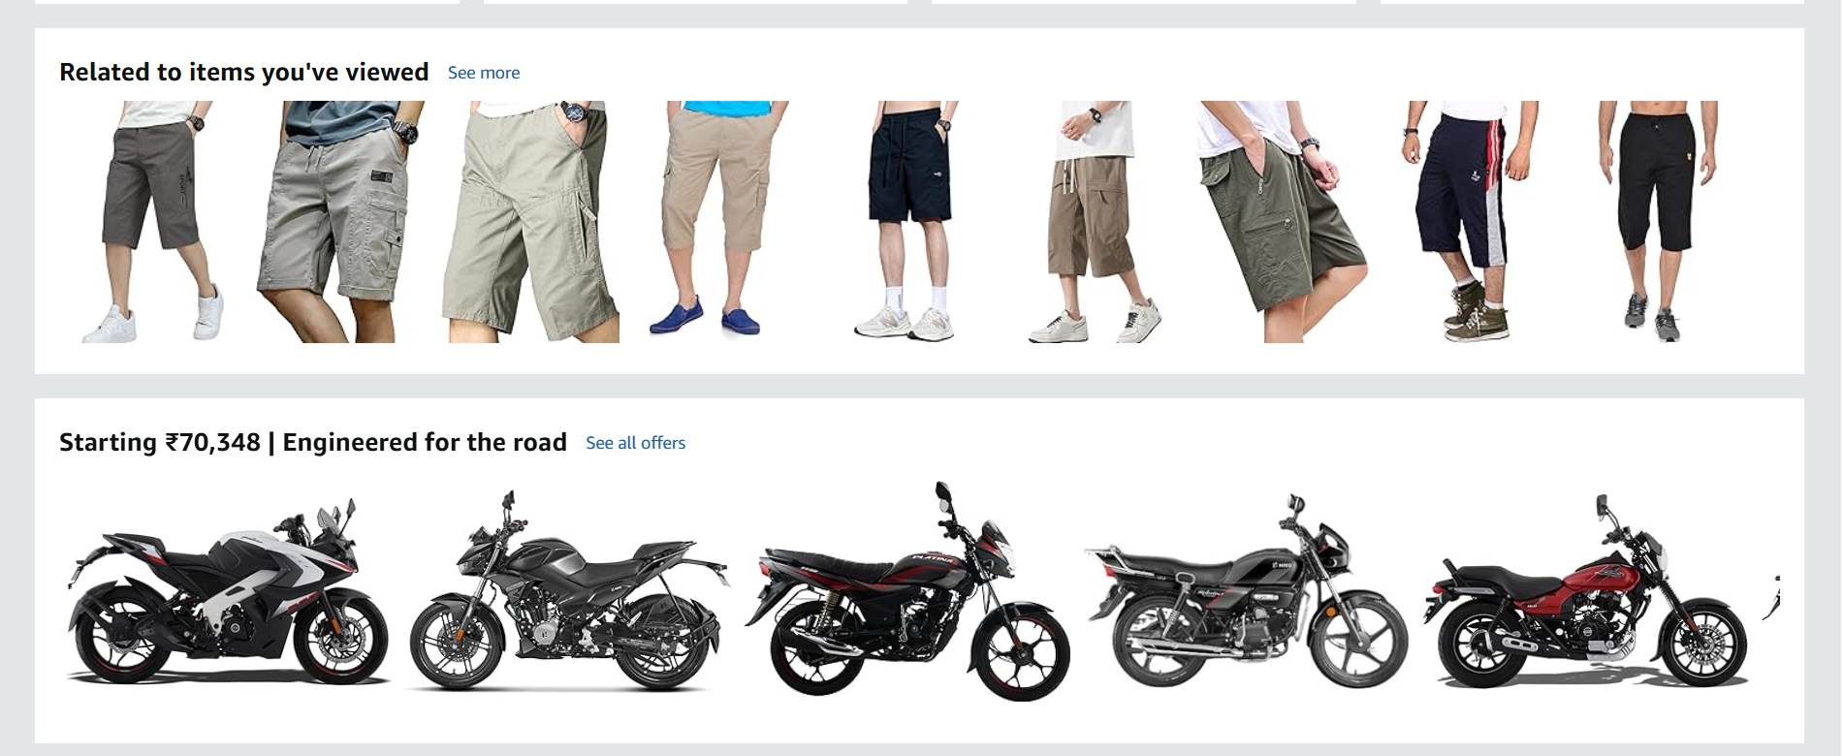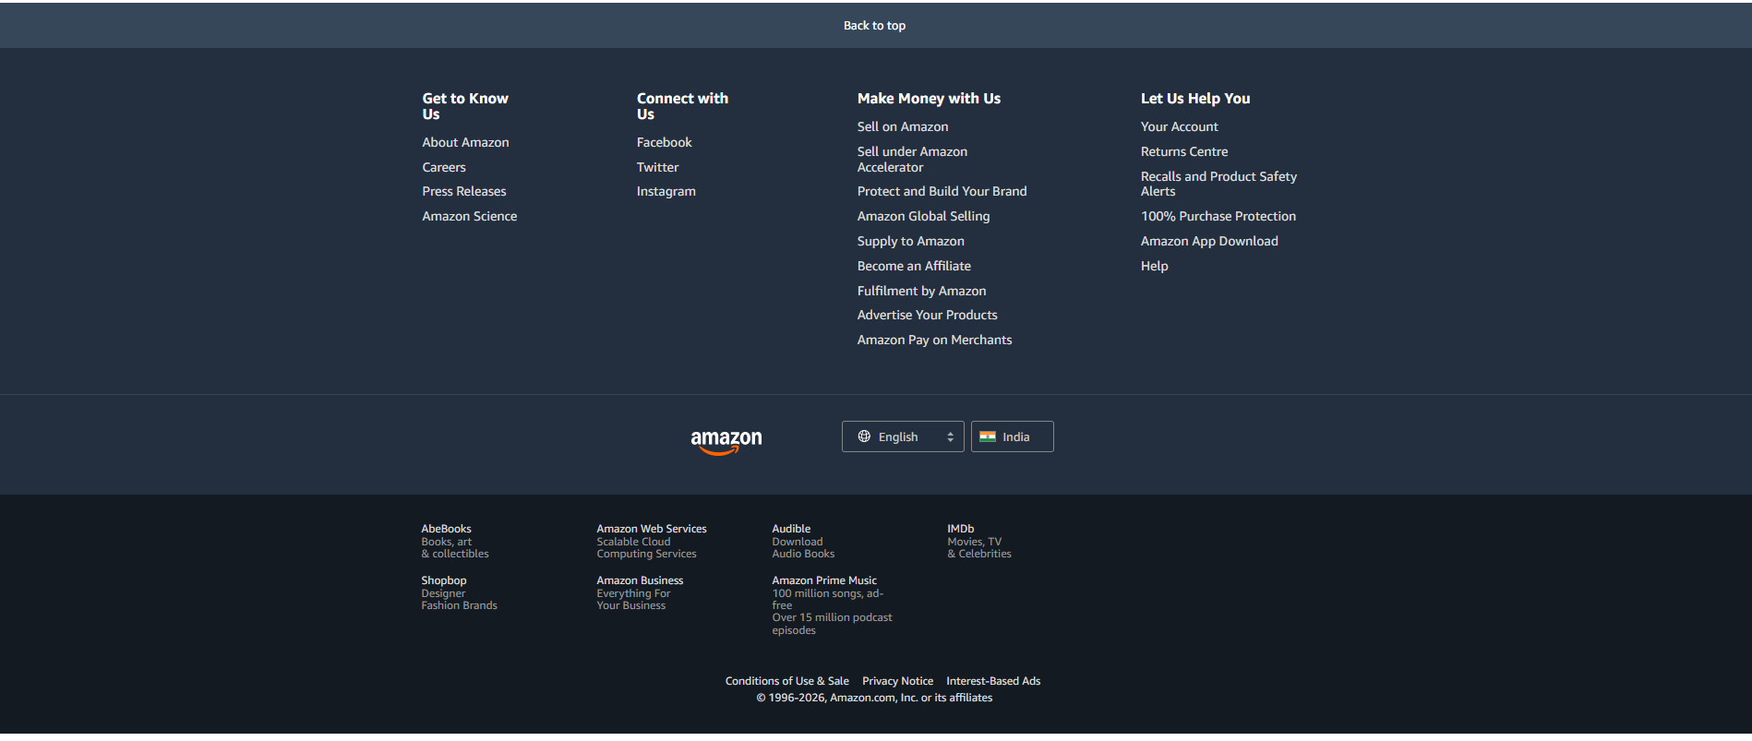

CODE:
index.html:
<!DOCTYPE html>
<html lang="en">

<head>
<meta charset="UTF-8">
<meta name="viewport" content="width=device-width, initial-scale=1.0">
<title>Amazon Clone</title>
<link rel="stylesheet" href="style.css">
</head>

<body>

<!-- HEADER SECTION -->
<header>

<!-- TOP NAVBAR -->
<div class="top-nav">

<!-- LOGO -->
<div class="logo" onclick="home()">
amazon<span>.in</span>
</div>

<!-- ADDRESS -->
<div class="address" onclick="openPopup('locationPopup')">
<small>Deliver to</small>
<b>📍 Mangalagiri 522503</b>
</div>

<!-- SEARCH BOX -->
<div class="search-box">

<select id="searchCategory" onchange="showSelectedCategory()">
<option value="all">All</option>
<option value="electronics">Electronics</option>
<option value="fashion">Fashion</option>
<option value="fresh">Fresh</option>
<option value="deals">Today's Deals</option>
<option value="home">Home</option>
</select>

<input
type="text"
id="searchInput"
placeholder="Search Amazon.in"
autocomplete="off"
spellcheck="false"
oninput="showSearchSuggestions()"
onkeydown="if(event.key==='Enter') searchProducts()">

<button onclick="searchProducts()">🔍</button>

<div id="suggestionsBox"></div>

</div>

<!-- LANGUAGE -->
<div class="lang">
🇮🇳 EN
</div>

<!-- ACCOUNT -->
<div class="nav-link" onclick="openPopup('loginPopup')">
<small>Hello, sign in</small>
<b>Account & Lists</b>
</div>

<!-- ORDERS -->
<div class="nav-link" onclick="openPopup('ordersPopup')">
<small>Returns</small>
<b>& Orders</b>
</div>

<!-- CART -->
<div class="cart" onclick="showCart()">
🛒 Cart
<span id="cartCount">0</span>
</div>

</div>

<!-- SECOND MENU BAR -->
<div class="menu-bar">
<span onclick="home()">☰ All</span>
<span onclick="showCategory('rufus')">Rufus</span>
<span onclick="showCategory('buyagain')">Buy Again</span>
<span onclick="showCategory('mx')">MX Player</span>
<span onclick="showCategory('sell')">Sell</span>
<span onclick="showCategory('giftcards')">Gift Cards</span>
<span onclick="showCategory('basics')">AmazonBasics</span>
<span onclick="showCategory('pay')">Amazon Pay</span>
<span onclick="showCategory('home')">Home Improvement</span>
<span onclick="showCategory('service')">Customer Service</span>
<span onclick="showCategory('deals')">Today's Deals</span>
<span onclick="showCategory('new')">New Releases</span>
</div>

</header>

<!-- MAIN CONTENT -->
<main id="mainContent">

<!-- HERO BANNER -->
<section class="hero">

<button onclick="changeHero(-1)">‹</button>

<div class="hero-text">
<span>Just Launched</span>
<h1>Up to 30% off on hotels</h1>
<p>Now available on desktop</p>
<h2>amazon pay</h2>
</div>

<button onclick="changeHero(1)">›</button>

</section>

<!-- WHITE SHOPPING CARDS -->
<section class="grid-boxes">

<!-- CARD 1 -->
<div class="home-card">

<h2>Pick up where you left off</h2>

<div class="mini-grid">

<img
src="https://images.pexels.com/photos/1488463/pexels-photo-1488463.jpeg"
onclick="showCategory('fashion')"
onerror="this.src='https://placehold.co/300x250?text=Fashion'">

<img
src="https://images.pexels.com/photos/1124465/pexels-photo-1124465.jpeg"
onclick="showCategory('fashion')"
onerror="this.src='https://placehold.co/300x250?text=Fashion'">

<img
src="https://images.pexels.com/photos/1598505/pexels-photo-1598505.jpeg"
onclick="showCategory('fashion')"
onerror="this.src='https://placehold.co/300x250?text=Fashion'">

<img
src="https://images.pexels.com/photos/7679720/pexels-photo-7679720.jpeg"
onclick="showCategory('fashion')"
onerror="this.src='https://placehold.co/300x250?text=Fashion'">

</div>

<p onclick="showCategory('fashion')">Men's shorts</p>

</div>

<!-- CARD 2 -->
<div class="home-card">

<h2>Keep shopping for</h2>

<div class="mini-grid">

<img
src="https://images.pexels.com/photos/2529148/pexels-photo-2529148.jpeg"
onclick="showCategory('electronics')"
onerror="this.src='https://placehold.co/300x250?text=Electronics'">

<img
src="https://images.pexels.com/photos/3394650/pexels-photo-3394650.jpeg"
onclick="showCategory('electronics')"
onerror="this.src='https://placehold.co/300x250?text=Electronics'">

<img
src="https://images.pexels.com/photos/90946/pexels-photo-90946.jpeg"
onclick="showCategory('electronics')"
onerror="this.src='https://placehold.co/300x250?text=Electronics'">

<img
src="https://images.pexels.com/photos/2115256/pexels-photo-2115256.jpeg"
onclick="showCategory('electronics')"
onerror="this.src='https://placehold.co/300x250?text=Electronics'">

</div>

<p onclick="showCategory('electronics')">View your browsing history</p>

</div>

<!-- CARD 3 -->
<div class="home-card">

<h2>Continue shopping deals</h2>

<div class="mini-grid">

<img
src="https://images.pexels.com/photos/428340/pexels-photo-428340.jpeg"
onclick="showCategory('deals')"
onerror="this.src='https://placehold.co/300x250?text=Deals'">

<img
src="https://images.pexels.com/photos/996329/pexels-photo-996329.jpeg"
onclick="showCategory('deals')"
onerror="this.src='https://placehold.co/300x250?text=Deals'">

<img
src="https://images.pexels.com/photos/985635/pexels-photo-985635.jpeg"
onclick="showCategory('deals')"
onerror="this.src='https://placehold.co/300x250?text=Deals'">

<img
src="https://images.pexels.com/photos/325876/pexels-photo-325876.jpeg"
onclick="showCategory('deals')"
onerror="this.src='https://placehold.co/300x250?text=Deals'">

</div>

<p onclick="showCategory('deals')">See more deals</p>

</div>

<!-- CARD 4 -->
<div class="home-card ad-card">

<h2>Get bulk discounts + cashback</h2>

<div class="business-box" onclick="showCategory('sell')">
amazon<br>business
</div>

<p onclick="showCategory('sell')">Register now</p>

</div>

</section>

<!-- PRODUCT ROW 1 -->
<section class="scroll-row">
<h2>Related to items you've viewed</h2>
<div class="row-products" id="shortsRow"></div>
</section>

<!-- PRODUCT ROW 2 -->
<section class="scroll-row">
<h2>Based on your cart</h2>
<div class="row-products" id="cartBasedRow"></div>
</section>

<!-- PRODUCT ROW 3 -->
<section class="scroll-row">
<h2>Best Sellers in Computers</h2>
<div class="row-products" id="computerRow"></div>
</section>

<!-- HISTORY SECTION -->
<section class="history-section">
<h2>Customers who viewed items also viewed</h2>
<div class="history-products" id="historyProducts"></div>
</section>

</main>

<!-- LOCATION POPUP -->
<div class="popup" id="locationPopup">
<h2>Choose your location</h2>
<input type="text" placeholder="Enter city or pincode">
<button onclick="closePopups()">Apply</button>
</div>

<!-- LOGIN POPUP -->
<div class="popup" id="loginPopup">
<h2>Sign in</h2>
<input type="email" placeholder="Email or mobile number">
<input type="password" placeholder="Password">
<button onclick="closePopups()">Sign in</button>
</div>

<!-- ORDERS POPUP -->
<div class="popup" id="ordersPopup">
<h2>Your Orders</h2>
<p>No orders yet.</p>
<button onclick="closePopups()">Close</button>
</div>

<!-- CART POPUP -->
<div class="popup" id="cartPopup">
<h2>Your Cart</h2>
<ul id="cartItems"></ul>
<button onclick="closePopups()">Close</button>
</div>

<!-- FOOTER -->
<footer>

<div class="back" onclick="window.scrollTo({top:0,behavior:'smooth'})">
Back to top
</div>

<div class="footer-top">

<div>
<h3>Get to Know Us</h3>
<p>About Amazon</p>
<p>Careers</p>
<p>Press Releases</p>
</div>

<div>
<h3>Connect with Us</h3>
<p>Facebook</p>
<p>Instagram</p>
<p>Twitter</p>
</div>

<div>
<h3>Make Money with Us</h3>
<p>Sell on Amazon</p>
<p>Advertise Products</p>
<p>Amazon Pay</p>
</div>

<div>
<h3>Let Us Help You</h3>
<p>Your Account</p>
<p>Returns Centre</p>
<p>Help</p>
</div>

</div>

<div class="footer-mid">
<h2>amazon</h2>
<button>🌐 English</button>
<button>🇮🇳 India</button>
</div>

<div class="footer-bottom">
<p>Amazon Frontend Clone Project</p>
<p>Developed by GOWRNENI MOKSHAGNASAI</p>
</div>

</footer>

<script src="script.js"></script>

</body>

</html>

style.css
* {
margin: 0;
padding: 0;
box-sizing: border-box;
font-family: Arial, sans-serif;
}

body {
background: #e3e6e6;
}

/* TOP NAVBAR */

.top-nav {
height: 60px;
background: #131921;
color: white;
display: flex;
align-items: center;
justify-content: space-evenly;
padding: 0 10px;
gap: 10px;
}

.logo {
font-size: 34px;
font-weight: bold;
cursor: pointer;
}

.logo span {
font-size: 20px;
}

.address {
cursor: pointer;
line-height: 1.2;
}

.address small {
color: #ccc;
font-size: 12px;
}

.address b {
font-size: 14px;
}

.lang,
.nav-link,
.cart {
cursor: pointer;
white-space: nowrap;
padding: 6px;
}

.lang:hover,
.nav-link:hover,
.cart:hover,
.address:hover {
border: 1px solid white;
}

.nav-link small {
display: block;
font-size: 12px;
color: #ccc;
}

.cart {
font-size: 20px;
font-weight: bold;
}

#cartCount {
color: #ff9900;
}

/* SEARCH BOX */

.search-box {
flex: 1;
display: flex;
height: 42px;
position: relative;
}

.search-box select {
width: 95px;
border: none;
padding: 10px;
font-size: 15px;
background: #f3f3f3;
outline: none;
cursor: pointer;
}

.search-box input {
flex: 1;
border: none;
padding: 10px;
font-size: 18px;
outline: none;
}

.search-box button {
width: 70px;
border: none;
background: #febd69;
font-size: 24px;
cursor: pointer;
}

.search-box button:hover {
background: #f3a847;
}

input::-webkit-calendar-picker-indicator {
display: none;
}

/* SEARCH SUGGESTIONS */

#suggestionsBox {
display: none;
position: absolute;
top: 45px;
left: 95px;
right: 70px;
background: white;
color: black;
z-index: 9999;
border-radius: 0 0 8px 8px;
overflow: hidden;
box-shadow: 0 4px 12px rgba(0, 0, 0, 0.3);
}

.suggestion-item {
padding: 12px;
cursor: pointer;
border-bottom: 1px solid #eee;
font-size: 15px;
}

.suggestion-item:hover {
background: #f2f2f2;
}

/* MENU BAR */

.menu-bar {
background: #232f3e;
color: white;
display: flex;
gap: 25px;
padding: 12px 18px;
font-size: 18px;
overflow-x: auto;
}

.menu-bar span {
cursor: pointer;
white-space: nowrap;
}

.menu-bar span:hover {
text-decoration: underline;
}

/* HERO SECTION */

.hero {
height: 380px;
display: flex;
justify-content: space-between;
align-items: center;
padding: 0 50px;
color: black;
transition: 0.5s;
background: linear-gradient(110deg, #ffd84d 0%, #ffd84d 55%, #f6c744 55%);
}

.hero button {
border: none;
background: none;
font-size: 80px;
cursor: pointer;
}

.hero-text {
max-width: 700px;
}

.hero-text span {
background: #f08804;
padding: 8px 14px;
font-size: 18px;
font-weight: bold;
}

.hero-text h1 {
margin-top: 20px;
font-size: 60px;
}

.hero-text p {
margin-top: 10px;
font-size: 22px;
}

.hero-text h2 {
margin-top: 20px;
font-size: 50px;
}

/* WHITE SHOPPING CARDS */

.grid-boxes {
display: grid;
grid-template-columns: repeat(auto-fit, minmax(300px, 1fr));
gap: 25px;
padding: 20px;
margin-top: -40px;
position: relative;
}

.home-card {
background: white;
padding: 20px;
}

.home-card h2 {
margin-bottom: 15px;
}

.mini-grid {
display: grid;
grid-template-columns: 1fr 1fr;
gap: 10px;
}

.mini-grid img {
width: 100%;
height: 150px;
object-fit: cover;
cursor: pointer;
}

.home-card p {
margin-top: 15px;
color: #007185;
cursor: pointer;
}

.business-box {
background: #ff6a00;
color: white;
height: 180px;
display: flex;
justify-content: center;
align-items: center;
text-align: center;
font-size: 50px;
font-weight: bold;
cursor: pointer;
}

/* PRODUCT ROWS */

.scroll-row {
background: white;
margin: 20px;
padding: 20px;
}

.scroll-row h2 {
margin-bottom: 20px;
}

.row-products {
display: flex;
gap: 20px;
overflow-x: auto;
}

.row-item {
min-width: 220px;
background: white;
padding: 10px;
cursor: pointer;
border: 1px solid #ddd;
transition: 0.3s;
}

.row-item:hover {
transform: scale(1.03);
}

.row-item img {
width: 100%;
height: 220px;
object-fit: cover;
}

.row-item h4 {
margin-top: 10px;
font-size: 18px;
}

.row-item p {
color: #b12704;
margin-top: 5px;
font-weight: bold;
}

/* HISTORY SECTION */

.history-section {
background: white;
margin: 20px;
padding: 20px;
}

.history-products {
display: flex;
overflow-x: auto;
gap: 20px;
}

.history-card {
min-width: 220px;
cursor: pointer;
}

.history-card img {
width: 100%;
height: 220px;
object-fit: cover;
}

.stars {
color: #ff9900;
margin-top: 5px;
}

.price {
color: #b12704;
font-weight: bold;
margin-top: 5px;
}

.deal {
background: #cc0c39;
color: white;
padding: 4px 8px;
font-size: 12px;
display: inline-block;
margin-top: 8px;
}

/* PRODUCT DETAIL PAGE */

.product-page {
display: flex;
gap: 40px;
background: white;
margin: 20px;
padding: 30px;
flex-wrap: wrap;
}

.product-img-box img {
width: 450px;
max-width: 100%;
object-fit: cover;
}

.product-info {
flex: 1;
min-width: 300px;
}

.product-info h1 {
font-size: 40px;
}

.product-info .rating {
color: #007185;
margin-top: 10px;
}

.product-info .price {
font-size: 34px;
margin-top: 15px;
}

.offers {
background: #f7f7f7;
padding: 15px;
margin-top: 20px;
border-radius: 8px;
}

.offers p {
margin-top: 10px;
}

.buy-box {
width: 300px;
border: 1px solid #ddd;
padding: 20px;
border-radius: 10px;
height: fit-content;
}

.buy-box h2 {
color: #b12704;
}

.stock {
color: green;
font-weight: bold;
margin: 15px 0;
}

.cart-btn,
.buy-btn,
.back-btn {
width: 100%;
padding: 12px;
margin-top: 12px;
border: none;
border-radius: 25px;
font-size: 16px;
cursor: pointer;
}

.cart-btn {
background: #ffd814;
}

.buy-btn {
background: #ffa41c;
}

.back-btn {
background: #232f3e;
color: white;
}

/* POPUPS */

.popup {
display: none;
position: fixed;
top: 50%;
left: 50%;
transform: translate(-50%, -50%);
background: white;
padding: 30px;
border-radius: 10px;
z-index: 9999;
width: 350px;
box-shadow: 0 5px 20px rgba(0, 0, 0, 0.4);
}

.popup h2 {
margin-bottom: 20px;
}

.popup input {
width: 100%;
padding: 12px;
margin-bottom: 15px;
border: 1px solid #ccc;
}

.popup button {
width: 100%;
padding: 12px;
border: none;
background: #ffd814;
cursor: pointer;
font-weight: bold;
}

/* FOOTER */

.back {
background: #37475a;
color: white;
text-align: center;
padding: 18px;
cursor: pointer;
margin-top: 20px;
}

.footer-top {
background: #232f3e;
color: white;
display: grid;
grid-template-columns: repeat(auto-fit, minmax(200px, 1fr));
gap: 30px;
padding: 40px;
}

.footer-top h3 {
margin-bottom: 15px;
}

.footer-top p {
margin-top: 10px;
color: #ddd;
cursor: pointer;
}

.footer-mid {
background: #232f3e;
border-top: 1px solid #3a4553;
padding: 30px;
text-align: center;
color: white;
}

.footer-mid h2 {
font-size: 40px;
margin-bottom: 20px;
}

.footer-mid button {
padding: 10px 20px;
margin: 0 10px;
border: 1px solid #888;
background: none;
color: white;
cursor: pointer;
}

.footer-bottom {
background: #131a22;
color: white;
text-align: center;
padding: 25px;
}

.footer-bottom p {
margin-top: 8px;
}

/* RESPONSIVE DESIGN */

@media (max-width: 900px) {
.top-nav {
flex-wrap: wrap;
height: auto;
padding: 10px;
}

.search-box {
width: 100%;
flex: none;
order: 2;
}

.hero {
height: auto;
padding: 40px 20px;
}

.hero-text h1 {
font-size: 36px;
}

.hero-text h2 {
font-size: 30px;
}

.hero button {
font-size: 50px;
}

.product-page {
flex-direction: column;
}

.buy-box {
width: 100%;
}
}

script.js:
let cart = [];
let heroIndex = 0;

/* HERO SLIDER */

const heroSlides = [
{
bg: "linear-gradient(110deg, #ffd84d 0%, #ffd84d 55%, #f6c744 55%)",
title: "Up to 30% off on hotels",
text: "Now available on desktop",
brand: "amazon pay"
},
{
bg: "linear-gradient(110deg, #a7d8ff 0%, #a7d8ff 55%, #6bbcff 55%)",
title: "Big deals on electronics",
text: "Laptops, headphones and accessories",
brand: "amazon deals"
},
{
bg: "linear-gradient(110deg, #ffc0cb 0%, #ffc0cb 55%, #ff8fa3 55%)",
title: "Fashion sale is live",
text: "Shop clothes, shoes and accessories",
brand: "amazon fashion"
},
{
bg: "linear-gradient(110deg, #b8f7c1 0%, #b8f7c1 55%, #7ee08e 55%)",
title: "Fresh groceries delivered",
text: "Daily essentials at your doorstep",
brand: "amazon fresh"
}
];

/* PRODUCTS */

const products = [
{
name: "Men Regular Fit Shorts",
price: "₹399",
img: "https://images.pexels.com/photos/6311644/pexels-photo-6311644.jpeg",
desc: "Comfortable men's casual shorts."
},
{
name: "Men Capri Pants",
price: "₹449",
img: "https://images.pexels.com/photos/5698851/pexels-photo-5698851.jpeg",
desc: "Stylish capri pants for men."
},
{
name: "Track Pants",
price: "₹599",
img: "https://images.pexels.com/photos/6311392/pexels-photo-6311392.jpeg",
desc: "Comfortable sports track pants."
},
{
name: "Screen Cleaner Kit",
price: "₹329",
img: "https://images.pexels.com/photos/777001/pexels-photo-777001.jpeg",
desc: "Cleaning kit for screens and laptops."
},
{
name: "Wireless Headphones",
price: "₹1,499",
img: "https://images.pexels.com/photos/3394650/pexels-photo-3394650.jpeg",
desc: "Premium wireless headphones."
},
{
name: "Gaming Headset",
price: "₹2,299",
img: "https://images.pexels.com/photos/3945667/pexels-photo-3945667.jpeg",
desc: "RGB gaming headset."
},
{
name: "HP Laptop",
price: "₹76,990",
img: "https://images.pexels.com/photos/18105/pexels-photo.jpg",
desc: "HP laptop for coding and office work."
},
{
name: "ASUS Gaming Laptop",
price: "₹79,790",
img: "https://images.pexels.com/photos/7974/pexels-photo.jpg",
desc: "Gaming laptop with high performance."
},
{
name: "MacBook Style Laptop",
price: "₹92,990",
img: "https://images.pexels.com/photos/205421/pexels-photo-205421.jpeg",
desc: "Premium laptop for editing and work."
},
{
name: "Kitchen Cookware Set",
price: "₹999",
img: "https://images.pexels.com/photos/699608/pexels-photo-699608.jpeg",
desc: "Kitchen cookware set."
},
{
name: "Non Stick Pan",
price: "₹699",
img: "https://images.pexels.com/photos/276528/pexels-photo-276528.jpeg",
desc: "Non stick frying pan."
},
{
name: "Beauty Face Wash",
price: "₹299",
img: "https://images.pexels.com/photos/6621338/pexels-photo-6621338.jpeg",
desc: "Face wash and skincare product."
},
{
name: "Body Lotion",
price: "₹249",
img: "https://images.pexels.com/photos/4465831/pexels-photo-4465831.jpeg",
desc: "Moisturizing body lotion."
},
{
name: "Home Decor Lamp",
price: "₹799",
img: "https://images.pexels.com/photos/112811/pexels-photo-112811.jpeg",
desc: "Decorative lamp for home."
},
{
name: "Wall Clock",
price: "₹499",
img: "https://images.pexels.com/photos/707582/pexels-photo-707582.jpeg",
desc: "Modern wall clock."
},
{
name: "Hand Grip Strengthener",
price: "₹339",
img: "https://images.pexels.com/photos/416717/pexels-photo-416717.jpeg",
desc: "Adjustable hand grip strengthener."
}
];

/* CATEGORIES */

const categoryData = {
all: products,

fashion: [
products[0],
products[1],
products[2]
],

electronics: [
products[3],
products[4],
products[5],
products[6],
products[7],
products[8]
],

deals: [
products[2],
products[3],
products[4],
products[7],
products[9],
products[10],
products[15]
],

fresh: [
{
name: "Fresh Apples",
price: "₹199",
img: "https://images.pexels.com/photos/102104/pexels-photo-102104.jpeg",
desc: "Fresh red apples."
},
{
name: "Vegetables Pack",
price: "₹299",
img: "https://images.pexels.com/photos/264537/pexels-photo-264537.jpeg",
desc: "Fresh vegetables pack."
}
],

sell: [
{
name: "Start Selling",
price: "Register Now",
img: "https://images.pexels.com/photos/3184291/pexels-photo-3184291.jpeg",
desc: "Start selling products online."
}
],

mx: [
{
name: "MX Player Subscription",
price: "Free",
img: "https://images.pexels.com/photos/7991373/pexels-photo-7991373.jpeg",
desc: "Watch entertainment online."
}
],

rufus: [
{
name: "AI Shopping Assistant",
price: "Free",
img: "https://images.pexels.com/photos/8386440/pexels-photo-8386440.jpeg",
desc: "Amazon-style AI shopping assistant."
}
],

buyagain: [
products[0],
products[1],
products[3],
products[8],
products[11]
],

giftcards: [
{
name: "Amazon Gift Card",
price: "₹500",
img: "https://images.pexels.com/photos/1303098/pexels-photo-1303098.jpeg",
desc: "Shopping gift card."
},
{
name: "Birthday Gift Card",
price: "₹1000",
img: "https://images.pexels.com/photos/1729791/pexels-photo-1729791.jpeg",
desc: "Birthday special gift card."
}
],

basics: [
{
name: "USB Cable",
price: "₹299",
img: "https://images.pexels.com/photos/4219862/pexels-photo-4219862.jpeg",
desc: "Fast charging USB cable."
},
{
name: "Laptop Bag",
price: "₹899",
img: "https://images.pexels.com/photos/2905238/pexels-photo-2905238.jpeg",
desc: "Laptop backpack bag."
},
{
name: "Wireless Mouse",
price: "₹699",
img: "https://images.pexels.com/photos/2115257/pexels-photo-2115257.jpeg",
desc: "Wireless computer mouse."
}
],

pay: [
{
name: "Mobile Recharge",
price: "Pay Now",
img: "https://images.pexels.com/photos/4968630/pexels-photo-4968630.jpeg",
desc: "Recharge using Amazon Pay."
},
{
name: "Electricity Bill",
price: "Pay Bill",
img: "https://images.pexels.com/photos/4386370/pexels-photo-4386370.jpeg",
desc: "Pay bills online."
}
],

home: [
{
name: "Wall Light",
price: "₹799",
img: "https://images.pexels.com/photos/112811/pexels-photo-112811.jpeg",
desc: "Decorative wall light."
},
{
name: "Study Table",
price: "₹3,499",
img: "https://images.pexels.com/photos/667838/pexels-photo-667838.jpeg",
desc: "Modern study table."
},
{
name: "Tools Kit",
price: "₹999",
img: "https://images.pexels.com/photos/162553/keys-workshop-mechanic-tools-162553.jpeg",
desc: "Basic home tools kit."
}
],

service: [
{
name: "Track Order",
price: "Support",
img: "https://images.pexels.com/photos/7709088/pexels-photo-7709088.jpeg",
desc: "Customer support and order tracking."
}
],

new: [
products[2],
products[5],
products[6],
products[9],
products[15]
]
};

/* IMAGE HELPER */

function imageTag(src, alt = "Product Image") {
return `
<img
src="${src}"
alt="${alt}"
onerror="this.src='https://placehold.co/300x250?text=Product+Image'">
`;
}

/* ALL PRODUCTS */

function getAllProducts() {
return [
...products,
...categoryData.fresh,
...categoryData.sell,
...categoryData.mx,
...categoryData.rufus,
...categoryData.giftcards,
...categoryData.basics,
...categoryData.pay,
...categoryData.home,
...categoryData.service
];
}

/* PRODUCT ROWS */

function createRow(id, items) {
const row = document.getElementById(id);
if (!row) return;

row.innerHTML = "";

items.forEach((p) => {
row.innerHTML += `
<div class="row-item" onclick="openProductDirect('${p.name}')">
${imageTag(p.img, p.name)}
<h4>${p.name}</h4>
<p>${p.price}</p>
</div>
`;
});
}

function createHistory() {
const history = document.getElementById("historyProducts");
if (!history) return;

history.innerHTML = "";

products.forEach((p) => {
history.innerHTML += `
<div class="history-card" onclick="openProductDirect('${p.name}')">
${imageTag(p.img, p.name)}
<h4>${p.name}</h4>
<p class="stars">★★★★☆</p>
<p class="price">${p.price}</p>
<span class="deal">Limited Deal</span>
</div>
`;
});
}

/* CATEGORY SELECT FROM SEARCH DROPDOWN */

function showSelectedCategory() {
const selectedCategory = document.getElementById("searchCategory").value;

if (selectedCategory === "all") {
home();
} else {
showCategory(selectedCategory);
}
}

/* SHOW CATEGORY */

function showCategory(category) {
if (category === "all") {
home();
return;
}

const items = categoryData[category] || products;

document.getElementById("mainContent").innerHTML = `
<section class="scroll-row">
<h2>${category.toUpperCase()} PRODUCTS</h2>
<div class="row-products" id="categoryRow"></div>
</section>
`;

const row = document.getElementById("categoryRow");

items.forEach((p) => {
row.innerHTML += `
<div class="row-item" onclick="openProductDirect('${p.name}')">
${imageTag(p.img, p.name)}
<h4>${p.name}</h4>
<p>${p.price}</p>
</div>
`;
});
}

/* PRODUCT DETAILS */

function openProductDirect(name) {
const allProducts = getAllProducts();
const p = allProducts.find(item => item.name === name) || products[0];
openProduct(p);
}

function openProduct(p) {
document.getElementById("mainContent").innerHTML = `
<section class="product-page">
<div class="product-img-box">
${imageTag(p.img, p.name)}
</div>

<div class="product-info">
<h1>${p.name}</h1>
<p class="rating">★★★★☆ 4.3 | 2,458 ratings</p>
<hr>

<h2 class="price">${p.price}</h2>

<p>
M.R.P:
<del>₹1,999</del>
<b> Limited Deal</b>
</p>

<p>Inclusive of all taxes</p>

<div class="offers">
<h3>Offers</h3>
<p>🏦 10% instant bank discount</p>
<p>💳 EMI available</p>
<p>🔁 Exchange offer available</p>
</div>

<h3>About this item</h3>
<p>${p.desc}</p>
<p>✔ Good quality product</p>
<p>✔ Easy replacement</p>
<p>✔ Secure transaction</p>
</div>

<div class="buy-box">
<h2>${p.price}</h2>
<p>FREE delivery Tomorrow</p>
<p>Delivering to Mangalagiri</p>
<p class="stock">In Stock</p>

<button class="cart-btn" onclick="addToCart('${p.name}')">
Add to Cart
</button>

<button class="buy-btn" onclick="alert('Buy Now selected for ${p.name}')">
Buy Now
</button>

<button class="back-btn" onclick="home()">
Back to Home
</button>
</div>
</section>
`;
}

/* CART */

function addToCart(name) {
cart.push(name);

const cartCount = document.getElementById("cartCount");
if (cartCount) {
cartCount.innerText = cart.length;
}

alert(name + " added to cart");
}

function showCart() {
closePopups();

const list = document.getElementById("cartItems");
list.innerHTML = "";

if (cart.length === 0) {
list.innerHTML = "<li>Your cart is empty</li>";
} else {
cart.forEach(item => {
list.innerHTML += `<li>${item}</li>`;
});
}

document.getElementById("cartPopup").style.display = "block";
}

/* POPUPS */

function openPopup(id) {
closePopups();

const popup = document.getElementById(id);
if (popup) {
popup.style.display = "block";
}
}

function closePopups() {
["locationPopup", "loginPopup", "ordersPopup", "cartPopup"].forEach(id => {
const popup = document.getElementById(id);

if (popup) {
popup.style.display = "none";
}
});
}

/* SEARCH SUGGESTIONS */

function showSearchSuggestions() {
const input = document.getElementById("searchInput").value.toLowerCase();
const box = document.getElementById("suggestionsBox");

box.innerHTML = "";

if (input.trim() === "") {
box.style.display = "none";
return;
}

const matched = getAllProducts().filter(product =>
product.name.toLowerCase().includes(input)
);

if (matched.length === 0) {
box.style.display = "none";
return;
}

matched.slice(0, 6).forEach(product => {
box.innerHTML += `
<div class="suggestion-item" onclick="selectSuggestion('${product.name}')">
${product.name}
</div>
`;
});

box.style.display = "block";
}

function selectSuggestion(name) {
document.getElementById("searchInput").value = name;
document.getElementById("suggestionsBox").style.display = "none";
openProductDirect(name);
}

/* SEARCH PRODUCTS */

function searchProducts() {
const selectedCategory = document.getElementById("searchCategory").value;
const text = document.getElementById("searchInput").value.toLowerCase();

let searchList;

if (selectedCategory === "all") {
searchList = getAllProducts();
} else {
searchList = categoryData[selectedCategory] || [];
}

const result = searchList.filter(p =>
p.name.toLowerCase().includes(text)
);

document.getElementById("mainContent").innerHTML = `
<section class="scroll-row">
<h2>Search Results</h2>
<div class="row-products" id="searchRow"></div>
</section>
`;

const row = document.getElementById("searchRow");

if (result.length === 0) {
row.innerHTML = "<h3>No products found</h3>";
return;
}

result.forEach((p) => {
row.innerHTML += `
<div class="row-item" onclick="openProductDirect('${p.name}')">
${imageTag(p.img, p.name)}
<h4>${p.name}</h4>
<p>${p.price}</p>
</div>
`;
});
}

/* HERO SLIDER */

function changeHero(direction) {
heroIndex += direction;

if (heroIndex < 0) {
heroIndex = heroSlides.length - 1;
}

if (heroIndex >= heroSlides.length) {
heroIndex = 0;
}

const slide = heroSlides[heroIndex];
const hero = document.querySelector(".hero");

if (!hero) return;

hero.style.background = slide.bg;

document.querySelector(".hero-text h1").innerText = slide.title;
document.querySelector(".hero-text p").innerText = slide.text;
document.querySelector(".hero-text h2").innerText = slide.brand;
}

/* HOME */

function home() {
location.reload();
}

/* INITIAL LOAD */

createRow("shortsRow", products.slice(0, 8));
createRow("cartBasedRow", products.slice(2, 10));
createRow("computerRow", products.slice(3, 12));
createHistory();

OUTPUT:
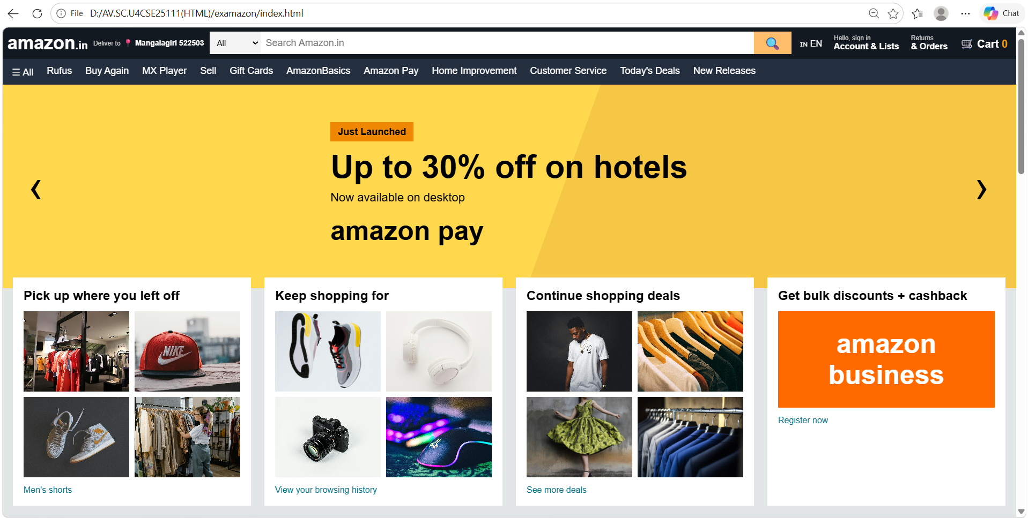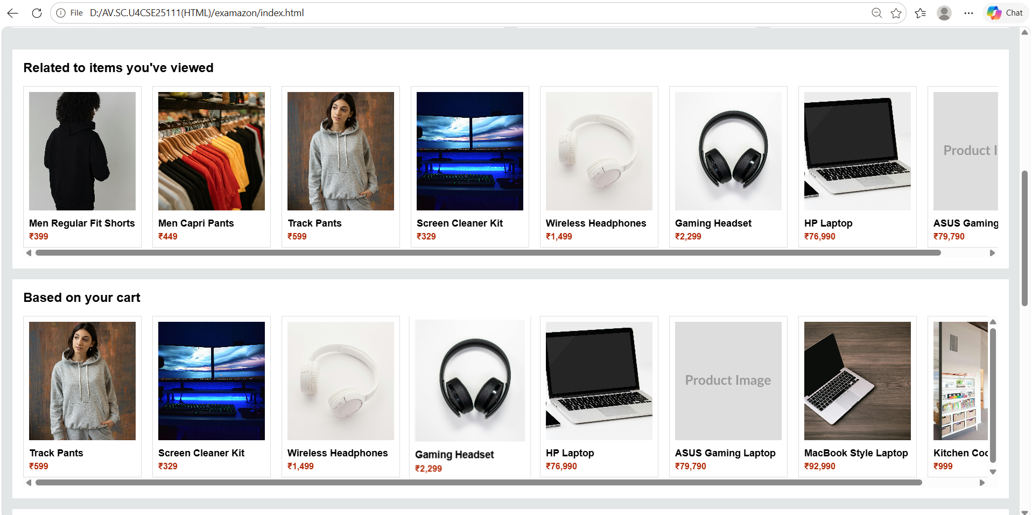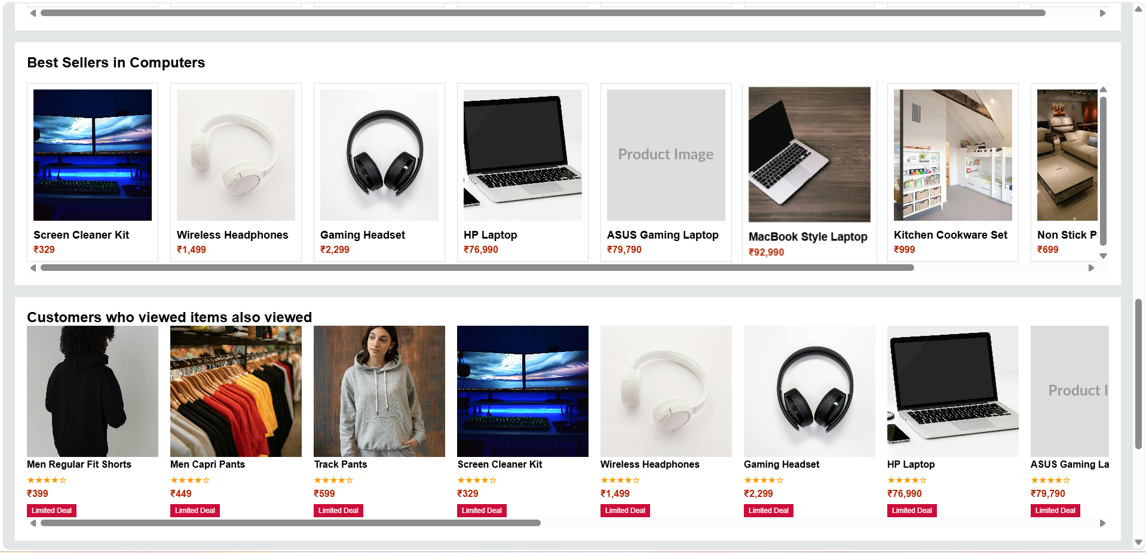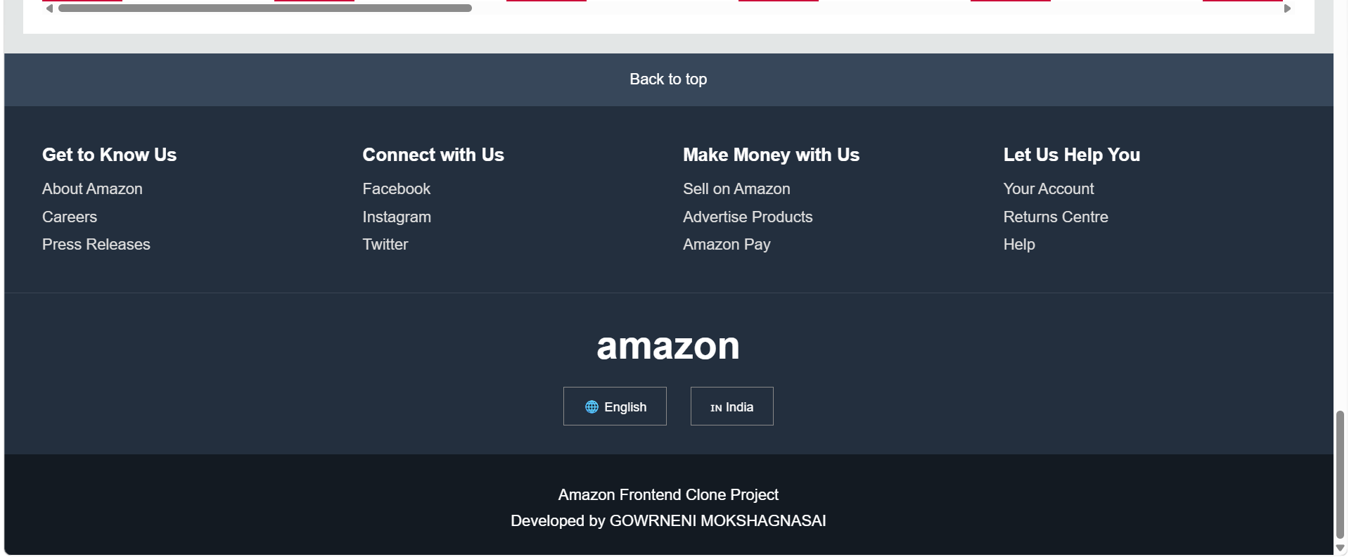

EXPLANATION:
This is my Amazon Frontend Clone Project developed using HTML, CSS and JavaScript. The main aim of this project is to create an Amazon-like shopping website interface and demonstrate frontend web development concepts.
In this project, I implemented features such as navbar, search bar, menu bar, hero slider, product cards, category filtering, popup system, cart system and responsive design. The project is completely frontend-based and does not use backend or database connectivity.
HTML, CSS and JavaScript Complete Explanation
HTML Explanation:
HTML stands for Hyper Text Markup Language. It is used to create the structure and content of the website. In this Amazon frontend clone project, HTML is used to design different sections such as the navbar, logo, search bar, menu bar, hero slider, product cards, product rows, popup boxes, cart section and footer. Different HTML tags like div, section, header, footer, image, input, button, h1, h2, p, span and select are used throughout the project.
The navbar section contains logo, address, search bar, account, orders and cart. Product cards and product rows are created using container divs. Popup boxes are created for login, location and cart sections. Footer contains links and project information. HTML also connects external CSS and JavaScript files using link and script tags.
CSS Explanation:
CSS stands for Cascading Style Sheets. It is used to style and design the website. In this project, CSS is used to give Amazon-like appearance using colors, spacing, font sizes, layouts and animations. Flexbox is used for arranging navbar items, search bar, hero section and product layouts in horizontal order. Grid layout is used for product cards and footer columns.
CSS is also used for hover effects, button styling, popup design, product card design and responsive layout. Background colors, borders, padding, margins and transitions are added using CSS. Media queries are used to make the website responsive for desktop, tablet and mobile screens. The popup boxes are centered using position fixed and transform properties. Product images are adjusted using object-fit property.
JavaScript Explanation:
JavaScript is used to make the website dynamic and interactive. In this project, JavaScript handles search functionality, category filtering, popup system, cart system, hero slider and dynamic product rendering. Products are stored inside arrays and objects. Category-wise products are stored inside categoryData objects.
When the user clicks category options in the menu bar, JavaScript dynamically displays related products. Search suggestions are displayed while typing in the search bar. Product detail pages are created dynamically using innerHTML and DOM manipulation. The cart system stores products inside arrays and updates the cart count dynamically.
JavaScript functions like openPopup(), closePopups(), showCategory(), searchProducts(), addToCart(), showCart() and changeHero() are used throughout the project. Event handling is done using onclick, oninput and onchange events. JavaScript also updates the hero banner dynamically when arrows are clicked.
Responsive Design Explanation:Responsive design is used to make the website adjust automatically on different screen sizes. Media queries are used to change layouts for mobile and tablet screens. Flexbox and Grid help the website rearrange elements properly. The search bar, navbar and product layouts become mobile-friendly when screen size decreases.
Conclusion:
This Amazon frontend clone project is developed using HTML, CSS and JavaScript. The project demonstrates important frontend concepts such as webpage structure, styling, responsive design, arrays, objects, event handling, popup systems, cart systems, category filtering, search functionality and dynamic DOM manipulation. The project provides an Amazon-like user interface and user experience using only frontend technologies.

