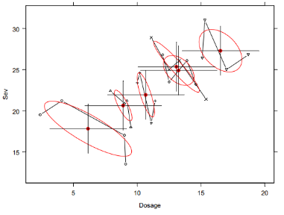

Suppose you are performing a multiple regression of Sev “Severity” of symptoms on the Dosage of a drug and a categorical variable for patients:

lm( Sev ~ Dosage + Patient )

The plot shows data obtained from 6 patients.

What is the approximate value of the coefficient of Dosage in the multiple regression? Explain the rationale for your answer.
This is the output for 3 regressions of Y on Z and/or X.

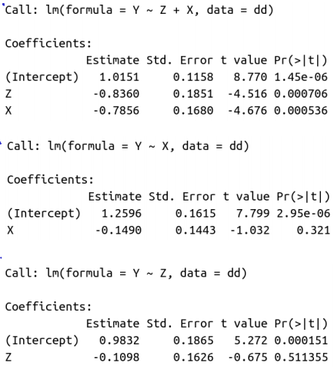

Draw a confidence ellipse consistent for the coefficients of the multiple regression that is consistent with this output.

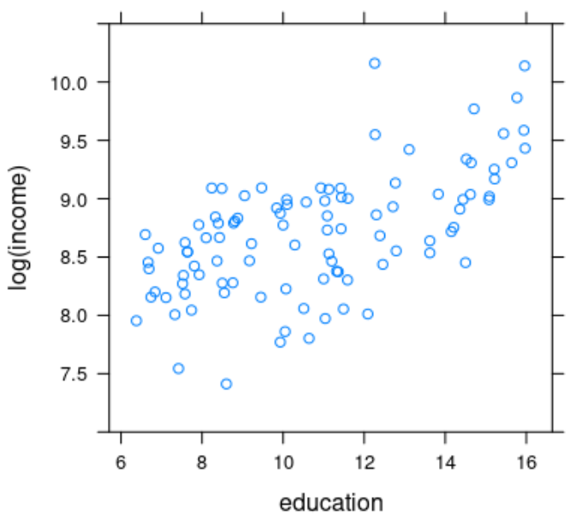

This is a plot of 100 points. Find an approximate value for the SE of the effect of education.

Show how you did this.

In a simple regression of Y on X, discuss the effect that the inclusion of an outlier of ‘Type 3’, i.e. an outlier that has an unusual value for X and whose value of Y is not consistent with that of the other points, would have on the regression. Draw a sketch to explain your reasoning.

Where would it appear in a residual versus leverage plot?

In a simple regression of Y on X, discuss the effect that the inclusion of an outlier of ‘Type 2’, i.e. an outlier that has an unusual value for X but whose value of Y is consistent with that of the other points, would have on the regression.

Draw a sketch to explain your reasoning.

Where would it appear in a residual versus leverage plot?

In a simple regression of Y on X, discuss the effect that the inclusion of an outlier of ‘Type 1’, i.e. an outlier that has a typical value for X but whose value of Y is not consistent with that of the other points, would have on the regression.

Where would it appear in a residual versus leverage plot?
Discuss this statement:



Discuss this statement:

If smoking is bad for your health, you expect that smokers will, on average, be less healthy than non-smokers.

Consider a simple regression of Y on X in which the regression coefficient is significantly positive.

Now, consider adding another predictor Z.

Discuss what could happen to the coefficient for X in the multiple regression.

Draw a suitable sketch to explain your reasoning.

Consider a simple regression of Y on X in which the regression coefficient is close to 0 and not significant.

Now, consider adding another predictor Z.

Discuss what could happen to the coefficient for X in the multiple regression.

Draw a suitable sketch to explain your reasoning.
Consider a multiple regression of Y on X and Z in which the regression coefficient for X is close to 0 and not significant.

Now, consider dropping the predictor Z.

Discuss what could happen to the coefficient for X.

Draw a sketch to explain your reasoning.

Consider a multiple regression of Y on X and Z in which the regression coefficient for X is positive and significant.

Now, consider dropping the predictor Z.

Discuss what could happen to the coefficient for X when you drop Z.

Draw a sketch to explain your reasoning.

In a multiple regression, is it ever important to omit a predictor that is significant? Discuss.

In a multiple regression, is it ever important to include a predictor that is not significant? Discuss.
Discuss: A very small p-value in a test of a null hypothesis is strong evidence that the null hypothesis is false.
Discuss variable selection strategies in multiple regressions taking into account the factors discussed in our course.

Suppose a test for COVID has a specificity of 95% and a sensitivity of 95%. Does this mean that the test is incorrect 5% of the time? Discuss.

Mary takes the test and has a positive result. Does this mean that the probability of not having COVID is 5%? Discuss.

