HOME: https://wireframe.cc/fulbX9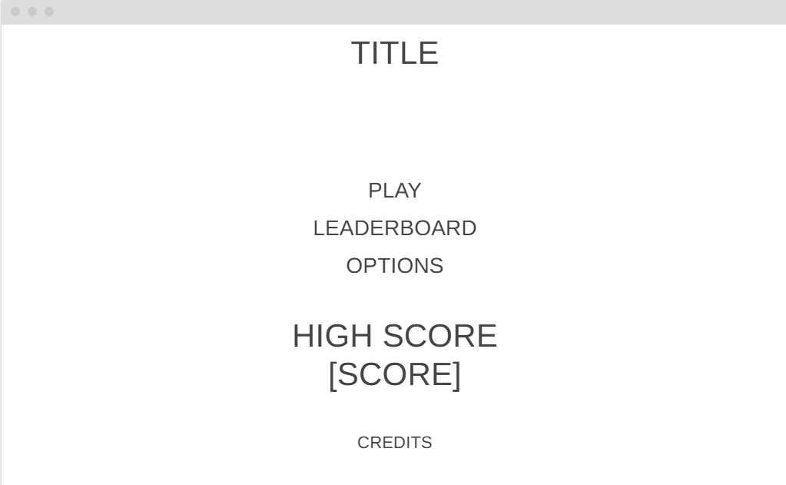

LEADERBOARD: https://wireframe.cc/pglL7q
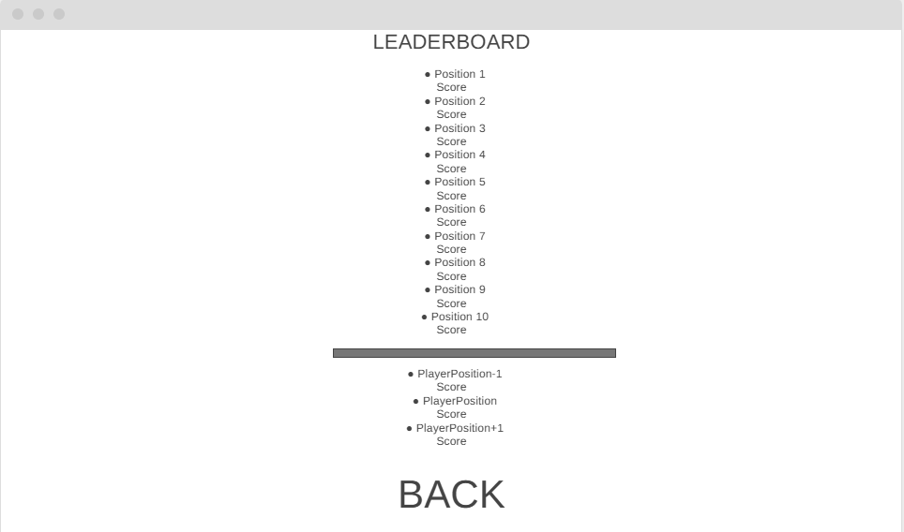

GAME: https://wireframe.cc/hClTzu
