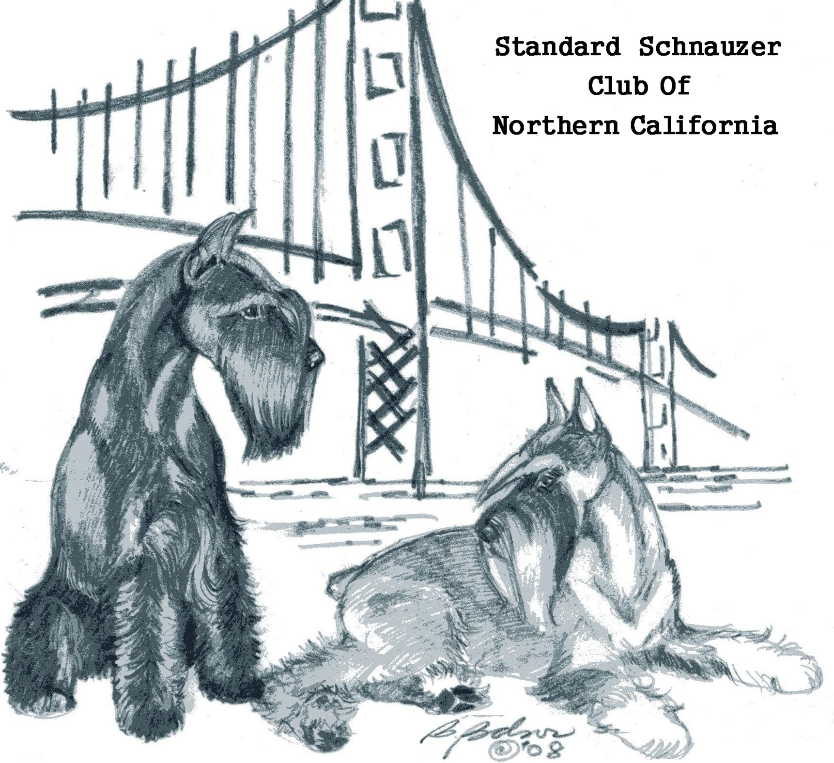
A
B
C
NISE
IRCH
LOVE
K9 NOSEWORK
The sport where dogs learn their

SSCNC MEMBERS & APPLICANTS ARE INVITED TO ATTEND
THIS INTRODUCTION TO THE SPORT OF K9 NOSE WORK

This sport is designed for all levels of dogs from couch potatos to speed demons and from puppies to geriatric dogs. It also caters to the shy, the outgoing and the sometimes tempermental personality dogs (and humans)

WHEN: Sunday April 3, 2010
TIME: 12:00 to 2:00 (instructor lead)
2:00-4:00 for SSCNC events
LOCATION: Meadowlark Field and Airway
4300 Greenville Road Livermore, CA.
CONTACT: Rene Nunzir for more information @
NUNZIRR@PEOPLEPC.COM

Due to current restrictions on Instructor training times, from the National Club for K9 Nose Work, and that we want to run this for maximum training experience and exposure, we will have only 8 slots available for dogs to work one-on-one with the instructor at this event. We have plenty of space available for humans to watch and learn. The training will be similar to a first day training you and your dog would receive in an Introduction to K9 Nose work course.

We ask that only one Standard Schnauzer per household be nominated to participate with the Instructor. As we know there will be more than 8 dogs interested in working with the instructor, we will have to draw from those interested to determine the “class” for the day. Please fill out and return the Registration slip before March 30, 2011 to be eligible for the Instructor Lead Section. All other dogs will have an opportunity to be exposed to the elements and do the work, after the initial class has completed their time.

Please bring a crate and training food and water for your dog and a snack or lunch, drinks and a chair for yourself to the event. We will have this event outdoors and it will be cancelled in the event of rain.

This is a private residence so please -- NO DOGS on the lawn areas around the homes. The rest of the acres (30+) are open for K9 potty breaks and for frolicking but are not fenced for keeping canines inside, so you run off leash at your own risk.

Restrooms are not available on the property except for emergencies and are inside the residences, please plan accordingly.

K9 N INTAKE SHEET FOR THOSE INTERESTED IN WORKING WITH THE INSTRUCTOR ON APRIL 3, 2011 AT THE NOSE WORK INTRO

1. Dog’s Call Name:

2. Age:

3. Intact or Spayed / Neutered

4. Does your dog have any health considerations, issues, and/or concerns we should know about? If yes, please describe: __________________________________________
Any food allergies? ____________________________________________________

5. Do you have any health considerations, issues, or concerns we should know about?

6. Describe your dog’s daily activity level: HIGH, MEDIUM, LOW

7. Please CIRCLE any fears (or nervousness) and phobias your dog may have, and please describe.

Strangers Other dogs Environments Noise

Class settings Food or Resource Guarding Other Not applicable.
____________________________________________________________________
____________________________________________________________________
____________________________________________________________________
(Description for #7)

8. How well does your dog play with people other than you?

9. What are your hopes/expectations?

10. What attracted you to learn more about Nose Wok?

OSEWORK Mini Workshop /
Please fill out and return before March 30, 2011 if you wish to be eligible to participate in the Instructor Lead section of the training. Limit of 8 dogs in this section. Instructor will determine which dogs to work on the day.

Information from the form can be emailed to Rene @ NUNZIRR@PEOPLEPC.COM for forwarding to the Instructor or you can send it via snail mail to Rene @ 1094 Glenn Common Livermore CA. 94551-1675

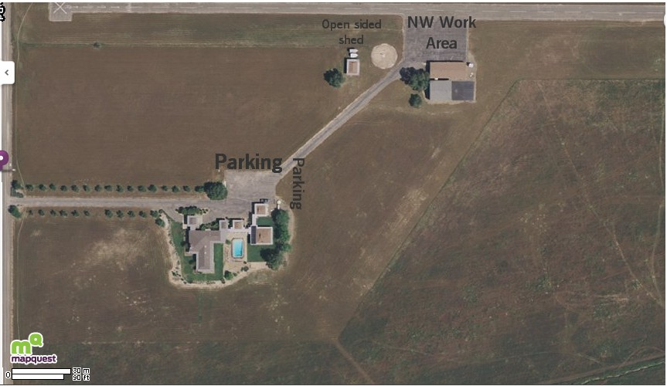

FACILITY Meadowlark Field
4300 Greenville Road Livermore CA.

FROM HIGHWAY 580 EAST OR WEST BOUND – TAKE THE GREENVILLE ROAD EXIT AND FOLLOW THE SIGNS SOUTH BOUND TOWARDS LAWRENCE-LIVERMORE LABORATORY.

CONTINUE SOUTH ON GREENVILLE FOR APPROXIMATELY SEVEN MILES TO THE INTERSECTION OF TESLA AND GREENVILLE ROAD. PROCEED THROUGH THE STOP SIGN ON GREENVILLE APPROXIMATELY 2/10 OF A MILE AND MEADOWLARK IS ON THE LEFT HAND SITE – LOOK FOR BALLOONS OR OBVIOUS SCHNAUZER MOTIFF AT THE FRONT GATE.

Please DRIVE SLOWLY ON THE MAIN ENTRY ROAD AS THIS IS A PRIVATE RESIDENCE WITH FARM DOG AND SMALL CHILDREN IN RESIDENCE.

EXPECT TO BE GREETED BY A LARGE BLACK GIANT SCHNAUZER NAMED “TROUT” – WHO IS GREAT FRIENDS WITH SOME OF THE LIVERMORE STANDARD SCHNAUZERS AND IS VERY GOOD AROUND STRANGERS AND OTHER DOGS.

PLEASE PARK WHERE INDICATED AND WALK THE ROAD UP TO THE RUNWAY AND HANGER – IT LOOKS LONGER THAN IT IS – WHERE THE NW WORKSHOP WILL TAKE PLACE.

We will bring the SSCNC Pop-up tents out for shade but please bring your own chair, crate for the dog, water and food for dog and human.

Bring lots of stinky treats about 1 inch x 1 inch. No pinch or halter collars permitted. Chain, flat, buckle and harness is welcome.

