**Parameters for video 2 animation**

**\* Slide 8**, 18

**sample:** 13

**show deaths:** off

**show risk backgrounds:** off

**\* Slides 19,20**

**sample:** 13

**show deaths:** off

**show risk backgrounds:** on

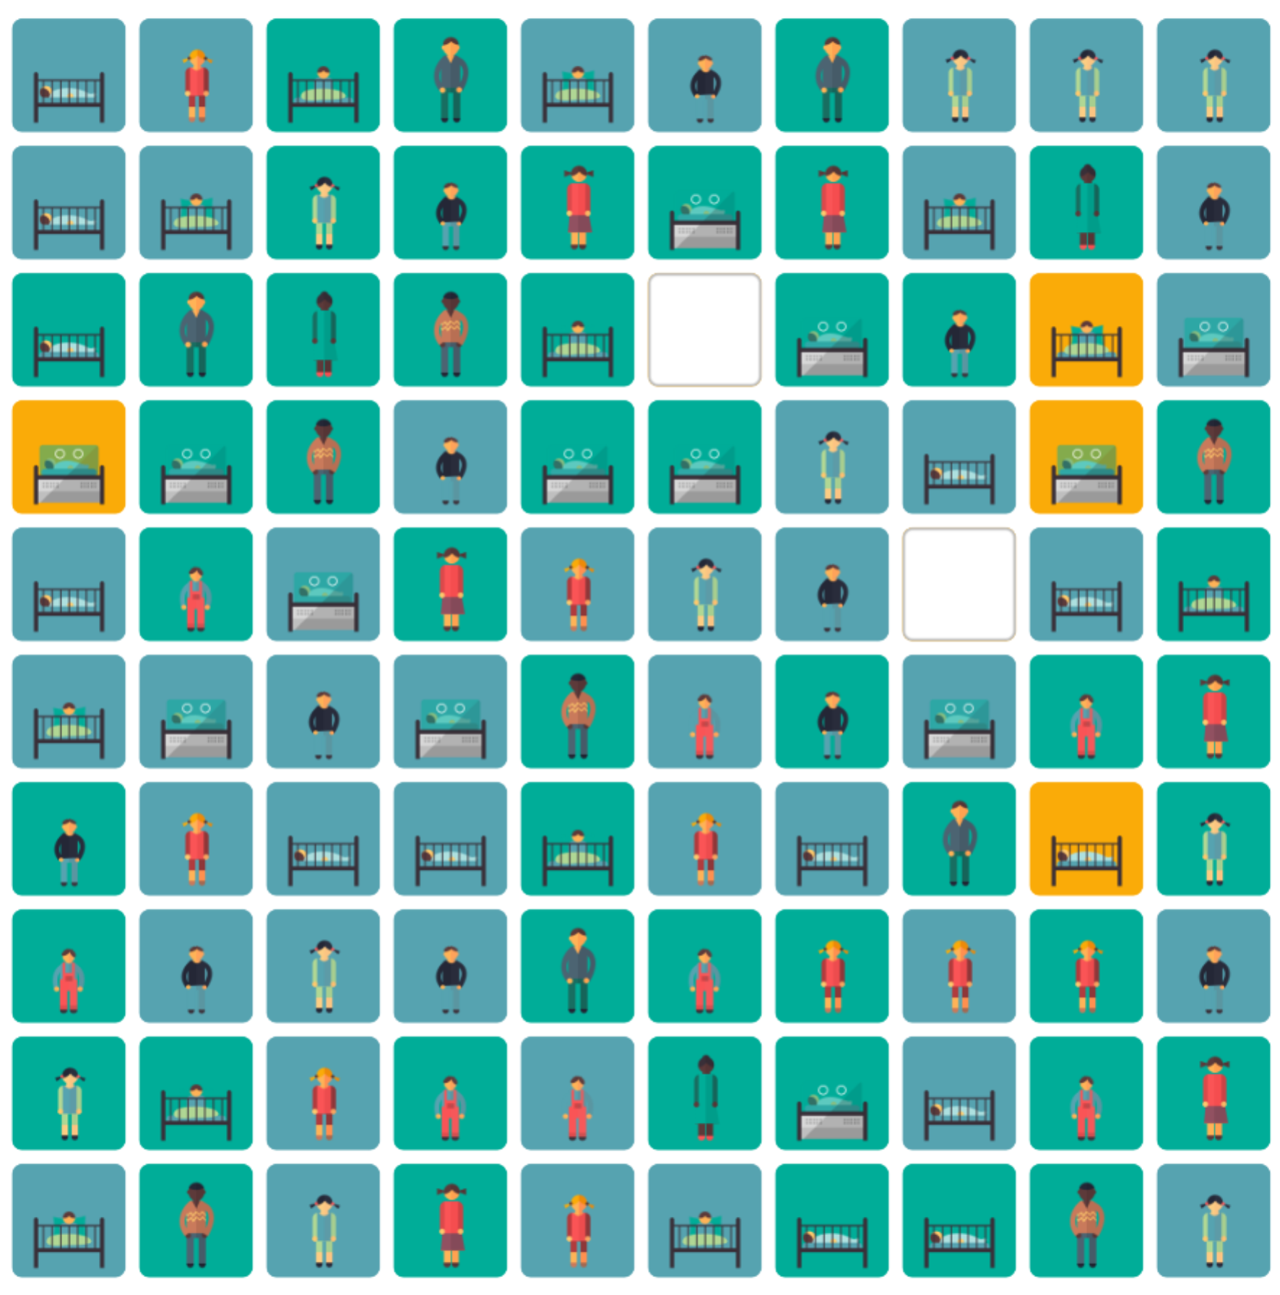**\*Slides 21,22**

**sample**: 13

**deaths**: 2

**skew%** 0

**spread** 0

**frame** 6

**future seed** 0

**show deaths**: on

**show risk backgrounds:** on

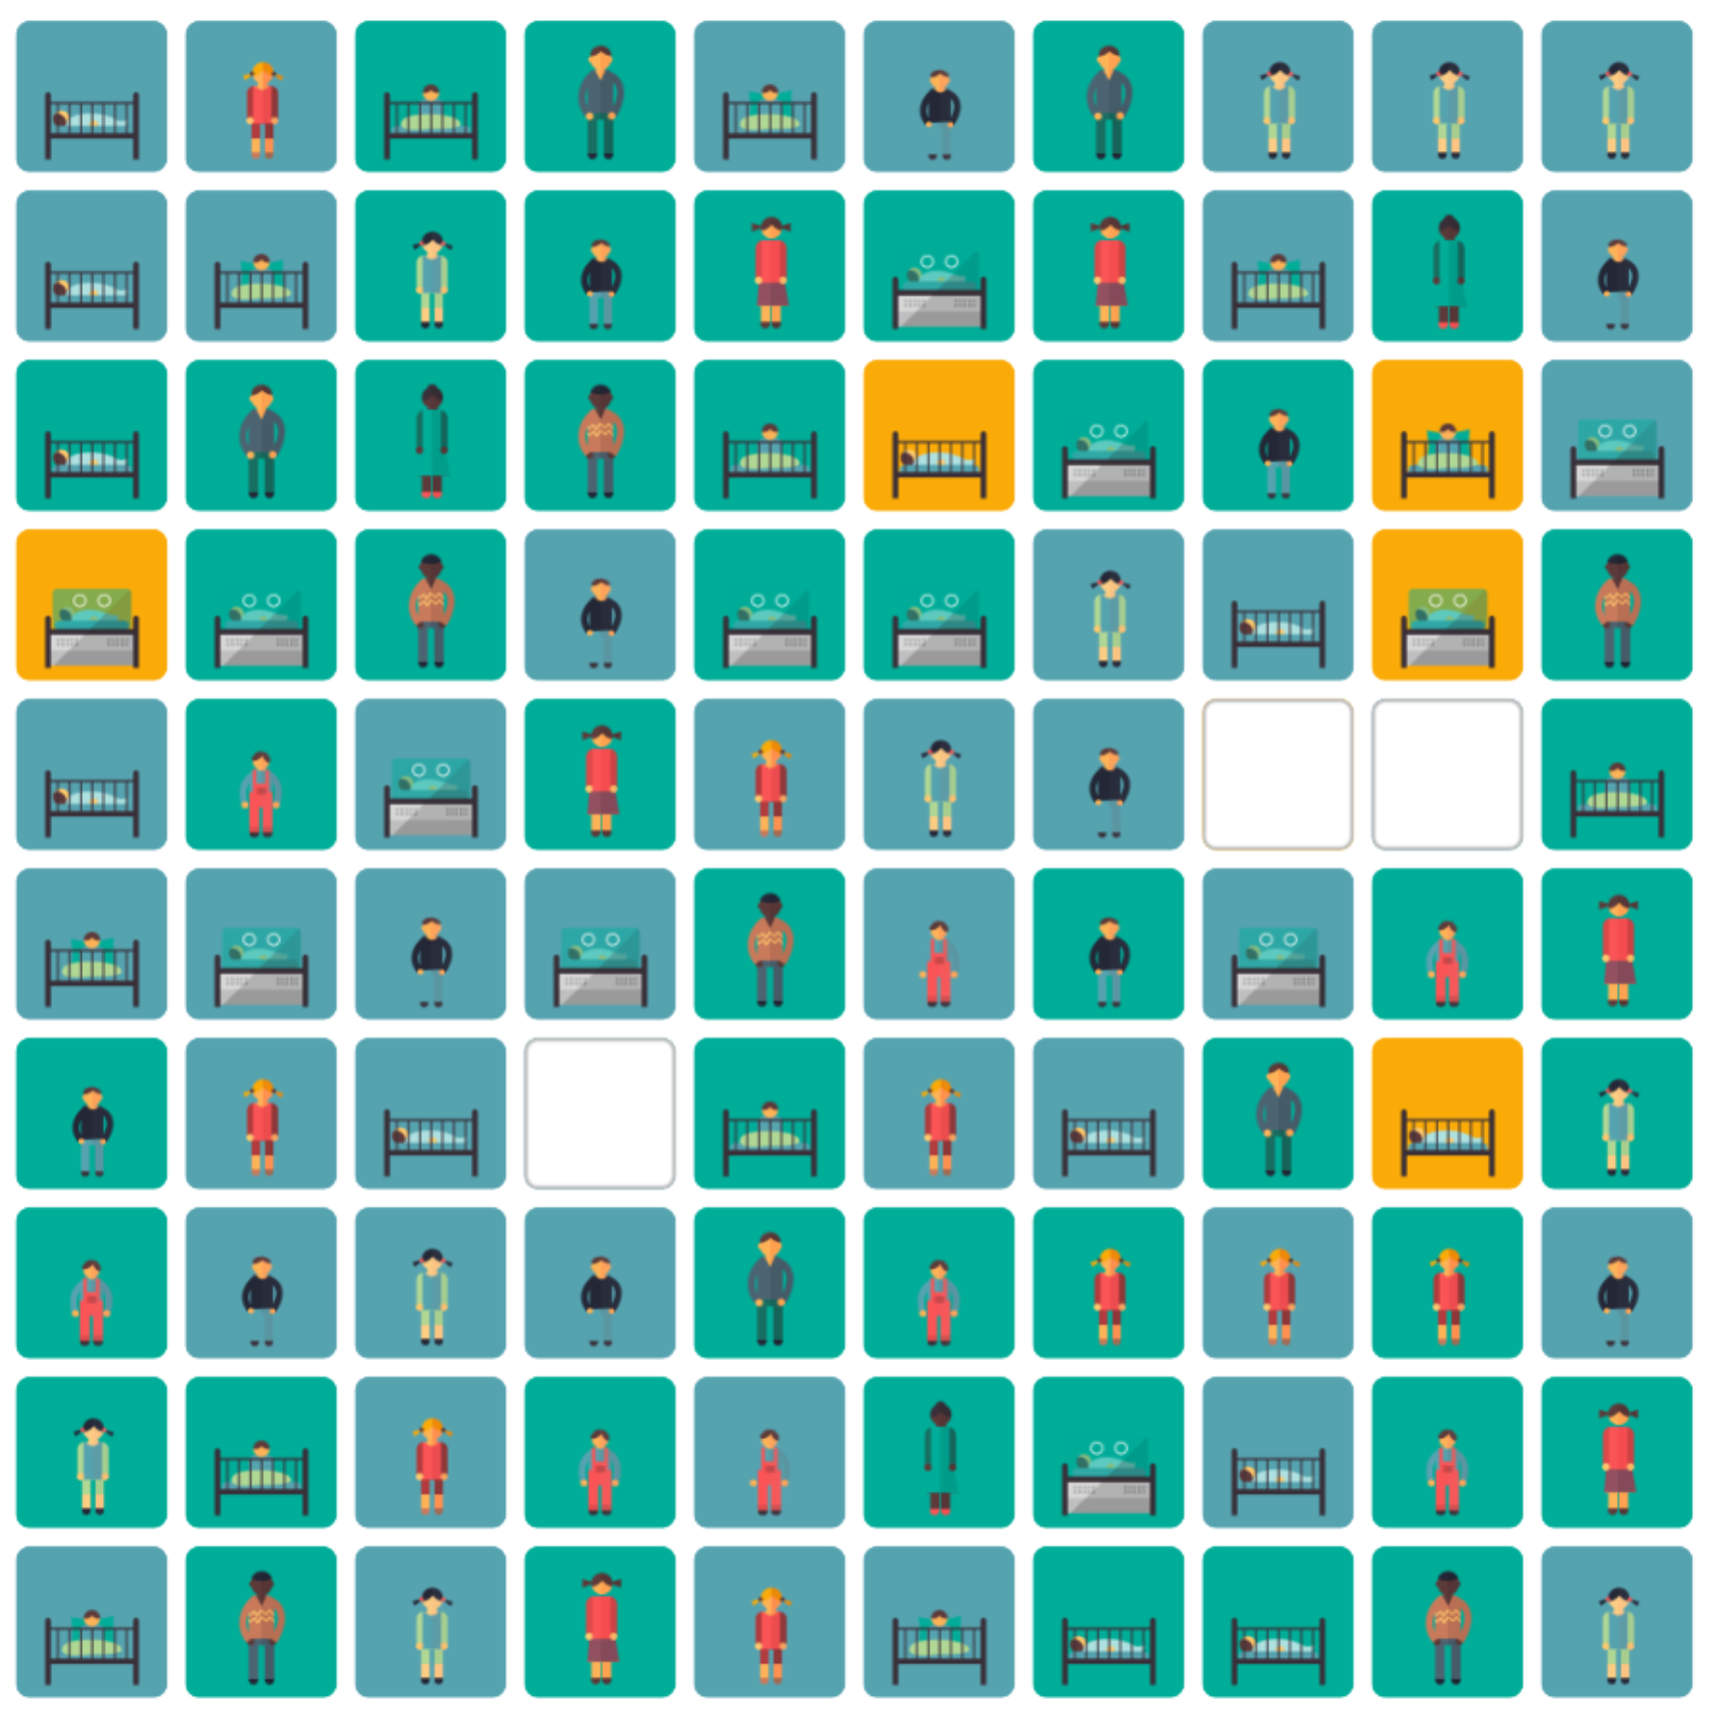

**\* Slides 23,24,25**

**sample**: 13

**deaths:** 3

**skew%** 0

**spread** 0

**frame** 6

**future seed** 0

**show deaths:** on

**show risk backgrounds:** on

**\* Slide 26-30 (use for-qudos to tween these)** . Use the animatic predicted range and axes, cutting out the icon-arrays and the red graph rectangles from for-qudos.

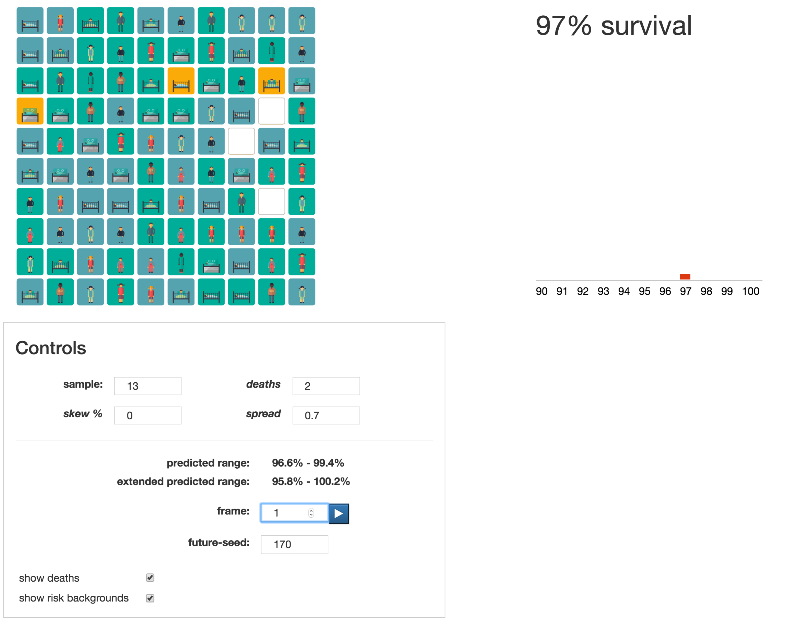**sample:** 13

**deaths**: 2

**skew%** 0

**spread** 0.7

**frame** 1 through 20

**future seed** 170

**show deaths**: on

**show risk backgrounds:** on

**Run these parameters through to frame=20**

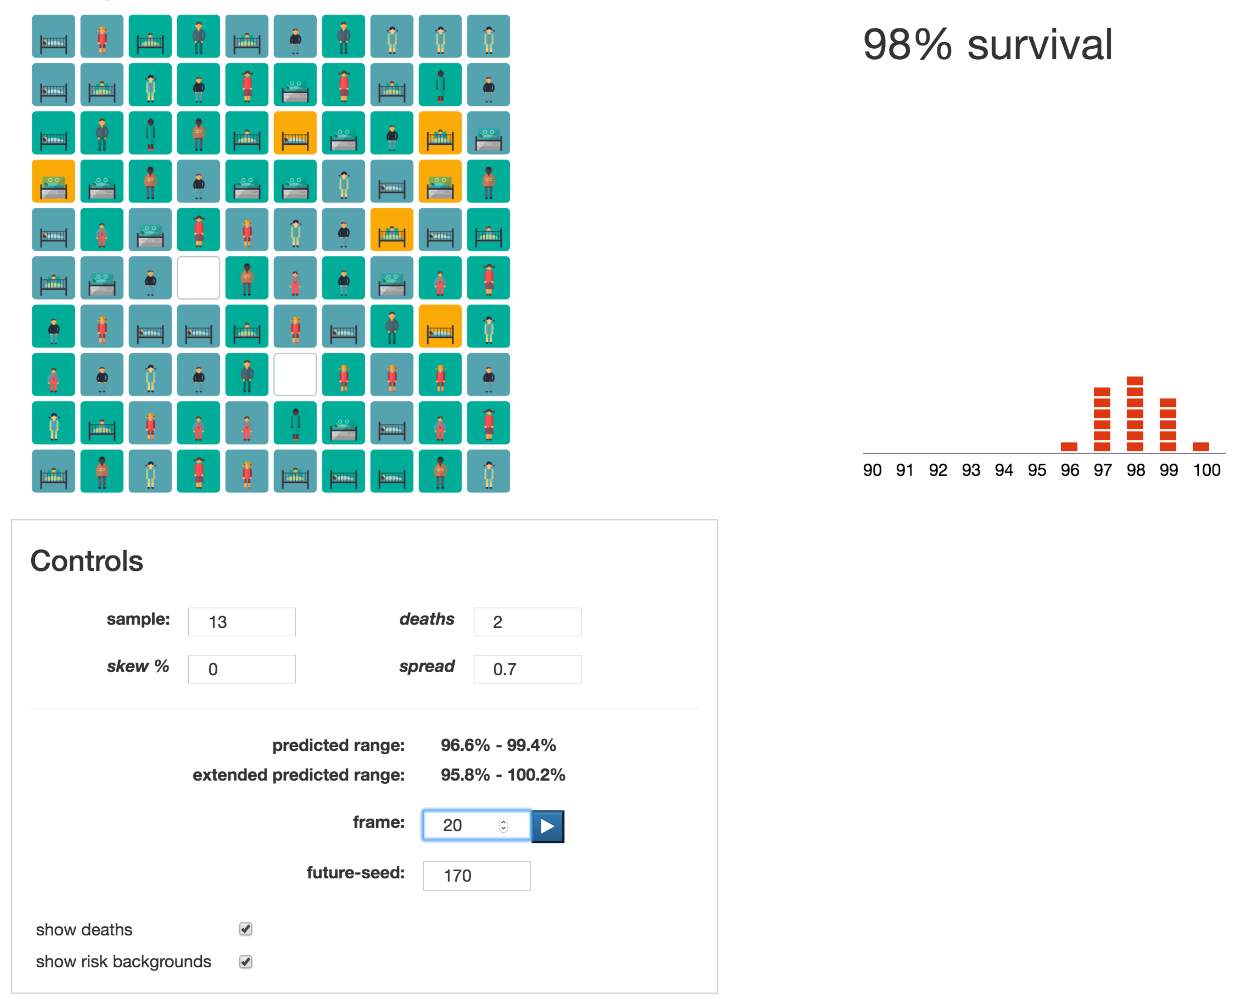

**Slide 31:**

Like Slide 30, but:

show deaths: off

**Slide 33 (The fast tween of 1000 possible futures).**

Use Slide 30 parameters, but along the way increase spread to 0.75

**spread**: Ramp this up smoothly from 0.7 to 0.75 between frames 500 to 1000

**frame:** 20 through to 1000 in steps of whatever you need to get a smooth animation.

**show deaths:** on

**The end result (animation slide 33) should be:**

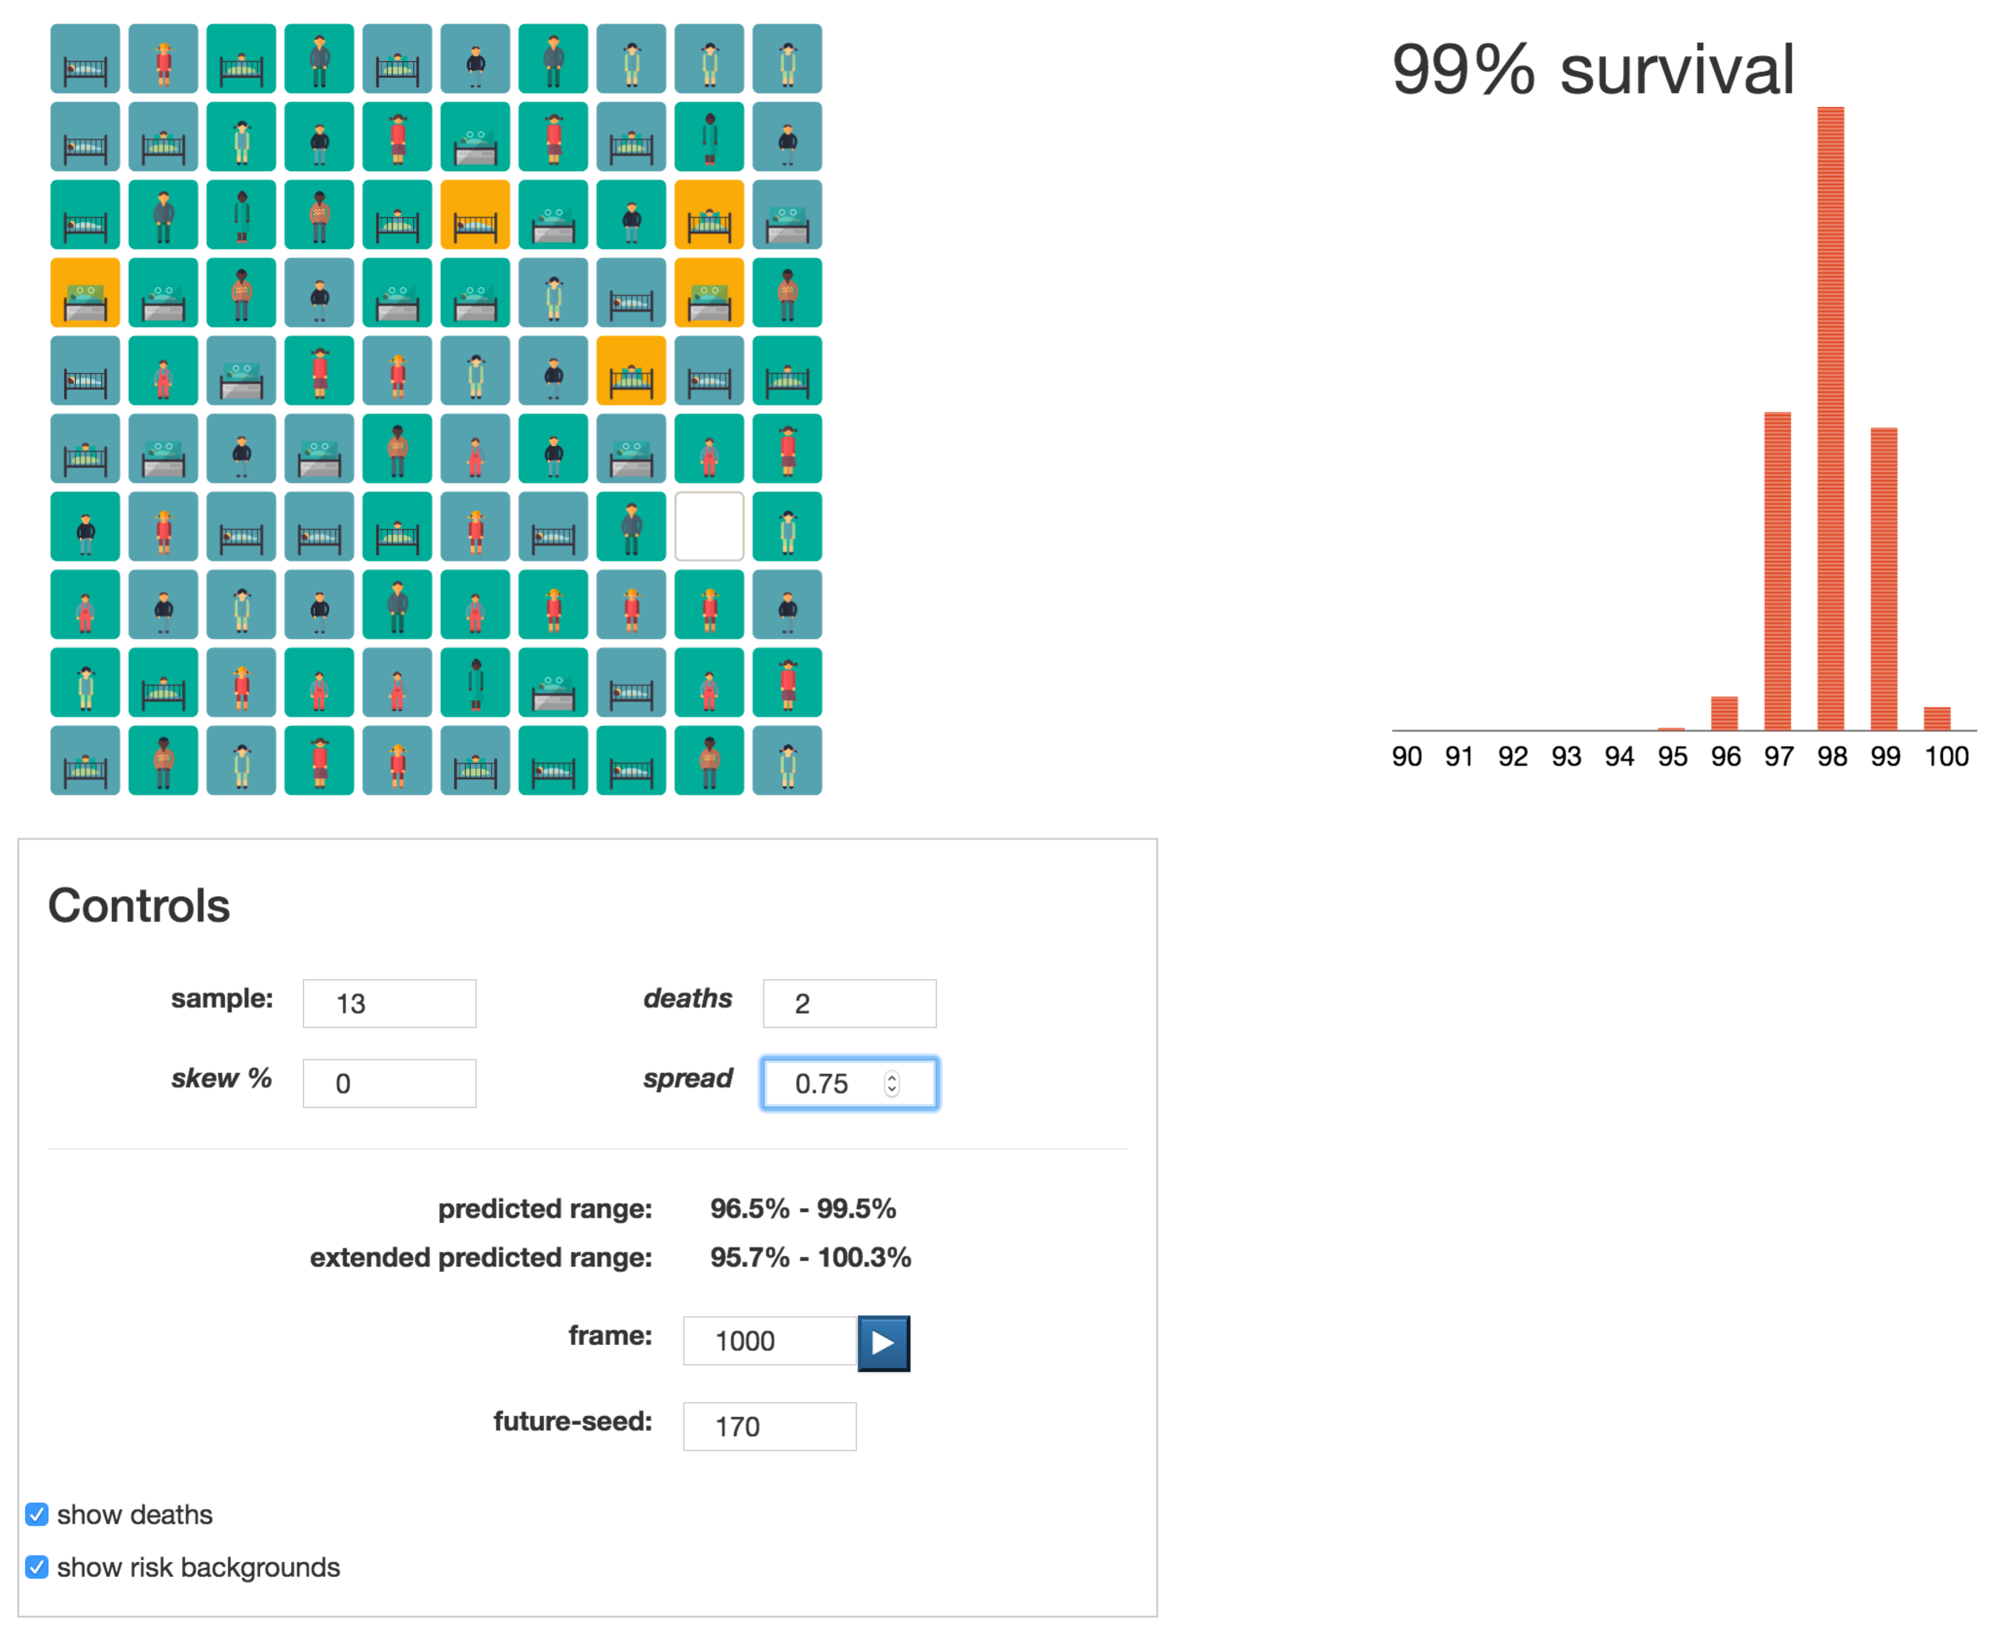

**Again, use the predicted range bars and axes from the animatic, fitting the red graph to them.**

**Slide 35**

Copy the animatic