ColViz Middleware Manual

ColViz (Collaborative Visualization) it's a Middleware oriented to the application of collaborative visualization techniques inside the HBP Project. This Middleware is mainly centered in the analysis of huge neuroscientific data sets that are growing up day by day, increasing the difficulty of knowledge extraction. Visualization techniques could help in the analysis by taking advantage of the human visual system. These advantages could be made more powerful if the visual analysis is done using collaborative visualization techniques, allowing several groups of neuronscientist to work collaboratively. ColViz allows Neuroscientists the aplication of collaborative visualization techniques to ease the analysis of neuroscientific data, using different Collaborative Visualization paradigms.

The ColViz Middleware lets the users to interact in a collaborative way during the visualization process. This collaboration could be achieved following different paradigims, such as coordinated views, where different users, running different instances of the same or different visualization tools, even on different locations, could share the data visualization, allowing ones to another to analyze this data from different points of view, for example, structural and functional at the same time. One incorporated funtionality is to let certain users guide others during the visualization process, for example, moving the camera remotely to show particular phenomena of the data under analysis; more over, this middleware is prepared to select objects of the scene and share this selection to other users to focus the attention during the anlysis and ease the knowledge extraction.

The analysis could be achieved in real time, where all the users involved in the visualization process shares the same view at the same time, but the collaboration could be achieved in and offline process, that means, the users start his applications (with the ColViz Middleware integrated into them) and is able to analyze the data generated for other users ensuring the collaboration, and make his contribution to one specific analysis and share this contribution with other scientisits. To give this funtionality to the final users, the ColViz Middleware has been designed with a persistence system to be able to store and retreive the data generated during the collaboration. This persitency system is based on a relational data base over MySQL infrastructure, but this part is slyghty coupled so it is easily interchangeable to allow other relational or not relational database systems.

This middleware is designed to incorporate this collaborative techniques directly inside the visualization tools, only adding this middleware to the visualization tools and of course, modifing the logic of the tool to incorporate the desired functionality, the idea is simple, just the tools comunicating between them. The persistence system is higly configurable, and could be mounted on any machine where the users that will collaborate could connected remotely. A simple server with public addres and an instance of MySQL service its enough. The configuration in the client side is higly configurable too, just modifing a simple configuration files is enough to stablish the comunication with the persistence system as well as other users involved in the collaborative analysis.

With the ColViz Middleware infrastructure, where the visualization tools can comunicate between them and at the same time, being able to store and retreive information over the persistence system, for example information about the experiments or even the discussion between the scientists during the analysis process.

Togheter with the ColViz Middleware, there are two simple visualization prototypes oriented to show the basic functionality of this infrastructure, conformed by the ColViz Middleware and the Persistence System.

The first prototype is called ColViz3DClient, and is oriented to the analysis of neuronal scenes, using realistic and schematic representations. This prototype gives the user the posibility to analyze neuronal scenes with complete 3D movement into the scene. The next figure shows a screenshot of this prototype.

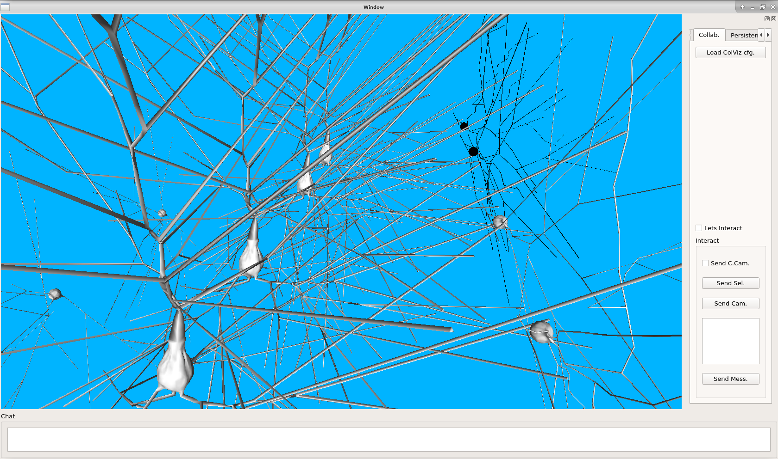
Image of the prototype ColViz3DClient, based on ColViz Middleware.

The second prototype is called ColVizWebClient, and is oriented to the analysis of neuronal scenes, but using only schematic representations using web render technologies, concretely javascript with some auxiliar libraries to ease the render, such as d3. This prototype can execute javascript, CSS and HTML5 code to show visual information about neuronal scenes. This prototype is able to inject javascript code into the visualization to update this visual information with data out of the application, such as the information sent by other users through ColViz Middleware during the collaboration. The next figure shows a screenshot of this prototype.

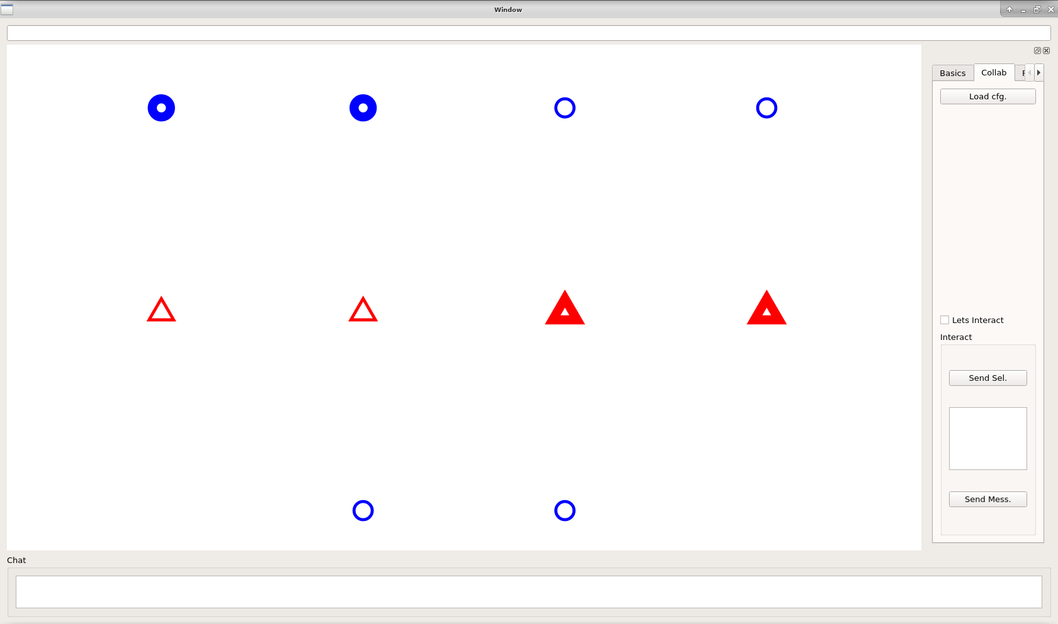
Image of the prototype ColVizWebClient, based on ColViz Middleware.

Both prototypes could be connected independently, for example, the users can connect ColViz3DClients between them, ColVizWebClient between them or even ColVizWebClient with ColViz3DClient, as proof of concept of different tools that work together under same functionality incorporated into the ColViz Middleware.

At the same time, both tools can comunicate directly one to another, and interchange information directly or they can store and receive the information from the persistence system or an specific experiment under analysis. In this case, the users must be logged into the persistence system, with simple user and passord autentication system, and after that, the user can download from this persistence system the information of this experiment from previous analysis, for example, messages from previous analysis of the data under analysis. The next figure shows an example of two intances of both visualization prototypes during a collaboration.

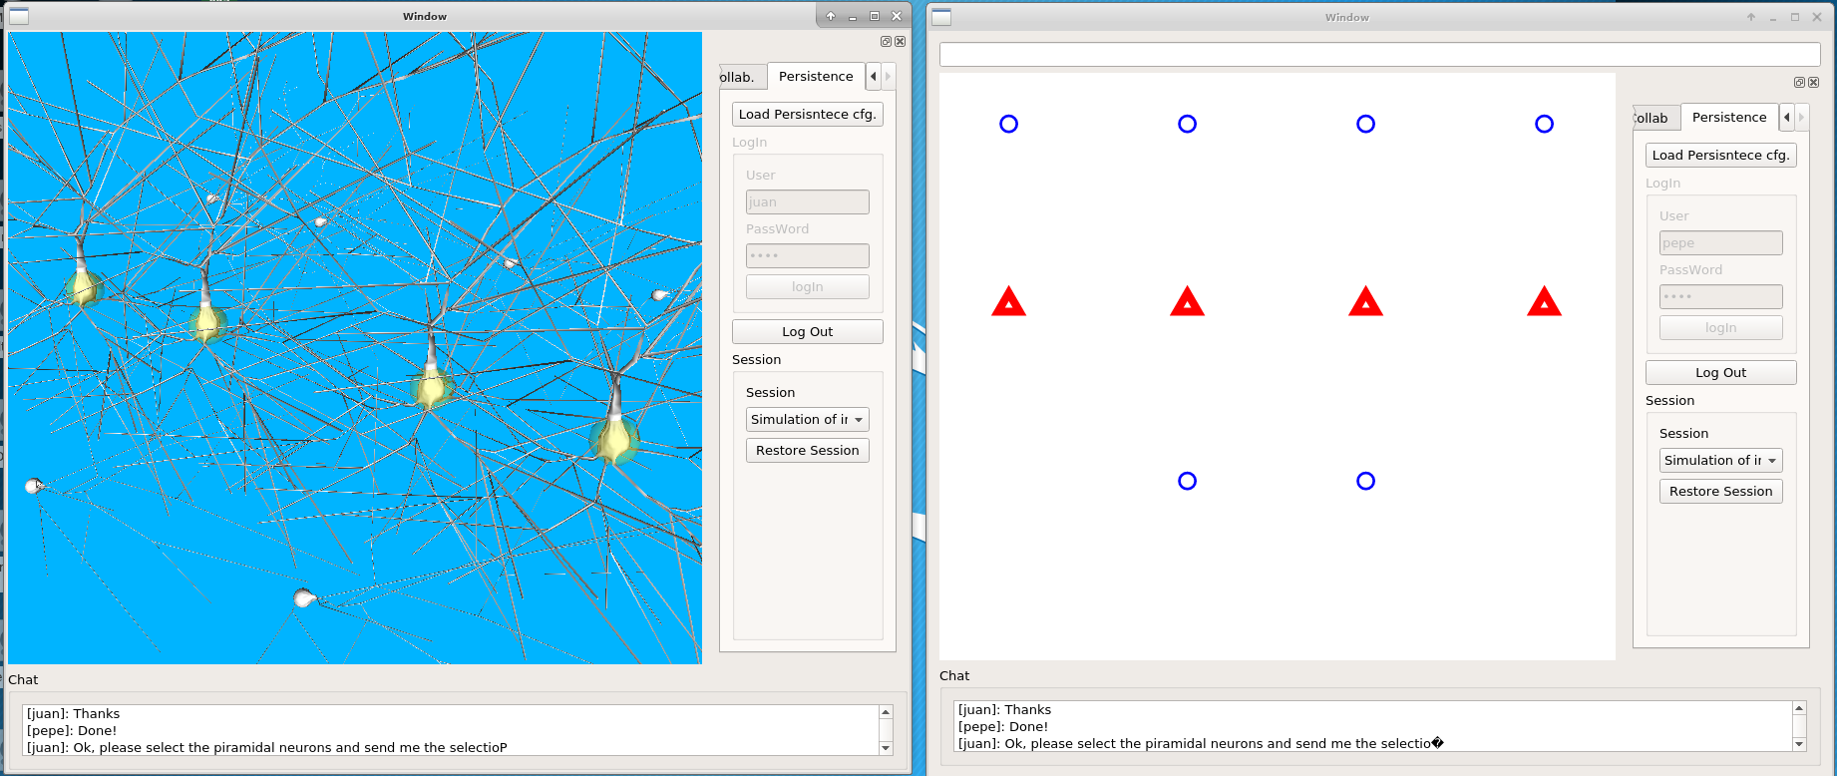
Both prototypes connected using ColViz and sharing data accross the Persistence System. In this example, one user asks for piramidal neurons and the other user select this neurons and send this selection to the other one, at the same time, both users uses the chat system to comunicate and this chats are stored on the persistence system.

