Solomine Vision

Solomine Functional Specification

Solomine Use Cases

Solomine System Architecture

Solomine Engagement Template

Solomine Technical Controls
Solomine Operational Controls

Solomine Management Controls
Solomine Build Plan

Blue Glacier Management Group

Solomine Software System Description Document

Date: 8/27/16


Solomine Surfer System and Software Engineering Plan
Solomine Surfer System and Software Engineering Plan 2
1. Organization Need 4
2. Vision Statement 4
3. Solomine Surfer Functional Specification 5
3.1 The system will access Twitter and retrieve data. 5
3.2 The system will access Facebook and retrieve data. 5
3.3 The system will access general Web pages and get data 6
3.4 The system will access YouTube and get data 6
3.5 The system will access Google Books and get data 6
3.6 The system will access Blogger.com and get data 6
3.7 The system will mine retrieved data 6
3.8 The system shall provide for management of users authorized to use the system. 7
3.8.1 The system will provide for selection of users from the organization Directory 7
3.8.2 The system shall define and enforce access roles 7
3.8.3 The system shall input and edit each user’s status 7
3.8.4 The system shall input and edit each user’s role 7
3.8.5 The system shall provide administrators messaging capability to users 7
3.9 System Availability 7
4. Use Case Scenarios 8
4.1 System Use Case 8
4.2 Situational Awareness Use Case 9
4.3 Sense Making Use Case 10
4.4 Meme Epidemiology Use Case 11
4.5 Dark Web Mapping Use Case 12
4.6 Executive Reporting Use Case 13
5. System Architecture 14
5.1 Component Architecture 15
5.2 Architecture: Second Level Decomposition 17
5.2.1 View Architecture: Third Level Decomposition 18
5.2.2 Router Architecture: Third Level Decomposition (continued) 19
5.2.3 Model Architecture: Third Level Decomposition (continued) 21
5.2.4 gmrSocial Architecture: Fourth Level Decomposition 22
5.3 System Data Flow by Component 24
5.4 System Data Flow By Mining Target 25
5.5 Solomine Surfer Access Management 26
5.5.1 Solomine Surfer User Account Management 26
5.5.1.1 New Account Request Control Flow 26
5.5.1.2 Solomine Surfer Add User Control Flow 26
5.5.1.3 Solomine Surfer Manage Users 29
5.5.2 Solomine Surfer Logon and Validation 34
Logon Control Flow Diagram 35
5.6 Solomine Surfer Log Management 37
6. Solomine Engagement Template 40
6.1 Organization mission that the engagement will support 40
6.2 Engagement goals 40
6.3 Stakeholders 41
6.4 Engagement deliverables 41
6.5 How engagement performance will be measured 41
6.6 Schedule for delivering the work 42
6.7 Major milestones 43
6.8 Acceptance 43
6.9 Level of Effort 43
6.10 Assumptions 43
6.11 Staffing 44
6.12 Risks facing social media mining project 44
7. Technical Controls 45
7.1 Identification and Authentication 45
7.2 Logical Access Control 45
7.3 Audit Trails 45
7.4 General Technical Description 45
8. Management Controls 46
8.1 Risk Assessment and Management 46
8.2 Rules of Behavior 46
9. Operational Controls 46
9.1 Organizational Separation 46
9.2 Personnel Security 46
9.3 Physical and Environmental Protection 47
9.4 Production, Input/Output Controls 47
9.5 Contingency Planning 47
9.6 Hardware and System Software Maintenance Controls 47
9.7 Documentation 48
9.8 Incident Response Capability 48
9.9 Hardware Maintenance and support 48
10. Build Plan 48
10.1 AWS Build Plan 48
10.2 Python build plan 48
10.3 Mongo Build Plan 49
10.4 Solomine Build Plan 50

1. Organization Need
Sentiment and influence are important characteristics of any communications from a person or group of interest. Sentiment or opinion is important because it is central to human behavior. For the first time in history, the Internet has provided a rich source of opinion data, opinions written by people, for people. Access to this data is problematic. The sum of opinion data is not in one location; but, instead, multiple social service providers are the collectors of partial, fragmentary pieces of the puzzle.

This presents a very complicated challenge to correlate the vast amounts of information retained in multiple systems. There is a data type problem in which an organization and its analysts need to process a wide variety of complex data structures, with each social media site having complex and very different data structures. Furthermore, there is a data glut problem and the consequent need to collect the right data, relevant data, and not just all data.

Sense making of the environment to develop situational awareness requires a toolset to develop, integrate, and maintain thorough, accurate, and current information about people, groups, concepts, products, and systems. The toolset must support the organization in understanding its environment, enacting policy in that environment, selecting or developing policy, and retaining relevant policy histories. An organization unable to retrieve key information and analyze it in a timely manner will miss both opportunities and threats that will slip through the cracks of their analytic systems.

2. Vision Statement
Solomine provides unparalleled data access and statistically based reasoning ability. It is a sophisticated analytical toolset that permits organizations to conduct analytic searches, conduct link analysis and data visualization, and triage information. Solomine ingests relevant data to allow operators, analysts and decision makers to identify, search, exploit, and correlate opportunity or threat information in a single environment. It can discover or locate predictive patterns, or anomalies indicative of disruptive change, to provide key intelligence information from multiple sources.

Thru its understanding of the different social Web complex data types, widely diverse information is transformed into a common format. Additionally, it extends existing investigation possibilities by automating data reduction thus enabling analysts to effectively exploit their immense, exiting datasets. This enables new business or agency opportunities by turning large volumes of social data into competitive opportunities; likewise with threat identification. Because of the nature of the Web, and especially the social Web, Solomine can provide real-time, instantly available information at the level of summary aggregates down thru individual details.

The access can be directly to social media or to data warehouses that store this information. Solomine is used by analysts to solve their assigned problem, selecting relevant data and mining it for patterns and selectively storing results in a flexible and scalable store that can be integrated with other stores. Solomine also provides text analytic services to assist analysts in speed reading and understanding the problem domain.

The long term vision for Solomine is that it will progress thru five phases to eventually become a self-organizing system that can augment analyst work or work independently.
- Solomine Surfer: interactive recon tool, NoSQL store (MongoDB), interactive data mining actions, works on Latin Alphabet languages (the current prototype is in this phase)
- Solomine World surfer: introduce Unicode so Solomine works with any world language
- Solomine Heuristic surfer: introduce grammars for relational word analysis
- Solomine Scalable surfer: deploy Solomine on AWS SSS and Elastic Compute for easy scalability
- Solomine Self Organizing Surfer: define a semantic framework for self-organizing systems and relate entities to each other in a system that automatically enacts with external environment, selects best processes to use, and retains appropriate methods for future use.

3. Solomine Surfer Functional Specification
The functional specification begins with access requirements for the various social media, and ends with the required mining capability.

3.1 The system will access Twitter and retrieve data.
3.1.1 The system will search Twitter for tweets by topic
3.1.2 The system will use Twitter stream for accessing tweets by topic
3.1.3 The system will use Tweet metadata to get Next search results
3.1.4 The system will get Retweets
3.1.5 The system will get Likes
3.1.6 The system will get Twitter trending by WOEID
3.1.7 The system will present tending topics
3.1.8 The system will present Followers count for a user
3.1.9 The system will get text from tweets
3.1.10 The system will get entities from tweets
3.1.11 The system will get user description from tweets
3.1.12 The system will get geolocation from tweets
3.1.13 The system will provide option to store tweets in a database
3.1.14 The system will provide the option to start background threads for Twitter stream

3.2 The system will access Facebook and retrieve data.

3.2.1 The system will Search for Facebook pages by topic
3.2.2 The system will Present Facebook pages on a topic to user
3.2.3 The system will Access a Facebook page by pageID
3.2.4 The system will Retrieve Posts on page
3.2.5 The system will use metadata to get Next post results
3.2.6 The system will Retrieve Facebook comments for a post
3.2.7 The system will Retrieve Likes
3.2.8 The system will Get text from posts
3.2.9 The system will Get text from comments

3.3 The system will access general Web pages and get data
3.3.1 The system will Search for Web Pages by topic
3.3.2 The system will Present Web URLs on a topic to user
3.3.3 The system will Access Web page by URL
3.3.4 The system will Retrieve text on Web page
3.3.5 The system will Retrieve links on Web page

3.4 The system will access YouTube and get data
3.3.1 The system will Search for YouTube videos by topic
3.3.2 The system will Present YouTube videos on a topic to user
3.3.3 The system will Access a YouTube video by ID
3.3.4 The system will Retrieve comment text for YouTube video
3.3.5 The system will Retrieve likes for YouTube video
3.3.6 The system will Retrieve author and title for video

3.5 The system will access Google Books and get data
3.5.1 The system will Search for Google Books by topic
3.5.2 The system will Present Google Books on a topic to user
3.5.3 The system will Access a Google Book by ID
3.5.4 The system will Retrieve comment text for the Google Book
3.5.5 The system will Retrieve likes for the Google book
3.5.6 The system will Retrieve author and title for the Google Book

3.6 The system will access Blogger.com and get data
3.6.1 The system will Access a Blogger blog by ID
3.6.2 The system will Retrieve posts content for a blog
3.6.3 The system will Retrieve blog description
3.6.4 The system will Retrieve author and title for blog post

3.7 The system will mine retrieved data
3.7.1 The system will perform Lexical Diversity
3.7.2 The system will perform Frequency analysis
3.7.3 The system will perform Sentiment analysis
3.7.4 The system will prepare a TDM
3.7.5 The system will perform Sentence tokenization
3.7.6 The system will perform Word tokenization
3.7.7 The system will perform POS, Chunking, Extraction
3.7.8 The system will perform Summarization techniques
3.7.9 The system will perform N-Grams
3.7.10 The system will perform TF-IDF
3.7.11 The system will perform Cosine Similarity
3.7.12 The system will perform Associations
3.7.13 The system will perform Geocoding
3.7.14 The system will perform Clustering

3.8 The system shall provide for management of users authorized to use the system.

3.8.1 The system will provide for selection of users from the organization Directory

3.8.2 The system shall define and enforce access roles

3.8.3 The system shall input and edit each user’s status

3.8.4 The system shall input and edit each user’s role

3.8.5 The system shall provide administrators messaging capability to users

3.9 System Availability
3.9.1 The Solomine system servers are to provide support 24 by 7 with an allowance of 10 minutes per day for server administration. This ten minute period is to be 16:20 to 16:30 each day.
3.9.2 No Quality of Service is guaranteed for network outages such as occurred when the router failover did not function properly and inter-site web connectivity was nonexistent for several hours while corrupted routing tables, caused by router failover failure, were rebuilt.
3.9.3 In the event of application unavailability, either a policy to retry the application in several minutes or the use of the paper form in use today will be put in place.

4. Use Case Scenarios
The following are example use cases for an example organization. They can be adapted to a specific organization and other use cases added as needed.

4.1 System Use Case
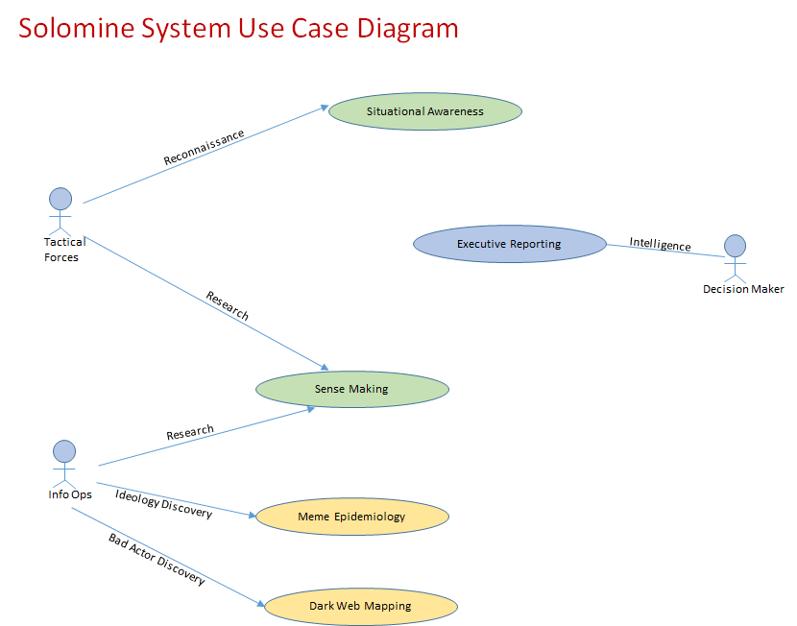

Solomine is a special social media and Web mining tool. The purpose of data mining is the transformation of a social, political or business problem into a data computational problem. The Web and social media on the Web is the most widely used communication platform in use today.

Solomine is a tool and a methodology to elicit meaningful strategic information from the firehose of data available on the Web. Organizations can use Solomine to enhance their research and situational awareness, using social media analysis to assist strategic planning.

It is a reconnaissance tool, in additional to a data mining toolset, that enables an agency to select focused data to mine rather than select all data and then try to mine the entire universe. Solomine instead lets the organization pinpoint domain parameters of interest and quickly mine that domain.
It uses application programming interfaces available on the Web to search, filter, and retrieve both: the content of people’s public interaction on the web
Demographic and psychographic data of those individuals.

It uses data mining techniques for classification, regression, clustering, deviation detection, association analysis, and evaluation of patterns mined from Web social data. It provides meaningful and timely intelligence to decision makers.

4.2 Situational Awareness Use Case
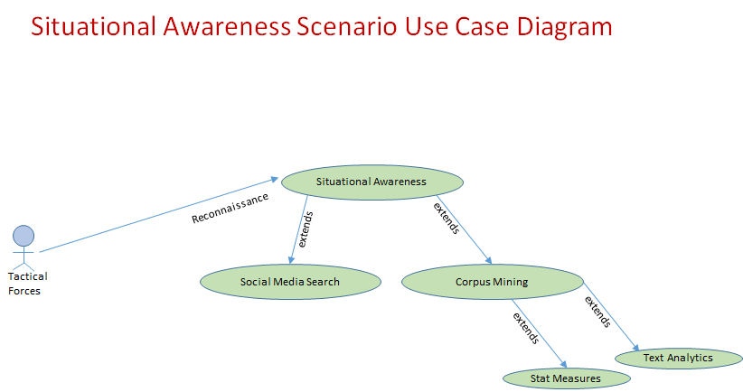

The Situational awareness tool provides sentiment and influence of messages as well as demographic and psychographic information of the message poster. It has a class for statistical based reasoning in the mining of intelligence from collected raw data. In addition, it has textual analytics class that reads collected raw data and prepares summaries based on inherent topic frequency as well as summaries based on sub topics of interest to the analyst. It provides grammatical analysis, preparation of parts of speech for ontology development, n-grams to complement summaries and identify memes and entities.

In contrast to old methods, Solomine media mining is: available at the individual level not as aggregates alone; its continuous and not done infrequently; formats social media data ideal for time studies, how things vary over time; and in addition, it make it better suited for cross correlation.

Solomine automates access to the Web and social media sites on the Web. The Situational Awareness function provides actionable intelligence for situations consistent with already defined standard operating procedures.

4.3 Sense Making Use Case
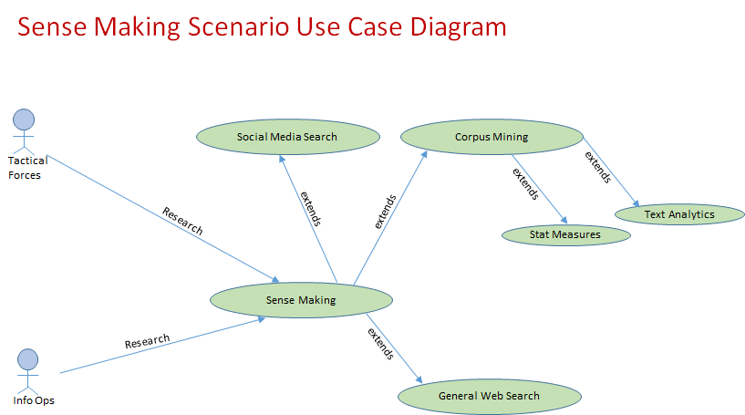

The Solomine Sense Making function assist the agency in understanding equivocal clues that are not quite consistent with its worldview and therefore inconsistent with standard operating procedures. This could be the result of the information being new and, therefore, not in the agency’s retained knowledge of the world; or it could be a different slant on information we have retained. This is an indication of what Polanyi discussed as a disconnect between the representational meaning of a concept to observer and the concept’s existential meaning. This is an indicator of potential threat and of opportunity.

This function also makes use of sentiment analysis and influence. Sentiment Analysis is synonymous with Opinion Mining: it analyzes the written opinions of people. Social media like Twitter and Facebook is a rich vein of material for this type of mining.

Sentiment analysis is not the interpretation of a structured survey with well defined attitude scales. Instead it deals with free form text document and the Solomine Sense Making function uses natural language processing methods to understand the measures and causes of behavior, and discover relationships and patterns in the corpus collected by an analyst. For example, the relative centrality of communication interactions can identify leaders based on the patterns of the communications.

The Solomine Sense Making function uses Natural language processing provides the agency with an automated tool for: Selecting relevant data, Memoing: read through the text, form classifier codes, Describing: describe the case and its context, Classifying: use categorical aggregation to establish themes or patterns, Interpreting: explain a case with naturalistic abstraction, Representing: present an in-depth picture of the cases using narrative, tables and figures.

4.4 Meme Epidemiology Use Case
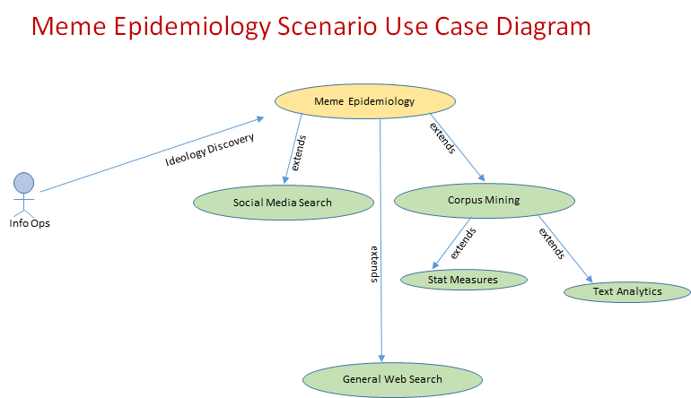

British scientist Richard Dawkins’ proposal is that information is like a virus and a meme is an agent that replicates itself to spread information. A meme is a primary element in trafficking concepts; it starts somewhere and grows exponentially. It is a template that disseminates throughout a domain by attaching to an idea, belief or pattern but allows the meaning to mutate as it goes along.

Memes are powerful tools or weapons to shape ideas, and influence a meaning making process that forms beliefs. In the asymmetrical battlefield confronting the US today, memes become the tools to understand, influence or attack ideologies. If successful with this type of Information Operation, memes can be used to persuade, dissuade and deter future adversaries, conserving budget and resources. Understanding cultural directions is an important step in analyzing insurgencies. A critical step is acknowledging an ideology as a disease and memes as the vector for its proliferation.

Meme engineering presents an opportunity for an agency to enter into the hotly contested information war, a contest where the United States Government is suffering humiliatiing losses. It should become an integral part of Information Operations (IO), Psychological Operations (PsyOps), and Strategic Communications (SC).
Meme Surfer is a special social media mining tool. The purpose of data mining is the transformation of a social, political or business problem into a data computational problem. The epidemiological nature of memes presents a fertile field for computational study to look for patterns in unstructured data sources such as social media sources.

Meme Surfer employs computational algorithms relevant to mining memes including frequency analysis, similarity and clustering analysis, hypothesis and inference testing, regression, machine learning, and natural language processing. As with computational epidemiology for disease, the intent with mining memes is to identify the origin, track the spread of memes and evaluate the impact of the meme or assist intervention to counteract its effects. Unlike epidemiology, there is also a need to understand the purpose of the meme.

4.5 Dark Web Mapping Use Case
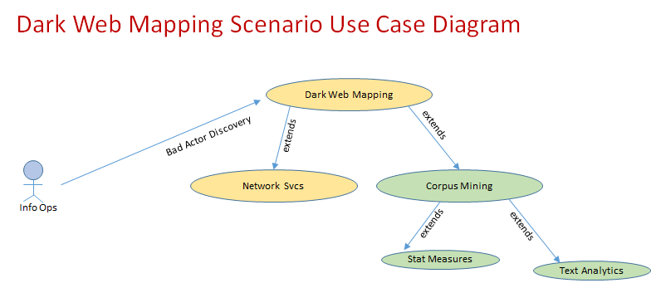

The Dark Web is a set of sites hidden from normal Web access and analysis. These sites have been manually configured to hide themselves from Internet organizers. The Dark Web is the habitat of bad actors. Illegal activities include extreme porn, terrorist communications and transactions, drug trafficking, weapons sales, credit card fraud, counterfeiters, anarchy groups and hackers.

Solomine Dark Web Mapping utilizes customized network services to circumnavigate the dark web and collect raw data, then process that data into meaningful intelligence. It leverages the same modules that illuminate the general Web to provide insight into activities on the dark Web.

4.6 Executive Reporting Use Case
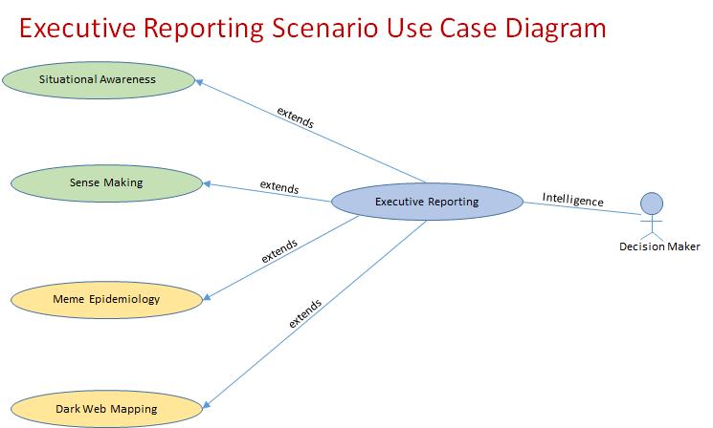

The Solomine Executive Reporting function leverages all the other Solomine functions to provide an answer to the question “what is going on?” This function brackets the raw data on the Web to assist the decision maker, who without such bracketing is left to confront the flow of raw data with no signifiers on what are the good parts, the bad, the interesting or what is trivia. Unpunctuated input fails to distinguish when one story ends and another begins.

Solomine deals with the chaos of the ecology be breaking it into chunks, ignoring parts of the data, and using the extracted portions, advise on decisions that can be made and what situations are present. Solomine provides a schema of the present environment based on standard practice. Moreover, the insights of boundary people are quickly and vividly available to the decision maker as well as analysts with central access to the data repositories.

5. System Architecture
Solomine is a tool and a methodology to elicit meaningful strategic information from the firehose of data available on the social Web. Organizations can use Solomine to enhance their research and situational awareness, using social media analysis to assist strategic planning. It uses application programming interfaces available on the Web to search, filter, and retrieve both the content of people’s public interaction on the web and demographic and psychographic data of those individuals. It uses data mining techniques for classification, regression, clustering, deviation detection, association analysis, and evaluation of patterns mined from Web social data.

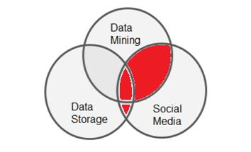

Solomine is about social media mining that enables organizations to
- Connect to the popular social web sites, as well as the general Web
- Customize the access, extraction, analysis and display of insights from those sites
- Turn a business, political or economic problem into a data problem
- Search data produced by people for people to identify patterns that will improve situational awareness
Solomine uses Python:
- Version 2 is the original and almost all of the python ecosystem is compatible with version 2
- Social media are based on JSON and handled inherently by Python
- Intuitive language for retrieving and parsing complex structures
- Supports Map/Reduce
- Open Source
- Vast array of open source packages to simplify work and comply with standard practice
Solomine has three components:
- Data model: data access and mining logic
- View: presentation of data
- Router: navigation - receives events, calls data model routines, and returns views to user

The components are loosely coupled: any component can be swapped out without impacting the others. Separating router from view logic, for example, means that a more sophisticated user interface can be substituted for the current, simple prototype user interface. Likewise, the model component uses open source packages for mining to follow standard practice; a custom, from scratch mining model can be substituted for this approach if needed.

5.1 Component Architecture
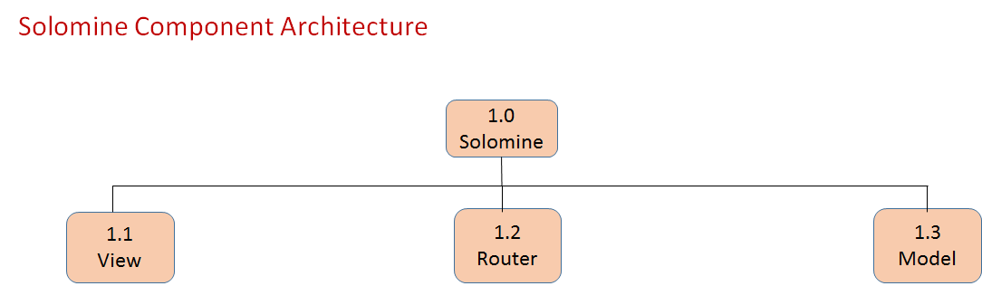

The Model component has the data access and mining logic. It is implemented as a Python package with 2 classes:
- gmrSocial
- gmrTextAnalytics

The Router component provides navigation for the system, while the View component provides presentation.
- Router and View group are implemented through a Web application framework
- URL mapping links Web server navigation with Web client presentation

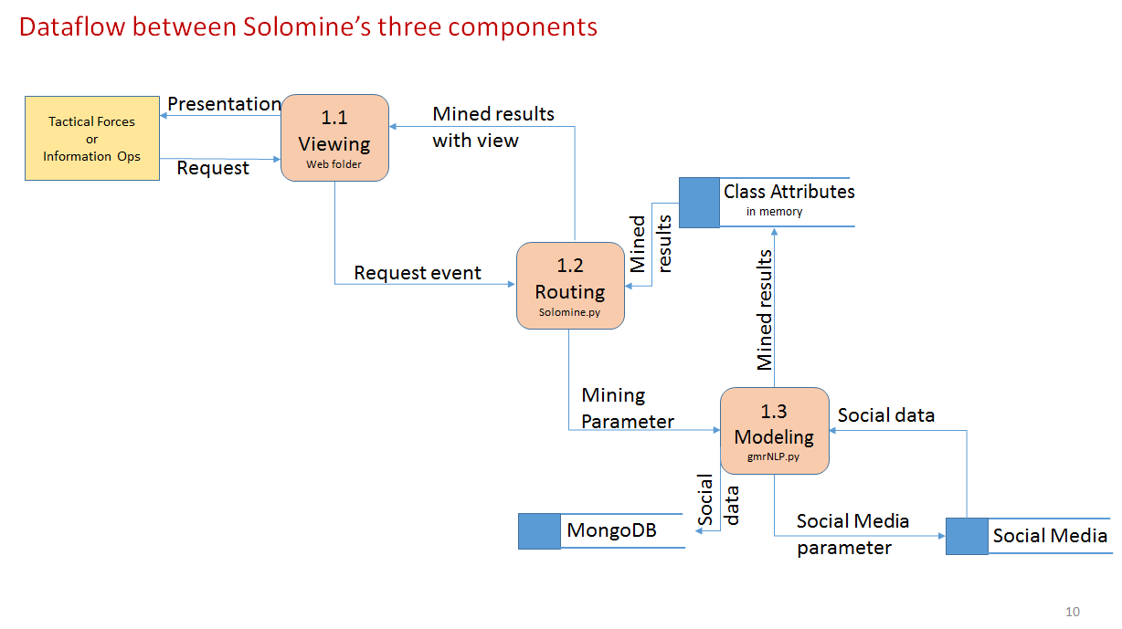

5.2 Architecture: Second Level Decomposition
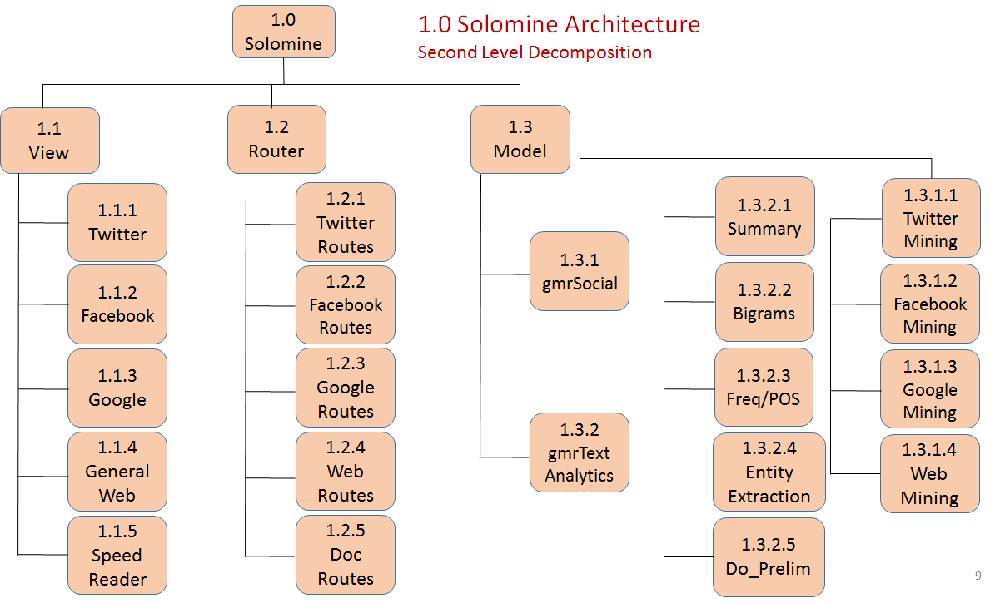

A new mining target is modularly added to each of the 3 components. For example, Google assets are their own modules in each of the components. The Model component has an additional layer. The Model component has responsibility for mining the social data. In addition to the data mining calculations, the actual social data itself is also returned as an item of interest. The gmrSocial module contains the mining targets as well as statistical routines used to mine those query results. The gmrTextAnalytics module contains document processing routines used by social media mining and also speed reading so it is separated out. It can be argued that the statistical routines in gmrSocial should be isolated into a separate class, and this can be easily done.

5.2.1 View Architecture: Third Level Decomposition

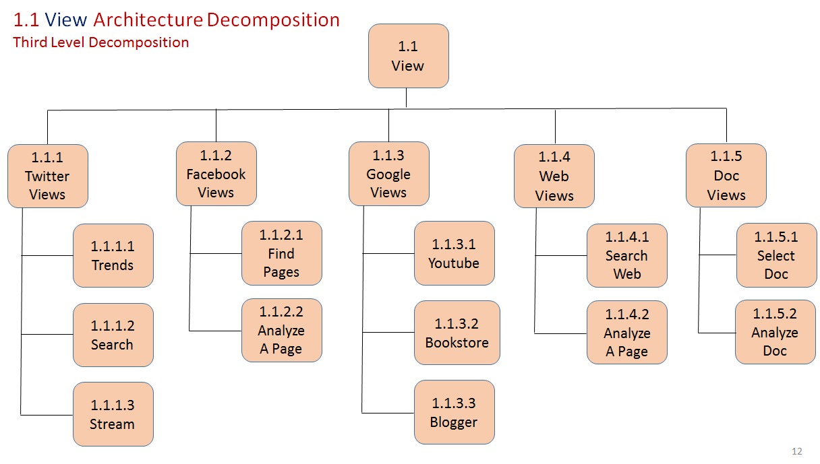
From the View home page, the user expands a category and selects a more detailed action. The categories are the mining targets currently available and each expands into the specific functions for that target.
Another category is for document analysis assistance; this is currently limited to automated summarization, entity extraction, n-gram identification, lexical and frequency analysis. The views are implemented as html, javascript and Python for a Web browser.

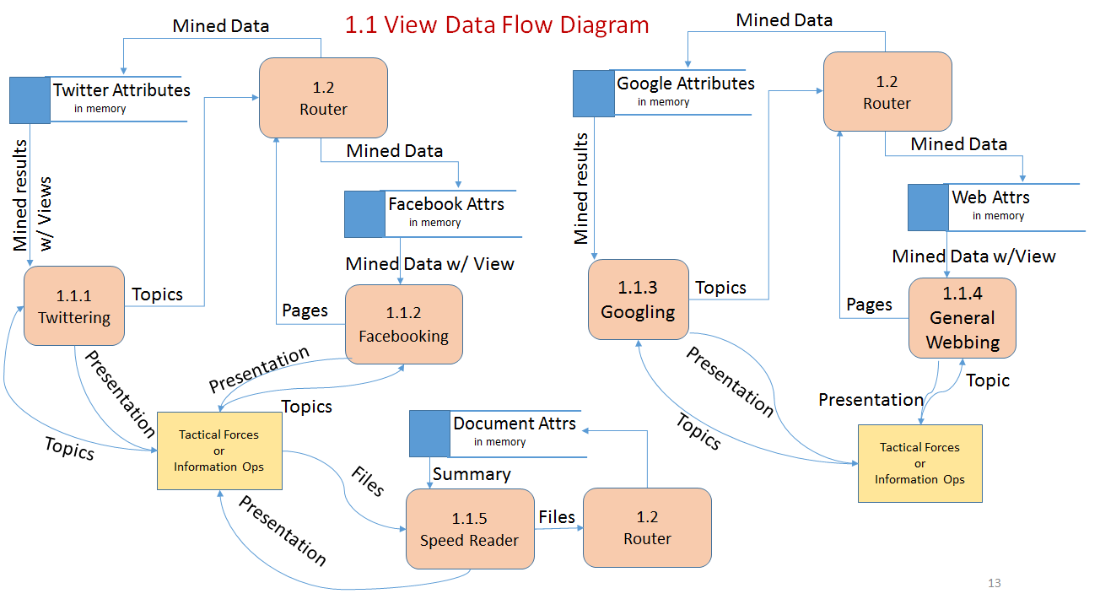

5.2.2 Router Architecture: Third Level Decomposition (continued)
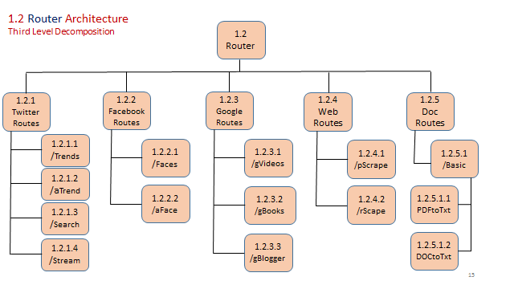

The router is a Web server and it responds to events in the action attribute on Web browser user clicks. The events are trapped as router /<event name> or post /<event name>. These are decorations for methods that call appropriate routines in the Model component to capture social media data and mine it. In the diagram, event decorators are shown preceded with a “/”.
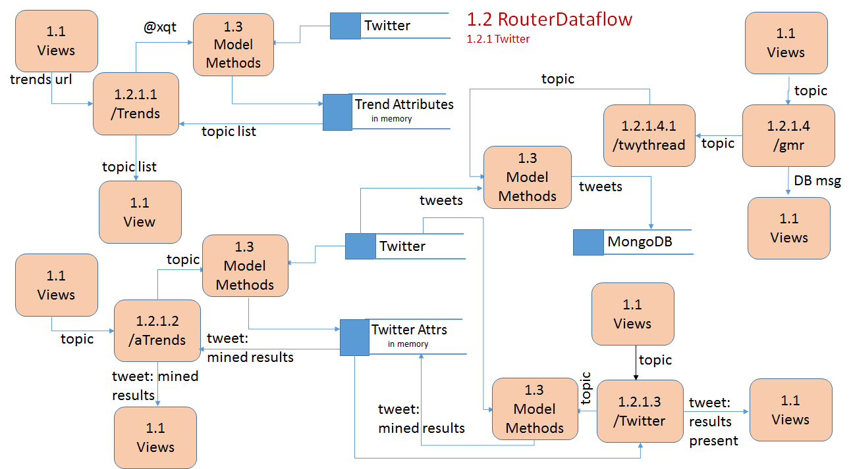

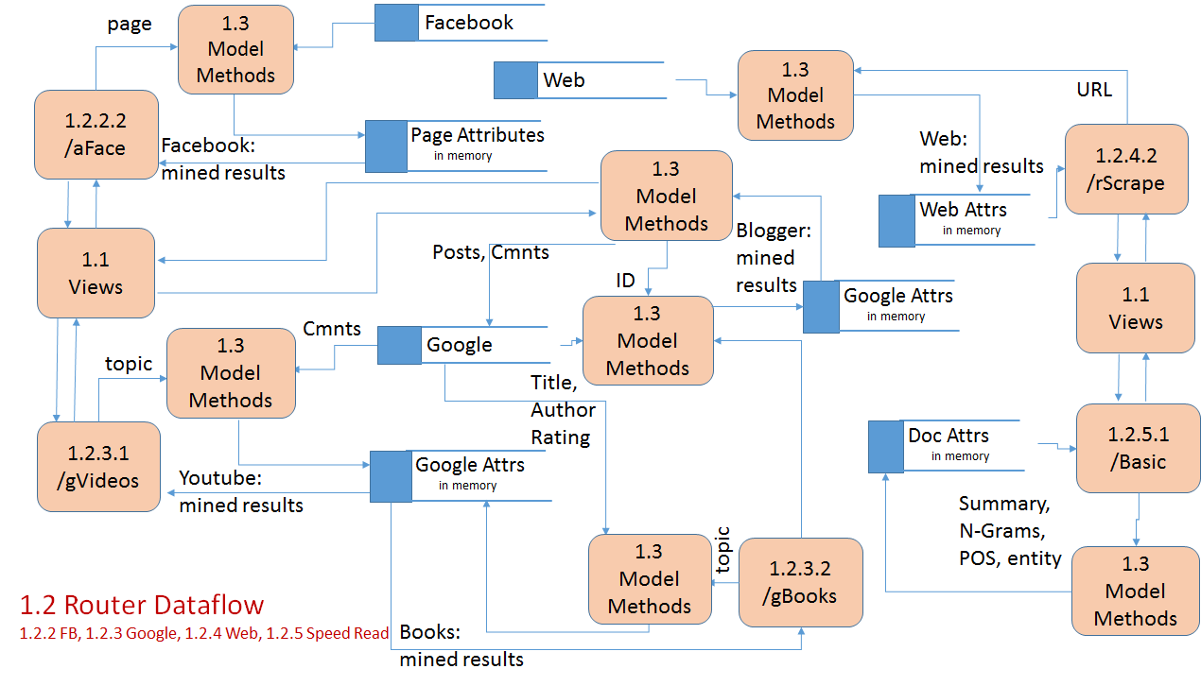

5.2.3 Model Architecture: Third Level Decomposition (continued)

Because of the added layering in the Model component, the data mining target routines are subordinate to gmrSocial. The four mining targets currently available are listed in the next diagram. The document processing functionality is listed subordinate to gmrTextAnalytics.

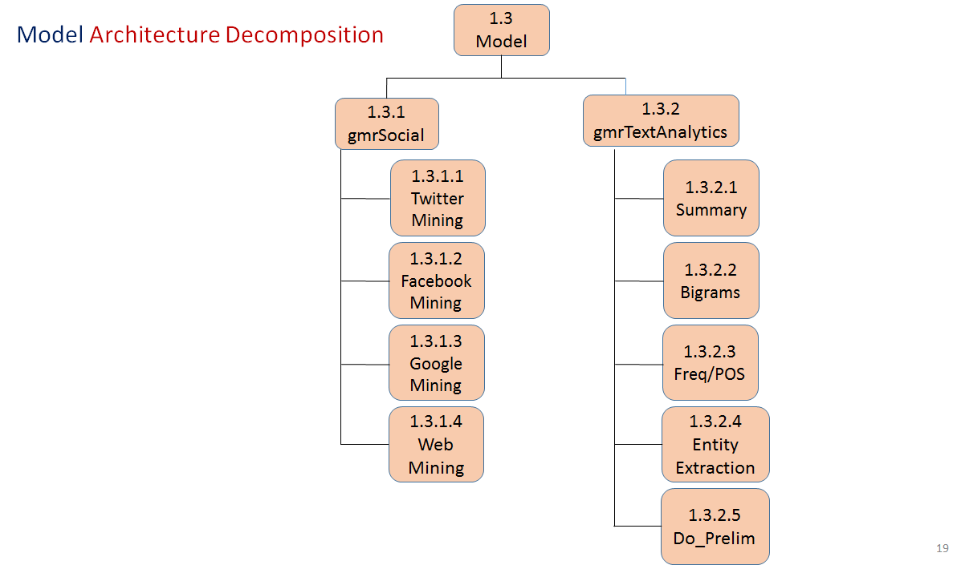

5.2.4 gmrSocial Architecture: Fourth Level Decomposition
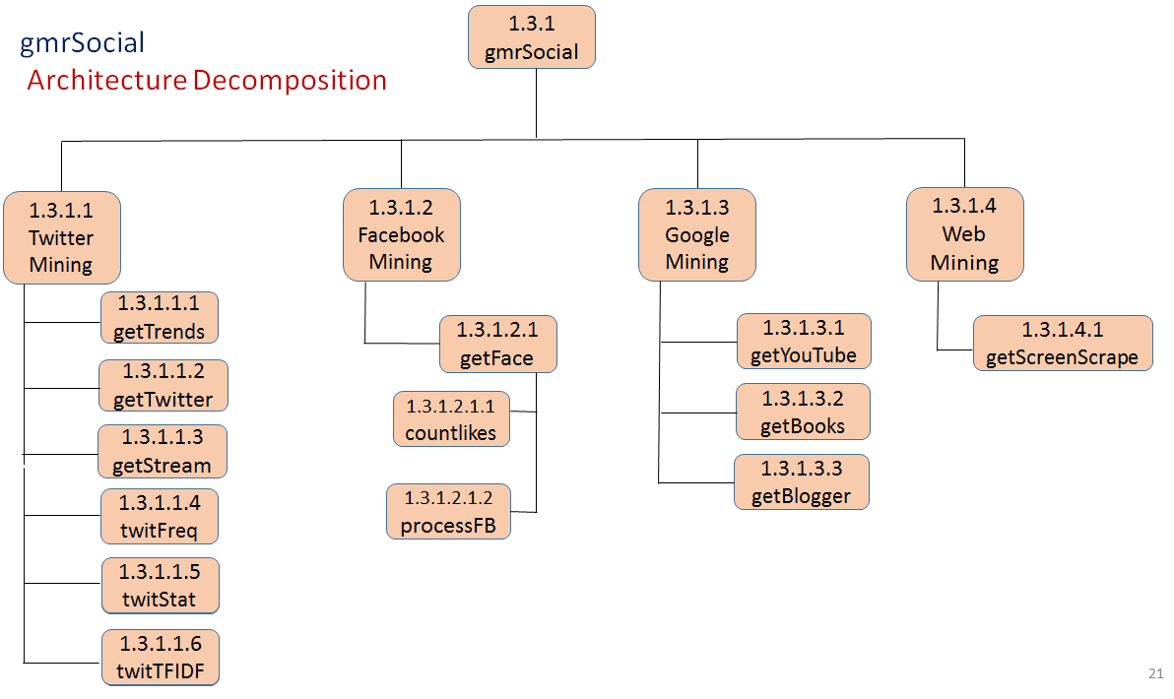
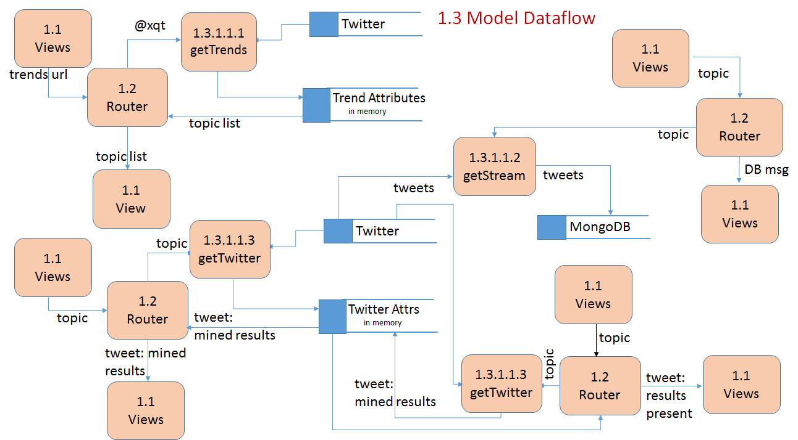

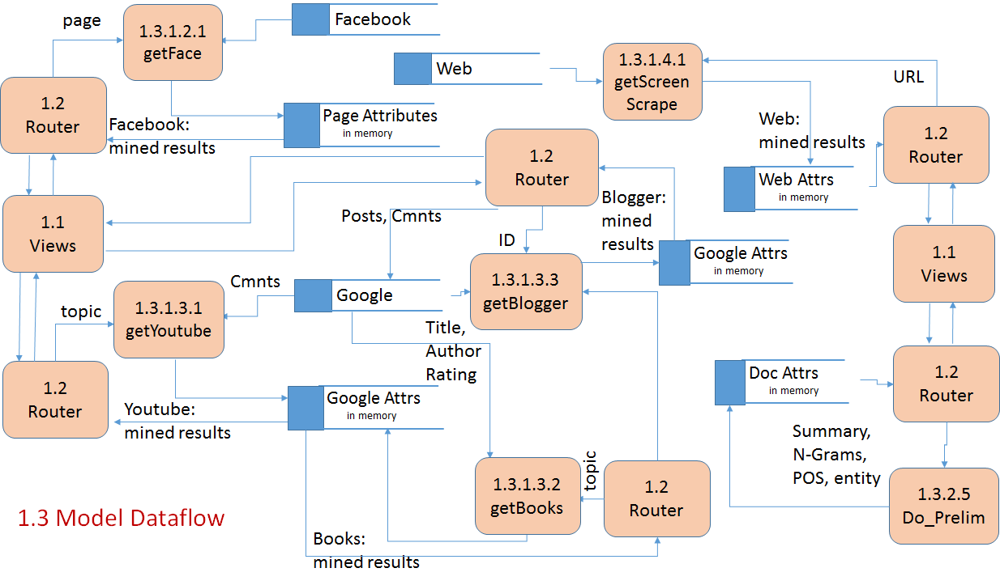

5.3 System Data Flow by Component
The interactions at the activity dataflow level between the router and model components is on the next two slides. Views are treated in a consolidated manner in order to add all relevant activity interaction between router and model in a readable manner.

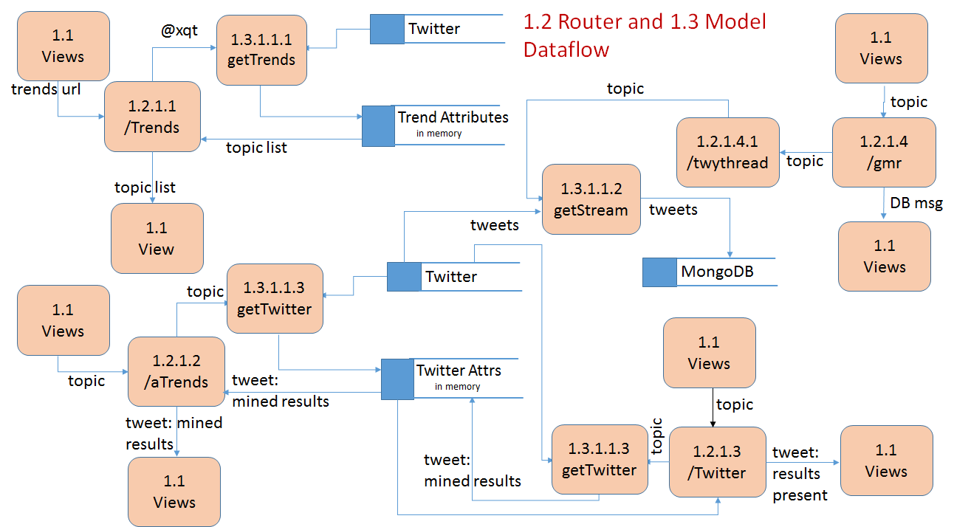

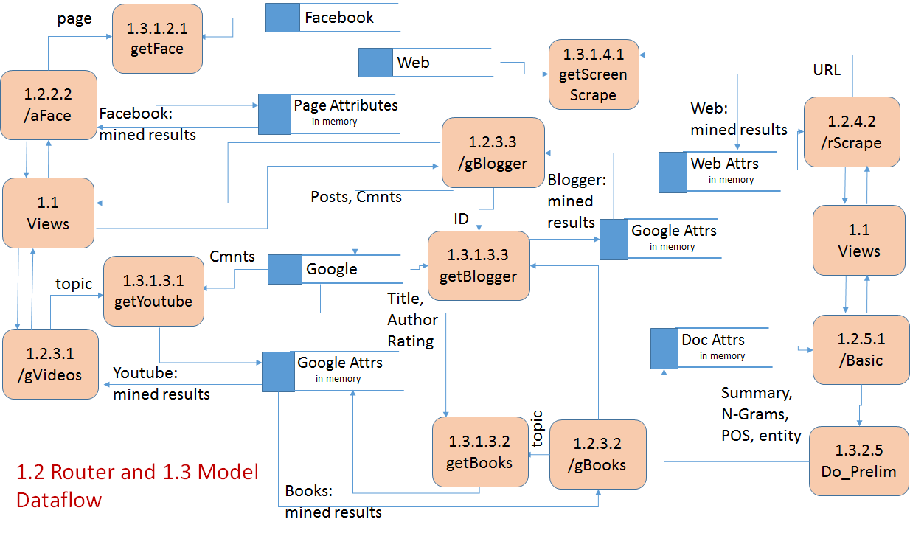

5.4 System Data Flow By Mining Target
The system level data flow diagram by target is presented on the next three slides. This diagram represents data flows for mining at a social media target level and not the subordinate functions. Data flows at a more granular level are available for you to optionally review in the next section of this document.
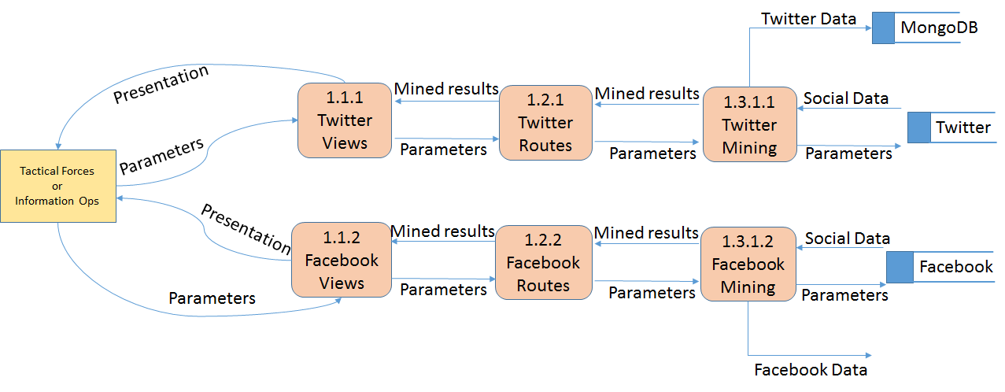
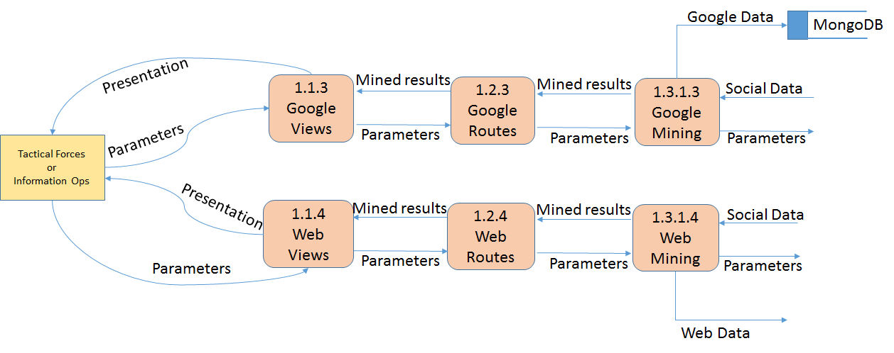
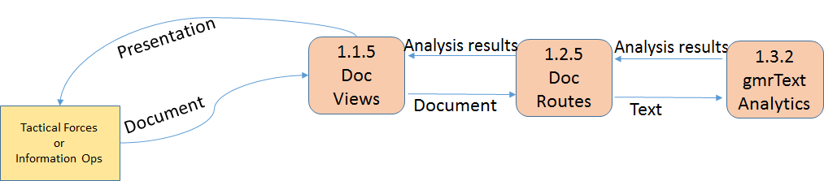

5.5 Solomine Surfer Access Management
The life cycle for a user’s interaction with Solomine Surfer is the following functionality:
- New Account Request (request to be permitted to use Solomine Surfer)
- Add User (an admin adds the user with specific access permissions)
- Logon and Validation (user connects with Solomine Surfer and their security credentials are reviewed)
- Role based security access

More details on these functions are in the following sections. These functions are not in the prototype but will be in the production system.

5.5.1 Solomine Surfer User Account Management
Diagrams for two of the User Account Management Functions in Solomine Surfers are on the following two pages. Overviews of the function are just below.

5.5.1.1 New Account Request Control Flow
We capture the user’s security credentials to get directoy data related to them and populate an email request for a new account with them rather than require them to complete a paper form. We also create a directory record for the user since having an Directory account is mandatory for Solomine Surfer users and this table is used by the application for getting Directory related data. The e-mail will be sent to the designated Solomine Admins, who can then add the candidate into the system with the appropriate user level.

5.5.1.2 Solomine Surfer Add User Control Flow
The next step in using Solomine Surfer is to assign users who are authorized to use the application. This is done by administrator users. Only they will have a menu item called Users that has a series of commands related to adding and managing users. A control flow for the process follows.

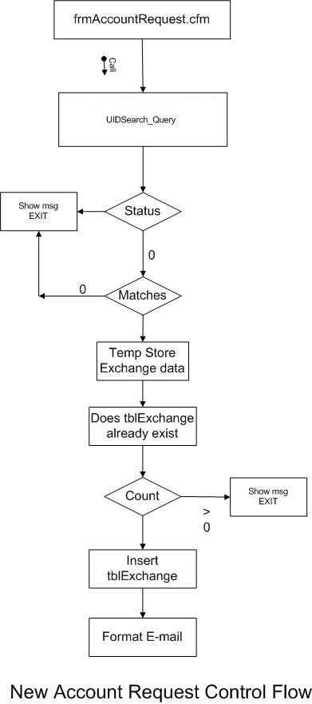

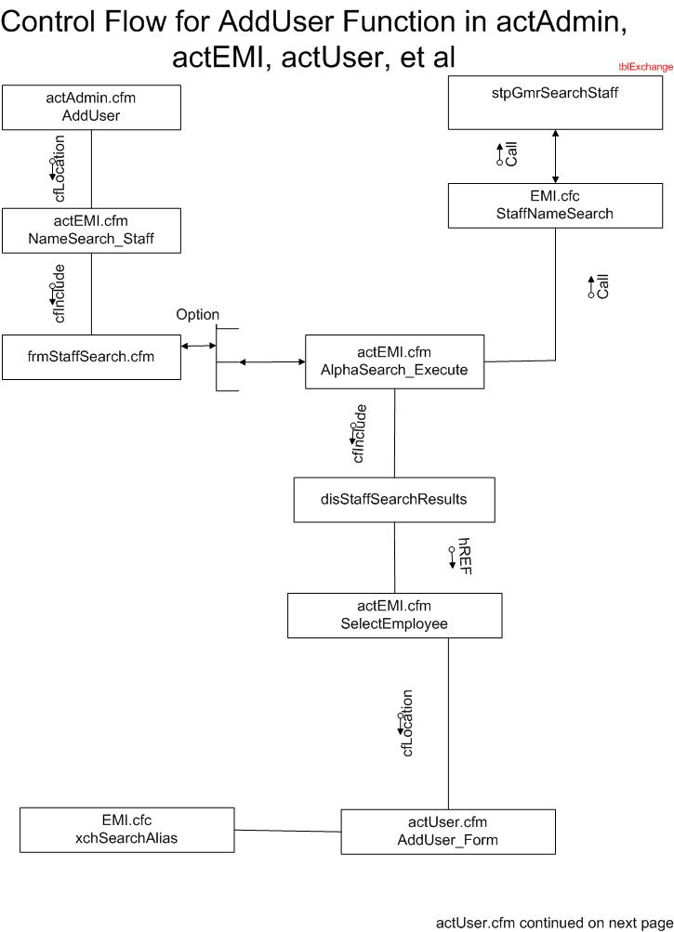

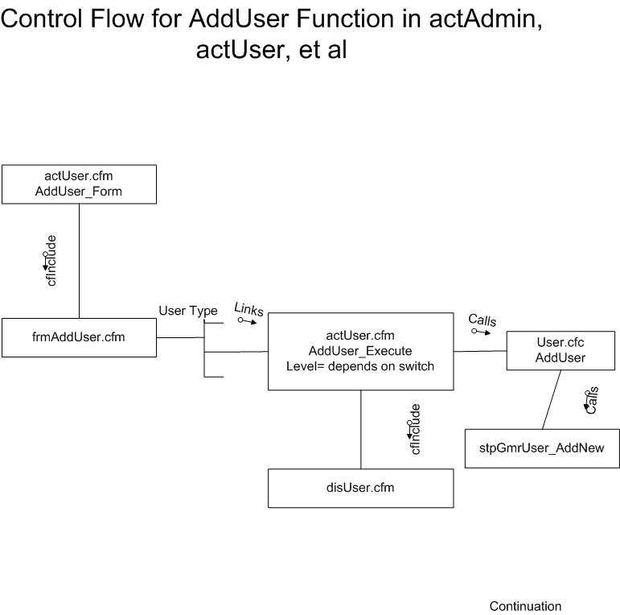

5.5.1.3 Solomine Surfer Manage Users

A third User Account Management function is to edit the status of the Users. There are three main functions for managing users, two are shown below. The first is viewing user details, the second is deactivating a user. Sending an e-mail is shown in another section of this document.

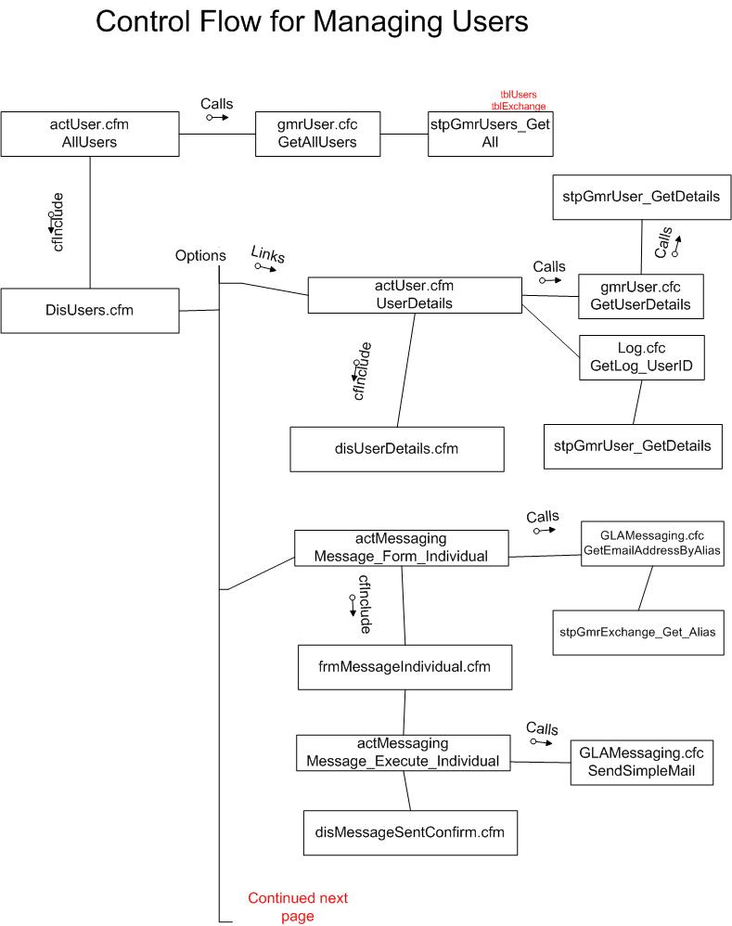
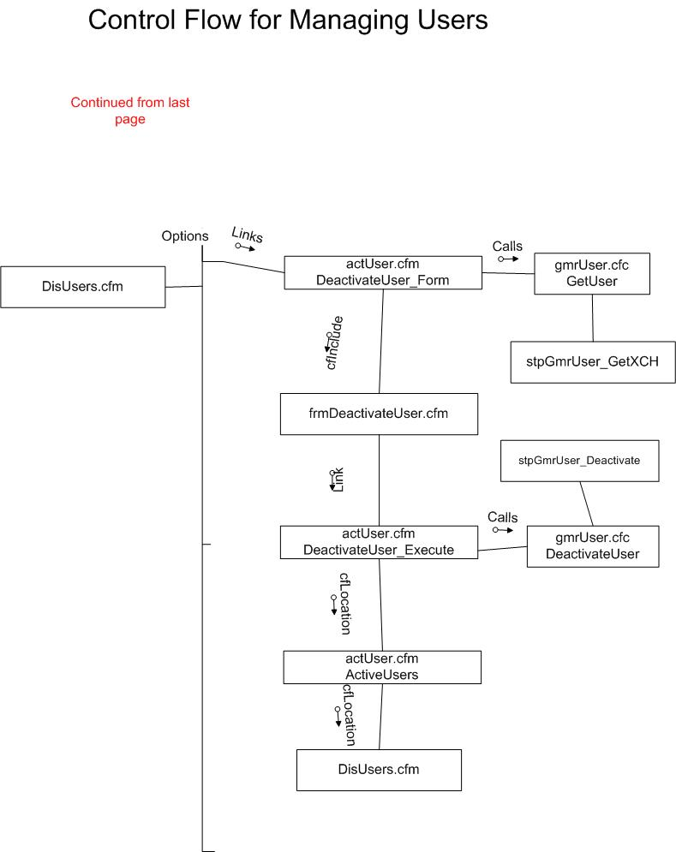
The User Details function in the Managing Users Menu command has two editing capabilities that are flowcharted on the following pages.

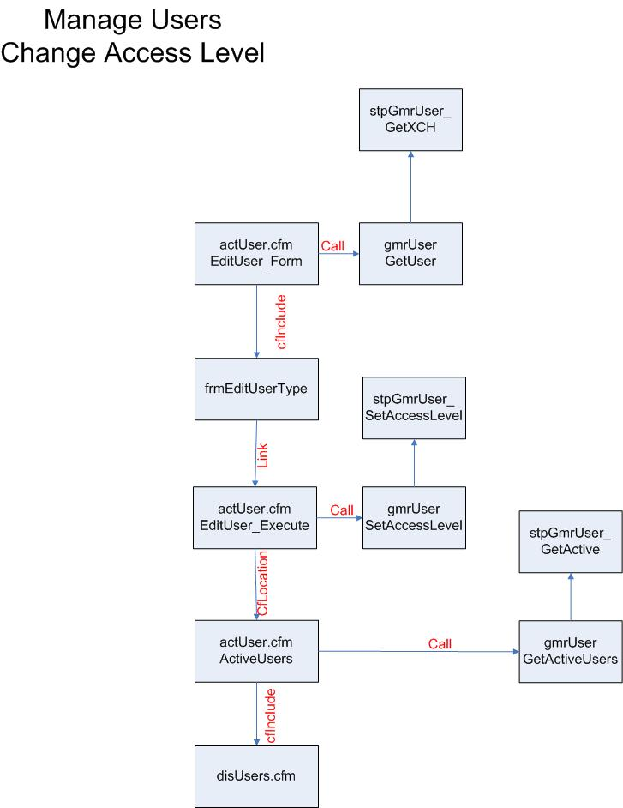
The first edit capability for the view details function of the managing users menu command is to change a users access level. A user is selected, then details displayed and the admin will select the new access level from a series of links on the display form.
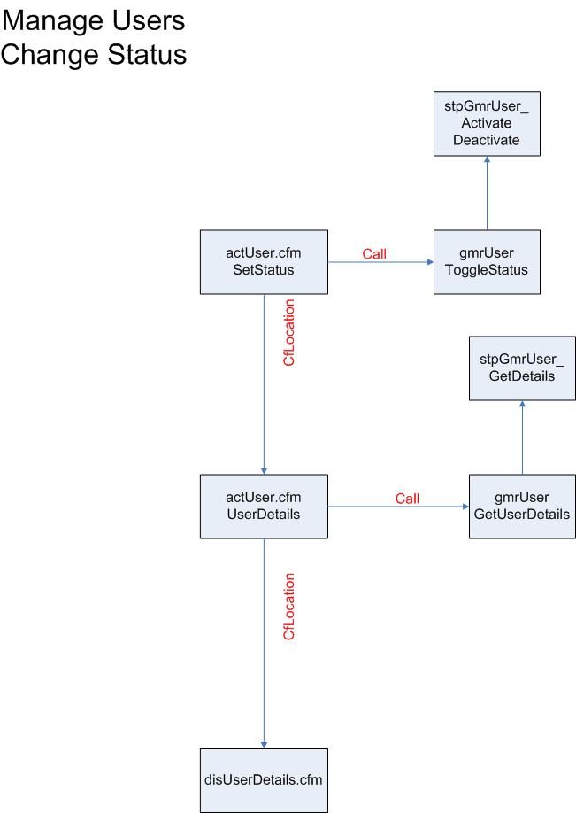
The second edit capability shown above is to toggle the active/deactivated status of a user.

5.5.2 Solomine Surfer Logon and Validation
After a user has been added to the Solomine Surfer they must logon to use the social media access and mining functions. Solomine Surfer logon uses the integrated security features of their directory to automate login to Solomine Surfer so that the users don’t need to login to the application separately. First, Solomine Surfer discovers the remote user attempting to access the site. Next, it uses the remote users network security credentials to validate against the tblDirectory. If the user is in the tblDirectory the code validates the user against the Solomine Surfer users table. If the user is not in the tblDirectory then the code routes the user to a login page. If the user is an Solomine Surfer User the code passes them through. If the user is not an Solomine Surfer User the code routes the user to a login page.

This FSD corresponds to the Validation Use Case in the Solomine Surfer functionality section of this document.

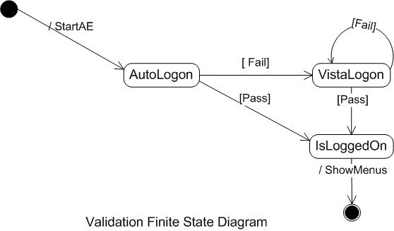

This FSM corresponds to the Validation Use Case in the Solomine Surfer functionality section of this document.
State/Stimuli | IsFrontliner | IsQM | IsMGR | IsMD | IsAdmin
IsLoggedOn | actXXXX.cfm | actYYYY.cfm | actManagers.cfm | actZZZZZZ.cfm | actAdmin.cfm

Logon Control Flow Diagram
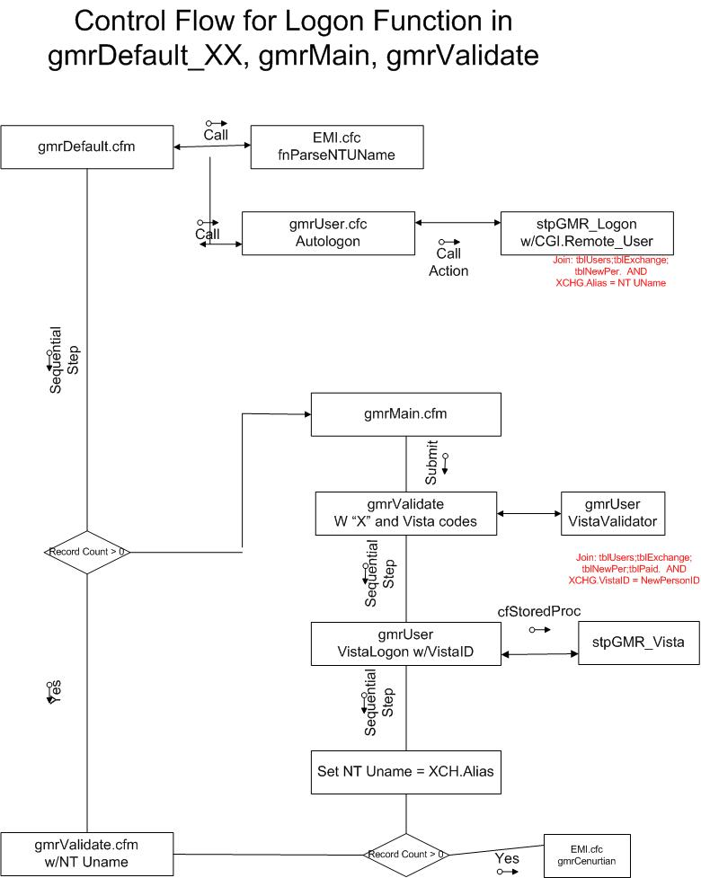
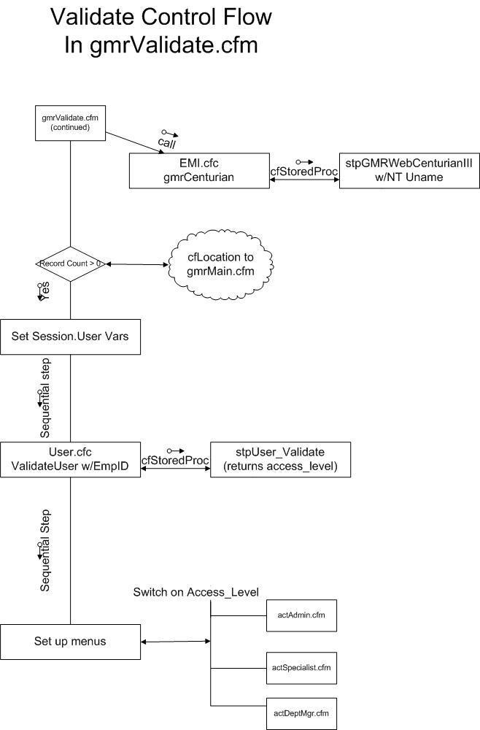

5.6 Solomine Surfer Log Management
One of the main menu commands is for managing the logs. The admin is given the ability to add a log entry, view all log entries or search for certain log entries. This functionality is not in the pilot but will be added to the production system.

The workflow for viewing all log entries flows.

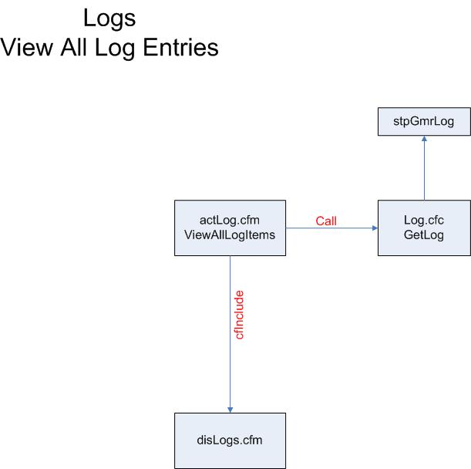

The flowchart for searching for certain entries is the following:

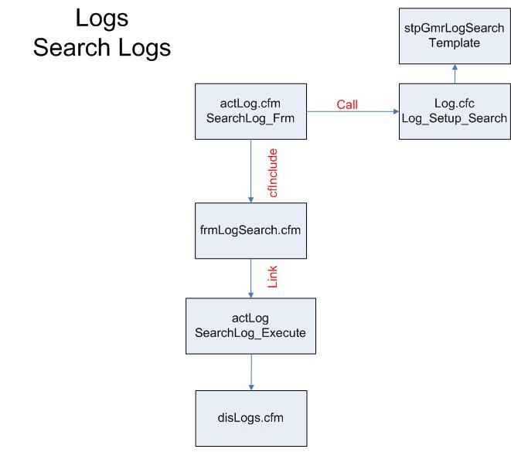

Finally for Log management, the flow chart for manually adding a log entry follows. The system will add automatic entries on its own, this is for an admin or manager to put in their own comment.
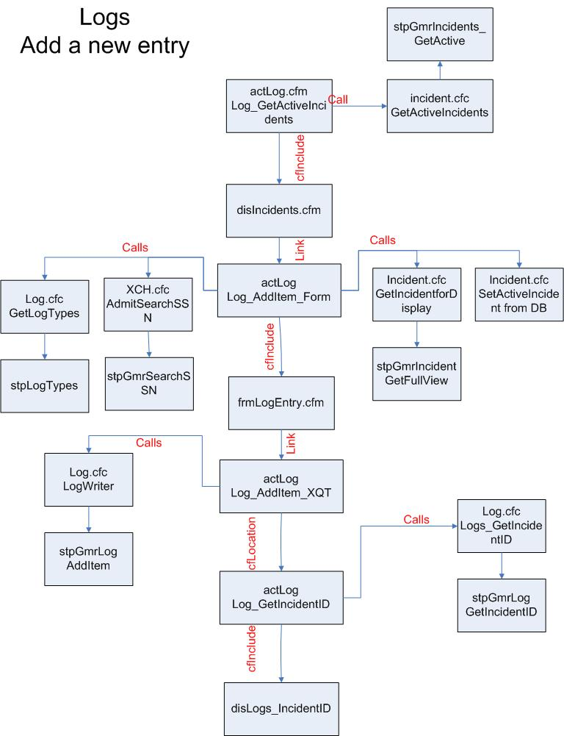

Solomine Engagement Template

6.1 Organization mission that the engagement will support
Social media mining is a methodology to elicit meaningful strategic information from the firehose of data available on the social Web. People today are actively expressing themselves through the social media channels, and organizations are using social media to enhance their research, situational awareness, and integrated marketing communications. Social media provides organizations with empirical data to guide strategic planning.

In this engagement, the Solomine social media mining toolset will be installed and configured to enable organizational staff to search, filter, and retrieve both the content of people’s public interaction in social media channels and the general Web as well as the demographic and pyschographic data of those individuals. The toolset further applies data mining techniques for classification, regression, clustering, deviation detection, association analysis, and evaluation of patterns mined from social data and apply them in organizational initiatives.

6.2 Engagement goals
Establish a social media mining and analysis operation that transforms a social, political or business problem into a data computational problem. Implement three types of mining operation:
- Descriptive Mining: This is the gathering and reporting of factual information such as attitudes, demographics, psychographics, domain behavior characteristics, and influence levels
- Diagnostic Mining: The diagnostic function identifies how the descriptive variables interact with each other. For example, which demographic groups are the most active in a domain, who are the nexus points in networks advocating certain actions
- Predictive Mining: The predictive function makes use of both descriptive and diagnostic research to identify patterns in social media activity that are associated with types of events, to make predictions about event potential

Install and configure Solomine to identify, extract, store and analyze social media data. Conduct an agile iteration to elicit needs for social media data relevant to the organization. Customize a social media mining solution framework for continuing operations.

Establish a Social Media Assets Program Management Office (SOMAPMO) to train users, establish and promulgate best practices, provide a liaison to the Data Strategy Group’s work on metadata definitions, and help offices with any additional report or workflow development after initial Solomine deployment

6.3 Stakeholders
The following stakeholders have an interest in the engagement.
- Organization executive sponsor
- Organization project manager
- Organization data governance chief
- Organization business domain experts and researchers
- Organization information technology operations
- Blue Glacier Management Group product managers
- Blue Glacier Management Group human factors designers
- Blue Glacier Management Group Web developers
- Blue Glacier Management Group software engineers
- Blue Glacier Management Group data scientists
- Blue Glacier Management Group platform engineers

6.4 Engagement deliverables
The following deliverables represent both methodological steps to accomplish the goals of the engagement as well as performance measures indicating the level of goal achievement.
- Requirements document and traceability matrix
- System design document
- System build plan
- Operational Solomine system on agency furnished equipment
- User and administrator manuals
- User education materials
- Social media mining solution framework manual
- Business case and vision document for program management office

6.5 How engagement performance will be measured
Course performance will be measured by the organization’s ability to use Solomine to do the following at the completion of the engagement.
- Establish access to all relevant social media
- Search for entities of interest
- Monitor trends and patterns in topics
- Establish an automated natural language pipeline
- Grammatical analysis
- Report automated summarization of extracted text for quick review
- Report named entity extraction
- Report lexical analysis
- Report sentiment analysis
- Report entity classifying
- Conduct Topic Modeling
- Perform frequency analysis
- Establish relevance for search findings
- Conduct both cross sectional and longitudinal studies
- Complement other organization activities with current analysis of behaviors and sentiments of entities in the area of operations
- (Other custom goals for the organization such as identifying flashmobs, analyzing the epidemioloical pattern for memes, etc)
A series of evaluated exercises is used to measure this set of abilities.

6.6 Schedule for delivering the work
 | DATE | ACTIVITY
T01 |  | Acquire access tokens
T02 |  | Install Python environment
T03 |  | Install MongoDB
T04 |  | Install MongoHadoop
T05 |  | Install ElasticSearch and workflow
T06 |  | Install Avro serialization environment
T07 |  | Install CSS bootstrap and D3 visualization
T08 |  | Test operation of local Solomine system
T09 |  | Elicit system requirements from business domain(s)
T10 |  | Interview cross cutting functions to coordinate long term operations
T11 |  | Design Solomine customizations
T12 |  | Configure or develop custom extensions to Solomine
T13 |  | Training and testing of local stack
Optional |  | Scale stack on Amazon Web Services
 |  | Configure dotCloud on AWS
 |  | Configure Simple Storage Service on AWS
 |  | Setup Elastic MapReduce on AWS
 |  | Setup replicated MongoDB clusters on AWS as needed
 |  | Testing of cloud stack
T14 |  | Acceptance
T15 |  | Recommend PMO organization

6.7 Major milestones
The following are major milestones for the course.
- Install operational Solomine default configuration
- Conduct requirements gathering
- System analysis and design
- Custom development
- Training and testing on local stack
- Scale stack on Amazon Web Services
- Acceptance
- Present findings and recommendations

6.8 Acceptance
The Blue Glacier Management Group will deliver all work products to Agency ABC for review for completeness, accuracy, clarity, format, and timeliness. Within ten (10) workdays of this delivery, the Agency will notify the Blue Glacier Management Group that the deliverables are acceptable or, if not, provide written comments. If needed, the Blue Glacier Management Group will resubmit a final deliverable within ten (10) workdays to the Agency. The Blue Glacier Management Group will deliver reports using electronic transmission; the Blue Glacier Management Group will provide hard copies if requested.

6.9 Level of Effort
The anticipated level of effort is 4,000 hours for the work described in this document.

Assumptions
Foremost is that there will be a shared accountability between Blue Glacier Management Group and Agency for the success of the project. This mutuality extends throughout the engagement so Blue Glacier Management Group is considered an integral partner with the Agency for every task in the project. This includes the continuous engagement of Agency and Blue Glacier Management Group at mutually agreed levels to fulfill project responsibilities.

The Blue Glacier Management Group assumes the project team will be given timely, appropriate access to Agency personnel, artifacts, and facilities to support information elicitation and analysis; and information technology needed to fulfill the tasks in this project. This includes background information such as existing process models; relevant policies; and sample reports.

Blue Glacier Management Group will have access to representatives from the various categories of Agency staff who will use the Solomine system or will review work products from that system. Furthermore, Blue Glacier Management Group will have access to information technology personnel who manage or maintain components of the infrastructure relevant to the installation and operation of Solomine such as personnel responsible for knowledge management, data governance, data analytics, Cybersecurity, and Enterprise Data Storage.

6.11 Staffing
The project work will be performed under the overall direction of the Blue Glacier Management Group project manager. The project manager will set the technical direction of the work, coordinate with the necessary Agency stakeholders, and organize the team efforts to produce the required deliverables. The project manager will assign Blue Glacier Management Group staff with the appropriate skills to fulfill its project responsibility. The Agency must assign Agency staff with business domain knowledge, as well as staff with authority to configure and implement information technology on the Agency infrastructure.

6.12 Risks facing social media mining project
- The search for new knowledge often starts with vague problem definitions. A social media mining search for new knowledge compounds a vague problem definition with the need to transform this problem into a data problem, and then transform the data solution into a business solution.
- Mitigation: Unlike traditional data mining, Solomine is an interactive toolset that enables researchers to explorer the problem domain and iteratively learn about the problem and refine the problem definition.

- Inability to schedule time with domain expertise in the Agency.
- Mitigation: Solomine can be installed in its default configuration and customized in a follow-on engagement(s).

- Difficulty creating new algorithms for behavior tracking; as an example, an algorithm to predict flash mob gatherings.
- Mitigation: Blue Glacier Management Group uses a methodical, heuristic approach to problem solving using a variety of techniques such as recombination, analogies, respice finem, stepwise refinement, varying constituent parts, think”ing”, and induction.

- The requisite variety of knowledge to solve these problems includes deep understanding of behavioral sciences, computer science and quantitative methods. These disciplines have widely different vocabularies.
- Mitigation: Each of the Blue Glacier Management Group Solomine staff have robust academic training and extensive experience in behavioral sciences, computer science and quantitative methods.
- Social media is continually changing platform used by sentient actors who change methods.
- Mitigation: Solomine leverages agile platforms in a modular manner so that it can be scaled and changed dynamically.

Technical Controls
The Federal Agency Data Mining Reporting Act of 2007, 42 U.S.C. § 2000ee-3, requires agencies to report annually to Congress on organizational activities that meet the Act’s definition of data mining. For each identified activity, the Act requires the agency to provide the following: (1) a thorough description of the activity and the technology and methodology used; (2) the sources of data used; (3) an analysis of the activity’s efficacy; (4) the legal authorities supporting the activity; and (5) an analysis of the activity’s impact on privacy and the protections in place to protect privacy.

7.1 Identification and Authentication
A domain authentication system with passwords is used to access the Solomine system. Passwords prevent others from using your User ID to access shared functions. These passwords can consist of any combination of keyboard characters, and are accepted according to the quality of protection they can give. Note Passwords are case-sensitive. For example, Solomine interprets "MickeyMouse" and "mickeymouse" as different passwords.

7.2 Logical Access Control
Access controls in the Solomine system have been utilized through the use of AccessLevel in the Python application pages that have been developed. Users will be assigned one of several levels of permissions (roles), and will be restricted to accessing only information which is necessary for them to perform their official duties These access-levels are read from the Solomine user table and are used throughout the program to determine what records can be accessed.

7.3 Audit Trails
Audit trails exist in Solomine in the form of logs that are only accessible to the administrators. Since access to these audit trails is protected by the ACL’s, the access is strictly enforced. The system administrator can review the logs whenever there is a problem and can also use the logs for a daily inspection and review of system activity including logon failures and system access.

7.4 General Technical Description
The Solomine Platform is in an AWS Windows 2012 Server domain and is the production platform for the following applications:

Mongo Database
Anaconda Python System

The system can just as easily be deployed on Linux.

Management Controls

8.1 Risk Assessment and Management
Risk is examined with regard to users, non-users in the organization, and the general population. The risk that is inherent to the Solomine system is managed through the use of security controls in the Python software, Bottle, MongoDB and those that exist on the Local Area Network (LAN) provided by AWS to eliminate unauthorized access to the server.

8.2 Rules of Behavior
The information contained in the Solomine system is sensitive, and security plans will be requested from the offices using the Solomine system before granting their administrator’s access to ensure that security awareness extends beyond the technical system configuration and is protected by process in the end user offices. Through the use of domain authentication within the system software, sensitivity is provided technical protection. Users are assigned one of several levels of permissions, and will be restricted to accessing only information, which is necessary for them to perform their official duties.

Additionally, an audit trail of all transactions on Solomine servers is recorded and maintained in transaction logs. Access is also restricted across organizations. The system provides different menus that permit only actions appropriate and authorized for each level that control the rules of behavior for each user classification.

Operational Controls

9.1 Organizational Separation
Database administration has responsibility for maintaining the system baselines, and making changes to various configuration items authorized by the project team for the Solomine implementation. These are maintained on the Solomine development server. Database administration will have no permissions on the staging and production servers. Deployment of the initial baseline and any subsequent changes approved by the project team will be handled by the organization director staff. Database administration will submit completed changes to these directors for deployment on the staging server where testing and final approval by the CIO will be granted. At that stage, the organization staff will notify the stakeholders of the scheduled time for rolling the change into production, and on the scheduled date, implement the change on the production server.

9.2 Personnel Security
All positions with server access have been reviewed for employment by the organization personnel office using standard organization security review policies regarding new hires. No other security or sensitivity levels actions have been taken.

Background screenings beyond this are part of the work taskings for each project. The user is restricted to the minimum access, which is necessary to perform their job. The organization will manage user accounts. The organization database administrator in the Chief Information Office will maintain the application security.

Critical functions are divided among different individuals. An audit trail is associated with each Solomine function and records all actions taken, and thereby hold users accountable for their actions. The organization Administrator will immediately close a user account in the case of an unfriendly termination, and will disable the account after the employee has signed out in the case of a friendly termination.

9.3 Physical and Environmental Protection
The server is maintained in the AWS cloud. The application is protected by a series of different passwords, which exist on the server, the operating system, and the application. AWS is secure from unauthorized entry through the use of FedRamp security provisions.

9.4 Production, Input/Output Controls
Security procedures will be put in place, which prohibit unauthorized persons from gaining access to electronic material. Printed material will be the responsibility of the authorized person to dispose of properly after use. Electronic media such as backup tapes are reused. If they are deemed as faulty, they will be destroyed.

9.5 Contingency Planning
A formal disaster recovery plan will be implemented and documented for each client. The operating system and application software is restored through the use of the AWS image files. The other systems are installed and configured according to build plans noted in later sections of this document.

The Solomine application data is backed up to a local disk from AWS using a two-generation backup system. A full backup is generated daily. These files are recycled according to organization policy. In addition, daily backups of the application code files are done to a NT file share protected by Windows network security to a laptop computer. These backups are done daily Monday to Friday on the Solomine server. The purpose is to provide the potential for off-site backup and recovery capability for the system in case of catastrophic facility failure.

9.6 Hardware and System Software Maintenance Controls
Controls for maintenance on hardware and software are in place. Procedures are in place to prohibit the use of illegal copies or shareware on the system. The project team’s system programmer/analyst, the organization database administrator has access to all aspects of the application only on the development server. He will not be able to impact the application on the production server itself.

Control of the backup software that is used for backup and recovery is under the control of the organization. Other backup media is controlled by the organization except for the offsite backup and recovery procedure, which is controlled by the organization database administrator.

In cases of performance of emergency on-site maintenance, all personnel will be escorted and supervised by organization security staff. There are no off-site maintenance contracts so the equipment will not be sent with confidential data to an independent commercial vendor for system repair work.

9.7 Documentation
The server plan documentation will be maintained in the organization. The documentation is updated as needed.

9.8 Incident Response Capability
Using email will support incident response. Logs are automatically generated in the Solomine application that the system programmer accesses which will assist him/her in detecting and resolving the incident.

9.9 Hardware Maintenance and support
Amazon Web Services provides maintenance and support service levels for the system.

Build Plan

10.1 AWS Build Plan
- Login into the AWS console
- Create an IAM user
- Create a key-pair
- Click on EC2
- From console, click launch instance
- Choose a Windows server 2012 AMI
- Choose review and launch
- Connect to instance
- Click get password
- Select IP address
- Open RDP with IP and password
- See AWS documentation for details on any step.

10.2 Python build plan

- Start your browser, e.g. Internet Explorer
- Go to https://www.continuum.io/downloads - this is the Anaconda distribution site
- Select your operating system: Windows, OS X, Linux
- Select Python 2.7, we will be using that in the class
- Select 64 bit
- Download graphical installer and install, following the instructions
- We will also use packages that require the MS C++ compiler
- Go to https://www.microsoft.com/en-us/download/details.aspx?id=44266
- Download and install the C++ compiler for Python 2.7
- Now start installing the special packages we will use
- Open a DOS box or command-line window
- Install the twitter package with the following command:
Python –m pip install twitter
- Install the facebook package with the following command:
Python -m pip install facebook-sdk
- Install our sentiment lexicon with the following command:
Python –m pip install vaderSentiment
- Install our parse tree for screen scraping
python -m pip install html5lib
- Install BeautifulSoup:
python -m pip install BeautifulSoup
- Install a numeric package
python -m pip install numpy
- Install our natural language toolkit
Python –m pip install nltk
- Make sure we have all the nltk classes, get into python command-line tool and:
Python
>>>import nltk
>>> nltk.download(‘all’)
- This will get us started; we may discover we need to install other packages:
- Python –m pip install (name of other package)

10.3 Mongo Build Plan
- Go to Solomine core systems site
- Download mongo.zip
- Create a directory on c: called mongodb
- Extract mongo.zip into that directory
- Next, download mongodb_data from Solomine core system site
- Create a directory on c: called Mongodb_data
- Extract mongo_data.zip into that directory
- Open a dos box
- Change to c:\mongodb\bin
- Type in:
mongod --dbpath c:\mongodb_data
- Open a separate dos box
- In c:\mongodb\bin, type in
mongo
- Now type in
use gmrDB
- Get as list of collections in the gmrDB database
db.getCollectionNames()
- Next, start using the Solomine collection, where we will store our data
- Get a count of the records already stored in the Solomine collection
db.solomine.count()
- Get one of the tweets to look at its structure, which should be familiar
db.solomine.findOne()
- Show all the indices in Solomine
db.system.indexes.find()
- Note the unique index which will prevent our programs from adding in duplicates
- Finally, remove all storage so we start with a blank slate
db.solomine.remove()

10.4 Solomine Build Plan
Available in a separate document.

