# VISULIZATION TOOLS FOR ELECTRIC VEHICLE CHARGE AND RANGE ANALYSIS

INTRODUCTION

1.Overview

A EV is defined as a vehicle that can be powered by an electric motor that draws electricity from a battery and is capable of being charged from an external source. An EV includes both a vehicle that can only be powered by an electric motor that draws electricity from a battery (all-electric vehicle) and a vehicle that can be powered by an electric motor that draws electricity from a battery and by an internal combustion engine (plug-in hybrid electric vehicle).

Electric vehicles (EVs) are a promising technology for achieving a sustainable transport sector in the future, due to their very low to zero carbon emissions, low noise, high efficiency, and flexibility in grid operation and integration. This chapter includes an overview of electric vehicle technologies as well as associated energy storage systems and charging mechanisms. Different types of electric-drive vehicles are presented. These include battery electric vehicles, plug-in [hybrid electric vehicles](https://www.sciencedirect.com/topics/social-sciences/hybrid-electric-vehicle), hybrid electric vehicles and fuel cell electric vehicles. The topologies for each category and the enabling technologies are discussed. Various power train configurations, new battery technologies, and different charger converter topologies are introduced. Electrifying transportation not only facilitates a clean energy transition, but also enables the diversification of transportation’s sector fuel mix and addresses energy security concerns. In addition, this can be also seen as a viable solution, in order to alleviate issues associated with climate change. Furthermore, charging standards and mechanisms and relative impacts to the grid from charging vehicles are also presented

**Disadvantages of electric vehicles in India:**

### . EV cost and battery cost:

The cost is the most concerning point for an individual when it comes to buying an electric vehicle. However, there are many incentives given off by central and state governments. But the common condition in all policies is that the incentives are only applicable for up to a certain number of vehicles only and after removing the discount and incentives the same EV which was looking lucrative to buy suddenly becomes unaffordable. This tells that buying EV’s no more be cheaper after a certain saturation point.

Battery Cost:

to last till 6-7 years or hardly 8 years and after the battery decay period of an electric vehicle battery its user remains with no other choice than to buy a newer battery which costs nearly 3/4 th of the whole vehicle cost.  
Battery cost is going to be a pressing issue for the EV buyers because electric vehicles are new to both market and customers the battery issue requires at least 5 years to surface this will going to be impacted in a long run It’s no more hidden from anyone that the Li-ion battery in electric vehicles is built.

Design thinking will play a critical role in the next, imminent stages of everything from consumer EV design to the experience we all enjoy traveling across country on a family vacation or grabbing the commuter train to work. The ease of travel. Connected digital environments and lifestyle-forward functionality. But there is also a strategic opportunity that exists now for companies to take a broader, ecosystem-thinking approach and get involved.

Whether you’re in utility power generation or automotive design and manufacture, find ways to start conversations now around accelerated collaboration initiatives for tomorrow. Doing so will create incredible efficiencies and better synchronize the consumer experience with the revolutionary products and services required to deliver it. For those companies seeking investment opportunities, consider initiating outreach to the wide diversity of public transportation, electrification initiatives and private sector startups working to effect change. Consider where you can fast track the game-changing ideas and technologies that will begin to super-charge the e-mobility ecosystem that’s coming.

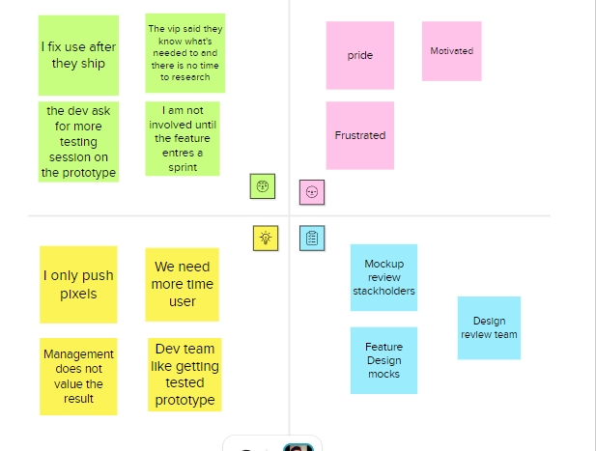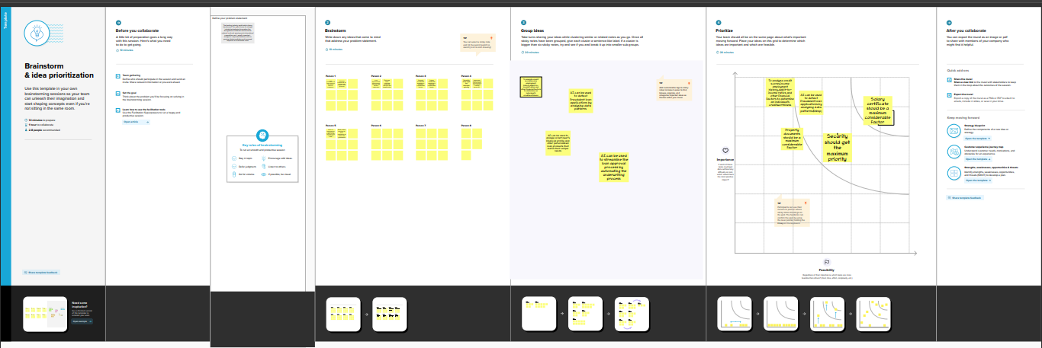





















***Electric Vehicle Advantages***

**Lower running costs**

The running cost of an electric vehicle is much lower than an equivalent petrol or diesel vehicle. Electric vehicles use electricity to charge their batteries instead of using fossil fuels like petrol or diesel. Electric vehicles are more efficient, and that combined with the electricity cost means that charging an electric vehicle is cheaper than filling petrol or diesel for your travel requirements. Using renewable energy sources can make the use of electric vehicles more eco-friendly. The electricity cost can be reduced further if charging is done with the help of renewable energy sources installed at home, such as solar panels.

**Low maintenance cost**

Electric vehicles have very low maintenance costs because they don’t have as many moving parts as an internal combustion vehicle. The servicing requirements for electric vehicles are lesser than the conventional petrol or diesel vehicles. Therefore, the yearly cost of running an electric vehicle is significantly low.

**Zero Tailpipe Emissions**

Driving an electric vehicle can help you reduce your carbon footprint because there will be zero tailpipe emissions. You can reduce the environmental impact of charging your vehicle further by choosing renewable energy options for home electricity.

**Tax and financial benefits**

Registration fees and road tax on purchasing electric vehicles are lesser than petrol or diesel vehicles. There are multiple policies and incentives offered by the government depending on which state you are in. To find out more about electric vehicle incentives.

**Petrol and diesel use is destroying our planet**

The availability of fossil fuels is limited, and their use is destroying our planet. Toxic emissions from petrol and diesel vehicles lead to long-term, adverse effects on public health. The emissions impact of electric vehicles is much lower than petrol or diesel vehicles. From an efficiency perspective, electric vehicles can covert around 60% of the electrical energy from the grid to power the wheels, but petrol or diesel cars can only convert 17%-21% of the energy stored in the fuel to the wheels. That is a waste of around 80%. Fully electric vehicles have zero tailpipe emissions, but even when electricity production is taken into account, petrol or diesel vehicles emit almost 3 times more carbon dioxide than the average EV. To reduce the impact of charging electric vehicles, India is ambitious to achieve about 40 percent cumulative electric power installed capacity from non-fossil fuel-based energy resources by the year 2030. Therefore, electric vehicles are the way forward for Indian transport, and we must switch to them now.

**No noise pollution**

Electric vehicles have the silent functioning capability as there is no engine under the hood. No engine means no noise. The electric motor functions so silently that you need to peek into your instrument panel to check if it is ON. Electric vehicles are so silent that manufacturers have to add false sounds in order to make them safe for pedestrians.

### *Conclusion*

The progress that the electric vehicle industry has seen in recent years is not only extremely welcomed, but highly necessary in light of the increasing global greenhouse gas levels. As demonstrated within the economic, social, and environmental analysis sections of this webpage, the benefits of electric vehicles far surpass the costs. The biggest obstacle to the widespread adoption of electric-powered transportation is cost related, as gasoline and the vehicles that run on it are readily available, convenient, and less costly. As is demonstrated in our timeline, we hope that over the course of the next decade technological advancements and policy changes will help ease the transition from traditional fuel-powered vehicles. Additionally, the realization and success of this industry relies heavily on the global population, and it is our hope that through mass marketing and environmental education programs people will feel incentivized and empowered to drive an electric-powered vehicle. Each person can make a difference, so go electric and help make a difference!