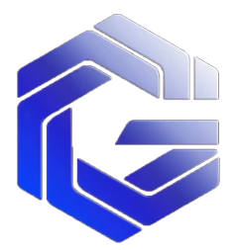

**CBTS**

**On-chain fork trading system**

CBTS

Chain Bifucate Trade System**catalogue**

**preface 3**

**1. Project introduction 4**

1.1 Project Introduction 5

1.2 Project Vision 6

1.3 Project solution 6

**2. The CBTS economic model 7**

2.1 Economic mechanism 8

2.2 Market value management 8

2.3 Incentive mechanism 9

2.4 Ecological incentives 10

**3. Technical implementation scheme 12**

3.1 The CBTS technical architecture 12

3.2 Design concept 15

3.3 CBTS technology implementation scheme 17

**4. The Team and the Foundation 32**

4.1 Core team members 33

4.2 Fund governance mechanism 33

**5. disclaimer 35**

**preface**

In the current digital era, human beings begin to migrate to the virtual world, and artificial intelligence, big data, digital twin, blockchain and other technologies accelerate innovation, gradually making human development to a new stage of "zero distance". Blockchain technology is a peer-to-point, distributed database based on a consensus mechanism. The new generation of digital technology represented by blockchain is accelerating the penetration and transformation into the consumer industry.

Through advanced block chain technology, big data and artificial intelligence technology, with decentralized consensus to establish a set of good incentive system, build a everyone can with small broad, everyone jointly held trading platform, everyone has the opportunity to do zhuang dividend platform, through digital token binding market excellent consensus, participate in the construction of the platform, the present and future ecological continuous distribution of dividends, associated project consumers, investors, promoters, service providers and ecological builders can get reasonable incentives and returns, build Web3.0 digital platform new formats, the benefit of ecological builders.

1. Project introduction

## 1.1 Project Introduction

CBTS, known as Chain Bifucate Trade System, the on-chain fork trading system, is initiated by the Node Alliance Foundation, gathering a group of core teams of blockchain and capital market to escort the project.

The world's first on-chain contract bifurcation deflation system, the world's leading automatic trading cycle token economy, with the idea of decentralized autonomy, consensus, integration, creation, governance and sharing. It mainly provides user passes, consumption exchange vouchers, behavior contribution rewards, and transaction data vouchers for Web3.0 ecology, artificial intelligence, yuan universe, Web3 e-commerce, IP entertainment, international cultural tourism projects and other scenarios. With the third-party platform as the traffic entrance, the scene application certificate as the economy, the industrial coordination as the support, and the data finance as the export, to promote the circulation and use of users to generate data capital value.

## 1.2 Project Vision

Build a safe, reliable, stable and efficient wealth appreciation platform for consensus users.

Provide transaction vouchers for the scene party to generate data value, improve market competitiveness, reduce marketing cost, and build a community of value and interests through the chain of commodities and assets.

Build a web3.0 value trading platform by generating user data flow through the trading platform.

Build a WEB 3 chain quantitative trading system held by the whole people

1. Sustainable development of the sharing market economy

Chain Bifucate Trade System Under the framework of global integration and multilateralism, we propose to continuously deepen international cooperation in the market field, seize the development opportunities of The Times, and share the sustainable development of the market economy.

2. Promote the common development of the market and digital economy

Chain Bifucate Trade System We hope to jointly plan and promote the market economy, jointly create a coordinated development of application scenarios, node alliance cooperation, strong consensus digital token economy, traffic integration and sharing, data mutually create value, and jointly build an open, equal and positive sustainable economic cooperation platform.

3. Build a platform community of shared interests

****Chain Bifucate Trade System Gather the sustainable development of the global market, focus on global top talents, attract ecological alliances, uphold the concept of a community with a shared market future,

promote market peace and ecological construction, integrated development, and share the distribution of ecological dividends.

**1.3 Project solution**

**1. Support the application of industrial digital token certificates**

Set up a green channel for market-related projects, obtain token + flow integration development + data exchange value realization through consumption incentive, improve circulation efficiency, and truly solve the business difficulties in the consumer market.

**2. Industry empowerment**

Chain Bifucate Trade System Relying on blockchain technology, it fully enables the development of industrial market economy in the consumer market.

1. Reduce marketing costs for application scenarios
2. Enhance economic effectiveness for application scenarios
3. To provide a platform for sustainable development of economic cooperation for partners
4. To generate data and financial sharing value for partners through consumption vouchers

**2. The CBTS economic model**

# **2.1 Economic rules**

**1. Distribution plan**

CBTS launched 6.13 million units worldwide, starting at the price of 0.1 USDT / piece, split through market transactions to the total of 900 million deflationary contracts, and then contracted to the Token economy that was no longer destroyed after 100 million consensus contracts, creating a million-level CBTS user market.

CBTS has a number of market-leading selling points, including: global leading: on-chain contract fork deflation system, on-chain circular trading system, intelligent C2C trading signature system, quantitative touch multi-dimensional fork system, node application access collaborative ecosystem. To provide global users with a more simple, more efficient, better development of the economic revenue platform.

**2. Trading rules**

All purchases will automatically deduct 20% of CBTS as the community contribution value for market rewards, Another 80% of CBTS was used as value-added chips, With the market expansion and quantitative demand, A CBTS price increase of 0.001 USTS based on 1% of the total purchase circulation, And 3% trading based on market supply and demand, At each fork, Users will hold more CBTS, Price reduction, No value remains, And CBTS began to enter a new round of rise to the fork, This cycle divides to 900 million deflation, When it shrinks to 100 million contracts through transaction destruction, Stop the fork, Online to the global exchanges.

The purchase limit of the first seed contract stage is 60U to 600U, the maximum amount of 1.5 times the amount limit, the suspension of each address income reaches 3 times, the user must buy how much to unlock how much.

Sell, you can sell freely. When the purchase volume exceeds 30% of the sold volume for 7 consecutive days, the system automatically sells more than 1.5 times the 30% of the account to meet the market.

60% of all the sold into CTC transaction realization, 10% commission (including 3% as community contribution value, 3% as destruction, 4% as platform commission), and another 30% into the unlocked wallet after 7 days, according to how much is unlocked according to the new buy.

1. **Fork rules**

When the purchase quantity exceeds 30% -50% of the total circulation for 7 consecutive days, or when the price exceeds the price after the last fork for 7 consecutive days, the system will automatically execute, currently holding the total amount of circulation between 1-2 times. In addition, when the market is seriously short of supply, by the seven decision makers joint signature authorization can split.

**4. Future planning**

Set sail: 6.13 million seed contracts, 1999 seed users, set sail from Dubai, Singapore, Asia;

Expansion: When the 1-30 fork reaches the total of 900 million deflation contracts, the world is expected to build 1.5 million user groups to provide digital token value sharing solutions for global collaboration scenarios.

Listing: When the market development transaction destroys deflation and returns to 100 million pieces, the world's five major digital exchanges will be launched;

Industry: Acquisition and acquire listed companies and financial industry, invite the Duke to become shareholders of listed companies, build an international digital market industry chain, and seek the welfare of the whole network users.

**2.2 Market value management**

Through quantitative technology, circular buying, node flow, industrial mergers and acquisitions, capital operation to boost the continuous growth of GMT value.

**2.3 Incentive mechanism**

1. Registration incentive

The first 400 each reward 688, after which the decreasing 100 per 400 is 568, to the last fifth 399 each reward 288, after which registration no reward.30% USDT to activate registered CBTS for 100 days after release.

2. Sharing motivation:

Reward 10 CBTS for each address shared.

1. Promote incentives

The recommended user produces a 15% reward for the contribution value.

4. Node incentive

Community awards for title status based on different community contributions.

5. node alliance

Island owner: the top 99 largest certification address of the whole network every week, enjoy the contribution value of the whole network

A 7% weighted dividend.

Chief: the top 31 weekly competition positions of the whole network, enjoy the whole network contribution value of the 5% weighted dividend and the island main dividend.

Principal: the top 7 largest certified addresses of the whole network every week, enjoying 3% of the contribution of the whole network to the competition

Weighted dividends and chief dividends.

See some benefits

Additional reward for enjoying the community contribution value

**2.4 Ecological incentives**

As the project progresses, the platform will gradually release the reserved handling fee Token, which is used to invite and encourage consumer ecological personnel to join the community. The specific performance is in the following aspects:

1. As an online and offline market consumption, NFT transaction and exchange voucher;

2. Reward for online application provider, CBTS club and excellent contributor rating;

3. It can be used to consume or pay for ecological expenses;

4, as the medium of the system circulation value;

5. Free fee points generated for transfer;

6. To reward content creation, sharing or reward fans of the active platform;

7. Appreciation and reward for offline ecological physical stores;

8. Invite and motivate high-level talents to join the project.

9. Other token and bonus items used for the exchange system

# 3. Technical implementation scheme

## 3.1 The CBTS technical architecture

CBTS is committed to creating a borderless blockchain world. Blockchain, developed since the early 21st century, is now the most potential and imaginative technological innovation in the world. In the history of human development has experienced three industrial revolution, the invention of the steam machine, the machine replaced manual labor, the breakthrough of electric energy, application and the invention of internal combustion engine as the symbol, directly promote the electrification era; the third of the electronic computer, nuclear energy, space technology, biological engineering invention and application as the symbol, not only promote the great change of human society, more profound impact on the human life and way of thinking. Every industrial revolution has brought about a huge increase in productivity, but the relations of production, as one of the factors of production, have not changed so much. It is still a centralized organization at the top-down and pyramid level. The more complex the organization's business, the more levels, the more difficult it is to improve efficiency. Blockchain is a decentralized and de-trusted network, which can realize peer-to-peer value exchange, which is called the value Internet. CBTS believes that blockchain technology is the most likely to improve the current relations of production, and we can create a world where a person and a person are directly connected, detrusted, collaborative, peer-to-peer exchange, value-driven world under community or social consensus.

The CBTS will be achieved in three phases. First of all, we use a modular design method to build a secure and stable blockchain network, which can realize smart contracts and digital assets. Meanwhile, we will introduce a smart sandbox: an environment that can intelligently test and monitor the operation of contracts, and the sandbox can ensure that contracts that will officially run on the chain are safe enough. Next, we use the blockchain fork to meet different business demands, such as lending, insurance electronic documents, digital assets, traceability tracking, personal credit records, etc. This phase will enable an evolving, easy-to-use, low-cost, and moderately customized blockchain network.

Finally, through the value swap protocol (Value Exchange Protocol, VEP), we connect these bifurcated and still active networks together, and even interact with other networks (possibly non-blockchain) to build an interconnected, multi-dimensional data-interconnected network world. Using multi-dimensional data, such as personal credit, assets, production and consumption data, can better integrate community consensus, individual behavior and value exchange. Token carries the value of the ecology, named it as CBTS, and obtained the blockchain basic services such as contract release and network fork.

## 3.2 Design concept

The technical team puts safety, stability, and scalability first in the design. By introducing modular virtual machines, smart sandboxes, value exchange and fork mechanisms, we creates an evolving, easy-to-use, low-cost, moderately customized blockchain network. In addition, the available performance of 1000 TPS can be theoretically achieved by optimizing the block interval, block capacity and consensus algorithm. There is reason to believe that technological innovation will be able to solve the trust between people, create a new network of production relations, and better integrate community consensus, individual behavior and value exchange.

1. Safety

PoW has previously contributed significantly to the security of the Bitcoin network, but due to the growing demand for mining and the increased difficulty in computing power, almost all rights are concentrated to miners and mining pools. Through professional cooperation, they have in fact become highly centralized "central servers". If the joint more than 51% of the computing power, theoretically can control most bitcoin transactions, such as the familiar DOS (Denial ofService) attack renai. In addition, the high lightning force consumption is also criticized. Compared with the PoW model, the PoS model is still developing, and these development directions are mainly based on security and application. PoS, mode has great advantages over PoW mode in safety, but the premise is to attract enough holders to conduct PoS mining, in order to give full play to the advantages of safety. DPoS is an improvement of PoS, while CBTSchain innovates a LPoS consensus mechanism of more commercial and universal significance. With the same security as DPOS, it can theoretically improve the block response, increase the stability and security of the network, and innovatively propose the intelligent sandbox mechanism. The published contract is first piloted in a smart sandbox, with full path automated testing and continuous monitoring of operational bears if their health deterioror vulnerabilities are found. The network will terminate it at its own judgment to avoid damage to the blockchain bear.

2, stability

Stability is necessary to ensure operational availability. Blockchain comes with decentralized features, and decentralized networks are often more complex and full of uncertainty. Therefore, we use modular design tools to abstraction and simplify the blockchain, and run smart contracts by building separate modular virtual machines- -Lua Vir-tual Machine (LVM), which brings two benefits. First, optimizing the LVM performance directly improves the efficiency of contract execution and reduces the interference factors caused by system coupling. Second, weaken the correlation between the blockchain network and the operating state of smart contracts. Even if the contract execution problems or the virtual machine operation is abnormal, the stability of the blockchain network can still be guaranteed.

3. Scalability

Scalability is proposed to solve the problem of information island that blockchain is incompatible with each other. First, we believe that upgrading and bifurcation is one of the effective ways of network evolution, after forming a main chain and several subchains. The backbone and subchains are completely equivalent from a technical point of view, only setting different identifiers for them based on community consensus. Each sub-chain can be appropriately customized according to different commercial uses. VEP is built between sub-chains, which works similar to gateway, and information can be exchanged through VEP between sub-chains. Through such collaboration, multi-application blockchain bears can be formed. Not only that, non-blockchain online data will also be included in CBTS bears. Add by smart contracts to respond to real-world events.

4. Easy to use

CBTSchain Easy of use is achieved through two aspects. One is to provide a blockchain as a service platform (Blockchain as aService BaaS) to reduce the threshold of enterprises and individuals. Through network fork, data customization, smart contract release and upgrade, asset transaction monitoring and visualization functions, make blockchain use simple and easy to use. The second is to provide multiple language support, from LuaC + + to Java, so that developers of different pingsystems can easily develop.

## 3.3 CBTS technology implementation scheme

**1. Smart contracts**

Traditional smart contracts only limit the input and output of data on the chain, which can only support some simple application scenarios. For this reason, we redefine and improve smart contracts to allow on-chain and off-chain data to interact in addition to on-chain data, and support event response to the dating of on-chain and off-chain data bears. Most business applications in the real world are very complex, which is reflected in the data structure and logical rules. In order to achieve the above goals, two preparations have been made in the top-level design. One is to abstract the potential application, extract the general requirements, and design the API interface and data structure in advance. The second is to choose a graph-complete language to approximate the rules in the real physical world as much as possible.

Lua is a graph-complete programming language, where compilers and bytecode virtual machines are designed and optimized in the blockchain. Therefore, the technical team uses Lua as the preferred language for smart contract programming on the blockchain, which enables static Bear to compile into bytecode and execute on demand in the blockchain network. The life cycle of contracts in a blockchain network can be divided into five stages:

(1) Create the Lua source code;

(2) The compiler compiles the source code to gpc bytecode;

(3) Register the temporary contract with gpc bytecode and recharge to the contract

(4) Call up the contract API

(5) Upgrade or destroy the contract.

In the life cycle, the registration, call, and upgrade of contracts require Token. On the one hand, the execution of contracts must occupy computer resources, blockchain capacity and network traffic, requiring rewarding resource providers: on the other hand, it also uses economic means to raise the threshold of cyber attacks to reduce risk. To execute the contract more stably, we build independent LVM modules. The LVM contains four modules. The contract is written in the command line through the user console (Console-User). Cli (CommandLineInterface) is the processing module of the contract command line, responsible for receiving and passing the input to the middle layer, and also responsible for feedback the results of the underlying processing to the console. The RPC (RemoteProcedureCall) module receives the Lua execution request from the blockchain network, sends the request to the middle layer, and returns the results to the blockchain network after the contract execution is completed.

The middle layer (Mid-Ware) is responsible for synchronizing commands and requests from Cli and RPC to the underlying Lua compiler and executor for compilation, execution, and returning the compilation execution results to CIi or RPC. The Lua Compactuator (LuaCompiler & Actuator) compiles, runs the Lua execution environment, receives and performs Lua scripts, and feeds the execution results to the middle layer. An active blockchain network with very frequent contract calls to ensure that the contract can operate stably and efficiently. LVM has two design principles: one is to shorten the process start and close time as much as possible; two is that the results of any operation must be consistent each time at different nodes at different times. In addition to Lua, LVM will also support high-level languages such as C #, Java, and solidity (Ethereum's contract editing language), enabling developers on different platforms to participate.

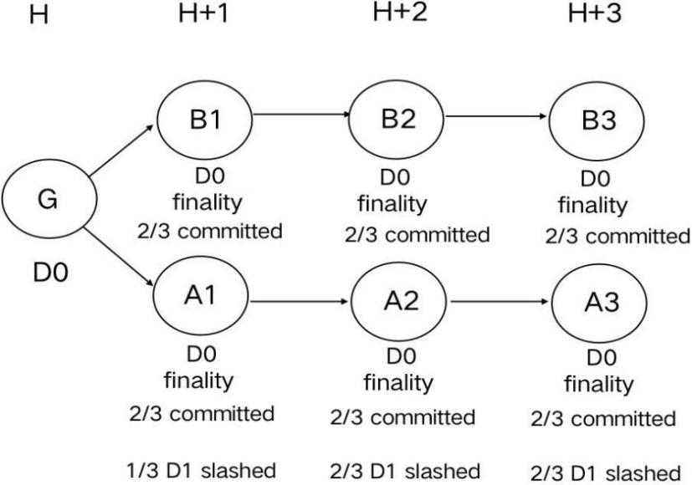

**2. Consensus mechanism**

Due to the distributed nature of blockchain, blockchain needs a consensus mechanism to function properly. At present, the widely used consensus algorithms mainly include: proof of work (PoW: ProofofWork) certificate of equity (PoS: ProofofStake), practical Byzantine fault-tolerant algorithm (PBFT: Practical Byz-antine Fault Tolerance) certificate of appointed equity (DPoS: Delegated ProofofStake). For safety considerations, CBTSchain selected DPoS and improved the LPoS consensus mechanism (Labor Proof of Stake). LPOS not only inherits the advantages of DPOS, and can realize the distribution of rights after the block without consuming additional computing power. It also can dynamically determine the execution result of the smart contract verified by the agent or all nodes according to the transaction state of the network.

As a public chain, we cannot leave the support of the economic means- -the incentive layer Token. Holding Token can not only obtain blockchain infrastructure services such as contract release and network fork, but also participate in voting and get Token rewards for providing services. We name this Token as CBTS, and each CBTS holder calls it as an equity holder, assigning corresponding weights according to the number of holdings, and guaranteeing that it cannot be tampered with. The normal work of the community can be profitable, while if the work is abnormal or not working, it will be subject to the corresponding restrictions.

In theory, LPoS can further improve the network transaction capability compared with DPoS. For example, for some smart contracts that take a long execution time or have a lot of internal bears. The agent packages only the Hash value of the resulting transaction, and all nodes verify the Hash value themselves. While satisfying the smart contract is rapidly verified, it also reduces the congestion of the whole network. Moreover, we do some optimization on the consensus algorithm to avoid gradually evolving into a centralized network.

**3. Technical agreement**

In the blockchain network, the account address is designed for secure exchange, in which the account, public key and private key generation process have the following relationships: private key 1> public key> public key> account address, all of which use the security hash algorithm (SecureHashAlgorithm, SHA) to ensure sufficient security. Hash is the extraction of information, usually whose output is much smaller than the input and is a fixed length. With the current technology means, the hash with strong encryption must be irreversible. That is, through the user's account address, the user's private key information cannot be derived.

According to the byte length of the account address, it can be divided into two types of accounts, the main account and the sub-account. The main account is 35 36 characters and the subaccount is 6768 characters. The sub-account is generated by adding 32 random characters after the main account. As long as the first 35 and 36 characters of the sub-account are exactly the same, they can be considered subordinate to the same main account. Such an account structure, it can expand its transaction performance. That is, sub-accounts belonging to the same main account can be traded in the same period of time without worrying about the "double flower" problem. In addition, the design of sub-accounts can save account overhead and management. CBTSchain UTXO model (UnspentTransactionOutput) using Account model rather than Bitcoin), the UTXO design is very clever, supports multiple transactions in parallel, and has relatively good account privacy protection. However, Bitcoin's account design is a transaction-specific design, and it is very difficult to implement smart contracts based on UTXO. However, smart contracts in CBTSchain bears often require conditions and bears to trigger asset transactions. In the operation of the platform, users have more contact with capital verification agreement, settlement agreement, flash exchange agreement and clearing agreement.

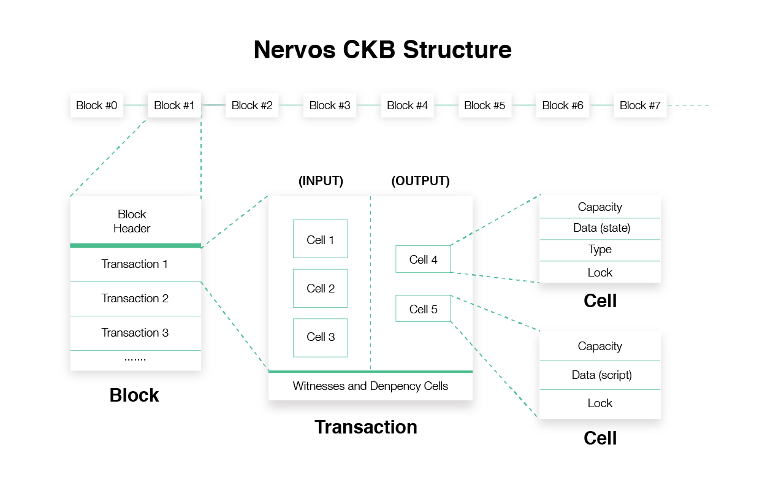

**4. Fork network**

To quote TaylorGerring, a board member of the Ethereum Foundation, a hard fork of blockchain can make networks more resilient. CBTS proposes networks suitable for bifurcation, based on three considerations. One is to maintain strong vitality, the second is to ensure the whole network consensus contract pool model, and the third is to meet different social goods demand scenarios. First, the blockchain network is a community that many participants build on certain consensus, and consensus divisions make hard forks happen, which are sometimes better and worse. Through people's screening and elimination, a batch of valuable blockchain network will eventually be left behind, which is very much in line with the law of continuous self-evolution of species and environment in the self-organized world. Second, blockchain is still in its early stages of development, and other applications need to be further explored compared to digital assets. At present, there are many innovations, such as lightning flash network, zero knowledge verification, side chain technology, isolation witness and so on. From these innovations can be summarized as a rule- -that is, different transaction performance, different consensus methods, different smart contracts, and different technical characteristics, combined to meet a certain type of specific needs. Therefore, it is feasible to implement different networks through bifurcation to meet diverse needs. But diversification can create other problems.

The CBTS seed contract will serve as the starting point of the entire fork network, which can also be called the main chain. The main chain can fork out of the subchains parallel to it, and the subchains can continue to bifurcate, and all chains are equal. When the fork occurs, VEP will record and broadcast the registration information of this sub-chain, such as creation block information, sub-chain ID, seed node, digital assets, service identification number, etc. If the fork continues to occur, the registration information will be updated by VEP and synchronized throughout the network. When the interaction between the chain is needed, the connection is established by registering information that can be found, and information interaction and value exchange are realized under the VEP framework.

To make these goals possible, CBTSchain has built a BaaS platform that uses visual interfaces and multilingual support to significantly lower the threshold for developers. Anyone can build their own apps through a fork to better motivate the community developers. Community activity increases, CBTS value increases, community appeal increases, and more developers and users participate. The positive feedback effect will make the ternary ecology better and better.

**Prophecy machine**

The Oracle, originally originated from the ancient Greek religion, meaning "theism, prophet, prophecy", is essentially a way for blockchain or smart contracts to interact with external data. As a bridge for the data interaction between the real world and the block chain, the prediction machine has rich application scenarios. It can be said that all Dapps that need to interact with the data under the chain need the prediction machine. For example, financial derivatives trading platform, lending platform, loT, stablecoin, gaming games, insurance, and market prediction, etc., the most important scene at present is DeFi.

The prophecy machine, the core of the future of the crypto revolution. The existence of the prophecy makes smart contracts smarter. With the prophecy, smart contracts can use data stored outside the blockchain and link daily events in the real world, allowing users to put billions of dollars worth of assets into smart contracts with external connectivity. Building a reliable network of prophemachines will not only allow us to experience the wider DeFi world, but also help better release the vitality of the bear field.

For the CBTS prophecy machine solution system, market participants (including data analysts, data providers and data users) can use the platform together to share trusted data. Provide external data calling services for smart contract and product block chain applications, processing hundreds of millions of data service requests on the CBTS platform. Feed price provides key market price data, which developers use to develop lending, stable assets, Derivatives, asset management and many other product applications, and users can use the key market price data provided to make rational scientific investment and collection.

CBTS data calls is based on mutual trust (not). When the CBTS prophet calls external data to introduce the smart contract, the final data feedback to the user is consistent with the data from the data source itself, so as to prevent the prophet from changing the calculation midway. After confirmation by the service requesting party and verification by other prophets, if the call data result is correct, the call data is written to the smart contract and the transaction record is uploaded to the blockchain; if the call data is inconsistent, the transaction will be defined as an illegal transaction.

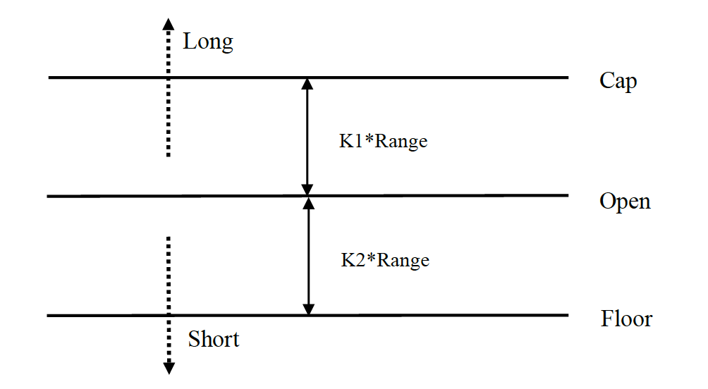

The CBTS data calling is highly efficient. The prophet stipulates through the smart contract that if the prophet does not respond to a user's request within the specified time after the request is issued, or does not feedback the data to the user within the specified time, it will automatically cancel the transaction and impose the badge penalty.data security. The unique design of the CBTS prophecy machine effectively prevents various data corruption behaviors, such as witch attacks, mirror attacks, copying answers and so on. In addition, by forcing the node in the TEE (Trusted Execution Environment) environment for decryption, and to the block chain huai

Report a universal answer that all users and nodes can see.

The establishment of CBTS prophecy machine incentive mechanism and supervision mechanism to achieve the goal of incentive compatibility. The design of the governance mechanism fully arouses the supervision enthusiasm of other competitive prediction machines, and does not allow the indicators that determine the returns of the prophet. With data assets, CBTS sets prices according to the importance and scarcity of data resources, and writes smart contracts in the form of fair value. This will change the current pricing method dominated by the resource party whose data pricing power belongs to the data, and realize decentralized pricing.

The CBTS prediction machine is designed with the following three elements:

Integrity (Integrity), confidentiality (Confidentiality), availability (Availability), integrity (Integrity) integrity means that the information is complete, accurate and reliable, not intentionally or unintentionally broken soil, tampering. How to ensure that the obtained external data sources obtained are authentic? This is the core problem in the use of our prophecy. In the design process, we mainly engage in the data source authentication, data acquisition standard process, data format unification and other aspects of constraints. The CBTS prophecy machine carefully selects external data sources to ensure that each selected external data source can be verified to be credible. For example, for Web data acquisition, the selected data source needs to hold a certificate. Standard process for data acquisition. Developers must clearly execute the data exchange process of the engine, users, external data sources and predictor, and distinguish the data interaction process for different data sources to ensure that the interaction scheme can be executed and implemented.

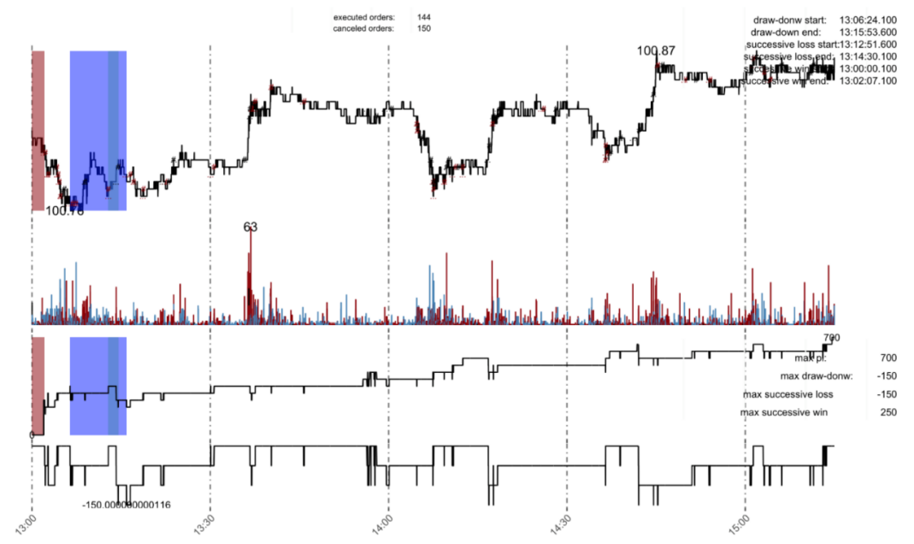

Unified definition of the data interaction format. Different data source types have different data interaction formats. The data formats obtained with sensor as data source and Web as data source are different. According to different situations, a unified data compilation and decoding layer is clearly defined to request and interpret the data of different data sources.

Confidentiality (Confidentiality): Confidentiality means that the content of smart contracts to request the prophet will not be leaked. For the decentralized insurance business, users may not want them to disclose their information to the world; for decentralized derivatives transactions, users may not want to disclose their portfolio and operational strategy.

CBTS uses the Schnorr multiple signature mechanism to solve the problem of Freeloading. The maximum number of fault-tolerant nodes is 2 / 3 of the total number of nodes, of which the number of Oracle without availability is 1 / 3 of the total number of nodes, and the fault-tolerant without borrowing accuracy is 1 / 3). There must be at least 1 / 3 of the peer signature. CBTS partly contained witch attacks and mirror attacks. The certificate certification mechanism is still under further design by monitoring the endorsement (authentication) of high-quality Oracle, and performing post-checking of the data submitted to the chain, comparing them with the answers obtained directly from reputable data sources. The diversification of data sources and predictions effectively spreads the risk of data distortion. Long-term introduction of the trusted execution environment (TEEs) as a hardware security guarantee, so as to realize the confidentiality of contracts, and generate reliable randomness.

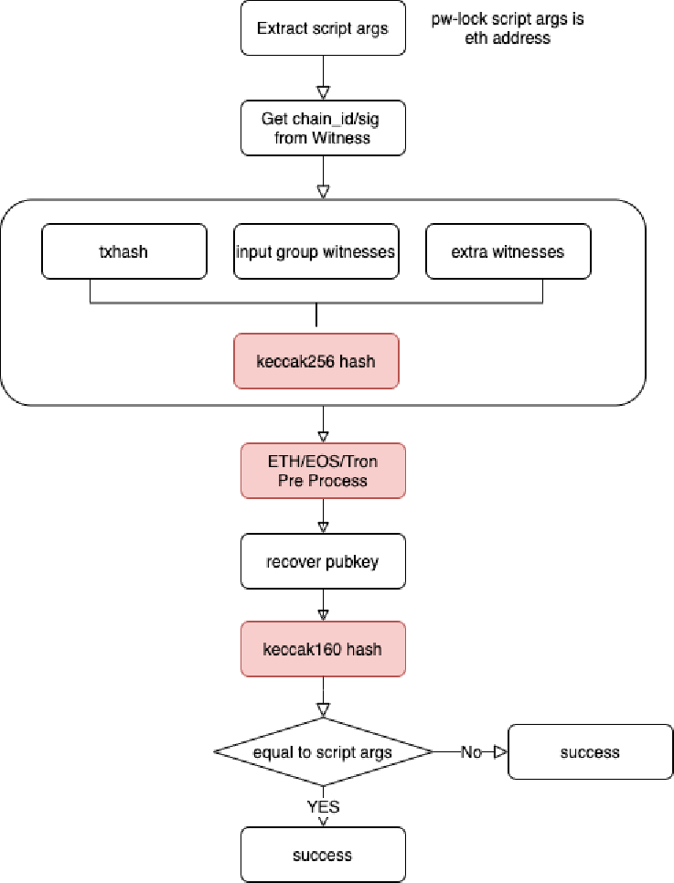

# 4. The Team and the Foundation

## 4.1 Core team members

Gilbert Gibert. George, graduated from Stanford university finance department, former Morgan Stanley financial division vice President, has 20 years of experience in the financial sector, the stock economy, mergers and acquisitions, capital operation has profound practice experience, gigbert in bloody capital markets familiar understand the human greed, hope to build a, easier operation, open and transparent, can let most people can make money economic platform, so, participate in the CBTS project, and served as the executive director.

Jack jack. Dan, graduated from the Australian national university, has worked in CAPSTONE kaishi group division marketing director, has more than 10 years of experience, has participated in SMI, MBI, AGK, fork project framework and market services, and in 2015 to participate in the currency exchange services, the financial and trading system security risk control consciousness has a very high experience, and industry solutions. Based on Jack's experience and industry resources, he jointly initiated the CBTS project and served as chief Executive Officer.

junjie weng, More than IBM 10 years of experience in development and solutions, the first batch of Fabric developers. Participated in the architecture design and core development of Onchain DNA / Ontology Core Ledger. Experience in blockchain application in bills, supply chain, points, data trading, shared finance and other fields.

Annderly, Graduated from the University of San Diego, French citizen, ATOS senior technical expert, proficient in 5 languages. Engaged in data information management, encryption algorithm application for 15 years; once worked in MODIS, AJILON, ADOMSYS, has rich service experience in various fortune 500 enterprises. At present, he is the most outstanding blockchain technology expert in Central Asia.

Shi-ming huang, graduated from Singapore institute of technology, participated in Australia rhapsody official resort, Sydney hyatt, Singapore engineering planners, industrial investment, modern consumption, consumption IP, international market project has a deep experience and creative elements, has been in the idea of digital life world, based on the expectations of the future, now participate in the CBTS project joint sponsors, is responsible for the investment.

## 4.2 Fund governance mechanism

Chain Bifucate Trade System The CBTS Foundation (hereinafter referred to as the foundation) will be set up, with 50% of the platform fee income as the fund source, to ensure the operation, development, planning, investment, market value and risk control and management of the Chain Bifucate Trade System ecological community. The organizational structure of the foundation

Will consists of the Chain Bifucate Trade System Community Assembly, the Autonomous Committee and the Executive Committee.

The community assembly is composed of all consensus participants, and the holders can drive their voting rights through the community assembly;

The self-governing committee consists of all title qualifications and holders of island owners and chiefs, and all the self-governing members are sufficient to drive their advice and vote through the community assembly.

Executive committee is composed of all dukes and continent holder, by five dukes, three continents, three executives form the highest signature decision-making, reach seven joint signature can exercise the decision, CBTS decision authority is the top CBTS, involved in the project ecological decision-making, jointly responsible for the development of the project, operational decisions, investment, mergers and acquisitions, ecological planning, financial risk control, market strategy.

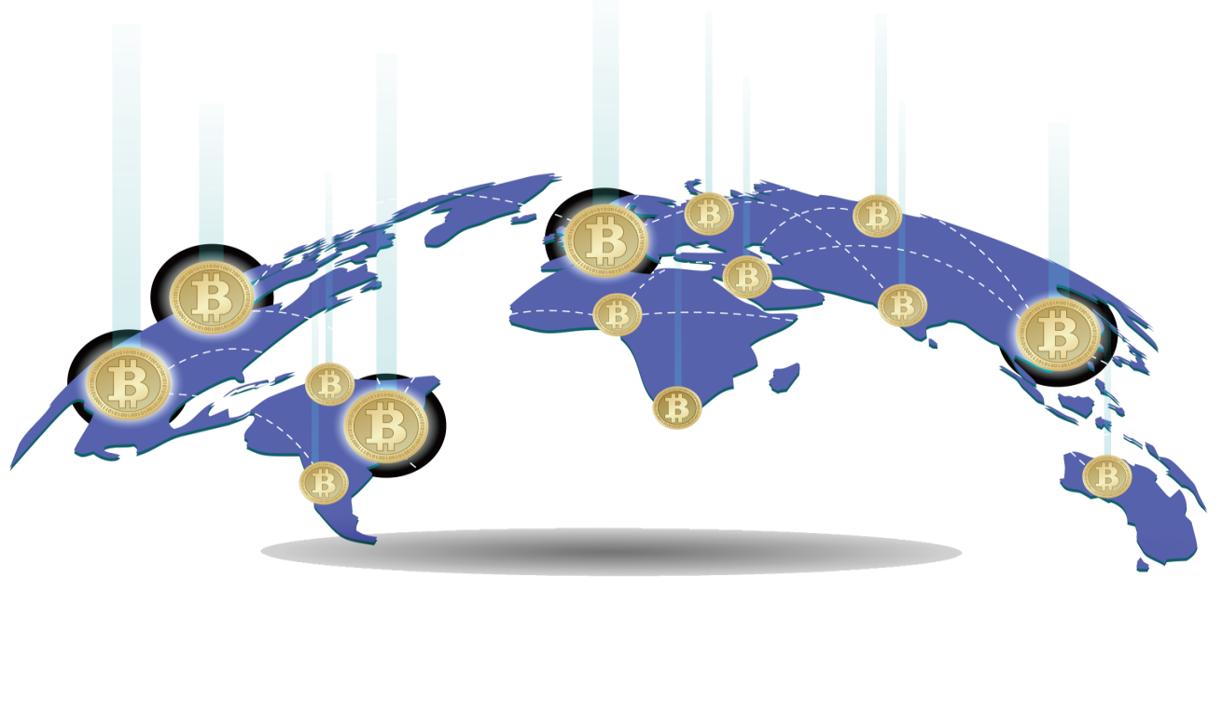The CBTS Foundation is responsible to the Executive Committee and exercises its management and supervisory functions. The Executive Committee is responsible to the Autonomous Committee, responsible for the normal operation and maintenance of the CBTS ecological community, and responsible for the actual work of the corresponding business of the community under its jurisdiction.

# 5. disclaimer

Nothing in this white paper constitutes legal, financial, commercial or tax advice, and you should consult your own legal, financial, business or other professional advisor before participating in any activity related to this. The staff of the platform, members of the project R & D team, third-party R & D and development organizations, and service providers shall not be liable for any direct or indirect damage and losses that may be caused by the use of this white paper.

This white paper is for general information purposes only and does not constitute any offer for a prospectus, offer documents, an offer for securities, solicitation of investment or sale of any product, article or asset (whether digital or other). The following information may not be exhaustive and does not mean any elements of the contract. The white paper cannot guarantee the accuracy or completeness of the information, and does not guarantee the accuracy and completeness of the information. In the case that this white paper contains information obtained from third parties, the platform and the team have not independently verified the accuracy and completeness of such information. In addition, you need to understand that the surrounding environment and conditions may change at any time, so this white paper may be outdated, and the platform has no obligation to update or correct the content and documents related to this.