Project: PTTA - SIGI

Date: 25/02/2016

Time: 10:30am

Duration: 3 hour

Attendees:
- MARNDR
  - Ary
  - Josias
  - GianMichele
- AVSI
  - Federico

Room: Bureau d’AVSI au Cap-Haitien
Agenda: Nouveau Cahier des Charges SIGI et proposition des OPERATEURS

Items Discussed:
- Duplication of “agriculteurs”:
  - During the data entry the system should check if the NIF exists already. If so, the data entry has to be blocked!
  - If the same “agriculteur” will be registered the first time using the NIF and the second time using the CIN, for the system are two different people. The solution would be to have a database of the government where the SIGI could control the relation between CIN<->NIF.
- Yearly “cultures”
  - Can the system manage an annual incitation? Can an “agiculteur” have more than one “incitation”?
- Link between supplier “fornisseurs” and client “agriculteurs”
  - To finish an incitation is compulsory to add a “fornisseur” to an “agriculteur”, the request is to eliminate this step. An agriculteur can get his goods for any “fornisseur”.
- Paquets techniques
  - Have the possibility to add a list of sub-activities (in one activity) to calculate the total cost of an activity adding the all different costs of each sub-activity.
  - The voucher sould have a detail of each sub-activity with quantity. The total cost should be fixed.
  - To select the sub activity the system should provide a dropdown menu with multiple selection 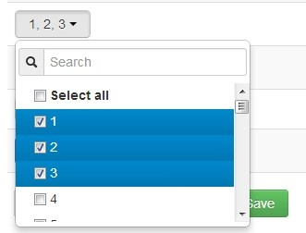
  - The list of sub activity has to be created in the “Configuration->Reference->Type sous-activité”. In the window the MARNR should be able to create a list of sub activities related to an activity.
  - The prices of the pacquet have to be editable by the “Chef d’antenne”.
- Agriculteurs
  - Avoir la possibilité de voir le poligone concernant la parcelle de l’agriculteur.
  - Avoir la possibilité de travailler offline :
    - Have a mirror cache server @OPERATOR
    - Give the possibility to upload an Excel file (with a standard structure) in order to write in the SIGI database.
    - Develop an android application to store the data locally and sync with the system.
- The system is slow when reading from the database
- CONTRACTS:
  - Have the possibility to auto-generate the contracts concerning an “agriculteurs” and an “incitation” (pdf format).
  - Have the possibility to auto-generate the “fiche de reception” of the vauchers.
- The system shoud be more detailed concerning the history of the batchs.

Other Info:

Send report to all attendees, VP of Marketing, VP of Recruitment.

