# Homework 0

## **SWE 432 Project Proposal & Getting Set Up**

## **Due: 9/6 before the start of class**

## Part 1: Project Proposal

Over the term, you will learn how to use both client facing and backend technologies to make a website. You will work on each homework with a partner, and over the course of the semester, will build a dynamic website piece by piece. To maintain some cohesion between each assignment, and leave you with a final, portfolio-worthy deliverable, we ask you to first decide on a project concept. While we provide several suggestions for project ideas below, we encourage you and your partner to define your own project based on something that is interesting to you.

You should first find a partner. If you are looking for a partner, please post on the Piazza thread for finding a partner.

**Project requirements:**

1. It must include dynamic behavior, where the front end responds to web service or user input events and updates the interface accordingly.
2. It must make use of at least one web service (more than one is ok). A list of example web services is listed below, but you are free to select any web services.
3. It must include an information visualization the visually depicts data that you will implement using D3.js. The D3 gallery has [examples of information visualizations](https://github.com/d3/d3/wiki/Gallery). In your project, you may either take an existing visualization and customize it or develop a new visualization.
4. It must include logic that will execute both (1) client side in a browser and (2) on a server.

**Guidelines on what we expect to make a good project:**

1. It should be something you and your partner can implement in a semester.
2. Your project need not be a complete, functioning application, but may rather be a prototype that focuses on a few of the most interesting aspects of the application but does not implement or provide a full range of functionality (i.e., a drawing application might only let the user draw, move, and resize lines).
3. You may choose to get started by adapting an existing starter project, as long as you explicitly acknowledge the source of your code when you do so.
4. Ideas for a project: a visualization of trending topics on Twitter, a sports statistics explorer, a Google Maps visualization of crime data,

**Example project proposal:**

Personalized News Visualization: *FLEXibleNews.* FLEXible news is a news aggregation and search application that will allow you to view a large number of different types of news articles in one go. Using FLEXible news you can view the latest happenings from around the world, filter them using a variety of different categories. After registration you can log in to the system, allowing it to customize search results. After logging in, FLEXible news shows users an overview of current news, visualized in a treemap. News is grouped by category, and then within each category, stories that are trending appear larger (see screenshot below, but note that screenshots are not expected for the proposal!). Users who are logged in can save their current view, or save searches.

Technically, the system uses the Bing news API to retrieve the stories, and stores all user information on a server backend. The system uses the D3 visualization API to create the treemap.

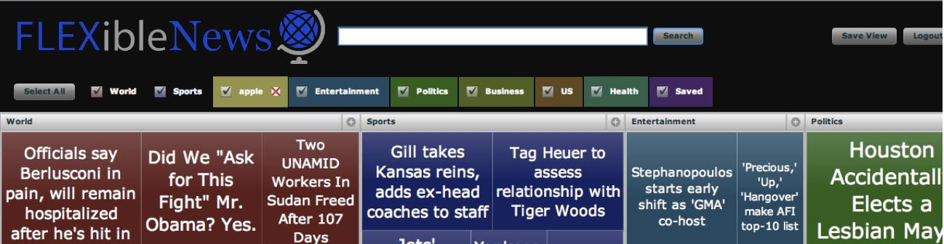

**Example web services:**

15,464 APIs on programmable web - <http://www.programmableweb.com/apis/directory>

Marvel **-** <http://developer.marvel.com/>

Google cloud entity recognition - <https://cloud.google.com/natural-language/>

Watson cloud - <https://github.com/watson-developer-cloud/node-sdk>

Twitter - <https://dev.twitter.com/overview/api>

Google Maps - <https://developers.google.com/maps/documentation/javascript/>

NFL play by play day - <http://nflsavant.com/about.php>

Bing news API - <https://www.microsoft.com/cognitive-services/en-us/bing-news-search-api>

Yahoo - Weather, photos, finance, etc. - <https://developer.yahoo.com/everything.html>

Foursquare API - <https://developer.foursquare.com>

Instagram API - <https://www.instagram.com/developer/>

GitHub API - <https://developer.github.com/v3/>

## Part 2: Setup Development Tools and Hosting

**Set up a website hosted on Github Pages**

First, both you and your teammate should create accounts on Github, if you do not already have one.

Second, setup a new Github repository entitled [YourProjectName]. Make sure both you and your teammate create separate Github accounts. Make sure you project is hosted under one of your two accounts and add the other account as a collaborator. Be sure to either (1) make the repository public or (2) create a private repository and add both the Instructor (Github ID: tlatoza (Section 001) or jon-bell (Section 002)) and TAs (Github ID: TBA) as collaborators. If you choose to make your repository private, you will need to first request a Github education discount using the form here (it’s free!): <https://education.github.com/discount_requests/new>.

Third, follow the instructions at <https://pages.github.com/> to create a Github Pages website associated with your repository. Choose the options to (1) Create a Project Site, (2) Start from Scratch, and (3) Make gh-pages the default branch. Follow the instructions to create an index.html file and test your website when you are done.

Finally, create your HW submission. Create a hw-submissions branch. Create a HW0 pull request from gh-pages into hw-submissions. Merge the pull request. Create a HW0 release from gh-pages.

## Submission Instructions

Please include:

1. Your name and the name of your partner
2. A one to two paragraph statement of intent describing your the goals of your project and how it satisfies project requirements one through four
3. The URL for your Github repository.
4. The URL for your Github pages website.

Only one person per group should submit on behalf of your group.Submit your assignment on Blackboard.