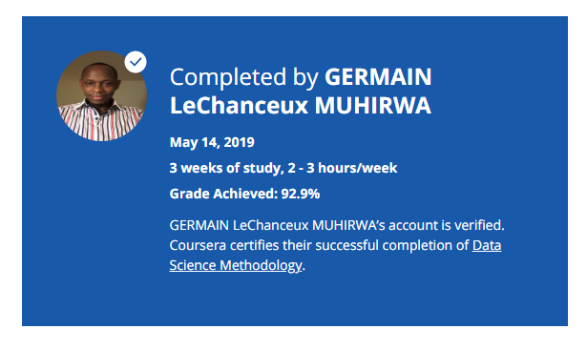

### About this Course

**Taught by: Alex Aklson & Polong Lin**

IBM

Despite the recent increase in computing power and access to data over the last couple of decades, our ability to use the data within the decision making process is either lost or not maximized at all too often, we don't have a solid understanding of the questions being asked and how to apply the data correctly to the problem at hand.

This course has one purpose, and that is to share a methodology that can be used within data science, to ensure that the data used in problem solving is relevant and properly manipulated to address the question at hand.

Accordingly, in this course, you will learn: - The major steps involved in tackling a data science problem. - The major steps involved in practicing data science, from forming a concrete business or research problem, to collecting and analyzing data, to building a model, and understanding the feedback after model deployment. - How data scientists think!