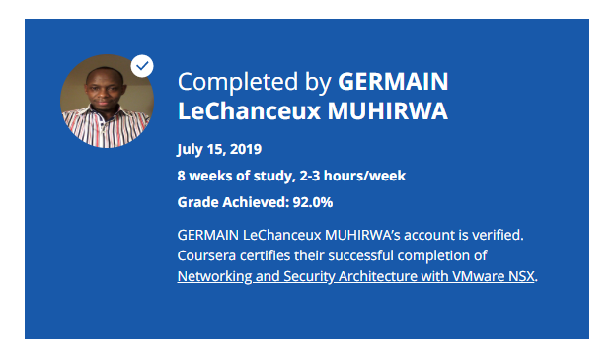

### About this Course

**Taught by: Chris McCain**

VMware

This 8 week online course equips learners with the basics of network virtualization with VMware NSX.

To get the most of this course, you should have familiarity with generic IT concepts of routing, switching, firewalling, disaster recovery, business continuity, cloud and security.

At the end of the course, you will be able to:

• Understand network virtualization basics

• Describe NSX business value and use cases

• Explain how NSX is different from traditional networking

• Summarize networking and security solution architecture with VMware NSX around these key areas:

+ Micro-segmentation

+ Automation with OpenStack

+ Automation with VMware vRealize Automation

+ Disaster Recovery and Business Continuity

+ Operational Transformation

• Demonstrate understanding through hands-on experience

• Develop a learning plan for network virtualization certification

If you are new to network virtualization, download our Network Virtualization for Dummies guide. http://learn.vmware.com/36350_NSX_ITAutomation_Reg?src=af_5acfd24cebb90&cid=70134000001YR9b All Hands on Labs referenced in this course are OPTIONAL and available for FREE. Direct links to free labs can be found on the Resources Tab or you can access our full library at https://labs.hol.vmware.com/HOL/catalogs/catalog/877