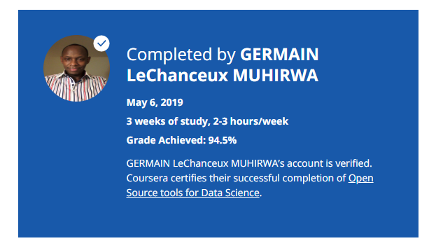

### About this Course

**Taught by: Polong Lin**

IBM

What are some of the most popular data science tools, how do you use them, and what are their features? In this course, you'll learn about Jupyter Notebooks, RStudio IDE, Apache Zeppelin and Data Science Experience. You will learn about what each tool is used for, what programming languages they can execute, their features and limitations. With the tools hosted in the cloud on Cognitive Class Labs, you will be able to test each tool and follow instructions to run simple code in Python, R or Scala. To end the course, you will create a final project with a Jupyter Notebook on IBM Data Science Experience and demonstrate your proficiency preparing a notebook, writing Markdown, and sharing your work with your peers.