Evaluate Regression and Regularized Regression Models in a Real-World Application

  - Gladys Murage
  - College of Business, Engineering, and Technology, National University

TIM-8131 v2: Data Mining (8221718749)
Dr. Yuksel Karahan
December 16, 2025

Evaluate Regression and Regularized Regression Models in a Real-World Application
Introduction
Regression is fundamental to predictive modeling, but Ordinary Least Squares (OLS) often underperforms in high-dimensional settings due to multicollinearity, overfitting, and unstable coefficients. Regularization techniques which include Ridge, Lasso, and Elastic Net do address these challenges by introducing penalty terms that shrink coefficients, resulting in more stable estimates, improved out-of-sample performance, and enhanced interpretability. The research in this project applies these regularized regression methods to the NutritionData.csv dataset, obtained from online sources.
Exploratory data analysis is carried out to visualize the shape, top 5 records, bottom 5 records, data types and a summarization of statistics. The data set has a lot of incomplete records and has mixed data types that require a lot of data preprocessing, imputing the missing numerical and categorical data and removing outliers. Linear regression and tree models are then implemented after preprocessing to predict the number of calories in the nutrition features. Six models ( linear and ensemble models) are built to evaluate regression: Ordinary Least Squares (OLS), Ridge , Lasso, Elastic Net, Random forest (RF) and XGBoost. Model performance is evaluated using k-fold cross validation using a minimum of k= 5. The metrics used to evaluate the models are Root Mean Squared Error (RMSE), Mean Absolute Error (MAE), Coefficient of Determination (R2) and Adjusted R2. Hyperparameter tuning using Grid Search for linear models and Random search for tree models is then implemented using cross validation Selected hyperparameters are reported and justified. The empirical findings are contextualized within a critical review of recent literature on regularization and the bias–variance tradeoff.
Problem Statement
A hypothetical scenario exists in which the Murage Mills advertising team has the nutrition information of some test foods that they plan to bring to market soon. However, their scientists have not had a chance to test each nutrition products’ amount of calories as of yet. The management, therefore, require the data scientist to build a model that can estimate the number of calories in a food type based on the nutritional information in the data set. This will enable the company’s marketing department to get a head start on their marketing material rather than having to wait for the research scientists testing which is estimated to take three months to perform The questions being answered are twofold, first, do linear methods of regression ( OLS, Ridge, Lasso, or Elastic Net) outperform ensemble methods (RF and XGBoost)? Secondly, which linear regression model (OLS, Ridge, Lasso, or Elastic Net ) performs most accurately in predicting the amount of calories when faced with high dimensionality and a lot of missing numbers the data set?
Part 1 Data Exploration and Model Implementation
Dataset Source
The research in this project applies regularized and ensemble regression methods to the NutritionData.csv dataset, obtained from online sources. The dataset contains 8790 observations of various types of foods and 52 predictors, before feature engineering including the number of calories in each food represented by the field “Energ_Kcal.”. The dataset consists of both numerical and categorical variables describing the nutrition value of foods. The variables used in the dataset include a variety of integers, objects and floats. The data is downloaded from an online source as a Zip file and saved in Dropbox as "NutritionData.CSV". The file is then uploaded into Jupyter notebook, and the file is loaded using a different encoding latin1 instead of the utf-8coding.
Preprocessing Steps
Exploratory data analysis is carried out to visualize the following: the shape of the data, top 5 records, bottom 5 records, data types, summarization of statistics, target distribution via a histogram, correlation analysis of top ten features with target, and finding the missing values. The data set has a lot of incomplete records and has mixed data types that require a lot of data preprocessing, imputing the missing numerical and categorical data and removing outliers. Refer to figure 1 for the distribution
Figure 1
Histogram of Feature Distribution
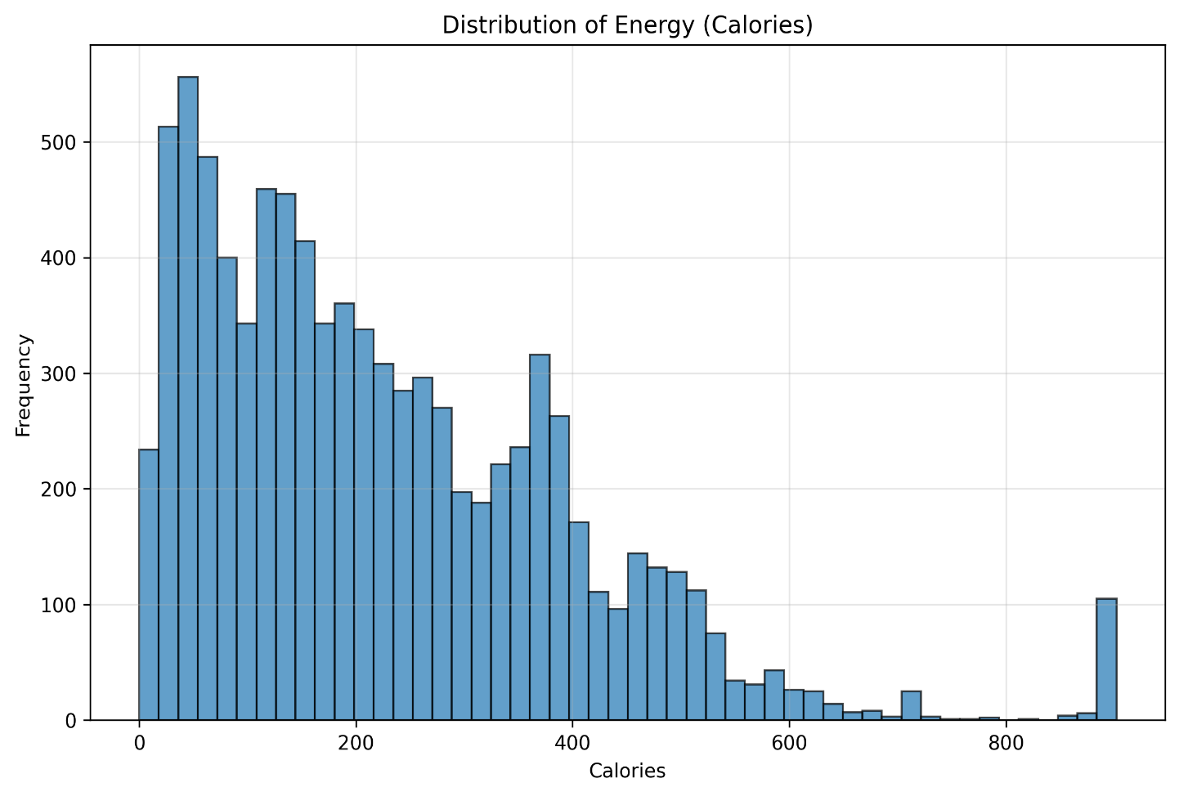
Refer to figure 2 for correlation analysis of the top 10 features to the predicted variable.
Figure 2
Correlation Analysis Heat Map of the Top 10 features to the Predicted
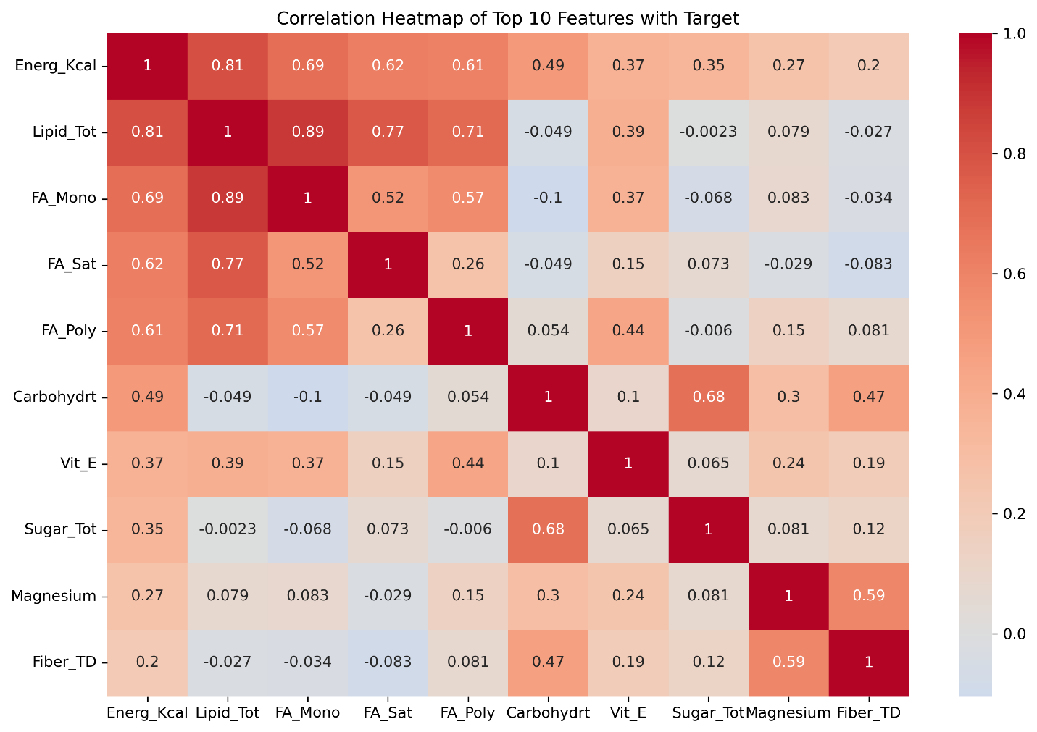
Missing numerical values are imputed using the median to handle outliers, and missing categorical values are imputed with the mode. Numerical features are scaled by standardizing them to have a mean of zero and a variance of one, which aids models sensitive to regularization. Categorical variables are encoded using one-hot encoding. Outliers are handled using the interquartile method from numeric columns Feature engineering is carried out to increase robustness and ability of the model to capture complex pattern relationships by creating 6 interaction and polynomial features to give the data set 8790 observations and 58 predictor variables Refer to Figure 3 for the heat map of relative missingness of columns and Figure 4 for the graph of the relative missingness of columns.
Figure 3
Heat Map of Relative Missingness of Columns
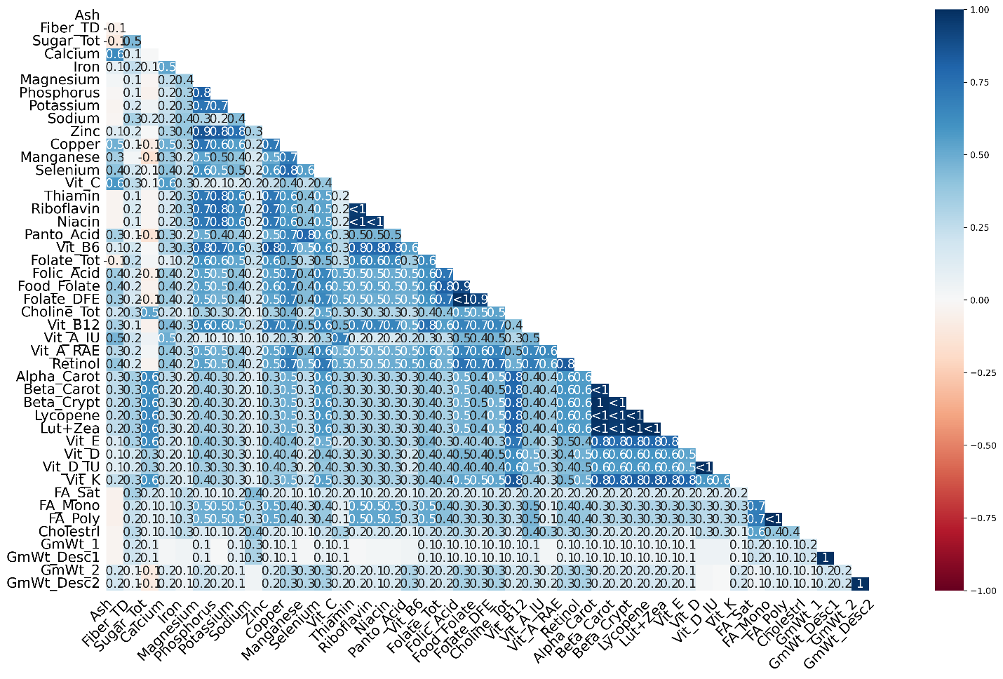
Figure 4
Basr Graph of the Relative Missingness in Columns
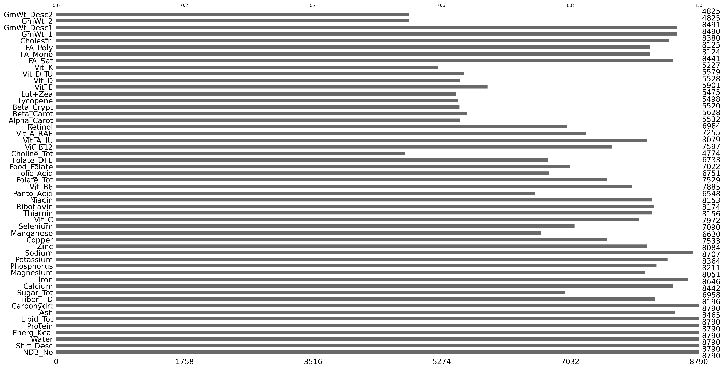
Model Implementation
Six total regression models are implemented to answer the two research questions in the problem statement. Four linear regression models and two ensemble methods are implemented in this study. First, Ordinary Least Squares (OLS) serves as the baseline linear model without regularization. Secondly, Ridge regression (L2) introduces a penalty on the sum of squared coefficients to address multicollinearity. Third, Lasso regression (L1) applies a penalty on the absolute values of coefficients, enabling feature selection. Fourth, Elastic Net combines both L1 and L2 penalties to balance feature selection and coefficient grouping.
Fifth, RF Random Forest (RF) is an ensemble learning method that constructs multiple decision trees using bootstrap samples and random feature selection. This approach reduces variance, enhances robustness, and effectively captures nonlinear relationships and feature interactions. RF is less sensitive to feature scaling and achieves high predictive accuracy by averaging the outputs of individual trees in regression tasks. Compared to other ensemble techniques such as bagging and boosting, RF demonstrates superior accuracy and reliability (Salman et al., 2024).Finally, XGBOOST uses boosting and reduces bias by sequentially correcting errors; it uses regularization and a conservative learning rate to avoid overfitting.
For this project, Python with scikit-learn is employed to implement the machine learning workflow, which includes a train-test split of 80% training and 20% testing. Hyperparameter tuning via grid search and random search cross validation using a 5-fold is conducted followed by model training and evaluation. Feature selection is carried out to identify the important predictive features for the model The coding component is prepared and submitted separately in the file MurageGTIM8131-4.ipynb, ensuring that the technical implementation is clearly documented and reproducible.
Evaluation
Model evaluation is conducted using k-fold cross-validation (k=5), which partitions the data into five subsets, ensuring each model is trained and validated on different splits for a robust estimate of performance. Several complementary metrics are employed which together provide a comprehensive assessment of model accuracy, error magnitude, and explanatory power, ensuring a balanced evaluation of regression performance. These metrics are as follows:
Root Mean Squared Error (RMSE)
RMSE is computed as the square root of the mean squared error, capturing the typical magnitude of prediction errors in the same units as the target variable. It penalizes larger errors more heavily, making it sensitive to outliers and providing a clear indication of prediction accuracy.
Mean Absolute Error (MAE)
MAE is calculated as the mean of the absolute residuals, providing a straightforward measure of average prediction error in the same units as the target variable. It is straightforward to interpret and reflects the typical magnitude of prediction errors, regardless of direction.
Coefficient of Determination (R²)
R² represents the fraction of the dependent variable’s variance that is explained by the fitted regression model. A higher R² indicates better model fit and predictive power.
Adjusted R²
Adjusted R² modifies the R² metric by incorporating model complexity, reducing the likelihood of overestimating fit when extra predictors are introduced.
Part 2: Hyperparameter Tuning
Hyperparameter tuning with cross validation
According to Arnold et al. (2024), hyperparameters do critically influence the performance of a machine learning model on how well the model performs on unseen data which is non training data. The authors argue that hyperparameter tuning goes a long way in building confidence about a machine learning model performance This is because hyperparameters determine the model’s capacity to generalize to new unseen data. Finding a good set of hyperparameters critically impacts the conclusions about a model’s performance.
For this real world data project, hyperparameter tuning with cross validation is carried out. Grid Search cross validation which searches through all the possible parameter combinations by dividing parameter space in the form of a grid is used. Then each of the grid points are evaluated as hyperparameters. It is ideal for a small parameter space when there is not a lot of data otherwise it can get to be computationally expensive. In this project grid search is applied for all four linear regression models (Shekhar et al., 2021).
Random search cross validation, another commonly used approach in which the hyperparameters are selected randomly performs well in a large parameter space where there is a lot of data and is employed for the 2 ensemble tree regression methods. Compared to the grid search, Random search converges much faster (Shekhar et al., 2021). For the Ridge/Lasso/ElasticNet the following parameters are chosen, alpha, solver types, and regularization strength. For RF, n_estimators, max_depth, min_samples, and max_features are selected. In XGBoost the parameters selected are learning rate, depth, subsampling, and regularization parameters (L1/L2).
Reporting and Justification for Selected Hyperparameters
Ridge/Lasso/ElasticNet Regression
Selected Hyperparameters. Alpha (α), regularization strength (λ), and solver optimization algorithms. Regularization strength L1/L2 mixing parameter is an extra hyperparameter chosen for ElasticNet.
Justification. Alpha is the single most critical parameter that controls the trade-off between fitting the training data and model complexity. Alpha tuning is essential for optimal bias-variance tradeoff in regularized regression. The L1/L2 regularization strength parameter in ElasticNet often denoted as l1_ratio balances sparsity which gives feature selection and coefficient shrinkage which is particularly valuable in high-dimensional settings or multicollinear settings (Zou & Hastie, 2005). This project does have many features, utilizes regulated regression, and calls for Alpha hyperparameter tuning. Since accurate results are of utmost importance to the marketing department, a sweet spot between bias and variance trade off must be sought by the models.
Secondly the features in this project are many and in excess of 50, therefore carefully increasing sparsity by selecting relevant features using the regularization strength parameter L1/L2 also known as l1 ratio in elastic net model is paramount. Third is the solver selection which affects computational efficiency and convergence. For example, stochastic solvers like saga are efficient for large datasets with L1 penalty; this situation fits the dataset in this research perfectly because it meets both conditions; large data set and use of Lasso regression (L1) which explains the need for Saga solver selection.
Random Forest Regression
Selected Hyperparameters. n_estimators: number of trees, max_depth: maximum tree depth., min_samples_split/leaf: controls node splitting and max_features: features considered per split.
Justification. The number of trees (n_estimators) is tuned because insufficient trees increase variance, while excessive trees yield diminishing returns and higher computational cost. Parameters such as max_depth and min_samples do directly control overfitting; deeper trees may fit noise causing overfitting, while shallow trees underfit. The max_features influences model diversity and the bias-variance trade-off. Optimal values depend on feature interactions in the dataset. Both the square root and log2 parameters are tuned jointly rather than using defaults which should significantly improve out-of-sample performance and generalizability(Bentéjac et al., 2021).
XGBOOST
- Selected Hyperparameters. Learning rate (η) or shrinkage shrinks step size to prevent overfitting. The parameter max_depth increases tree complexity. While subsample & colsample_by carries out Stochastic subsampling for robustness. Finally, reg_alpha / reg_lambda provides L1 and L2 regularization respectively on weights and leaf scores (Bentéjacet al., 2021).
  - Justification. XGBoost’s performance is highly sensitive to the learning rate and tree depth, where lower η with higher n_estimators often yields better generalization but requires careful early stopping. Subsample and column sampling parameters introduce randomness, improving robustness and reducing overfitting and is a technique validated in large-scale benchmarking studies. Regularization parameters (reg_alpha, reg_lambda) are essential for handling noisy data and preventing model complexity, with L1 promoting sparsity in leaf weights. Modern tuning approaches treat these as interdependent via Bayesian optimization (Bentéjacet al., 2021).
Model Comparison Results
Results of R² and MAE right out of the box showed XG Boost to be the better model with R² of 0.995 and MAE of 6.1calories, Random Forest was second with R² of 0.994 and MAE of 5.7 calories versus OLS. For the linear regression models, OLS and Ridge have excellent performance with R² of 0.978 and MAE of 11.6 calories. This shows a strong linear relationship between nutrients and calories. Lasso was slightly worse R² of 0.975, indicating that feature selection is not heavily needed. Elastic Net has especially poor R² of 0.901 and MAE of 28.51, suggesting that it needs careful hyperparameter tuning. Refer to Table 5 for results below.
Table 5
Initial Results After Model Implementation and Evaluation With Cross Validation
Evaluating Regression Model | MAE | RMSE | R² | Adj R²
OLS | 11.63 ± 0.22 | 25.13 ± 1.83 | 0.978 ± 0.003 | 0.978 ± 0.003
Ridge | 11.67 ± 0.22 | 25.13 ± 1.82 | 0.978 ± 0.003 | 0.978 ± 0.003
Lasso | 12.86 ± 0.27 | 26.50 ± 1.56 | 0.975 ± 0.003 | 0.975 ± 0.003
Elastic Net | 28.51 ± 0.91 | 53.27 ± 2.96 | 0.901 ± 0.009 | 0.900 ± 0.009
Random Forest | 5.74 ± 0.18 | 12.49 ± 0.96 | 0.994 ± 0.001 | 0.994 ± 0.001
XGBOOST | 6.06 ± 0.16 | 12.24 ± 0.59 | 0.995 ± 0.001 | 0.995 ± 0.001

Results after cross validation with a k of 5 shows that all models perform exceptionally well( R² >0.988). Meaning that greater than 98.8% of the time for all models the variance of the calories is due to nutrition. Tree models are clearly superior to linear models. XGBOOST has the highest R² of 0.991 with an MAE of 7.6 which is the highest MAE suggesting some over fitting. MAE of 7 to 8 calories for tree models is excellent for marketing use However next, hyperparameter tuning will be conducted to improve the bias and variance and increase model robustness. Refer to figure 6 for results.
Figure 6
Model Ranking After Performing Cross Validation (k=5)
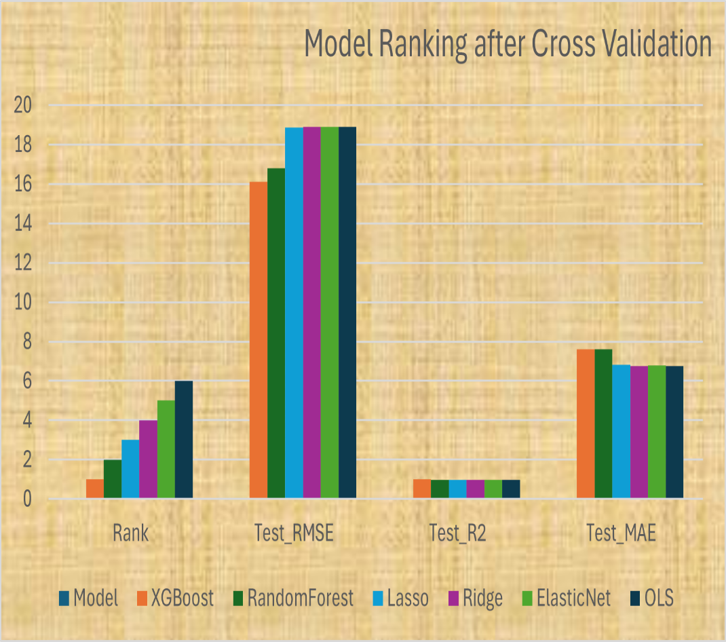

Results after tuning hyperparameters discussed for each model shows a huge improvement especially for the linear regression models OLS, Ridge, Lasso and Elastic Net in RMSE. The numbers for RMSE drop to 18.9 while the RMSE for XGBOOST go up to 16.1, and Random Forest to 16.8. R² the coefficient of determination remains highest with XGBOOST followed by Random Forest while the linear models are at 0.988. This shows the amount of variance that is seen in the target variable (amount of calories) is as a result the independent variable (nutrition information). The higher the number of R² the better and more robust the model is. The MAE drastically improves for the linear models to 6.8 while it goes up for the tree models with XG boost having a 7.6. Suggesting that there is still overfitting in existence. An overfitting assessment indicates that Random Forest has the highest overfitting at 11.47, followed by XGBOOST at 9.02, while all the linear models have a value of 4.74 for Lasso, and 4.81 for Ridge, Elastic Net and OLS, respectively.
The training versus Test RMSE graph also indicates overfitting any time there is a gap between testing versus training. Finally, is the performance heat map for all models anything dark green means better performance while red is poor performance This further supports that the linear regressions had the best MAE, while tree models had higher MAE, RMSE which penalizes errors in the model is more important measure than MAE and the tree models had lower RMSE than linear models with XGBOOST leading the way at 16.09, followed by Random Forest.
For the linear models Lasso ranked number one for RMSE of 18.86 and R² 0.9881 compared to the baseline OLS, Elastic Net and Ridge which had RMSE of 18.90 and R² 0.9880. This similarity of results for both Elastric Net and Ridge regression suggests that the Elastic Net model is designed to capture more of the L2 (Ridge) regularization than the L1 ( Lasso) regularization in the l1 parameter setting. Refer to comparison plots on Figure 7 after performing hyperparameter tuning. Refer to Figure 8 below for comparisons of the residual plots after conducting hyperparameter tuning with cross validation on all models.
Figure 7
Model Comparison Plots After Hyperparameter Tuning
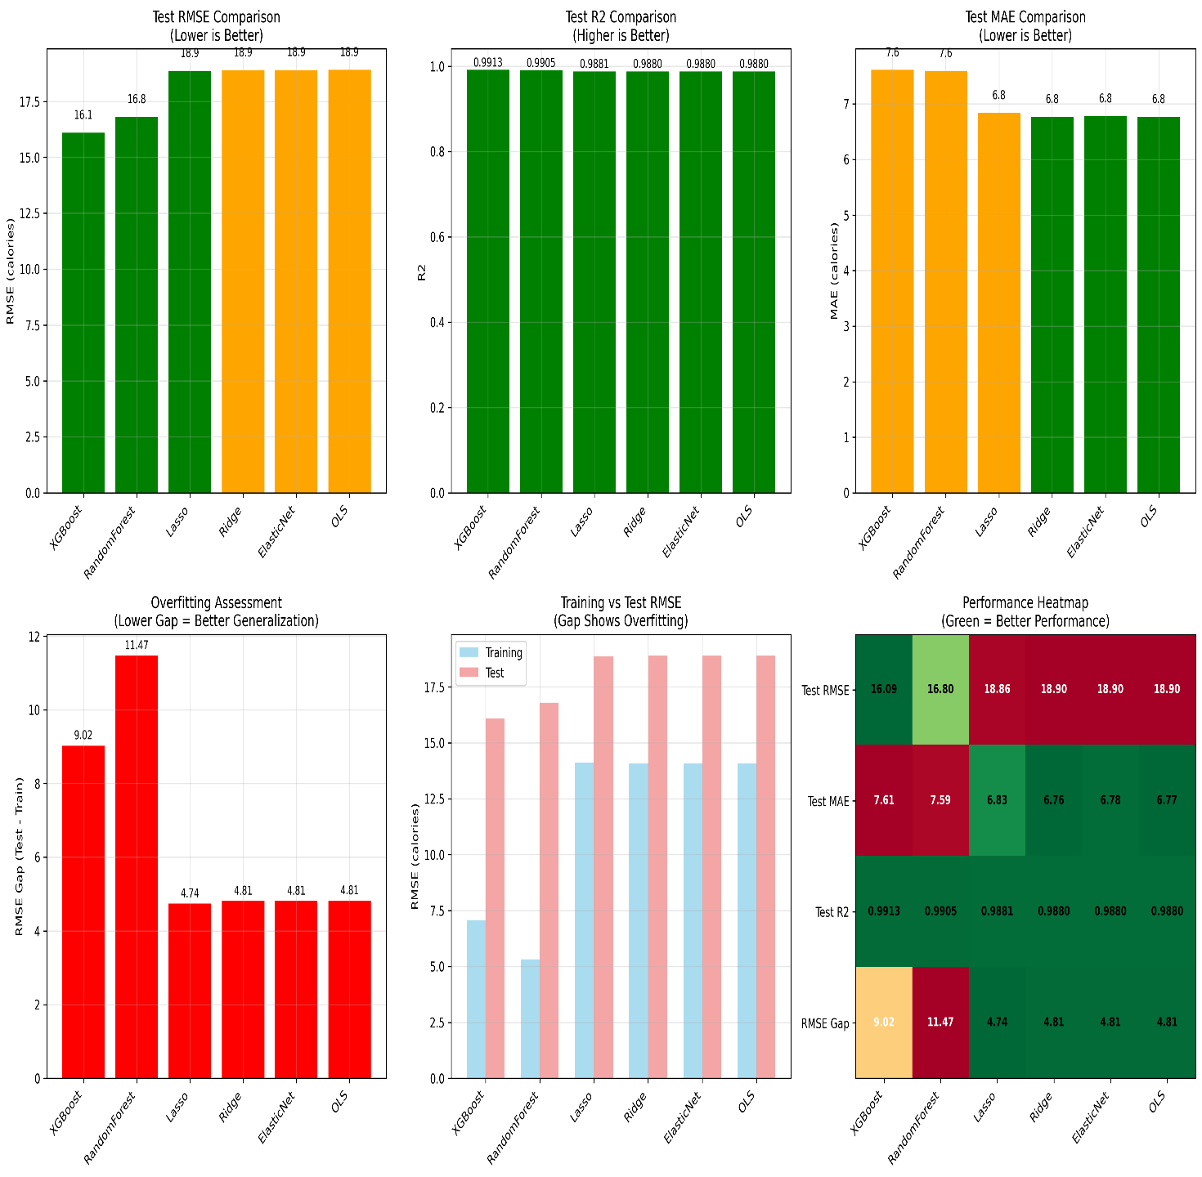
Refer to Figure 8 for below for comparisons of the residual plots.
Figure 8
Residual Plots for All Models After Hyperparameter Tuning
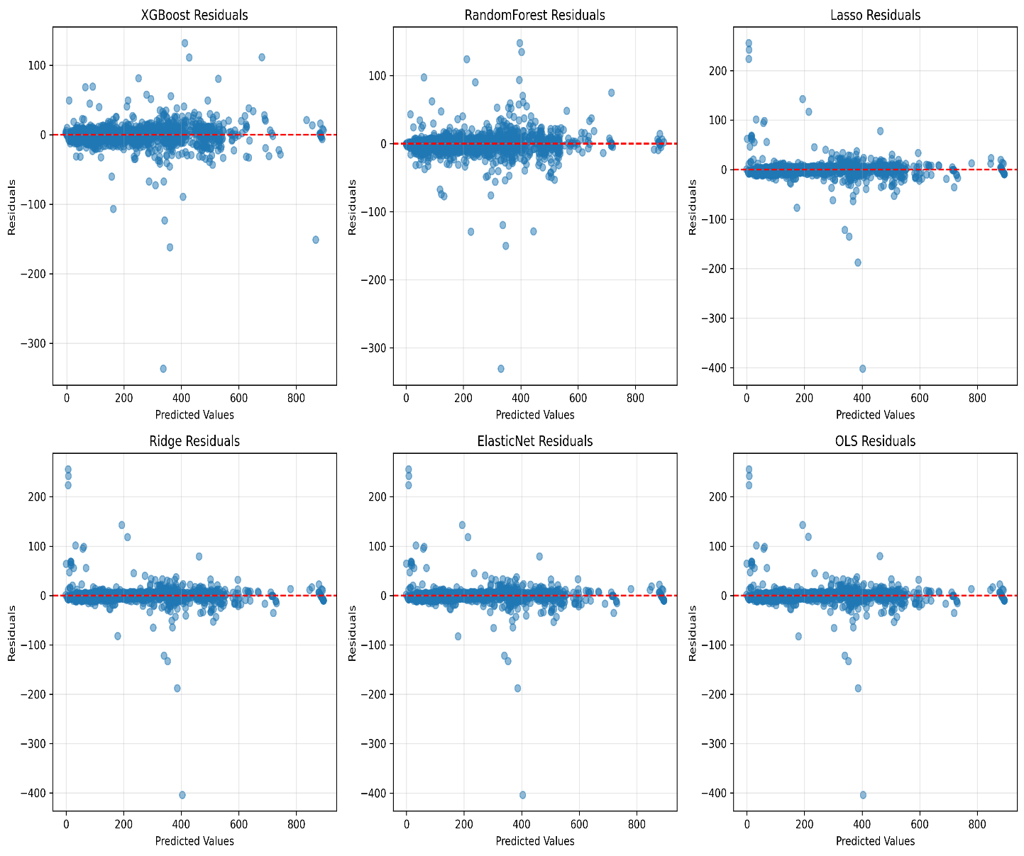
For a data set of 8790 total samples on nutrition and 52 original features of which 47 are numeric, an 80%/20% split is carried out to give 7032 training samples and 1758 test samples. The best model performance is XGBOOST out of 6 models. With test RMSE of 16.09, test MAE: of 7.61,and test R²: 0.9913. Refer to Figure 9 below.
Figure 9
The Best Model Prediction is XGBOOST
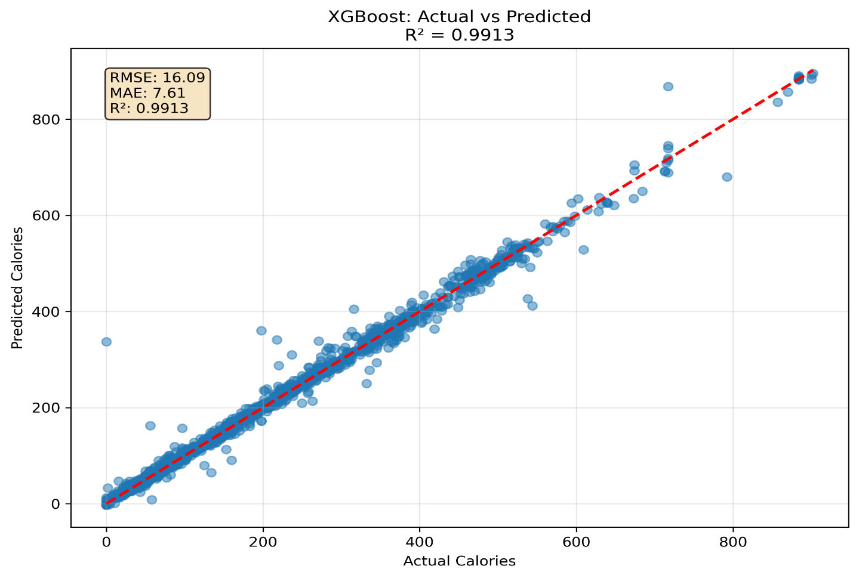
For the XG Boost Feature Selection report, out of original 47 numeric features, 15 features are selected effectively reducing features by 68.1%. The RMSE is 15.4953 for all features and is 16.6816 for selected 15 features. Respectively MAE is 6.6802 and 6,5971 while R² is 0.9920 for all features and 0..9907 for selected 15 features providing a retention of 99.9% of R² with 68.1% feature reduction. The top 3 most important features are Lipid_Tot which changes prediction by ±90.4 calories on average. Second is Carbohydrt which changes prediction by ±73.1 calories on average. Third is Protein which changes prediction by ±31.2 calories on average. This can be interpreted for business insights as follows: first macronutrients (fat, carbohydrates, protein) are the most important for calorie prediction. Secondly, the model maintains >99% accuracy with 70% fewer features. Third, feature reduction enables faster predictions and simpler deployment. For feature contribution analysis, refer to Figure 10 below.
Figure 10
Feature Contribution Analysis
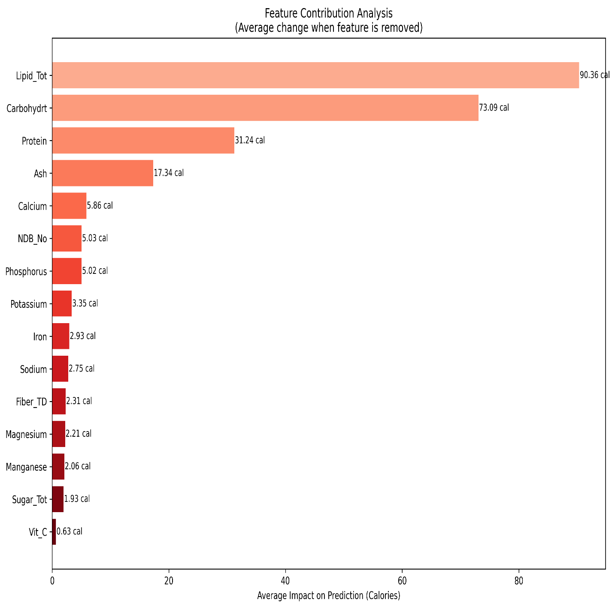
For feature XGBOOST selection analysis, to uncover the top 15 features, correlation matrix, RFE feature ranking, feature count versus model performance , correlations with target variable , final feature selection scores, and model performance, refer to Figure 11 below.
Figure 11
Feature Selection Analysis
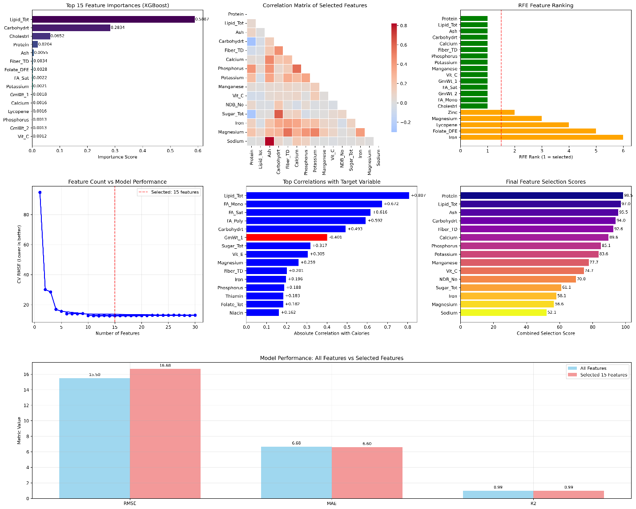
Part 3: Critical Paper Review and Justification
Discussion
This research effectively answers the two posed questions and offers insights into the bias-variance tradeoff in a practical setting. On question one, about Linear versus. Ensemble methods when it comes to Regression, results clearly show that ensemble methods (RF and XGBOOST) outperform linear regression models. This is expected given the complexity of nutritional data, which is likely to contain non-linear relationships and complex interactions between nutrients such as how fats, proteins, and carbohydrates jointly determine calories. Tree-based models inherently capture these patterns, whereas linear models assume a simple additive relationship. The findings from the study aligns with other literature stating that ensemble methods often achieve higher predictive accuracy in complex, real-world datasets.
On the second research question about establishing the best linear regression model The finding that OLS, Ridge, and Lasso performed nearly identically after hyperparameter tuning is highly informative. It indicates that for this specific, processed nutrition dataset, the traditional problems of OLS which is overfitting and coefficient instability due to high dimensionality, are mitigated by the preprocessing and feature engineering. The lack of significant feature selection by Lasso suggests that most engineered features that are introduced are relevant. This result is valuable; it demonstrates that with robust data preparation, simpler linear models can be highly competitive and offer excellent interpretability, though still at a lower accuracy than ensembles.
On the central role of the bias-variance trade off, this research is a practical case study of this fundamental concept. Linear regression models have higher bias and lower variance due to their simplistic mechanism: In this research, linear methods show a smaller gap between training and test error which suggests lower overfitting, indicating better generalization control but at the cost of higher overall error (RMSE) which points towards bias. They are simpler and less prone to overfitting the noise in the data but they come at the cost of higher underfitting through bias.
Conversely, tree models have lower bias and a higher variance: XGBOOST and RF achieved much lower training error (RMSE) meaning they have low bias but, both exhibited a larger train-test performance gap, signaling higher variance and a tendency to overfit. The hyperparameter tuning carried out in this research such as limiting max_depth, using regularization in XGBoost is essential in reducing the variance. This helps in pushing the models toward the optimal tradeoff point. The superior final test performance of the tuned tree models confirms they achieved a more favorable balance for this dataset.
For the critical evaluation of methodology and findings, this research shows strength in rigor. The use of k-fold cross validation, separate tuning with appropriate search strategies and multiple error metrics provides a robust and trustworthy comparison. In interpretation of Elastic Net, the initial poor performance of this model which is remedied by tuning underscores the point made by Zou and Hastie (2005), the strength of Elastic Net in blended scenarios with both irrelevant features and correlated groups. The results suggests the final feature set may not have this specific structure, making the simpler Ridge or Lasso sufficient.
Literature Integration and Justification
The results obtained in this study do not align well and greatly outperforms scholarly research according to Kocabaş et al.(2024), who conducted a study to compare 8 regression techniques applied to a one dimensional data set correlating years of experience with Salary. The study compared the following regression techniques: OLS (linear regression), Ridge, Lasso, Decision Tree, Random Forest, Support Vector Regression. (SVR) and Gradient Boosting regression. The key metrics used in the study have similarities and differences to what is used in the current study: MAE, , Mean Squared Error (MSE) and R² are used to evaluate performance. The study did not address adjusted R² to account for a penalizing effect when the number of features was large.
The findings in the study by Kocabaş et al.(2024), show significant differences in the accuracy and robustness of different models. OLS and polynomial regression are baseline models just like OLS is the baseline model in this study, while regularization models Ridge and Lasso provide improve stability against overfitting similar to this research. Thirdly, decision trees and random forest regression models capture nonlinear relationships with different levels of success . In this study RF does a better job than linear models at capturing complexity. SVR using a kernel method adopts well to complex patterns while gradient boosting regression captures the worst in predictive performance via ensemble learning which diverges directly with the results of this nutrition predictive project.
Kocabaş et al.(2024), neither does support my model selection of XGBOOST for its predictive power, nor RF for the model’s robustness . With exception of SVR, these two ensembles perform the worst according to results of R² , MAE and MSE. There are key differences between the data set used in Kocabaş et al.(2024), and that of this project. For Kocabaş et al.(2024),to call their data set reliable is misleading, especially since it is not a real world data set that is messy and with complex relationships as the one used in this study. Kaggle is known for simple already clean and synthetic data sets that do not require much preprocessing. Furthermore, the researchers conduct their research under consistent conditions and never include the number of records or predictors unlike the 8790 observations and 58 predictors in this study, which adds to the degree of complexity with real world data
Secondly the Kocabaş et al.(2024), use only three metrics to evaluate their data, MAE, MSE and R², while this project utilizes 4 metrics: MAE, RMSE, R² and Adjusted R^{2.} Thirdly Kocabaş et al.(2024), mention utilizing grid search or cross validation and are never specific on when these tuning methods are used. In this project cross validation evaluation is performed for all models after they are implemented using a k of 5. Then Hyperparameter tuning with cross validation is carried out. Grid Search cross validation is conducted for linear regression while random search cross validation is performed for RF and XGBOOST
Fourth, Kocabaş et al.(2024), call for future work to be conducted for hyperparameter tuning and for investigation of various data preprocessing methods on model performance. This research project involved intense preprocessing including imputing missing values, removing outliers, one hot encoding categorical variables and normalizing the numerical variables and feature engineering the data with polynomials and interactions.
Fifth the two research projects yield very different results for the common metrics . For Kocabaş et al.(2024), OLS the MAE is 6286 versus the 6.77 for this study, Ridge regression is no better at MAE of 6274 versus 6.76 for this study, RF at 6872 versus 7.59 and XGBOOST at 8530 versus 7.61.The R2 is 0.902 versus 0.988 for OLS, 0.902 versus 0.988 for Ridge, 0.902 versus 0.9881 for Lasso, RF is 0.875 versus 0.9905, and XGBOOST 0.805 versus 0.9913 for this study.
Sixth, it is important to note that the results for Kocabaş et al.(2024),indicate that linear methods led by OLS had the best R² at 0.902, followed by Lasso, then Ridge regression; ensemble tree models performed the worst with RF outperforming Gradient boost by 0.875 to 0.805. In this project the tree models led with XGBOOST having an accuracy of 0.9913 and OLS at the other end of the spectrum with an R² of 0.988. All models in this trial after hyperparameter tuning with cross validation had greater than 0.988 R² for all models. This is a strong showing in predictive power and accuracy.
The weakness of the MSE results, for Kocabaş et al.(2024), is evident once again, while we cannot directly compare RMSE to MSE, it is disheartening to see that the prediction error in MSE is largest for the tree models especially for XGBOOST and that linear models have less error with Linear Regression being the top performer with the lowest MSE. The only strength of Kocabaş et al.(2024),is in their conclusion of their findings when they insist that .each regression method has its own strength and weakness making the techniques suitable for different types of datasets and modelling tasks. This is congruent with the findings and conclusions of this research.
Conclusion and Reflections
This research successfully demonstrates that while advanced regularized linear models remain robust and interpretable tools, modern ensemble methods like XGBOOST deliver superior predictive power for complex nutritional prediction tasks, provided they are carefully regularized to manage overfitting. The project underscores a key machine learning principle; that there does not exist a universally best model; the optimal choice is dictated by the data structure and the business problem context, therefore, emphasizing the need for systematic preprocessing, model comparison, and hyperparameter optimization as is accomplished in this study.
The results of this study are ready for marketing to be used at Murage Mills for marketing while waiting to conduct scientific research Business context justification shows that the choice of XGBOOST as the best model is well-justified for the stated problem of calorie prediction. A prediction error (RMSE) of approximately16 calories on a calorie scale that often ranges into the hundreds is likely accurate enough for marketing purposes. The slight sacrifice in interpretability for a significant gain in accuracy is a valid trade-off given the business need for speed and reliability.
XGBOOST correctly identifies the factors for calorie calculation, with feature selection validating domain knowledge that macronutrients: Lipd_Tot (fat), Carbohydryt (carbohydrates) and Protein are the most important features, which aligns with nutrition science. Furthermore, feature selection shows that the business can run a more simplified model with just 15 features selected instead of all 47 and not have to compromise on R² performance. This gives faster predictions, lower costs and better interpretability

REFERENCES
Arnold, C., Biedebach, L., Küpfer, A., & Neunhoeffer, M. (2024). The role of hyperparameters in machine learning models and how to tune them. Political Science Research and Methods, 12(4), 841-848. https://doi.org/10.1017/psrm.2023.61
Bentéjac, C., Csörgő, A., & Martínez-Muñoz, G. (2021). A comparative analysis of gradient boosting algorithms. Artificial Intelligence Review, 54(3), 1937-1967. Artificial
https://doi.org/10.1007/s10462-020-09896-5
Kocabaş, M. B., Tashan, W., Shayea, I., & Alibek, M. (2024). Comparative analysis of one-dimensional regression techniques. 2024 IEEE 16th International Conference on Computational Intelligence and Communication Networks (CICN), 1365-1370.
https://doi.org/10.1109/CICN63059.2024.10847388
Salman, H. A., Kalakech, A., & Steiti, A. (2024). Random forest algorithm overview. Babylonian Journal of Machine Learning, 2024, 69-79. https://doi.org/10.58496/BJML/2024/007
Shekhar, S., Bansode, A., & Salim, A. (2021) A comparative study of hyper-parameter optimization tools, 2021 IEEE Asia-Pacific Conference on Computer Science and Data Engineering (CSDE), 2021,1-6.
https://doi.org/10.1109/CSDE53843.2021.9718485.
Zou, H., & Hastie, T. (2005) Regularization and variable selection via the elastic net. Journal of the Royal Statistical Society Series B: Statistical Methodology, 67(2), 301- 320. https://doi.org/10.1111/j.1467-9868.2005.00503.x

