**Name:** gorripetimurali

**Batch:** June 01 2022

**Project Name:** Artifactory and Code.

**NEXUS ARTIFACTORY ON UBUNTU:**

1. As a Prerequisite installed the vim package and java package



1. Went to the cd/opt directory and Fetched the Nexus download link <https://download.sonatype.com/nexus/3/nexus-3.39.0-01-unix.tar.gz> from the internet.

1. Untar the nexus-3.39.0-01-unix.tar.gz file by running the ( tar -zxvf nexus-3.39.0-01-unix.tar.gz ) command

1. Rename the nexus-3.39.0-01 to nexus by running the ( mv /opt/nexus-3.39.0-01 /opt/nexus ) command.

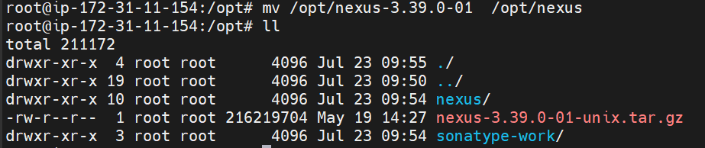

1. Added nexus user by running the ( useradd nexus ) command.



1. Given Root Privileges to nexus user by running the ( visudo ) command.
2. Changed the ownership of the nexus by running the (chown -R nexus:nexus /opt/nexus and chown -R nexus:nexus /opt/sonatype-work ) commands.

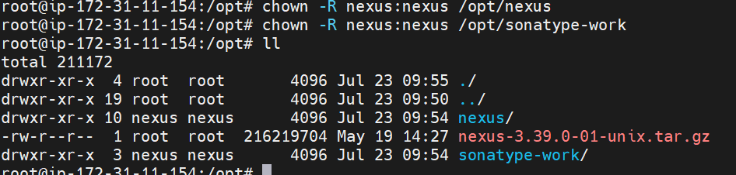

1. Ran the vim /opt/nexus/bin/nexus.rc and nexus to run as a user.



1. To check the memory allocation ran the ( vim /opt/nexus/bin/nexus.vmoptions ) command and checked the memory allocation.
2. Wrote the simple script to launch the nexus repos by running the ( vim /etc/system/system/nexus.service ) command.

1. Started the nexus services by running the ( systemctl start nexus ) command.
2. Enabled the nexus service by running the ( systemctl enable nexus ) command.
3. Checked the nexus service status by running the ( systemctl status nexus ) command.
4. Taken the Public IP address and log into the web console with port 8081.
5. Successfully launched the nexus artifact.

1. Default admin user password is located in /opt/sonatype-work/nexus3/admin.password on the server.

1. Accessed the Password by running the ( cat /opt/sonatype-work/nexus3/admin.password ) command.
2. To log in used admin as the username and password as the default password.
3. Changed the password immediately once login with the default password and enabled a few steps.

1. Successfully logged in to nexus artifact and was able to access it.

**SONARQUBE INSTALLATION ON AMAZON LINUX:**

1. Installed Java 11 by running the ( amazon-linux-extras install java-openjdk11 ) command.
2. Fetched the sonarqube setup file from the internet by using the wget <https://binaries.sonarsource.com/Distribution/sonarqube/sonarqube-9.4.0.54424.zip>

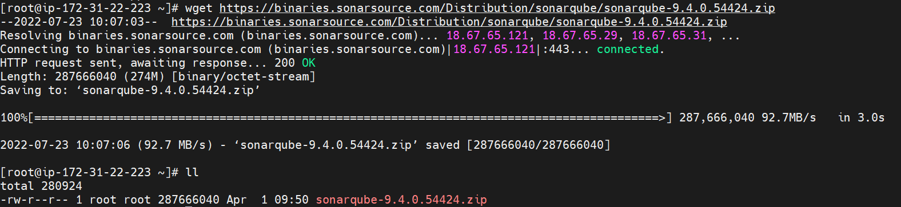

1. Moved to /opt directory and unzipped by running command unzip the sonarqube-9.4.0.54424. directory

1. Added sonaradmin user
2. Changed the ownership of the file to sonaradmin by running the ( chown -R sonaradmin:sonaradmin sonarqube-9.4.0.54424 ) command.

1. Switched to sonaradmin to start the sonar services
2. Moved to /opt/sonarqube-9.4.0.54424/bin/linux-x86-64 directory.
3. Started the sonar.sh services by running ( ./sonar.sh start ) command.
4. Checked the status of the sonarqube services by running the ( ./sonar.sh status ) command.

1. Taken the instance Public IP address: 18.215.148.126 and used port 9000 to access the SonarQube web interface.
2. Successfully launched the sonarqube.

1. Logged with admin user name and password admin.
2. Changed the Password.
3. Successfully accessed SonarQube Web interface.

**JFROG INSTALLATION ON AMAZON INSTANCE:**

**Artifactory Pro Install in Linux**

1. Connected to instance and switched to root user
2. Performed below commands:

$ cd /opt/

$ wget <https://releases.jfrog.io/artifactory/artifactory-pro/org/artifactory/pro/jfrog-artifactory-pro/7.23.3/jfrog-artifactory-pro-7.23.3-linux.tar.gz>

$ tar -zxvf jfrog-artifactory-pro-7.23.3-linux.tar.gz

$ cd artifactory-pro-7.23.3

$ cd app/bin

$ ./artifactory.sh start

$ ./artifactory.sh status

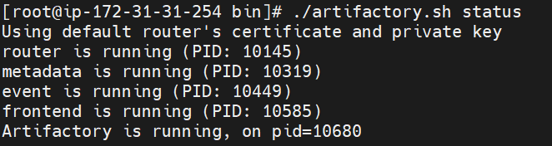

1. Taken the Public IP address and accessed the JFROG with port number 8082.
2. Graphical user interface, application, website

   Description automatically generated
3. Logged into JFROG with username= admin and Password: password. After Successfully logged in changed the password. Graphical user interface, application, website

   Description automatically generated