**Name:** Gorripetimurali

**Batch:** June 01, 2022

**Project:** Configuration through Ansible.

**Project:**

1. Created 3 instances one Amazon Linux (Master node) and one ubuntu and red hat Linux
2. Added user and created password in all servers
3. Changed password authentication to yes and provided sudo privilege to user created in sudoers file (visudo)
4. Then restarted sshd service.
5. Logged in as ansible user in master node, installed ansible and generated ssh keys and copied to nodes (Redhat and ubuntu)
6. In etc/ansible/hosts added ipaddress of nodes [target] name of group
7. Used ping module to test Ansible and after successful run you can see the below output.

1. Created ansible playbook for installation in os family as per requirement
2. Uncommented lines in /etc/ansible.cfg for hosts and root user
3. Playbook was run and the task was completed. (Ansible-playbook task.yml)



Installation in ubuntu server:

As docker is not supported in redhat podman is installed



In ubuntu server: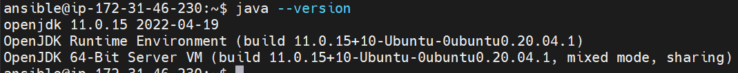

Jenkins connection through port:8080

