On open of the blog page you should see all the blogs that are present in the database. It should contain the title, author, date, and description.

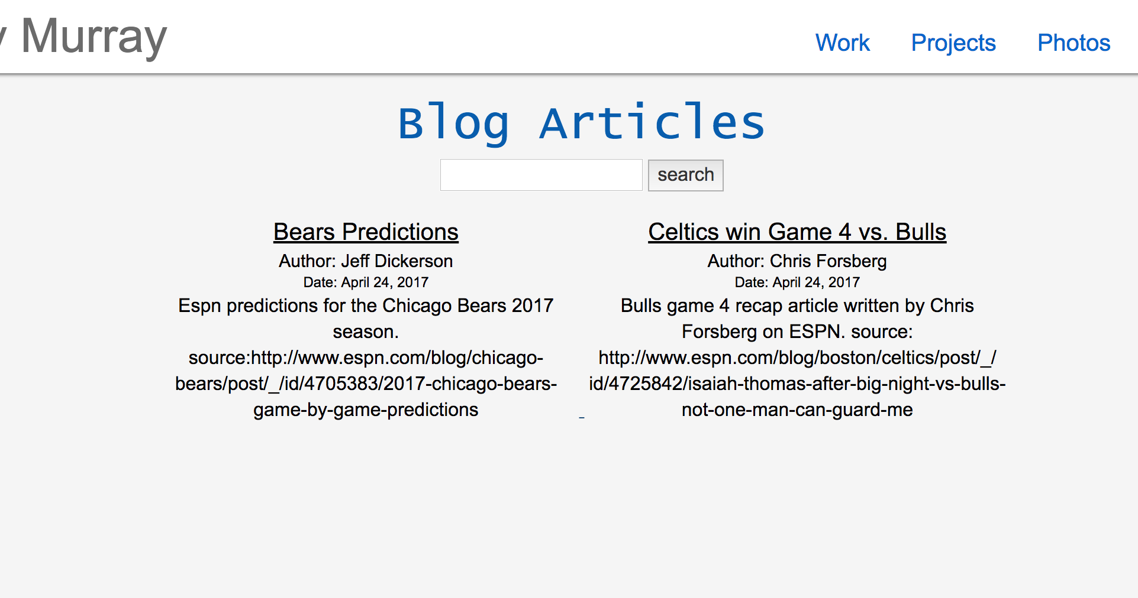

On search it should show only the articles that contain that word somewhere in the article with a word count as well.

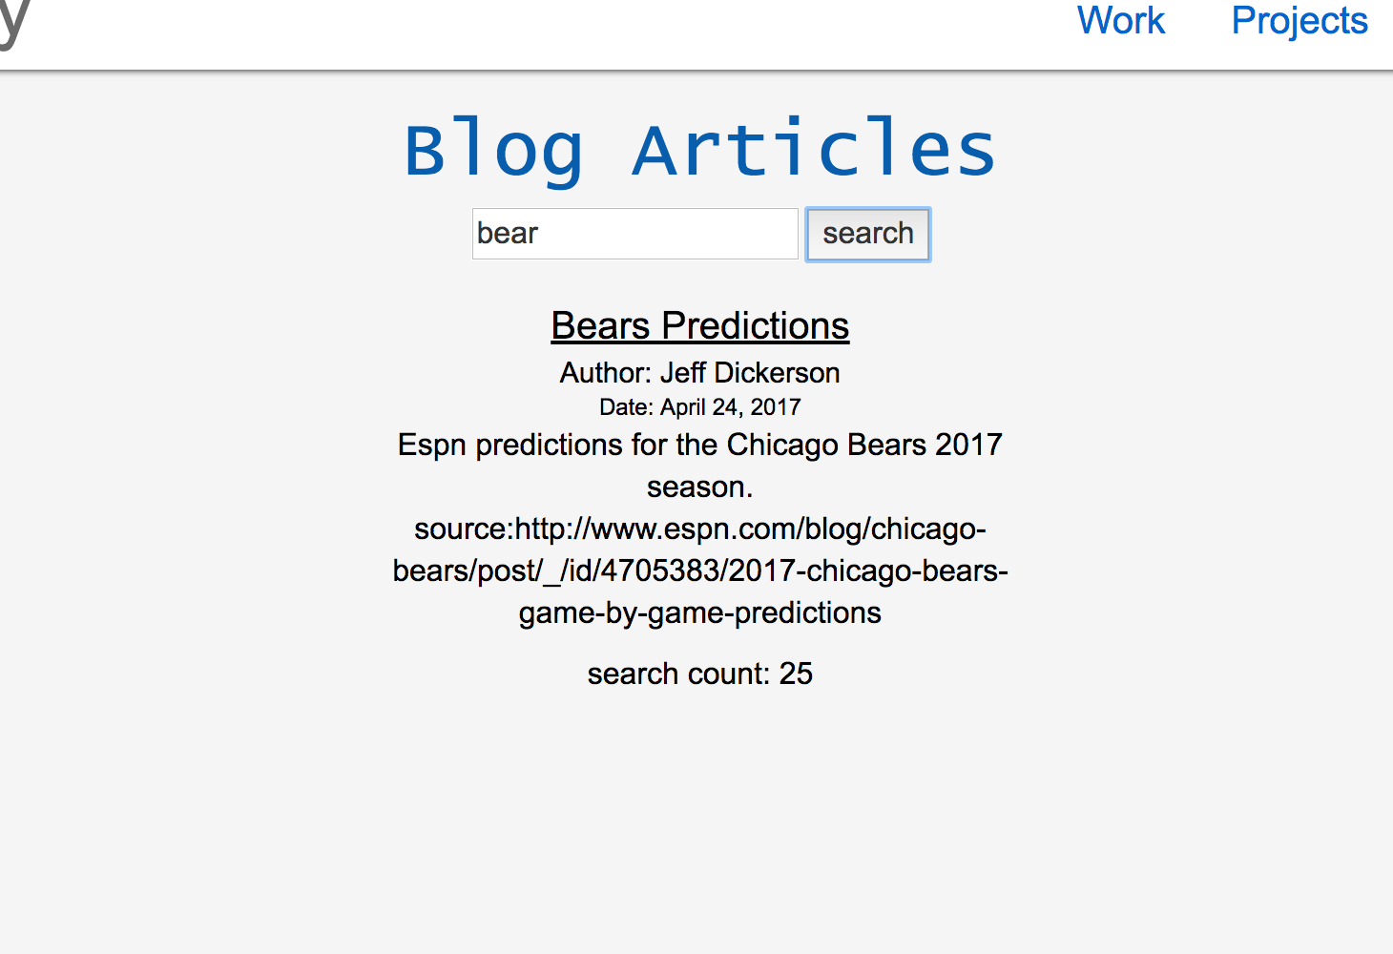

If you search a common word that contains both of the words, it should give prevalence to the higher count like so.

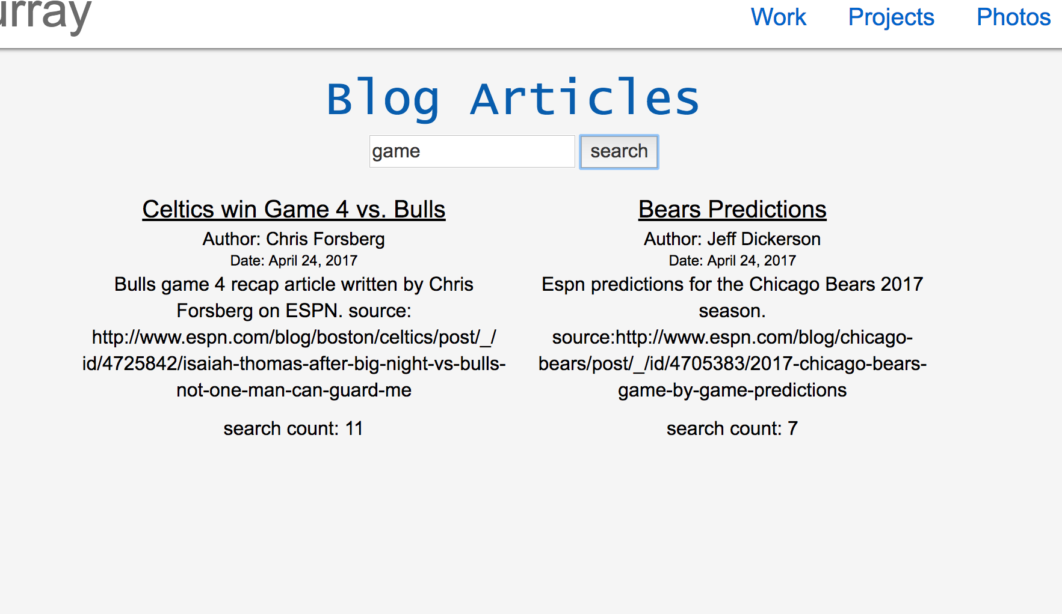

If you click an article, it will take you the article page. It should contain all the relevant information with a picture as well.

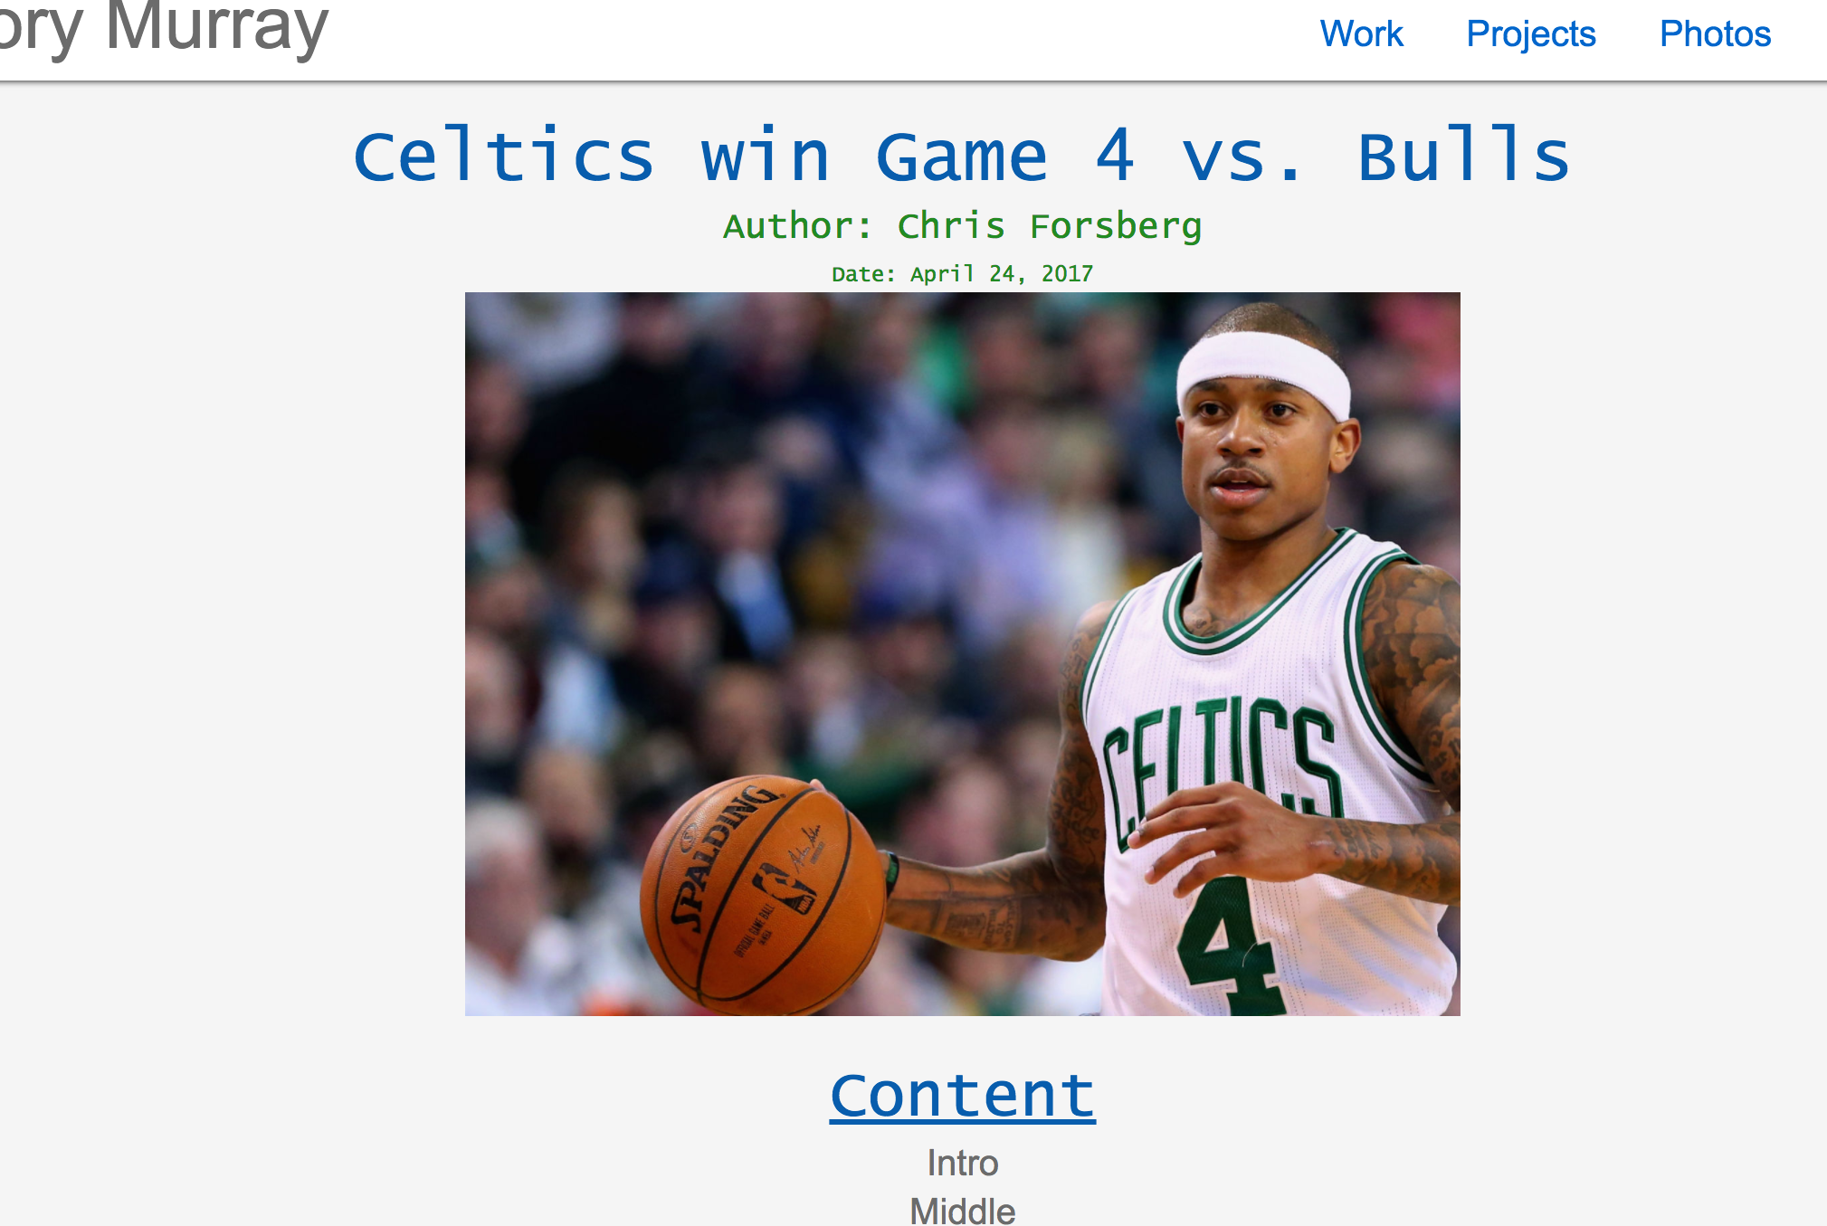

The content should contain 3 section titles, with each link slowly scrolling to the approximate location of the article. At the bottom there should be three share buttons, although they currently do not do anything.

